**Healthcare Application in Blockchain**

A proof of concept implementation of digital health records

Michael Tsao  
 Computer Science Dept.  
 Ryerson University  
 Toronto, ON CANADA  
 michael.tsao@ryerson.ca

Sai Nidumukkala  
 Computer Science Dept.  
 Ryerson University  
 Toronto, ON CANADA  
 sai.nidumukkala@ryerson.ca

**ABSTRACT**

A look into whether a blockchain implementation of a Healthcare System is feasible using the Hyperledger Fabric architecture. The healthcare application includes participants such as Patients and Healthcare providers, who access information-sensitive assets such as consents, medical reports, prescriptions and risk analysis tools to successfully diagnose and prescribe medications securely over a blockchain.

1. **INTRODUCTION**

Blockchain is a distributed ledger technology that assists in managing and storing decentralized data in time stamped blocks. The data is usually transferred over computer networks and secured using the cryptographic standards. Although blockchain was originally used for cryptocurrencies such as Bitcoin and Ethereum, its features and capabilities can be far extended to other fields such as Finance, Internet of Things (IOT) and Healthcare.

Healthcare is usually referred to as a rigid industry due to the lack of rapid innovative practices. But many issues such as privacy, quality of care and information security of patient data have long been drawing attention. Many healthcare systems around the world have come to realize the importance of data analytics in treatments, avoiding preventable diseases and improving the quality of life. There is a need to establish a data distribution network that is secure as well as decentralized and Blockchain has been recognized as a tool to address these issues.

Blockchain is usually defined in a context-sensitive manner where increasing collection of records, referred to as blocks, are linked together using cryptographic standards in such a way that it prevents unauthorized modifications and promotes transparency and security. In healthcare, this helps us eliminate costs and privacy concerns while improving coverage, quality and user provisions.

Since most of the blockchain network is based on peer-to-peer networks, it updates in real time eliminating intermediary costs **[1]**. Also, since blockchains are able to detect modifications, this offers a transparent environment where healthcare providers and patients are able to access records seamlessly without any additional costs **[2]**. This greatly increases the security by limiting lost records and errors.

Recently various solutions have been proposed to utilize blockchain applications in healthcare. Many are designed to help healthcare professionals and patients in managing treatments and administrative functions.

* Secure Health Chain (<https://secure.health>): a provider that offers an EMR solution, that maintains digital medical records using blockchain.
* Doc.AI (<https://doc.ai>): an application that uses natural language processing, computer vision and blockchain to generate patterns from medical data.

Despite this growing trend in blockchain application to many industries, a recent survey by *Deloitte* in 2018 has shown that the understanding of this technology varies greatly. About 40% of the senior executives in the United States had little knowledge about blockchain. While 55% of the senior executives are planning to invest more than 10 million USD into blockchain technology over the next year.

In this paper, we will look into a theoretical understanding and application of blockchain concepts to the healthcare industry using available architecture and discuss our findings and unique perspectives.

2**. Background**

Blockchain is a decentralized ledger system that allows independent agents to collaborate within an ecosystem that allows transparency and time-stamped recordings. This helps improve processing speed and security while simultaneously decreasing risks and costs. In traditional applications information is usually stored in a database. Whereas blockchain utilizes peer-to-peer (P2P) network that involves having multiple copies of the same data stored in different locations and devices. A peer allows a portion of computing resources (processing power, disk storage, network bandwidth) to be used by other participants without the need for a central coordination server. Periodically, each node takes a different role within the network while preserving and coordinating data exchange.

The security in the blockchain is implemented through cryptographic keys. This is achieved through distributed networks and network servicing protocols where information is recorded into a block. Once a transaction request is validated, the metadata is recorded into a block and cannot be modified, removed or disputed without the knowledge and permission of those who created the record or the network. The validated block is then added to the chain of other blocks and will remain unchanged.

One of the key concepts in blockchain is smart contracts or digital contracts. Smart contract is a program that self-executes complex instructions autonomously. This greatly reduces the costs involved in monitoring and enforcing contracts and payments. Smart contracts also allow modularity in developing micro or macro applications, thereby reducing agency and coordination costs in a system such as healthcare or finance.

2.1 **Blockchain in Healthcare**

The decentralized, openness and permissionless nature of blockchain plays a vital role in healthcare. Additional application of blockchain can be implemented in health aspects such as IOT medical devices and medical research. Like the finance industry, healthcare has a growing demand for blockchain implementations and is actively pursuing the current available solutions to address its critical needs **[3]**.

Immutability, a key feature offered by blockchain is sought by the healthcare industry. This feature allows healthcare systems to maintain secure health records and clinical records while maintaining regulatory compliances **[4]**. A successfully implemented system will ensure security of records while also providing access to medical professionals and patients according to the Health Insurance Portability and Accountability Act (HIPAA).

Further applications of blockchain in healthcare include pharmaceuticals and identifying counterfeit drugs. Since the cost of developing new drugs and conducting trials are substantially high, smart contracts will facilitate the simplification of consent management as well as improve the privacy of individual health data.

3**. Architecture**

3.1 **Hyperledger Fabric**

Fabric is a distributed operating system for permissioned blockchains that usually execute distributed applications written in various programming languages. It tracks the execution history in an append-only ledger structure with no built in cryptocurrency. The Fabric operates in an execute-order-validate **[5]** blockchain architecture (refer to Figure 1 below) and does not follow the standard order-execute design.

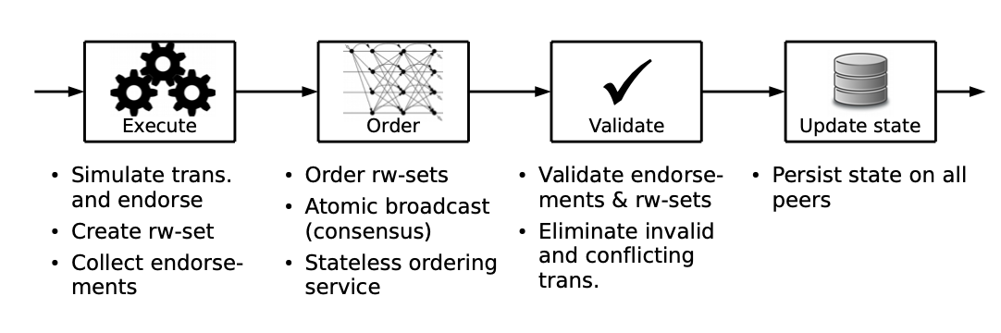

**Figure 1: Execute-Order-Validate architecture of Fabric**

Hyperledger Fabric used to build a distributed application usually consists of two parts.

* Smart Contract, also known as the chaincode. It mainly includes the program code that consists of the complex application logic that runs during the execution phase. In Hyperledger Fabric, Javascript is used to write the said logic.
* Endorsement Policy, which runs during the validation phase is a static library that is usually referenced during the transaction validation process. Usually an endorsement policy lets the chaincode specify the endorsers for the transaction, in the form of peers.

A client sends transactions to the peers as listed in the endorsement policy. Then each transaction is executed by the peers and its output is recorded as an endorsement. After execution, transactions then enter the ordering phase, which uses a pluggable consensus protocol to produce ordered sequences of endorsed transactions usually grouped in a block. This is then broadcasted to all the peers. Each peer then validates the state changes of transactions and its consistency in the validation phase. All peers validate the transactions in the same order and the validation is deterministic **[5]** (refer to Figure 2 below).

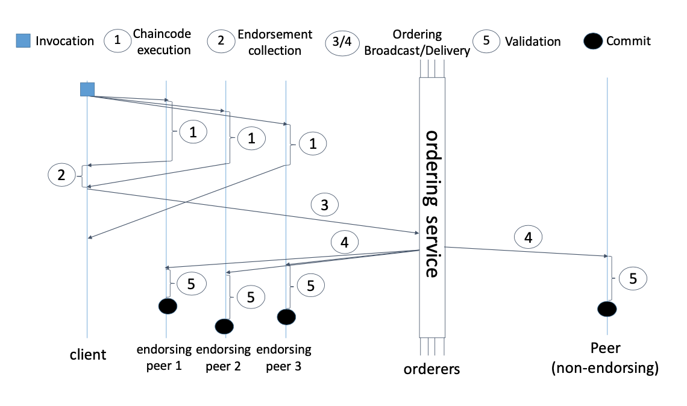

**Figure 2: Hyperledger Fabric transaction flow.**

Private blockchain allows one to restrict as to who can access the system. Permissioned blockchain allows restricted access to certain participants of the system. This can be used to restrict participants of a certain type from accessing private information. This concept has been implemented in the application as listed in Section 4 of this paper.

3.2 **Hyperledger Composer**

Hyperledger Composer is a set of tools that allows various business owners, operators and developers to create blockchain applications and smart contracts aimed at solving business problems and improving operating efficiency. Hyperledger Composer is built in Javascript and is platform independent. It also allows the use of built-in libraries and functions to make blockchain applications more reusable and scalable. It is hosted by the Linux Foundation.

In our application, despite Hyperledger Composer being depreciated as of August 2019, we used it as a means to quickly prototype and develop the blockchain network. This allowed us to experiment and develop the necessary data structures needed to successfully implement the Healthcare application.

Hyperledger Composer offers many tools such as:

1. Adding network to blockchain
2. Upgrading a network to updated rules
3. Setting up a REST API server and a front-end interface

Among the many tools that Hyperledger composer offers, it allows to quickly setup a REST API in order to interact with the blockchain. Additionally, Hyperledger Composer provides a feature known as a Composer Playground, that is a front-end interface, used to manage and interact with the blockchain networks.

4**Implementation**

In this section, we show the settings that were adopted in the implementation of the healthcare blockchain. Initial implementation was achieved using the composer command line utilities, REST API and the Composer Playground.

4.1**Participants / Permissions**

The participants of the system were first added by the administrator and then added into the registry via the Composer Playground. We mainly divide participants into two distinctive roles:

1. Patient - a registered person using healthcare services
2. HealthcareProvider - a organization / individual offering healthcare services (Examples: Hospital, Family Doctor, Pharmacist)

Permissions are defined in the *permissions.acl* file and are summarized below (refer to Figure 3 below).

| **Asset (Resource)** | **Patient** | **Healthcare Provider** | **Admin** |
| --- | --- | --- | --- |
| Consent | CREATE  VIEW (owner only) UPDATE | VIEW (all) | CREATE  VIEW (all) UPDATE  DELETE |
| Medical Report | DENY | CREATE  VIEW (all) UPDATE | CREATE  VIEW (all) UPDATE  DELETE |
| Prescription | VIEW (owner only) | CREATE  VIEW (all)  UPDATE | CREATE  VIEW (all) UPDATE  DELETE |
| Risk Analysis | DENY | CREATE  VIEW (all)  UPDATE | CREATE  VIEW (all) UPDATE  DELETE |

**Figure 3: Participants and their respective roles**

With the above mentioned permissions, Patients can view their consent information for Ontario’s After Death Organ Donation program as well as their own personal information that they can themselves configure. Additionally, data privacy is maintained as patients can only view their own information and are restricted from accessing other patient’s private information. Healthcare Providers also benefit from storing the information in the blockchain. One such example would be recent appointment visits.

4.2**Assets**

Assets are the data structure representation of objects that is used in the chain code (refer to Figure 4 below). Our assets are defined as follows:

1. Consent - an object that holds all the health consent information
2. Medical Report - an object that holds appointment information to be shared with other providers
3. Prescription - a record of prescribed drugs for the patient
4. Risk Analysis - a object that represents health risk score maintained and visible only by healthcare providers

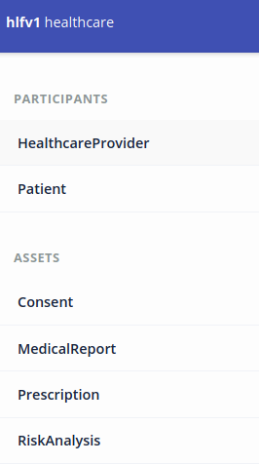

**Figure 4: HyperLedger Composer Interface**

4.3**Chain Code**

In our implementation, we used chaincode to implement two transactions dealing with the Healthcare Providers.

Our first transaction is to calculate the risk score based on a patient’s existing condition and risk factors. Risk condition information is stored in the asset, Risk Analysis. The transaction will read properties of this asset and update into the respective field. This transaction is intended to be updated after changing any patient's risk information.

Our second transaction is used to create a prescription which prefills certain fields to standardize record format of structured string data like the date formats. Ensuring that record formats can make data more uniform, which not only prevents misunderstanding of the data but can allow other automated processing such as totaling the amount prescribed drugs possible.

5**Findings and Conclusions**

We successfully implemented a blockchain in Hyperledger Fabric that can facilitate information sharing between our different classes of participants. In addition, we were able to implement our use cases where the system easily allows the sharing of medical information between the proper parties.

All information used to interact with the blockchain used a REST JSON API. This is a common standard that is widely accepted by current ehealth record standards. This results in a more smooth integration with existing solutions as there are no major standards shift.

With our set permissions, we were able to have controlled access to patient information and implement our business rules. Immutability is controlled both by the nature of Hyperledger Fabric itself and also by the permissions affecting the participants of the blockchain.

5.1**Problems Encountered**

Earlier in the project, we faced many challenges in getting the chaincode to be recognized. It was a bit unclear due to the documentation not properly demonstrating the relationship between permissions and access to the chain code. After referring to similar Hyperledger examples and various trial and errors, we were able to edit the permissions to allow the proper access.

Additionally, we found that the Hyperledger documentation on chaincode and permissions is sparse and as a result not as beginner friendly. This significantly slowed down the development of the project.

We do believe this learning curve to be a potential problem for those that are reimplementing the blockchain in the future using our architecture.

6**Future Work**

In this paper, we showed a hyperledger fabric blockchain from only a back-end perspective. This can be further improved by adding a front-end interface that uses the API endpoint. For example, one can use an Angular or React JS front-end, both of which have features that can connect with REST API’s and to subscribe to data.

We may also want to improve the application by opting to more granular participants, particularly for healthcare providers as it seemed too general.

Additionally, due to the Hyperledger Composer being depreciated, we would recommend switching to other more up to date and better supported tools to build future blockchain networks.

**ACKNOWLEDGMENTS**

We would like to acknowledge the Hyperledger Composer Tutorial documentation, where certain code snippets were adapted into the project. **[10]**

**ADDITIONAL REFERENCES**

[6] Androulaki, Elli et al. “Hyperledger Fabric.” Proceedings of the Thirteenth EuroSys Conference on - EuroSys ’18 (2018): n. pag. Crossref. Web.

[7] Prokofieva, Maria & Miah, Shah. (2019). Blockchain in healthcare. Australasian Journal of Information Systems. 23. 10.3127/ajis.v23i0.2203.

[8] Zhang, Peng & White, Jules & Schmidt, Douglas & Lenz, Gunther & Rosenbloom, S.. (2018). FHIRChain: Applying Blockchain to Securely and Scalably Share Clinical Data. Computational and Structural Biotechnology Journal. 16. 10.1016/j.csbj.2018.07.004.

[9] Frankenfield, Jake. “Hyperledger Composer.” *Investopedia*, Investopedia, 29 Jan. 2020, www.investopedia.com/terms/h/hyperledger-composer.asp.

[10] https://hyperledger.github.io/composer/v0.19/tutorials/tutorials