Submission:

● Github repo URL, deployed site URL, docker images name must be added in the submission

● Upload the screenshots of below mentioned to github repo:

o Jenkins (login page, configuration settings, execute step commands)

o AWS (EC2-Console, SG configs)

o Docker hub repo with image tags

o Deployed site page

o Monitoring health check status

**Github repo URL** : <https://github.com/tiikna/React-app-project3.git>

**deployed site URL**: <http://13.233.88.155/>

**docker images names :**mishraankit062/reactapp3-prod

mishraankit062/reactapp3-dev

**Screenshots:**

**o Jenkins (login page, configuration settings, execute step commands)**

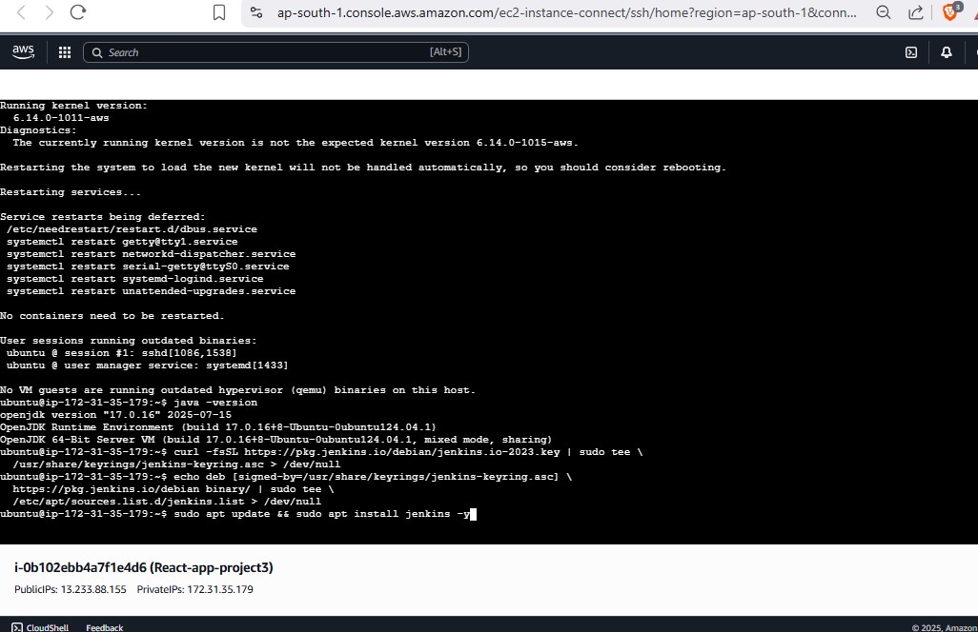

1.jenkins installation

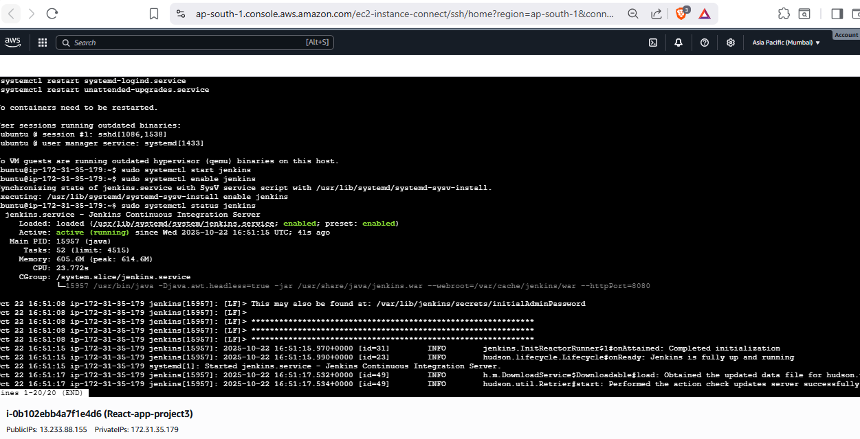

2.Jenkins running

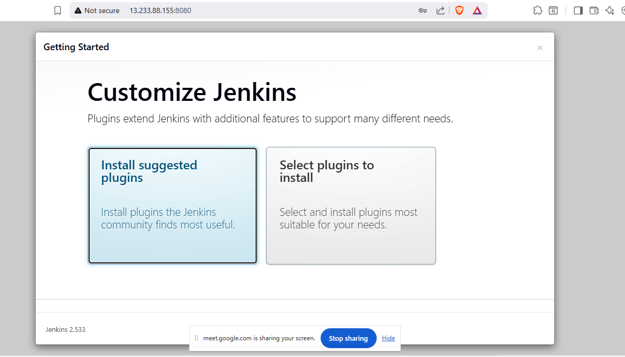

3.Jenkins plugin installation

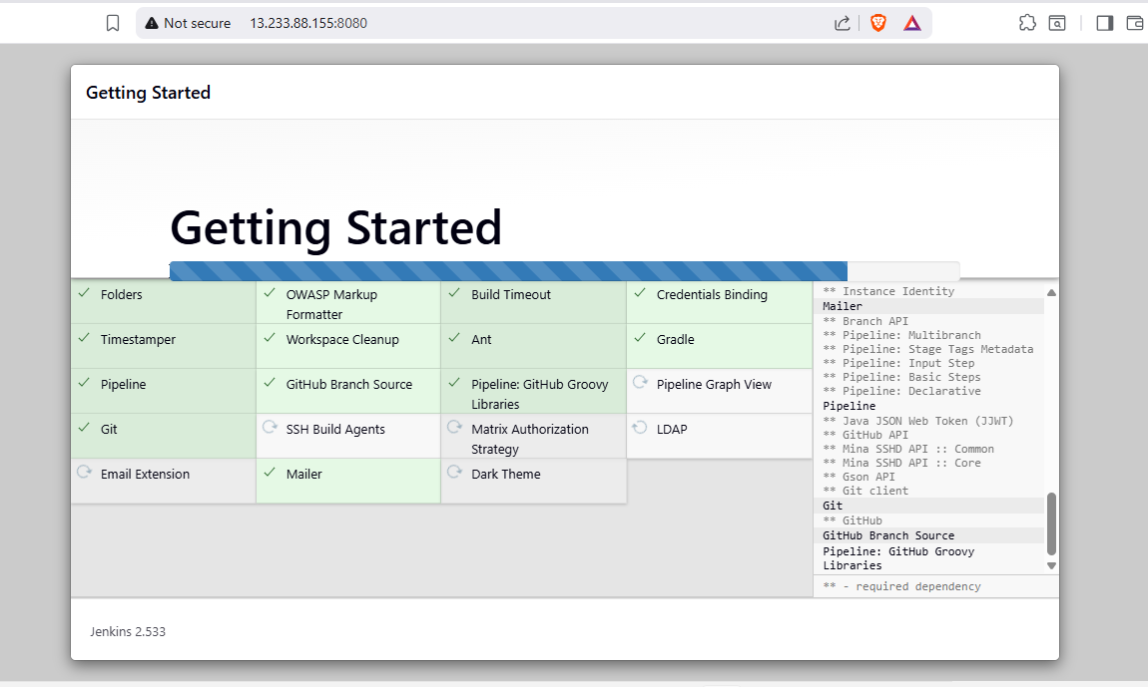

3.1

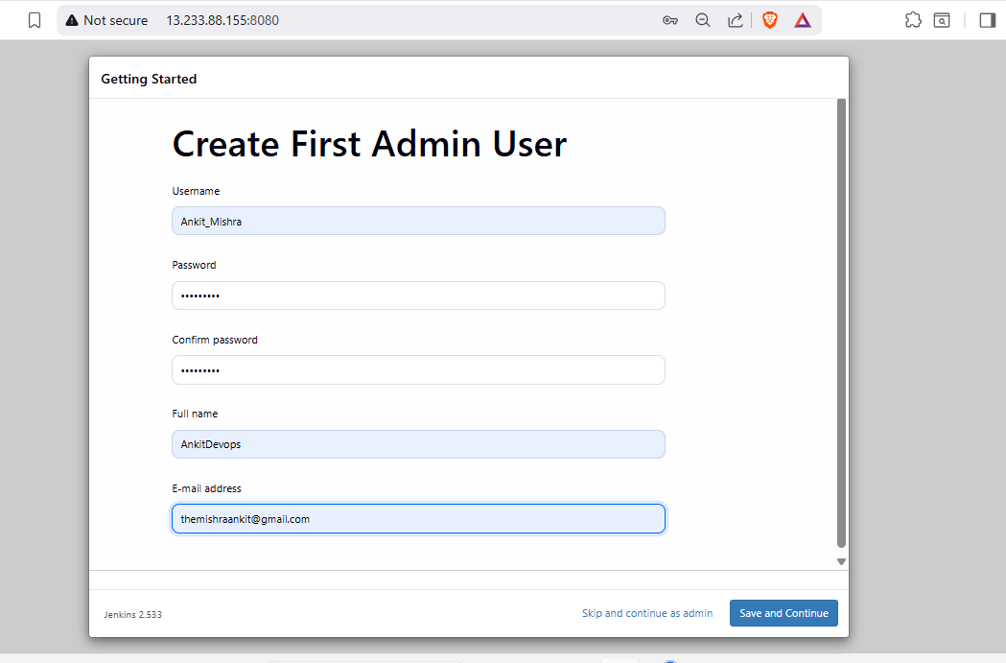

4.creating user in Jenkins

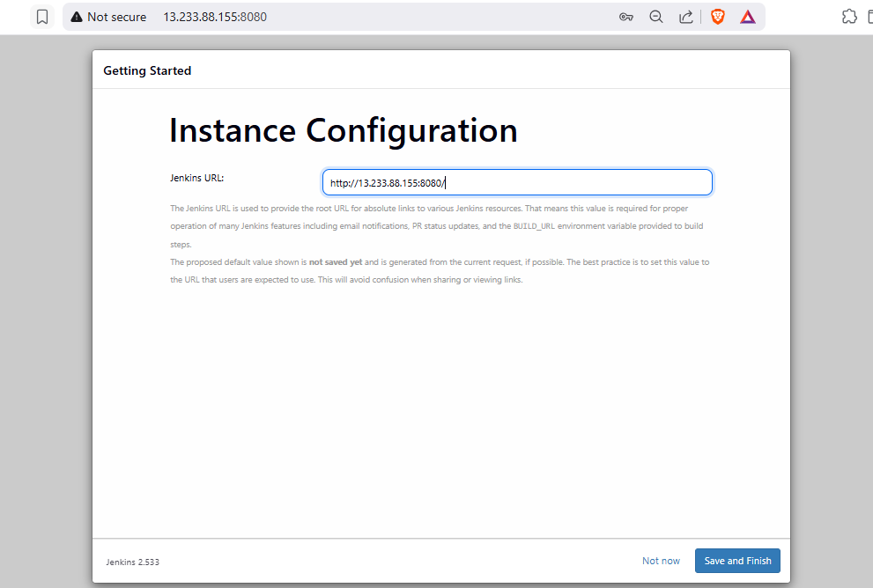

5. Jenkins IP address configuration

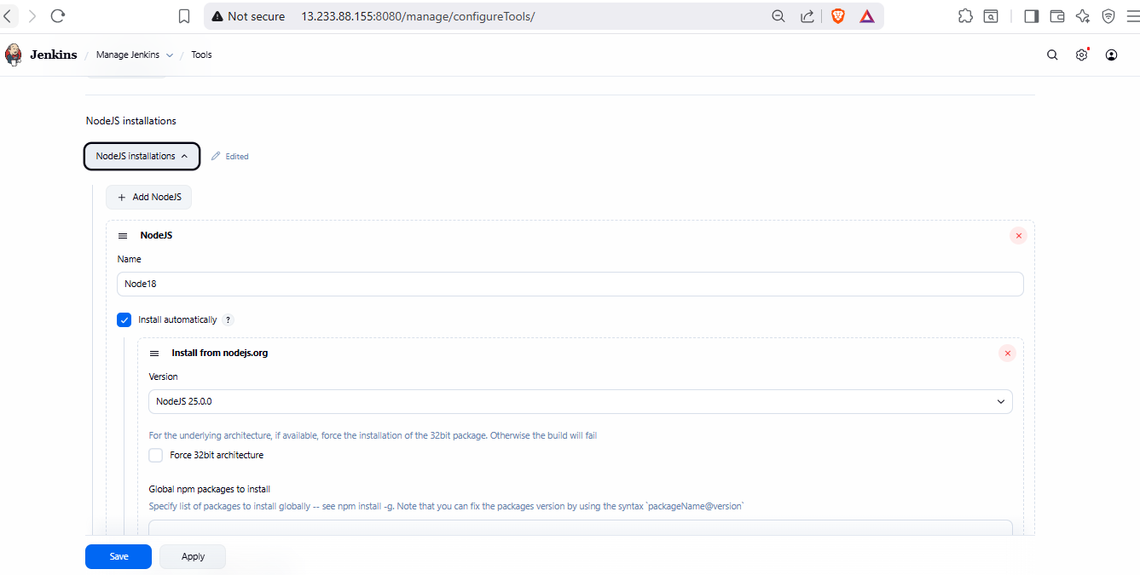

6.adding node18 in tool configuration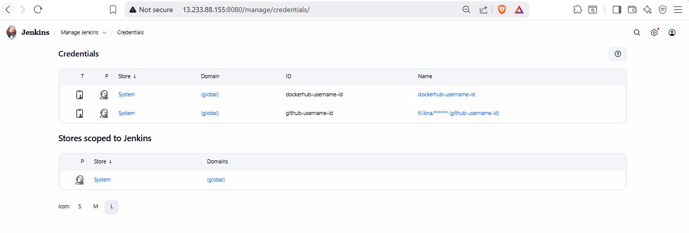

7. adding credentials for docker and GitHub

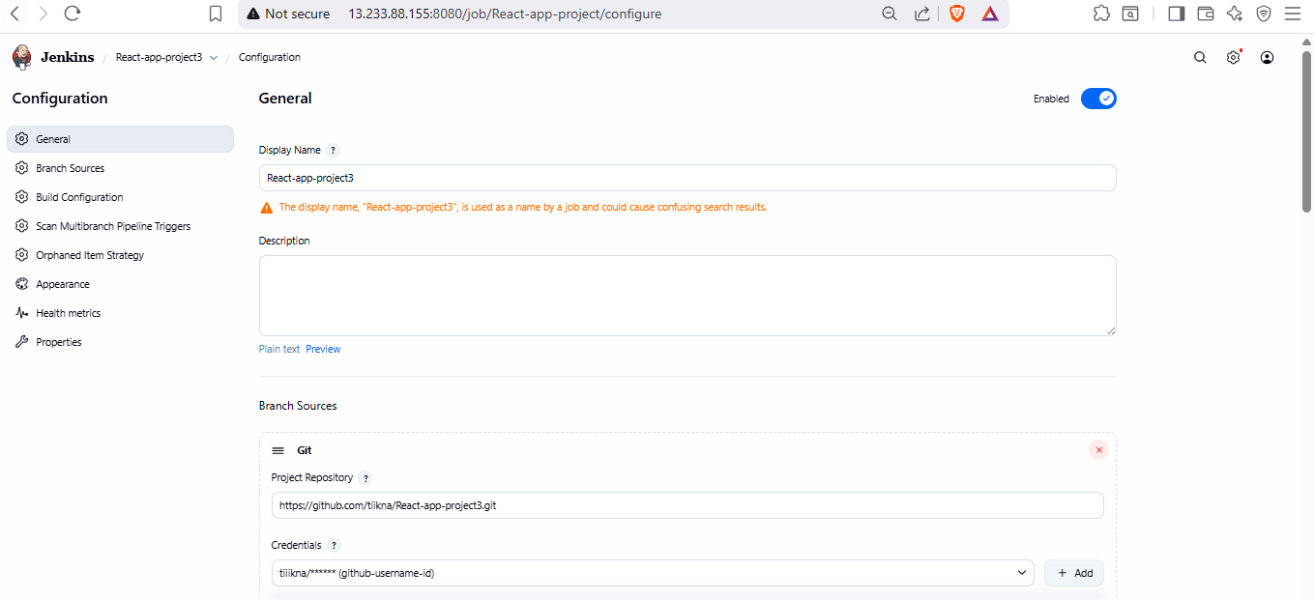

8. creating multibranch pipeline

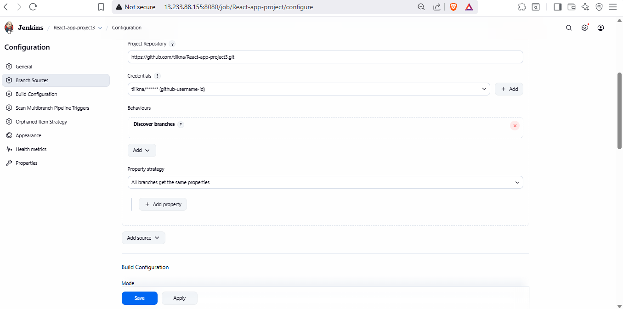

8.1 adding repo to pipeline

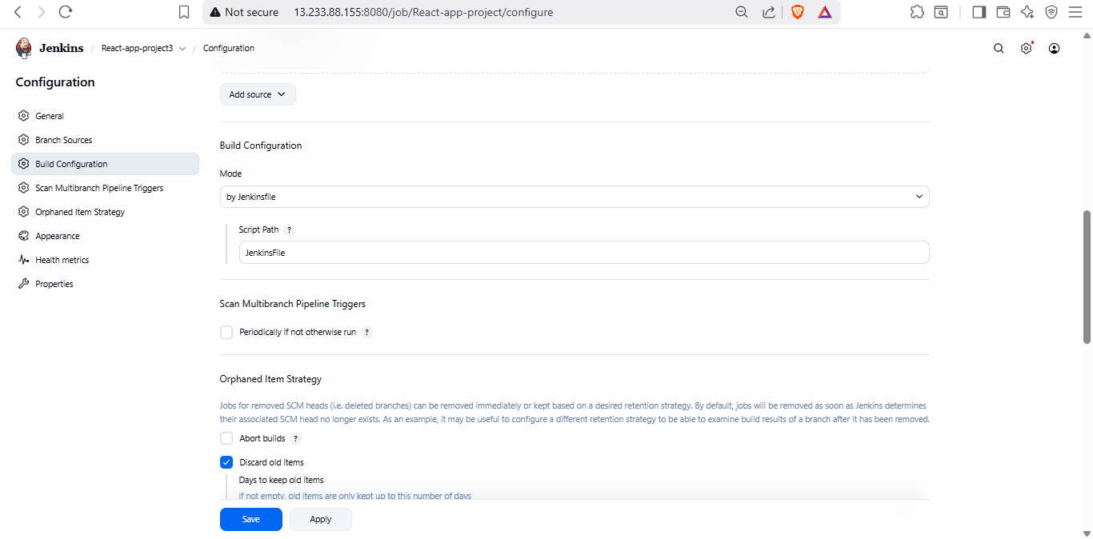

8.2

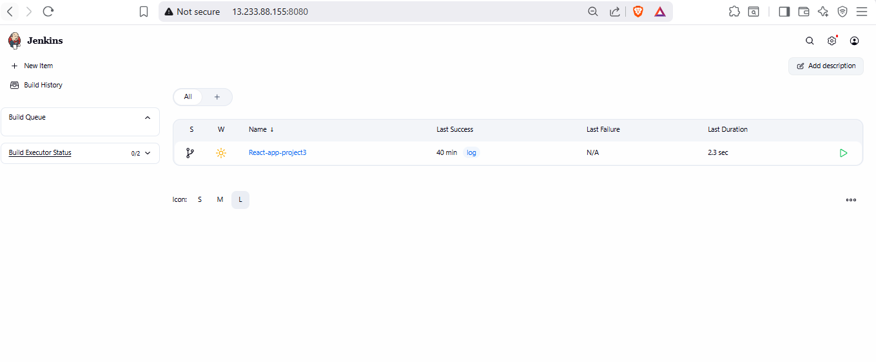

8.3 Jenkins Home page after pipeline configuration.

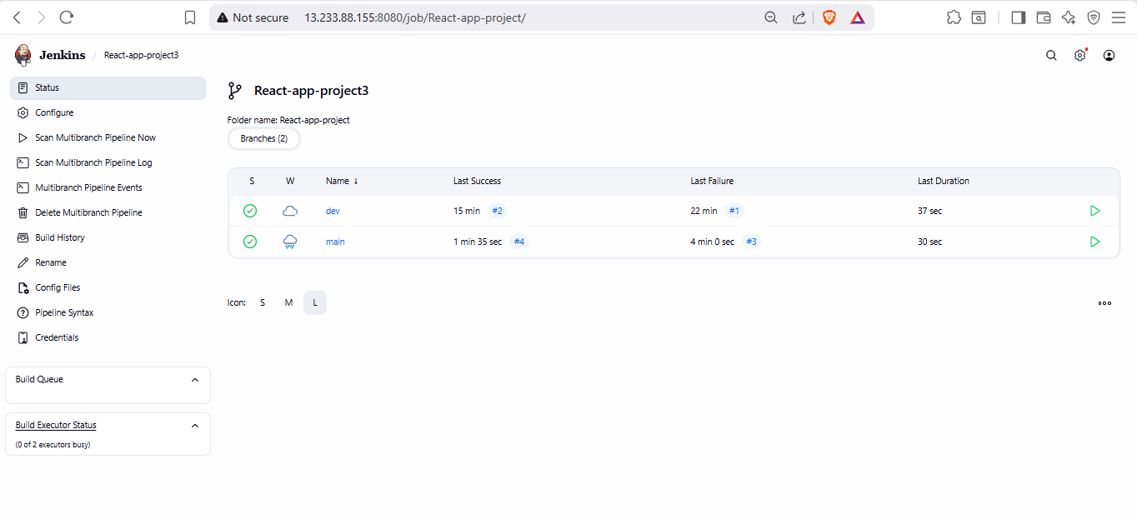

9.both dev and main branch got executed successfully.

**o AWS (EC2-Console, SG configs)**

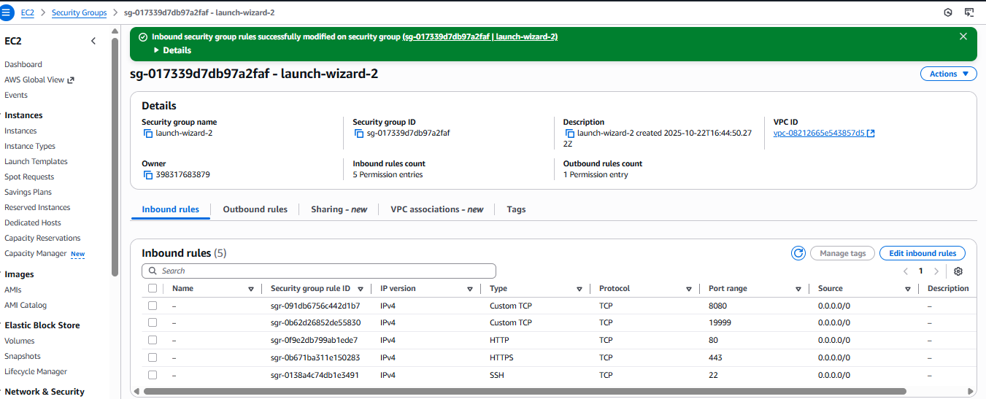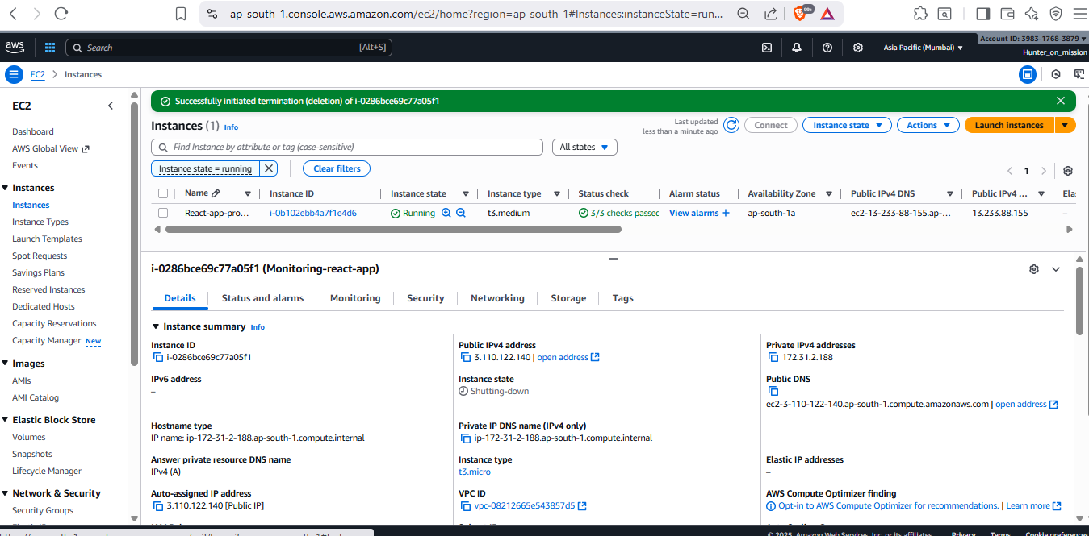

10. EC2 instance with SG

**o Docker hub repo with image tags**

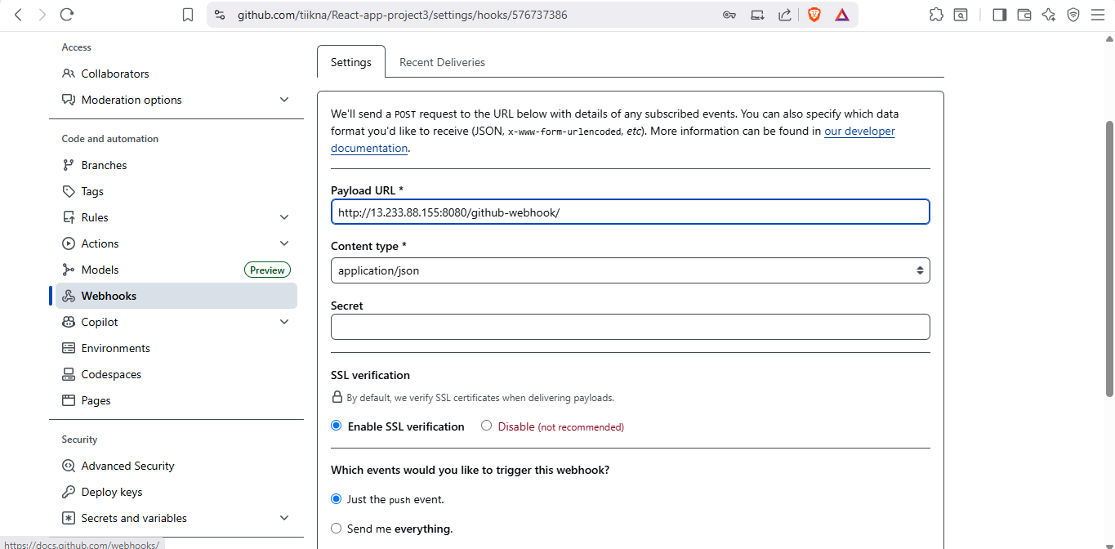

11. webhook configuration In GitHub

Dev images

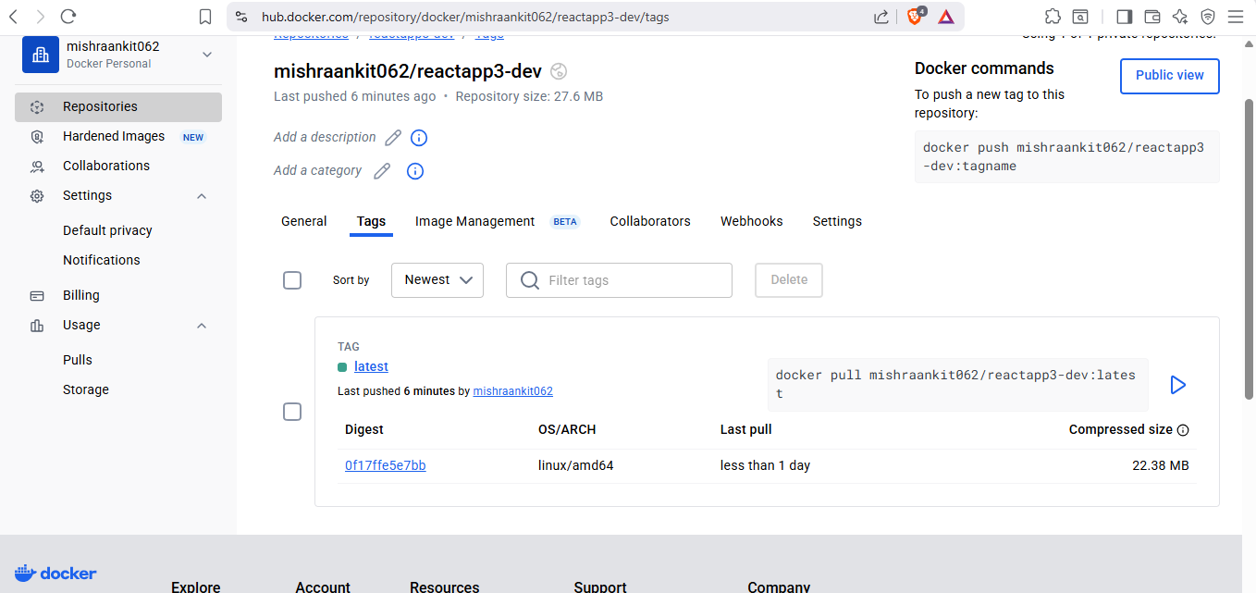

12.

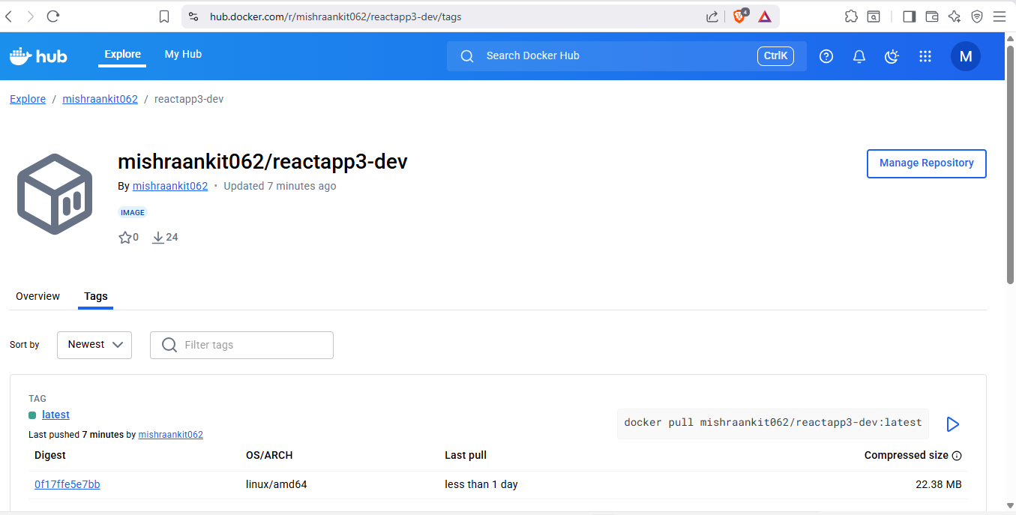

13

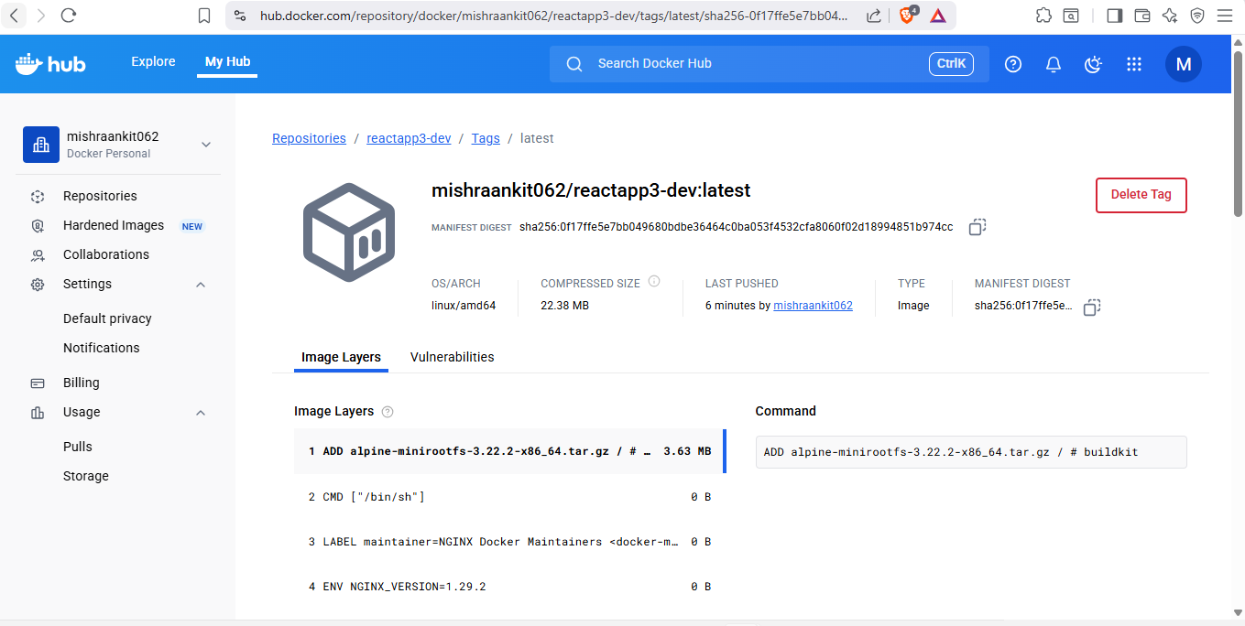

14

Prod images:

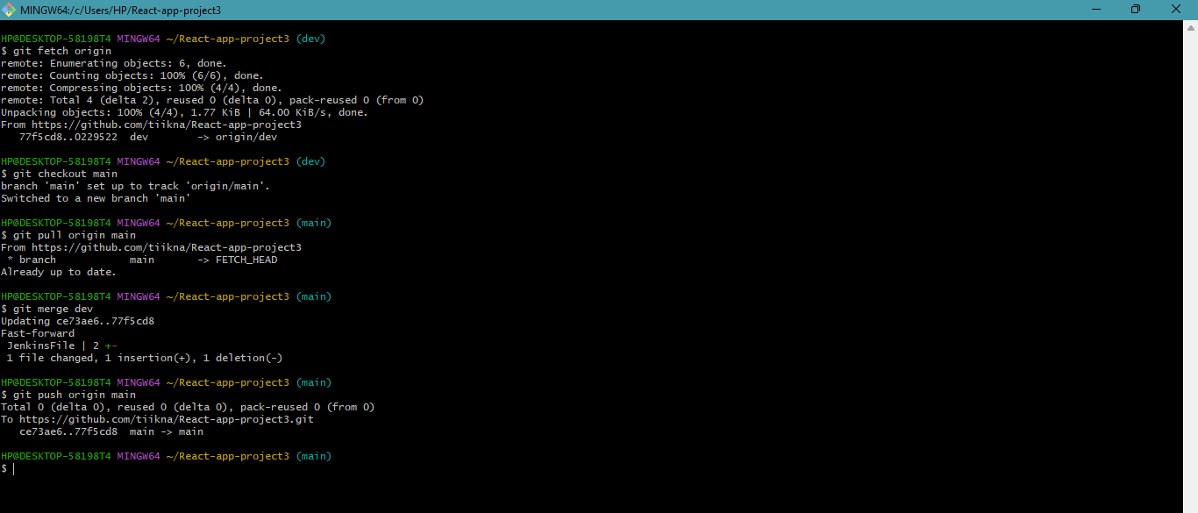

Merging dev branch to main branch.

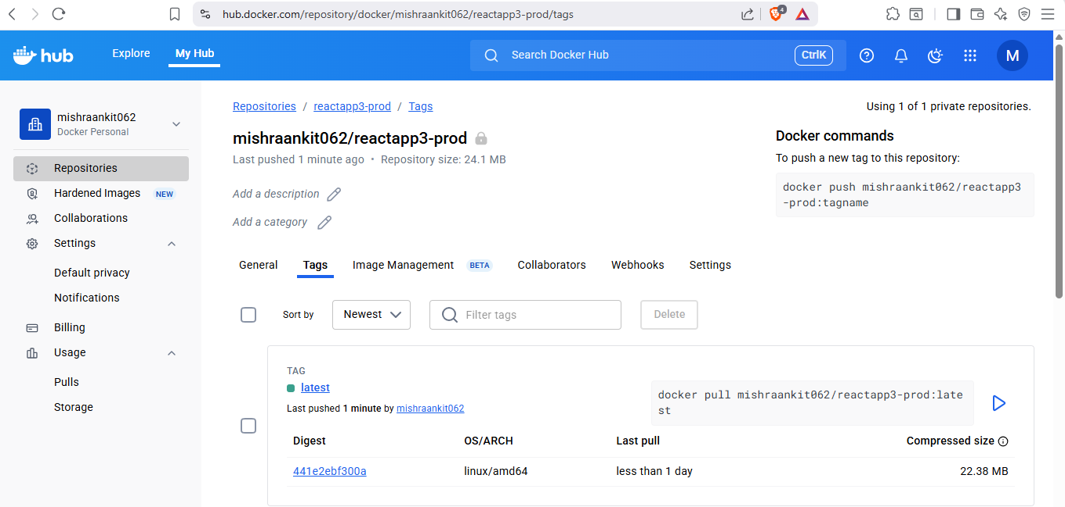

15

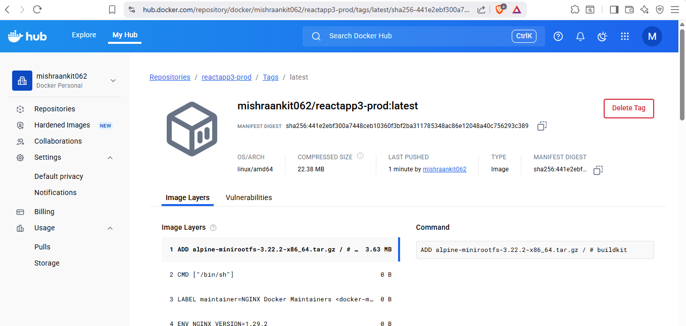

16

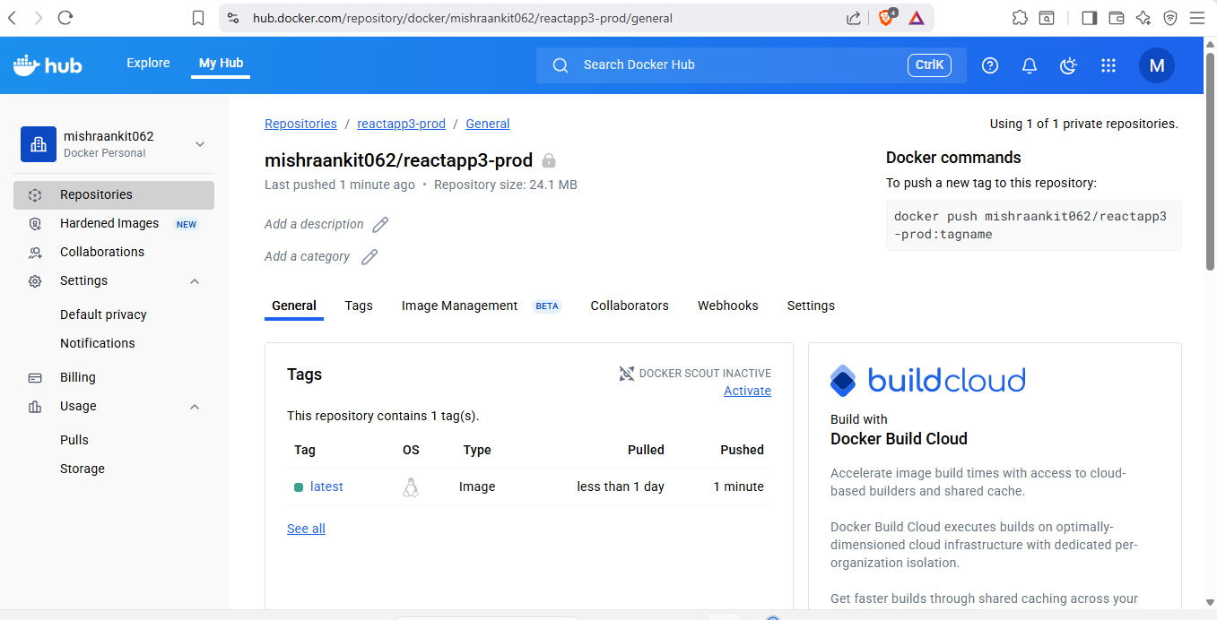

17



18. Both the image running in docker

**o Deployed site page**

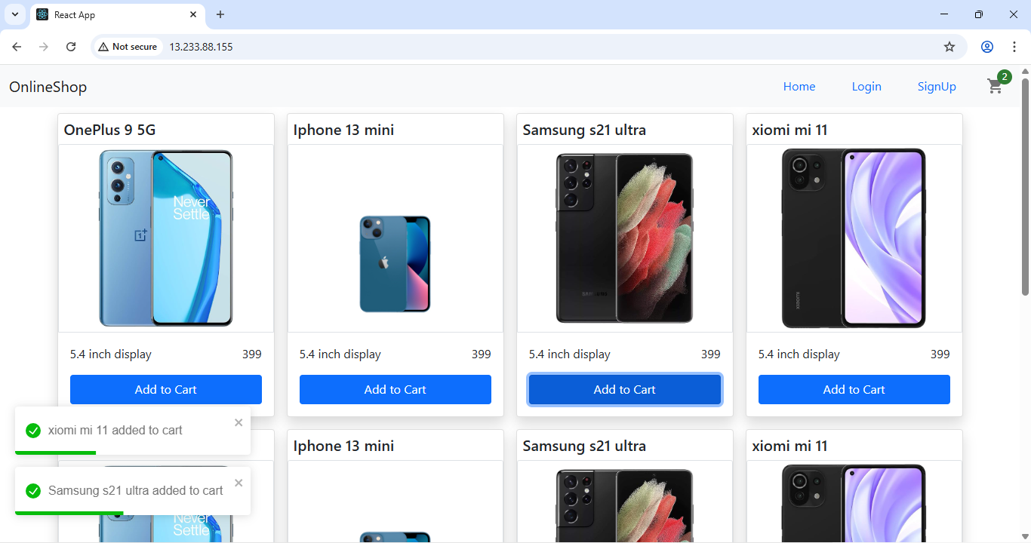

19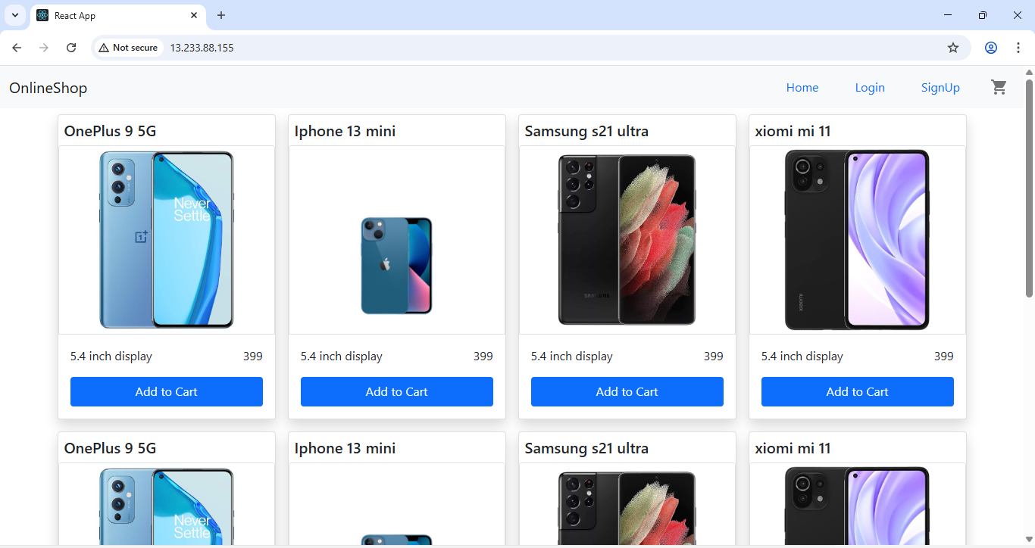

20

**o Monitoring health check status**

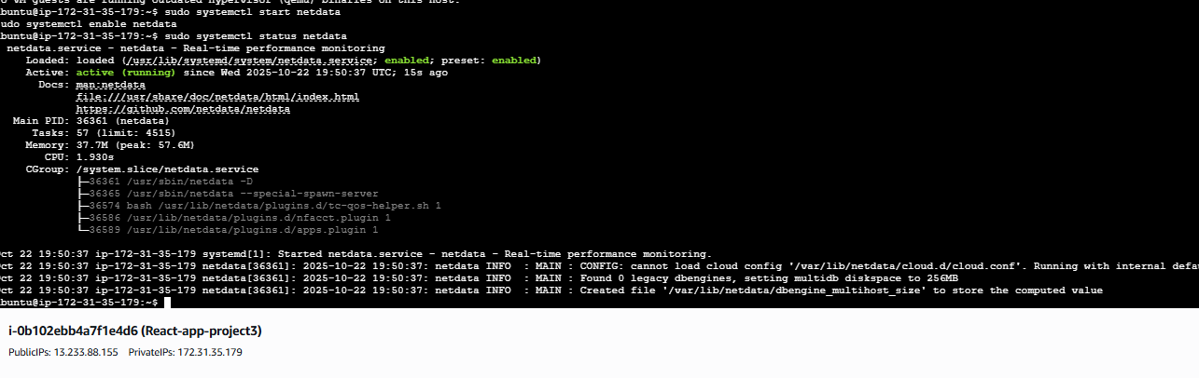

21. installation of netdata for monitoring

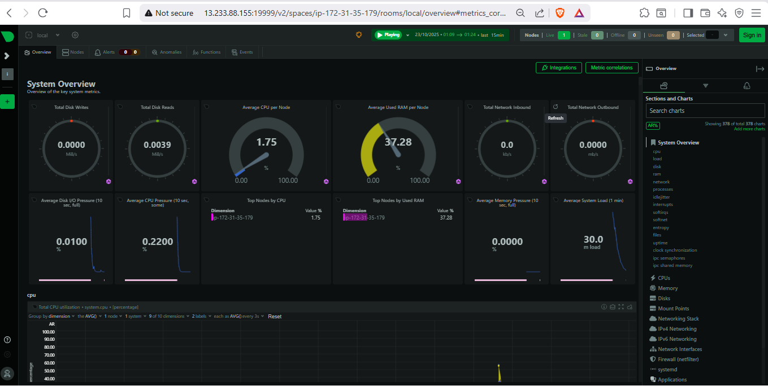

Overview of whole system

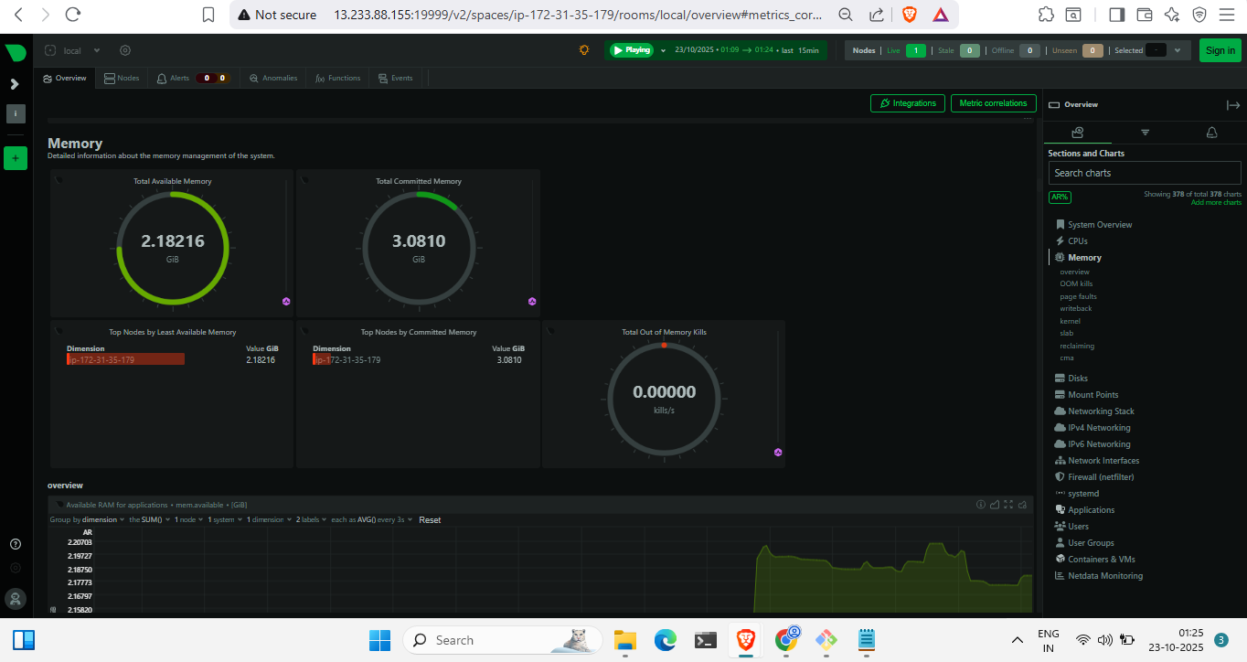

22. memory usage

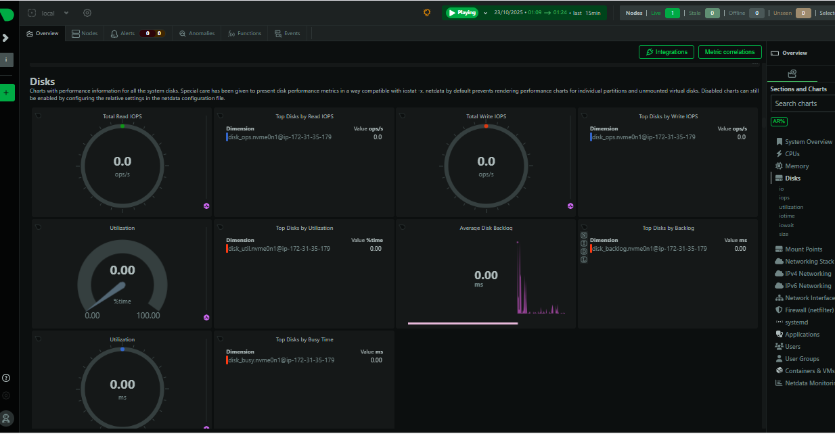

Disk usage

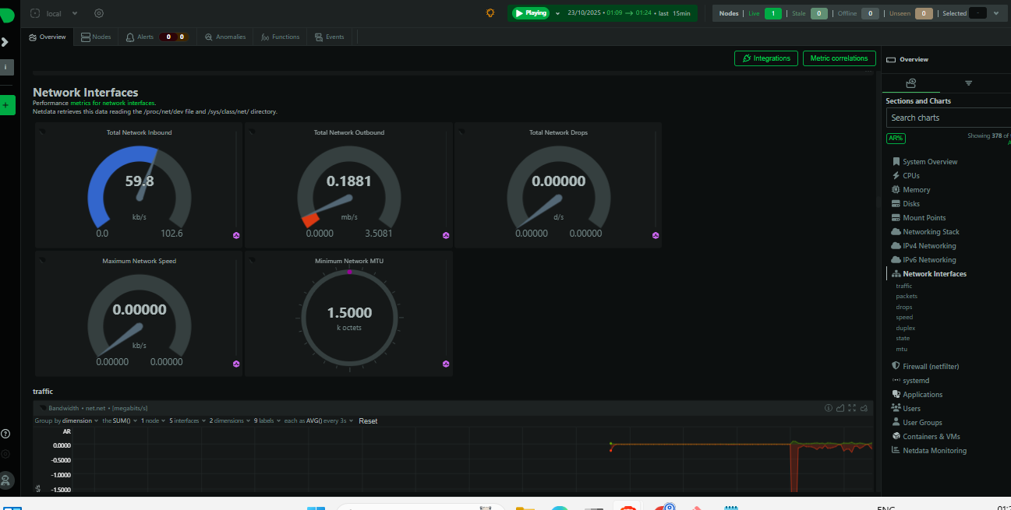

23.netwrok interface

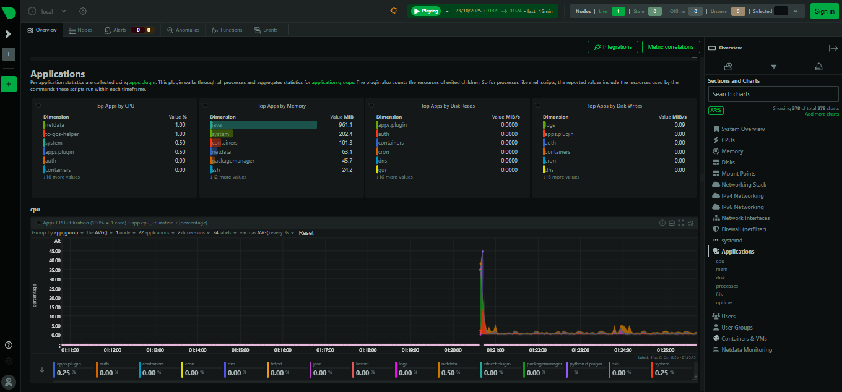

24.application

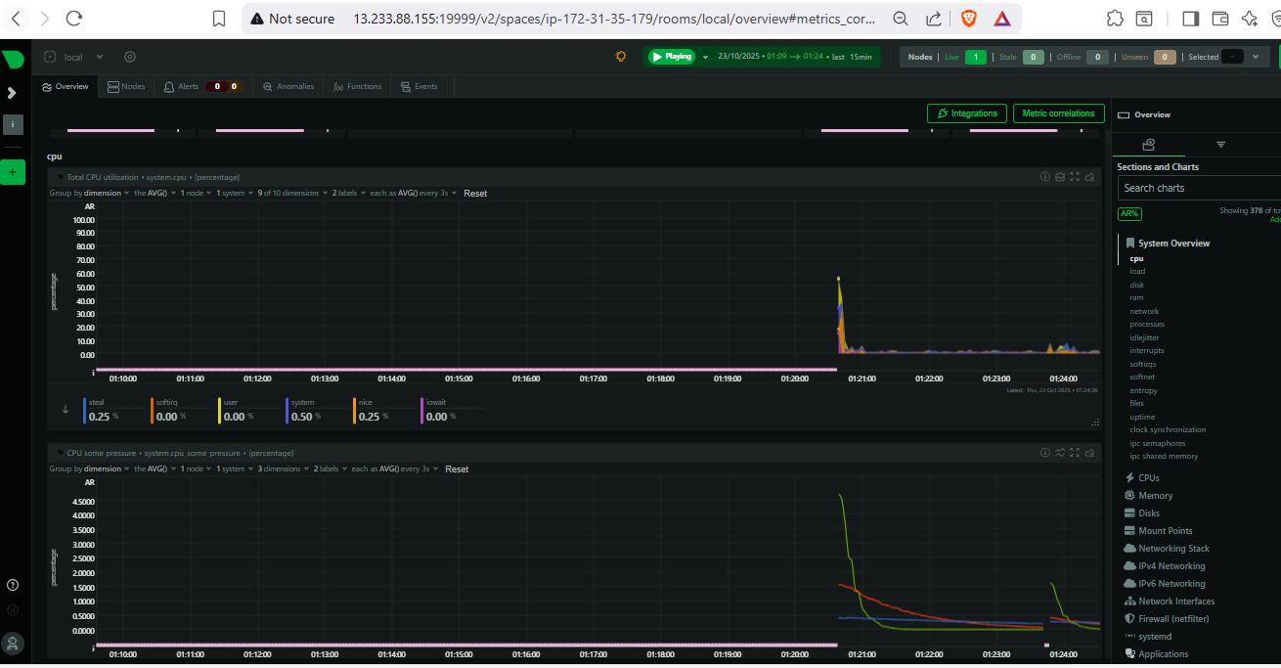

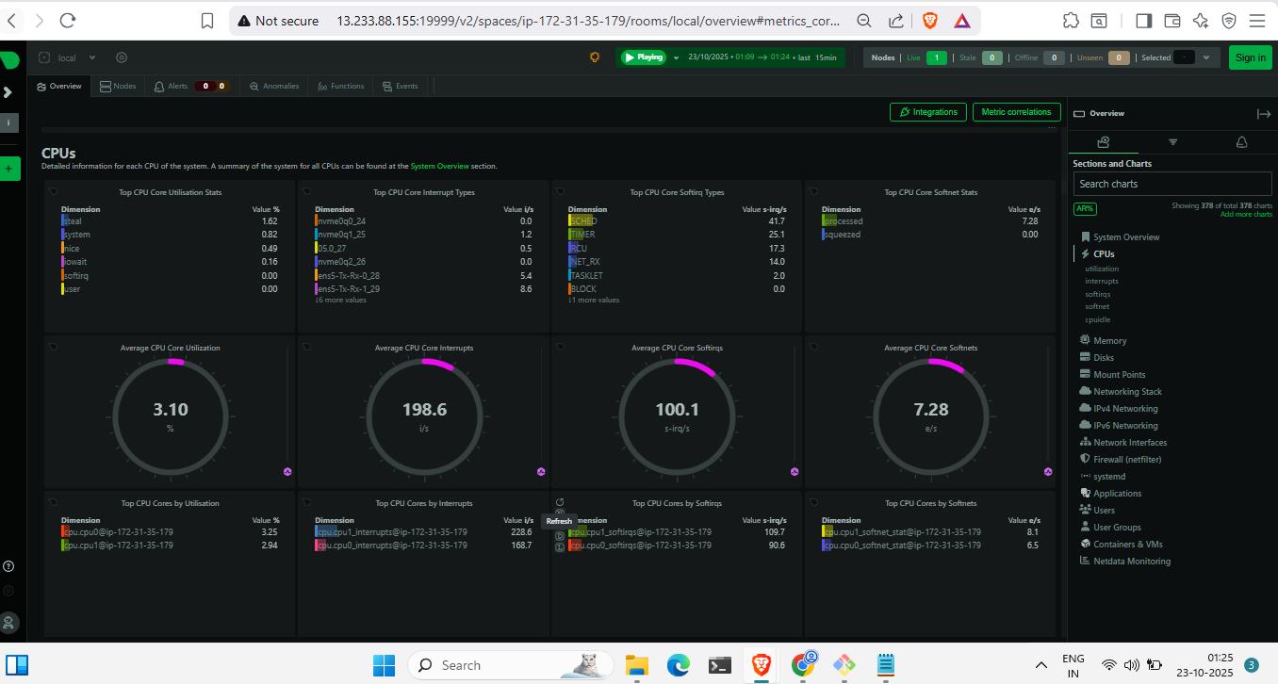

CPU utilization.