# CHAPTER ONE

# INTRODUCTION

## 1.1 Background to the Study

Deceptive messages may widely spread during the minutes, even seconds unsearched with the resulting spread of general and diffused disinformation and panic. Disinformation can be found in various forms, e.g., health misinformation, political disinformation and financial disinformation. These events have made it clear that there is a critical need for the development of effective misinformation management and prevention (Hirlekar & Kumar, 2020).

Standard ad hoc detection approaches for fake messages have a serious limitation that applies to any size of data and end-to-end encryption even in an environment as deep as WhatsApp (WhatsApp uses end-to-end encryption, and privacy of the company's user based on the above), on one side, but negatively affects detection of the fake messages on the other side. Solutions to this issue call for novel methods which provide both accuracy and the privacy of the users (Gupta et al., 2022).

Natural Language Processing (NLP), an area within the field of Artificial Intelligence, may have relevance as a mechanism for combating the propagation of misinformation in social media (Kazemi, 2024). NLP allows computers to understand, process, and interpret human language in a way that is more than just a keyword, giving them the power to not just identify but also to understand and contextualize underlying meaning. The multi-paradigm versatility of NLP permits us to characterize communication content within a WhatsApp conversation as being related to the linguistic salience of signs that are common and highly stable in the dissemination of disinformation (e.g., sensationalism, unverifiable claims or biased rumor structure). NLP systems may be able to identify potentially false messages by means of Text Classification, Sentiment Analysis and Semantic Context (Altay et al., 2023). NLP provides an accessible (large scale/scalable) detection of false premises from linguistic characteristics of communication. The integration of NLP based approaches to WhatsApp can make an enormous difference in the control of misinformation which brings about a safer and more trustworthy message experience without compromising Users' privacy.

Fraudulent communication identification using NLP requires the design of sophisticated algorithms (i.e., to identify deceptive syntactical patterns and false claims, etc). For instance, Sentiment Analysis would be able to pick up emotional nuances that are often associated with fake news, and Text Classification would categorize a given message for its content and its goal. Semantic analysis can, therefore, verify the logical validity and truthfulness of messages. When combined, NLP systems will be even better equipped to drive disinformation detection in progress and its propagation altogether. In addition, NLP techniques may be employed to develop automatic alert functions to alert the user to refrain from posting perhaps questionable messages prior to forwarding (Mridha et al., 2021). This type of NLP-based intervention would ensure that network users are (openly) informed of the presence/absence of an integrity (or the lack of the integrity) of a message and thus support them for responsible networking. With the combined NLP integration of the encryption scheme and privacy of WhatsApp messages, this approach is a reasonable strategy for the detection of a false rumor with users' privacy assured (Tien, 2013).

This paper examines the potential that NLP techniques can be used on WhatsApp to combat the spread of fake news. Benchmarking of NLP techniques, namely, context recognition, predictive modelling, and linguistic patterns are done for possible application in the secure WhatsApp platform. Specifically, this work explores the application of NLP for disinformation detection that is in line with a privacy violating ethical issue. If WhatsApp can provide to its users such a realistic virtual reality in which the content shared with other users admits to look believable (i.e. shared in a real, lived intersubjective agency rather than a constructed/projectable one) and therefore the spread of harmful disinformation could be obstructed.

## 1.2 Statement of the Problem

WhatsApp's fastest sharing of misinformation is considered a severe threat to information integrity and the trust set by online users in online communication. Inaccurate information can be diffused through social media in a number of negative ways: it may cause a mass panic; promote risky beneficial behaviour; and can create political prejudices. Although WhatsApp's end-to-end encryption is actually meant to protect user privacy, the aforementioned part of the application has made it impossible to follow and manipulate the spread of false information. Currently, methods for identifying and countering misinformation are usually impractical, lacking any capacity to handle the number of messages being disseminated every day. As a result, the users are not aware of the risks of sharing or forwarding information that is not substantiated.

## 1.3 Aim And Objectives

The aim of this study is to develop a Naive Bayes model for fake news identification on WhatsApp.

The specific objectives are:

1. data exploration and visualization
2. data preprocessing based on the identified issue in (i)
3. train, test, validate and evaluate the NB-based model.

## 

## 1.4 Significance of the Study

1. Enhances the reliability of information on WhatsApp applications by mitigating the spread of fake messages by individuals.
2. Mitigate the societal impact of misinformation, such as public panic and political manipulation.
3. Contribute to academic research by advancing NLP and machine learning applications in content moderation and ethical digital communication practices.

## 1.5 Scope of the Study

The goals of the current experiment are to carry out the common Natural Language Processing (NLP) shared task as designing a system by detecting and preventing on line false/modified messages in WhatsApp environments in real time. Its range covers Data Acquisition and Data Pre-processing, Feature Selection, Machine Learning Model Training and Online Detection System deployment. Acceptance by the user and ethics are the most important factors in order to gather the best possible system accuracy and have the ability to build users' confidence. The aim is to create a reliable platform that can defend digital commerce from strategies designed to promote disinformation, whilst also ensuring trust (integrity) and validity (authenticity) in how a service is providing a messaging service.

## 

## 1.6 Limitation Of The Study

The major constraints in developing the effective model for detecting fake messages on WhatsApp include data bias, linguistic complexity, and the evolving nature of disinformation. Data bias happens when training data is incomplete or biased, an issue that could lead to the model producing wrong or unjust decisions. Linguistic complexity is also a constraint, as fake messages often include sarcasm, slang, or cultural terms that models may not decode properly. Also, disinformation tactics change constantly as users adapt language and methods to avoid detection, requiring frequent model updates to maintain the pace.

## 1.7 Definition Of Terms

1. **Deep Learning:** A sub area of machine learning that uses neural networks with multiple layers to extract data representations. NLP tasks are realized by using deep learning models, such as Recurrent Neural Networks (RNN) or Transformer (e.g., BERT) because of their competence to understand intricate patterns present in the text data.
2. **Disinformation:** On purpose made up information, that is spread by intention to deceive/misinform people, for political, economic or other malicious objectives.
3. **Fake or False Messages:** They can include lies (disinformation), deceptive (misinformation), gossip, perjury, and propaganda (hoaxes) as well as fabrications (manipulated media).
4. **Feature Extraction:** The procedure of extracting useful features from unprocessed text data, including word frequencies, sentiments, and linguistic structures etc. These characteristics can be exploited to train machine learning models to fake message detection.
5. **Machine Learning Models:** Learning algorithms (and statistical models), that are adapted by training them on data to make a prediction or classification. These models are trained to discriminate between truthful and manipulative messages with the help of the learned features.
6. **Misinformation:** Unintentional misleading information transmitted, typically as a result of error, misconception or misinterpretation.
7. **Natural Language Processing (NLP):** A part of artificial intelligence (AI) that deals with computers acquiring the capability to understand, decode, and speak human language. At the WhatsApp level NLP is used to process messages and extract patterns/features that indicate an indication of fake or de facto information.
8. **Real-Time Detection:** The ability of a system to detect and identify fake or fabricate messages as they appear on WhatsApp in order to stop it as soon as possible and to stop the dissemination of bad content.
9. **Sentiment Analysis:** A branch of natural language processing focused on the analysis of the sense or opinion of a text (messages). It can be applied to the selection of messages potentially spreading false/biased information with the help of the emotional valence or the subjective material.
10. **Text Classification:** An approach to text categorization using machine learning that makes a "Yes" (or No) classification of the text, based on the content observed.
11. **User Behavior Analysis:** An analysis of the ways in which both the messages made and the behaviors of the message consumers can be indications of the diffusion and acceptance of disinformation. Understanding of user behavior can be exploited to improve the schemes for detection models and the associated responsive strategies.

# CHAPTER TWO

# LITERATURE REVIEW

## 2.1 Introduction

The proliferation of social media has changed the way information is disseminated and accessed around the world. Of these platforms, WhatsApp differentiates itself by the end-to-end encryption and real-time communication possibilities and can thus be used as an information exchange tool. But this capability is dangerous in many ways, primarily because of the risk of false or deceitful messages. Disinformation on WhatsApp is rapidly disseminating and has the potential to be very damaging to people, swaying public opinion, disrupting elections, and even leading to violence. Because of this, identifying and stopping the dissemination of lies on WhatsApp is of great relevance to academics, policymakers and the wider public.

False news is not a new occurrence; it is as old as the early history of print media. Yet, the digital age has also expanded its reach and impact. Fake news is false material that resembles news media content in form but lacks the method and aim of true journalism. Communications are often designed to deceive, inflame, or coerce audiences. The structure of WhatsApp, indeed, promotes the spread of this kind of content by allowing fast transmission without deep review (Polatty, 2022). In order to tackle this severe problem, a number of Natural Language Processing (NLP) based solutions have been designed and implemented. NLP, a branch of artificial intelligence, is the study of interaction of computers with human language. It enables robots to learn, analyze, and build human language, which is applicable to a range of applications, such as false news detection. The huge volumes of textual data generated on WhatsApp may be analyzed using NLP approaches to identify and limit the spread of disinformation (Zhang et al., 2019).

This literature review chapter seeks to offer a complete summary of current research on false news detection using NLP in the WhatsApp context. Specifically, it will explore the characteristics and effects of fake news, the application of a range of NLP techniques for text analysis, and the integration of fact-checking infrastructures. This paper will also consider the theoretical backgrounds and methods that have been applied in this field, critically discuss the strengths and shortcomings of them. Considerations are prior research and approaches to understand the level of progress that has been made in the efforts to stop false news on WhatsApp alongside areas that future work could address.

## 2.2 Fake News and Misinformation

Disinformation, in the form of fake news, has become a serious issue in the digital age, and it is even more pronounced due to the popularity of messaging systems (for example, WhatsApp). This platform has shifted the way information flows, so that it is now possible to spread information at an incredible speed over large distances. Nevertheless, the unfettered flow of information has led to the rampant proliferation of inaccurate information and falsehood, which is a major threat to public debate and trust. False information is knowingly false material presented as real news with the purpose of misleading readers and shaping public opinion (Baptista & Gradim, 2022).

Such information is a bit in the style and genre of journalism, however it does not aspire to the rigor of a journalism unreported article and is not to be considered as being subject to the ethical and verifications in journalism that shape unreported journalism. Sensational headlines, emotional appeals and lack of evidence sources are common features of fake news, whose sole aim is to attract an attentional and intense emotional response in order to increase the share/spread of information through social media.

The psychological and social impact of fake news is significant. From a psychology perspective, fake news capitalizes on cognitive biases "confirmation bias", in that people tend to favor information that corroborates previous beliefs and ignore opposing evidence. This reinforcement of prevailing views has the potential to cause polarization and fissure across society. Emotional intensity associated with false news (i.e., anger, to fear) enhances the memorability and curability of the false information, further spreading the falsehood. Culturally, the propagation of false news may influence public opinion, affect political outcomes, and damage trust of authentic news media and news institutions. For example, fake news may influence voters' decisions in elections by spreading false information about candidates or policies. When unchecked, disinformation can incite violence or generate undesirable public behavior on the basis of both example conspiracy theories and spurious health messages.

Disinformation is not a new phenomenon, propaganda and disinformation are techniques that never stop for the purpose of promoting and achieving public opinion and strategic aim. However, the informational world has been greatly expanded by the digital era both in terms of scale and social reach. Messaging applications, such as WhatsApp, have opened the era of information democratization, since everyone with an internet connection can now easily produce and disseminate information. This has led us to an environment in which disinformation is spreading quickly, even ahead of attempts to debunk and correct it. Misinformation travels faster in WhatsApp, owing to WhatsApp's features such as ‘Forward’ within a chat. For example, in other social media platforms, when users encounter and spread content that eliciting noticeable emotional reactions, content curation by algorithms could inadvertently also support sensationalized and false narratives, fostering a climate in which disinformation can circulate (Bakir & McStay, 2018).

Many countermeasures and detection methods have been created and deployed because of the opposition to fake news on social media. NLP, or natural language processing, has become an efficient tool in these applications. NLP algorithms could potentially detect patterns that would be indicative, if present, of the presence of disinformation when communication content is within the control. These patterns include the use of emotionally charged language, repeating material, and the lack of reliable sources. By applying these techniques to identify possibly deceptive content for deeper evaluation or deletion, such techniques can also help stationary the spreading of such content. Actually, it is also crucial to know disinformation properties, consequences and historical background in order to formulate a practical countermeasure. In order to preserve public discourse and confidence for reliable sources of information, state-of-the-art technologies, for instance, natural language processing (NLP), open up immense possibilities for detection and prevention of the propagation of disinformation (Khan et al., 2021). Theoretical underpinnings and practical uses for such technologies in the current battle against the dissemination of disinformation will be elaborated in detail in the following sections.

## 2.3​ Natural Language Processing in Social Media

Natural Language Processing (NLP) at the heart of the social media revolution, now rewriting how large chunks of text, generated by billions of users in the world each day, are handled (at the heart of an application such as WhatsApp), has begun a new age. Clearly, at its most fundamental level, NLP allows computers the ability to understand and process human language, which can lead to a profound understanding, a meaningful relationship to emerge, and disinformation challenges to be overcome. NLP is a vital means to enhance user experiences in the evolving social media space, where data is disseminated rapidly and opinions are generated in real time. Relied on user interactions, user preferences, and background, the NLP systems flexibly reach the context recommendation and topical trend depending on the needs of users. One of the effects of personalization goes beyond user acquisition (i.e., user engagement and satisfaction). and in addition it can help consumers to receive the kind of material that meets their interest and is engaging for them (Albalawi et al., 2019).

In addition, NLP has emerged as a centerpiece for content moderation, one of the most fundamental challenges in achieving the online commons good in safety and inclusivity. NLP algorithms provide automated textual analysis with the ability to identify and flag what it deems as possibly abusive, unacceptable content such as hate speech, harassment, spamming, etc. In virtue of continuous and efficient social valuation based on community norms, social media companies could potentially be freed from the power of toxic content to destabilize the social order and help establish a thoughtful, civilized society for all community members. One of the most serious problems facing today's social media platform is the proliferation of disinformation or fake news. NLP is a potential ally in combating fake news. Classification algorithms from NLP could be exploited for discriminating between trustworthy and fake sources, for example thereby acting as a bottleneck preventing the spread of misinformation. These algorithms consider the textual structure, the linguistic context, and context information to determine whether or not the WhatsApp conversation is real.

Moreover, NLP-enabled ability enables NLP-driven fact-checking methods to be implemented in social media (i.e. Platforms might be - equipped to verify content assertions in the blowing real- time as they are done with cult fact-checkers. Such preventive strategy is not only able to stop false information dissemination, but is also conducive to openness and trust among users. Following text classification and fact-checking, NLP allows for a deep network analysis to detect and decompose organized disinformation campaigns with a systematic architecture. NLP algorithms support the detection of the overlapping mechanisms by which the propagation of disinformation takes place, analyzing information propagation patterns and spotting suspicious accounts or botnets. The level of analytic power is very important for understanding how disinformation spreads and how to develop effective counter-influence (CE) strategies. Social media innovation by and through NLP is a major impetus for using the language power of platforms like WhatsApp for positive social change. Social media sites can demonstrate their power of constructing intelligent, respectful, and engaged online communities by leveraging the capability of NLP to improve user experiences, enforce content policies, and combat disinformation. This, for instance, is also capable of NLP along with natural language processing (NLP) technologies impacting the evolution of the type and direction of social dynamics online (Zhang et al., 2019).

### 2.3.1 ​Key NLP Techniques for Text Analysis

Text classification (i.e., as part of the classical social media NLP applications). That includes the problem of associating text with a predefined set of discrete classes or categories based on content of the text. The text classification algorithms in the current study, as implemented in WhatsApp, may be trained to distinguish between bona fide and disinformation. Logistic Regression, support vector machines (SVM) and deep learner models (e.g., Convolutional neural networks, CNNs), and Transformers (e.g., BERT) are amongst the most popular approaches for this. These models use word frequencies, sentence context, and morphology to discriminate communication and to detect disinformation.

Sentiment analysis means retrieving the affective (or sentiment) of a specific text. Sentiment analysis on WhatsApp has potential in extracting the public opinion, identifying trends and monitoring the opinion of a consumer group on a subject, event or situation. This information can also become highly valuable for companies, marketers, and politicians to track public opinion and sentiment changes in live time. Stakeholder opinion analysis is promising and may result in the proactivity of directions and user demand being discovered.

Named Entity Recognition (NER) is another major NLP task, which tries to recognize and mark the entities (e.g., person, organization, region) in a sentence. In social media, NER is used to obtain a valuable insight from the messages, e.g., an insight on the sensitive people, on the entities that are currently trending, on the locations of interest for the trending activities. This capability is especially valuable for content suggestion, trend identification and personalized user experiences, which can lead to user engagement using targeted content.

One of the class members is topic modelling such as Latent Dirichlet Allocation (LDA), and its extensions, which are another kind of topic modelling approaches for inferring latent theme(s)/subject(s) of a potentially huge sequence of text. Social media analysis can be carried out by topic modeling, which can reveal the most discussed topic, reveal the most discussed theme, and classify the materials posted by the users according to the topics that they want to have in common interest or more topics. Platforms are able to exploit analysis to choose and rank online debates that are new and evolving, and tailor the content to reflect the user's personal preferences.

Text Summarization algorithms produce a concise (length) summary (presentation) of the original text which captures the primary concepts and most relevant content. Text summarization techniques can be helpful for WhatsApp users, whose ability to communicate short messages is constrained, in quickly deciding the content of long discussions or shared articles present in chat sessions. This usability enhancement gives them the ability to trigger an alertə without having to convey the details all over again.

As cross-lingual natural language processing techniques are essential due to the ubiquity of WhatsApp, techniques of cross-lingual NL processing are also crucial to achieve cross-lingual communication. Machine translation and cross-lingual retrieval, through which it is possible to encode communication and annotate multilingual documents, in practice, offer some kind of universal access, or access to all, from a globally interconnected world. With this capability, a new level of communication on the platform is introduced, providing a good level of understanding on the part of the users and of information, regardless of the spoken language.

## 2.4 Machine Learning and Deep Learning Model

Methods of Machine Learning (ML) and Deep Learning (DL) are very powerful to optimize and secure social media, e.g., WhatsApp. These techniques may assume the shape of supervised or unsupervised learning, respectively, which offer different perspectives on the treatment of data at classification and in the search for disinformation. Platforms using these approaches can enhance content moderation, user experience, and the perceived credibility of data plugged into the system.

**Supervised and Unsupervised Learning Methods**

**Supervised Learning** is the process of training models with labeled data in which the output (label) is associated with the input (feature) itself. This method is applicable to applications where a target sequence is predicted or classified on the basis of previously observed examples. As an example of such applications for identification of fraudulent information on WhatsApp, supervised learning algorithms are trained from datasets with e.g., annotated messages, in such a way that patterns that can be used for the delimitation between trustworthy and unreliable providers can be captured. Following are examples of traditional supervised learning techniques, including Logistic Regression, Decision Tree and so on. These models are capable of learning through experience in order to be real-time predictive.

**Unsupervised Learning** is the process for training models on unlabeled data for the purpose of discovering latent patterns or structures in the data. Due to, for instance, its ability to be tailored to specific tasks, the strategy is of particular interest for applications like content similarity classification of messages, or identifying unusual behavior that differs from an expected user behavior. Unsupervised machine learning algorithms can be utilized to discover anomalous activity profiles on the social media that may serve as indicators of bot networks, or orchestrated disinformation campaigns. Clustering algorithms, such as K-means or hierarchical clustering, can group messages by text features that platforms could use to identify potential disinformation sources. In a general sense, both supervised and unsupervised learning algorithms help uncover and control information campaigns or the proclivity to spread misinformation on social media platforms.

### 2.4.1​ Common Algorithms Used In Fake News Detection

1. Logistic Regression is a trainable supervised learning method, and is therefore used for binary classification problems. It spectrally extracts the probability of a specific class (e.g., real news vs. fake news) from the features in the input. In fake news detection, Logistic Regression can be used to evaluate textual features and metadata associated with communication to detect whether a message is false or misleading. Due to its simplicity and interpretability, it is a promising choice towards exploratory experiments based on disinformation detection.
2. Naïve Bayes is a simple yet powerful probabilistic classifier based on **Bayes’ Theorem**, widely used in text classification tasks such as spam detection and fake news detection. It assumes that all features (e.g., words) are conditionally independent given the class label, which simplifies computation. The algorithm calculates the probability of a class given the input features and assigns the class with the highest probability. Common variants include Multinomial NB for word counts, Bernoulli NB for binary features, and Gaussian NB for continuous data.

The main advantages of Naïve Bayes are its speed, efficiency, and good performance with small datasets, especially in high-dimensional spaces like text. However, its key limitation is the unrealistic assumption of feature independence, which can reduce accuracy when features are correlated. Despite this, Naïve Bayes often performs competitively in practice and is commonly used for tasks like fake news detection, sentiment analysis, and spam filtering due to its simplicity and effectiveness.

1. Support Vector Machines (SVM) are also a robust supervised learning solution to the classification problem. It is based on identifying an optimal hyperplane that maximizes the separation between data points of different classes by the largest margin. SVMs are very effective at detecting falsehoods due to their ability to handle high-dimensional features and nonlinear relationships, and so they can be well suited to text classification applications in environments like WhatsApp. It also enhances their ability to distinguish true from false content due to their resistance to overfitting.
2. Random Forest is an ensemble learning technique, which uses certain decision trees to improve classification accuracy. All trees in the forest are contained in a randomly chosen subset of features and samples. Random Forest models combine the outputs of a large number of decision trees to improve robustness as well as mitigate an over fit in the false news detection process, thereby leading to higher classification accuracy. Using this ensemble technique, it is also possible to extract rich patterns in data and thereby achieve accurate and dependable predictions.
3. BERT (Bidirectional Encoder Representations from Transformers) is a state-of-art deep learning model built upon the Transformers architecture. It has changed the circumstances of natural language understanding tasks by learning bidirectional context from input data. For hoax detection, BERT models have the ability to analyze the semantic intention and text of messages looking for subtle linguistic cues that could belie disinformation or misleading information. Its capacity to learn the context and the subtleties of language enables a more accurate, more refined detection of a fake news story.
4. Long Short-Term Memory (LSTM) is a recurrent neural network (RNN) that can process long-range dependencies in time-dependent input. However, LSTMs are effective in text time dynamics, so they can be used for applications, including sentiment analysis or detection of temporal characteristics in message content. LSTM models, scanning message strings, may be used in the social media space to detect patterns of information that arise from disinformation or coordinated behavior thereby to improve information/bio misinformation detection on platforms such as WhatsApp.

In conclusion, Machine Learning (ML) and Deep Learning (DL) models are powerful instruments in combating misinformation of WhatsApp. Using supervised and unsupervised learning methodologies, and advanced algorithms such as Logistic Regression, Naive Bayes, SVM, Random Forest, BERT, and LSTM, social media organizations’ can enhance the safeguards of the platforms against disinformation and build a safer, more competent virtual space for internet users around the world.

## 2.5​ Fact-Checking and Verification

Fact checking and verification are among the most potent tools for the ongoing war against, and with, disinformation and outright falsehoods on social media platforms, for example, WhatsApp. Indeed, at the same time as exponential rapid delivery of this information at speeds that can be difficult to control and, for all too many, its uncritical adoption, there is a need greater than ever for good and authentic information. Information Request Mapping Fact-checkers are uniquely valuable in this context, where they are able to pinpoint, validate, and expose verifiable evidence to the public. The challenge of disinformation is compounded, moreover, by the enormous scale of the amount of content constantly circulating day by day in which stories, opinions and testimonials are shared at a fever pitch.

Normal fact-checking is done by experienced professionals (journalists, researchers) who apply investigative techniques to verify the information put forward. They scrutinize credentials, cross-check data with trusted sources/media outlets, and critically assess data so they can determine whether a claim is credible. This manual approach is based on journalistic tenets of accuracy, impartiality, and neutrality, in which assertions are checked in detail prior to being accepted or rejected. At the same time state-of-the-art fact-checking systems using auto-fact-swapping have been developed and demonstrated to be a useful tool to fight big-data disinformation on social media. These systems can process, both in terms of the fact/topology and linguistics level, significant amounts of text data, in real time through Natural Language Processing (NLP) and Machine Learning (ML) technologies, and detect data that appears to be false in terms of the language pattern and historical pattern. Although automated solutions are extremely scalable, powerful enough to enable the platforms to analyze large volumes of data, there are inherent limits in both automated and manual approaches. Limited time and money can be a hurdle for participating humans to create the velocity required to keep pace with the increasingly large number of digital items, and human-based approaches can be subject to human factors. Achieving success, however, requires continual adaptation and optimization of automated systems to effectively deal with the complexity of natural language and evolving disinformation tactics.

Advances in fact-checking are increasingly a question of technical and human intelligence in partnership. Speeding up and improving the trust of information check on social networking sites can be achieved with the integration of the latest AI facilities into human expertise. Additionally, promotion of a digitally literate and critically thinking society that can differentiate between credible and non-credible information requires training individuals to critically and analytically process information when evaluating source credibility. Finally, fact-checking and validation are critical safety nets in the digital world, required to ensure the truthfulness of information in order to inform the decision-making process on WhatsApp. Social media companies have roles to play in limiting the spread of falsehoods, becoming transparent, and constructing the internet that is more probable to be trustworthy for everyone involved through a mixture of technical and human experience of teaching.

## 2.6​ Network Analysis and User Behavior

Flow of information and interaction patterns of social network platforms (e.g., WhatsApp) cannot be fully understood with network analysis, but are also required with studies on user behaviors’. These analytical methods provide insights into the development of influence mechanisms that are at the base of the online discourse, the formation of a community of practice in the topic/hashtag areas, and the evolution of the spreading of the content.

### 2.6.1 Understanding Information Spread

Network Analysis is a norm basis of characterizations for the information transfer of a networked user community of users for the messaging and instant messaging service, WhatsApp. Interpreters that deconstruct users' interaction network by the permutation content of group interactions, mentions and messages can perform channel assignment on information flow and solve for representative nodes characterized by locations as propagation hubs.

And if the speed animatic of information flow, say, the temporal dimension of a network, is desired, e.g., the researcher may also have new information about the structural features of WhatsApp networks, i.e. The following three metrics are considered, that is clustering coefficients, which describe community structures, network density, which describe the degree of connections among users, and centrality, which describe the role of a user or node. That knowledge of information flow mechanisms has emerged now and thus in vivo offers a more targeted definition of information flow, the flow of true information, and representations of misinformation into thought.

### 2.6.2 Detection of Bot Networks and Anomalous Behaviors

The network analysis has been one of the key features in a lot of case studies which aimed for recognition and combating the spread of fake news in WhatsApp. These methods have been adopted by scientists to study the structural features of spreading information networks in the form of misinformation purges and also to identify structures that are indicative of organized campaigns to disinformation. For example, studies have examined the dynamics of the false rumor or conspiracy theory on the WhatsApp social network, measuring its origin and propagation route. An analyst can follow the associations between users that have propagated inaccurate information, and can identify groups of users involved in a concerted effort to spread inaccurate information. This approach allows the specific interventions, namely, policies and/or public information campaigns that can influence the impact of false narratives on public speech and social sentiment.

## 2.7 ​Theoretical Framework and Approaches

With regard to both the theory by which, and the methods used to, social media dynamics are explored on e.g., WhatsApp they are constantly developing, to reflect the intricacy involved in user behavior, digital interaction and spreading of information. Social media sites are virtual communities, repositories of (and sites within) contemporary society. Not only do these frameworks offer theoretical context, but they also provide a framework for method selection in a particular practical context.

### 2.7.1 Theoretical Foundations in Depth

By analyzing interpersonal relationships and interactions within a networked environment, the theory of social networks is developed. Scientists might develop a more profound understanding of how users behave on WhatsApp, create lists for common interests or subjects, and try to affect the behavior of the other participant on a variety of levels of engagement, according to this theory. Social network research visualizes these relationships to uncover the organization of WhatsApp communities, to discover hubs or influential people, and to follow the paths for the diffusion of viral information.

**DIFFUSION OF INNOVATIONS:** This theory considers the spread of new ideas or innovation in a social system across time. If applied together with WhatsApp it provides an idea of how uptake and distribution of messages happens at the level of the app. Information value, source credibility, and audience receptivity, through the three mediating factors, are the main contribution to the speed and diffusion of messages becoming popular. In relation to the mechanisms of how information circulates in digital ecosystems, researchers can infer the impact and the spreading of information in this type of ecosystems by understanding how the information flows, and this can then be used, in turn, for proposing countermeasures against disinformation and for enforcing or amplifying truthful information.

A field of study that aims at defining the complex interplay and interaction between media technology, communication systems and cultural context, referred to as media ecology. In this paradigm WhatsApp is used in relation to the use of the platform in public discourse, to the development of communication practice and to the creation of digital cultures. It analyses the affordances of medium vis-a-vis and effects of WhatsApp, i.e., live-time communication, world-wide presence, and an algorithmic curation, as well as their impact on user engagement, trends in information consumption, and social implications. In terms of a focus of media ecology, concerned with the importance of context in digital interaction and media consumption, technical context and social context mutually sustain and contribute to each other.

### 

### 2.7.2 Methodological Approaches Explored

1. Quantitative Analysis: Quantitative methods in the area of pattern, trend, and correlation detection in WhatsApp data are grounded in the laborious choice and statistical treatment of quantitative data. In order to measure user engagement indicators like network topologies and information diffusion, these computational tools have been utilized. Quantitative methods show definite evidence for platform dynamics, user behavior, and the efficacy of disinformation countermeasures.
2. Qualitative Analysis: By means of in-depth interviews, content analysis and theme coding of textual content, qualitative methods reveal the meanings, interpretations and subjective experience of users. Researchers investigate information use and processing and identity construction by WhatsApp users, respectively. Complementing quantitative data with the richness that quantitative results bring, qualitative approaches generate rich, substantive, contextual data about motivations, objectives and behavior of the users. Qualitative research promotes our understanding of how digital platforms contribute to experience, mediate social interaction, and influence everyday human communication by uncovering the social, cultural and psychological dimensions of WhatsApp usage.
3. Mixed-Methods Approach: Using both quantitative and qualitative research approaches, or combined mixed-method approaches, it is also possible to gain a comprehensive insight into social media dynamics. In order to triangulate quantitative patterns with qualitative interpretations and to analyze multifaceted problems with various readings, researchers use mixed methods. Quantitative mixed-methods research provides a veritable cornucopia of insights in addition to a description of the use of WhatsApp for information sharing, forming of communities, and social capital, which, through combining data of different kinds and relevant analytical or methodological views, can be easily disseminated.

### 2.7.3 Practical Applications and Future Directions

Methodological and theoretical frameworks for the study of WhatsApp's social media dynamics have much to contribute in the context of today's challenges, such as disinformation, digital polarization, and ethics of platform governance. These frameworks allow academics and platform developers to:

1. Create Evidence-Based Interventions: Based on theoretical information and empirical research, specific interventions, algorithms and laws are devised to facilitate positive information flow, digital literacy and counter disinformation on WhatsApp.
2. Inform Policy and Platform Governance: Drawing on study findings to guide the development of community standards, ethical guidelines, and content moderation strategies for encouraging openness, accountability, and user trust about online environments.
3. Empower Users: Prepare people with the analytical thinking skills and Information they require to make the right material selections, confidently move through the online world, and responsibly decide what to do when using Social media platforms such as WhatsApp.

The theoretical underpinnings and analytical methods that have been used investigating social media activity on WhatsApp offer an excellent platform around which to conceptualize the complexity of digital communication, user interaction and social implications. Scientists make a contribution to generating new knowledge, provide policy advice and develop a smarter, smarter and more trustworthy digital space by bringing together multidisciplinary viewpoints and an exigent research approach.

### **2.8 Summary** o**f** ​**Related Works**

The problem of fake news detection has attracted extensive research interest in recent years, particularly leveraging Natural Language Processing (NLP) techniques. Several studies have proposed methods ranging from classical machine learning approaches to advanced deep learning and large language models (LLMs), with varying levels of performance and generalizability.

***Table 1.0*** presents a detailed overview of related studies, including the methodologies applied and their respective limitations.

|  | **Author(s)**  **& Year** | **Title Of The Work** | **Methodology** | **Limitations** |
| --- | --- | --- | --- | --- |
| **1.** | Xu et al., 2025 | A Hybrid Attention Framework for Fake News Detection | Combines semantic features from LLM embeddings with statistical cues using dual attention layers. | Purely content-based; lacks user features; computationally expensive. |
| **2.** | Oshikawa et al., 2020 | A Survey on NLP for Fake News Detection | Reviewed NLP-based methods, datasets, and propagation-based solutions for misinformation detection. | Theoretical review; no experimental validation or integration framework proposed. |
| **3.** | Roy et al, 2018 | A Deep Ensemble Framework for Fake News Detection. | Combined CNN and Bi-LSTM representations with MLP classifier. | Modest accuracy; no user/context integration; limited to single-language datasets. |
| **4.** | Ma et al., 2016 | A Comparative Study of ML and DL Techniques for Fake News Detection. | Compared classical ML (LR, SVM, RF) vs DL (CNN, Bi-LSTM, BERT) | High-performing models (e.g., BERT) require large data and heavy compute; lacks user/context features |

# 

# 

# 

# 

# 

# CHAPTER THREE

# METHODOLOGY

## 3.1 Introduction

The methods for the detection of false news in WhatsApp through Natural Language Processing (NLP) are described in structured form. This chapter discusses the most important steps, i.e., data acquisition and processing, feature extraction, model selection and training, real-time monitoring and filtering, community, and ongoing improvement.

## 3.2 Research Design

The study design for using Natural Language Processing (NLP) to identify fraudulent or deceptive communications on WhatsApp is based on a comprehensive and stepwise approach. By means of machine learning and natural language processing, this architecture proposes to create a precise system, able to reliably identify and stop the dissemination of disinformation using the Naive Bayes Algorithm. This work's main goals are to develop functional detection systems, benchmark different methods in natural language processing, develop continuous surveillance systems, facilitate the reporting and verification of information by individuals, and automatically respond to the emergence of novel disinformation patterns.

An experiment, as it comes based on a conceptual framework that integrates various NLP techniques with machine learning and community involvement tactics, is presented here. Data collection and preparation form the base of the framework. This covers the extraction of user metadata, interaction statistics, and a massive, heterogeneous communication dataset that contains communications certified to be genuine or fabricated. Preprocessing of this data (i.e., steps of noise filtering, tokenization, normalization, stopword removal, handling missing data, and stemming or lemmatization) guarantees the data is clean and easily able to be further analyzed.

## 3.3 Data Collection And Preprocessing

### 3.3.1 Data Collection

The dataset used for this project, titled **“News”**, was obtained from **Kaggle.com**. This dataset forms the foundation for developing the Naive Bayes-based system for fake news identification on WhatsApp. It contains a collection of 6,335 news articles categorized as either **Real** or **Fake** with REAL news of 3,171 entries and FAKE news of 3,164 entries, making it suitable for training and evaluating classification models.

The dataset was chosen because it provides a diverse range of news items across different topics, ensuring a balanced representation of accurate and misleading information. This diversity is essential for building a robust detection system capable of identifying misinformation in various contexts.

By leveraging this dataset, the project aims to model and analyze textual patterns, linguistic cues, and other features commonly associated with fake news, enabling the system to classify content effectively on platforms such as WhatsApp.

### 3.3.2 Data Preprocessing

Once the data is collected, it is preprocessed into a format suitable for the study. This phase begins with noise cleaning (e.g., removing URLs, mentions, special characters, and multimedia content), which often cause clutter and obscure key information. Cleaning allows us to focus on the core content of the messages. As part of data preparation, we handled missing data in our dataset by applying row deletion to eliminate features with excessive null values, ensuring consistency and reliability for further analysis.

After cleaning, the text is tokenized by splitting it into individual words or tokens, enabling detailed analysis of each component of the message. The tokens are then converted to lowercase to maintain consistency and reduce typos. Stopword removal follows, eliminating common but non-informative words such as “the,” “and,” and “but”. To standardize the text further, stemming or lemmatization is applied to reduce words to their root or dictionary forms, improving feature extraction and modeling efficiency. Additional steps, such as slang normalization, spell correction, and informal language standardization, address variations common in conversational data. Finally, data normalization processes, including categorical encoding and numerical scaling, ensure that all data points are in an appropriate format for analysis and model training.

## 3.4 Feature Extraction

Proper feature extraction is essential for discriminant classification between correct and incorrect data. Both the text content and supporting data may be used as features in feature extraction.

### 3.4.1 Textual Features

Text-based features are extracted directly from the content of messages. Metrics such as Term Frequency–Inverse Document Frequency (TF-IDF) are applied to measure the importance of specific words within a message relative to their occurrence across the entire dataset, allowing identification of the most relevant terms for classification. Additionally, N-grams are utilized to capture sequences of words, providing context and revealing common patterns in fake news narratives.

Because fake news often contains emotionally charged or sensational language, sentiment analysis is employed to evaluate the emotional tone of a message, identifying expressions that may indicate manipulative intent. Furthermore, Named Entity Recognition (NER) is used to detect and categorize entities such as names of people, organizations, and locations within the text, offering a richer and more structured representation of the content.

### 3.4.2 User Features

User features describe the **behavior and credibility of the account sharing a message**, providing insight into whether the sender is a legitimate user or part of a misinformation network. In WhatsApp, where messages spread quickly through personal and group chats, user-level patterns play a crucial role in detecting fake news sources.

The key user features considered are:

1. **Account Age:** Duration since the WhatsApp account was created.

**Relevance to Fake News:**

1. **Older accounts** are generally associated with real users who have established communication history.
2. **Newly created accounts** may be used for spam campaigns or automated bot networks that spread disinformation.
3. **Group Membership and Broadcast Activity:** Number of groups a user belongs to and the number of broadcast lists they participate in.

**Relevance to Fake News:**

1. Accounts spreading fake news often join **multiple groups** to maximize reach.
2. High participation in **broadcast lists** is another sign of coordinated misinformation efforts.
3. **Message Forwarding Behavior:** How often a user forwards messages.

**Relevance to Fake News:**

1. Fake news tends to circulate via forwards.
2. A user with an **abnormally high forward count** may be an active participant in spreading misinformation.
3. **Message Rate:** Average number of messages sent per day or within a specific time frame.

**Relevance to Fake News:**

1. Bots or organized fake news actors exhibit **high-frequency posting**, often sending similar messages across multiple groups.
2. Genuine users generally have lower, more natural message activity.
3. **Engagement Metrics:** Responses or reactions received on a user’s shared messages (e.g., replies, reactions).

**Relevance to Fake News:**

1. A user whose forwarded messages rarely receive replies might be distributing unwanted or suspicious content.
2. Conversely, high engagement on verified messages may indicate authenticity.
3. **Contact Network Size:** Number of contacts or linked accounts.

**Relevance to Fake News:**

1. Fake news accounts often **connect widely** for dissemination, but patterns may differ from genuine social networks (e.g., disproportionate contact numbers).

### 

### 3.4.3 Content Features

Content features focus on analyzing the language patterns and structure of messages. Fake news often uses simplified language to appeal to a broad audience, while readability scores indicate how easy a message is to read. Messages with very simple wording can sometimes conceal ambiguity or misleading claims.

Language complexity also provides valuable clues, as fake news frequently employs **sensationalistic or dramatic language** to capture attention. Detecting excessive use of punctuation, such as multiple exclamation marks or question marks, can indicate emotional manipulation or hype commonly found in disinformation.

By combining these linguistic characteristics—such as simplicity, readability, emotional tone, and punctuation usage—the system can effectively distinguish between authentic and false information.

## 3.5 Model Selection And Training

The selection of an appropriate model and its proper training is crucial in the recognition of forged messages.

### 3.5.1 Supervised Learning Models

Supervised learning algorithms are trained on labeled datasets of messages that are true/false labelled. Other widely used algorithms include support vector machines (SVM), which perform well in the space of high-dimensional text classification, random forests which use a collection of decision trees to improve accuracy and robustness, and gradient boosting which iteratively builds models and "fixes" errors from previous iterations to achieve superior general performance.

### 3.5.2 Deep Learning Models

The rich structure of text data can be described by deep learning algorithms (DL). Text spatial hierarchies may be learned via convolutional neural networks (CNNs). Using control-based long-term dependencies, recurrent neural networks (RNN), more specifically GRU (Gated Recurrent Unit) and LSTM (Long Short-Term Memory), can effectively handle sequential related input. The state of the art at NLP is the transformer architecture, and more precisely, the Bidirectional Encoder Representations from Transformers (BERT), which offers a greater contextualization capability in the NLP domain than most widely used models.

### 3.5.3 Ensemble Methods

Ensemble methods can further improve accuracy and robustness by combining different models that leverage the advantages of various methods. This methodology is also ensured to allow the system to adequately cope with a wide range of scenarios and datasets.

## 3.6 Real-Time Monitoring and Filtering

To prevent the spread of misinformation, real-time monitoring and filtering mechanisms are essential.

### 3.6.1 Streaming Api

Utilizing WhatsApp's API enables real-time data collection and analysis. The system, by continually monitoring messages and conversation, is in a position to detect and dissect emerging trends and patterns, searching for nascent false information as it arises. Detection systems can highlight anomalous peaks of the messages activity, which could indicate the burst viral information propagation process and thus be quickly tethered.

Real-time tracking may include tracking of the content, user interaction, and engagement metrics, the goal is to achieve fidelity of information exchanged. This preventive measure could be applied not only to detect misinformation as soon as possible but also to analyze the features of information spreading activities in the platform user community. The application of filtering mechanisms can be exploited for automatic identification/filtering of access to potentially sensitive content and therefore the likelihood that users are exposed to misleading content can be reduced.

### 3.6.2 Anomaly Detection

Anomaly detection algorithms form the basis for detecting abnormal patterns in message count or message, etc. Such systems are capable not only to summarize the potential falsity of a piece of information but also to identify the likelihood of misinformation for subsequent investigation and action, which can help ameliorate the impact against wide propagation.

### 3.6.3 Alert Systems

The use of alarm mechanisms based on keyword or pattern recognition are efficient for quickly responding to the onset of a threat. Such systems may also cause moderators or automatic responses to be triggered thereby to stop the spread of what could be doubtful content.

## 3.7 Continuous Improvement and Adaptation

An ongoing battle against disinformation is in effect, a consequence of the continuous adaptation and iterated upgrade of the response.

### 3.7.1 Feedback Loop

The addition of data from observed false positives and false negatives has synergistic effects for improving model performance. In order to maintain effectiveness, and to accommodate emerging forms of misinformation and evolving techniques, training data and model parameters must be refreshed on an ongoing basis.

### 3.7.2 Adaptation to New Trends

It is necessary to keep up to date with the newest developments of disinformation and adjust the models and methods accordingly. This includes the creation of new capability, training of models on new data, and continued interaction with the state of the art in disinformation detection and in NLP. The responsiveness of the system to this new class of threat will remain robust and effective at the cost of which the new, possibly novel, threat is fought provided that, whilst novel patterns are encountered, they are accommodated.

## 3.8 Naive Bayes Pseudocode

**BEGIN**

**Step 1:** Load Dataset

**LOAD** dataset containing WhatsApp messages and labels (fake/real)

**Step 2:** Encode Labels

**CONVERT** label 'fake' to 1 and 'real' to 0

**Step 3:** Split Dataset

**SPLIT** dataset into training set (X_train, y_train) and testing set (X_test, y_test)

**Step 4:** Feature Extraction

**INITIALIZE TF-IDF** vectorizer with lowercase and stopword removal

**FIT** vectorizer on X_train TRANSFORM X_train and X_test into TF-IDF feature matrices

**Step 5:** Train Naïve Bayes Model

**INITIALIZE** Multinomial Naïve Bayes classifier TRAIN model using X_train features and y_train labels

**Step 6:** Prediction

**PREDICT** labels for X_test using the trained model

**Step 7:** Evaluation

**CALCULATE** Accuracy = (TP + TN) / (TP + TN + FP + FN)

**CALCULATE** Precision = TP / (TP + FP)

**CALCULATE** Recall = TP / (TP + FN)

**CALCULATE** F1-score = 2 * (Precision * Recall) / (Precision + Recall)

**DISPLAY** confusion matrix

**END**

## 3.9 Performance Metrics Explored

Evaluating a fake news detection model requires performance metrics that accurately measure classification effectiveness, particularly because datasets may be imbalanced (more real news than fake news or vice versa). Below are the explored metrics:

1. **Accuracy:** Accuracy measures the proportion of correctly classified instances and provides a quick overall performance view, but it can be misleading for imbalanced datasets (e.g., if 90% of data is real news, predicting all as real gives 90% accuracy).

**Python code to measure**: accuracy = accuracy_score(y_test, pred)

**Equation:** Accuracy = (TP + TN) / (TP + TN + FP + FN)

1. **Precision:** Precision calculates how many predicted fake news items are actually fake, which is important for reducing false positives, though it may fail to detect all fake news when recall is low.

**Python Code to measure**: precision = precision_score(y_test, pred, average='weighted', zero_division=0)

**Equation:** Precision = TP / (TP + FP)

1. **Recall (Sensitivity):**Recall measures how many actual fake news items are correctly identified, making it crucial when missing fake news is costly, but high recall can lead to more false positives.

**Python Code to measure**: recall = recall_score(y_test, pred, average='weighted', zero_division=0)

**Equation:** Recall = TP / (TP + FN)

1. **F1-Score:** The F1-score balances precision and recall, making it ideal for imbalanced data, yet it ignores true negatives.

**Python Code to measure**: f1 = f1_score(y_test, pred, average='weighted', zero_division=0)

**Equation:** F1-score = 2 * (Precision * Recall) / (Precision + Recall)

## 3.10 Naive Bayes Based System Model Diagram

The model diagram below illustrates the interaction between the user and the fake news identification system on Whatsapp. It highlights key actions, such as the sending of messages and the identification of misleading content, thus presenting a consistent overview of the capabilities of the system.

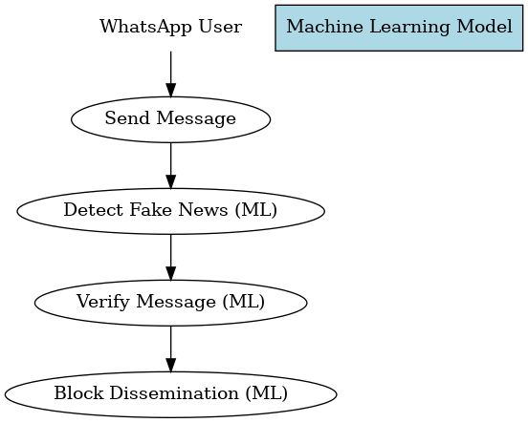

***Figure 3.1*:** *Model Diagram*

## 3.11 Naive Bayes System Algorithm

The following algorithm outlines the system's workflow:

1. Start
2. User Registration/Login
3. User Sends Message
4. System Checks Message for Fake Content

If message is fake:

System Sends Error Message to User

If message is not fake:

Message is Sent Successfully

1. User Logs Out
2. End

## 3.12 FLOWCHART DIAGRAM

The diagram below is the graphical illustration of the system process of fake news identification and prevention on WhatsApp. The flowchart outlines the processes from user interaction to message analysis, giving clarity and transparency on how the system works.

















No Yes

## 





***Figure 3.2:*** *Flowchart Diagram*

# 

# 

# 

# CHAPTER FOUR

# IMPLEMENTATION AND RESULT

## 4.1 IMPLEMENTATION

This chapter presents the system architecture and the implementation of a software program that relies on the capabilities of Naive Bayes algorithm to identify and prevent the dissemination of fake news on WhatsApp. The ability of a system to identify and flag misleading information before it is shared has become increasingly important due to the rapid spread of misinformation across social media platforms. If a news is identified as potentially false or misleading, the user is notified, and such news is blocked from being sent. The system's web-based interface is easily accessible, and the integration of the system with Machine Learning enables the automatic processing of news patterns from the trained datasets.

### 4.1.1 Data Exploration and Visualization

This section outlines the implementation of data exploration and visualization, as specified in Objective (i), which helps to understand the structure, patterns, and significant properties of the dataset. This helped in identifying imbalanced classes, noise, and irrelevant features.

The project data set has 6,335 news articles each labeled as REAL or FAKE. Each article has the following format:

1. Title
2. Text content
3. Label (REAL or FAKE)

**Label Distribution**

1. REAL news: 3,171 entries
2. FAKE news: 3,164 entries

The diagram below displays a screenshot of our dataset, illustrating its structure and a sample of its contents.

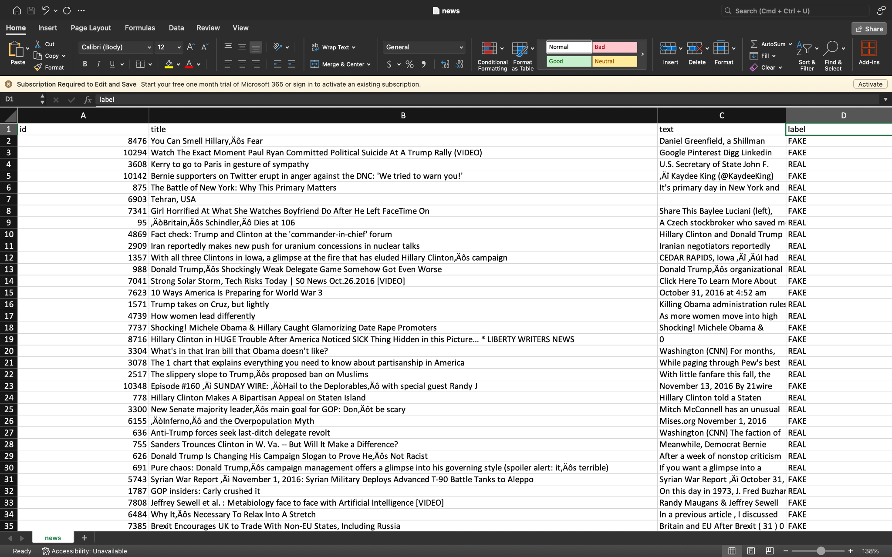

***Figure 4.1:*** *Dataset Structure*

The diagram below shows the label distribution of our dataset, which is nearly balanced, helping to reduce bias during model training and improve the accuracy of evaluation metrics.

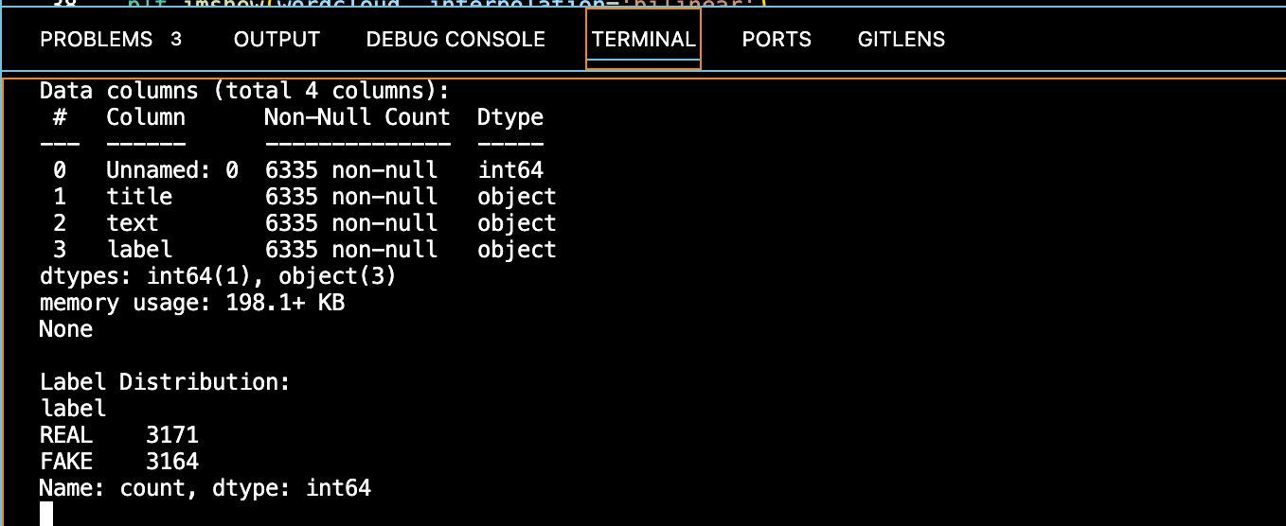

***Figure 4.2:*** *Label Distribution*

**Word Cloud Visualization**

The diagram below presents a visualization of the data, featuring two separate word clouds: one for fake news and another for real news, created to better understand patterns in language use.

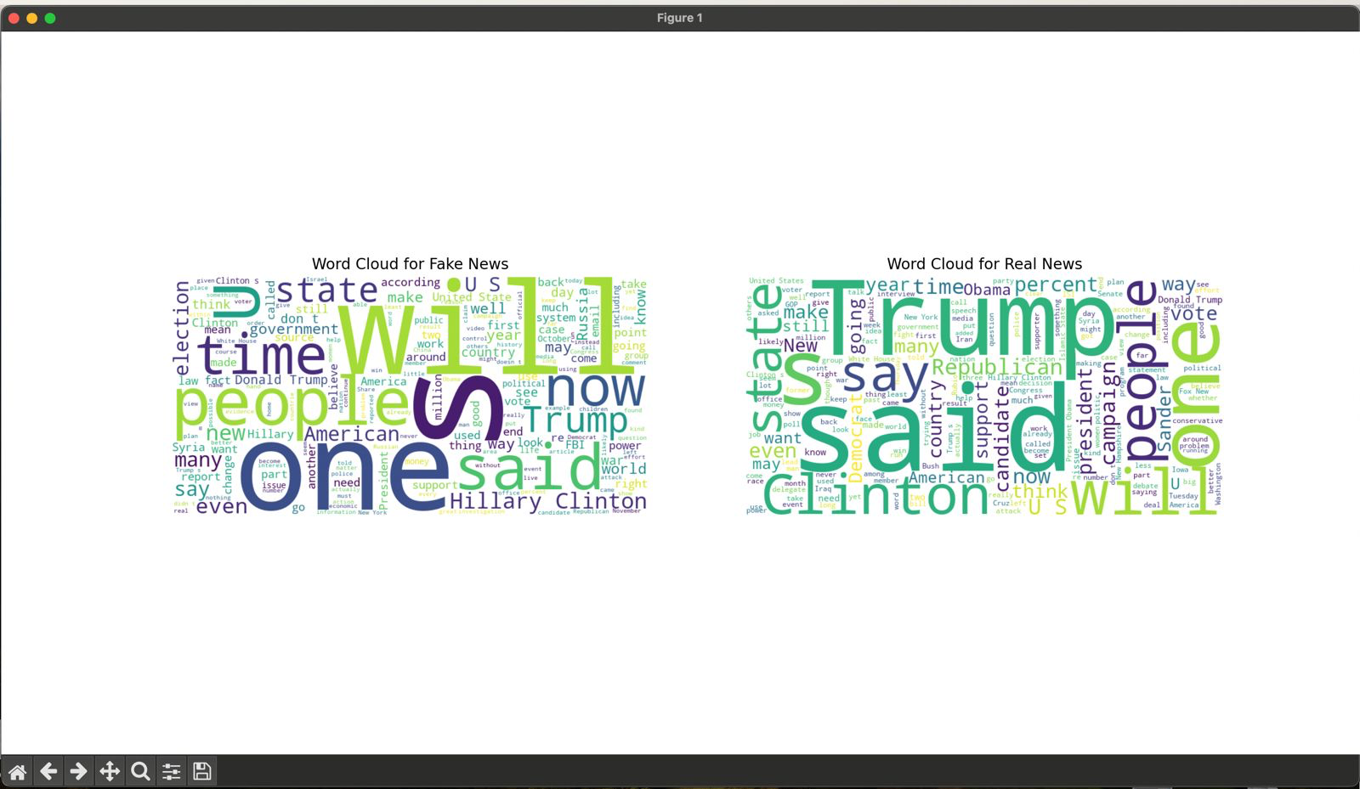

***Figure 4.3:*** *Word Cloud Visualization*

**Observations:**

1. Fake news articles frequently include sensational and emotionally charged words such as "people," "win", and "time".
2. Real news articles more commonly contain named entities and political terms such as "Trump," "Clinton", and "Republican".

These observations provide valuable insights into the linguistic features that may help differentiate between fake and real news, and they informed subsequent steps in feature engineering and model training.

### 4.1.2 Data Preprocessing based on the identified issue in Objective (i)

This section outlines the implementation of Data Preprocessing, as specified in Objective (ii). Preprocessing was necessary in preparing the dataset for both traditional and deep learning models.

It was discovered that some entries in the 'text' column were either empty or contained only a value of 0. Such entries were not meaningful for text classification and could negatively affect model performance. To address this issue:

1. All records with empty or zero-valued text fields were removed (Row Deletion) from the dataset.
2. The remaining dataset was cleaned and validated to ensure that each entry contained usable content and a corresponding label.

After cleaning, the following preprocessing steps were applied to facilitate maximum model performance:

1. The dataset was divided into features (X) and labels (Y).
2. Train-test split was implemented based on ratio 80:20 for splitting training data and test data.
3. For machine learning, a pipeline was constructed using TF-IDF vectorization (stopword removal) and a Multinomial Naive Bayes classifier.

**Tokenization for Deep Learning**

For enhancing classification performance by employing deep learning techniques, additional preprocessing was needed. Since deep learning models cannot accept raw text, the following steps were conducted:

**Tokenization**: The text data was converted to sequences of integers, with each word corresponding to its index in a dictionary of the 5,000 most frequent words in the dataset.

**Padding**: Sequences were padded to have equal lengths for all samples before being input into the LSTM model.

These treated the text data in such a way that the deep learning model could learn context representations of the text to be able to detect fake news.

### 

### 4.1.3 Model Training, Testing, Validation, and Evaluation

The image below shows the implementation of Objective (iii), which involves training, testing, validation, and evaluation of the Naive Bayes-Based model developed.

Predictions were generated based on the test set after training, and model performance was evaluated in terms of the following evaluation metrics:

1. Accuracy
2. Precision (weighted)
3. Recall (weighted)
4. F1-score (weighted)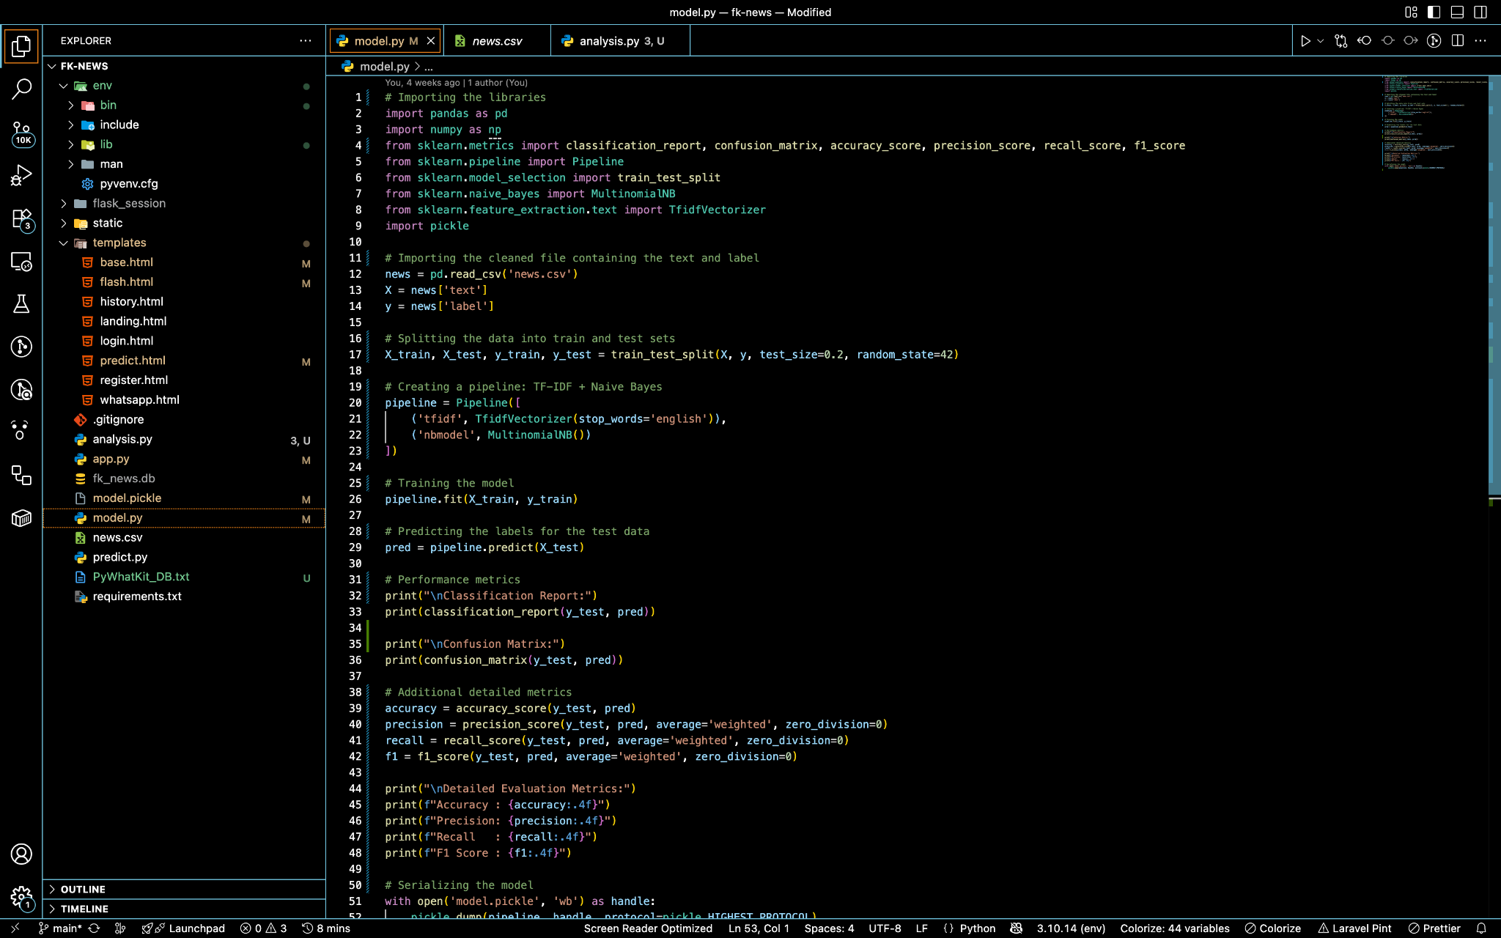

***Figure 4.4:*** *Model Training, Testing and Evaluation*

**Evaluation Results**

***Table 4.1:*** *Model Evaluation Results*

| **Metric** | **Score** |
| --- | --- |
| Accuracy | 0.8453 |
| Precision | 0.8732 |
| Recall | 0.8453 |
| F1-Score | 0.8421 |

These results indicate good performance generally. The model was well-performing in accuracy, with precision and recall being evenly balanced, which justifies its ability to distinguish real from fabricated news messages within the data.

## 4.2 Result

In this section, a specific description of the main characteristics of the software developed to prevent false and malicious messages in WhatsApp is presented. This section emphasizes the key components that shape the user experience and the usability of the application to guarantee the news credibility.

### 4.2.1 Landing Page

The Landing Page is the gateway to the platform. It presents the purpose of the system, to help users detect and prevent the spread of fake news, in a clean and modern design. The page uses vivid branding and has a low call to action to initialize the users.

Below is a screenshot of the Landing page of the system.  


***Figure 4.5:*** *Landing page*

### 4.2.2 The Register Page

The Register Page provides new users with the option to register through their full name, username, and password. Both login and the registration pages maintain the design theme of the app, using soft gradients and bare forms to provide an intuitive user interface. Below is a screenshot of the Register page.  
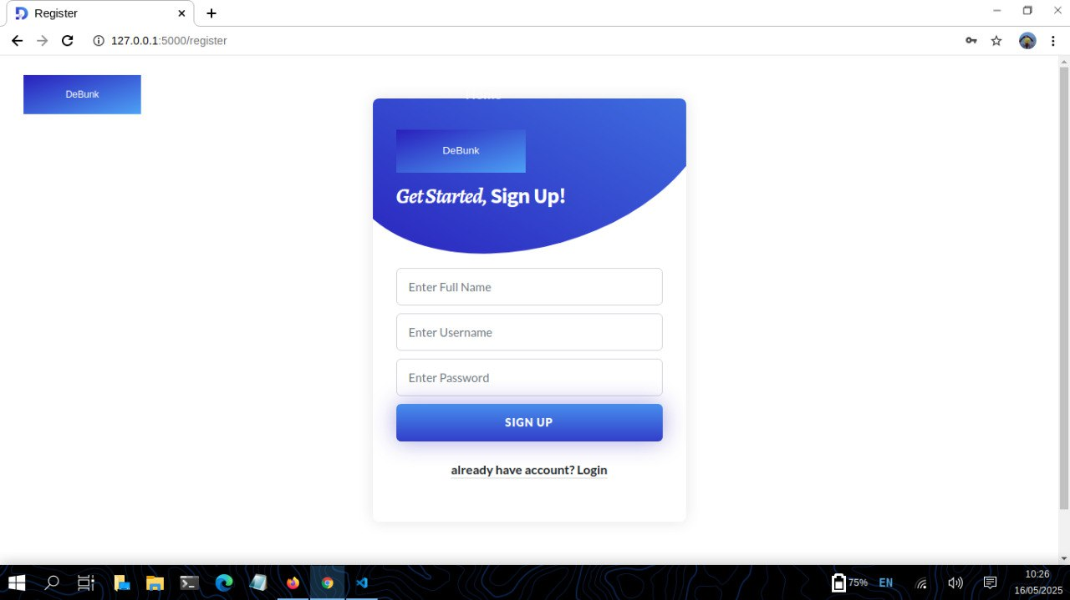

***Figure 4.6:*** *Register page*

### 

### 4.2.3 Login Page

The Login Page provides already registered users with access to their accounts based on their username and password. For non-logged-in users, there is a link provided to transfer them to the registration page. Below is a screenshot of the Login page.  
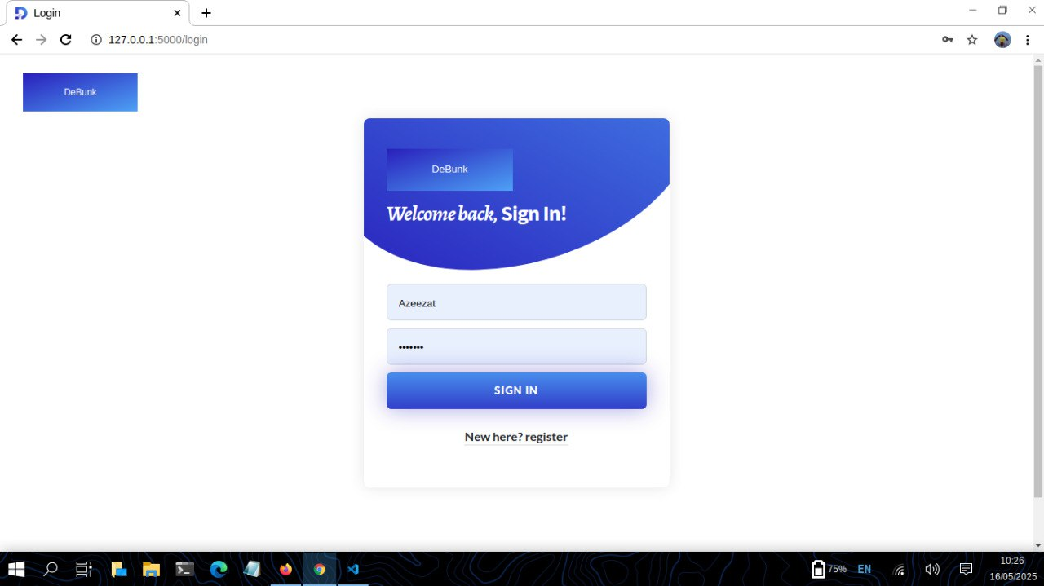

***Figure 4.7:*** *Login page*

### 4.2.4 Homepage

After a successful login attempt, the user is redirected to the homepage, which is the central hub for interaction on the system. The top navigation bar provides the means for logged-in users to access the features of the website such as verifying news, messaging by WhatsApp, viewing history, and a link to logout. Below is a screenshot of the Homepage.

***Figure 4.8:*** *Homepage*

### 

### 4.2.5 The Verify Page

The Verify Page is a core part of the application where the user copies and pastes or simply types in news to test whether it is authentic or not. After submission, the content is examined by the system using its machine learning-powered classification model and returns with a verdict stating whether the news is "FAKE" or "REAL". The verdict is presented using a Bootstrap alert component, which provides immediate feedback. The verification process is easy and fast for anybody to cross check facts before forwarding them. Below is a screenshot of the Verify page.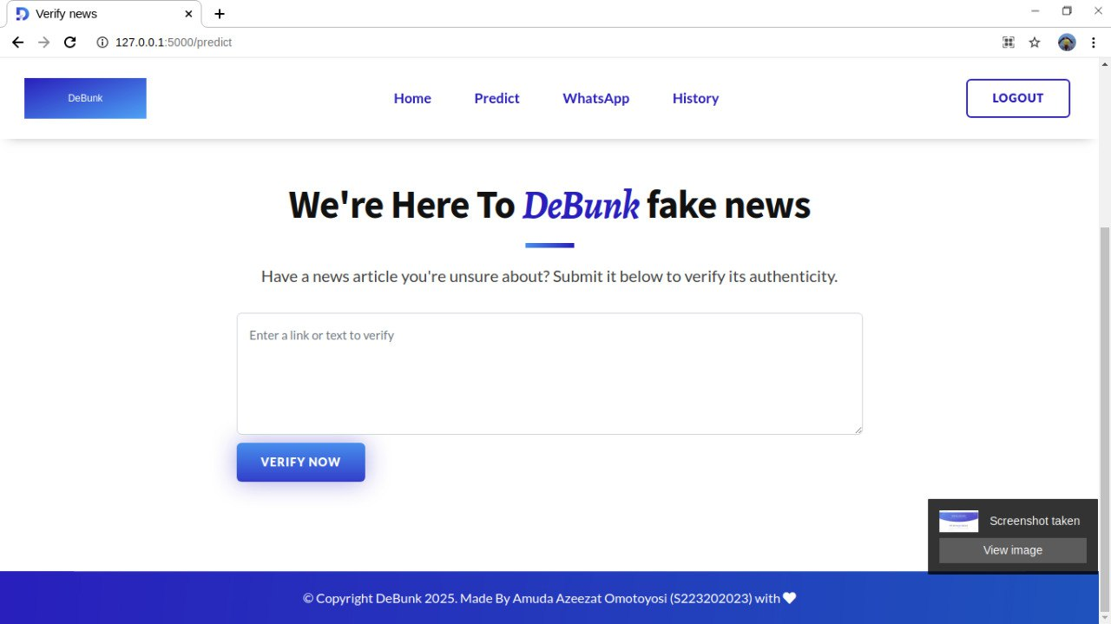

***Figure 4.9:*** *Verify page*

### 

### 4.2.6 WhatsApp Integration Page

To offer simple use and intuitive command, the WhatsApp page is organized in a highly systematic and user-friendly way so that anyone may easily authenticate and send news through WhatsApp. As the interface between the user and the message delivery system, such a page is a very essential mechanism for preventing the spreading of misinformation. Before any news could be sent, the system first authenticates it. If the news is genuine, it continues to get delivered to the target WhatsApp number, else the system immediately blocks it and shows an unmistakable notice to the user, guaranteeing misinformation does not leave the platform. Major features of the WhatsApp page are:

**Input Fields:** The interface allows the user to enter the recipient’s WhatsApp phone number, specifying who will receive the news. Below that, a text box is provided where the user can type or paste the news content they wish to send. Writing the message is straightforward and user-friendly. The design supports messages of any length, making it suitable for both short and long text news without limitations.

**Send Button**: After the news content is provided, the user can then click this button to enable the machine learning model to verify the genuinity of the news before sending the news through WhatsApp. The button is designed to be noticeable without being distracted.

**Alert Notification**: A warning notification is displayed based on the validity of the news. The notification is simple and concise, presenting the users with plain information about why their message can't be delivered. This ability creates an ownership and consciousness on the users' side, that they can actively, all on their own, help to create a stable communication environment.

Below is a screenshot of the Whatsapp integration page.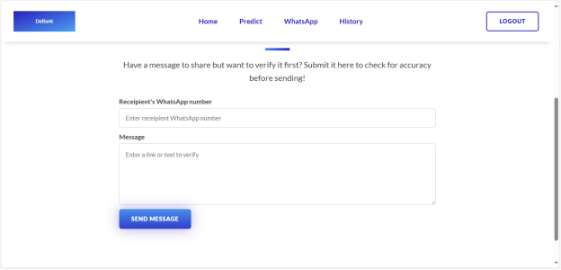

***Figure 4.10:*** *WhatsApp Integration Page*

### 4.3.6 The History Page

The History Page contains a searchable, paginated table that shows each message and its classification result (either fake or real) and gives users a personal history of their verification activity. This promotes transparency and allows users to see how often they engage with misinformation. Below is a screenshot of the History page

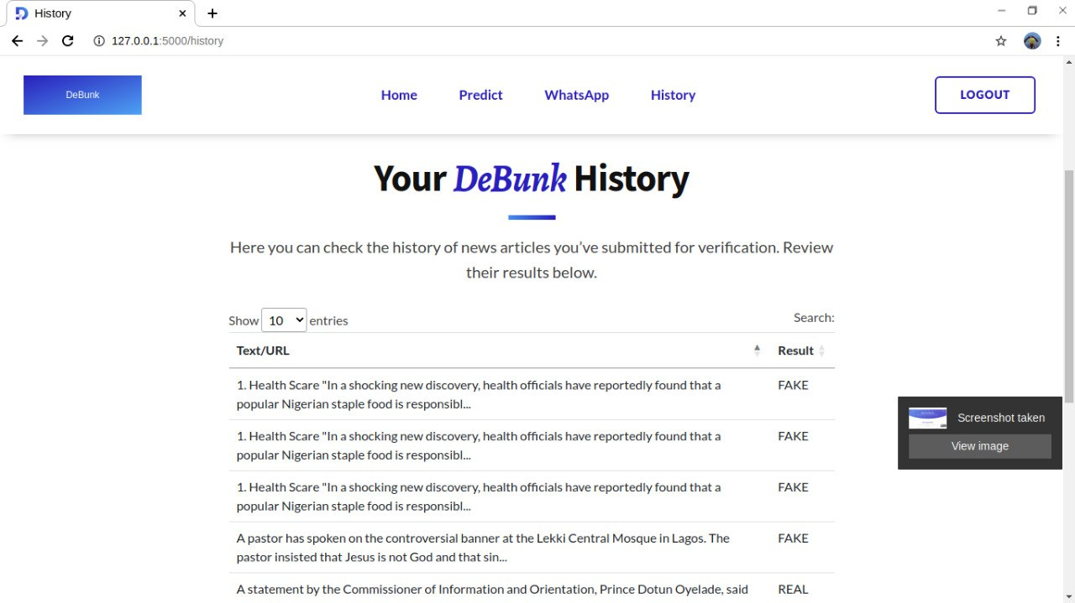

***Figure 4.11:*** *History page*

# 

# 

# 

# 

# 

# 

# 

# 

# 

# 

# 

# CHAPTER FIVE

# SUMMARY, CONCLUSION, AND RECOMMENDATIONS

## 5.1 SUMMARY

With the intention of preventing the escalating issue of misinformation on social media networks, particularly WhatsApp, this project was designed to build a Naive Bayes-based system for fake news identification using Natural Language Processing (NLP) techniques and Naive Bayes algorithm. The project was initiated to research and apply methods that were able to read and identify fake news before they were sent by any user.

Using a combination of text classification, contextual analysis, and sentiment detection, the system can identify fake news from real news. The NB algorithm, which was trained on a labeled set of real and fake news, has high accuracy with balanced precision and recall.

The results confirmed that Naive Bayes-based model, if trained on the right datasets, can effectively help users identify potentially false content. This shows how machine learning can be leveraged to improve the trustworthiness of digital communication on social media platforms like WhatsApp by warning users when a news content is likely to be misleading.

## 5.2 CONCLUSION

This study establishes that Natural Language Processing techniques can be of great help in identifying fake news content spread via WhatsApp. The system developed was able to categorize messages with high accuracy, offering users real-time feedback before sending messages. This serves the purpose of improving the quality of digital communication and users' trust.

The use of the Naive Bayes model and NLP techniques provided a solution to the fake news identification problem. Though the system was successful, it also created challenges with the possibility of false positives, where actual content may be incorrectly flagged due to very small news contents and the need to adapt to emerging trends in misinformation. Additional challenges include data bias, where skewed or incomplete training data can lead to inaccurate predictions; linguistic complexity, as models may struggle with sarcasm, slang, or culturally nuanced language; and the constantly evolving nature of misinformation, which demands frequent model updates to stay effective.

## 5.3 RECOMMENDATIONS

Recommendations are made for professionals and researchers active in natural language processing and machine learning, within the context of the application WhatsApp. Here are recommendations addressing the identified limitations:

1. Implement Real-Time Fact-Checking Mechanisms on WhatsApp
2. To increase user confidence in digital interactions on social media platforms, the integration of this model within the WhatsApp environment is recommended. This model can act as intelligent assistants, identifying message content instantly and enhancing the credibility of information exchanged.
3. Mitigating Data Bias
4. Use diverse, representative datasets across demographics, languages, and contexts.
5. Regular auditing and retraining of models to identify and reduce bias.
6. Handling Linguistic Complexity
7. Incorporate state-of-the-art NLP techniques like contextual embeddings (e.g., BERT, RoBERTa).
8. Training on region-specific or culturally dense datasets to improve detection of fake news.
9. Adapting to Evolving Misinformation
10. Use continuous learning pipelines to update models with new data.
11. Use human-in-the-loop systems to post-edit model outputs and identify new patterns of misinformation early.

# REFERENCES

Albalawi, R., Yeap, T. H., & Benyoucef, M. (2019, November). Toward a real-time social recommendation system. In *Proceedings of the 11th International Conference on Management of Digital EcoSystems* (pp. 336-340).

Altay, S., Berriche, M., & Acerbi, A. (2023). Misinformation on misinformation: Conceptual and methodological challenges. *Social media+ society*, *9*(1), 20563051221150412.

Bakir, V., & McStay, A. (2018). Fake news and the economy of emotions: Problems, causes, solutions. *Digital journalism*, *6*(2), 154-175.

Baptista, J. P., & Gradim, A. (2022). A working definition of fake news. *Encyclopedia*, *2*(1).

Gupta, A., Kumar, N., Prabhat, P., Gupta, R., Tanwar, S., Sharma, G., ... & Sharma, R. (2022). Combating fake news: Stakeholder interventions and potential solutions. *Ieee Access*, *10*, 78268-78289.

Hartley, K., & Vu, M. K. (2020). Fighting fake news in the COVID-19 era: policy insights from an equilibrium model. *Policy sciences*, *53*(4), 735-758.

Hirlekar, V. V., & Kumar, A. (2020, June). Natural language processing based online fake news detection challenges–A detailed review. In *2020 5th International Conference on Communication and Electronics Systems (ICCES)* (pp. 748-754). IEEE.

Kazemi, A. (2024). *Human-Centered Natural Language Processing for Countering Misinformation* (Doctoral dissertation).

Khan, T., Michalas, A., & Akhunzada, A. (2021). Fake news outbreak 2021: Can we stop the viral spread?. *Journal of Network and Computer Applications*, *190*, 103112.

Khanna, S., & Srivastava, S. (2020). Patient-centric ethical frameworks for privacy, transparency, and bias awareness in deep learning-based medical systems. *Applied Research in Artificial Intelligence and Cloud Computing*, *3*(1), 16-35.

Kim, B., Park, J., & Suh, J. (2020). Transparency and accountability in AI decision support: Explaining and visualizing convolutional neural networks for text information. *Decision Support Systems*, *134*, 113302.

Ma, J., Gao, W., & Wong, K. F. (2016). *A comparative study of machine learning and deep learning models for fake news detection*. Proceedings of the 25th International Conference on Computational Linguistics (COLING), 2328–2339.

Mridha, M. F., Keya, A. J., Hamid, M. A., Monowar, M. M., & Rahman, M. S. (2021). A comprehensive review on fake news detection with deep learning. *IEEE access*, *9*, 156151-156170.

Oladokun, B. D., Aruwa, J. E., Ottah, G. A., & Ajani, Y. A. (2024). Misinformation and Disinformation in the Era of Social Media: The Need for Fact-Checking Skills. *Journal of Information and Knowledge*, 1-7.

Oshikawa, R., Qian, J., & Wang, W. Y. (2020). *A survey on natural language processing for fake news detection*. Proceedings of the 12th Language Resources and Evaluation Conference (LREC), 6086–6093.

POLATTY, J. (2022). *Securing Veracity: Defenses Against the Pervasive Influence of Social Media* (Doctoral dissertation, Brown University).

Roy, S., Ghosh, S., & Chakraborty, T. (2018). *A deep ensemble framework for fake news detection and classification*. Proceedings of the 27th International Joint Conference on Artificial Intelligence (IJCAI), 3541–3547.

Shu, K., Sliva, A., Wang, S., Tang, J., & Liu, H. (2017). Fake news detection on social media: A data mining perspective. *ACM SIGKDD explorations newsletter*, *19*(1), 22-36.

Southwell, B. G., Niederdeppe, J., Cappella, J. N., Gaysynsky, A., Kelley, D. E., Oh, A., ... & Chou, W. Y. S. (2019). Misinformation as a misunderstood challenge to public health. *American journal of preventive medicine*, *57*(2), 282-285.

Tien, J. M. (2013). Big data: Unleashing information. *Journal of Systems Science and Systems Engineering*, *22*, 127-151.

Topol, E. J. (2019). High-performance medicine: the convergence of human and artificial intelligence. *Nature medicine*, *25*(1), 44-56.

Wardle, C., & Derakhshan, H. (2017). *Information disorder: Toward an interdisciplinary framework for research and policymaking* (Vol. 27, pp. 1-107). Strasbourg: Council of Europe.

Xu, Y., Zhang, L., & Chen, X. (2025). *A hybrid attention framework for fake news detection*. Journal of Artificial Intelligence Research, 78(1), 34–56.

Zhang, C., Gupta, A., Kauten, C., Deokar, A. V., & Qin, X. (2019). Detecting fake news for reducing misinformation risks using analytics approaches. *European Journal of Operational Research*, *279*(3), 1036-1052.

Zhang, C., Fan, C., Yao, W., Hu, X., & Mostafavi, A. (2019). Social media for intelligent public information and warning in disasters: An interdisciplinary review. *International Journal of Information Management*, *49*, 190-207.

# APPENDIX

## Naive Bayes Algorithm Implemented

# Importing the libraries

import pandas as pd

import numpy as np

from sklearn.metrics import classification_report, confusion_matrix, accuracy_score, precision_score, recall_score, f1_score

from sklearn.pipeline import Pipeline

from sklearn.model_selection import train_test_split

from sklearn.naive_bayes import MultinomialNB

from sklearn.feature_extraction.text import TfidfVectorizer

import pickle

# Importing the cleaned file containing the text and label

news = pd.read_csv('news.csv')

X = news['text']

y = news['label']

# Splitting the data into train and test sets

X_train, X_test, y_train, y_test = train_test_split(X, y, test_size=0.2, random_state=42)

# Creating a pipeline: TF-IDF + Naive Bayes

pipeline = Pipeline([

('tfidf', TfidfVectorizer(stop_words='english')),

('nbmodel', MultinomialNB())

])

# Training the model

pipeline.fit(X_train, y_train)

# Predicting the labels for the test data

pred = pipeline.predict(X_test)

# Performance metrics

print("\nClassification Report:")

print(classification_report(y_test, pred))

print("\nConfusion Matrix:")

print(confusion_matrix(y_test, pred))

# Additional detailed metrics

accuracy = accuracy_score(y_test, pred)

precision = precision_score(y_test, pred, average='weighted', zero_division=0)

recall = recall_score(y_test, pred, average='weighted', zero_division=0)

f1 = f1_score(y_test, pred, average='weighted', zero_division=0)

print("\nDetailed Evaluation Metrics:")

print(f"Accuracy : {accuracy:.4f}")

print(f"Precision: {precision:.4f}")

print(f"Recall : {recall:.4f}")

print(f"F1 Score : {f1:.4f}")

# Serializing the model

with open('model.pickle', 'wb') as handle:

pickle.dump(pipeline, handle, protocol=pickle.HIGHEST_PROTOCOL)