Headings:
1 - Introduction
1.1 - Description
2 - Installation and configuration
2.1 - Display options
2.2 - Initialisation of the default configuration
2.3 - Kicad: principles of use
3 - Use
3.1 - Main window
3.2 - Utility launch pane
3.3 - Project tree view
3.4 - Toolbar:

Introduction

Description
The Kicad suite is a group of programs for schematics and PCBs that is available for the following operating systems:
- LINUX
- Windows XP/2000

The kicad utility program is a project manager that facilitates the use of the various programs required to draw schematics, lay out PCBs, generate and check the production files.
The programs included are:
- Eeschema: the schematic editor.
- Pcbnew: the PCB editor.
- Cvpcb: enables the association of schematic components with physical modules (packages) for placement on the PCB.
- Gerbview: is used to visualize Gerber files.

Installation and configuration

Display options
It is recommended to set your display/graphics card to use 24 or 32 bits per pixel.
The 16-bit mode will work for Eeschema, but in Pcbnew the display will not function correctly under Linux in this mode.

Initialisation of the default configuration
A default configuration file (kicad.pro) is supplied in kicad/template. It serves as the template for each new project. It can be modified or added to if necessary, usually for the list of libraries to load. Run Eeschema via kicad or directly (Linux command; /usr/local/kicad/bin/eeschema). Update the configuration and then save it in /usr/local/kicad/template/kicad.pro

Kicad: principles of use
In order to manage simply a project, i.e. all the files it constitutes (representing schematics, printed circuit boards, supplementary libraries, manufacturing files for phototracing, drilling and automatic component placement), it is recommended to create a project:
- Create a working directory for the project (using kicad or by other means).
- In this directory, use kicad to create the project file (file .pro) via the icon.

It is strongly recommended to use the same name for the project and its directory.

Kicad creates a file with a .pro extension that maintains a number of parameters relating to project management (such as the filename of the principal schematic, list of libraries used in the schematics and PCBs). The default names of both the principal schematic and the printed circuit board are based upon the name of the project. Thus, if a project called example was created in a directory called example, the default files created would be:
example.pro | project management file.
example.sch | principal schematic file.
example.brd | printed circuit board file.
example.net | netlist file.
example.xxx | various files created by the other utility programs.
example.cache.lib | cache file of the libraries used in the schematic  (backup of the components used)

Use

Main window
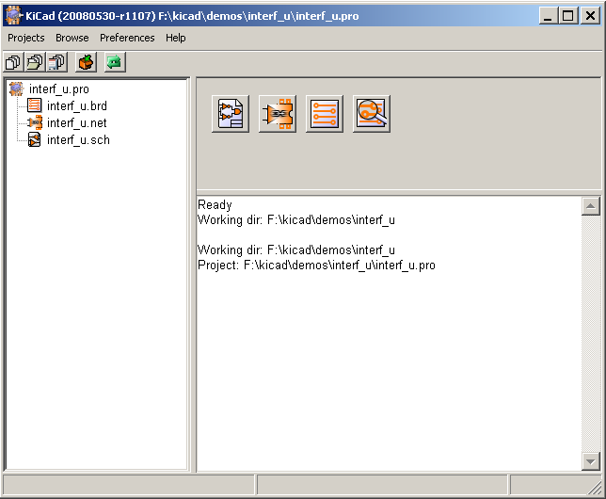
The main window is composed of a tree view of the project, a pane containing buttons used to run the various utilities, and a message window. The menu and the toolbar can be used to create, read and save project files (*.pro).

Utility launch pane
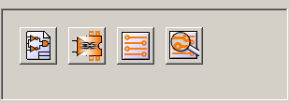

The buttons correspond to the following commands:

 | Run Eeschema
 | Run Cvpcb.
 | Run Pcbnew.
 | Run Gerbview.

Project tree view

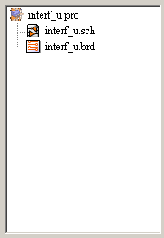 | Double-clicking on runs the schematic editor, in this case opening the file interf_u.sch.  Double-clicking on runs the layout editor, in this case opening the file interf_u.brd.  Right clicking allows files operations

Toolbar:
Create a configuration file for a new project. If the template kicad.pro is found in kicad/template, it is copied into the working directory.
Open an existing project.
Update (save) the current configuration.
Create a zip archive of the whole project (schematic files, libraries, pcb, etc).
Redraw the tree list (useful after a tree change)

