Headings:
3 - General Operations
3.1 - Access to the operations
3.2 - Commands with the Mouse
3.2.1 - Basic commands
3.2.2 - Operations on blocks
3.3 - Selection of grid size
3.4 - Adjustment of the ZOOM
3.5 - Displaying the Cursor Coordinates
3.6 - Quick Commands using the keyboard (“Hot Keys”)
3.7 - Operation on blocks
3.8 - Menu Bar Options
3.8.1 - Files
3.8.2 - Preferences
3.8.3 - Dimensions
3.8.4 - Miscellaneous
3.8.5 - Postprocess
3.8.6 - 3D Display
3.8.7 - Help
3.9 - Commands using icons on the upper toolbar
3.10 - Commands using icons on the right hand toolbar
3.11 - Commands using icons on the left hand toolbar
3.12 - POP Up Windows and fast editing of elements

General Operations

Access to the operations
One reaches the various operations by using:
- the menu bar (top of screen).
- the icons at the top of the screen (general orders)
- the icons on the right of the screen (specific orders or “tools”)
- the icons on the left of the screen (Display Options)
- the mouse buttons (provides menu options).
In particular:
The right-hand mouse button reveals a POP Up Menu the contents of which depend on the element under the cursor (Zoom, grid and editing the element).
- the keyboard (Function keys F1, F2, F3, F4, Shift, Delete, +, - Page Up, Page Down and “space” bar).
In particular:
the “Escape” key generally cancels an operation in progress.

The screenshot below illustrates some of the possible accesses to the operations:
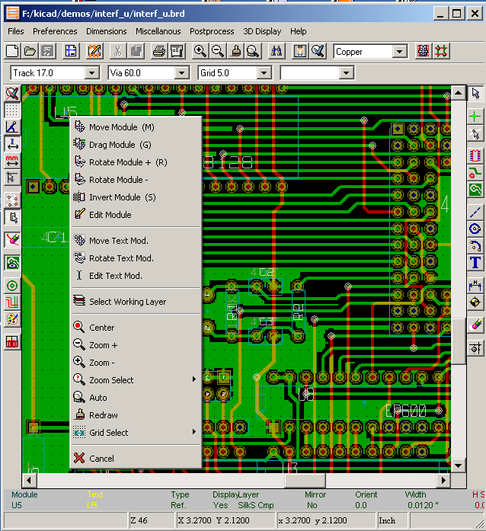

Commands with the Mouse

Basic commands
- Left Button:
- Single click: displays the characteristics of the module or text under the cursor to the lower status bar.
- Double click: displays the editor (if the element is editable) of the element under the cursor.
- Centre Button/Wheel:
- Rapid Zoom.
The rapid zoom operation is only available on the 3 button mouse consequently it has the advantage over a 2 button mouse. Hold down the centre button and draw a rectangle to zoom to the described area.
Rotation of a mouse wheel zooms in and out.
- Right Button:
- Displays a Pop-up Menu

Operations on blocks
Operations to move, invert (mirror), copy, rotate and delete a block are all available on the pop-up menu. In addition the view can zoom to the area described by the block.
The framework of the block is traced by moving the mouse whilst holding down the left mouse button. The operation is carried out on releasing the button.
By holding down one of the keys “Shift” or “Ctrl”, or both keys “Shflt and Ctrl” together, whilst the block is drawn the operation invert, rotate or delete is automatically selected as shown in the table below:

Summarised orders:
Left mouse button held down | Trace framework to move block
Shift + Left mouse button held down | Trace framework for invert block
Ctrl + Left mouse button held down | Trace framework for rotating block 90°
Shft+Ctrl + Left mouse button held down | Trace framework to delete the block
Centre mouse button held down | Trace framework to zoom to block

When moving a block:
- Move block to new position and operate left mouse button to place the elements.
- To cancel the operation use the right mouse button and select Cancel Block from the menu (or press Esc key).
Alternatively if no key is pressed when drawing the block use the right mouse button to display the pop-up menu and select the required operation.
For each block operation a selection window enables the action to be limited to only some elements.

Selection of grid size
The cursor during layout of elements moves on a grid, the display of the grid can be turned on or off using the icon on the left hand side toolbar.
Any of the pre-defined grid sizes, or a User Defined grid, can be chosen using the pop-up window, or the drop-down selector on the toolbar at the top of the screen. The size of the User Defined grid is set using the menu bar option Dimensions - User Grid Size.

Adjustment of the ZOOM
To change the “ZOOM”:
- Open the POP-Up window (using the right mouse button) and to select the desired zoom.
- Or use the function keys:
F1: Enlarge (zoom in)
F2: Reduce (zoom out)
F3: Redraw the display
F4: Centre view at the current cursor position
- Or rotate the mouse wheel.
- Or hold down the centre mouse button and draw a rectangle to zoom to the described area.

Displaying the Cursor Coordinates
The cursor co-ordinates are displayed in inches (inch or “) or millimetres (mm) as selected using the 'I' or 'mm' icons on the left hand side toolbar.
Whichever unit is selected PCBNEW always works to a precision of 1/10,000 of inch.
The status bar at the bottom of the screen gives:
- The current zoom setting.
- The absolute position of the cursor.
- The relative position of the cursor. Note the relative co-ordinates (x,y) can be set to 0,0 at any position by pressing the space bar. The cursor position is then displayed relative to this new datum.
In addition the relative position of the cursor can be displayed using its polar co-ordinates (ray + angle). This can be turned on and off using the icon on the left hand side toolbar.

Quick Commands using the keyboard (“Hot Keys”)
Certain commands are accessible directly with the keyboard (selection can be either upper or lower case). The options are:

- Delete (or Del): Deletes a Module or track (only if the Module tool or the track tool is active)
- V, if the track tool is active Switches working layer (Component <> Copper) or place via, if a track is in progress.
- R: Rotates a module
- S: Switches module to opposite layer (Component <> Copper)
- M: Move module (placement by click of left mouse button).
- G: Drag module (placement by click of left mouse button).
- + et -: Active layer = next or previous layer.
- « Page Up » Active layer = component.
- « Page Down » Active layer = cppper.

Operation on blocks
Operations to move, invert (mirror), copy, rotate and delete a block are all available on the pop-up menu. In addition the view can zoom to that described by the block.
The framework of the block is traced by moving the mouse whilst holding down the left mouse button. The operation is carried out on releasing the button.
By holding down one of the keys “Shift” or “Ctrl” or both “Shflt and Ctrl” together or “Alt”, whilst the block is drawn the operation invert, rotate,delete or copy is automatically selected as shown in the table below:

Left mouse button held down | move block
Shift + Left mouse button held down | invert (mirror) block
Ctrl + Left mouse button held down | rotate block 90°
Shft+Ctrl + Left mouse button held down | delete the block
Alt + Left mouse button held down | copy the block

If move block is initially selected (no keys held down), one of the alternative options can be chosen by displaying the pop-up menu using the right mouse button.
Any of the commands above can be cancelled via the same pop-up menu or pressing the Escape key (Esc).

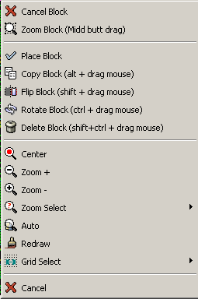

Menu Bar Options
The menu bar provides access to the files (loading and saving), configuration options, printing, plotting and the help files.

Files
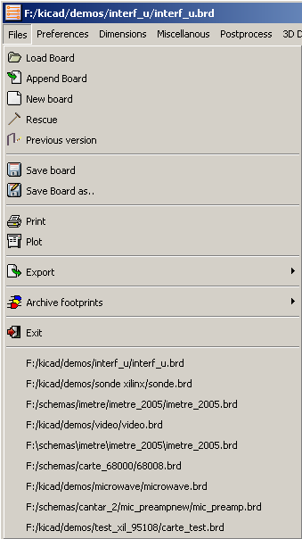
Allows the loading and saving of the printed circuits files, as well as printing and plotting the circuit board. Also enables the export (with the format GenCAD 1.4) of the circuit for use with automatic testers.

Preferences
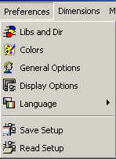
Allows:
- Selection of the module libraries.
- The choice of the colours for displaying layers and other elements. Also enables the display of elements to be turned on and off.
- Management of general options (units, number of layers, etc.).
- The management of other display options.

Dimensions
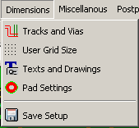
Allows adjustment of:
- Width of tracks and the type and size of vias.
- User grid size.
- Size of texts and the line width for drawings.
- Dimensions and characteristic of pads.

Miscellaneous
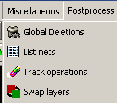
Provides access to:
- Global deletion of elements.
- Listing of Nets.
- Deletion of redundant segments of track.
- Switching elements between layers.

Postprocess
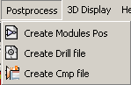
Allows the creation of the following files:
- Components placement (for automatic placement).
- Drilling.
- Association of components/modules (normally generated by CVPCB).

3D Display
Brings up 3D viewer to display the circuit board in 3 dimensions. e.g.
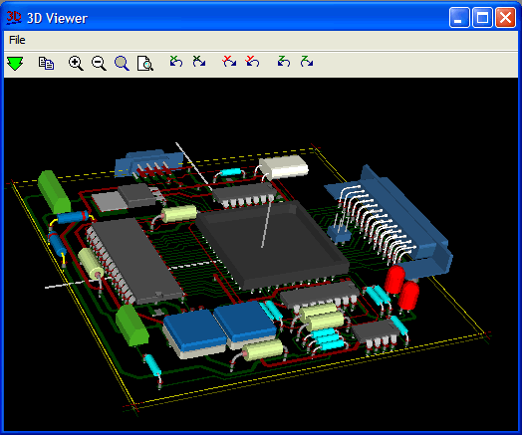

Help
Provides access to the help file and version information (Pcbnew About).

Commands using icons on the upper toolbar
This toolbar gives access to the principal functions of PCBNEW.

Creation of a new printed circuit.
Opening of an old printed circuit.
Save printed circuit.
Selection of the page size and modification of the file properties.
Opens module editor (Modedit) to display/edit library or pcb modules.
Delete the elements selected during a move block operation.
Undo the last deletion
Display print menu.
Display plot menu.
Zoom in and Zoom out (relative to the centre of screen).
Redraw the screen and Auto Zoom.
Find module or text.
Netlist options (selection, reading, testing and compiling).
DRC (Design Rule Check): Automatic check of the tracks.
Footprint mode: when active this enables module options in the pop-up window.
Routing mode: when active this enables routing options in the pop-up window
Direct access to the web router FreeRoute

Auxiliary toolbar:
Selection of the work layer.
Selection a thickness of track already in use.
Selection of a dimension of via already in use.
Selection of the grid size.
Selection of the zoom.

Commands using icons on the right hand toolbar
This toolbar gives access to the tools for:
- Placement of modules, tracks, zones of copper, texts…
- Net Highlighting.
- Creating notes, graphic elements….
- Deleting elements.

Cancel the tool in progress.
Highlight net selected by clicking on a track or pad.
Display local ratsnest (Pad or Module).
Add a module from a library.
Placement of tracks and vias.
Placement of zones (copper planes).
Draw Lines on technical layers (i.e. not a copper layer).
Draw Circles on technical layers (i.e. not a copper layer).
Draw Arcs on technical layers (i.e. not a copper layer).
Placement of text.
Draw Dimensions on technical layers (i.e. not the copper layer).
Draw Alignment Marks (appearing on all layers).
Delete element pointed to by the cursor (see note below)
Note:
when Deleting if several superimposed elements are pointed to priority is given to the smallest (in the decreasing set of priorities tracks, text, module).
the function “Undelete” of the upper toolbar allows the cancellation of the last item deleted.
Offset adjust for drilling and place files.

Commands using icons on the left hand toolbar
This left hand toolbar provides display and control options

Turns DRC (Design Rule Checking) on/off. Caution: when DRC is off incorrect connections can be made.
Grid display on/off (Note: a small grid may not be displayable).
Polar display of the relative co-ordinates on the status bar on/off.
Display/entry of co-ordinates in inches or millimetres.
Change cursor display.
Display general ratsnest (incomplete connections between modules).
Dislay module ratsnest dynamically as it is moved.
Enable/Disable automatic deletion of a track when it is redrawn.
Display of the copper zones on/off.
Display of pads in sketch mode on/off.
Display of tracks and vias in sketch mode on/off.
High contrast display mode on/off. In this mode the active layer is displayed normally, all the other layers are displayed in grey. Useful for working on multi-layer circuits.
Under development

POP Up Windows and fast editing of elements
A click of the right mouse button reveals a Pop-Up Window the contents of which depend on the element pointed at by the cursor.
This gives immediate access to:

- Changing the display (centre display on cursor, zoom in or out or selecting the zoom).
- Setting the grid size.
- Additionally a right click on an element enables editing of the most usually modified element parameters.
The views below show the pop-up windows:

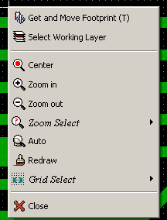 | Pop Up with no selected item.
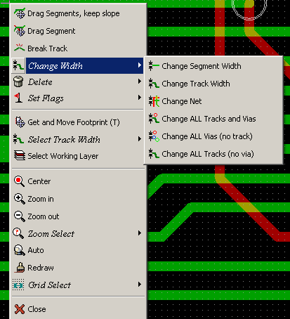 | Pop Up on a track.
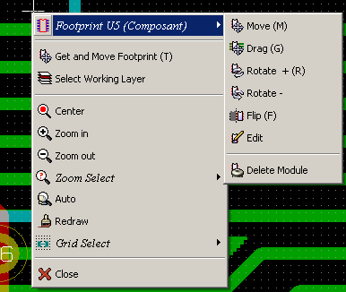 | Pop up on a footprint.

Same cases in Footprint mode ( on)
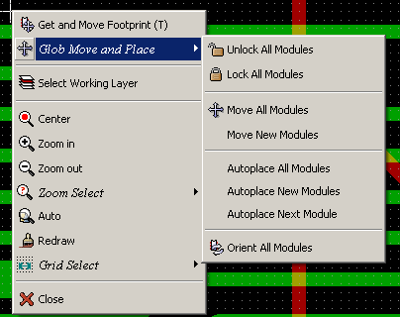 | Pop Up with no selected item.
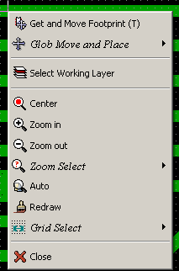 | Pop Up on a track.
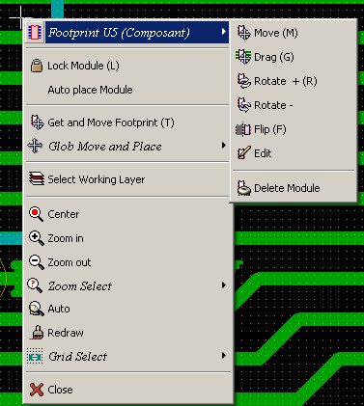 | Pop up on a footprint.

Same cases in Routing mode ( on)

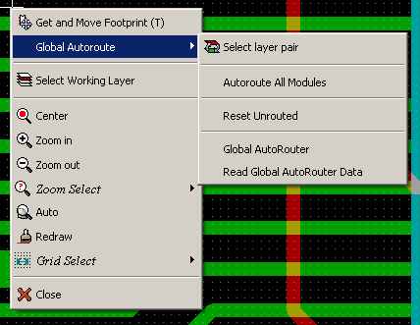 | Pop Up with no selected item.
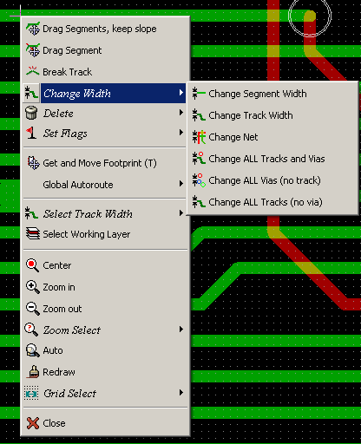 | Pop Up on a track.
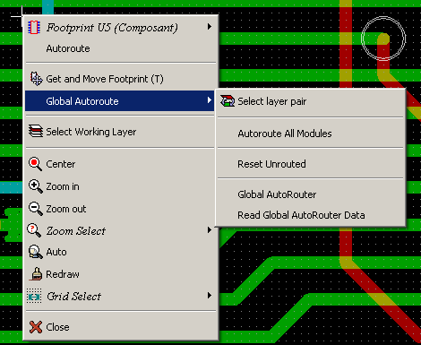 | Pop up on a footprint.

