- Viewlib

Table of Contents
13 - Viewlib 1
13.1 - Introduction 1
13.2 - Viewlib - main screen 2
13.3 - Viewlib top toolbar 3

  - Introduction
Viewlib allows you to quickly examine the content of libraries. Viewlib is called by the tool  or by the “place component” tool available from the right-hand side toolbar.

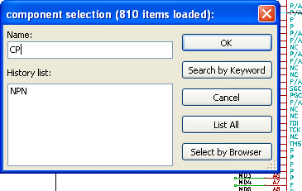

  - Viewlib - main screen
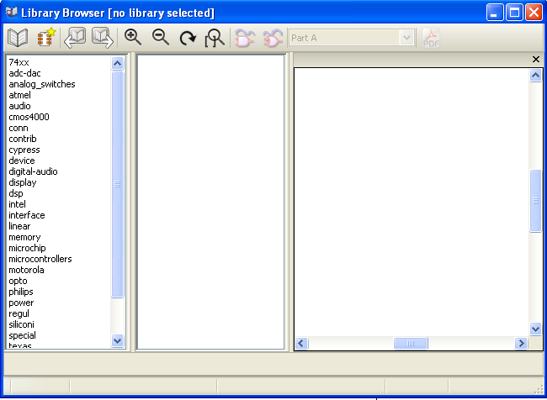
To examine the library content you need to select the wanted library from the list on the left-hand side. Available components will then appear in the second list which allow you to select a component.
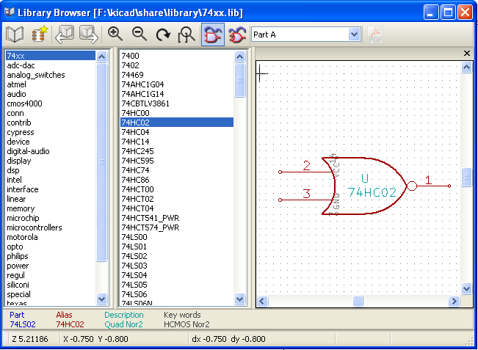
  - Viewlib top toolbar
The top tool bar in Viewlib is shown below.

or, when called by the place component dialog frame from Eeschema it appears as below.

The available commands are.
 | Selection of the desired library which can be also selected in the displayed list.
 | Selection of the component which can be also selected in the displayed list.
 | Display previous component.
 | Display next component.
 | Zoom tools.
 | Selection of the representation (normal or converted) if exist.
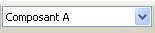 | Selection of the part (if multi-part component).
 | If it exist, display the associated documents.  Exists only when called by the place component dialog frame from Eeschema.
 | Close Viewlib and place the selected component in Eeschema.

