- Main top menu
Table of Contents
3 - Main top menu 1
3.1 - File menu 1
3.2 - Preferences menu 2
3.2.1 - Preferences 2
3.2.2 - Hot-keys sub menu 2
3.2.3 - Preferences menu / Libs and Dir 3
3.2.4 - Preferences menu and colors 4
3.2.5 - Preferences and Options 5
3.2.6 - Preferences and Language 6
3.3 - Help menu 6

  - File menu
Here you can see what the “File” menu looks like.
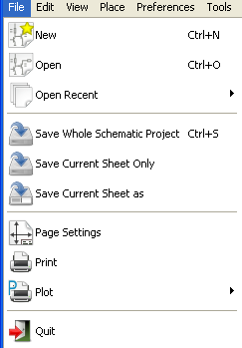

New | Clear current schematic and initialize a new one
Open | Load a schematic hierarchy
Open Recent | Open a list of recent opened files for loading
Save Whole Schematic project | Save current sheet and all its hierarchy.
Save Current Sheet Only | Save current sheet, but not others in a hierachy.
Save Current sheet as... | Save current sheet with a new name.
Print | Access to print menu (See also chap “Print and Plot”).
Plot | Plot in Postscript HPGL or SVF format (See chap “Print and Plot”).
Quit | Quit without saving.

  - Preferences menu
    - Preferences
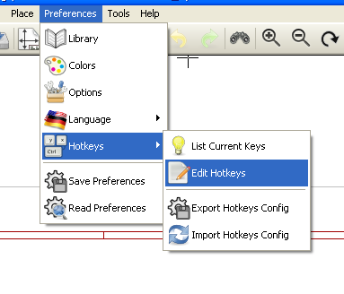
Library | Select libraries and the library's path
Colors | Select colors.
Options | Display options (Units, Grid size.).
Language | Access to the current list of translations.  Use default.  Mainly for translators and developers
Read preferences  Save preferences | Read and Save configuration file.
Hotkeys | Access to the hot keys menu
    - Hot-keys sub menu
List Current Keys | Shows the current hotkeys, Same as the hotkey “?”
Edit Hokeys | Launch the hotkeys editor
Export Hotkeys Config | Create a hotkeys configure file.
Import Hotkeys Config | Read a previously exported hotkeys configure file.

    - Preferences menu / Libs and Dir
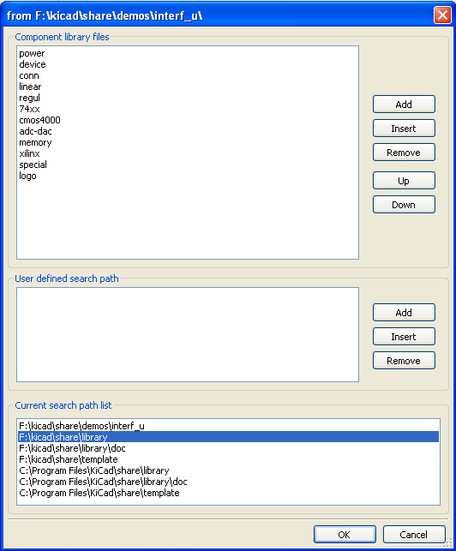
Eeschema configuration is essentially used for:
- Library's path.
- Library's list.
The configuration parameters are saved in the .pro file. Different configuration files in different directories are also possible.
Eeschema seeks and uses by decreasing priorities:
- The configuration file (project>.pro) in the current directory.
- The kicad.pro configuration file in the kicad directory. This file can thus be the default configuration.
- Default values if no file is found. It will at least then be necessary to fill out the list of libraries to load, and then save the configuration.
    - Preferences menu and colors
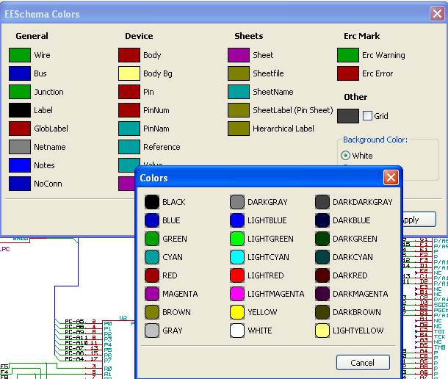
Various drawing elements, colur selection and background colur (black or white only).
    - Preferences and Options
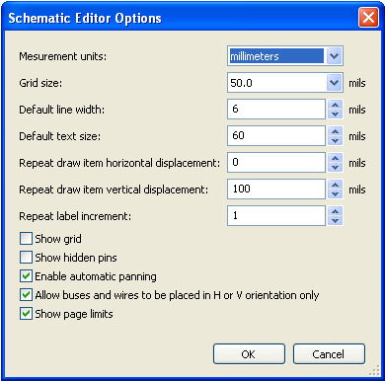

Measurement units: | Select the display and the cursor coordinate units (Inches or Millimeters).
Grid Size: | Grid size selection.  One must work with normal grid (0,050 inches or 1,27 mm). Smaller grids are used for component building.
Default line width: | Pen size used to draw objects that do not have a specified pen size.
Default text size: | Value used when creating new texts or labels
Repeat draw item horizontal displacement | shift value on X axis during element duplication (usual value 0)  (after placing an item like a component, label or wire, a duplication is made by the Inser key)
Repeat draw item horizontal displacement | shift value on Y axis during element duplication (usual value is 0,100 inches or 2,54 mm)
Repeat label increment: | Increment during duplication of texts ending in a number, such as bus members (usual value 1 or - 1).
Show Grid : | If checked : display grid.
Show hidden pins: | Display invisible (or hidden) pins .  If checked, allows the display of power pins.
Enable automatic panning | If checked, automatically shifts the window if the cursor leaves the window, during wire drawing, or element moving.
Allow buses and wires to be placed in H or V orientation only | If checked buses and wires can be only vertical or horizontal.  Else buses and wires can be placed in any direction.
Show page limit | If checked, shows the page limits on screen.
    - Preferences and Language
Use default mode. Other languages are available mainly for maintenance purpose.
  - Help menu
Access to on-line help (this document) for an extensive tutorial about KiCad and also for checking the current version of Eeschema (Eeschema about).

