- Design verification with electrical rules check

Table of Contents
8 - Design verification with electrical rules check 1
8.1 - Introduction 1
8.2 - How to use ERC 2
8.3 - Example of ERC 3
8.4 - Displaying diagnostics 3
8.5 - Power flags and Power flags 4
8.6 - Configuration 4
8.7 - ERC report file 5

  - Introduction
The Electrical Rules Check (ERC) tool performs an automatic check of your schematic. The ERC checks for any errors in your sheet, such as unconnected pins, unconnected hierarchical symbols, shorted outputs, etc. Naturally, an automatic check is not infallible, and the software that make it possible to detect all design errors is not yet 100% complete. Such a check is very useful, because it allows you to detect many oversights and small errors.
In fact all detected errors must be checked and then corrected before proceeding as normal. The quality of the ERC is directly related to the care taken in declaring electrical pin properties during library creation. ERC output is reported as “errors” or “warnings”.
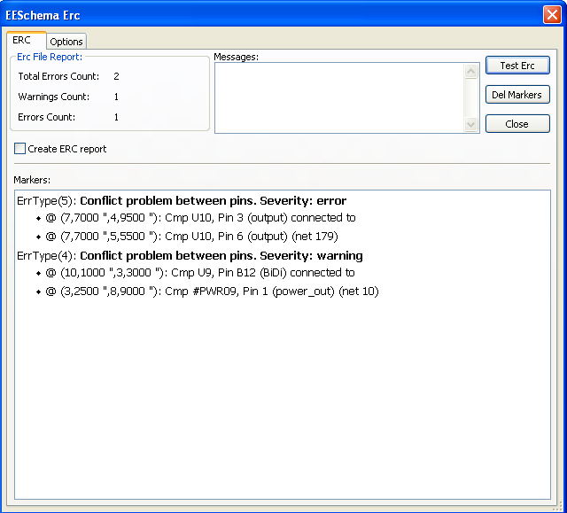
  - How to use ERC
ERC can be started by clicking on the icon .
Warnings are placed on the schematic elements rising an ERC error (pins, or labels).
Notes:
- In this dialog window, when clicking on an error message you can jump to the corresponding marker in schematic.
- In the schematic right click on a marker to access the corresponding diagnostic message.
You can also delete error markers from the dialog.

  - Example of ERC

Here you can see four errors:
- Two outputs have been erroneously connected together (red arrow).
- Two inputs have been left unconnected (green arrow).
- There is an error on an invisible power port, power flag is missing (green arrow on the top).
  - Displaying diagnostics
By right clicking on a marker the pop menu allows to access the ERC marker diagnostic window.
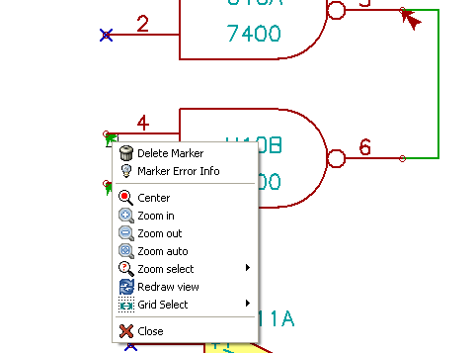
and when clicking on Marker Error Info you can get a description of the error.
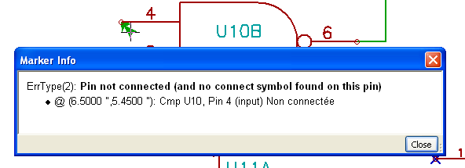
  - Power flags and Power flags
It is common to have an error or a warning on power pins, even though all seems normal. See example above. This happens because, in most designs, the power is provided by connectors, that are not power sources (like regulator output, which is declared as Power out).
The ERC thus won't detect any Power out pin to control this wire and will declare them not driven by a power source.
To avoid this warning you have to place a “PWR_FLAG” on such a power port. Take a look at the following example.

The error marker will then disappear.
Most of the time, a PWR_FLAG must be connected to GND, because usually regulators have outputs declared as power out, but ground pins are never power out (the normal attribute is power in), so grounds never appear connected to a power source without a pwr_flag.
  - Configuration
The Options panel allows you to configure connectivity rules to define electrical conditions for errors and warnings check.

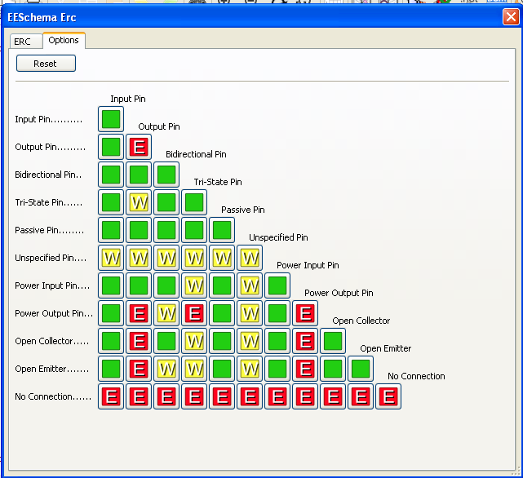
Rules can be changed by clicking on the desired square of the matrix, causing it to cycle through the choices : normal, warning, error.
  - ERC report file
An ERC report file can be generated and saved by checking the option Write ERC report. The file extension for ERC report files is .erc. Here is an example of ERC report file.

ERC control (4/1/1997-14:16:4)

***** Sheet 1 (INTERFACE UNIVERSAL)
ERC: Warning Pin input Unconnected @ 8.450, 2.350
ERC: Warning passive Pin Unconnected @ 8.450, 1.950
ERC: Warning: BiDir Pin connected to power Pin (Net 6) @ 10.100, 3.300
ERC: Warning: Power Pin connected to BiDir Pin (Net 6) @ 4.950, 1.400

>> Errors ERC: 4

