Using GerbView

Introduction to GerbView
GerbView is a Gerber files viewer ( RS 274 X format ), and also is able to display drill files from Pcbnew ( Excellon format ).
It accepts up to 32 files (Gerber and/or Drill files)
Files can be displayed using a transparency mode or stacked mode.

Main Screen:
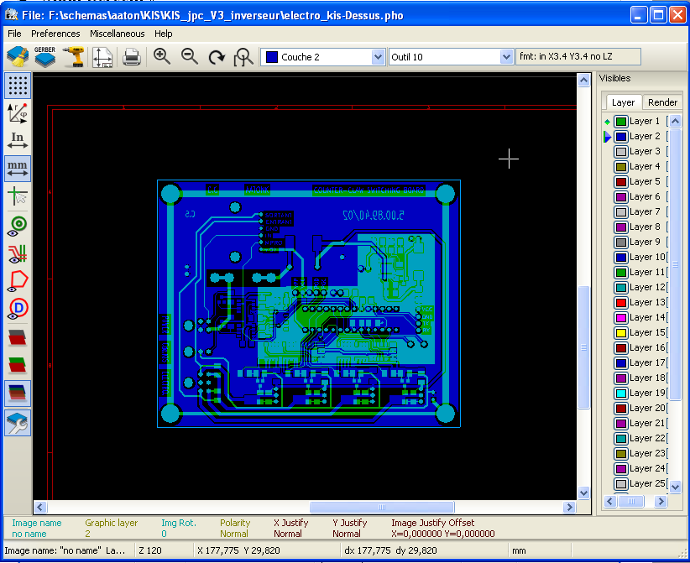

Upper toolbar:

 | Clear all layers
 | Load Gerber files
 | Load drill files (Excellon format from Pcbnew)
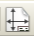 | Set page size for printing and show/hide page limits
 | Open print dialog
 | Zoom in and out
 | Refresh screen
 | Zoom fit in page
 | Layer selection
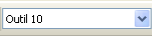 | D Code selection (hight light items that use this dcode)
 | Info about Gerber file options loaded in the current layer

Left toolbar:

Options :
 | 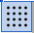 | Grid on / off
 | 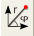 | Display polar coordinates on / off
 |  | Units selection to display coordinates
 |  | On grid cursor shape selection
 |  | Display mode selection (solid or outlines) for flashed items
 |  | Display mode selection (solid or outlines) for lines
 |  | Display mode selection (solid or outlines) for polygons
 |  | Show / hide D Codes values ( for items using a dcode )
 |  | Mode used by Gerbview to show layers.
 |  | Show / hide the layers manager

Layer Manager:
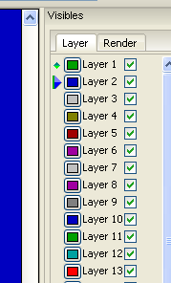 | The layer manager has 2 purposes :  - Select the active layer  - Show/hide layers  The active layer is drawn after the other layers.  When loading a new file, the active layer is used (the new data replace the prévious data)  Note :  - Mouse left click on a line : select the active layer  - Mouse right click on the layer manager : show/hide all layers  - Mouse middle click on a icon : select the layer color.

Modes to show Gerber layers:
 | « Raw » mode.  Each gerber file and each item is files are drawn in the order files are loaded.  However the « active layer » is draw last.  When Gerber files have negative items (drawn in black) artefacts are visible on already drawn layers | 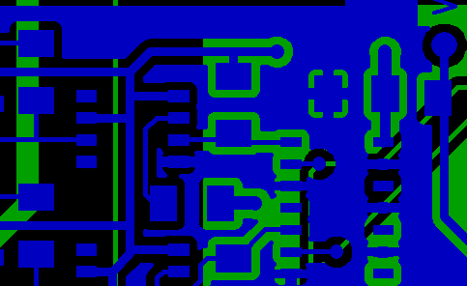
« Stacked » mode.
Each gerber file is drawn in the order files are loaded.
The « active layer » is draw last.
When Gerber files have negative items (drawn in black) there is no artefacts on already drawn layers, because this mode draws each file in a local buffer before show it on screen. Negative items do not create artefacts.
 | Transparency mode | 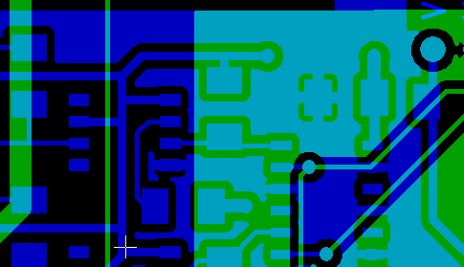

Effect of layer selection for drawings:
This effect is visible only in raw or stacked mode.
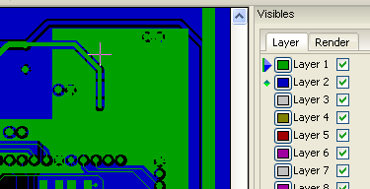 | The layer 1 (green layer) is drawn after the layer 2
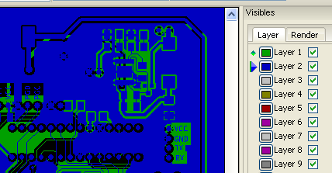 | The layer 2 (blue layer) is drawn after the layer 1

Print layers:

Print dialog access:
To print layers, use the tool, or the main menu (files)

Caution:
But be sure items are inside the printable area (select by a suitable page format).
Do not forget photoplotters uses large plottable area, bigger than page sizes used by printers)
Moving (by block move command) the entire layers is often needed.

Move block command:
You can move items by select them (drag mouse with left button down) and move the selected area on screen.
Click the left button to place the moving area, currently selected.

Commands in menu bar:

Menu Files:

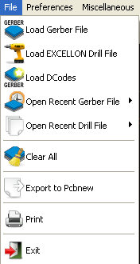

There are 2 special commands:
- Load Dcodes.
- Export to Pcbnew.

Load Dcodes is now obsolete. It is used to load a Dcode file definition when using old RS 274 D Gerber files.
Unfortunately, Dcode file definition has no standard format.

Export to Pcbnew
GerbView has a limited capability to export Gerber files to Pcbnew.
The final result depends on what features of RS 274 X format are used in Gerber Files.
RS 274 X format has raster oriented features that cannot be converted (mainly all features relative to negative objects).
Flashed items are converted to vias.
Lines items are converted to track segments (or graphic lines for non copper layers)
So the usability of the converted file is very dependent of the way Gerber files were built by the Pcb tool.

Preference menu:
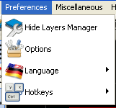
Gives access to the hot keys editor, and some options to display items.

Miscellaneous menu:

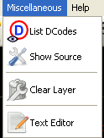

- List Dcodes shows Dcodes in use and some of Dcodes parameters.
- Show Source display the Gerber file content of the active layer in a text editor.
- Clear Layer erase the content of the active layer.

