- General Top Toolbar

Table of Contents
4 - General Top Toolbar 1
4.1 - Sheet Management 1
4.2 - Options of the schematic editor 2
4.2.1 - General options 2
4.2.2 - Template fields names 3
4.3 - Search tool 4
4.4 - Netlist tool 4
4.5 - Annotation tool 5
4.6 - Electrical Rules Check tool 6
4.6.1 - Main ERC dialog 7
4.6.2 - ERC options dialog 8
4.7 - Bill of Material tool 8
4.8 - Import tool for footprint assignment: 12
4.8.1 - Access: 12
4.8.2 - Note for Pcbnew 12

  - Sheet Management
With the icon 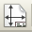 you have access to the sheet settings. Here, you can define the sheet size and various text sections in the title block on the bottom right-hand corner.
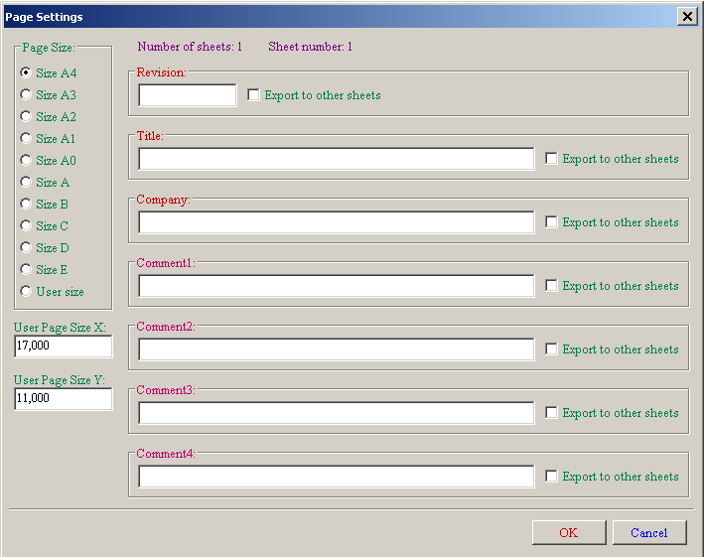
The date is automatically updated. Total number of sheets and sheet number are automatically updated.

  - Options of the schematic editor
    - General options
These options are relative to the drawings
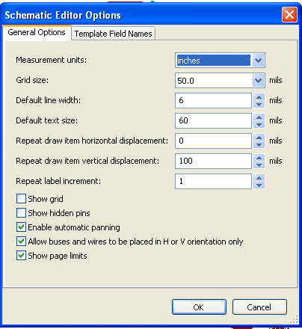

    - Template fields names
You can define custom fields that will always existing in each component (even if the fields are left empty in a given component).
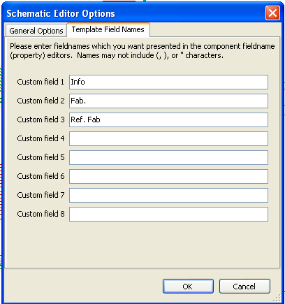

  - Search tool
the following icon  can be used to access the search tool.
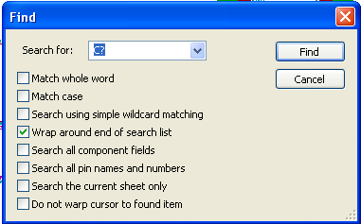
You can search a component, a value, or a text string in the current sheet or in the whole hierarchy. Once found, the cursor will be positioned on the found element, in the relative sub-sheet.
  - Netlist tool
The icon  gives access to the netlist tool used to generate a netlist file.
This netlist file can apply to the whole hierarchy (usual option), or only to the current sheet (the netlist is then partial, but this option can be useful for some software).
In a multisheet hierarchy, any local label is known only inside the sheet to which it belongs.
Thus the label TOTO of sheet 3 is different from the label TOTO of sheet 5 (if no connection has been intentionally introduced to connect them). This is due to the fact that the sheet number (updated by the annotate command) is associated with the local label. In the previous example, the first label TOTO is actually TOTO_3, and the second label TOTO is actually TOTO_5.
This association can be inhibited if it is wished, but be aware of possible undesired connections.
Note 1:
Label lengths have no limitations in Eeschema, but the software exploiting the generated netlist can be limited on this point.
Note 2:
Avoid spaces in the labels, because they will appear as separated words. It is not a limitation of Eeschema, but of many netlist formats, which often suppose that a label has no spaces.
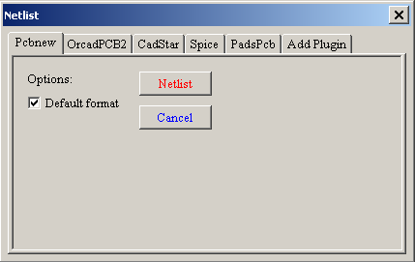
Option:
Default Format :
Check to select Pcbnew as the default format.
Other formats can also be generated :
- Orcad PCB2
- CadStar
- Spice, for the Spice simulator.
External plugins can be launch to extend the netlist formats list (a PadsPcb Plugin was added here)
  - Annotation tool
The icon 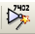 gives access to the annotation tool. This tool performs an automatic naming for all used components.
For multi-part components (such as 7400 TTL which contains 4 gates), a multi-part suffix is also allocated (thus a 7400 TTL designated U3 will be divided into U3A, U3B, U3C and U3D).
You can unconditionally annotate all the components, or only the new components, i.e. those which were not previously annotated.
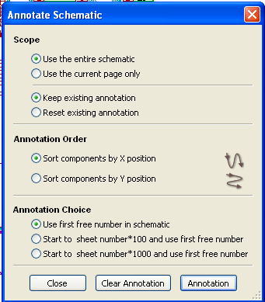
Scope
1) Use the entire schematic. All the sheets are re-annotated (usual Option).
2) Use the current page only. Only the current sheet is re-annotated (this option is to be used only in special cases, for example to evaluate the amount of resistors in the current sheet.).
3) Keep existing annotation. Conditional annotation, only the new components will be re-annotated (usual option).
4) Reset existing annotation. Unconditional annotation, all the components will be re-annotated (this option is to be used when there are duplicated references).
Order
Sorting option to set the annotation numbers to components
  - Electrical Rules Check tool
The icon  gives access to the electrical rules check (ERC) tool.
This tool performs a design verification and is particularly useful to detect forgotten connections, and inconsistencies.
Once you have run ERC, Eeschema places markers on the pins or labels able to highlight a problem. The diagnosis can then be given by left clicking on the marker. An errors file can also be generated.
    - Main ERC dialog
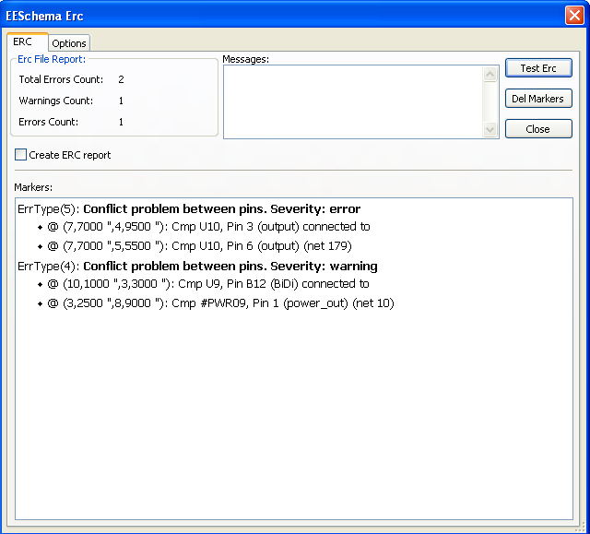
Errors are displayed in the Erc Diags dialog box:
- Errors and warnings count.
- Errors count.
- Warnings count.
Option:
- Create the ERC report: check this option to generate an ERC report file.
Commands:
- Test Erc: to perform an Electrical Rules Check.
- Del Markers: to remove all ERC markers.
- Close: to exit this dialog box.
Note:
- When clicking on an error message, jump to the corresponding marker in schematic.
    - ERC options dialog
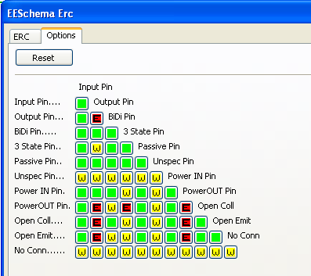
This Setup ERC dialog box allows you to establish connectivity rules between pins; you can choose between 3 options for each case:
- No error
- Warning
- Error
Each square of the matrix can be modified by clicking on it.
  - Bill of Material tool
The icon 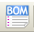 gives access to the bill of material (BOM). This menu allows the generation of a file listing of the components and/or hierarchical connections (global labels).

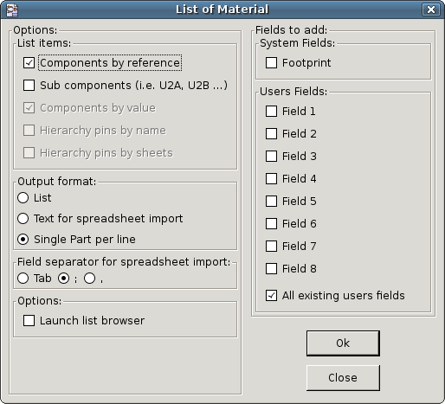

Components can be sorted by:
- Reference.
- Value.
And multi-part components can be detailed. Global labels can be sorted by :
- Alphabetical classification
- Sub-sheet
Different kinds of sorting can be used simultaneously. Options are:
Components by Reference | Bill of Material sorted by Reference.
Component by Value | Bill of Material sorted by Value.
Sub components | The BOM shows every device of multi-part components (ex U2A, U2B…).
Hierarchy Pins by name | Hierarchical connections sorted alphabetically.
Hierarchy Pins by Sheet | Hierarchical connections sorted by sheet number.
List | Creates a plain text file ready to print
Text for spreadsheet import | Creates an ASCII file which can be easily imported in a spreadsheet
Single Part per line | Creates a csv file combining components with the same Value into a single line, listing reference designators comma separated.
Launch list browser | Run the text editor to load and display the BOM list file after creating.

A useful set of component properties to use for a BOM are:
- Value – unique name for each part used.
- Footprint – either manually entered or back-annotated (see below).
- Field1 – Manufacturer's name.
- Field2 – Manufacturer's Part Number.
- Field3 – Distributor's Part Number.
For example:
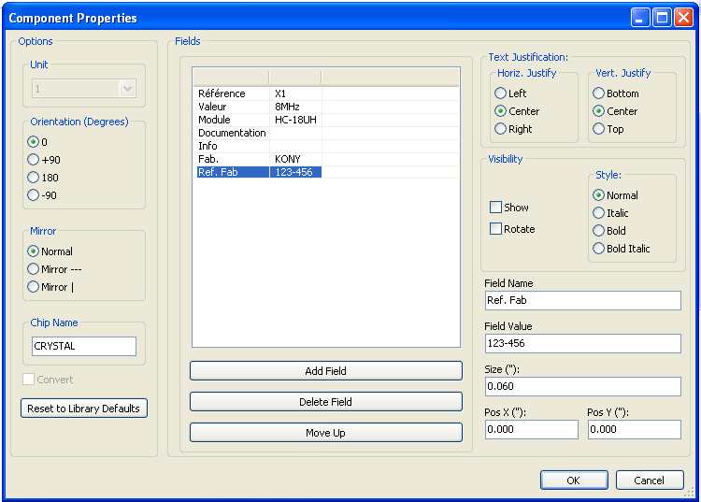
Using the BOM Format Single Part per line only requires the component properties to be edited for one component on the schematic and not all components with that same Value.
However, if there are different parts, both with a Value of 33K, may be one is 1/10 W and another is ¼ W, or may have a different footprint, specify one as 33K and the other as 33KBig and these will be listed as different parts.
The output is in a format than can be imported into a spreadsheet where cost numbers (or optionally even Field4) may be added to derive a board cost and assist with parts procurement.
  - Import tool for footprint assignment:
    - Access:
The icon  gives access to the back-annotate tool.
This tool allows a schematic to be captured, make footprint assignments using Cvpcb's table and browser tools, then export that assignment back to the schematic.
This function reads the .cmp file previously created by Cvpcb and initialize the footprint field (Field 3) of components.
This is not mandatory for Pcbnew, but useful to add the footprint field when creating the Bill of Material and the netlist.
This feature keeps the component footprint/reference information in a single source file, the schematic, which is the source for the netlist and makes the .cmp file redundant.
The footprint assignments will appear in any future netlist export from Eeschema. This is useful when using some netlist formats.
    - Note for Pcbnew
Using the .cmp file or the netlist only to assign a footprint to a component is a choice inside Pcbnew.
When Pcbnew does not find a .cmp file corresponding to the .net file, it uses the component footprint/reference found in the .net file.
However, using the .cmp file is better, because if the designer changes a footprint assignment from Pcbnew, the corresponding .cmp file is also updated.

