Headings:
10 - Plot and Print
10.1 - Overview
10.2 - Plot (HPGL File format)
10.2.1 - General purpose commands
10.2.2 - Sheet size selection
10.2.3 - Offset adjustments
10.3 - Plot (Postscript File format)
10.4 - Print icon.

Plot and Print

Overview
You can access both commands via the file menu:
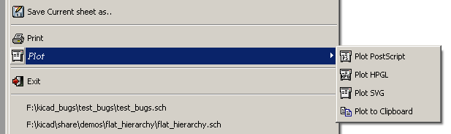
The output formats are POSTSCRIPT,HPGL. or SVG. You can also print directly on your printer.

Plot (HPGL File format)

General purpose commands
This command allows you to create an HPGL file.
In this format you can define:
- Pen number
- Pen thickness (in 0,001 inch).
- Drawing speed (in cm/S).
- Sheet size.
- Print offsets.

Plotter setup dialog box :

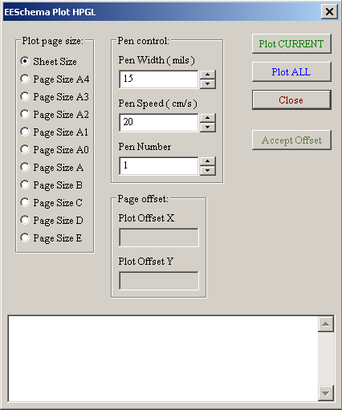

Plot All allows you to plot the whole hierarchy (a file is generated for each sheet).
Plot CURRENT generates a file for the current sheet only. The filename is the sheetname with the extension .plo.

Sheet size selection
Sheet Size is normally checked. In this case, the sheet size defined in the title block menu will be used and the scale is 1.
If another sheet size is selected (A4 with A0, or A with E), the scale is automatically adjusted to fill the page.

Offset adjustments
For all standard dimensions, one can adjust “offsets”, to center the drawing as accurately as possible.
Because plotters have an origin point at the center or at the lower left corner of the sheet, it is necessary to be able to introduce an offset, in order to plot properly.
Generally:
- For plotters having their origin point at the center of the sheet, the offsets must be negative and set at half of the sheet dimension.
- For plotters having their origin point at the lower left corner of the sheet, the offset must be set close to 0.

Set an offset:
- Select sheet size.
- Set OffsetX and OffsetY.
- Click on Accept Offset.

Plot (Postscript File format)
This command allows you to create PostScript files.

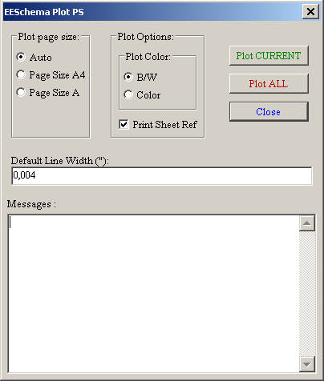

Plot CURRENT generates a file for the current sheet only.
Plot All for the whole hierarchy (a .ps file is generated for each sheet).
The filename is the sheetname with an extension .ps.
You can uncheck the option : Print title block. This is useful if you want to create a postscript file for encapsulation (format .eps) to insert a diagram in a word processing software.
The message window displays the filenames created.

Print icon.
This command , similar to the previous one, allows you to visualize and generate design files on the standard printer under LINUX (with the Postscript format). and under Windows.

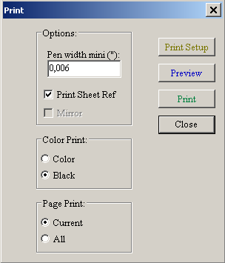
The Page Print option allows you to print :
Print CURRENT creates a file for the current sheet only.
Print All allows you to plot the whole hierarchy (a .ps file is generated for each sheet).

The Color Print options allow you to choose a colour or black and white printing.
In black and white, any colour other than white is printed in black. This option is generally necessary if you uses a black and white laser printer, because colours are printed into not very readable half-tones.

