Headings:
13 - Viewlib
13.1 - Role
13.2 - Main screen
13.3 - Viewlib Toolbar

Viewlib

Role
Viewlib allow you to examine the content of the libraries quickly.
Viewlib is called by the tool

Main screen
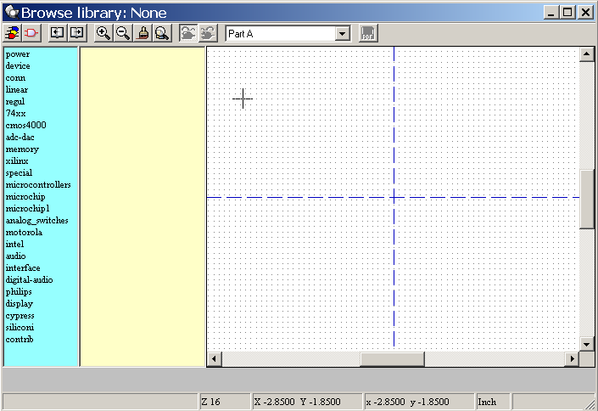
To examine a library, you have to select it in the list displayed to the left.
Its content then appears in the second list which allow you to select a component.
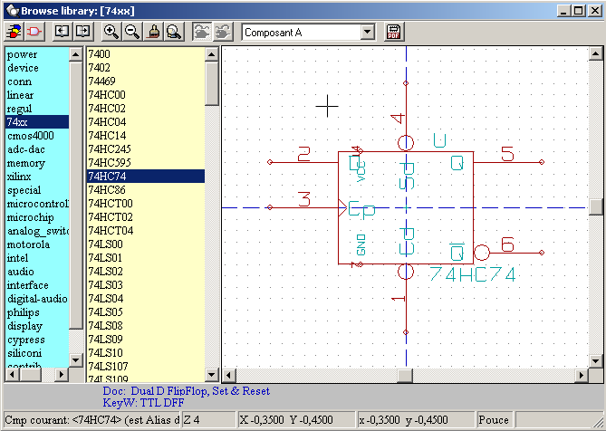

Viewlib Toolbar
or (when called by the place component dialog frame from Eeschema)
The commands are :
Selection of the desired library (which can be also selected in the displayed list).
Selection of the component (which can be also selected in the displayed list).
Display the previous component.
Display the next component.
Zoom management.
Selection of the representation (normal or converted) if exist.
Selection of the part (if multi-part component).
Display the associated documents (if they exist).
Close Viewlib et and place the selected component in Eeschema.

