Headings:
7 - Automatic classification Annotation.
7.1 - Role.
7.2 - Example.

Automatic classification Annotation.

Role.
This (tool ) allows you to automatically assign a designator to the components, and for multiparts components, assign a multipart suffix to minimize the number of these packages.
The menu is:
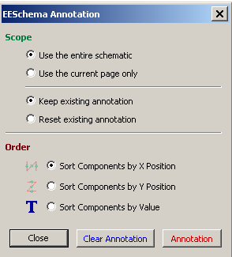
Various possibilities are available :
- Annotate all the components (option all components checked)
- Annotate new components only (i.e. those whose reference finishes by? like IC? ) (new components only option checked).
- Annotate the whole hierarchy (check Project option).
- Annotate the current sheet only (Check Current Sheet).

Except in particular cases, an automatic annotation applies to the whole project (all sheets) and to the new components, if you don't want to modify previous annotations.

Example.

This example shows 5 elements placed, but not annotated.
After annotation :
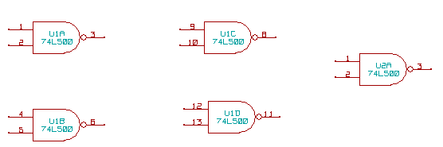
Sort by X position
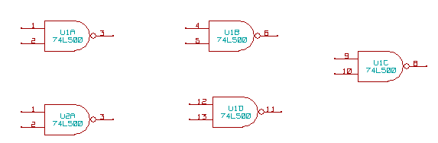
Sort by Y position
You can see that four 74LS00 gates were distributed in U1 package, and that the fifth 74LS00 has been assigned to the next , U2.

