Headings:
5 - The Working layers
5.1 - Layers of copper
5.1.1 - General information:
5.1.2 - Selection of the number of layers:
5.2 - Auxiliary technical layers
5.3 - Selection of the Active Layer:
5.3.1 - Selection using the upper toolbar:
5.3.2 - Selection Using the Pop-Up Window:
5.4 - Selection of the Layers for Vias:

The Working layers
PCBNEW works on 28 different layers:
- 16 layers of copper (or of routing of tracks)
- 12 auxiliary technical layers.

Layers of copper

General information:
They are the usual layers of work, used by the automatic router, on which tracks can be placed. Layer 1 is the copper (solder) layer. Layer 16 is the component layer. The other layers are the internal layers (L2 to L15).

Selection of the number of layers:
To aid navigation between layers, it is necessary to select the number of working layers.
To do this from the menu bar select Preferences – General Options.
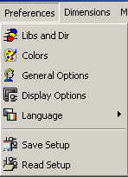
Then enter the required number of layers (1 to 16).
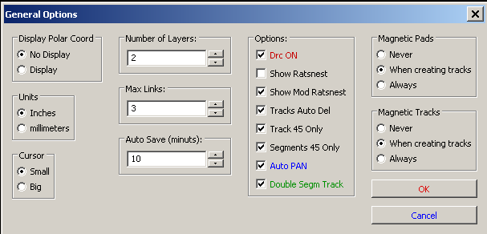

Auxiliary technical layers
Some are associated in pairs, others not. When they appear as a pair this affects the behaviour of modules. The elements making up a module (pads, drawing and text) appearing on a layer (solder or component), appear on the other complementary layer when the module is inverted (mirrored).
The technical layers are:
- The Adhesives layers (Copper and Component):
These are used in the application of adhesive to stick SMD components to the circuit board, generally before wave soldering.
- The Solder Paste layers paste SMD (Copper and Component):
Used to produce a masks to allow solder paste to be placed on the pads of surface mount components, generally before reflow soldering. In theory only surface mount pads occupy these layers.
- The Silk Screen layers (Copper and Component):
They are the layers where the drawings of the components appear.
- The Solder Mask layers (Copper and Component):
These define the solder masks. Normally all the pads appear on one or the other of these layers (or both for through pads) to prevent the varnish covering the pads.
- Layers for general use:
- Comments
- E.C.O. 1
- E.C.O. 2
- Drawings
These layers are for any use. They can be used for text such as instructions for assembly or wiring, or construction drawings, to be used to create a file for assembly or machining.
- Layer Edges PCB: this layer is reserved for the drawing of circuit board outline. Any element (graphic, texts…) placed on this layer appears on all the other layers.

Selection of the Active Layer:
The selection of the active working layer can be done in several ways:
- Using the upper toolbar.
- With the Pop-Up window (activated with the right mouse button).
- Using the + and – keys (works on copper layers only).
- By hot keys.

Selection using the upper toolbar:
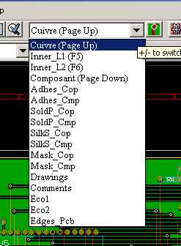
This directly selects the working layer.
Hot keys to select the working layer are displayed.

Selection Using the Pop-Up Window:
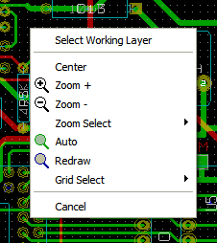
The Pop-up window opens a menu window - which provides choice of the working layer:
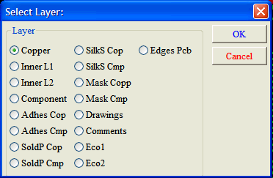

Selection of the Layers for Vias:
If the Add Tracks and Vias icon is selected on the right hand toolbar, the Pop-Up window provides the option to change the layer pair used for vias:
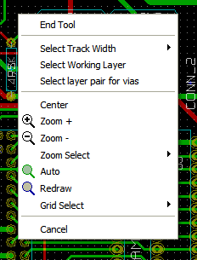
This selection opens a menu window - which provides choice of the layers used for vias.
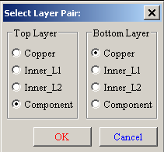
When a via is placed the working (active) layer is automatically switched to the alternate layer of the layer pair used for the vias.
One can also switch to an other active layer by hot keys, and if a track is in progress, a via will be inserted.

