Headings:
2 - General commands.
2.1 - Access to the commands
2.2 - Commands with the MOUSE
2.2.1 - Basic commands
2.2.2 - Operations on blocks
2.3 - Hot keys
2.4 - Selecting the grid size.
2.5 - Selecting ZOOM.
2.6 - Displaying the coordinates of the cursor
2.7 - Menu Bars
2.8 - Upper toolbar
2.9 - Right toolbar icons
2.10 - Left toolbar icons
2.11 - Pop-up menus and fast editing of elements

General commands.

Access to the commands
You can reach the various commands by:
- Clicking on the menu bar (top of screen).
- Clicking on the icons on top of the screen (general commands).
- Clicking on the icons on the right side of the screen (particular commands or “tools”).
- Clicking on the icons on the left side of the screen (Display options).
- Clicking on the mouse buttons (important complementary commands); In particular a right click opens a contextual menu, depending on the element under the cursor (Zoom, grid and edition of the elements).
- Function keys of the keyboard (F1, F2, F3, F4, Insert and space keys).
Particularly :
The “Escape” key often allows the canceling of a command in progress.
The ”Insert” key allows the duplication of the last element created.

Here are the various possible accesses to the commands.
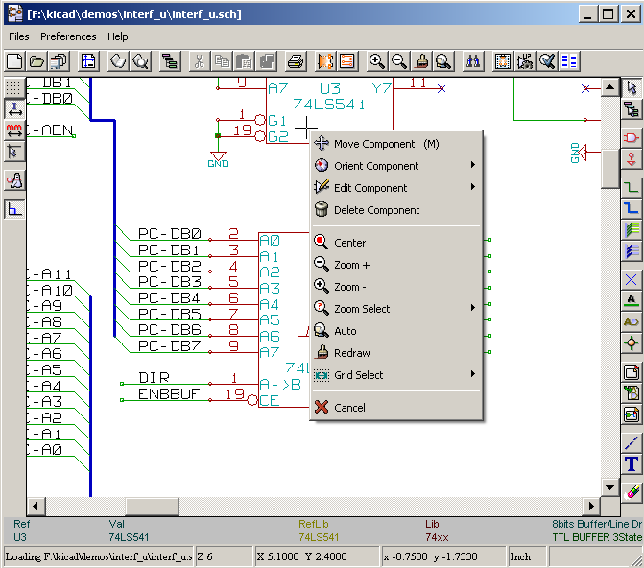

Commands with the MOUSE

Basic commands
Left button :

- Single click : displays the characteristics of the component or text under the cursor.
- Double click: edit (if the element is editable) this component or text.

Right button :

- Opens a pop-up menu.

Operations on blocks
You can move, drag, copy and delete selected areas in all Eeschema menus.
Areas are selected with the left mouse button. The command is completed with the release of the button.
By holding one of the keys “Shift”, “Ctrl”, or the 2 keys “Shift and Ctrl”, during selection this results in the copying, dragging or deletion of the selected area.

Commands summary:

left mouse button | Move selection.
Shift + left mouse button | Copy selection.
Ctrl + left mouse button | Drag selection.
Control + Shift + left mouse button | Delete selection.

The command is executed at button release.
During selection move :
- Click again to place back the elements.
- Click right button to cancel.
If a move bloc command has started, an other command bloc can be slecteted by Pop Up menu (mouse, right button):
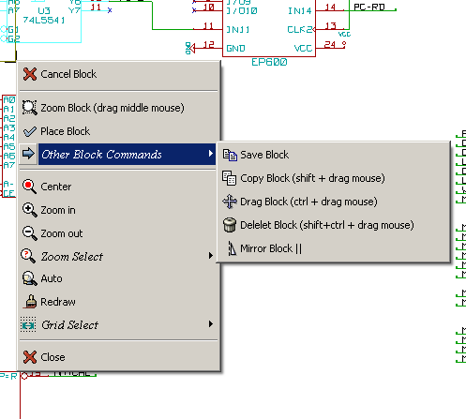

Hot keys
The hot keys are not case sensitive.
- The ? key displays the current hot keys list.
- The Preference menu manage the hot keys

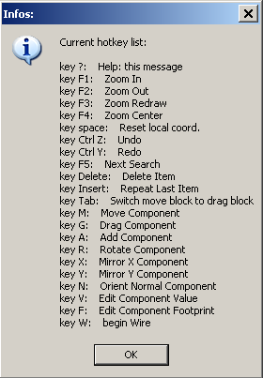 | Here is an example

The hot keys can be programmed by users
To do it:
- Create or recreate the hotkey file:
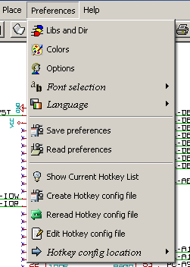
- Edit the file (it is commented).
- In order to use the new hot keys setup, Reread the hotkeys config file (or rerun Eeschema).

Selecting the grid size.
The cursor moves on a grid, which can be displayed or not (this grid is always displayed in the library management menus ).
You can change the grid size via the pop-up menu or the Preferences/Options menu.
The default grid size is 50 mil (0.050 ") or 1,27 millimeters.
One can also work with the average (20 mil) or fine grid(10 mil).
This is not recommended for usual work.
This average or fine grid is especially intended to design or handle components with large numbers of pins (several hundreds).

Selecting ZOOM.
To change “ZOOM”:
- Right click to open the Pop-up menu and select the desired zoom.
- Or use the function keys:
  - F1: Zoom in.
  - F2: Zoom out.
  - F3: Redraw.
  - F4: Center around the cursor
Or simple click on the mouse middle button (without moving the mouse)
- Window Zoom: Mouse drag, with the middle button.
  - Mouse weel: Zoom in / Zoom out
  - SHIFT+Mouse weel: Up/down panning
  - CTRL+Mouse weel: Left/Right panning

Displaying the coordinates of the cursor
The display units are in inches (inch or “) or millimetres.
However, Eeschema always works internally with 1/1000 of an inch.
The following information is displayed at the bottom right hand side of the window :
- The zoom factor.
- The absolute position of the cursor.
- The relative position of the cursor.
- The relative co-ordinates (x, y) can be reset with the space bar.
- The coordinates posted will then relate to this point.

Menu Bars
This menu allows the opening and saving of schematics, the program configuration, and it also contains the help menu.

Upper toolbar
This toolbar gives access to the main functions of EESchema.

Create a new schematic.
Open a schematic.
Save complete schematic (with the whole hierarchy).
Select the sheet size and title block editing.
Call component editor Libedit (Examination, modification, and editing of library components).
Display libraries (Viewlib).
Call the “navigator”, to display the tree structure of the diagram hierarchy (if it contains sub sheets) and the immediate selection of any sheet of the hierarchy.
Remove the selected elements during a move block.
Copy selected elements in the clipboard during a move block.
Copy last selected element or block in the current sheet.
Undo: Cancel the last change (up to 10 levels).
Redo (up to 10 levels).
Open print menu.
Call CVPCB.
Call PCBNEW.
Zoom in and out, around the center of screen.
Redraw of the screen and optimal Zoom.
Call the menu of components localization and texts.
Creation of the netlist (Pcbnew , Spice .... format).
Component annotation.
ERC (Electrical Rules Check) : automatic checking of electrical connections.
Generate the BOM (Bill of materials) and/or hierarchical labels.
Import a stuff file from Cvpcb (fill the footprint field of components)

Right toolbar icons
This toolbar gives access to tools for:
- Component placement, wires and buses, junctions, labels,texts…
- Navigation in the sheets hierarchy.
- Creation of hierarchical subsheets and connection symbols.
- Component deletion.

The detailed use of these tools is described in the chapter “ Diagram Creation/Editing”.
An outline of their use is given below.
Stop the order or tool in progress.
Navigation in the hierarchy: this tool makes it possible to open the subsheet of the displayed schematic (click in the symbol of this subsheet), or to go back up in the hierarchy (click in a free area of the subsheet)
Call the component placement menu.
"Powers" placement menu.
Wire placement.
Bus placement.
Wire to bus connections. These elements have only a decorative role and do not allow connection; thus they should not be used for connections between wires.
Bus to bus connections. They can only connect two buses between themselves.
“No connection” symbols. These are to be placed on component pins which are not to be connected. This is useful in the ERC function to check if pins are intentionally left not connected or are missed.
Local label placement. Two wires may be connected with identical labels in the same sheet. For connections between two different sheets,you have to use global symbols.
Global label placement. This makes it possible to place a connection between a subsheet and the root sheet which contains the subsheet symbol.
Junction placement. To connect two crossing wires, or a wire and a pin, when it can be ambiguous. (i.e. if an end of the wire or pin is not connected to one of the ends of the other wire).
Hierarchical label placement. This makes it possible to place a connection between a sheet and the root sheet which contains this sheet symbol.
Hierarchical subsheet symbol placement (resizable rectangle). You have to specify the file name to save the data of this “subsheet”.
Global label importation from subsheet, in order to create a connection on a subsheet symbol. Global labels are supposed to be already placed in this subsheet.
For this hierarchy symbol, the created connection points are equivalent to a traditional component pin, and must be wired.
Global label creation in subsheets to create connection points. This function is similar to the previous one which does not require already defined global symbols.
Lines for framings… Only decorative, and does not perform a connection.
Placement of comment text. Only decorative.
Delete selected element.
if several superimposed elements are selected, the priority is given to the smallest (in the decreasing priorities : junction, NoConnect, wire, bus, text, component). This also applies to hierarchical sheets. Note: the “Undelete” function of the general toolbar allows you to cancel last deletions.

Left toolbar icons
This toolbar manages the display options :
Grid.
Units.
Cursor.
“Invisible” pins.
And allowed directions of wires and buses.

Pop-up menus and fast editing of elements
A right click opens a pop-up menu whose content depends on the element selected (if there is one).
You have immediate access to:
- Zoom factor.
- Grid adjustment.
- And according to the case, editing of the most usually modified parameters.

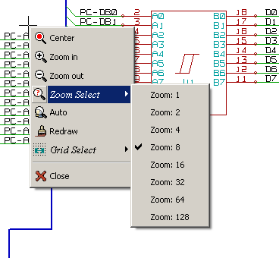 | Pop-up without selected element.
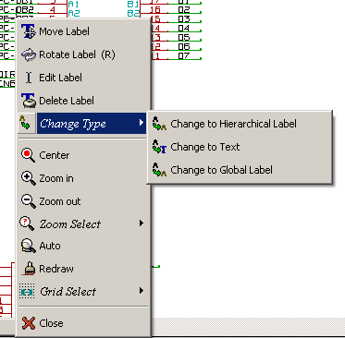 | Editing of a label.
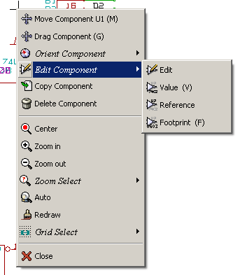 | Editing of a component.

