- Files for circuit fabrication

Table of Contents
10 - Files for circuit fabrication 1
10.1 - Final preparations 1
10.2 - Final DRC test 2
10.3 - Setting coordinates origin 3
10.4 - Generating files for photo-tracing 3
10.4.1 - GERBER format 5
10.4.2 - POSTSCRIPT format 6
10.4.3 - Plot options 6
10.4.4 - Other formats 6
10.5 - Global clearance settings for the solder stop and the solder paste mask 7
10.5.1 - Access: 7
10.5.2 - Solder mask clearance 8
10.5.3 - Solder paste clearance 8
10.6 - Generating drill files 8
10.7 - Generating cabling documentation 9
10.8 - Generation of files for automatic component insertion 9
10.9 - Advanced tracing options 9

Let us see now what are the step necessary for the creations of the necessary files for the production of your printed circuit board.
All files generated by Kicad are placed in the working directory which is the same directory that contains the file xxxxxx.brd for the printed circuit board.
  - Final preparations
The generation of the necessary files for the production of your printed circuit board includes the following preparatory steps.
- Mark any layer (e.g., 'top or front' and 'bottom or back') with the project name by placing appropriate text upon each of the layers.
- All text on copper layers (sometimes called 'solder' or 'bottom') must be mirrored.
- Create any ground planes, modifying traces as required to ensure they are contiguous.
- Place alignment crosshairs and possibly the dimensions of the board outline (these are usually placed on one of the general purpose layers).
Here is an example showing all these elements, except the ground planes, which have been omitted for better visibility.

A color key for the 4 copper layers has also been included:
  - Final DRC test
Before generating the output files, a global DRC test is very strongly recommended.
Note:
Zones are filled or refilled when starting a DRC. Press the button  to launch the following DRC dialog.
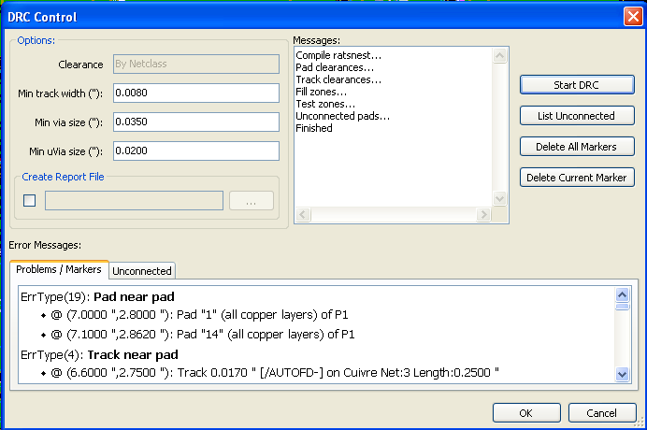
Adjust parameters accordingly and then press .
This final check will prevent any unpleasant surprise.
  - Setting coordinates origin
Set the coordinates origin for the photo plot and drill files, one must place the auxiliary axis on this origin. Activate the icon . Move the auxiliary axis to the chosen location by clicking for instance on this location.
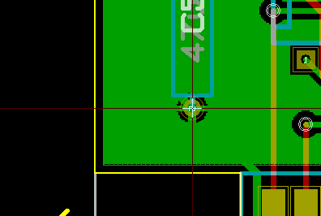
  - Generating files for photo-tracing
This is done via the Files/Plot menu option.
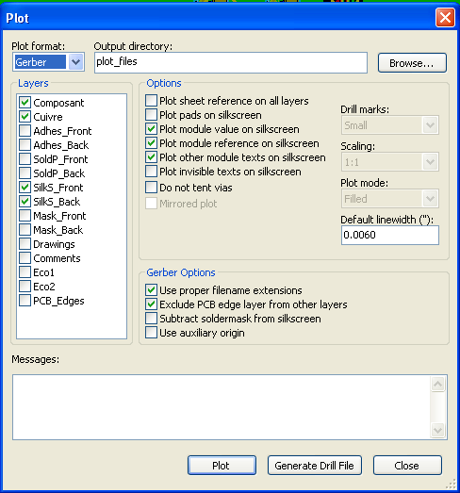
Usually, the files are in the GERBER format. Nevertheless, it is possible to produce output in both HPGL and POSTSCRIPT formats. When Postscript format is selected, this dialog will appear.
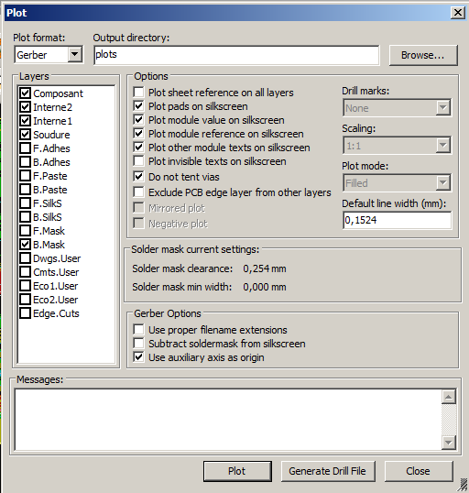

In these formats, a fine scale adjust can be used to compensate for the plotter accuracy and to have a true scale 1 for the output:
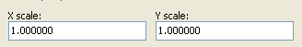
    - GERBER format
For each layer, Pcbnew generates a separate file following the GERBER 274X standard, by default in 3.4 format (each coordinate in the file is represented by 7 digits, of which 3 are before the decimal point and 4 follow it; the units are inches). The tracing is always drawn to scale 1)
It is normally necessary to create files for all of the copper layers and, depending on the type of circuit, for the solder stop, solder mask, and silkscreen (component markings) layers. All of these files can be produced in one go, by selecting the appropriate check boxes.
For example, for a double-sided circuit with solder stop, silkscreen and solder mask (for CMS components), 8 files should be generated ('xxxx' represents the name of the .brd file).
- xxxx.copper.pho for the copper side.
- xxxx.cmp.pho for the component side.
- xxxx.silkscmp.pho for the component-side silkscreen markings.
- xxxx.silkscu.pho for the copper-side silkscreen markings.
- xxxx.soldpcmp.pho for the component-side solder mask.
- xxxx.soldpcu.pho for the copper-side solder mask.
- xxxx.maskcmp.pho for the component-side solder stop mask.
- xxxx.maskcu.pho for the copper-side solder stop mask.
GERBER files format:
The format used by Pcbnew is RS274X format 3.4, Imperial, Leading zero omitted, Abs format. This is very usual settings.
    - POSTSCRIPT format
The standard extension for the output files is .ps in the case of postscript output.
As for HPGL output, the tracing can be at user-selected scales and can be mirrored.
If the Org = Centre option is active, the origin for the coordinates of the tracing table is assumed to be in the centre of the drawing.
If the Print Sheet Ref option is active, the sheet cartridge is traced.
    - Plot options

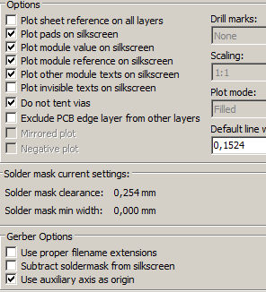 | 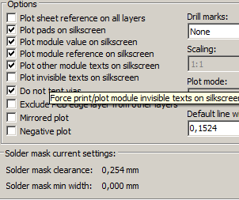
Gerber format | other formats (SVG here)

GERBER format specific options:
Use Proper Gerber Extensions | use .gbl .gtl instead of .pho for file name extensions.
Exclude Pcb Edge Layer | Do no draw items on Edge layer onto other layers
Subtract Mask from Silk | Remove all Silk from solder paste areas.

    - Other formats
The standard extension depends on the output file type.
Some options can be not available for some formats.
The plot can be done at user-selected scales and can be mirrored.
The Print Drill Opt list offers the option of pads that are filled, drilled to the correct diameter or drilled with a small hole (to guide hand drilling).
If the Print Sheet Ref option is active, the sheet cartridge is traced.
  - Global clearance settings for the solder stop and the solder paste mask
Masks clearances values can be set globally for the solder mask layers and the solder paste layers. These clearances can be set following these steps.
- At pads level.
- At footprint level.
- Or globally.
And Pcbnew uses by priority order.
- Pad values. If null:
- Footprint values. If null:
- Global values.
    - Access:
The menu option for this is available via the Dimensions menu.
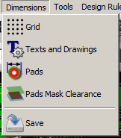
The dialog box is the following.
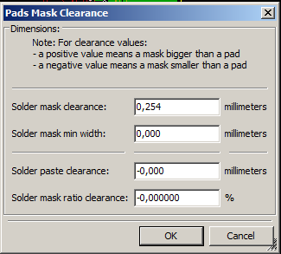
    - Solder mask clearance
A value near to 0.2 mm is usually good. This value is positive because the mask usually is bigger than the pad.
One can set a minimum value for the solder masque width, between 2 pads.
If the actual value is smaller than the minimum value, the 2 solder mask shpaes will be merged.
    - Solder paste clearance
The final clearance is the sum of the solder paste clearance and a percentage of the pad size.
This value is negative because the mask usually is smaller than the pad.
  - Generating drill files
The creation of a drill file xxxxxx.drl following the EXCELLON standard is always necessary.
One can also produce an optional drill report, and an optional drill map.
- The drill map can be plotted using several formats
- The drill report is a plain text file).
The generation of these files is controlled via:
- the button.
- or the Files/Fabrication Outputs/Drill file menu selection.

The Drill tools dialog box will be the following.
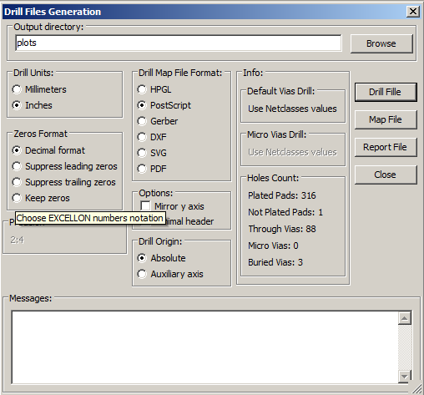
For setting the coordinate origin, the following dialog box is used.
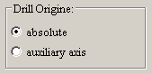
- Absolute: absolute coordinate system is used.
- Auxiliary axis: coordinates are relative to the auxiliary axis (use the icon (right toolbar) to set it.
  - Generating cabling documentation
To produce cabling documentation files, the component and copper silkscreen layers can be traced. Usually, just the component-side silkscreen markings are sufficient for cabling a PCB. If the copper-side silkscreen is used, the text it contains should be mirrored in order to be readable.
  - Generation of files for automatic component insertion
This option is accessed via the Postprocess/Create Cmp file menu option. However, no file will be generated unless at least one module has the Normal+Insert attribute activated (see Editing Modules). One or two files will be produced, depending upon whether insertable components are present on one or both sides of the PCB. A dialogue box will display the names of the file(s) created.
  - Advanced tracing options
The options described below (part of the Files/Plot dialogue) allow for fine-grained control of the tracing process. They are particularly useful when printing the silkscreen markings for cabling documentation.
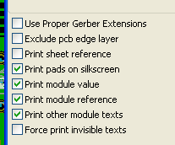
The available options are:
Use Proper Gerber Extensions | GERBER format specific.  When creating files, use specific extensions foe each file.  If disabled the Gerber file extension is .pho
Exclude pcb edge layer | GERBER format specific.  Do not plot graphic items on edge layer.

Print Sheet Ref | Trace sheet outline and the cartridge.
Print Pads on Silkscreen | Enables/disables printing of pad outlines on the silkscreen layers (if the pads have already been declared to appear on these layers). In fact useful for preventing any pads from being printed, in the disabled mode.
Print Module Value | Enables printing of VALUE text on the silkscreen.
Print Module Reference | Enables printing of the REFERENCE text on the silkscreen.
Print other module texts | Enables the printing of other text fields on the silkscreen.
Force Print Invisible Texts | Forces printing of fields (reference, value) declared as invisible. In combination with Print Module Reference and Print Module Value, this option enables production of documents for guiding cabling and repair. These options have proven necessary for circuits using components that are too small (CMS) to allow readable placement of two separate text fields.

