Setting the routing parameters
Headings:
8 - Setting the routing parameters
8.1 - Current settings:
8.1.1 - Access to main dialog:
8.1.2 - Current settings:
8.2 - General Options.
8.3 - Netclasses:
8.3.1 - Setting routing parameters
8.3.2 - Netclass editor:
8.3.3 - Global Design Rules.
8.3.4 - Via Parameters.
8.3.5 - Track Parameters.
8.3.6 - Specific sizes:
8.4 - Examples and typical dimensions
8.4.1 - Track width
8.4.2 - Insulation (clearance)
8.4.3 - Examples:
8.4.3.1 - 'Rustic'
8.4.3.2 - 'Standard'
8.5 - Manual routing
8.5.1 - Help when creating tracks:
8.5.2 - Creating tracks:
8.5.3 - Moving and dragging tracks
8.5.4 - Via Insertion
8.6 - Select/edit the track width and via size
8.6.1 - Using the horizontal toolbar:
8.6.2 - Using the pop-up menu:
8.7 - Track edition and correction:
8.7.1 - Change a track:
8.8 - Global Changes:

Current settings:

Access to main dialog:
Most important parameters are accessed from:
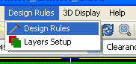
and are set in the Design Rules dialog.

Current settings:
Current settings are displayed on the toolbar:

General Options.
General options are acceded from:
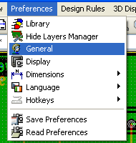
The opened dialog is:
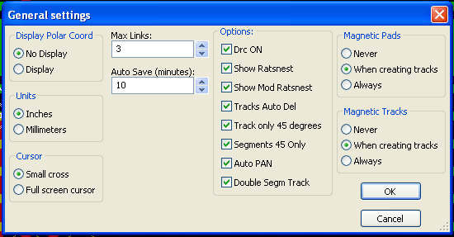
For tracks creation, parameters are:
- Tracks 45 Only: Directions allowed for track segments are 0, 45 or 90 degrees
- Double Segm Track: When creating tracks, 2 segments will be displayed.
- Tracks Auto Del: When recreating tracks, the old one will be automatically delete if it is redundant.
- Magnetic Pads: The graphic cursor goes to pad, center when entering the pad area.
- Magnetic Tracks: The graphic cursor goes to track axis.

Netclasses:
Pcbnew allows you to define routing parameters foe each net.
In fact, parameters are defined for a group of nets.
- A group of nets is called a Netclass.
- There is always a netclass called default.
- Users can add some others Netclasses.
A netclass specify:
- The width of tracks and via diameters and drills.
- The clearance between pads and tracks (or vias)

When routing, Pcbnew selects automatically the netclass corresponding to the net of the track to create or edit, and therefore the routing parameters.

Setting routing parameters
The choice is made in the menu: Design Rules ->Design Rules .

Netclass editor:
The Netclass editor allows you :
- To add or delete Netclasses.
- To set routing parameters values : Clearance, track witdth, via sizes
- To group nets in netclasses.

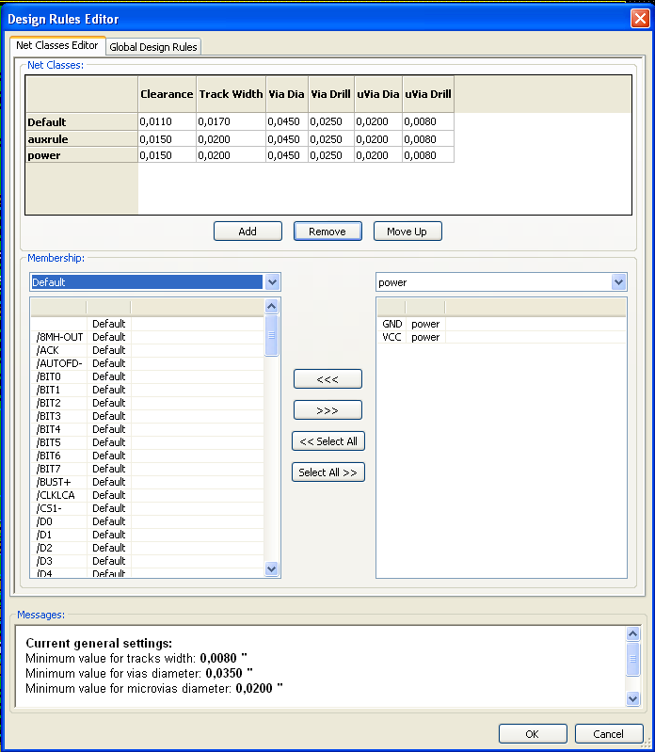

Global Design Rules.
They are:
- Via type
- Enabling/disabling micro-via use.
- Minimum clearance (minimum distance between tracks, vias and pads).
- Minimum tracks and vias sizes.

A DRC error is set when a value less than a minimum value specified her is encountered

The second dialog panel is:
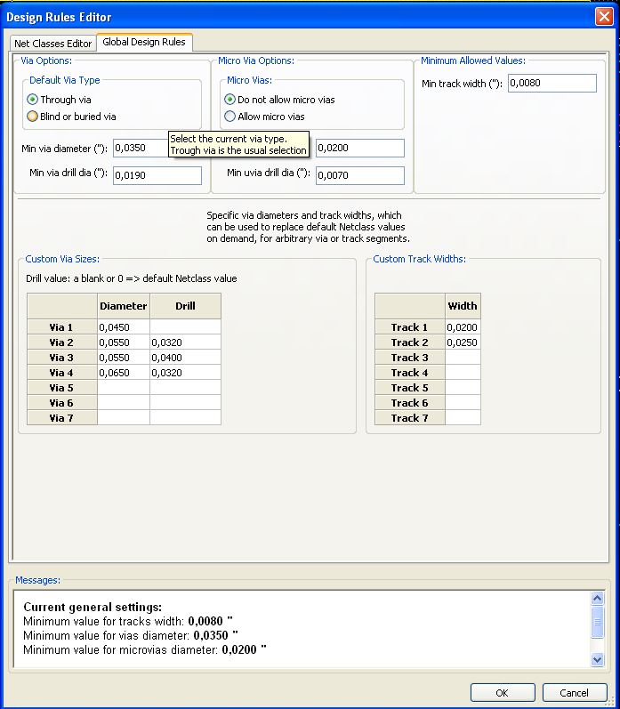
This dialog also allows to enter a “stock” of tracks and vias sizes.
When routing, one can select one of these values to create a track of via, instead of using the default netclasses values ones.
Useful in critical cases when a small track segment must have a specific size.

Via Parameters.
Pcbnew handles 3 types of vias:
- The through via (usual vias).
- Blind or buried vias,.
- Micro Vias, like buried vias but restricted to an external layer to its nearest neighbor.
They are intended to connect BGA to the nearest inner layer. the diameter is usually very small and they are drilled by laser.
By default, all vias have the same drill value.
This dialog specify the smallest acceptable values for vias parameters.
On board, a via smaller than specified here generates a DRC error.

Track Parameters.
Specify the minimum acceptable track width.
On board, a track width smaller than specified here generates a DRC error.

Specific sizes:
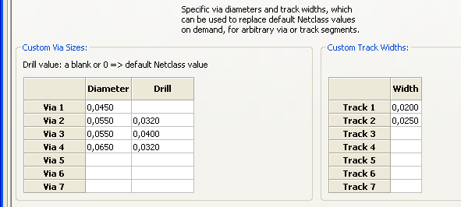
One can enter a stock of extra tracks and/or vias sizes.
While routing a track, these values can be used on demand instead of the values from the current netclass values.

Examples and typical dimensions

Track width
Use the largest possible value and conform to the minimum sizes given here:
Units | CLASS 1 | CLASS 2 | CLASS 3 | CLASS 4 | CLASS 5
mm | 0,8 | 0,5 | 0,4 | 0,25 | 0,15
mils | 31 | 20 | 16 | 10 | 6

Insulation (clearance)
Unité | CLASS 1 | CLASS 2 | CLASSE3 | CLASS 4 | CLASS 5
mm | 0,70 | 0,5 | 0,35 | 0,23 | 0,15
mils | 27 | 20 | 14 | 9 | 6
Usually, the minimum clearance is very similar to the minimum track width.

Examples:

'Rustic'
- Clearance: 0.35mm (0.0138 inches).
- Track width: 0.8mm (0.0315 inches).
- Pad diameter for ICs and vias: 1.91mm (0.0750 inches ).
- Pad diameter for discrete components: 2.54mm (0.1 inches).
- Ground track width: 2.54mm (0.1 inches).

'Standard'
- Clearance: 0.35mm (0.0138 inches).
- Track width: 0.5mm (0.0127 inches).
- Pad diameter for ICs: make them elongated in order to allow tracks to pass between IC pads and yet have the pads offer a sufficient adhesive surface (1.27 x 2.54 mm -->0.05x 0.1 inches).
- Vias : 1.27mm (0.0500 inches).

Manual routing
Manual routing is recommended, because it is the only method offering control of routing priorities. For example, is is preferable to start by routing power tracks, making them wide and short and keeping analog and digital supplies well separated. Then sensitive signal tracks should be routed. Amongst other problems, automatic routing often requires many vias. However, automatic routing can offer useful insight into the positioning of modules. With experience, you will probably find that the automatic router is useful for quickly routing the 'obvious' tracks, but the remaining tracks will best be routed by hand.

Help when creating tracks:
Pcbnew can display the full ratsnest, if the toll is activated.
The tool allows to highlight a net (click to a pad or an existing track to highlight the corresponding net net).
The DRC checks in real time tracks when creating them. One cannot create a track which does not match the DRC rules.
It is possible to disable DRC by activate , but it is very dangerous. Use it only in specific cases.

Creating tracks:
Access by
A new track must starts on a pad or on an other track, because Pcbnew must knows the net used for the new track (in order to match the DRC rules).
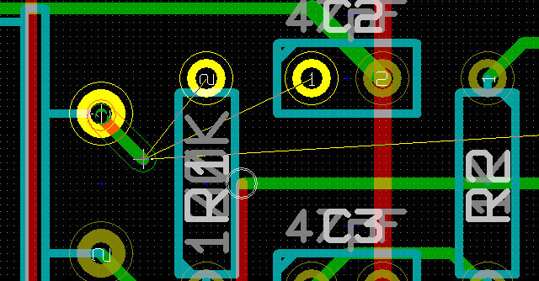
When creating a new track, Pcbnew shows links to nearest not connected pads (link number set in option "Max. Links" in General Options.
Finish the track by a double click, or by the Pop-up menu or by the hot key:
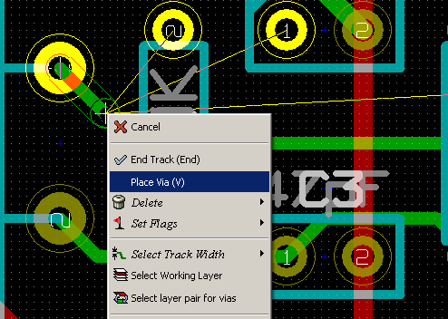

Moving and dragging tracks
When the tool is active, the track where the cursor is pointed to can be moved with the hotkey 'm'. If you want to drag the track you use the hotkey 'g'.

Via Insertion
A via can be inserted only when a track is in progress:
- By the Pop-up menu
- By the hot key (here: 'V').
- By switching to a new copper layer using the suitable hotkey.

Select/edit the track width and via size
When clicking on a track or a pad, Pcbnew automatically selects the corresponding Netclass, and the track size and vias dimensions from this netclass.
As previously seen, the Global Design Rules editor has a tool to enter extra tracks and vias sizes.
- The horizontal toolbar can be used to select a size.
- When the tool is active, the current track width can be selected from the Pop-up menu (accessible also when creating a track)
Therefore, the user can use the default Netclasses values, or, when needed, a specified value.

Using the horizontal toolbar:

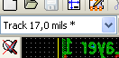 | Track width selection.  The symbol * is a mark for default Netclass value selection
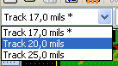 | Selecting a specific track width value.  The first value in list is always the netclass value.  Others values are tracks widths entered from the Global Design Rules editor.
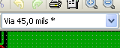 | Via size selection.  The symbol * is a mark for default Netclass value selection
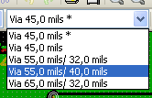 | Selecting a specific via dimension value.  The first value in list is always the netclass value.  Others values are vias dimensions entered from the Global Design Rules editor.
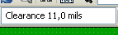 | Display the current clearance value.  This this the clearance value set in the current selected Netclass.
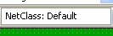 | Current selected Netclass.  When clicking on a track or a pad, Pcbnew automatically selects the corresponding Netclass, and displays its name here.
When enabled: Automatic track width selection:
When starting a track on an existing track, the new track has the same width as the existing track.

Using the pop-up menu:
One can select a new size for routing, or to change a previously created via or track segment.
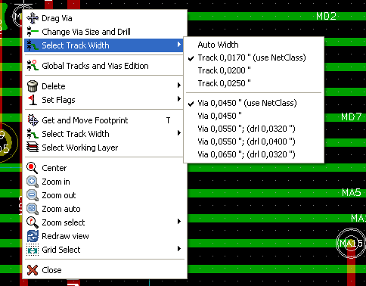
If you want to change many vias (or tracks) size, the best solution is to use a specific Netclass to for the net(s) that must be edited (see global changes).

Track edition and correction:

Change a track:
In many cases redraw a track is enough:
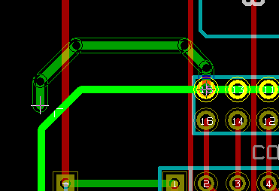 new track (in progress).
When finished:
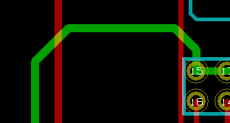
Pcbnew remove automatically the old track if it is redundant.

Global Changes:
Access to the global tracks and vias sizes dialog editor is by right clicking on a track to show the Popup menu
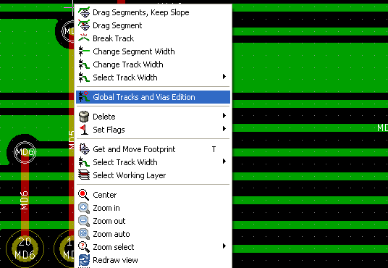
The dialog editor allows a global change of tracks and/or vias for:
- The current net.
- The whole board.

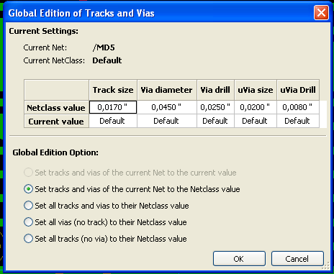
I

