- ModView

Table of Contents
13 - ModView 1
13.1 - Purpose: 1
13.1.1 - Lauching ModView : 1
13.2 - Main screen: 2
13.3 - ModView toolbar: 2
13.3.1 - Toolbar : 2
13.3.2 - Commands : 2

  - Purpose:
ModView allows you to browse footprint libraries.
When ModView is launched by the footprint placement menu, it allows the selection of a footprint and loading it in the footprint editor (ModEdit) or in the board editor.
    - Lauching ModView :
ModView is launched by the tool 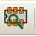,
or by the footprint loading dialog
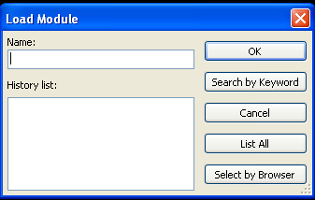
  - Main screen:
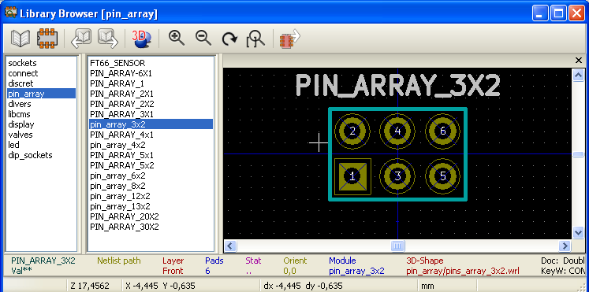
To browse a library, select it in the library list on the left side.
Its content is shown in the footprint list which can be used to select the footprint to display.

  - ModView toolbar:
    - Toolbar :
When ModView is launched by :


or launched by the footprint loading dialog :
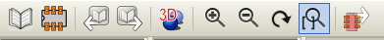

    - Commands :
 | Select the active library (It can also be selected by the library list to the left side of the screen).
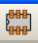 | Selection the footprint (It can also be selected by the footprint list to the left side of the screen).
 | Select the previous footprint in list.
 | Select the next footprint in list.
 | Zoom.choice
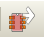 | Displayed only when ModView was launched by the footprint loading dialog.  Close ModView and load the selected footprint in ModEdit or the board editor.

