- Creating copper zones

Table of Contents
9 - Creating copper zones 1
9.1 - Creating zones on copper layers 1
9.2 - Creating a zone 2
9.2.1 - Creating the limits of a zone 2
9.2.2 - Filling the zone 3
9.3 - Filling options 6
9.3.1 - Filling mode 6
9.3.2 - Clearance and minimum copper thickness 6
9.3.3 - Pad options 6
9.3.4 - Thermal reliefs parameters 7
9.3.5 - Parameters choice 8
9.4 - Adding a cutout area inside a zone 8
9.5 - Outlines editing 9
9.6 - Editing zone: parameters 11
9.6.1 - Final zone filling 11
9.6.2 - Change zones net names 11
9.7 - Creating zones on technical layers 12
9.7.1 - Creating zone limits 12

Copper zones are defined by an outline (closed polygon), and can include holes (closed polygons inside the outline). A zone can be drawn on a copper layer or alternatively on a technical layer.
  - Creating zones on copper layers
Pad (and tracks) connections by filled copper areas are checked by the DRC engine. A zone must be filled (not just created) to connect pads. Pcbnew uses currently track segments or polygons to fill copper areas.
Each option has its advantages and its disadvantages, mainly when redraw screen. The final result is however the same.
For calculation time reasons, the zone filling is not remade after each change, but only:
- If a filling zone command is executed.
- When a DRC test is made.
Copper zones must be filled or refilled after changes in tracks or pads. Copper zones (Usually ground and power planes) are usually attached to a net.
In order to create a copper zone you should:
- Select parameters (net name, layer …). To switch on the layer and highlight this net is not mandatory but is a good practice.
- Create the zone limit (If not, all the board will be filled.).
- Fill the zone.
Pcbnew tries to fill all zones in one piece, and usually, there will be no unconnected copper blocks. So it can happens that some areas remain not filled. Zones having no net are not cleaned and can have insulated areas.
  - Creating a zone
    - Creating the limits of a zone
Use the tool 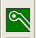. The active layer must be a copper layer. When clicking to start the zone outline, the following dialog box will be opened.
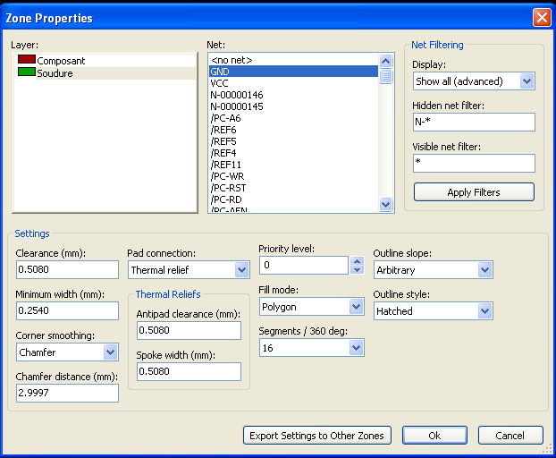
You can specify all parameters for this zone:
- net
- layer
- filling options
- pad options
- Priority level
- …
Draw the zone limit, on this layer. This zone limit is a polygon, created by a left clicking at each corner. A double click will end the polygon.
The polygon will be automatically closed. If the starting point and the ending point are not at the same coordinate, Pcbnew will add a segment from the end point to the start point.
Remarks:
- The DRC control is active when creating zone outlines.
- A corner which creates a DRC error will not be accepted by Pcbnew.
Here=follow you can see and example of a zone limit (polygon in thin hatched line)
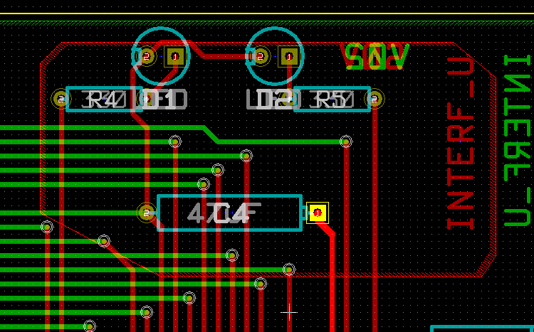

    - Priority level:
Sometimes a small zone must be created inside a large zone.
This is possible if the small zone has a highter priority level than the large zone.
Level setting : 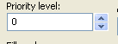

Here is an example :
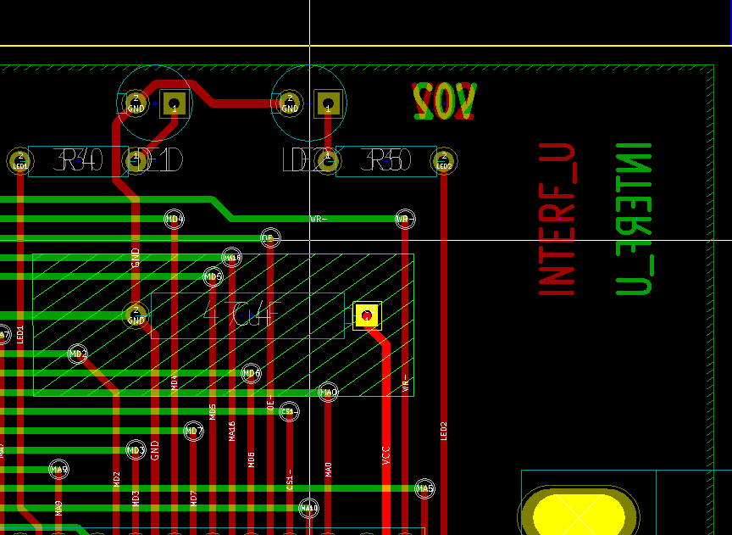
Priority level 0
Priority level 5

After filling:
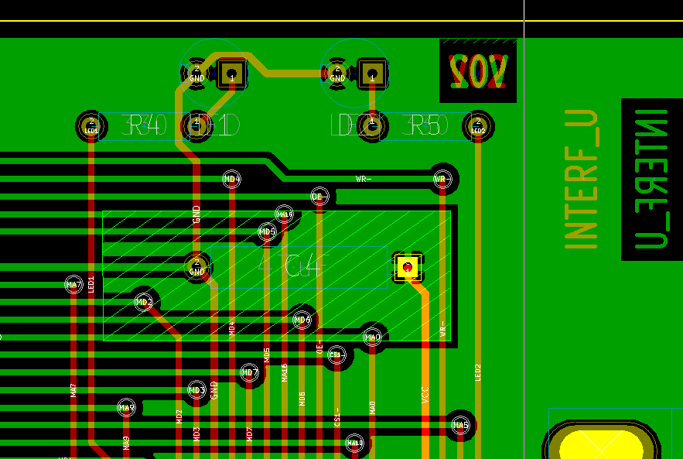
    - Filling the zone
When filling a zone, Pcbnew remove all not connected copper islands. To access the zone filling command, right click on the edge zone.
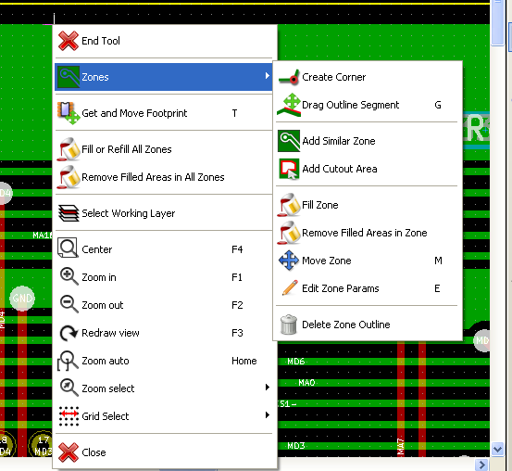
Activate the "Fill Zone" command. Here-follow is the filling result for a starting point inside the polygon.
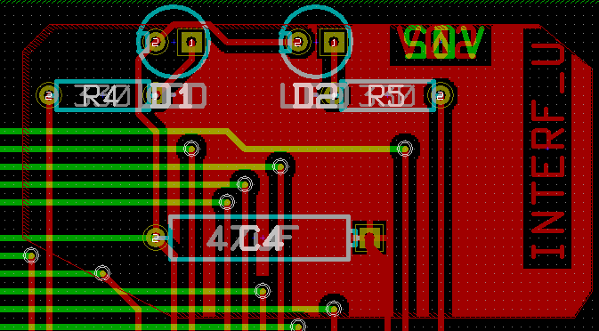
The polygon is the border of the filling area. You can see a non-filled area inside the zone, because this area is not accessible:
- A track creates a border and
- There is no starting point for filling in this area.
Note:
you can use many polygons to create cutout areas. Here-follow you can see an example.
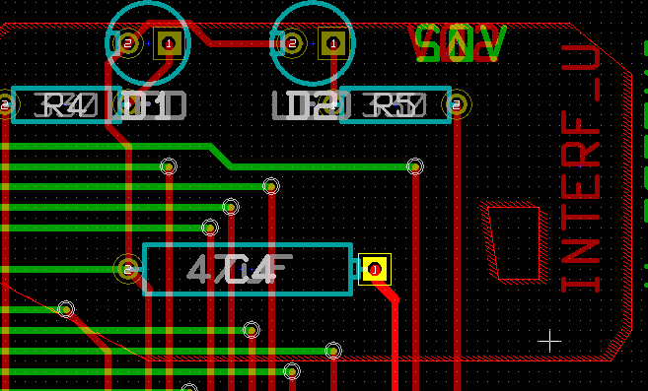
And here is the result.
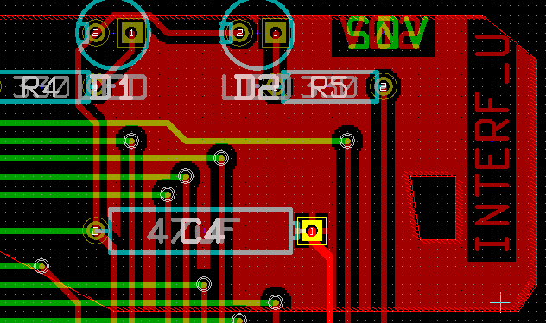
  - Filling options
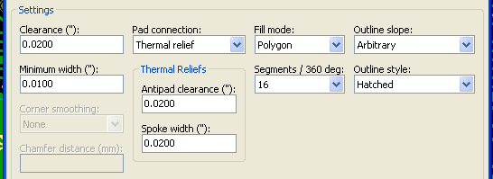
When you fill and area, you must choose:
- The mode for filling.
- The clearance and minimum copper thickness.
- How pads are drawn inside the zone (or connected to this zone).
- Thermal reliefs parameters.
    - Filling mode
Zones can be filled using polygons or segments. The result is the same. If you have problems with polygon mode (slow screen refresh) you should use segments.
    - Clearance and minimum copper thickness
A good choice for clearance is a grid that is a bit bigger than the routing grid. Minimum copper thickness value ensures that there are no too small copper ares.
Warning: if this value is too large, small shapes like thermal stubs in thermal reliefs cannot be drawn.
    - Pad options
Pads of the net can either be included or excluded from the zone, or connected by thermal reliefs.
- If included, soldering and un-soldering can be very difficult.
- If excluded, the connection to the zone will not be very good.
- A thermal relief is a good compromise.
Here is the result for the 3 options.

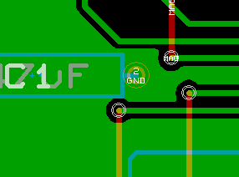 | Include Pads
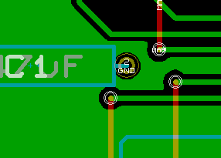 | Exclude Pads  Note:  - The zone can be filled only if tracks exists to connect zones areas.  - Pads must be connected by tracks.
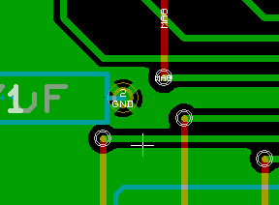 | Thermal relief.  Pad is connected by 4 track segments.  The segment width is the current value used for the track width.

    - Thermal reliefs parameters
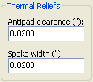
You can set two parameters for thermal reliefs.
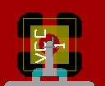
Copper width
AntiPad Size
    - Parameters choice
The copper width value for thermal reliefs must be bigger than the minimum thickness value for copper zone. If not, they cannot be drawn.
Additionally, a too large value for this parameter or for antipad size does not allow to create a thermal relief for small pads ( like pads sizes used for SMD components).
  - Adding a cutout area inside a zone
A zone must already exist. To add a cutout area (a non filled area inside the zone):
- Right click on an existing edge outline.
- Select Add Cutout Area.
- Creates the new outline.
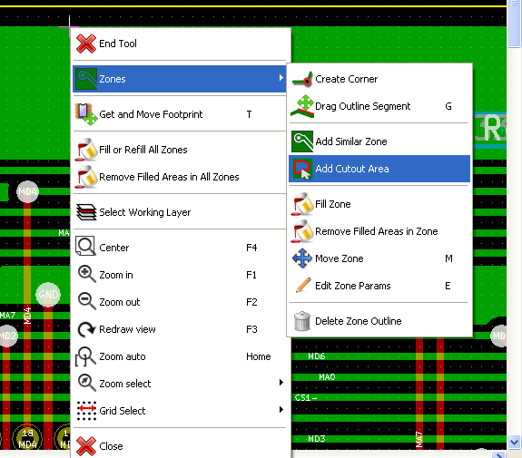

After creating the outline.
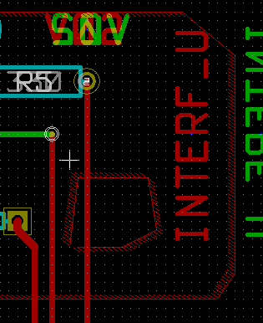 | See the cutout outline.

  - Outlines editing
An outline can be modified by:
- Moving a corner or an edge.
- Deleting or adding a corner.
- Adding a similar zone, or a cutout area.
If polygons are overlapping they will be combined.
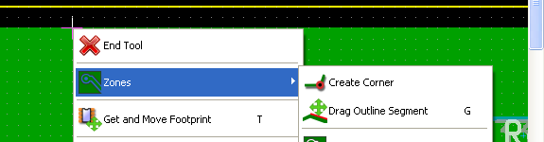
To do that, right click on a corner or on an edge, en select the proper command.
Here is a corner (from a cutout) that has been moved.
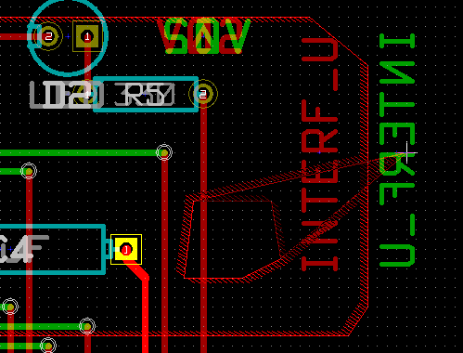
Here is the final result:
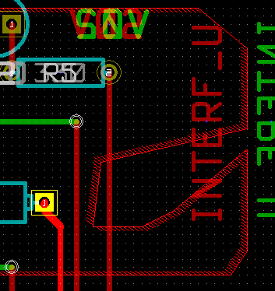
Polygons are combined. Adding a similar zone:
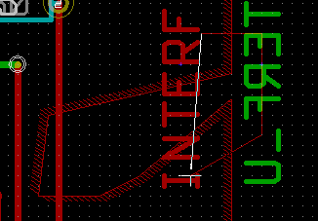 | Adding the zone
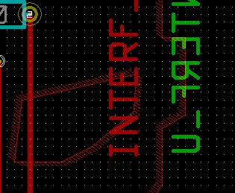 | Final result

  - Editing zone: parameters
When right clicking on an outline, and using 'Edit Zone Params' the Zone params Dialog box will open. Initial parameters can be imputed . If the zone is already filled, refilling it will be necessary.
    - Final zone filling
When the board is finished, one must fill or refill all zones. To do that:
- Activate the tool zones via the button .
- Right click to display the pop-up menu.
- Use Fill or Refill All Zones 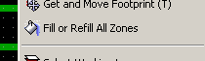
Warning, calculations can take some time, if the filling grid is small.
    - Change zones net names
After editing a schematic, you can change the name of any net. For instance VCC can be changed to +5V.
When a global DRC control is made Pcbnew checks if the zone net name exists, and displays an error if not.
A "by hand" parameter zone edition will be necessary to change the old name to the new one.
  - Creating zones on technical layers
    - Creating zone limits
This is done using the button . The active layer must be a technical layer.
When clicking to start the zone outline, this dialog box is opened.
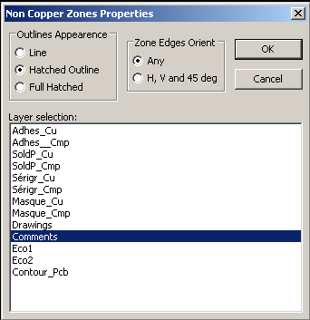
Select the technical layer to place the zone and draw the zone outline like explained previously for copper layers.
Notes:
- For editing outlines use the same way as for copper zones.
- In necessary, cutout areas can be added.

