- General operations

Table of Contents
3 - General operations 1
3.1 - Toolbars and commands 1
3.2 - Mouse commands 2
3.2.1 - Basic commands 2
3.2.2 - Operations on blocks 2
3.3 - Selection of grid size 3
3.4 - Adjustment of the zoom level 3
3.5 - Displaying cursor coordinates 3
3.6 - Keyboard commands - hot keys 3
3.7 - Operation on blocks 4
3.8 - Units used in dialogs 4
3.9 - Top menu bar 5
3.9.1 - The File menu 5
3.9.2 - The Preferences menu 6
3.9.3 - Other preferences and dimensions 6
3.9.4 - The Design Rules menu 7
3.9.5 - The Display 3D model menu 7
3.9.6 - The Help menu 7
3.10 - Using icons on the top toolbar 7
3.11 - Right hand-side toolbar 9
3.12 - Left hand-side toolbar 11
3.13 - Pop-up windows and fast editing 12
3.13.1 - Available modes 12
3.13.2 - Normal mode 13
3.13.3 - Footprint mode 14
3.13.4 - Tracks mode 14

  - Toolbars and commands
In Pcbnew it is possible to executes command via various means:
- text-based menu at the top of the main window.
- top toolbar menu.
- right toolbar menu.
- left toolbar menu.
- mouse buttons (menu options). Specifically:
  - The right-hand mouse button reveals a Pop up menu the content of which depends on the element under the mouse arrow.
- keyboard (Function keys F1, F2, F3, F4, Shift, Delete, +, - Page Up, Page Down and “space” bar). The “Escape” key generally cancels an operation in progress.
The screen-shot below illustrates some of the possible accesses to the operations:
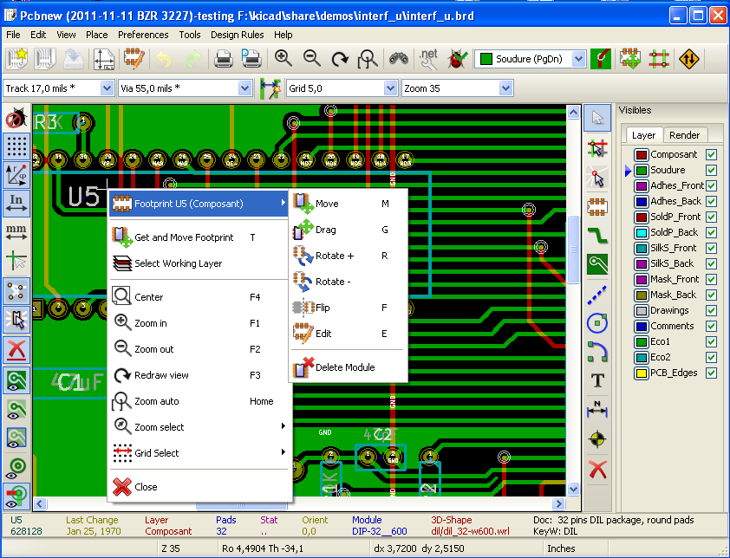
  - Mouse commands
    - Basic commands
- Left button
  - Single click displays the characteristics of the module or text under the cursor to the lower status bar.
  - Double click displays the editor (if the element is editable) of the element under the cursor.
- Centre button/wheel
  - Rapid zoom and some commands in layer manager. A 2 button mouse is undesirable.
Hold down the centre button and draw a rectangle to zoom to the described area.
The rotation of the mouse wheel will allow you to zoom in and zoom out.
- Right button
  - Displays a pop-up menu
    - Operations on blocks
Operations to move, invert (mirror), copy, rotate and delete a block are all available via the pop-up menu. In addition the view can zoom to the area described by the block.
The framework of the block is traced by moving the mouse whilst holding down the left mouse button. The operation is executed when the button is released.
By holding down one of the hotkeys “Shift” or “Ctrl”, or both keys “Shflt and Ctrl” together, whilst the block is drawn the operation invert, rotate or delete is automatically selected as shown in the table below:
Summarised orders:
Left mouse button held down | Trace framework to move block
Shift + Left mouse button held down | Trace framework for invert block
Ctrl + Left mouse button held down | Trace framework for rotating block 90°
Shft+Ctrl + Left mouse button held down | Trace framework to delete the block
Centre mouse button held down | Trace framework to zoom to block

When moving a block:
- Move block to new position and operate left mouse button to place the elements.
- To cancel the operation use the right mouse button and select Cancel Block from the menu (or press the Esc key).
Alternatively if no key is pressed when drawing the block use the right mouse button to display the pop-up menu and select the required operation.
For each block operation a selection window enables the action to be limited to only some elements.
  - Selection of grid size
During elements layout the cursor moves on a grid. The grid can be turned on or off using the icon on the left toolbar.
Any of the pre-defined grid sizes, or a User Defined grid, can be chosen using the pop-up window, or the drop-down selector on the toolbar at the top of the screen. The size of the User Defined grid is set using the menu bar option Dimensions - User Grid Size.
  - Adjustment of the zoom level
To change the zoom level:
- Open the pop-up window (using the right mouse button) and to select the desired zoom.
- Or use the function keys:
F1: Enlarge (zoom in)
F2: Reduce (zoom out)
F3: Redraw the display
F4: Centre view at the current cursor position
- Or rotate the mouse wheel.
- Or hold down the middle mouse button and draw a rectangle to zoom to the described area.
  - Displaying cursor coordinates
The cursor coordinates are displayed in inches or millimetres as selected using the 'In' or 'mm' icons on the left hand side toolbar.
Whichever unit is selected Pcbnew always works to a precision of 1/10,000 of inch.
The status bar at the bottom of the screen gives:
- The current zoom setting.
- The absolute position of the cursor.
- The relative position of the cursor. Note the relative coordinates (x,y) can be set to (0,0) at any position by pressing the space bar. The cursor position is then displayed relative to this new datum.
In addition the relative position of the cursor can be displayed using its polar co-ordinates (ray + angle). This can be turned on and off using the icon on the left hand side toolbar.

  - Keyboard commands - hot keys
Many commands are accessible directly with the keyboard. Selection can be either upper or lower case. Most hot keys are shown in menus. Some hot keys that do not appears are:
- Key Delete (or Del): deletes a module or a track. Available only if the Module tool or the track tool is active)
- Key V: if the track tool is active switches working layer or place via, if a track is in progress.
- Key + and -: active layer = next or previous layer.
- Key ?: display the list off all hot keys.
- Key space: reset relative coordinates.
  - Operation on blocks
Operations to move, invert (mirror), copy, rotate and delete a block are all available from the pop-up menu. In addition the view can zoom to that described by the block.
The framework of the block is traced by moving the mouse whilst holding down the left mouse button. The operation is carried out on releasing the button.
By holding down one of the keys “Shift” or “Ctrl” or both “Shflt and Ctrl” together or “Alt”, whilst the block is drawn the operation invert, rotate,delete or copy is automatically selected as shown in the table below:

Left mouse button held down | move block
Shift + Left mouse button held down | invert (mirror) block
Ctrl + Left mouse button held down | rotate block 90°
Shft+Ctrl + Left mouse button held down | delete the block
Alt + Left mouse button held down | copy the block

When a block command is made, a daialog window is displayed, and items involved in this command can be chosen.
Any of the commands above can be canceled via the same pop-up menu or pressing the Escape key (Esc).

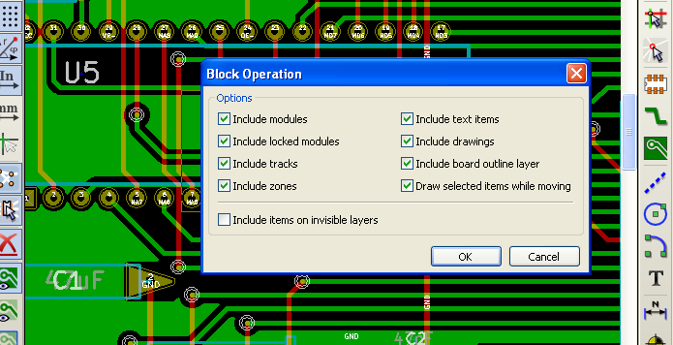
  - Units used in dialogs
Units used to display dimensions values are inch and mm. The desired unit can be selected by pressing the icon 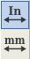 located in left toolbar. However one can enter the unit used to define a value, when entering a new value.
Accepted units are:
1in | 1 inch
1" | 1 inch
25th | 25 thou
25mi | 25 mils, same as thou
6mm | 6 mm
The rules are:
- Spaces between the number and the unit are accepted.
- Only the first two letters are significant.
In countries using an alternative decimal separator than the period, the period (.) can be used as well. Therefore 1,5 and 1.5 are the same in French.
  - Top menu bar
The top menu bar provides access to the files (loading and saving), configuration options, printing, plotting and the help files.
    - The File menu
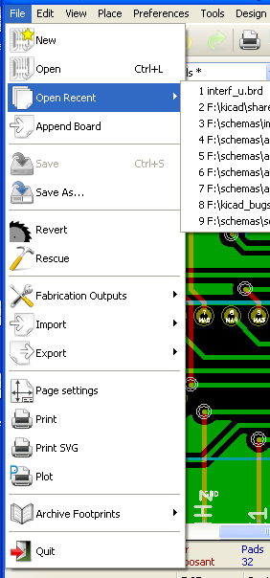

The File menu allows the loading and saving of printed circuits files, as well as printing and plotting the circuit board. It enables the export (with the format GenCAD 1.4) of the circuit for use with automatic testers.
    - The Preferences menu
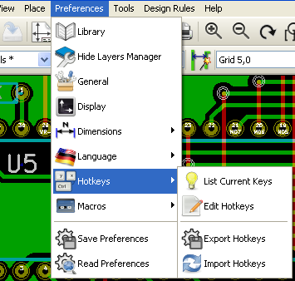
Allows:
- Selection of the module libraries.
- Hide/Show the Layers manager( colors selection for displaying layers and other elements. Also enables the display of elements to be turned on and off.)
- Management of general options (units, etc.).
- The management of other display options.
- Creation, edition (and reread) of the hot keys file.
    - Other preferences and dimensions
An important sub menu.
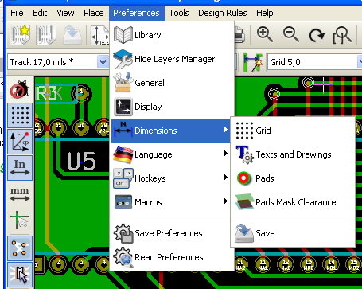
Allows adjustment of:
- User grid size.
- Size of texts and the line width for drawings.
- Dimensions and characteristic of pads.
- Setting the global values for solder mask and solder paste layers
    - The Design Rules menu
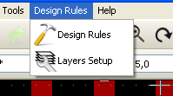
Provides access to 2 dialogs:
- Setting the Design rules (tracks and vias sizes, clerances).
- Setting layers (Number, enabled and layers names)

    - The Display 3D model menu
Brings up the 3D viewer used to display the circuit board in 3 dimensions.
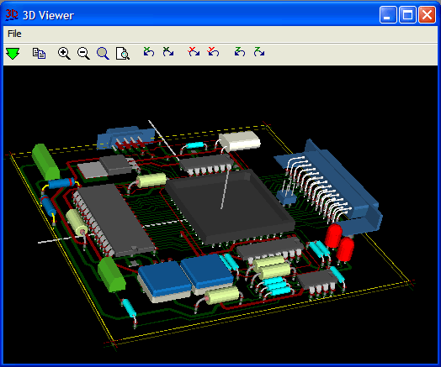
    - The Help menu
Provides access to the user manuals and to the version information menu (Pcbnew About).
  - Using icons on the top toolbar
This toolbar gives access to the principal functions of Pcbnew.

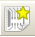 | Creation of a new printed circuit.
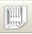 | Opening of an old printed circuit.
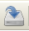 | Save printed circuit.
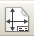 | Selection of the page size and modification of the file properties.
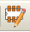 | Opens module editor (Modedit) to display/edit library or pcb modules.
 | Undo Redo last commands (10 levels)
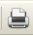 | Display print menu.
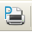 | Display plot menu.
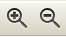 | Zoom in and Zoom out (relative to the centre of screen).
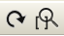 | Redraw the screen and Auto Zoom.
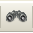 | Find module or text.
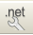 | Netlist operations (selection, reading, testing and compiling).
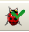 | DRC (Design Rule Check): Automatic check of the tracks.
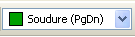 | Selection of the working layer.
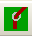 | Selection of layer pair (for vias)
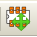 | Footprint mode: when active this enables module options in the pop-up window.
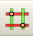 | Routing mode: when active this enables routing options in the pop-up window
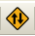 | Direct access to the web router FreeRoute

Auxiliary toolbar:
 | Selection a thickness of track already in use.
 | Selection of a dimension of via already in use.
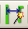 | Automatic track width: if enabled when creating a new track, when starting on an existing track, the width of the new track is set to the width of the existing track.
 | Selection of the grid size.
 | Selection of the zoom.
  - Right hand-side toolbar
This toolbar gives access to the tools for:
- Placement of modules, tracks, zones of copper, texts, etc.
- Net Highlighting.
- Creating notes, graphic elements, etc.
- Deleting elements.

 | Select the standard mouse mode.
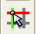 | Highlight net selected by clicking on a track or pad.
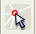 | Display local ratsnest (Pad or Module).
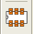 | Add a module from a library.
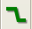 | Placement of tracks and vias.
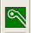 | Placement of zones (copper planes).
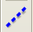 | Draw Lines on technical layers (i.e. not a copper layer).
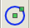 | Draw Circles on technical layers (i.e. not a copper layer).
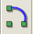 | Draw Arcs on technical layers (i.e. not a copper layer).
 | Placement of text.
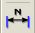 | Draw Dimensions on technical layers (i.e. not the copper layer).
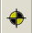 | Draw Alignment Marks (appearing on all layers).
 | Delete element pointed to by the cursor (see note below)  Note:  when Deleting if several superimposed elements are pointed to priority is given to the smallest (in the decreasing set of priorities tracks, text, module).  the function “Undelete” of the upper toolbar allows the cancellation of the last item deleted.
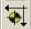 | Offset adjust for drilling and place files.
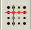 | Grid origin. (grid offset). Useful mainly for edition and placement of footprints.  Can also be set in Dimensions/Grid menu.

  - Left hand-side toolbar
This left hand-side toolbar provides display and control options

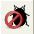 | Turns DRC (Design Rule Checking) on/off. Caution: when DRC is off incorrect connections can be made.
 | Turn grid display on/off (Note: a small grid may not be displayable).
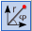 | Polar display of the relative co-ordinates on the status bar on/off.
 | Display/entry of coordinates or dimensions in inches or millimeters.
 | Change cursor display.
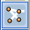 | Display general rats nest (incomplete connections between modules).
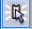 | Display module rats nest dynamically as it is moved.
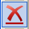 | Enable/Disable automatic deletion of a track when it is redrawn.
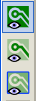 | Display mode for copper zones.  = Shows all (outlines + filled areas)  = Shows outlines only (no filled areas)  = Shows all outlines ( zone outlines + filled areas outlines ) Filling itself is not shown
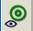 | Display of pads in sketch mode on/off.
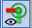 | Display mode for vias (Filled/Sketch)
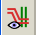 | Display of tracks in sketch mode on/off.
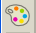 | High contrast display mode on/off. In this mode the active layer is displayed normally, all the other layers are displayed in gray. Useful for working on multi-layer circuits.
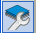 | Hide/Show the Layers manager
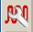 | Access to microwaves tools. Under development
  - Pop-up windows and fast editing
A right click of the mouse open a pop-up window. Its contents depends on the element pointed at by the cursor.
This gives immediate access to:
- Changing the display (centre display on cursor, zoom in or out or selecting the zoom).
- Setting the grid size.
- Additionally a right click on an element enables editing of the most usually modified element parameters.
The screenshot below shows what the pop-up window looks like.
    - Available modes
There are 3 modes when using pop up menus.
and disabled | normal mode
enabled | footprint mode
enabled | tracks mode
In the pop-up menus, these modes add or remove some specific commands.
    - Normal mode
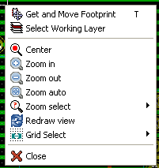 | Pop up with no selected item.
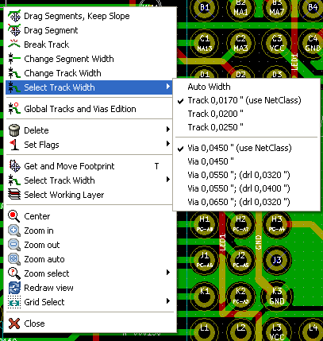 | Pop Up on a track.
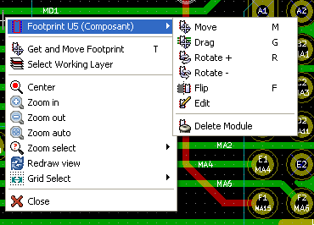 | Pop up on a footprint.

    - Footprint mode
Same cases in Footprint mode ( on)
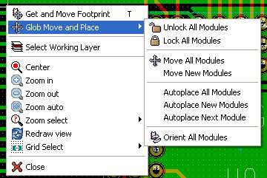 | Pop up with no selected item.
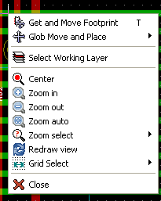 | Pop up on a track.
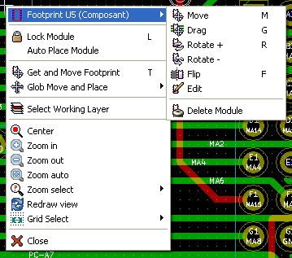 | Pop up on a footprint.

    - Tracks mode
Same cases in Tracks mode ( on)

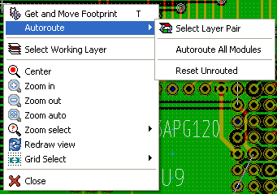 | Pop up with no selected item.
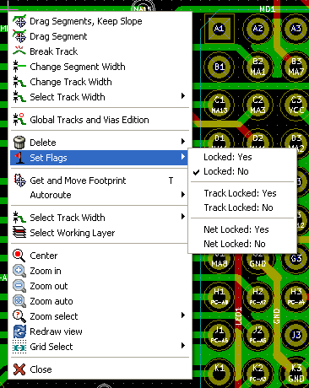 | Pop up on a track.
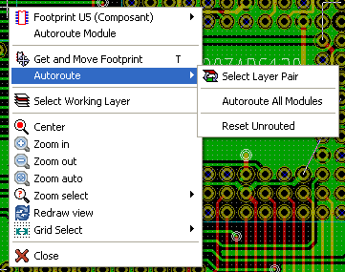 | Pop up on a footprint.

