- Create and modify a board

Table of Contents
6 - Create and modify a board 1
6.1 - Creating a board 1
6.1.1 - Drawing the board outline 1
6.1.2 - Reading the netlist generated from the schematic 1
6.2 - Correcting a board 3
6.2.1 - Steps to follow 3
6.2.2 - Deleting incorrect tracks 3
6.2.3 - Deleted components 3
6.2.4 - Modified modules 4
6.2.5 - Advanced options - selection using time stamps 4
6.3 - Direct exchange for footprints already placed on board 4

  - Creating a board
    - Drawing the board outline
It is usually a good idea to define the outline of the board first. The outline is drawn as a sequence of line segments. Select 'Edges pcb' as the active layer and use the 'Add graphic line or polygon' tool to trace the edge, clicking at the position of each vertex and double-clicking to finish the outline. Boards usually have very precise dimensions, so it may be necessary to use the displayed cursor coordinates while tracing the outline. Remember that the relative coordinates can be zeroed at any time using the space bar, and that the display units can also be toggled using 'Alt-U'. Relative coordinates enable very precise dimensions to be drawn. It is possible to draw a circular (or arc) outline:
- Select the 'Add graphic circle' or 'Add graphic arc' tool
- Click to fix the circle centre
- Adjust the radius by moving the mouse
- Finish by clicking again.
Note that the width of the outline can be adjusted, in the Parameters menu (recommended width = 150 in 1/10 mils) or via the Options, but this will not be visible unless the graphics are displayed in other than outline mode.
The resulting outline might look something like this:

    - Reading the netlist generated from the schematic
Activate the  icon to display the netlist dialog window:
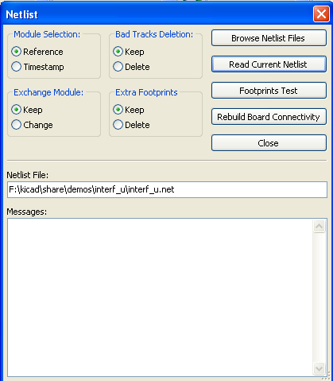
If the name (path) of the netlist in the window title is incorrect, use the 'Select' button to browse to the desired netlist. Then 'Read' the netlist. Any modules not already loaded will appear, superimposed one upon another (we shall see below how to move them automatically).

If none of the modules have been placed, all of the modules will appear on the board in the same place, making them difficult to recognize. It is possible to arrange them automatically (using the command 'Global Place/Move module' accessed via the right mouse button). Here is the result of such automatic arrangement:

Important note:
If a board is modified by replacing an existing module with a new one (for example changing a 1/8W resistance to 1/2W) in CVPCB, it will be necessary to delete the existing component before PCBNEW will load the replacement module. However, if a module is to be replaced by
an existing module, this is easier to do using the module dialog accessed by clicking the right mouse button over the module in question.
  - Correcting a board
It is very often necessary to correct a board following the corresponding change in the schematic.
    - Steps to follow
- Create a new netlist from the modified schematic.
- If new components have been added, link these to their corresponding modules in cvpcb.
- Read the new netlist in Pcbnew.
    - Deleting incorrect tracks
Pcbnew is able to delete automatically tracks that have become incorrect as a result of modifications. To do this, check the 'Delete' option in the 'Bad tracks deletion' box of the netlist dialog:
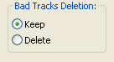
However, it is often quicker to modify such tracks by hand (the DRC function allows their identification).
    - Deleted components
Pcbnew can delete modules corresponding to components that have been removed from the schematic.
This is optional.
This is necessary because there are often modules (holes for fixation screws, for instance) that are added to the PCB that never appear in the schematic.
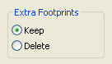
If option Remove Extra Footprints is checked, a footprint corresponding to a component not found in netlist will be deleted, unless they have the option "Locked" active.
This is a good idea to activate this option for "mechanical" footprints.
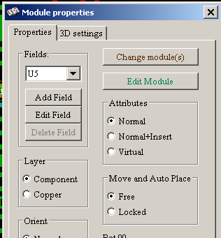 | 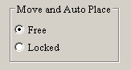  Option to lock/unlock a footprint.

    - Modified modules
If a module is modified in the netlist (using Cvpcb), but the module has already been placed, it will not be modified by Pcbnew, unless the corresponding option of the 'Exchange module' box of the netlist dialog is checked:
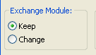
Changing a module (replacing a resistance with one of a different size, for instance) can be effected directly by editing the module.
    - Advanced options - selection using time stamps
Sometimes the notation of the schematic is changed, without any material changes in the circuit (this would concern the references - like R5, U4...).The PCB is therefore unchanged (except possibly for the silkscreen markings). Nevertheless, internally, components and modules are represented by their reference. In this situation, the 'Timestamp' option of the netlist dialog may be selected before rereading the netlist:
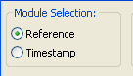
With this option, Pcbnew no longer identifies modules by their reference, but by their time stamp instead. The time stamp is automatically generated by Eeschema (it is the time and date when the component was placed in the schematic).
Great care should be exercised when using this option (save the file first!)
This is because the technique is complicated in the case of components containing multiple parts (e.g. a 7400 has 4 parts and one case). In this situation, the time stamp is not uniquely defined (for the 7400 there would be up to four – one for each part). Nevertheless, the time stamp option usually resolves re annotation problems.
  - Direct exchange for footprints already placed on board
Changing a footprint ( or some identical footprints) to an other footprint is very usefull.
This is very easy:
Cick on a footprint to open the Edit dialog box.
Activate Change Modules.

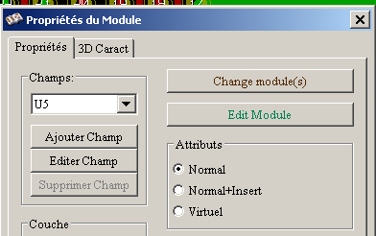 | access to Change Modules

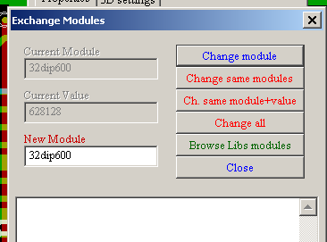 | Options for footprints exchange:

One must choose a new footprint name and use:
- Change Module for the current footprint
- Change same modules for all footprints like the current footprint.
- Change same module+value for all footprints like the current footprint, restricted to components which have the same value.
Note:
- Change all reload all footprints on board.

