- Setting routing parameters

Table of Contents
8 - Setting routing parameters 1
8.1 - Current settings 1
8.1.1 - Accessing the main dialog 1
8.1.2 - Current settings 1
8.2 - General options 2
8.3 - Netclasses 2
8.3.1 - Setting routing parameters 3
8.3.2 - Netclass editor 3
8.3.3 - Global Design Rules 4
8.3.4 - Via parameters 5
8.3.5 - Track parameters 6
8.3.6 - Specific sizes 6
8.4 - Examples and typical dimensions 6
8.4.1 - Track width 6
8.4.2 - Insulation (clearance) 6
8.4.3 - Examples 6
8.5 - Manual routing 7
8.5.1 - Help when creating tracks 8
8.5.2 - Creating tracks 8
8.5.3 - Moving and dragging tracks 9
8.5.4 - Via Insertion 9
8.6 - Select/edit the track width and via size 9
8.6.1 - Using the horizontal toolbar 9
8.6.2 - Using the pop-up menu 10
8.7 - Editing and changing tracks 10
8.7.1 - Change a track 10
8.7.2 - Global changes 11

  - Current settings
    - Accessing the main dialog
The most important parameters are accessed from the following drop-down menu.
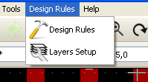
and are set in the Design Rules dialog.
    - Current settings
Current settings are displayed by the top toolbar.
  - General options
The General options menu is available via the top toolbar link Preferences → General dialog.
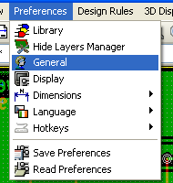
The dialog menu looks like the following.

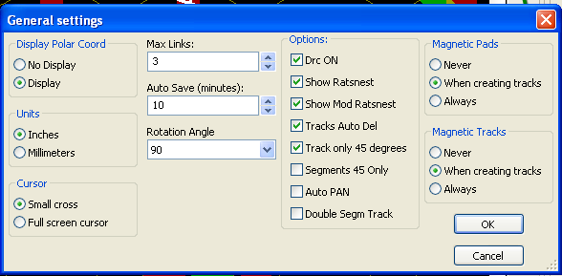
For the creation of tracks the necessary parameters are:
- Tracks 45 Only: Directions allowed for track segments are 0, 45 or 90 degrees.
- Double Segm Track: When creating tracks, 2 segments will be displayed.
- Tracks Auto Del: When recreating tracks, the old one will be automatically delete if considered redundant.
- Magnetic Pads: The graphic cursor becomes a pad, centered in the pad area.
- Magnetic Tracks: The graphic cursor becomes the track axis.
  - Netclasses
Pcbnew allows you to define different routing parameters foe each net. Parameters are defined by a group of nets.
- A group of nets is called a Netclass.
- There is always a netclass called default.
- Users can add others Netclasses.
A netclass specifies:
- The width of tracks, via diameters and drills.
- The clearance between pads and tracks (or vias).
When routing, Pcbnew selects automatically the netclass corresponding to the net of the track to create or edit, and therefore the routing parameters.
    - Setting routing parameters
The choice is made in the menu: Design Rules → Design Rules.
    - Netclass editor
The Netclass editor allows you to:
- add or delete Netclasses.
- set routing parameters values : clearance, track width, via sizes.
- group nets in netclasses.
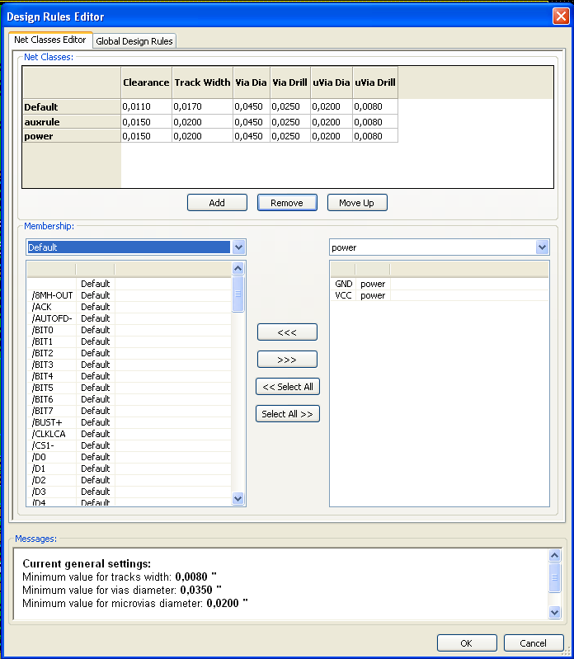
    - Global Design Rules
The global design rules are:
- Via type.
- Enabling/disabling micro-via use.
- Minimum clearance (minimum distance between tracks, vias and pads).
- Minimum tracks and vias sizes.
A DRC error is rose when a value smaller than the minimum value specified is encountered. The second dialog panel is:
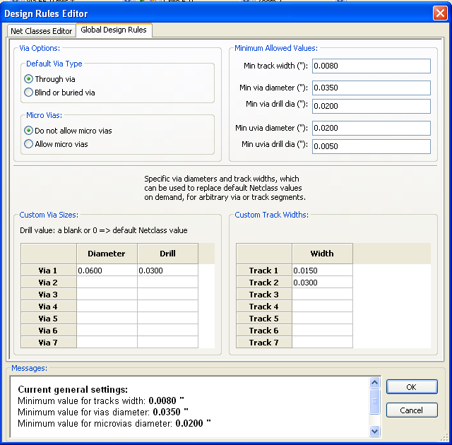
This dialog also allows to enter a “stock” of tracks and vias sizes.
When routing, one can select one of these values to create a track of via, instead of using the default netclasses values ones.
Useful in critical cases when a small track segment must have a specific size.
    - Via parameters
Pcbnew handles 3 types of vias:
- The through via (usual vias).
- Blind or buried vias.
- Micro Vias, like buried vias but restricted to an external layer to its nearest neighbor.
They are intended to connect BGA pins to the nearest inner layer. Their diameter is usually very small and they are drilled by laser.
By default, all vias have the same drill value.
This dialog specify the smallest acceptable values for vias parameters. On a board, a via smaller than specified here generates a DRC error.
    - Track parameters
Specify the minimum acceptable track width. On a board, a track width smaller than specified here generates a DRC error.
    - Specific sizes
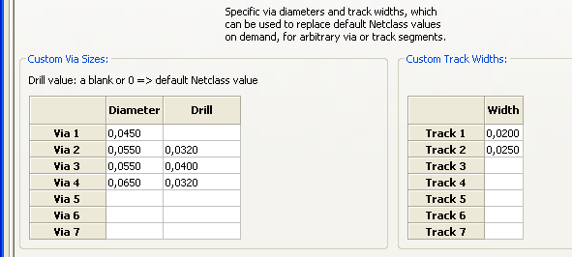
One can enter a set of extra tracks and/or vias sizes. While routing a track, these values can be used on demand instead of the values from the current netclass values.
  - Examples and typical dimensions
    - Track width
Use the largest possible value and conform to the minimum sizes given here.
Units | CLASS 1 | CLASS 2 | CLASS 3 | CLASS 4 | CLASS 5
mm | 0,8 | 0,5 | 0,4 | 0,25 | 0,15
mils | 31 | 20 | 16 | 10 | 6
    - Insulation (clearance)
Unité | CLASS 1 | CLASS 2 | CLASSE3 | CLASS 4 | CLASS 5
mm | 0,70 | 0,5 | 0,35 | 0,23 | 0.15
mils | 27 | 20 | 14 | 9 | 6
Usually, the minimum clearance is very similar to the minimum track width.
    - Examples

'Rustic'
- Clearance: 0.35mm (0.0138 inches).
- Track width: 0.8mm (0.0315 inches).
- Pad diameter for ICs and vias: 1.91mm (0.0750 inches ).
- Pad diameter for discrete components: 2.54mm (0.1 inches).
- Ground track width: 2.54mm (0.1 inches).

'Standard'
- Clearance: 0.35mm (0.0138 inches).
- Track width: 0.5mm (0.0127 inches).
- Pad diameter for ICs: make them elongated in order to allow tracks to pass between IC pads and yet have the pads offer a sufficient adhesive surface (1.27 x 2.54 mm -->0.05x 0.1 inches).
- Vias : 1.27mm (0.0500 inches).

  - Manual routing
Manual routing is often recommended, because it is the only method offering control over routing priorities. For example, is is preferable to start by routing power tracks, making them wide and short and keeping analog and digital supplies well separated. Later, sensitive signal tracks should be routed. Amongst other problems, automatic routing often requires many vias. However, automatic routing can offer useful insight into the positioning of modules. With experience, you will probably find that the automatic router is useful for quickly routing the 'obvious' tracks, but the remaining tracks will best be routed by hand.
    - Help when creating tracks
Pcbnew can display the full ratsnest, if the button 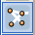 is activated.
The button 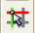 allows to highlight a net (click to a pad or an existing track to highlight the corresponding net).
The DRC checks in real time tracks when creating them. One cannot create a track which does not match the DRC rules. It is possible to disable the DRC by clicking on the button . This is however not recommended, use it only in specific cases.
    - Creating tracks
A track can be created by clicking on the button . A new track must starts on a pad or on an other track, because Pcbnew must knows the net used for the new track (in order to match the DRC rules).
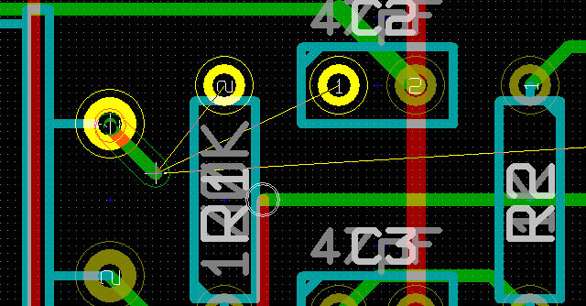
When creating a new track, Pcbnew shows links to nearest not connected pads, link number set in option "Max. Links" in General Options.
End the track by a double click, by the pop-up menu or by its hot key.
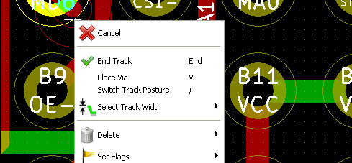
    - Moving and dragging tracks
When the button is active, the track where the cursor is positioned can be moved with the hotkey 'm'. If you want to drag the track you can use the hotkey 'g'.
    - Via Insertion
A via can be inserted only when a track is in progress:
- By the pop-up menu.
- By the hotkey 'v'.
- By switching to a new copper layer using the appropriate hotkey.
  - Select/edit the track width and via size
When clicking on a track or a pad, Pcbnew automatically selects the corresponding Netclass, and the track size and vias dimensions from this netclass.
As previously seen, the Global Design Rules editor has a tool to insert extra tracks and vias sizes.
- The horizontal toolbar can be used to select a size.
- When the button is active, the current track width can be selected from the pop-up menu (accessible as well when creating a track).
The user can utilize the default Netclasses values or a specified value.
    - Using the horizontal toolbar

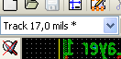 | Track width selection.  The symbol * is a mark for default Netclass value selection.
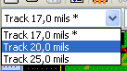 | Selecting a specific track width value.  The first value in list is always the netclass value.  Others values are tracks widths entered from the Global Design Rules editor.
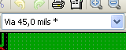 | Via size selection.  The symbol * is a mark for default Netclass value selection.
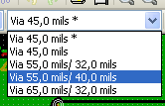 | Selecting a specific via dimension value.  The first value in list is always the netclass value.  Others values are vias dimensions entered from the Global Design Rules editor.
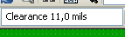 | Display the current clearance value.  This is the clearance value set in the current selected Netclass.
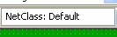 | Current selected Netclass.  When clicking on a track or a pad, Pcbnew automatically selects the corresponding Netclass, and displays its name.
When enabled: Automatic track width selection.
When starting a track on an existing track, the new track has the same width as the existing track.

    - Using the pop-up menu
One can select a new size for routing, or to change a previously created via or track segment.
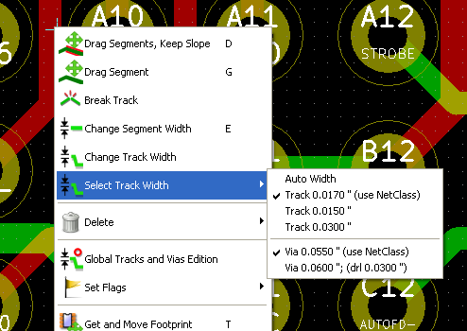
If you want to change many vias (or tracks) size, the best way is to use a specific Netclass to for the net(s) that must be edited (see global changes).
  - Editing and changing tracks
    - Change a track
In many cases redrawing a track is recommendable.
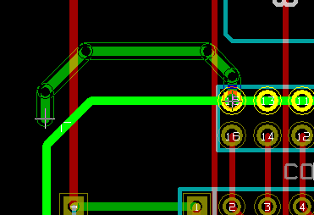 new track (in progress).
When finished:
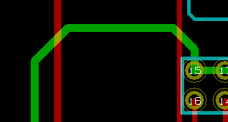
Pcbnew remove automatically the old track if it is redundant.
    - Global changes
Global tracks and via sizes dialog editor is accessible via the pop-up window by right clicking on a track.
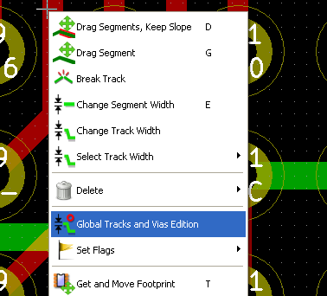
The dialog editor allows global changes of tracks and/or vias for:
- The current net.
- The whole board.

