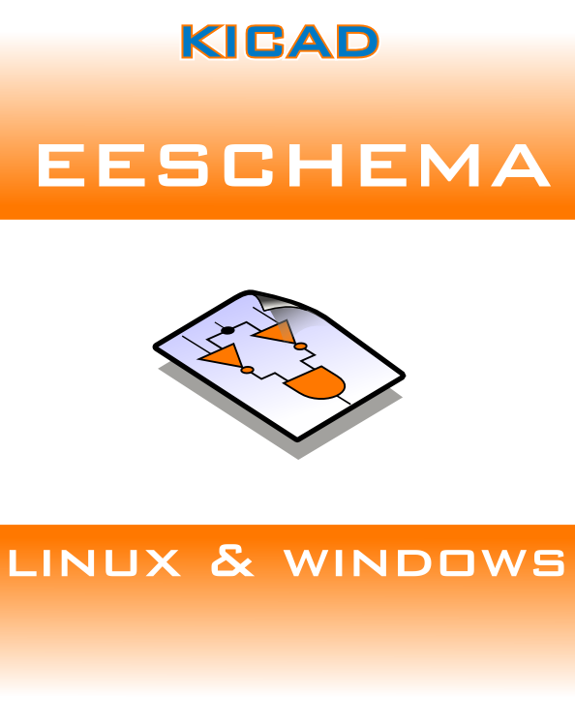

Author: Jean-Pierre Charras
Version: February, 2011

