Headings
1 - Purpose
2 - General characteristics
2.1 - Characteristics
2.2 - Input netlist format
2.3 - Output Netlist
3 - Invoking Cvpcb
4 - CVPCB Commands
4.1 - Main screen
4.2 - Main Screen Toolbar
4.3 - CVPCB Configuration
4.3.1 - General screen
4.3.2 - Footprint Library selection
4.3.3 - Selecting the equivalence files
4.4 - Selecting library path and default extensions
4.5 - Viewing the current footprint
4.5.1 - Display
4.5.2 - Keyboard Commands
4.5.3 - Pop Up Menu
4.5.4 - Toolbar
4.5.5 - 3D Display
5 - Associating components with footprints
5.1 - Principle
5.2 - Assignment
5.3 - Changing an existing assignment
5.4 - Filtering the footprint list:
6 - Equivalence files
6.1 - Purpose
6.2 - Format
7 - Back- annotation file

Purpose
CVPCB allows you to assign each component that appears in the netlist created by the Schematic program to the name of the footprint which will represent it on a printed circuit board, and adds this information to the netlist.
Generally the netlist does not specify which footprint (i.e. the physical appearance of the component) the printed circuit software (PCBNEW) will have to display to create the general drawing of the card.
Components can be assigned to their corresponding footprints manually. You can create Equivalence files, which are look-up tables associating each component with its footprint. When equivalence files are available, automatic assignment is possible.
The list of the footprints available for the PCB software is contained in one or more FOOTPRINT libraries.
This interactive approach is much simpler than directly placing the assignments on the schematic, because as well as allowing automatic assignment, CVPCB, allows you to see the list of the footprints available, and to display them on the screen.

General characteristics

Characteristics
Interactive assignment of components with footprints or automatic assignment via equivalence files.
Generation (if necessary) of back- annotation files of this assignment to the schematic.

Input netlist format
- EESchema (without footprint references).
- VIEW LOGIC WIRELIST.
- VIEW LOGIC NETLIST * (.NET+.PKG)

Output Netlist
Two files are generated for Pcbnew:
- The enhanced Netlist file (with footprint references)
- An auxiliary component assignment file . (.CMP).

Invoking Cvpcb
cvpcb (the file is then selected in CVPCB, via the file menu) or cvpcb <filename>, (filename being the name of the netlist file to be processed, from the schematic tool Eeschema).
The name of the file can be given with or without extension.
The extensions will if necessary be supplied by the defined in cvpcb configuration.
The two generated files will have the same name (with different extensions).
The standard extension of the file to be processed is .net.
The standard extension of the generated netlist file is .net, and will replace the old .net.
The standard extension of the file assigning components to the corresponding footprints (also generated by CVPCB) is .cmp.
These standard extensions can be modified by changing Cvpcb configuration.

CVPCB Commands

Main screen
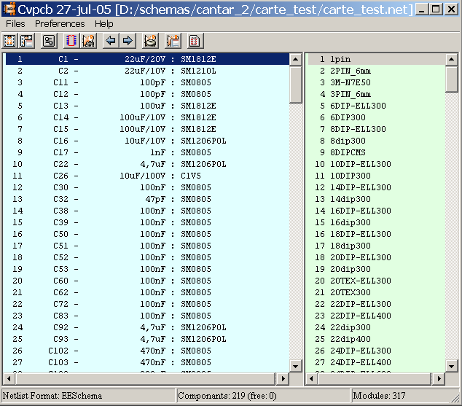
The Component window (on the left) displays the list of components appearing in the Netlist read.
The footprint window (on the right) displays the list of footprints contained in the libraries read.
The component window is empty if no file is loaded, and the footprint window can be also empty if no footprint libraries are found.

Main Screen Toolbar
The various functions are:
Select the Netlist file to be processed.
Create the assignment (stuff) file .CMP and the .NET file, the modified, expanded Netlist .
Invoke the CVPCB configuration menu.
Display the current footprint (i.e. whose name is highlighted in the footprint window).
Automatically assign components/footprints starting from the equivalence files.
Using this order obviously assumes that these files are available.
Automatically run through the components towards the beginning of the list until the first component not yet assigned a footprint.
Automatically run through the components towards the end of the list until the first component not yet assigned a footprint.
Delete all assignments.
Generate footprint assignment back-annotation file.
Go to footprint documentation.
Allows or forbids the footprint filtering to display the list of footprints
When the footprint filtering is allowed, the list of footprints shows only the autorized footprints for the current selected component.

CVPCB Configuration

General screen
Invoking the configuration menu displays the following screen:
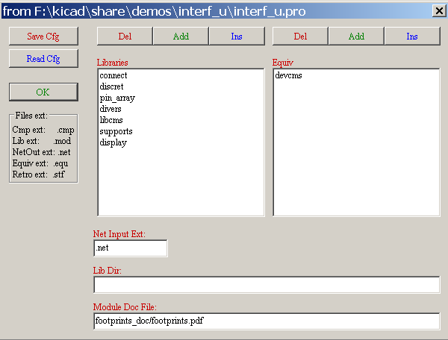

Footprint Library selection
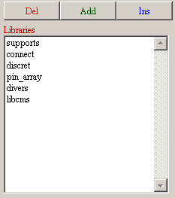
To select a file with the mouse:
- Del removes this name from the list.
- Add adds a new name to the list, after the selected name
- Ins adds a new name to the list, before the selected name.
Note:
Any modification of this list also affects pcbnew.

Selecting the equivalence files
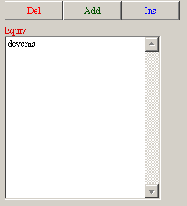
To select with the mouse a file name.
- Del removes this name of the list.
- Add adds a new name to the list, after the selected name
- Ins adds a new name to the list, before the selected name

Selecting library path and default extensions
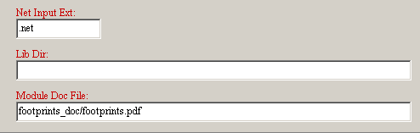
Lib Dir is the default path of the footprint file (.mod) and of the equivalence (.equ) files.
If this field is left empty, the default path used will be kicad/share/modules.

Viewing the current footprint
The Visu command allows display of the current footprint, i.e. the one that appears highlighted on the central line of the footprint window.
The various footprints can be displayed by clicking on the desired footprint (in the list of the footprints), as long as this window is in displayed.
One can also display the 3D view (if it has been created and assigned to the footprint)
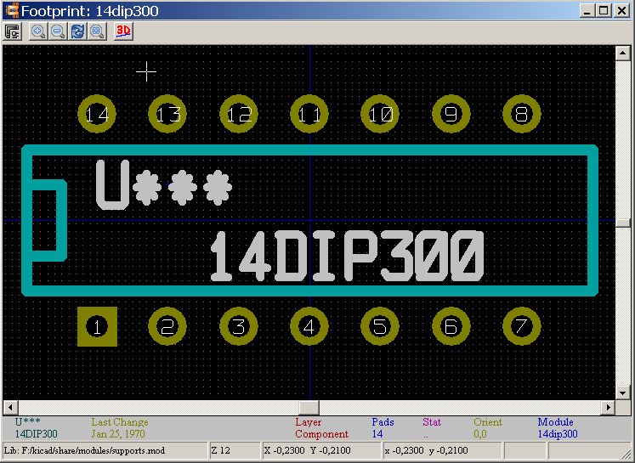

Display
The co-ordinates of the cursor are displayed at the bottom of the screen :
Absolute co-ordinates (X nnnn Y nnnn) and relative co-ordinates (dx nnnn dy nnnn)
The relative co-ordinates are zeroed by the space bar.

Keyboard Commands
F1 | Zoom In
F2 | Zoom Out
F3 | Refresh Display
<space bar>: | Zero relative co-ordinates.

Pop Up Menu
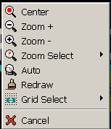
Displayed by right-clicking the mouse:
Zoom Selection (Select Zoom) | Direct selection of the display zoom .
Grid Selection (Grid Select) | Direct selection of the grid.

Toolbar

Display Options
Zoom Level
3D Display

3D Display
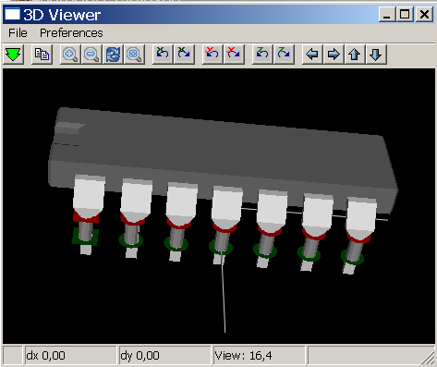

Associating components with footprints

Principle
In the footprint window double-click on the name of the desired footprint (This name is highlighted), to assign it the component whose name is highlighted on the central line of the component window.
The next component in the list is selected:
- Automatically after an assignment.
- Manually using the mouse or cursor keys.

Assignment
Double- click the left mouse button on the desired footprint

Changing an existing assignment
This is done like a new assignment:
Double-click the left mouse button on the new desired footprint

Filtering the footprint list:
If the selected component has an allowed footprint list, the displayed footprint list in Cvpcb is filtered according to this list.
Without filtering:
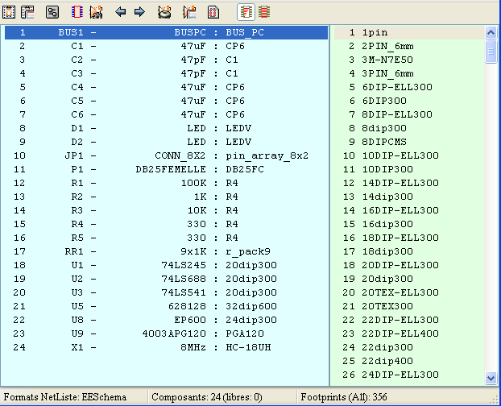
With filtering:
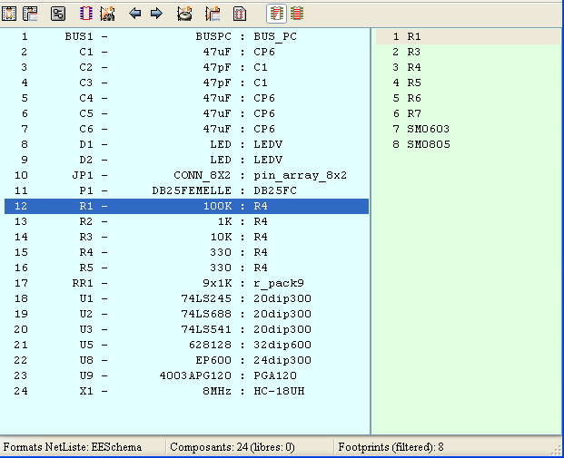

Under Eeschema, the allowed footprint list was:
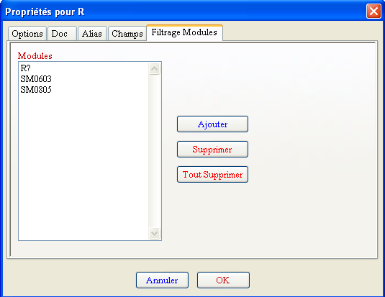
The icone allows or .forbids the filtering
When the filtering is not allowed, the full footprint list is shown.

Automatic associations

Equivalence files
These files allow automatic assignment.
They give the name of the corresponding footprint according to the name (value) of the component.
These files have the standard extension .equ
By selecting suitable files for a given, project, it is easy to use different technologies (like smd,or dip packages …)
See “Selecting the equivalence files”.

Format
They consist of a line for each component.
Each line has the following structure:
'component value' 'footprint name'
Each name being framed by the letter ', the 2 names being separated by one or more spaces.
Example:
If the U3 component is circuit 14011 and its footprint is 14DIP300, the line is:
'14011' '14DIP300'
A line starting by # is a comment.
Here is a sample:

#integrated circuits (smd):
'74LV14' 'SO14E'
'74HCT541M' 'SO20L'
'EL7242C' 'SO8E'
'DS1302N' 'SO8E'
'XRC3064' 'VQFP44'
'LM324N' 'S014E'
'LT3430' 'SSOP17'
'LM358' 'SO8E'
'LTC1878' 'MSOP8'
'24LC512I/SM' 'SO8E'
'LM2903M' 'SO8E'
'LT1129_SO8' 'SO8E'
'LT1129CS8-3.3' 'SO8E'
'LT1129CS8' 'SO8E'
'LM358M' 'SO8E'
'TL7702BID' 'SO8E'
'TL7702BCD' 'SO8E'
'U2270B' 'SO16E'
#Xilinx
'XC3S400PQ208' 'PQFP208'
'XCR3128-VQ100' 'VQFP100'
'XCF08P' 'BGA48'

#upro
'MCF5213-LQFP100' 'VQFP100'

#regulators
'LP2985LV' 'SOT23-5'

Association:
The automatic association is launch by:
All components found (by their value) in a *.equ file will have their footprint automatically select.

Back- annotation file
This file can be used for back- annotation of a schematic but is not used by PCBNEW.
It consists of a line for each component, giving the name of the footprint according to its reference.
Example:
If the U3 component was assigned the footprint14DIP300, the generated line is
comp “U3” = footprint “14DIP300”
The file created has the root name of the CVPCB input file, with extension .stf, and is placed in the same folder as the generated netlist.

