Schematic Implementation
Headings:
4 - Schematic Implementation
4.1 - Linking the Schematic to the Printed Circuit
4.2 - Procedure for Creating the Printed Circuit
4.3 - Procedure for Updating the Printed Circuit
4.4 - Reading netlist - Loading footprints - Options:
4.4.1 - Dialog box:
4.4.2 - Options:
4.4.3 - Loading new footprints:

Linking the Schematic to the Printed Circuit

The schematic is linked to PCBNEW by means of the Netlist file, which is normally generated by the schematic program used.
Note: PCBNEW accepts Netlist files with the Eeschema or ORCAD PCB 2 formats.
The Netlist file initially generated is usually incomplete as there has been no assignment of the modules that correspond to the various components used in the schematic. Consequently an intermediate stage is necessary, the generation of the file of association components/modules.
CVPCB is used to create this file which is named * .CMP.
CVPCB also updates the Netlist file using this information.
PCBNEW reads the modified Netlist file * .NET and, if it exists, the file * .CMP.
In the event of a module being changed directly in PCBNEW the * .CMP file is automatically updated so avoiding the requirement to run CVPCB again.
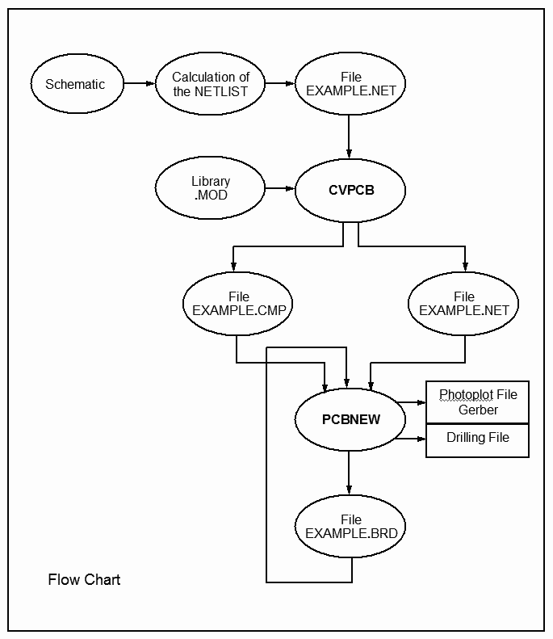

Procedure for Creating the Printed Circuit
After having created the required schematic:
- Generate the netlist using Eeschema.
- Assign each components in the Netlist produced by Eeschema to the corresponding module used on the printed circuit using CVPCB.
- Launch PCBNEW and read the modified Netlist (this will also read the file with the module selections).
PCBNEW will then load automatically all the modules.
The modules can now be placed manually or automatically on the board and and the tracks routed.

Procedure for Updating the Printed Circuit
If the schematic is modified, the following steps must be repeated:
- Generate a new netlist using Eeschema.
- If the changes to the schematic involve new components, the corresponding modules must be assigned using CVPCB.
- Launch PCBNEW and re-read the modified Netlist (this will also re-read the file with the module selections).
PCBNEW will then load automatically any new modules, add the new connections and remove redundant connections.

Reading netlist - Loading footprints - Options:

Dialog box:
Access by the tool:
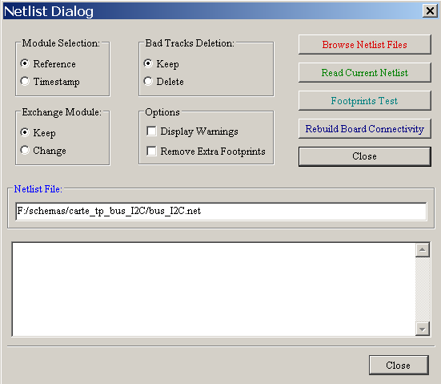

Options:
Exchange Module: | If a footprint has changed in the netlist: keep old footprint or change to the new one.
Bad Tracks Deletion | Keep all existing tracks, or delete erroneous tracks
Options :  (on/off) | Display all messages (or not)  Remove footprints which are on board but not in netlist.  Footprint with attribute "Locked" will be not removed

Loading new footprints:
When new footprints are found in netlist, they are automatically loaded:
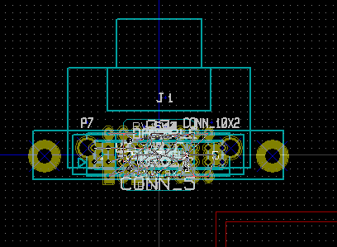
They are stacked at coordinate 0,0.
One can move footprints one by one.
But a better way is to automatically move (unstack) them:
- Activate footprint mode"
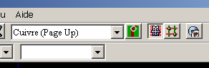 | activate the "footprint mode"
 | footprint mode activated

Move the mouse cursor to a suitable (free) area, and activate the right button:

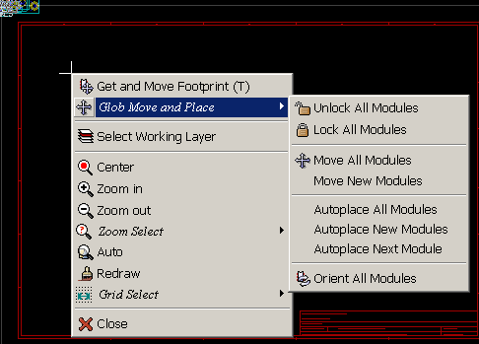
Use:
- Move New Modules if there is already a board with existing footprints.
or
- Move All Modules, the first time (when creating a board)
Here is result:
