Creating zones
Headings:
9 - Creating zones
9.1 - Creating the zones on copper layers:
9.2 - Creating a zone:
9.2.1 - Creating the zone limits:
9.2.2 - Filling the zone:
9.3 - Fill Options:
9.3.1 - Mode for filling.
9.3.2 - Clearance and minimum copper thickness
9.3.3 - Pad options
9.3.4 - Thermal reliefs parameters:
9.3.5 - Parameters choice:
9.4 - Adding a Cutout area inside a zone:
9.5 - Outlines editing:
9.6 - Editing zone: parameters
9.7 - Final zone Filling.
9.8 - Zones net names changes:
9.9 - Creating the zones on technical layers:
9.9.1 - Creating the zone limits:

Copper zones are defined by an outline (closed polygon), and can include holes (closed polygons inside the outline).
A zone can be drawn on a copper layer, or a technical layer.

Creating the zones on copper layers:
Pad (and tracks) connections by filled copper areas are tested by the DRC.
So a zone must be filled (not just created) to connect pads.

Pcbnew uses currently track segments or polygons to fill copper areas.
Each option has its advantages ands its drawbacks, maintly when redraw screen.
The final result is the same.
For calculation time reasons, the zone filling is not remade after each change, but only:
- If a filling zone command is made.
- When a DRC test is made

Copper zones must be filled or refilled after changes in tracks or pads.

Copper zones (Usually ground and power planes) are usually attached to a net.
In order to create a copper zone one must:
- Select parameters (net name, layer ...)
Switch on the layer and highlight this net is not mandatory but is a good practice.
- Create the zone limit (If no, All the board will be filled.)
- Fill the zone.
Pcbnew try to fill zones all of a piece, and usually, there is not any unconnected copper block. So it can happens some fragments of areas remain not filled.
Zones having no net are not cleaned and can have insulated islands.

Creating a zone:

Creating the zone limits:
Use the tool .
The active layer must be a copper layer.
When clicking to start the zone outline, the dialog box is opened:
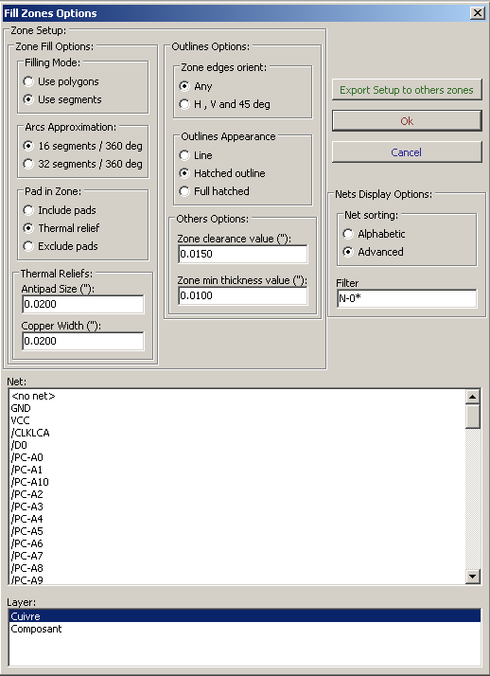
On can set parameters for this zone (net, layer, filling options, pad options ...)
Draw the zone limit, on this layer.
This zone limit is a polygon, created by a click (left button) for each corner.
A double click ends the polygon.
The polygon will be automatically closed. If the starting point and the ending point are not at the same coordinate, Pcbnew will add a segment from the end point to the start point.
Remark:
- The DRC control is active when creating zone outlines.
- A corner which creates a DRC error will NOT be accepted by Pcbnew.

Here is a zone limit created (polygon in thin hatched line):
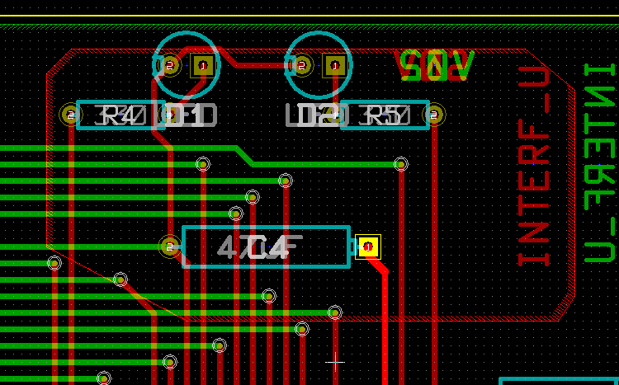

Filling the zone:
Note:
When filling a zone, Pcbnew remove all not connected copper islands.
To access to the zone filling command, right click on the edge zone::
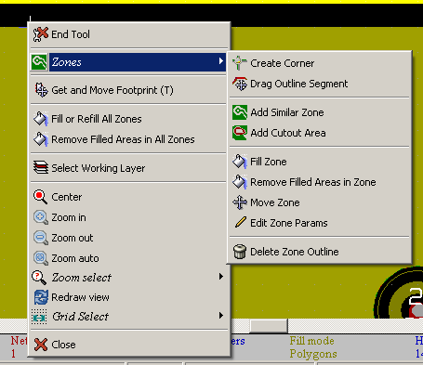
Activate the "Fill Zone" command
Here is the filling result for a starting point inside the polygon:

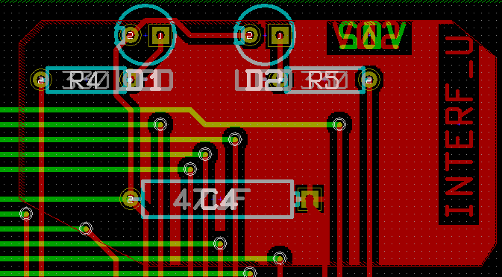r

The polygon is a frontier for filling.
One can see a non filled area inside the zone, because this area is not accessible:
- A track creates a frontier and
- There is no starting point for filling in this area.

Note:
you can use many polygons to create cutout areas. Here is an example:
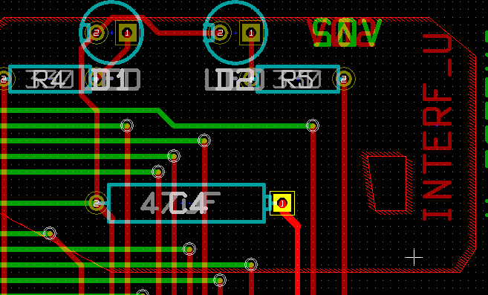
Here is the result:
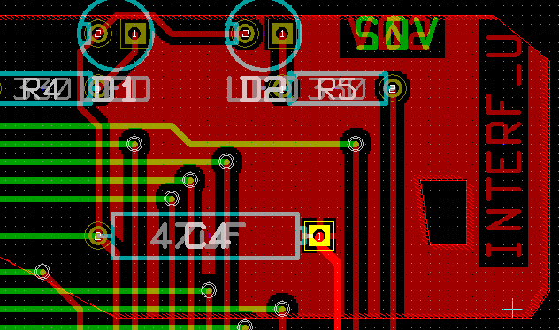

Fill Options:
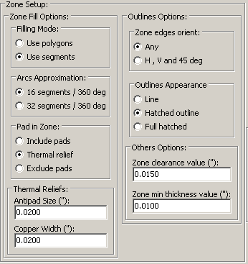
One must choose:
- The mode for filling.
- The clearance and minimum copper thickness.
- How the pads are drawn inside the zone (or connected to this zone).
- Thermal reliefs parameters.
- ….

Mode for filling.
Zones can be filled using polygons or segments.
Results are same.
If you have problems with polygon mode (slow screen refresh) uses segments.

Clearance and minimum copper thickness
A good choice for clearance is a grid a bit bigger than the routing grid.
Minimum copper thickness value ensures there is no too small copper ares in zones.
Warning: if the value is too large, small shapes like thermal stubs in thermal reliefs cannot be drawn.

Pad options
Pads of the net can either be included or excluded from the zone, or connected by thermal reliefs.
- If included, soldering and unsoldering can be very difficult.
- If excluded, the connection to the zone is not very good.
- A thermal relief is a good compromise.

Here is the result for the 3 options:

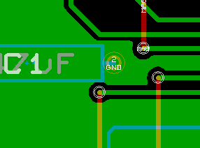 | Include Pads
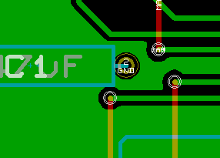 | Exclude Pads  Note:  - The zone can be filled only if tracks exists to connect zones areas.  - Pads must be connected by tracks.
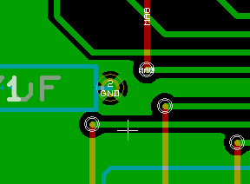 | Thermal relief.  Pad is connected by 4 track segments.  The segment width is the current value used for the track width.

Thermal reliefs parameters:
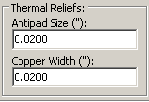
One can set 2 parameters for thermal reliefs:
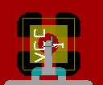
Copper width
AntiPad Size

Parameters choice:
The copper width value for thermal reliefs must be bigger than the minimum thickness value for copper zone. If not the case, they cannot be drawn.
Besides, a too large value for this parameter or for antipad size does not allow to create a thermal relief for small pads ( like pads sizes used in SMD).

Adding a Cutout area inside a zone:
Obviously, a zone must already exist.
To add a cutout area (a non filled area inside the zone):
- Right click on an existing edge outline.
- Select Add Cutout Area.
- Creates the new outline.

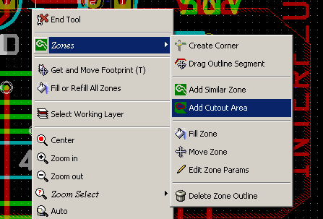

After creating outline:
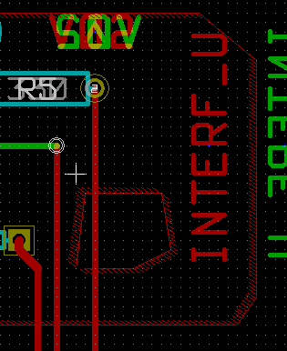 | See the cutout outline.

Outlines editing:
An outline can be modified by:
- Moving a corner or an edge
- Deleting or Adding a corner
- Adding a similar zone, or a cutout area
And if polygons are overlapping they will be combined.
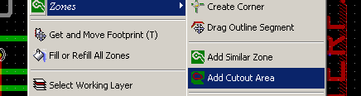
To do that:
Right click on a corner or on an edge, en select the command.

Here is a corner (from a cutout) moving:
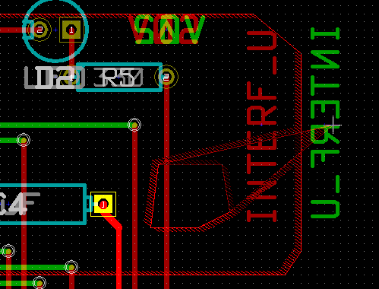
Here is the result:
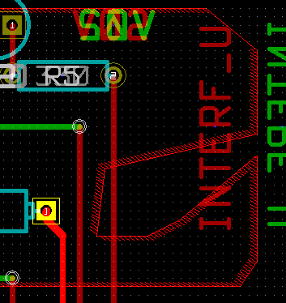
Polygons are combined.

Adding a similar zone:
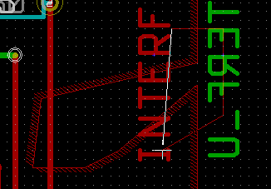 | Adding the zone
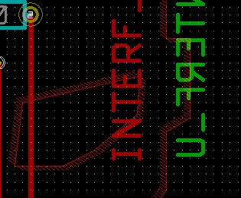 | Result

Editing zone: parameters
When right clicking on an outline, and using Edit Zone Params , The Zone params Dialog box is opened.
Inital parameters can be edited.
If the zone is already filled, refilling it will be necessary.

Final zone Filling.
When the board is finished, one must fill or refill all zones.
To do that:
- Activate the tool zones ().
- Right click to display the Popup menu.
- Use Fill or Refill All Zones 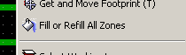

Warning, calculations can take some time, if filling grid is small.

Zones net names changes:
After editing a schematic, nets can have their name changed.
For instance VCC can be changed to +5V.
When a global DRC control is made Pcbnew checks if the zone net name exists, and displays an error if not.
A "by hand" parameter zone edition will be necessary to change the old name to the new one.

Creating the zones on technical layers:

Creating the zone limits:
Sélectionner l'outil .
Use the tool .
The active layer must be a technical layer.
When clicking to start the zone outline, the dialog box is opened:
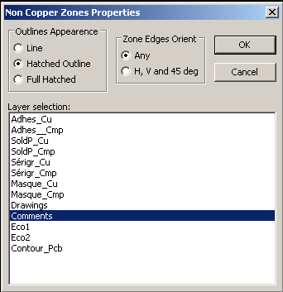
Select the technical layer to place the zone
Draw the zone outline like previously said for copper layers..

Notess:
- For outlines edition, uses the same way as for copper zones.
- One also can add Cutout Areas.

