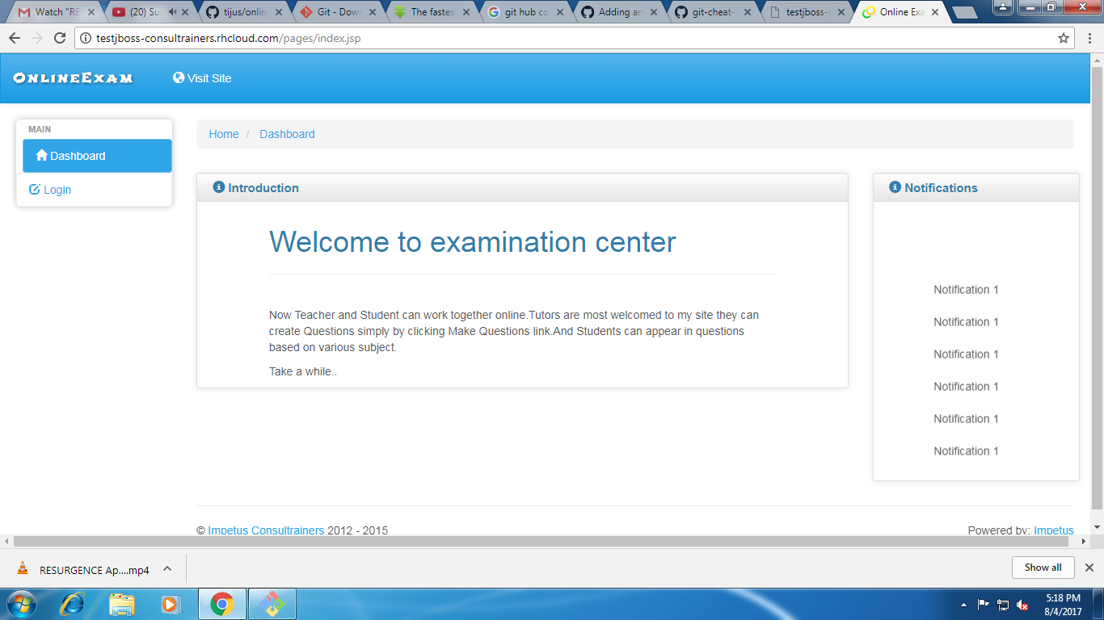

**LANDING PAGE**

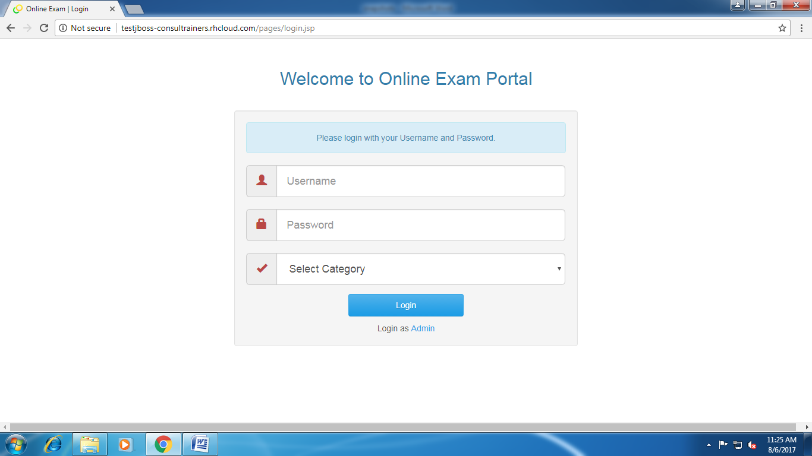

**LOGIN PAGE**

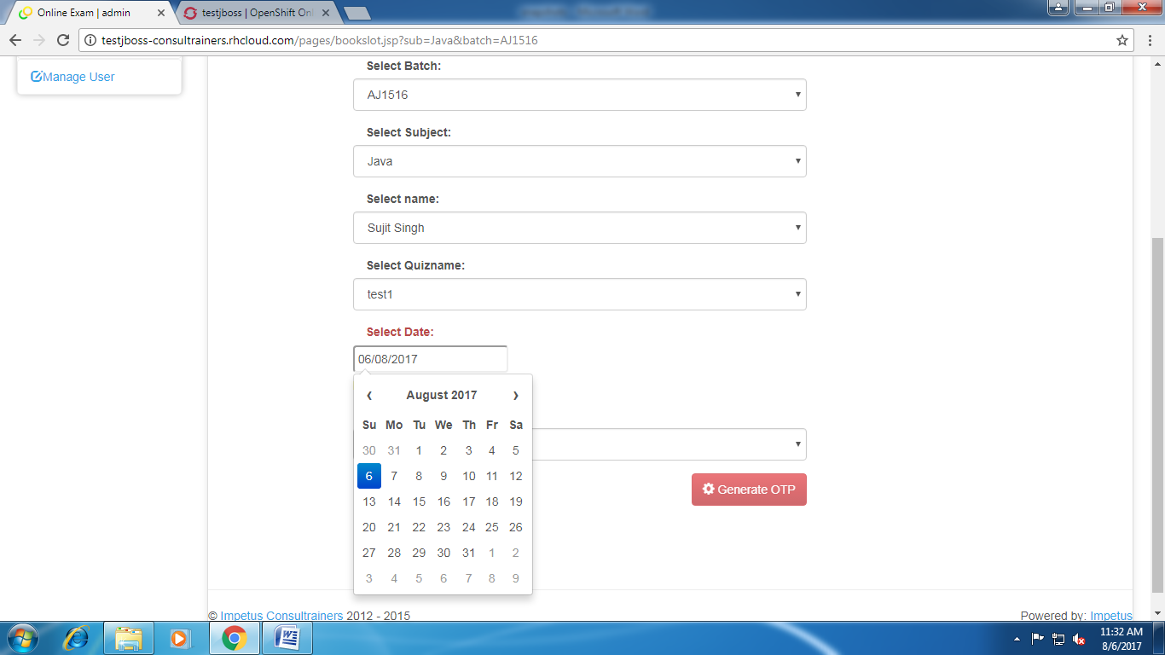

**SLOT BOOKING**

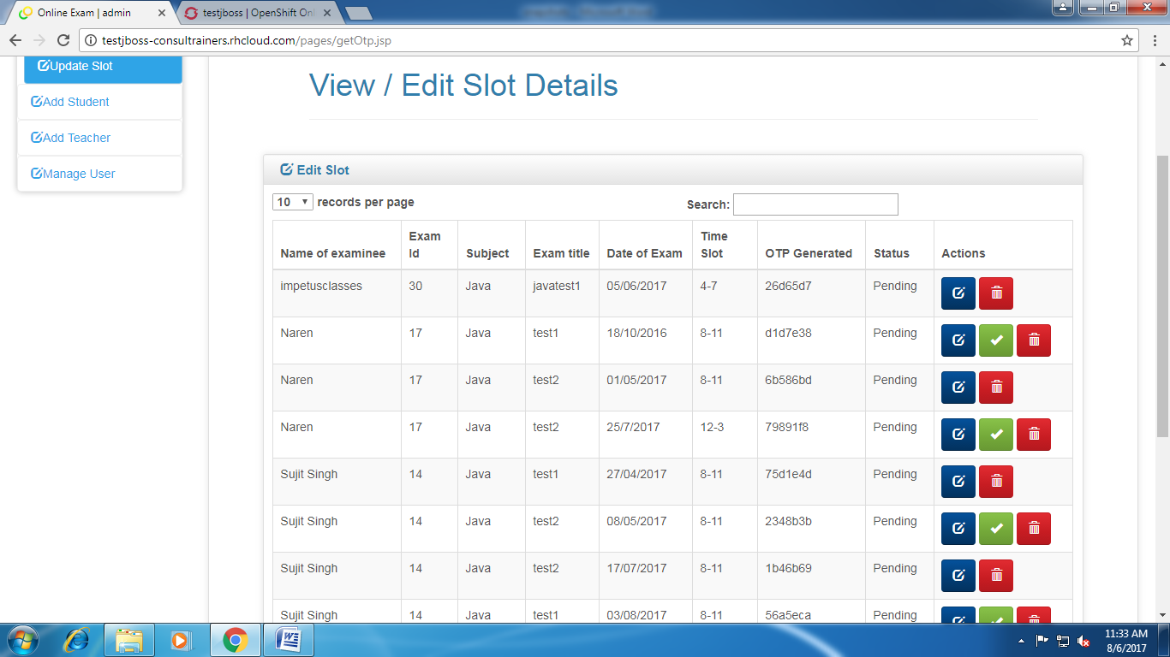

**MONITOR EXAMS**

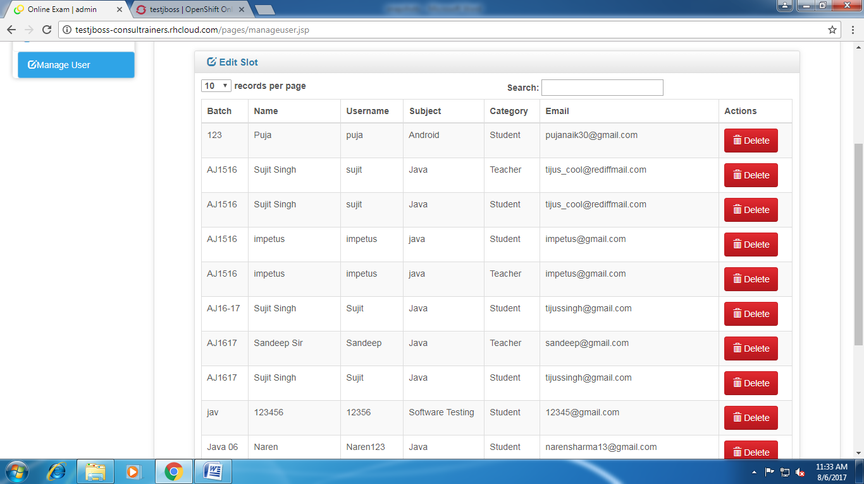

**MANAGE USER**

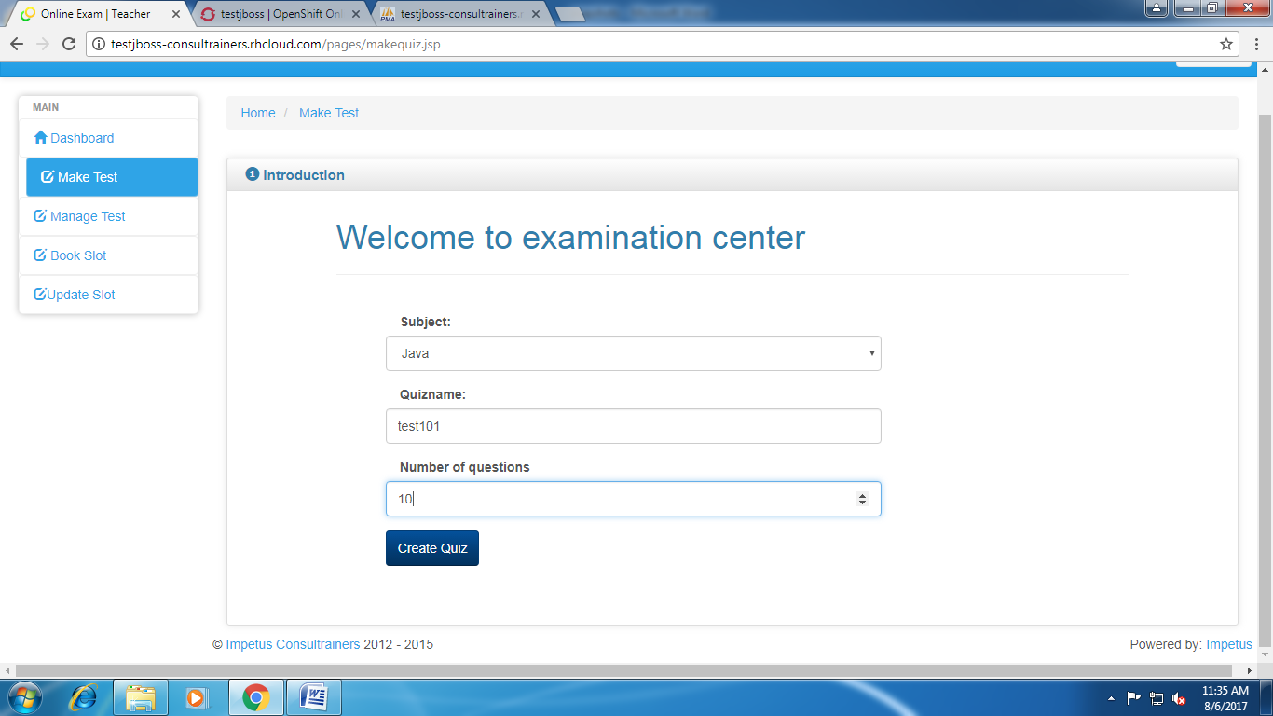

**CREAT TEST**

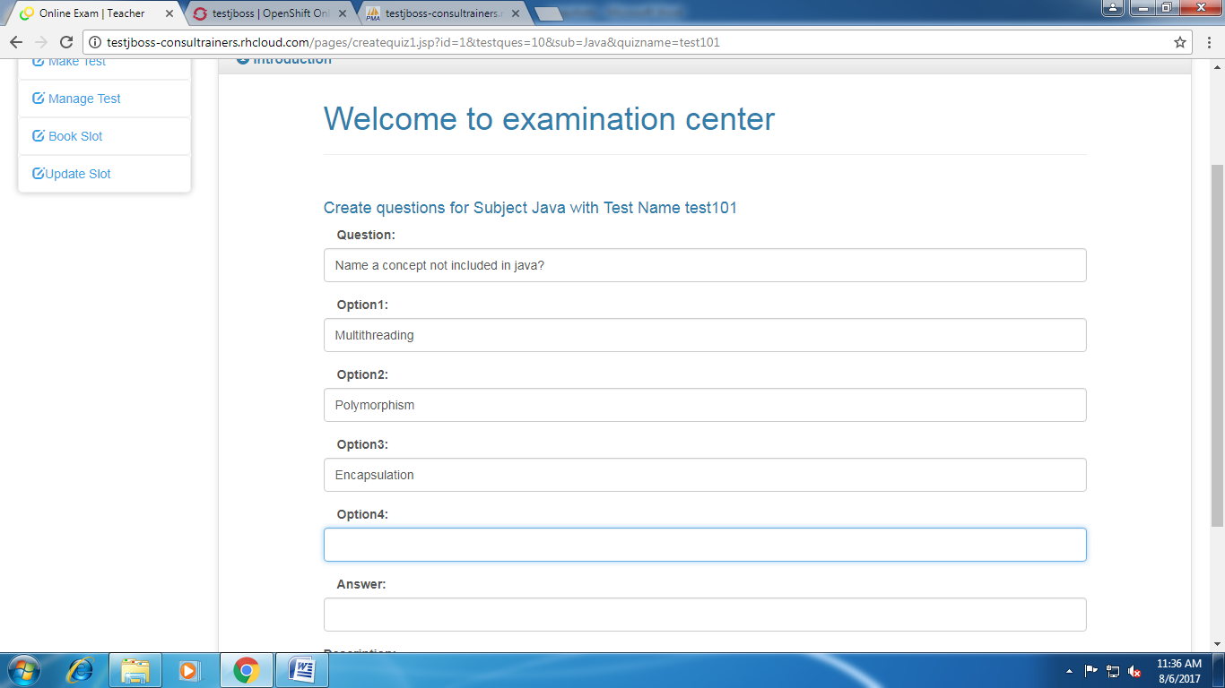

**CREATE QUESTIONS**

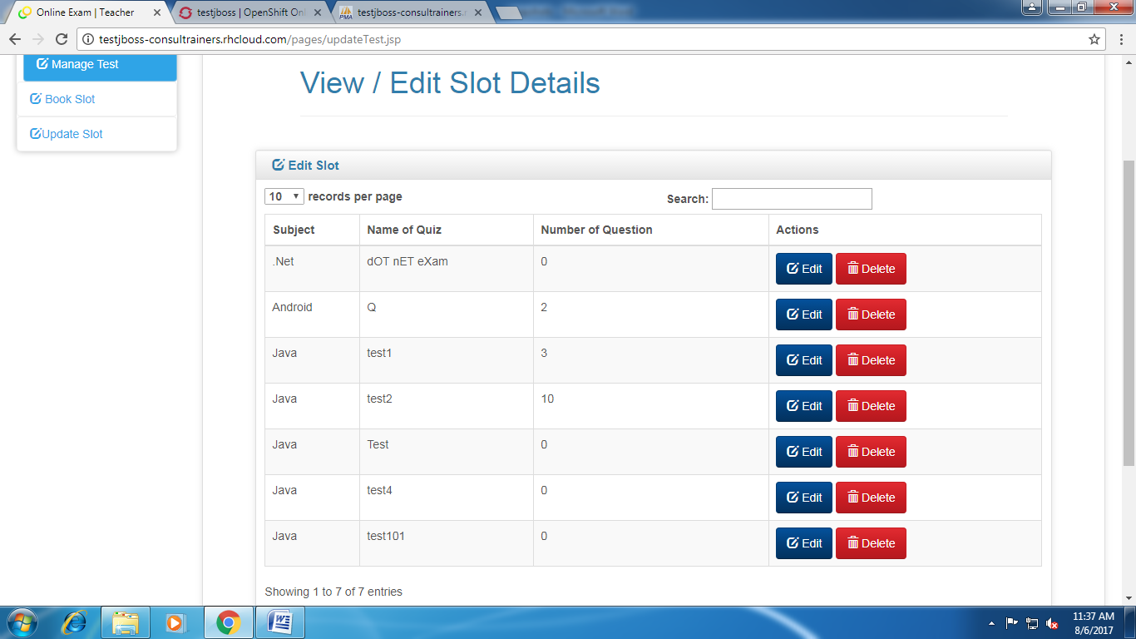

**MANAGE TESTS**

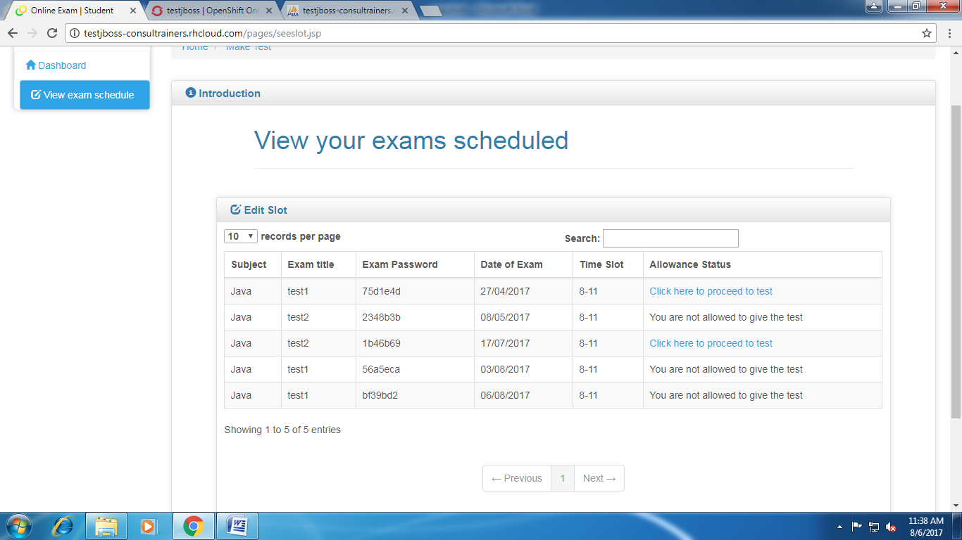

**MANAGE TESTS (STUDENT’S DASHBOARD)**

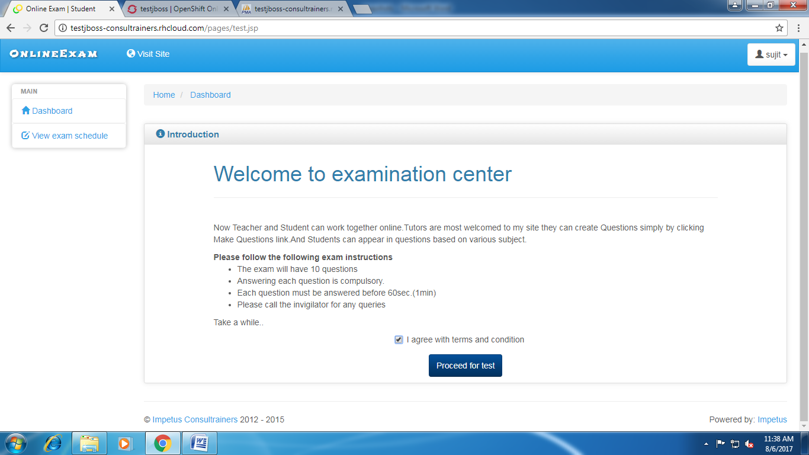

**PROCEED TO TEST**