JAVA PROJECT FILE

NAME: TIKESHWAR OMKAR BARADE

STEPS:

1. Extract RNO_59_AIRPORT.RAR file through winrar in your folder.
2. You will get src file open with IntelliJ …You will find Airport package
3. It consists of 3 java class file in which Airservice.java is the service class please run it to see functionality of project.
4. Before running the runner class file please set up connection.properties file
5. Please provide a database name where you want to store data in the above file.

KEY FEATURE:

In this project I have tried to manage the access of airport system, where I have separated logins of ADMIN and USER where there authority of retrieving and manipulating with data are different:

ADMIN : Have authority of insert,update,get:

USER : Have authority of GET any details…

* When running the airservice.java file and UI to enter as admin.

* CREATING A FLIGHT DETAILS TABLE BY CHOOSING 1

* INSERTING DATA OF FLIGHT BY CHOOSING 2

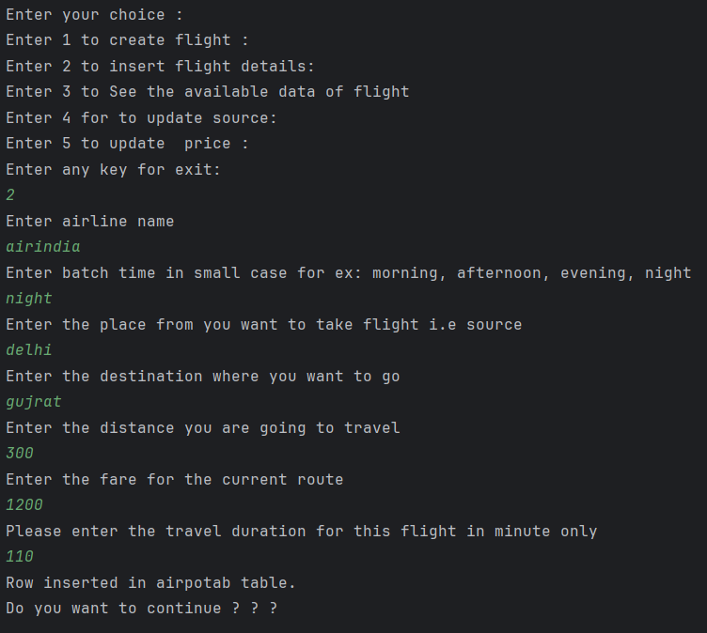

* RETRIEVING ALL DATA AT ONCE BY CHOOSING 3

* UPDATING SOURCE BY CHOOSING 4

* UPDATING FARE BY CHOOSING 5

* EXITING AS ADMIN AND LOGIN AS USER

* FIND FLIGHT BY CHOOSING 1

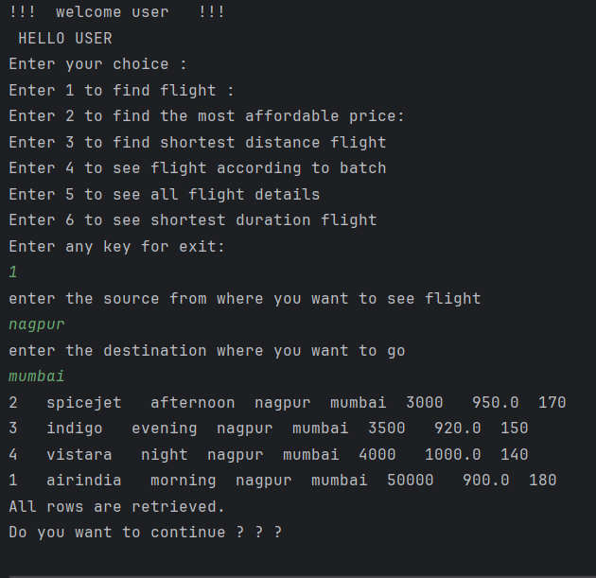

* FIND THE CHEAPEST FLIGHT BY CHOOSING 2

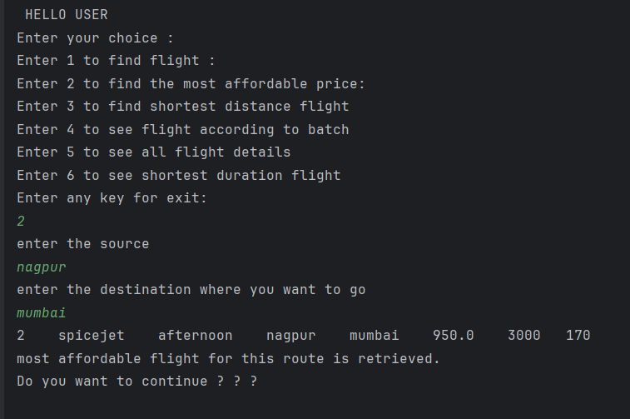

* FIND THE SHORTEST DISTANCE FLIGHT BY CHOOSING 3

* FIND THE FLIGHT ACCORDING TO TIME BY CHOOSING 4

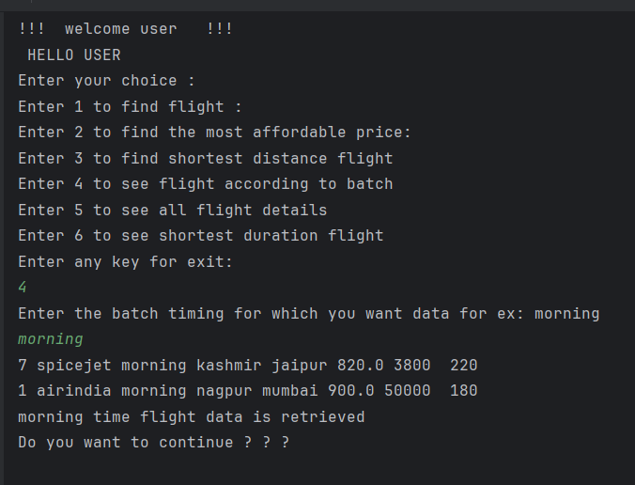

* FIND ALL FLIGHT DETAILS BY CHOOSING 5

* FIND ALL SHORTEST DURATION FLIGHT BY CHOOSING 6

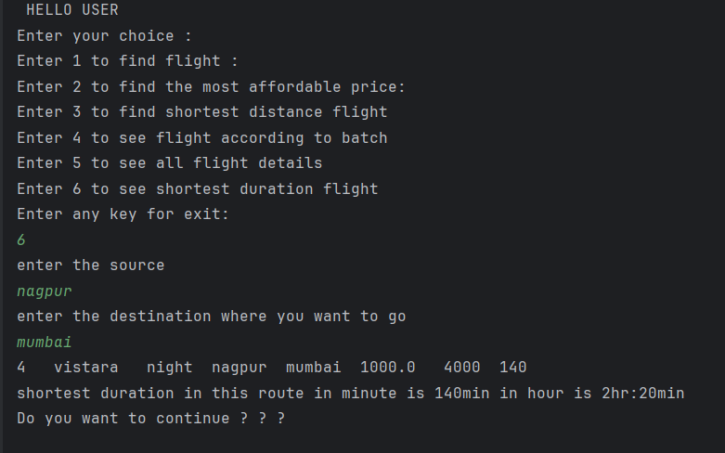

* MANIPULATED DATA IN POSTGRES SQL
* 