- A passenger cancels their booking. You need to remove the booking for the flight. Ensure the ‘booking’ table no longer contains the booking. Simulate an error to test rollback (for example, invalid booking_id).
Пассажир отменяет бронирование + тестирование отката

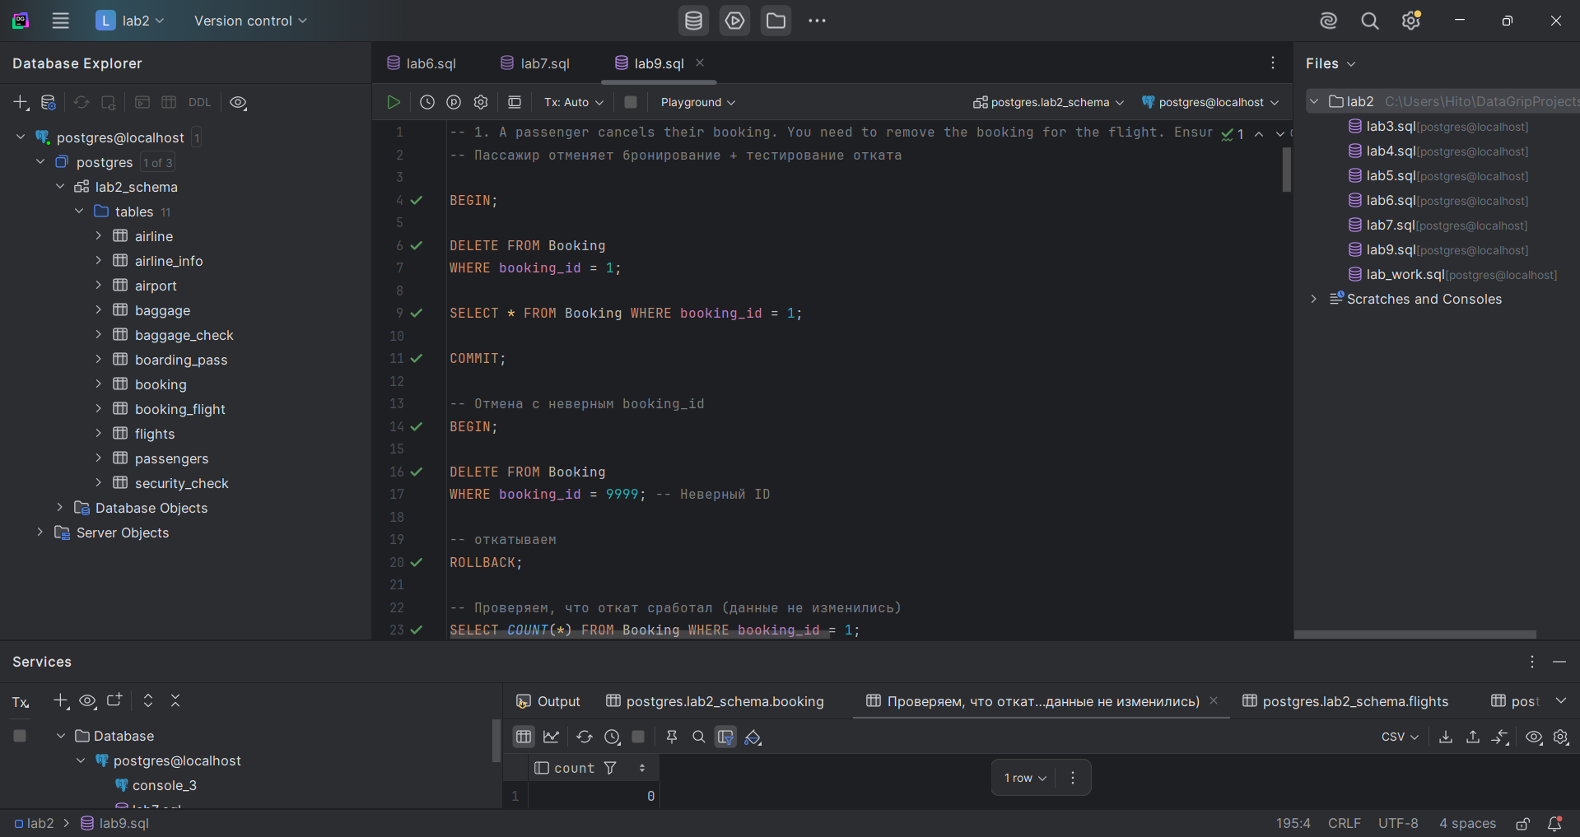

- Rescheduling a flight. You need to reschedule a flight. Verify the ‘flights’ table reflects the new departure time. Simulate an error to test rollback (for example, invalid flight_id).
Перенос рейса + тестирование отката

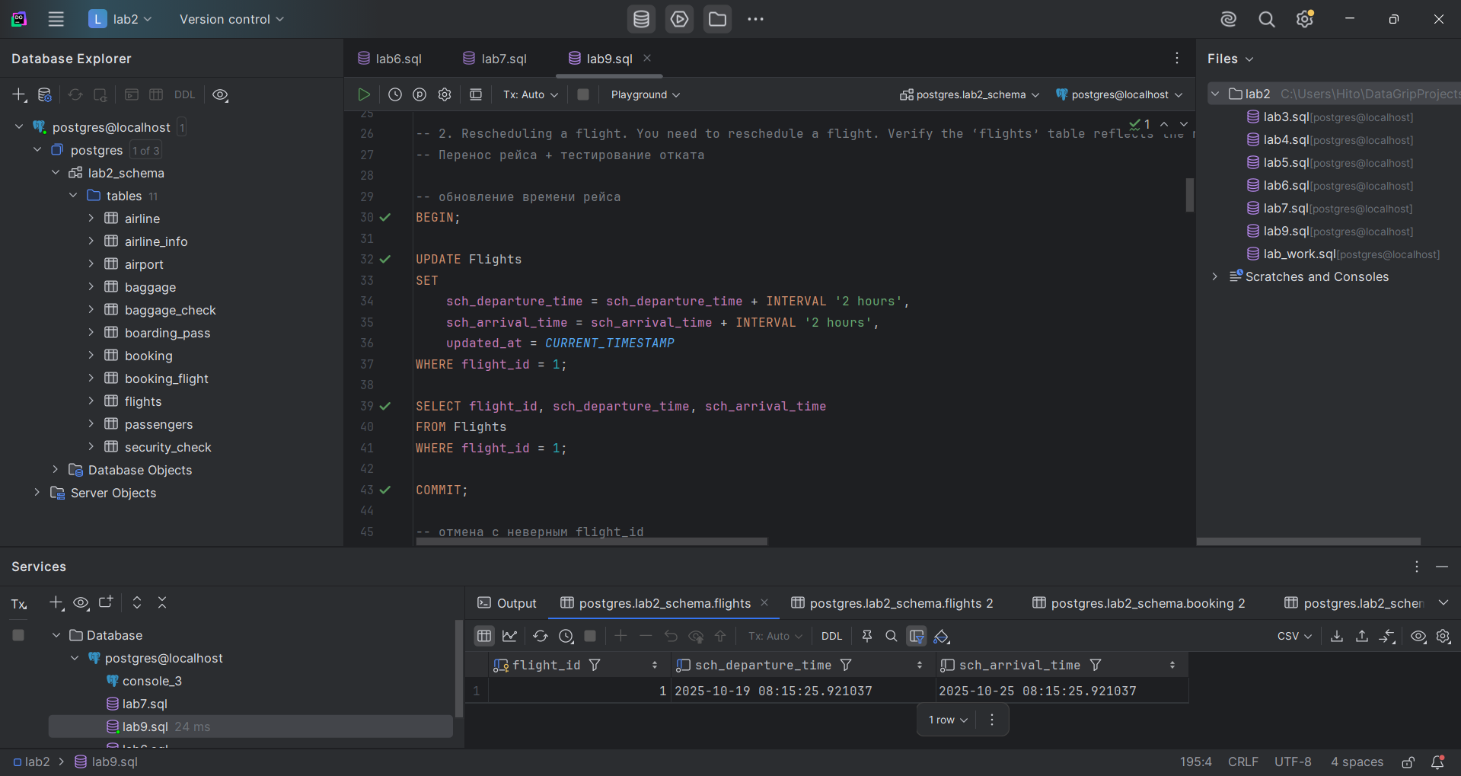

- Updating ticket prices. You need to decrease the ticket price for a specific flight for all existing bookings. If an error occurs, no changes should be applied.
Обновление цен на билеты с гарантией отката при ошибке

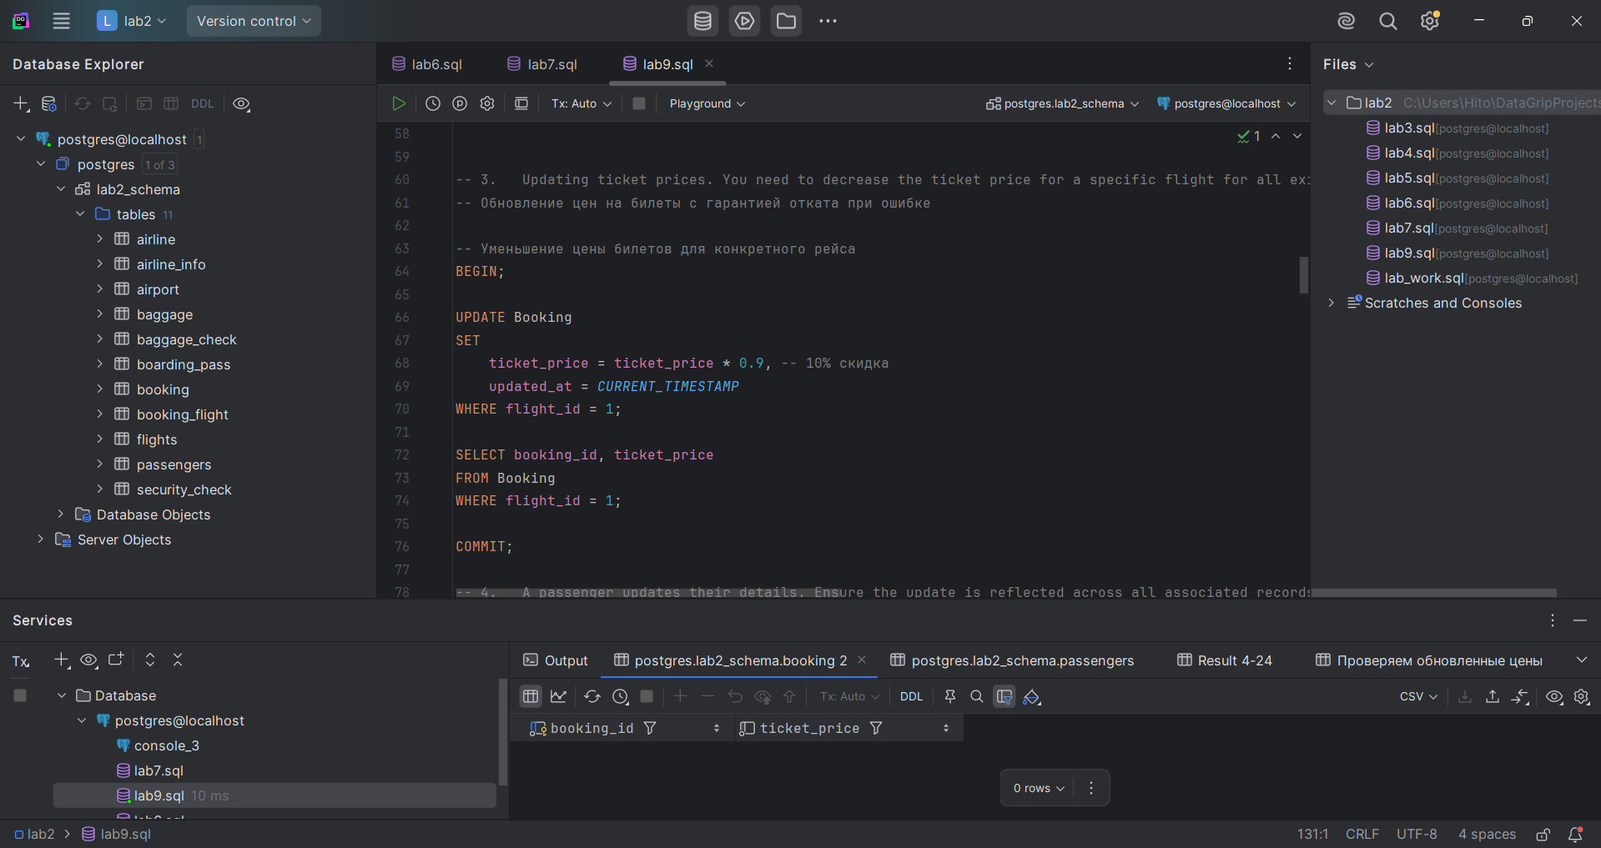

- A passenger updates their details. Ensure the update is reflected across all associated records, including bookings.
Обновление данных пассажира во всех связанных записях

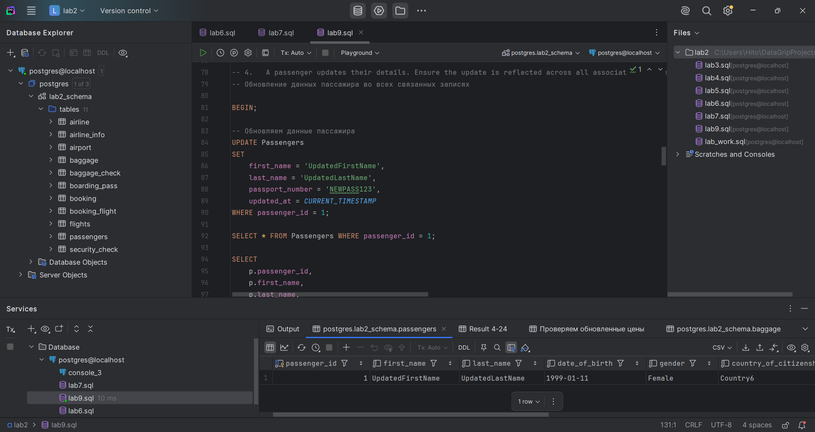

- A new passenger is registered, and a booking is created. Ensure the new passenger is added and the booking succeeds.
Регистрация нового пассажира и создание бронирования

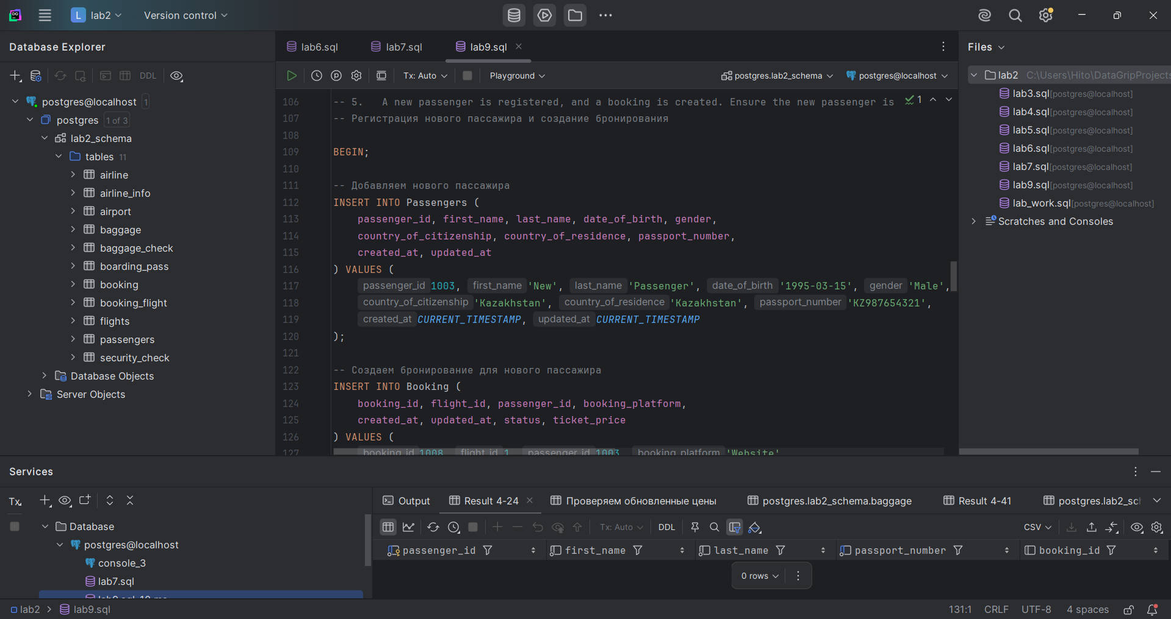

- Increase the ticket price for all bookings on a specific flight by a fixed amount.
Увеличение цены билетов для всех бронирований конкретного рейса

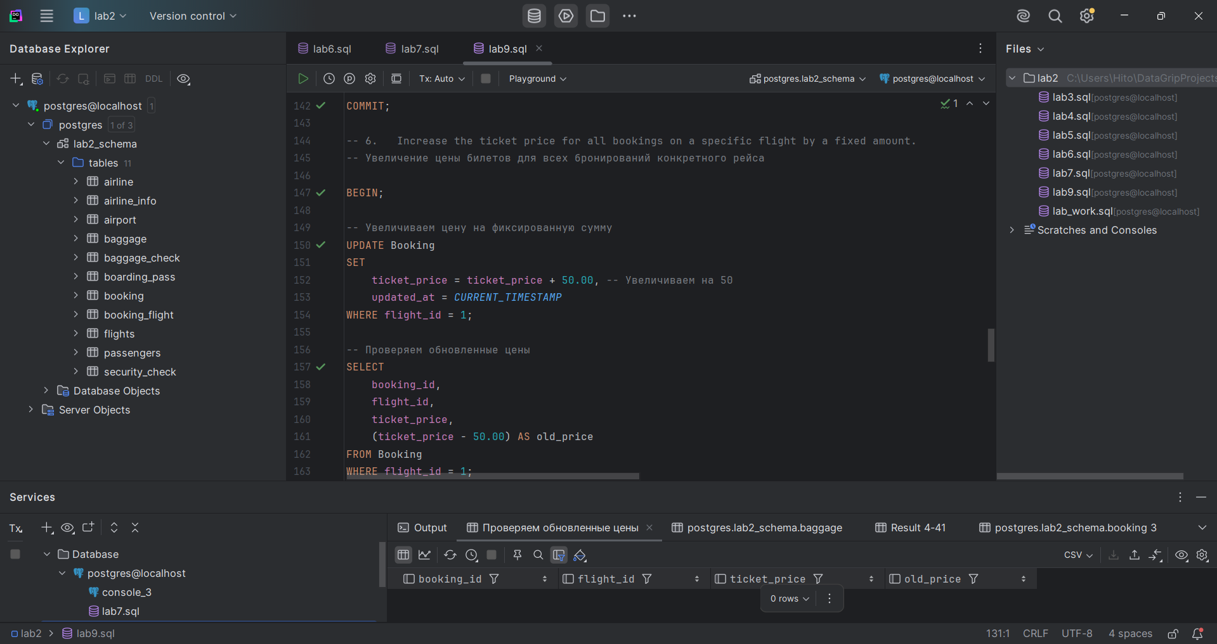

- Update a baggage weight. A passenger updates the declared weight of their baggage. Ensure that the change is correctly reflected in the database.
Обновление веса багажа

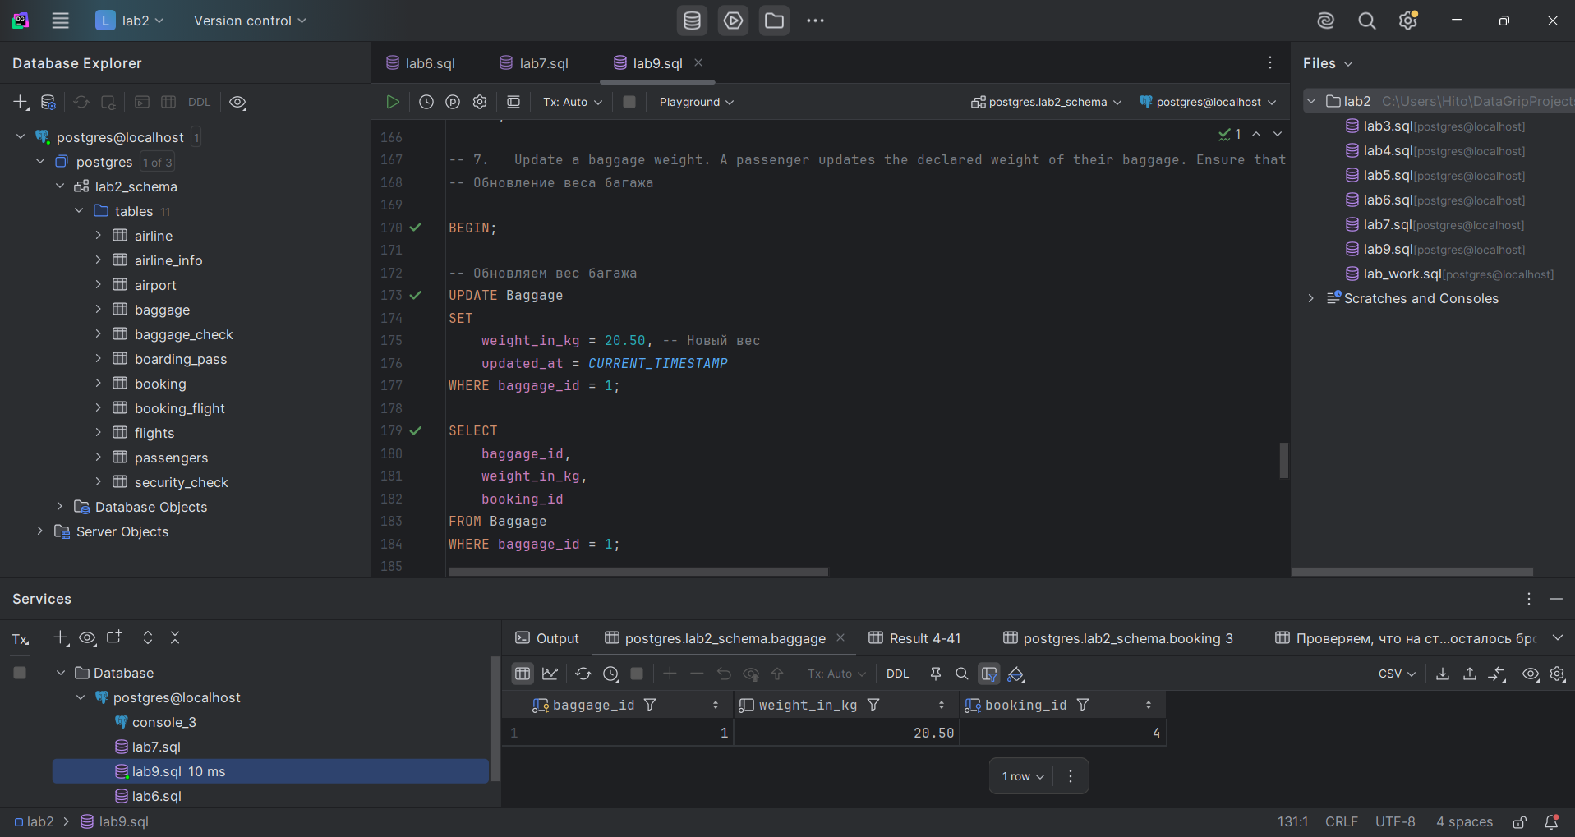

- Apply a discount to a booking for a specific passenger. If any error occurs, roll back.
Применение скидки к бронированию с откатом при ошибке

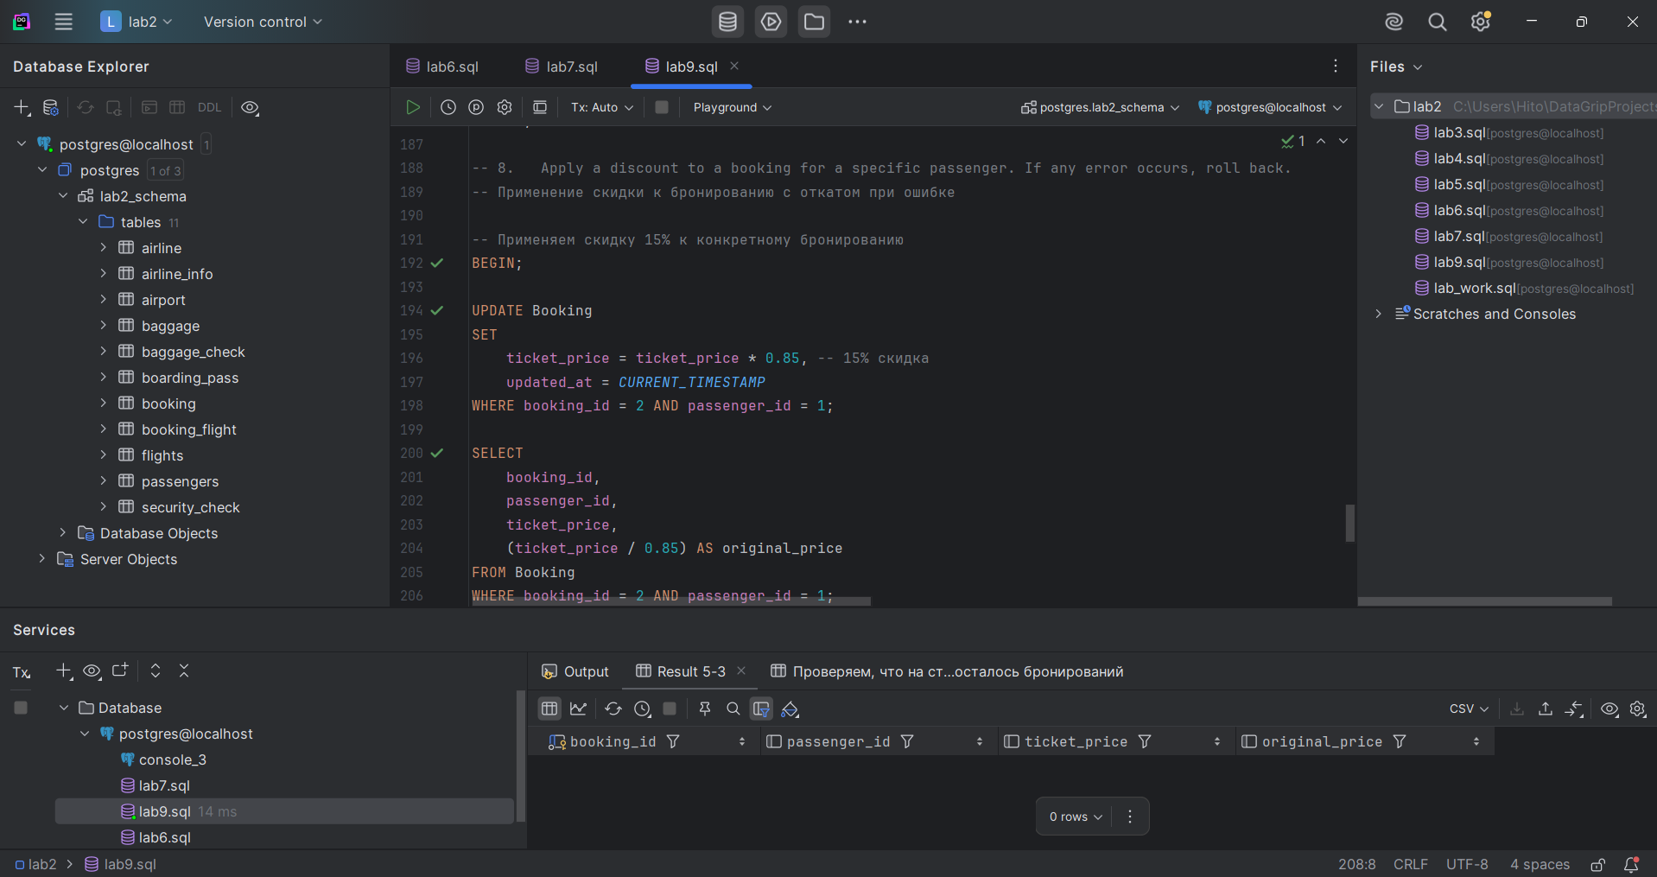

- Reschedule all bookings for a flight to a new flight.
Перенос всех бронирований с одного рейса на другой

