Tiki v0.9: Spica

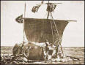

Documentation and User Manual

What is Tiki?

Tiki is a CMS system based on a Wiki, if you are not familiar with CMS systems or Wikis just keep reading we’ll explain. Tiki is designed to be international, clean and extensible.

About this version

This is version 0.9 codename: Spica. This is a beta version, the application was tested but not in the level of detail that we would have want. Please help us by testing the application and reporting bugs/errors/features and suggestions to the author: lrargerich@yahoo.com. Tiki versions are named after popular stars. Spica is the brightest star in the constellation of Virgo (αVir), it’s magnitude is 0.98 making it the 16th brightest star. It’s a blue star that slightly varies it’s magnitude. Spica is at about 220 light years from earth.
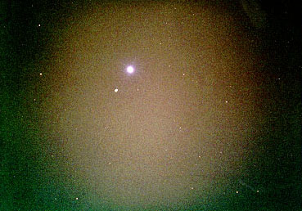

Introduction

Welcome to Tiki 0.9! the most advanced Wiki-System ever. The Tiki-Wiki incorporates all the features present in several excellent wiki systems available today plus a lot of new features and options allowing your wiki application to be whatever you want it to be, from a simple wiki to a complex weblog for a whole user community.

Table of contents

What is Tiki? 2
About this version 2
Introduction 2
Features 5
Requirements 6
Optional 6
Installation 6
Understanding directories 7
Configuring the database 7
Installation Troubleshooting 8
Initial Configuration 8
The Wiki 10
Using the wiki 10
Creating and Editing Pages 10
Backlinks 13
Search engine 13
Ranking 14
Like Pages 14
Managing page versions 14
View 15
Remove 15
Diff 15
Rollback 15
Removing Pages 15
Pritntable version 15
The Wiki Tag System 15
Normal text 16
References to other wiki pages 16
Links to external pages 16
Bold and italic text 16
Lists 17
Bullet lists 17
Numbered lists 17
Definitions 17
Monospaced text 17
Using tables 17
Including images in your pages 18
Full HTML editing 18
Dumps 19
Galleries 19
Creating and Editing Galleries 19
Populating galleries 20
Featured Links 21
Administration functions 22
Understanding users and groups 22
User administration 22
Group administration 23
Assigning users to groups. 24
Assigning permissions to groups. 24
Permissions 24
Permissions for individual users 25
Permissions for individual pages 25
The general administration panel 26
Creating/Restoring tags 26
Preferences 27
Features 28
Modules 29
User modules 29
Assign module 30
Assigned modules 30
Edit/Create user module 31
Featured Links 32
The cache 33
The RSS feed 33
Customizing the application (Tiki for programmers) 33
Style, themes and look and feel 34
Internationalization and language 34
Creating a new language (this is easy!) 34
Appendix A: List of application templates 35

Features

- Works with PHP4 even if register globals is off
- Uses CSS to define the look and feel, themes are CSS files
- The generated code is valid XHTML 1.0 transitional
- Uses PEAR to allow the application to use any database
- Windows & Unix compatible
- Easy installation and configuration
- PEAR:DB is used, you can use this application with your favourite DBMs without changing the code
- Templates allow the user to change the look and feel of the whole application (Smarty the PHP template engine is used)
- Automatic – internationalization, translate a language file and use it, language files are automatically generated by a provided script.
- Edit pages using wiki-tags including the following:
  - Bold text
  - Italic text
  - Headings
  - Bullet lists
  - Monospaced text
  - Images*
  - Tables*
- Administrators can edit pages using full HTML tags
- Manage permissions using groups (permissions are assigned to groups)
- Image galleries
- Configurable boxes
- Auto-Caching system for URLs
- Auto capture for images.
- Last Changes to pages
- Versioning system for pages where you can
  - Review a page version
  - Rollback a page to a given version
  - Remove unwanted versions or pages
  - Diff different versions of a Page
- Backlinks
- Lock/unlock pages
- Individual permissions for pages can be set-up optionally
- Search engine
- Page ranking
- Dump to XHTML
- Integrated RSS feed describing last changes to the wiki

Requirements

- PHP 4.2+ [Should work with 4.1+ but not tested]
- A database

Optional

- GD library > 1.5 and PHP compiled to use GD (for thumbnails), not needed if you use pHP 4.3+ since GD is bundled.

Installation

Installing Tiki is easy, first of all you should obtain a distribuition of the application, you should already have one if you are reading this file. Tiki can be distributed in several formats, zip, bz, tgz, etc. Unzip, untar or uncompress the Tiki distribution in a directory that can be accessed from your web server. For example /www/htdocs, Tiki will create a tiki directory and put all the files and directories of the application under that directory.

This is the directory structure used by Tiki

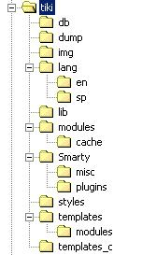
These directories must be writeable by PHP

Understanding directories
(you can skip this section if you just want to install and use Tiki)

You can install tiki in any directory and you can name the tiki directory as you want, but you have to respect the internal directory structure of the application since Tiki relies on certain directory names to find modules, images and language files.

The directories contain the following information:

Directory | Description
db | This is where the database connection script is included and the SQL script to create the database is found.
dump | In this directory is where Tiki generates the xhtml dump of the pages to allow users/admins to download a locally browseable version of the Wiki
img | Images used by Tiki
lang | Root for languages
lang/en, lang/sp, etc | Each directory contains a language.php file with the translation of the application strings to the language.
lib | Library files used by Tiki (The Tiki API)
modules | PHP code for modules
modules/cache | This is where Tiki stores cached results from modules
Smarty | The Smarty distribution used with Tiki
styles | CSS files used by the application, each CSS file defines a « Theme » that can be used
templates | Smarty templates for the application
templates/modules | Smarty templates for modules
templates_c | This is where Smarty stores compiled templates (Smarty compiles templates as php scripts)

Configuring the database

Once all the files are in-place you should create a database for Tiki tables, we’ll use MySQL in this example but since Tiki uses PEAR you can use Tiki with any DBMS supported by PEAR: Oracle, Postgress, etc.

Create a database

mysqladmin create tiki

And then run the tiki.sql script that creates and inits the tables.

mysql tiki < tiki.sql

You can create a user that will be used by the application to access the database in such a case don’t forget to give the database user permission to select, read and write to the tiki database.

NOTE: Tiki tables are named tiki-name and users-* thus you can make tiki share the database with another application without name-collisions between tables, this is particularly useful when installing the application in a hosting.

Now point your browser to http://yoursite.com/something/tiki/tiki-index.php and you should see some page displaying an error message since you won’t have permission to access the Wiki yet. If you see a page generated by Tiki then congratulations, you have successfully installed Tiki.

Installation Troubleshooting

If tiki-index.php fails complining about not being able to include “DB.php” then PEAR is not visible from your PHP installation, Tiki needs PEAR to use PEAR::DB, the database abstraction layer used in PHP. Find the “pear” directory included in your PHP installation and make sure that you have that directory in the include_path in your php.ini file.

Initial Configuration

Once installed you are ready to configure Tiki to meet your needs, this is the initial screen that will be displayed when you access Tiki:

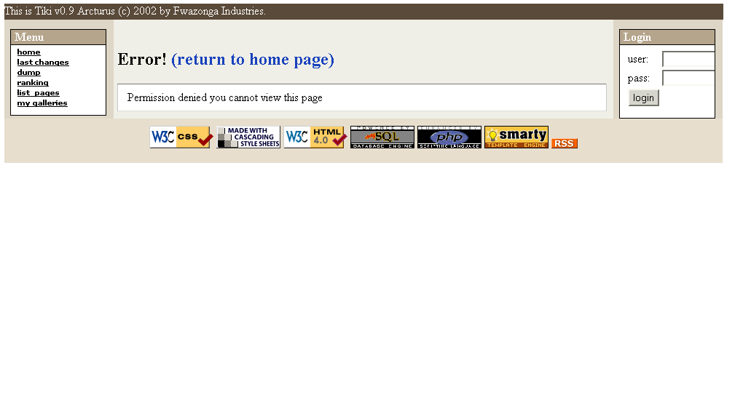
This page is displaying the Application menu, the login box and an error message since initially anonimous (not logged) users can’t view the Wiki pages, the first step in order to be able to configure Tiki is to be logged as admin, log in using the login box as ‘admin’ using password ‘admin’.

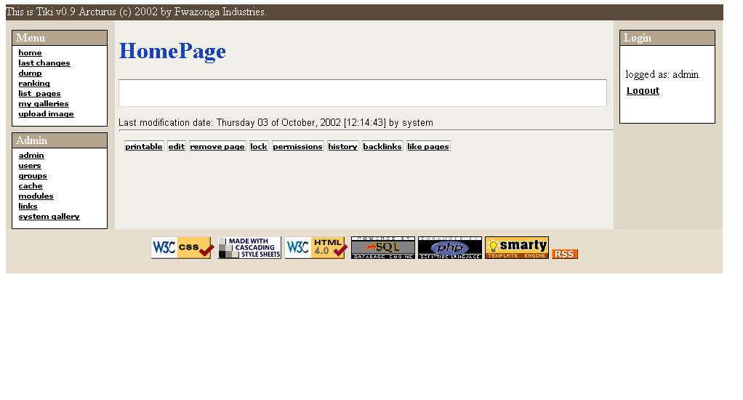

You may need to refresh the browser in order to see the Admin menu on the left bar.
Now you can see the HomePage of the Wiki (blank) and you can also see a new module on the left navigation bar displaying the admin menu.

Tiki is now installed and ready to be configured and used, Jump to administration functions in order to learn how to configure users, groups, permissions, modules and features if you want.

The Wiki

Using the wiki

The Wiki is an environment where users can edit pages as they want adding information, links, lists and images that they find useful, you can use a Wiki as a feature of a users community, a club, a fan site, etc. The most important elements in the Wiki are the Wiki pages.

Creating and Editing Pages

If you have the appropiate permissions you will see a menu at the bottom of pages with several options and one of them will be “edit”, when you click “edit” you are able to edit the page that you are watching, you can try editing a page and writing some text on it. Use the “preview” feature as many times as you need it before clicking “save”.

In order to create a new Wiki you should first generate a “reference” to the page from an existing page, Wiki automatically generates a reference when you write a word using Capitalized words smashed together, for example ThisIsMyPage or TennisResults or VisitLondon, when Tiki first sees a reference the page will display the name followed by a “?”, let’s see an example.

We’ll edit the home page.

Access the home page and click “edit” at the bottom of the page.

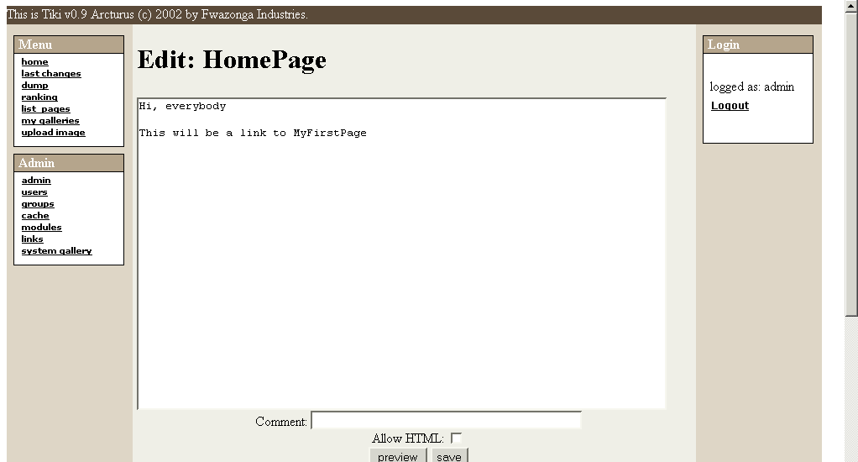

Write some text making sure you use the word MyFirstPage, save the page using “save”. You will se something like this:

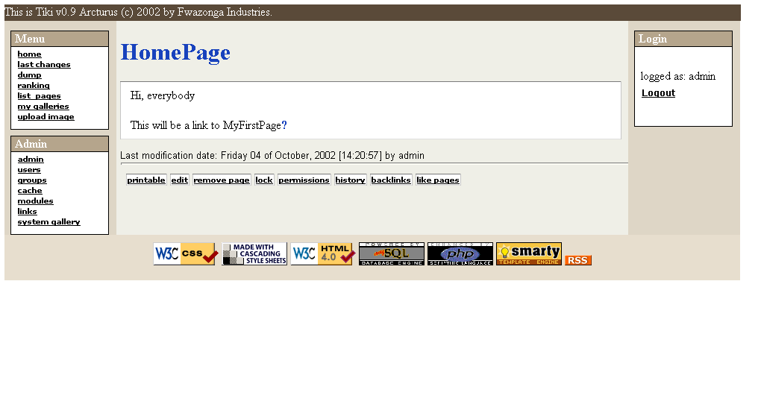
As you can see there’s a “?” question mark following MyFirstPage, this indicates that MyFirstPage is referenced from this page but has no content (it was never edited) so the “?” question mark is a link to “edit” the page. Click the question mark and edit the page.

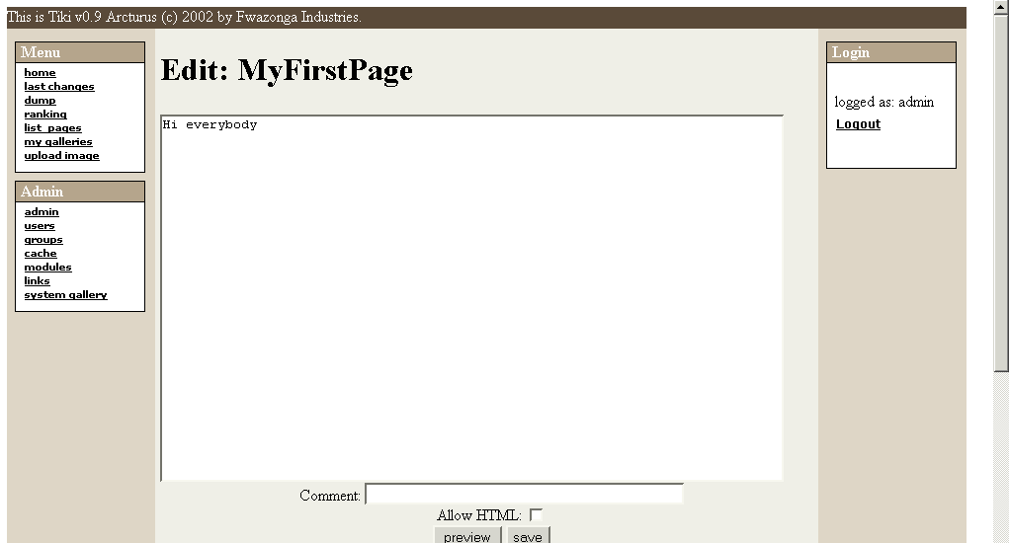
Save the page using the save button and you will see:

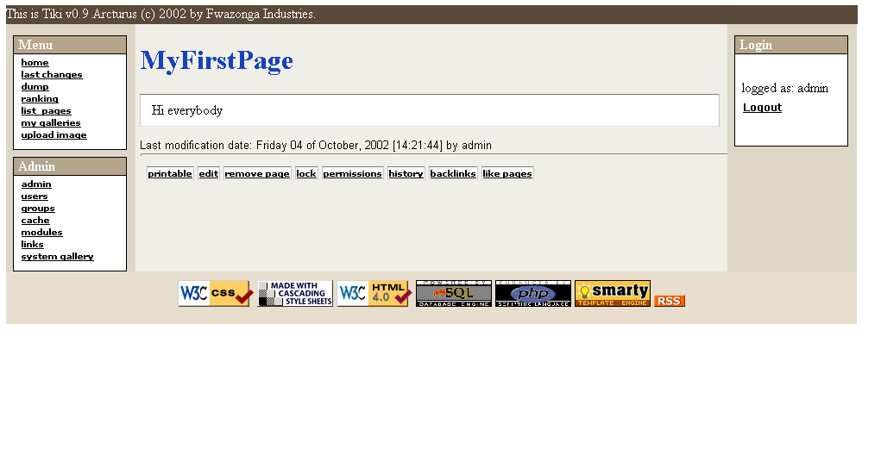

Click the “home” option in the menu to return to the HomePage, this will be displayed:

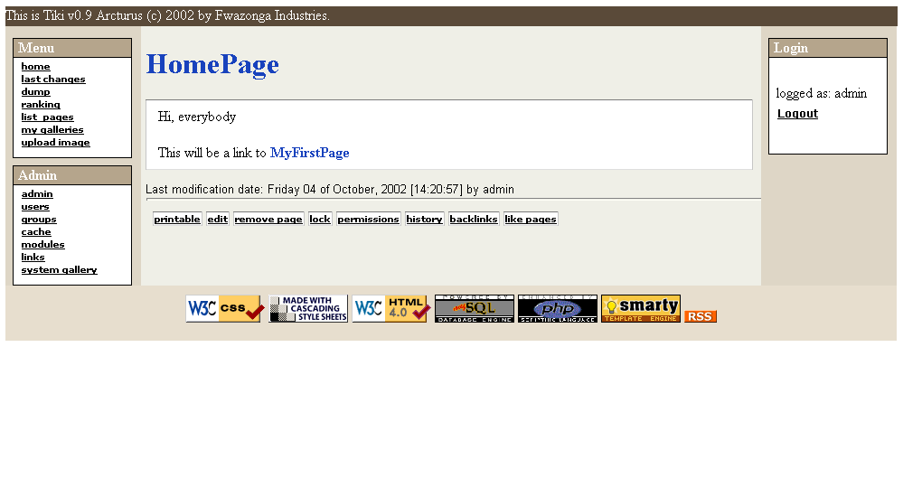
As you can see MyFirstPage is now displayed as a link, if you click on it you will access MyFirstPage viewing the content you just edited.

This is how new pages are created and edited and how the Wiki is navigated, as you can see creating pages is really easy and that’s why Wiki’s are populated at a very high speed rate by their users adding pages and content as they need.

If you want to know what kind of features you can use when you edit a page visit the Wiki Tag System section where you will learn how to use titles, lists, images etc.

Backlinks

The backlinks page shows pages that have a reference to the page you are viewing, this is particularly useful to know where is your content being used or referenced and it is a nice toy too.

Search engine

The search engine can be used once the search module is configured and placed on the left or right side bar of the application, if you are admin see the configuring modules section to learn how to configure modules.

If you see a search box, just enter some text and the search engine will find pages where the title or the content match the text you entered, results are ordered by relevance.

Ranking

The ranking shows the “Top n” most accessed pages in the wiki, each time a page is visited a counter is incremented, unless you have modified the index page the HomePage will be always the most accessed page of your site.

Like Pages

This option shows pages where the page name contains some word used in the name of the page you are visiting, for example, MyPage and MyCar share the word “My” so will be displayed as “Like pages”.

Managing page versions

One of the most interesting features of the Wiki is that each time you edit a page the previous version is not discarded but stored in the history. If you have the right permissions you can view previous versions and rollback a page to a previous version if needed. This is how vandalizing is prevented/countered if a page is vandalized it will stay in that state only until a user restores a previous version.

You can see the history of a page using the “history” button at the bottom of a page. A table will be displayed showing the last versions of the page and several options for each version.

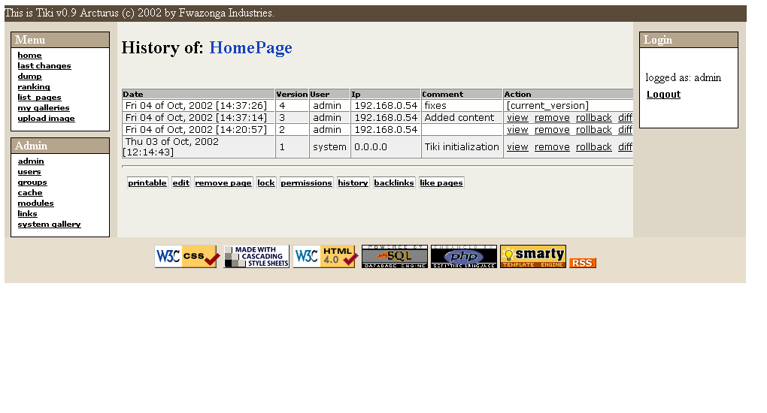
For each version the following actions are available:

View

View will show you that version of the Page 16 of 37

Remove

Remove can be used to remove a version, you will be asked for confirmation before removing a version.

Diff

Diff shows a diff between the actual version of the page and the version you selected.

Rollback

Rollback is used to revert a page to a given version. You will be asked for confirmation before rolling back a page to a previous version.

Removing Pages

The “remove” button at the page bar can be used (if you have permission) to remove a page, you will be asked for confirmation and you can also remove all the previous versions if you want to remove a page permanently.

Pritntable version

The “print” button can be used to view a printer-friendly version of the page without the side bars, bottom bar and the top-bar.
The wiki-tag system

The Wiki Tag System

The wiki-tag system is the “language” you can use when you edit wiki pages, there’s a common set of features that are usually present at all wikis that Tiki mantains and some special features not frequently found in Wikis that Tiki adds.

You have a quick-reference to the wiki-tag system available at the bottom when you edit a page in the Wiki.

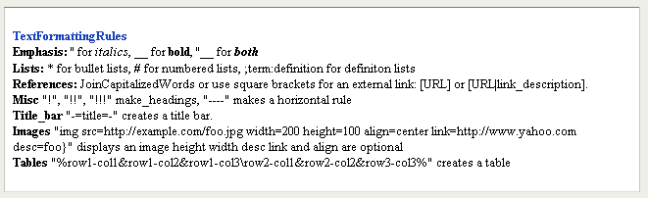

Normal text

Normal text is just entered as-is.

References to other wiki pages

References are created when you use capitalized words smashed togeteher, if the page exists a link to the page will be shown, if not a link to edit the page will be displayed.

ThisIsaReference

Links to external pages

Links to external pages can be entered using one of the following formats:

[http://www.somesite.com]
[http://www.somesite.com|This is a nice site to visit]

The first format will display the URL as a link while the second one will display the description as a link to the given URL.

Tiki will automatically cache references to external pages or sites and a link to the cache will be displayed following the link, this is particulary useful when you link to notes or sections that may change or that may disappear in a near future. (Very similar to the google cache when you see the results of a search in google)

Bold and italic text

Bold text can be entered using two underscores before and after the text.

__This is text in bold__

Italics are displayed using two quotes before and after the text

‘’this will be displayed in italics’’

Lists

Bullet lists

Bullet lists are automatically created when you prefix a line of text with an asterisk “*” (as you do when using Word for example)

Numbered lists

Numbered lists can be entered prefixing each line in the line with a hash mark “#”

Definitions

Definition lists can be entered using the following format:

;term1:definition1
;term2:definition2
etc...

Monospaced text

Monospaced text can be used to show portions of code or text that needs to be properly aligned (ASCII art anyone?). To enter monospaced text prefix each line of text with a blank space. Lines starting with a blank are displayed in a courier monospaced font.

Using tables

You can create rudimentary tables using Tiki, a table can be entered using the following notation:

%row1column1&rowcolumn2&row1column3\row2column1&row2column2&row2column3%

Note: % delimites the table, & delimites cells and \ delimites rows.

Including images in your pages

Images can be included in a Wiki page using the following syntax

{img src=http://www.something/image.jpg with=100 height=100 desc=foo align=center link=http://site.com}

Where only src is mandatory and the rest of the attributes are optional. Note that you mustn’t use quotes for the attribute values. The attributes are:

src | URL for the image
height | Image height
width | Image width
align | can be center, right or left
desc | Image description to be displayed below the image
link | an URL to make the image link to that URL

If you include an image from a URL Tiki will automatically “capture” the image and replace the link to an internal database-stored version of the image, that allows images to persist in the pages even if they are removed from the remote servers that originally had them.

Full HTML editing

If you are admin or if you have the proper permission you can use full HTML when you edit a Wiki page, normally you don’t want regular users to use HTML since they can use wrong HTML, alter the page layout or break pages that’s why the Wiki-Tag system exists. However for admins or trusted editors full HTML editing is a powerful way to make a page look exactly as you want. Whenever you edit a page containing HTML code make sure that the “Allow HTML” checkbox is checked or the HTML tags will be eliminated. IF you accidentally estroy a page that previously contained HTML don’t worry just rollback the page to the previous version using the rollback button from the page history.

Dumps

If dumps are enabled you’ll see link to “dump” in the application menu, this will allow the user to download an XHTML dump of the Wiki pages that can be browsed locally, this is useful to create CDs or a quickly on-the-go version of the Wiki. Note that images are not dumped in this version and no cache is available.

Dumps are generated by the administrator using the “generate” dump feature in the admin screen.

Galleries

Galleries are collection of images, if you have the right permission you will be able to create galleries and upload images to the galleries.

Creating and Editing Galleries

To create a gallery click the “my galleries” link in the application menu, you will see a list of the galleries that you can “access”, if you created the gallery you’ll see links to edit the gallery, remove it, etc. If you don’t own the gallery you’ll only be able to visit the gallery.

Note that all galleries can be accessed by all users, there’s not a way to make a gallery only accesible by some users, don’t include private photos in a gallery unless you can accept that everybody can see the images.

In the gallery list there’s a link to “create gallery” if you have the permission to do it. The create gallery page is as follows:

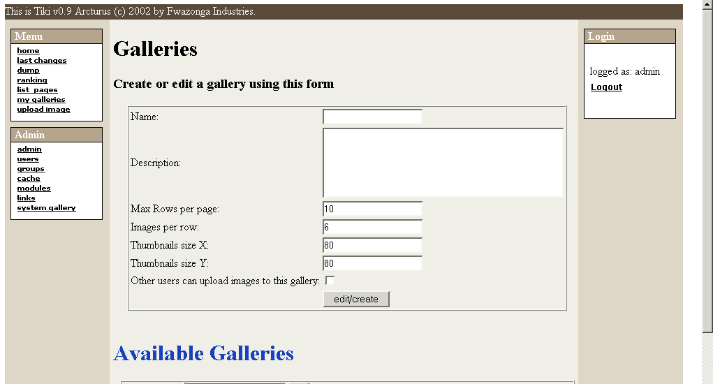

The fields are described as follow:

Field | Description
Name | The gallery name
Description | The gallery description
Max Rows per page | Maximum number of rows of thumbnails that will be displayed when someone visits the gallery.
Images per row | Maximum number of thumbnails per row when visiting the gallery.
Thumbnails size X | Width for Thumbnails
Thumbnails size Y | Height for Thumbnails
Other users can upload images to this gallery | If checked then other users can upload images to your gallery, they won’t be able to delete images or change the gallery.

Populating galleries

Once a gallery is created you should start uploading images to the gallery, you’ll see a link to ‘upload image’ in the application menu or as an option when listing galleries. The upload image screen is similar to this one:

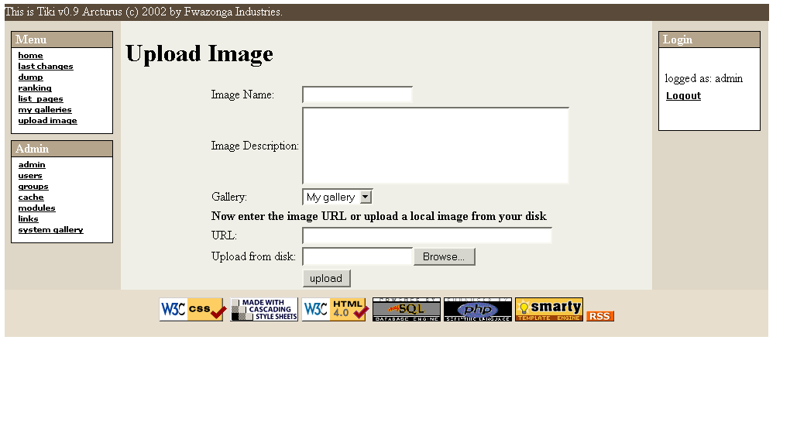
The fields are self-explanatory, note that you have to select a gallery where the image will be uploaded, you can upload images to galleries you created or public galleries created by other users(!).

Thre’re two ways to upload images: entering the image URL or uploading an image from your disk, the upload screen admits both formats but you should use only one method for each image. (If you enter a URL you dont’ have to upload and if you upload you don’t have to enter a URL).

If everything goes fine the image will be uploaded and you will see the image and the thumbnail displayed.

If you see the thumbnail with the same size as the image then: if the image was a GIF file this is normal, don’t worry, if the image is not a GIF your PHP installation doesn’t have the GD extension or the GD extension is too old, in such a case thumnbnails will be generated resizing the original image.

Featured Links

Featured liks are links to sites/pages of special interest by the user community of the Wiki, when you click on a featured site link the site will be displayed as a Wiki page (as if it were framed). That’s all, links to sites.

Administration functions

So you are the admin user, you are the one that can decide what other users can or can’t do and how the application will be used by your users, Tiki allows a lot of flexibility that requieres just a little reading.

Understanding users and groups

The most important part of the Tiki administration is uderstanding the permission system used by Tiki, basically the rules are:

- Administrators can create and edit groups.
- Users can be assigned to one or several groups.
- Permissions are assigned to groups, NOT users.

There’re two pre-defined groups:

- Anonymous : Users that are not logged automatically belong to the anonimous group.
- Registered group: Users logged in automatically belong to this group.

Tiki has the option to allow users to register themselves using the application or not, so registered users can or can’t be trusted depending on that setting.

User administration

The user administration screen allows you to administer users:

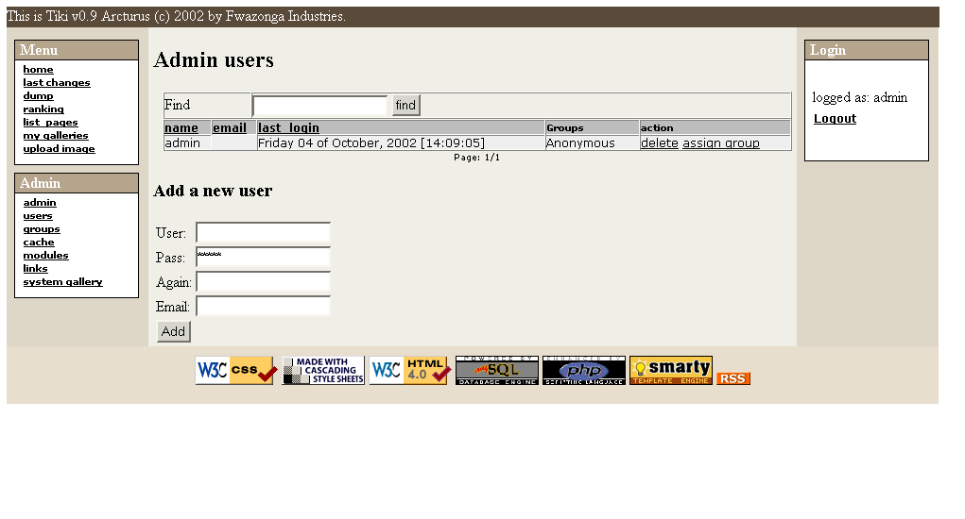
You can create new users (useful if users can’t register themselves), you can remove users and you can assign groups to a particular users. You can find users by login name using the find button at the top of the listing (it will act as a filter)

Group administration

The group administration screen is similar.

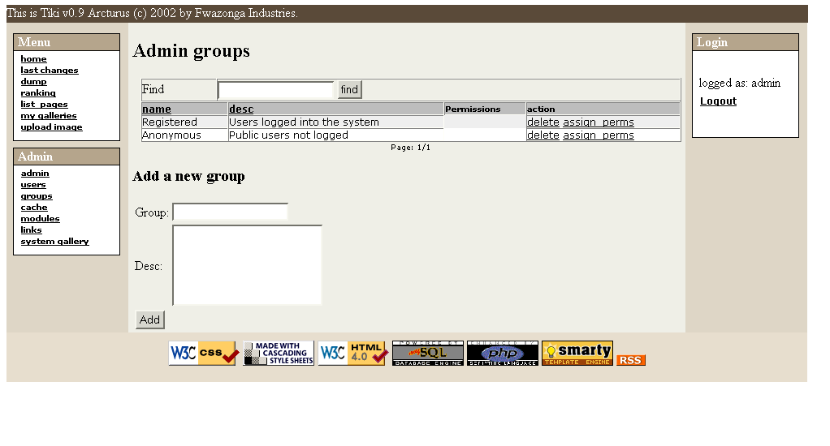
You can create groups, delete groups, find groups by name/description and you can assign permissions to a particular group clicking assign_perms in the row of the group. Note that by default the Registered and Anonymous groups are predefined.

Assigning users to groups.

Create a group, for example test and create a user, for example foo, then from the user administration screen click assign_groups for the user. You will be able to assign groups to that particular user a user can belong to as many groups as you want.

Assigning permissions to groups.

From the group administration screen click on assign_perms for a paritcular group and you will see a screen like this one:

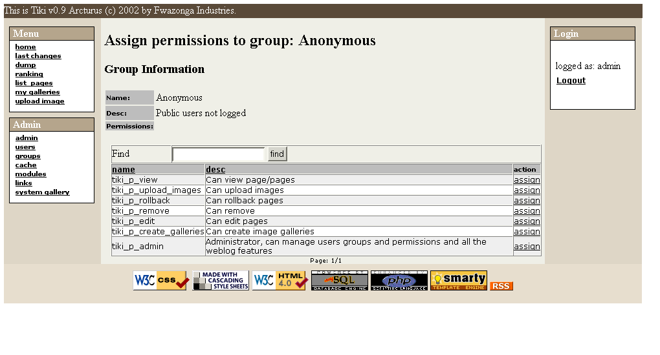
From this screen you will be able to add or remove permissions from a group.

When a user belongs to more than one group the permissions are accumulated.

Permissions

Permissions are what groups CAN do, note that permissions always ALLOW groups to do things, there’re no restrctive permissions in Tiki because they can conflict if the user has more than one group.

The list of permissions that you can assign to groups are:

Permission | Description
tiki_p_view | Groups with this permission can visit and read the Wiki pages
tiki_p_upload_images | Allows users to upload images to their galleries or galleries that were created allowing other users to upload images
tiki_p_use_HTML | Allows the user to use HTML when editing a page (doesn’t give edit permission to the group)
tiki_p_rollback | Allows the group to rollback a page to any previous version
tiki_p_remove | Allows the group to remove pages and versions of pages
tiki_p_edit | Allows the group to edit Wiki pages
tiki_p_create_galleries | Allows the group to create image galleries
tiki_p_admin | Makes the group ‘admin’ admins can do everything. This can be used to have more than one admin in the Wiki (the user named ‘admin’ is automatically assigned to this permission)

Permissions for individual users

What if you want to give a specific user some permissions? Just create an artificial group, assign the user to that group and give the group the permissions that you need.

Permissions for individual pages

The permission system explained above is what we call the GLOBAL permissions, if you are admin you can set INDIVIDUAL permissions for a page. You use the permissions button at the page bar. If the page has some individual permission then individual permissions apply, if not then global permissions apply. This is why a user that can edit pages may not be able to edit some particular pages. This is useful if you want only some users to be able to edit some pages on the Wiki, for example the home page, you can set individual permissions to the page and that will be that.

The permission system allows you to make Tiki behave as you want.

The general administration panel

The admin panel is where several settings about Tiki can be set, only users with admin permission can enter this screen, you can access it using the admin link from the Admin menu box.

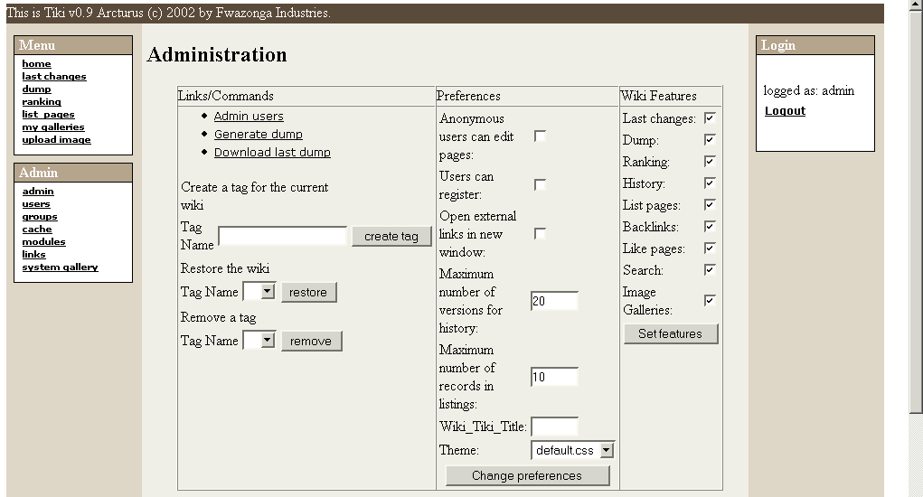

Let’s examine the options in this screen in detail:

Creating/Restoring tags

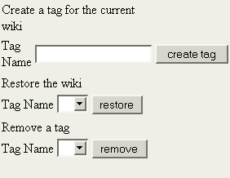

A tag is a “mark” that you can create for the Wiki at any moment, when you create a tag all the current versions of the pages in the Wiki are marked under that name. Later you can restore all the pages in the Wiki to a specific state using the tag, for example you may want to tag your wiki before testing several features and then recover the state before the test. You can create a tag enetering a name and pressing the create tag button. You can also restore the Wiki to any tag using the restore button (selecting a tag first) and you can also select a tag and remove it if you don’t need it any more (tags uses some space in the database)

When you create a tag the pages are saved to a special table, they are not only “marked” so you can always recover a tag even if all the pages were removed using the remove feature and even if all the versions were removed too. The restore option will automatically recreate the pages from the versions saved under the tag.

Preferences

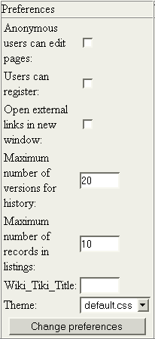

Preferences allow you to set some preferences that are explained below:

Preference | Description
Anonymous users can edit pages | If set then anonymous users will be able to edit pages (it’s preferred to leave this unchecked and use the permission system instead). This option may be deprecated in future versions of Tiki
Users can register | If checked users not logger may be able to register themselves filling a form. If not checked only admins can create new users. (This allows you to set a closed Wiki for some users only)
Open external links in new window | Links to external pages will be openen in a new browser window
Maximum number of versions for history | Number of versions that will be stored for each page
Maximum number of records in listings | Maximum number of records in the lists, pagination is used when there’re more than this number of records.
Wiki_Tiki_Title | A tuitle that is NOT used
Theme | The theme used in the application (one of the CSS files available in the styles dir)
Language | The language to be used.

Features

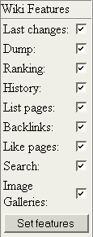

With this set of checkboxes you can set which features will be available and which ones not, if you disable a feature it won’t be shown in menus and it won’t be accessed regardless of the permissions or the user trying to use the feature.

Modules

Modules are the boxes you see in the left and right side bars of the application, modules can be configured to appear on the left or right bar and you can also configure the order in which modules appear. Finally you can create your own modules using HTML content and they will be ready to be placed as regular Tiki modules.

The modules are administered from the module administration screen:

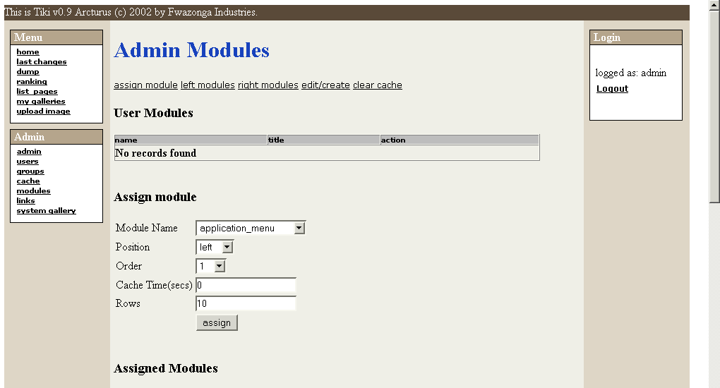

The screen is divided in 4 parts:

- User modules
- Assign modules
- Assigned modules
- Create/edit modules

User modules

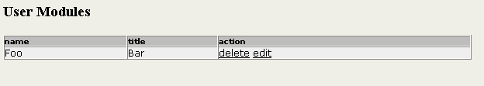

This shows a list of user modules and you have the option to edit or delete a module, user modules are created or edited in this same screen at the bottom.

Assign module

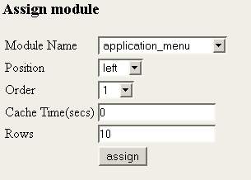

This is where you can assign a module to be displayed on the left or right side bar of the application, you have to select the module name, the position (left or right) and the order, modules will be displayed in an ascending order way so module 1 goes first then 2, etc. If two modules share the same order value they will be displayed in random order but never before a module with a lower number or before a module with a higher order.

Cache Time is the time that the module content can be in the cache (regardelss of this number some modules are never cached), if a module can be cached then it will be refreshed after the indicated time passes. Use 0 if you don’t want modules to be cached.

Rows are the maximum number of rows a module will display if that makes sense to the module, modules displaying rankings or listings will use this number.

Assigned modules

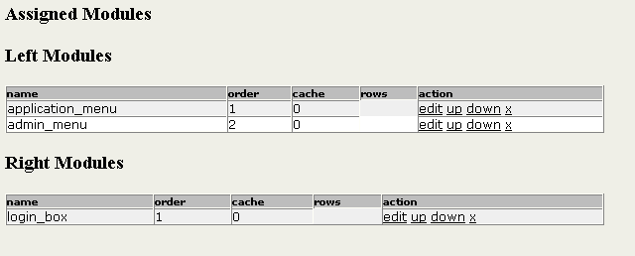

This part of the screen shows currently assigned modules and their order, cache and number of rows. There’re two tables, one for the modules at the left bar and other for the modules at the right bar. You can edit (assign) a module, remove it (it will only unassign the module, you can reassigned later) and you can also move the module up or down one position using the up/down links.

Edit/Create user module

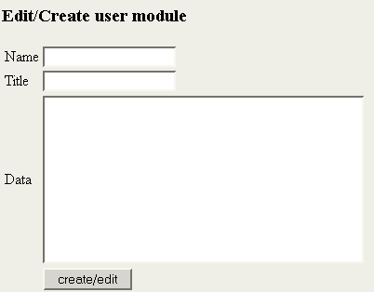

This allows the creation of a new user module, you need to indicate the name (used in the select box to assign the module), the title and the data that will be displayed, the data must be HTML (any since you are admin).

Some modules are already defined by Tiki, this is the list of modules distributed with this version of tiki.

Module | Uses Rows? | Cacheable? | Description
Top Images | Y | Y | Most accessed images from the galleries listing the image name.
Top Images th | Y | Y | Most accessed images from the galleries listing the image thumbnail.
Last Galleries | Y | Y | Last modified galleries
Top Galleries | Y | Y | Most accessed galleries
Top Pages | Y | Y | Most accessed pages
Last Modified | Y | Y | Last modified pages
Login Box | N | N | The login box
Search Box | N | N | The search box
Logo Box | N | N | Logo box, shows the tiki logo linking to tiki-index.php
Featured Links | Y | Y | Featured links
Logged users | N | N | Number of online users
Calendar | N | N | A calendar (doesn’t do anything just a calendar)
My Pages | N | N | Pages created by the user
MyGalleries | N | N | Galleries created by the user

Featured Links

The featured links screen let’s you enter links that will be displayed in the featured links module.

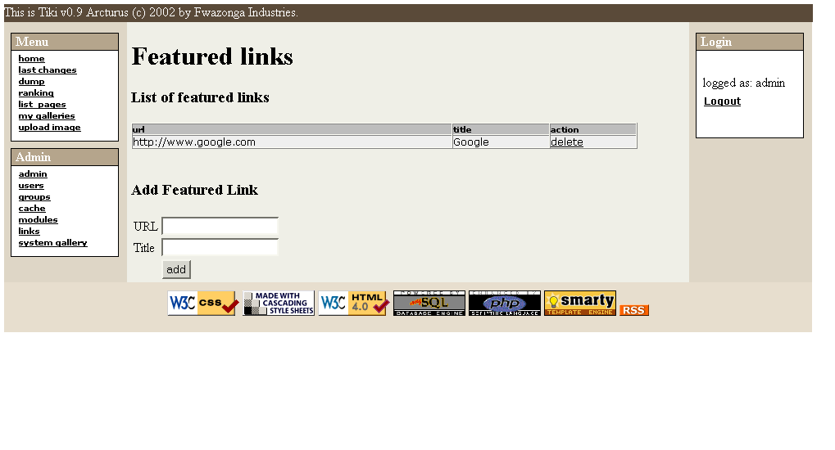

The cache

Whenever Tiki founds a link to an external site in a Wiki page the lilnk is cached in the Tiki cache, this allows the Wiki users to visit the page even if the site is offline or the page is removed or changed.

The “cache” option in the Admin menu lets you administer the Tiki cache:

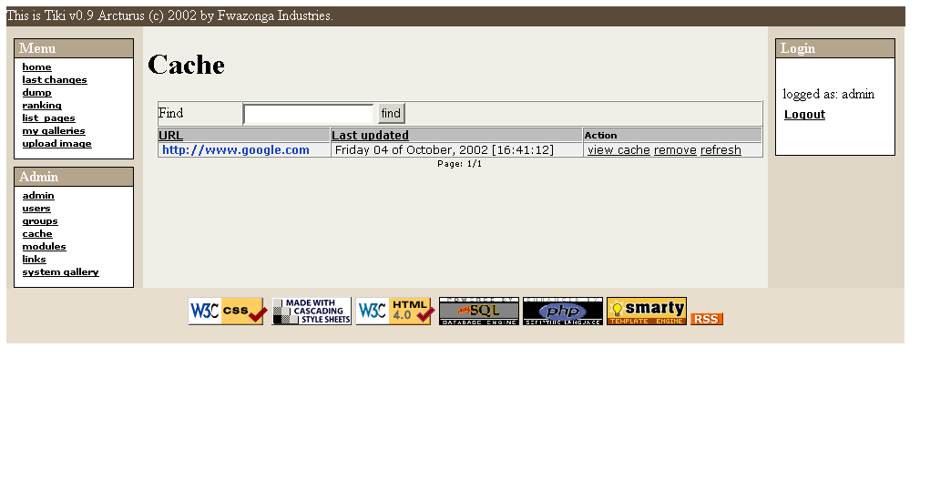
You can list the cached pages, find pages using the find button and for each cache entry you can view it, remove it, or refresh it (will retrieve a fresh copy of the page). If the enrty is removed it will no longer display a “cache” link from the Wiki page where the site is referentiated.

The RSS feed

Tiki provides an RSS feed listing the last changes made to the Wiki, the RSS feed can be accessed using the URL http://yoursite.com/tiki/tiki-rss.php, or by clicking the RSS button at the footer of the pages.

The feed can be used to display the last changes to your site in other sites or applications.

Customizing the application (Tiki for programmers)

Tiki is an application designed to grow in a neat and usable way, the’re several features that allow this application to be easily enhanced and customized by programmers.

- Smarty (the template engine) is used to sepparate content from presentation, all the logic is in the foo.php files and there’s a foo.tpl file that contains the template used to display what the php file generates.
- The whole layout of the application is present in only one file: tiki.tpl (the main template) so you can change the layout as you want by changing just this file
- CSS is used to define the presentation properties of all the elements in the Tiki pages, themes are defined creating new CSS files and putting them in the CSS directory.
- All the database-accessing functions are in library files in the lib directory as classes, the code in PHP files access/changes entities by calling the Tiki API.If you code new pages/modules/whatever please respect this, thanks!
- Tiki is really easy to customize/extend, please give it a chance!

Style, themes and look and feel

The look and feel and style of tiki is defined in CSS files, each CSS file defines a particular theme, you can copy a CSS file and change it to create a new theme, the CSS files are self-documented so you will know what are you changing when you edit it. If you think you can improve the CSS files or document them better please do it!

Internationalization and language

Tiki supports multiple languages and defines a mechanism to easily make the application available in other languages. In the PHP scripts all the strings must be written as tra(“here goes the string”); calling the “tra” function that translates the string. In templates you should use the Smarty {tr} block, for example {tr}Hello world{/tr}. This is how you write string in Tiki to be language-aware.

Once you have modified Tiki the “get_strings.php” script can be used to scan all the .php and .tpl files in the application regenerating/changing the language files. New strings are added to language files untranslated.

Creating a new language (this is easy!)

- Create a new directory under the “lang” directory, please name it using a 2 letter convention, example: en=english, sp=spanish.
- Copy a language file from some other language that you are familiar to this directory.
- Edit/translate the language.php file.
- The language is ready to use from Tiki (Tiki will automatically detect the new language)

When tetsing new languages keep in mind that modules can be cached so they may not change their language unless you clear the cache (in the module administration screen you have an option to clear the cache)

Appendix A: List of application templates

Wiki Templates

Name | Description
error.tpl | Error template, displays the layout and an error message.
tiki.tpl | Main template all non-error pages use this template, the mid area of the template is replaced by another template depending of the page.
tiki-admin.tpl | Administration screen
tiki-admin_links.tpl | Featured links administration
tiki-admin_modules.tpl | Module administration
tiki-admingroups.tpl | Group administration
tiki-adminusers.tpl | User administration
tiki-assignpermission.tpl | Assign permission to a group
tiki-assignuser.tpl | Assign a user to a group
tiki-backlinks.tpl | Displays backlinks to a page
tiki-bot_bar.tpl | Footer
tiki-browse_gallery.tpl | Browse gallery
tiki-browse_image.tpl | Browse an image
tiki-editpage.tpl | Edit a page
tiki-featured_link.tpl | Displays a featured link
tiki-galleries.tpl | Admin galleries (not only admins)
tiki-lastchanges.tpl | Last changes to the wiki
tiki-likepages.tpl | Shows pages similar to the current page
tiki-list_cache.tpl | Lists the cache
tiki-list_gallery.tpl | Lists a gallery (non-graphical browsing)
tiki-listpages.tpl | List pages
tiki-page_bar.tpl | Page menu (history,lock,etc)
tiki-pagehistory.tpl | Displays page history
tiki-pagepermissions.tpl | Assign permissions to a page
tiki-preview.tpl | Preview of a page
tiki-print.tpl | Printable version of a page
tiki-register.tpl | Register a new user
tiki-tanking.tpl | Ranking of pages
tiki-removepage.tpl | Remove a page
tiki-rollback.tpl | Rollback a page
tiki-searchresults.tpl | Displays search results
tiki-show_page.tpl | Shows a wiki-page (used in other templates)
tiki-top_bar.tpl | Header
tiki-upload_image.tpl | Upload an image
tiki-view_cache.tpl | View a cached page

