Featuring: The Wiki, File Galleries, Comments, Articles & Submissions, Image Galleries, Banners, Dynamic Content System, Blogs, Categories, RSS feeds, Forums, Polls, Communications center and Chatrooms.

Tiki v1.2:
“Antares”

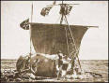

Documentation and User Manual

This page intentionally left blank

What is Tiki?

Tiki is a CMS system based on a Wiki, if you are not familiar with CMS systems or Wikis just keep reading we’ll explain. Tiki is designed to be international, clean and extensible.

About this version

This is version 1.2 codename: Antares. This new version adds a lot of Major new features to Tiki. Among the huge list of new features we can mention forums, chatrooms, a communication center, rss modules, categories, a menu-builder and polls. Lot of enhancements have been made, many bugs have been corrected, a lot of feature-requests by from our SourceForge site were considered and added to this version. Since a lot of new features are now incorporated we recommend you to re-read this manual even if you already read the whole manual for Tiki 1.1, it’s worth the try to understand and get used to the brand-new features in Tiki 1.2

Please help us by testing the application and reporting bugs/errors/features and suggestions to the author: lrargerich@yahoo.com. The home page of Tiki where you can find downloads, report bugs or request features is http://tikiwiki.sourceforge.net/ . And you are also invited to join our mailing list at tikiwiki-devel@lists.sourceforge.net

Tiki versions are named after popular stars: Antares is a brilliant jewel set within the Summer Milky Way in Scorpio. Antares, gleaming redly, has a color similar to Mars. Since it is found within the zodiac, which contains the apparent path of the Sun and planets, it is commonly mistaken for the red planet, a fact shown by its name, Antares, or "Ant-Ares," which means "like Mars,". This magnificent first magnitude star, is the 13th brightest in the sky even though at a great distance of 600 light years, revealing that it is truly luminous, to the eye over 12,000 times brighter than the Sun. A low temperature coupled with high luminosity tells us that the star must be huge, so big that astronomers can actually detect and measure the size of its apparent disk. If placed at the Sun, the star, aptly called a supergiant, would extend outward for over 4 Astronomical Units (the distance between the Earth and Sun). The star is slowly evaporating under a fierce wind that blows from its surface and that has encased it in a small gas cloud or nebula. Antares probably does not have much time left to it. It is massive enough someday to develop an iron core and eventually to explode as a brilliant supernova long before it would ever have a chance to evaporate completely. The event may be a million years off, an astronomical blink of an eye; or it may occur tonight, so keep a watch on one of the great stars of the nighttime sky.

New features and changes in version 1.2

- Added a find feature to the lastchanges section in the Wiki (Ramiro)
- Added Categories: You can create categories and subcategories building a category tree, objects (pages, forums, blogs, image galleries, file galleries, etc) can be assigned to one/many categories, the user can browse categories finding objects for each specific category.
- Communications center: Now you can send/receive Wiki pages from/to other Tiki-enabled sites using a simple XMLRPC API, received pages are stored in an "ibox" where an admin can view,edit,remove,accept the pages. This new feature can be used to send a Tiki page from one site to another one!
- Consolidated CSS file, there're two CSS files in this distribution: subSilver and default2, if you wantto produce a new theme you can change any of these, subSilver is longer and uses an individual style for every element in Tiki while default2 applies the same style to multiple elements (ie: tables) and thus is a faster way to get a theme ready.
- Forums!, now you can set-up mesage forums, forums are organized by topics and topics by threads, users can post, reply and quote messages in forums, messages can be voted using the same karma system used in comments. Many features are "copied" from phpBB since it is the best forum software for PHP, we copied those features and integrated the forums with the Tiki permission system, rankings, modules and search engine.
- Now you can upload th thumbnail of an image when uploading an image, this will prevent automatic thumbnail generation. Some users wanted this feature because thumbnail generation didn't work or theywanted to upload their own thumbnails. Maybe you want to have a thumbnail that is not the same as the full image so you can use this feature. Thumbnails will be displayed using the size assignated for thumbnails to the image gallery.
- Now you can set up how old must a version be at least to be removed from the history, this can prevent a user from saving a page "n" times destroying a previous version. (Thanks to tesla2k for the tip)
- Links to help including objects in user modules where added to the admin_modules screen.
- Next and prev buttons where added to view the next/prev image when browsing images from a gallery (Ramiro)
- Now you can control which groups can view image galleries and filegalleries
- Individual permissions for image galleries, as an admin you can control which groups can view,admin, upload to a specific gallery overriding global permissions.
- Individual permissions for file galleries, as an admin you can control which groups can view,admin, upload and download to a specific gallery overriding global permissions.
- Individual permissions can be set up by admins to weblogs, so you can control which groups can read, admin and post to specific weblogs.
- From the page-permissions screen admins can set up email addresses that will receive an email when the page changes. If you want to remotely monitor some page this is for you.
- Chatrooms feature (experimental), you can create chatrooms and the users can enter chatrooms and chat, the refreshing time for each chatroom can be configured and the page is not reloaded, only an invisible frame with size 0 is reloaded to get fresh chat messages.
- RSS modules, create RSS modules to display news/events from other sites, you can display RSS feeds in user modules using {rss id=n}, you can set up which feeds can be displayed and the refreshing time for each feed. RSS 0.91 and 1.0 are supported.
- Polls, you can create polls, set polls to be "active,closed,current". Polls can be displayed in modules using {poll id=n} or {poll} to select a random poll from the "current" polls. There's a page to view poll results and old poll results and old polls not closed can be voted. A mechanism to prevent a user from voting many times is also included.
- Menu builder section, you can build menus using sections and options, menus can be static (no javascript) or dynamic. Menus can be displayed in user modules using {menu id=n}
- Comments can now be filtered by threshold
- Comments for weblogs,articles, image galleries, file galleries and polls
- A selected file gallery can be used as the home page for the site
- Now you can enable/disble RSS feeds from the admin screen and limit the maximum number of items for any feed
- New RSS feed for individual file galleries listing the last images uploaded to a given gallery
- New RSS feed for individual image galleries listing the last images uploaded to a given gallery
- New RSS feed for weblogs listing last posts to any weblog
- New RSS feed for file galleries listing last files uploaded
- New RSS feed for image galleries listing last images uploaded
- Random pages module
- Now you can include dynamic content blocks in wiki pages using {content id=n} or {rcontent id=n}
- Now you can use {rcontent id=n} to select a random content from a dynamic block content, the {content id=3} syntax can also be used to select the last current content for a block
- New Wiki element: ^some^ will render "some" inside a simple box
- The layout can be configured from the admin screen you can enable disable the columns, top bar and footer

New features and changes in version 1.1

- The edit button now shows on red if someone may be editing the page, this helps preventingtwo users from editing the same page. This feature can be enabled/disabled from the admin menu.
- Now HTML tags are filtered out from weblog posts except normal tags such as a,p,img,br,table,i,b,etc
- Link added to edit the page from the wiki pagelist
- Page generation time was added below the footer
- The featured links admin screen has been revamped, now featured links can be enabled/disabled and ordered as you want, an automatic ordering feature by link-hits was also added. Hits are now counted and displayed for featured links.
- The titlebars in wikipages are now brown instead of the terrible blue ones.
- File galleries, create galleries, add files to galleries, download files. Permissions configurable, rankings for file galleries and modules available.
- Module names are now sorted in the admin modules screen
- Now you can see permissions according to categories when assigning permissions to groups, the assign permissions screen was revamped
- Wiki page comments, now you can activate/deactivate comments for wiki pages, comments can be voted and replied, configurable permissions and karma system for comment points(!)
- Fixed minor layout problems and xhtml glitches
- Several bugfixes and minor improvements on the code.

New features and changes in version 1.0

- Added blogs to Tiki, users can create blogs, post entries in blogs, find entries, etc.
- The calendar can be now used to navigate blogs watching the posts for a given day.
- Added an XMLRPC interface compatible with blogger, users can use desktop applications such as blogbuddy or bloggar to send posts to weblogs.
- Added a CMS system to Tiki, topics and articles can be edited and published or programmed to be published.
- Added submissions to Tiki, users can send submissions, admins can approve them and make them articles.
- Improved the search engine, now you can search in pages, galleries, images, blogs and/or articles, added pagination to the search results page.
- Added an option to select the home page of the application, it can be the Wiki HomePage, a blog, the articles homepage (listing last n articles) or an Image Gallery.
- Make the main application menu expandable/collapsable per section.
- Added banners (Beta version) admins can add banners classified in zones, a banner can be displayed in any template using a simple syntax (including user modules) banners can display HTML code, an image or text (text adds) a page with banner stats accessible by users (clients) is also available
- Templates can now be edited from Tiki
- Added a dynamic content system, this allows to edit blocks that can be included in any template or user module using a simple syntax. Blocks can be programmed for the future and are automatically changed by Tiki. This feature adds a lot of flexibility to the application.

Introduction

Welcome to Tiki! the most advanced system ever (not true ☺). Tiki incorporates all the features present in several excellent wiki systems available today plus a lot of new features and options allowing your wiki application to be whatever you want it to be, from a simple wiki to a complex site fir a whole user community with many intermediate steps, you can use Tiki for a forums site, a chatroom, polls, etc etc.

Tiki Features

The Wiki

The Wiki is a collaboration environment where the users can edit the pages they read. Links to wikipages are created automatically using capitalized words smashed together. A special editing syntax is used to provide features such as bold text, images, external links etc. A history is kept for each page so admins can view diffs and rollback a page to a previous version if a user breaks a page. Wikis can be used for documentation, support, intranets, and many other uses. The Tiki Wiki system has all the normal features Wikis have plus a lot more.

Image Galleries

Image galleries are collections of images, users can create galleries and upload images to their galleries or public galleries. You can select the number of thumbnails to appear in rows/files of galleries as well as the thumbnails size. Thumbnails are automatically created by Tiki, you don’t have to upload them. Galleries can be used for albums, stories, showrooms and many other applications.

Articles and submissions

The articles & submissions system allows editors to publis articles, articles can belong to a topic and topics can be administered, the articles can use an image or the topic image, you can set up the publishing date of any article allowing you to program articles for the future. The article content can use the Wiki syntax or regular HTML. Links and images in articles are automatically cached to prevent content that resides in other pages from disappearing from your articles. The CMS system has also submissions, users can send ‘proposed articles’ as submissions and the editors can edit the submissions, remove them or approve them becoming articles. There’s a home page where the last “n” articles are shown. With this CMS system you can easily set-up a site like you did using systems such as PHPNuke or PostNuke.

Blogs

Blogs are great and they are ver popular today of course we have blogs ☺. A weblog is a collection of “posts” ordered by date, it’s like a Journal on the web. A post can be a comment about something the user did, a review, a thought, anything. The Tiki Blogs system is quite powerful, users can create blogs and of course post entries into their blogs or public blogs. If you want you can choose a Blog and make it appear as the home page of the site. Tiki also implements the Blogger XMLRPC interface allowing you to use applications such as wBloggar or Blogbuddy to manage and edit weblogs.

Banners

Some time ago banners were used to generate revenues for succesful websites, today this practice is not that frequent but banners are still popular. Why? Because they are a great way to generate traffic for a web site, community sites, weblogs, e-zines and many sites can use banners and interchange banners with other sites to generate more visitors, more pageviews and more traffic to their sites.

This version of Tiki incorporates the first stage of the banners system, it support image banners, HTML banners (used in banner exchange sites) and TextAdds. Banners are assigned to “zones” in your application. There’re a lot of configurable options for banners such as maximum number of impressions, weekdays when the banner can be displayed, hours, etc. Banner clients are normal Tiki users and they can view banners assigned to them accessing a page where banner stats are displayed. Including banners in Tiki is easy using a very simple syntax in any template or user module.

Dynamic Content System

The Dynamic Content System (DCS) is a very simple concept, you can edit blocks of HTML code or text from a admin screen and you can display a block in any Tiki template or user module. Updating the block content will update the template. You can also program block content by date storing several blocks to be displayed in future dates. This simple system adds a lot of flexibility to Tiki, you can display anything you like anywhere in the screen and you can set-up portions that can be changed or that change atomatically along time.

The DCS can be used for example:
- To display a quote in the top bar or a user module
- To display news in a user module
- To announce products, chats, news according to time
- To announce any event
- To display sport results or sports information
- Anything!

File Galleries

The file galleries section of Tiki is a download manager, you can create/edit file galleries which are collections of files, you can define with the permission system who can create file galleries, upload files and download files. Statistics are recorded for each download, rankings where defined for the top downloaded files, most visited file galleries and last uploaded files. Modules are also available to display last changed file galleries, last uploaded files, top downloaded files and top visited file galleries.

You can use file galleries to distribute free multimedia (mp3, avis, etc), to distribute software (versions, patches, releases), to add files that users can download from Wiki pages, articles or weblog posts, etc.

Featured Links

The featured links section is just a link manager, you can enter as many links as you want and there’s an user module to display the links in the order that you want. Clicking the links will open the site in a frame inside the central section of Tiki. Statistics are kept about the number of times that featured links were visited and you can automatically order featured links by the number of hits they had.

Comments

Version 1.1 of Tiki adds a comments engine to Tiki, in v 1.1 comments are used to provide user-feedback to many Tiki features: users can comment: Wiki pages, image galleries, file galleries, articles and polls. The comment system can be configured to allow users to vote comments, a karma system mantains a “level” for each user the level improves when a user comment is voted by another user. Good qualified users votes add more points to a comment than users who didn’t get good qualifications. Comments can be displayed/hidden using simple controls and the user can control how to sort votes, the number of votes to see by page and the minimum threshold (score) for a vote to be displayed.

Forums

Forums are a must-have feature for a community site, a forum is a collection of topics and each topic is a collection of user messages about that topic. Using Tiki you can configure as many forums as you want and stablish permissions to determine who can create forums, admin forums, create topics, post messages, vote messages, etc. Individual permissions can be set for forums so you can have private forums only visible to some user groups. The forums section in Tiki has many advanced features such as auto-prunning to prevent the base of messages growing to big, flood-preventing, sticky topics, locked topics etc. The forums section in this manual describes all the user-level features for forums while the admin section of forums in this manual will describe how to admin the forums system.

ChatRooms

Chatrooms are an experimental feature in Tiki, admins can create chat channels and the users can join the channels, once in a channel users post messages that are broadcasted to all the users in the same chatroom. Chatroom messahes are updated at a given interval that can be configured for each chat channel (you may want a channel to refresh faster than others). Future Tiki version might add new features such as private channels, moderated chats, etc.

Communications center

The communications center is a feature not found in many CMS systems, basically it lets you send/receive objects to and from other Tiki-powered sites. You can control who can send you objects and who can admin the received objects. A special inbox is used to examine received objects and you can edit the objects, remove them or accept them from this inbox. Accepted objects will appear as normal Tiki objects. In 1.2 this feature can be used to send and receive Tiki pages from/to Tiki sites, for example if you see a nice Wiki page about a specific topic or a set of pages useful to your site you can ask for them and use this feature to receive the pages from another site. The communications center is based on an XMLRPC api to send/receive objects so you can build desktop applications or adapt existing systems to interact with your Tiki site.

Polls

Polls are another typical feature in user-community sites, using Tiki you can create as many polls as you want and display from zero to “n” polls in the Tiki pages, you can also have a set of “active” polls and display only one poll in the page, in such a case Tiki will rotate through the set of active polls. Users with the right permission can vote polls, see poll results, examine old polls and vote any poll that is not “closed”.

Categories

Categories are a way to classify Tiki objects (Blogs, Image galleries, Articles, Polls, Forums, Wiki Pages, File Galleries). You can create a ctaegory tree creating categories and adding as many sub-categories as you want to any category. Any Tiki object can then be added to one or many categories if you want. The user will be able to use a category browser navigating the category tree with links to the objects in the category. This can be used to let the users find all the information your Tiki site has about a specific topic/subject regardless if the information is in an article, a weblog or a file gallery.
In future versions categories can be used for other powerful features such as stablishing permissions per category etc.

What is Tiki? 3
About this version 3
New features and changes in version 1.0 4
Introduction 6
Tiki Features 6
The Wiki 6
Image Galleries 6
Articles and submissions 6
Blogs 7
Banners 7
Dynamic Content System 7
Extra Features 13
Requirements 14
Optional 14
Installation 14
Understanding directories 15
Configuring the database 15
Upgrading the database 16
Installation Troubleshooting 16
(read this if all you see is a blank page!) 16
Initial Configuration 17
Understanding the application menu 19
The Wiki 20
Using the wiki 20
Creating and Editing Pages 20
Wiki Menu 23
Last Changes 23
Rankings 24
Dump 24
List Pages 24
Sand Box 25
The Tiki pages menu bar 27
Printable 27
Edit 27
Remove Page 28
Lock 28
Permissions 28
History 29
View 29
Remove 30
Diff 30
Rollback 30
Backlinks 31
Like Pages 31
Editing Pages 31
The Wiki Tag System 32
Normal text 32
References to other wiki pages 32
Links to external pages 32
Bold and italic text 33
Lists 33
Bullet lists 33
Numbered lists 33
Definition lists 33
Monospaced text 34
Using tables 34
Including images in your pages 34
Full HTML editing 35
Special Pages 35
The SandBox 35
Personal User Pages 36
Image Galleries 36
The galleries menu 36
Galleries 36
Creating a gallery 37
Edit 38
Remove 39
Upload 39
Browse 39
List 39
Upload Image 39
Browsing galleries 42
Rankings 43
The System Gallery 44
Articles and Submissions 44
Editing Articles 44
Articles Home 46
List Articles 47
Rankings 47
Submit Article 48
View Submissions 48
The Blog System 49
Create/Edit Blog 49
List Blogs 50
Post 51
Reading a weblog 51
Rankings 52
Using Desktop Applications for your Blogs 53
Using wBloggar 53
The search engine 61
Featured Links 61
The user preferences screen 62
Administration 63
Understanding users and groups 63
User administration 63
Group administration 64
Assigning users to groups. 65
Assigning permissions to groups. 65
Permissions 66
Permissions for individual users 69
Exception: Permissions for individual wiki pages 69
The general administration panel 69
Features 70
General preferences and settings 72
Wiki settings 74
Image Galleries settings 77
CMS settings 77
Blog settings 78
Modules 79
User modules 80
Assign module 80
Assigned modules 81
Edit/Create user module 82
Including dynamic content in user modules 83
Including banners in user modules 83
Advanced editing 84
Available System Modules 84
Special modules: The calendar module 85
Featured Links 86
The cache 86
Hotwords 87
Edit templates 88
Banners 89
Creating and editing banners 90
Fixed URL banner 92
Text banner 93
Displaying banners 93
Viewing stats 94
Dynamic Content System 95
Creating and editing blocks 95
Creating and editing content for a block 97
Displaying DCS blocks 99
Programming content 101
RSS feeds 103
The Wiki RSS feed 103
The Articles RSS feed 103
The Blogs RSS feed 104
Customizing the application (Tiki for programmers) 104
Style, themes and look and feel 104
Internationalization and languages 105
Creating a new language (this is easy!) 105
Adding new features to Tiki 105
Basic rules 105
Tutorial: adding a graffiti wall to Tiki 106
Planning our module 106
The library 107
Coding the graffitti module 110
Adding the graffitti module as a tiki feature. 112
Appendix A: List of application templates 113

Extra Features

- Works with PHP4 even if register globals is off
- Uses CSS to define the look and feel, themes are CSS files
- The generated code is valid XHTML 1.0 transitional
- Windows & Unix compatible
- Easy installation and configuration
- PEAR:DB is used, you can use this application with your favourite DBMs without changing the code
- Templates allow the user to change the look and feel of the whole application (Smarty the PHP template engine is used)
- Automatic – internationalization, translate a language file and use it, language files are automatically generated by a provided script.
- Administrators can edit pages, blogs and articles using full HTML tags
- The calendar can be used to view articles or blog entries for a given day.
- Manage permissions using groups (permissions are assigned to groups)
- Configurable sidebar boxes
- Auto-Caching system for URLs
- Auto capture for images.
- Versioning system for pages where you can
  - Review a page version
  - Rollback a page to a given version
  - Remove unwanted versions or pages
  - Diff different versions of a Page
- Individual permissions for pages, file galleries, image galleries, forums and weblogs can be set-up optionally
- Search engine for Wiki pages, blogs, images, image galleries, forums, file galleries and articles.
- Rankings for pages, blogs, articles , image galleries, file galleries and forums.
- Dump to XHTML of the Wiki.
- Integrated RSS feeds (many) to sindycate your site’s content

Requirements

- PHP 4.2+ [Should work with 4.1+ but not tested]
- A database

Optional

- GD library > 1.5 and PHP compiled to use GD (for thumbnails), not needed if you use PHP 4.3+ since GD is bundled.

Installation

Installing Tiki is easy, first of all you should obtain a distribuition of the application, you should already have one if you are reading this file. Tiki can be distributed in several formats, zip, bz, tgz, etc. Unzip, untar or uncompress the Tiki distribution in a directory that can be accessed from your web server. For example /www/htdocs, Tiki will create a tiki directory and put all the files and directories of the application under that directory.

This is the directory structure used by Tiki

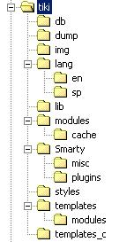
These directories must be writeable by PHP

Understanding directories
(you can skip this section if you just want to install and use Tiki)

You can install tiki in any directory and you can name the tiki directory as you want, but you have to respect the internal directory structure of the application since Tiki relies on certain directory names to find modules, images and language files.

The directories contain the following information:

Directory | Description
db | This is where the database connection script is included and the SQL script to create the database is found.
dump | In this directory is where Tiki generates the xhtml dump of the pages to allow users/admins to download a locally browseable version of the Wiki
img | Images used by Tiki
lang | Root for languages
lang/en, lang/sp, etc | Each directory contains a language.php file with the translation of the application strings to the language.
lib | Library files used by Tiki (The Tiki API)
modules | PHP code for modules
modules/cache | This is where Tiki stores cached results from modules. Must be writeable by PHP.
Smarty | The Smarty distribution used with Tiki
styles | CSS files used by the application, each CSS file defines a « Theme » that can be used
templates | Smarty templates for the application. If you plan to use the Tiki edit templates feature then this diretory has to be writeable by PHP.
templates/modules | Smarty templates for modules
templates_c | This is where Smarty stores compiled templates (Smarty compiles templates as php scripts). Must be writeable by PHP.

Configuring the database

Once all the files are in-place you should create a database for Tiki tables, we’ll use MySQL in this example but since Tiki uses PEAR you can use Tiki with any DBMS supported by PEAR: Oracle, Postgress, etc.

Create a database

mysqladmin create tiki

And then run the tiki.sql script that creates and inits the tables.

mysql tiki < tiki.sql

You can create a user that will be used by the application to access the database in such a case don’t forget to give the database user permission to select, read and write to the tiki database.

NOTE: Tiki tables are named tiki-name and users-* thus you can make tiki share the database with another application without name-collisions between tables, this is particularly useful when installing the application in a hosting.

Now point your browser to http://yoursite.com/something/tiki/tiki-index.php and you should see some page displaying an error message since you won’t have permission to access the Wiki yet. If you see a page generated by Tiki then congratulations, you have successfully installed Tiki.

Upgrading the database

If you have a previous Tiki version and you want to keep the content you have in your database you should use a tiki_vX.XtoX.X.sql style file to upgrade the database. For example tiki_0.95to1.0.sql upgrades the Tiki 0.95 database to version 1.0 adding the tables and changes needed to run the new features in version 1.0

If you want to add 0.9 to 1.0 without losing your data upgrade first 0.9 to 0.95 and then 0.95 to 1.0 using the ad-hoc .sql files. Etc...

Installation Troubleshooting

(read this if all you see is a blank page!)

If tiki-index.php fails complining about not being able to include “DB.php” then PEAR is not visible from your PHP installation, Tiki needs PEAR to use PEAR::DB, the database abstraction layer used in PHP. Find the “pear” directory included in your PHP installation and make sure that you have that directory in the include_path in your php.ini file.

ADOdb instead of PEAR::DB

We recommend to run Tiki with the PEAR::DB database abstraction layer as distributed, however, if you are familiar with ADOdb or you can’t find a way to run PEAR this section will explain how to run Tiki using ADOdb instead of PEAR::DB. Thanks to A.Kaiser who submited this section.

Requirements
ADOdb has a PEAR::DB wrapper, so you must not change the code in Tiki.
You need the file PEAR.php from the PEAR distribution for the error_reporting.
Copy this file in a directory pear in your Tiki root.
Copy the ADOdb files in a directory adodb in your Tiki root.

Changes

ADOdb
File: adodb/adodb-pear.inc.php line: 41
require_once("pear/PEAR.php")

Tiki
File: db/tiki-db.php line: 3
instead of
require_once('DB.php');

new code
require_once('adodb/adodb-pear.inc.php');
Thats all!

Downloads:
ADOdb: http://php.weblogs.com/ADOdb
PEAR.php: http://www.vocote.de/dl/PEAR.phps

Initial Configuration

Once installed you are ready to configure Tiki to meet your needs, this is the initial screen that will be displayed when you access Tiki:

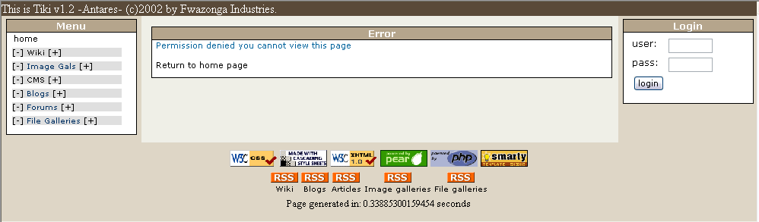

This page is displaying the Application menu, the login box and an error message since initially anonimous (not logged) users can’t view the Wiki pages, the first step in order to be able to configure Tiki is to be logged as admin, log in using the login box as ‘admin’ using password ‘admin’.

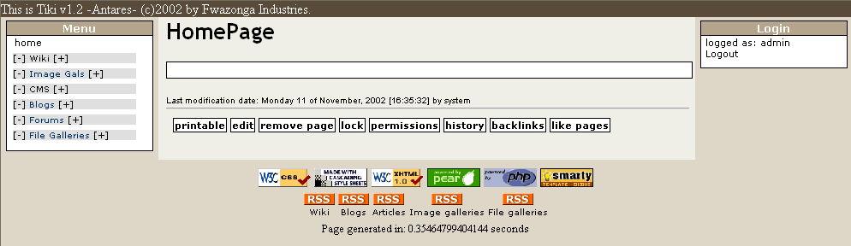

You may need to refresh the browser in order to see the Admin menu on the left bar.
Now you can see the HomePage of the Wiki (blank) and you can also see a new module on the left navigation bar displaying the admin menu.

Understanding the application menu

The application menu is the first menu at the left sidebar:

The menu is divided in three sections here (Wiki, Galleries and CMS),it can have many sections if you enable the different Tiki features from the Tiki admin screen. In order to use the menu you should use the [+] and [-] links to expand and collapse sections, if you click [+] in the Wiki section this is what happens:
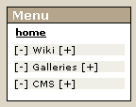

Now you can see the different links for the Wiki, use [-] if you want to close this section of the menu.
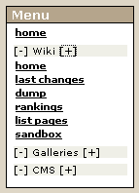

Clicking the “Menu” title will collapse/expand the whole menu if you want. Each section “name” links to the section home if enabled and configured, Wiki will take you to the Wiki page named HomePage, Galleries will take you to a gallery selected as the Home Gallery, CMS will take you to the articles home page and Blogs will take you to the Blog selected as the Home Blog if configured. The “home” link at the first line of the menu takes you to one of the different sections that can be used as a HomePage, you can select which section will be used as the HomePage from the admin screen.

Tiki is now installed and ready to be configured and used, Jump to administration functions in order to learn how to configure users, groups, permissions, modules and features if you want.

Complete menues

If you enable “all the features” in Tiki the application menu will have the following options in Tiki 1.2:

User level options | Admin options
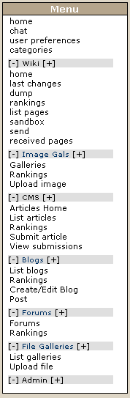 | 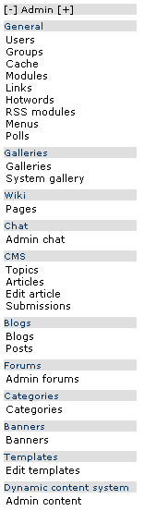

Building your own menus

The Tiki application menu is automatically populated with the features that you have enabled and where the use has the right permission to access. But in some cases you don’t want to use this menu because you don’t like it or you want options in a different order, or something. Tiki 1.2 incorporates a menu-builder tool where admins can create menus that can be used in Tiki for whatever you want, links to special sections of the site, links to external sites, any link can be used and there’re three different menu-types that can be used. Read about this tool in the admin section of this manual: Menu builder.

The Wiki

Using the wiki

The Wiki is an environment where users can edit pages as they want adding information, links, lists and images that they find useful, you can use a Wiki as a feature of a users community, a club, a fan site, etc. The most important elements in the Wiki are the Wiki pages.

Creating and Editing Pages

If you have the appropiate permissions you will see a menu at the bottom of pages with several options and one of them will be “edit”, when you click “edit” you are able to edit the page that you are watching, you can try editing a page and writing some text on it. Use the “preview” feature as many times as you need it before clicking “save”.

In order to create a new Wiki you should first generate a “reference” to the page from an existing page, Wiki automatically generates a reference when you write a word using Capitalized words smashed together, for example ThisIsMyPage or TennisResults or VisitLondon, when Tiki first sees a reference the page will display the name followed by a “?”, let’s see an example.

We’ll edit the home page.

Access the home page and click “edit” at the bottom of the page.

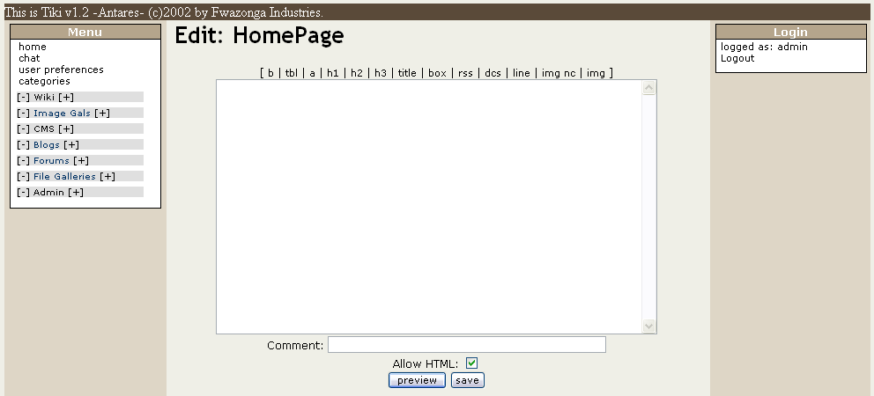

Write some text making sure you use the word MyFirstPage, save the page using “save”. Use the preview button if you want to preview how the page will look like once edited.

After saving you will se something like this:

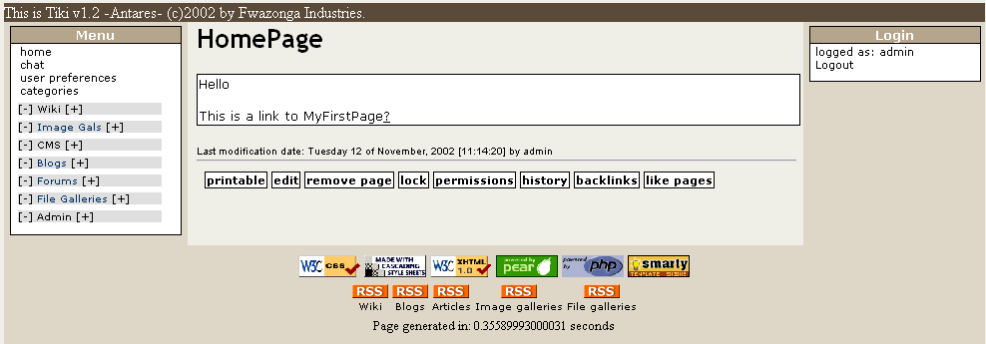

As you can see there’s a “?” question mark following MyFirstPage, this indicates that MyFirstPage is referenced from this page but has no content (it was never edited) so the “?” question mark is a link to “edit” the page. Click the question mark and edit the page.

Save the page using the save button and you will see:

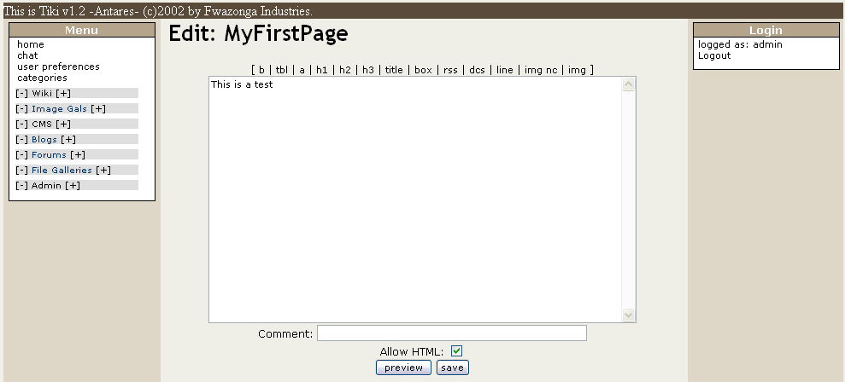

Click the “home” option in the menu to return to the HomePage, this will be displayed:

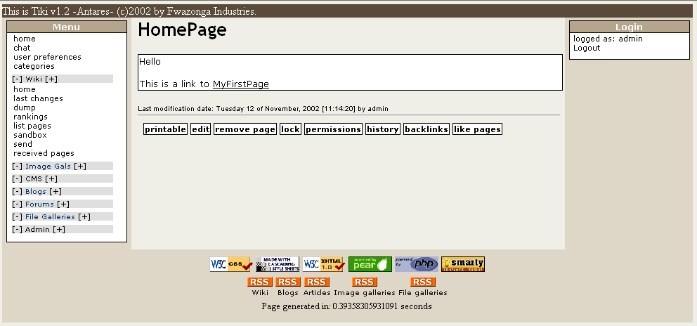

As you can see MyFirstPage is now displayed as a link, if you click on it you will access MyFirstPage viewing the content you just edited.

This is how new pages are created and edited and how the Wiki is navigated, as you can see creating pages is really easy and that’s why Wiki’s are populated at a very high speed rate by their users adding pages and content as they need.

If you want to know what kind of features you can use when you edit a page visit the Wiki Tag System section where you will learn how to use titles, lists, images etc.

Wiki Menu

Now let’s examine the options available in the Wiki Menu:

- Home (go back to the Wiki HomePage)
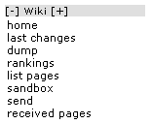
- Last Changes (see last changes)
- Rankings (see several rankings)
- Dump (download a dump of the wiki)
- List Pages (listing of wiki pages)
- Sand Box (test page to practice editing skills)
- Send is used to send Wiki pages to other sites
- Received pages shows a list of pages received from other sites and you will be able to edit/remove/accept them

Note: All the features can be enabled/disabled from the admin menu

Last Changes

The last changes screen can be used to see what happened to the Wiki recently (or not so recently), as you can see the information is displayed in a tabular way indicating for each change the page and action, the user that changed the page an Ip for that user and the comment (if entered).

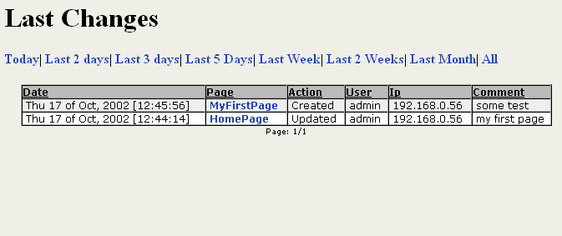

In our example you can see that we updated “HomePage” and then we created “MyFirstPage”. While this screen can be used by anyone wanting to see what happened recently it is also a great tool for admins to check what is happening in the Wiki without having to check if page. The links above the table allows you to select the period of time you want to cover. Pagination is used so clicking “all” want destroy the server but you may have to navigate a lot of pages.

Rankings

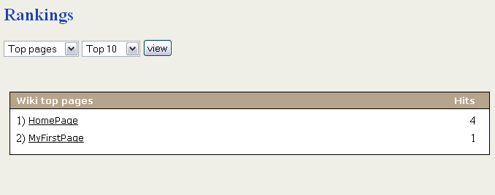

The rankings screen can be used to see several “charts” or rankings about the Wiki, you have to select the ranking you want to see from the select box and you can select if you want to see the Top 10, 20, 50 or 100 results. Clicking “view” displays the ranking. The rankings that you have available may depend on the Tiki version you are using since one of the things that we may add in new versions is new rankings. Check it out!

Dump

The Dump link is a link to a Dump of the Wiki (if the Dump was created from the admin screen) this will download a .tar file containing a xhtml representation of the pages in the Wiki.

List Pages

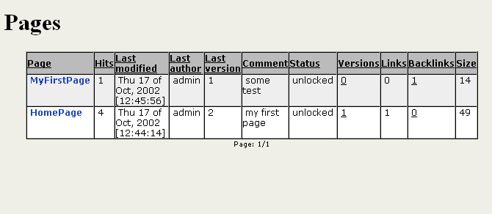

This screen will show you a list of the Wiki pages with some interesting information about pages such as number of visits (hits), who was the last user that edited the page, number of versions in the page. Links found in the page and the size in bytes. This listing can be ordered by any column clicking the column title, note that if you reclick the same column the order is reversed. This behaviour is the same in all the listings in Tiki so we should remark it.

Note: In all the Tiki listings if the column title is a link you can click it to make the listing appear ordered by the selected column, to reverse the order just click again on the column title.

Sand Box

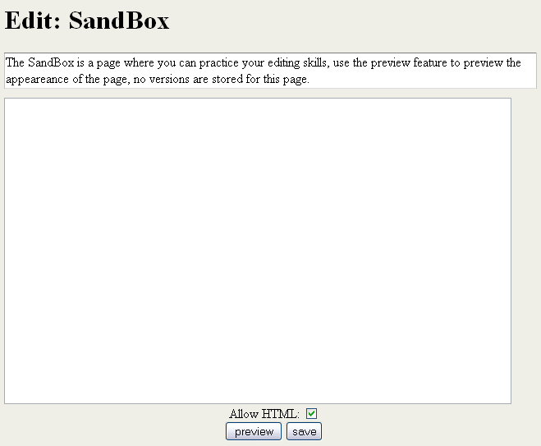

If enabled from the admin screen there will be a special page in the wiki named “SandBox” the SandBox behaves like a normal page with the following exceptions:

- everybody can edit edit the SandBox bypassing permissions.
- no versions of the SandBox will be stored, the page cannot be deleted, or rolled back.

The SandBox is useful as a practice page where users can practice their editing skills and get used to the WikiTiki editing syntax. Many wikis offer a SandBox as a way to get familiar with the Wiki.

The Tiki pages menu bar

When you are viewing a Wiki page, a menu bar with some options will be displayed at the end of the page, the number of options in the bar may be different depending on the permissions you have. This is the bar with all the options appearing:

The options are:

- Printable: view a printer-friendly version of the page
- Edit: edit the page
- Remove Page : remove the page
- Lock: lock the page
- Permissions: set page permissions
- History: view the page history
- Backlinks: view pages that link to this page
- Like Pages: view pages similar to this one

So let’s examine each option in detail.

Printable

This option will display a printer-friendly version of the page removing menus, sidebars, banners and all that kind of things. It should be nice to provide also a PDF version of each page and we are planning to add this feature in a future version of Tiki –stay tuned-.
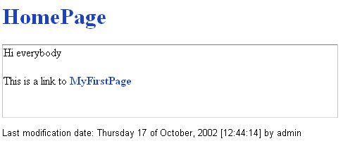

Edit

The Edit button takes you to the edit screen where you can edit Wiki Pages, since editing Wiki pages is the most important feature of the Wiki section we have a special dedicated section in this manual and you can find it after the rest of the page-bar options are explained.

Remove Page

The remove page option takes you to a page where confirmation is asked. In that page you can remove the page and if you want you can also remove all the versions of the page. If you don’t remove all the versions of the page the next-to-last version becomes the current page. Yes, you should use this feature carefully.
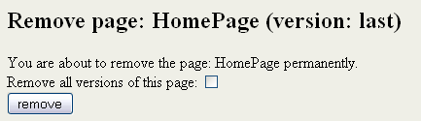

Lock

The lock/ unlock button is used to lock/unlock pages, when a page is locked nobody can edit the page when until it is first unlocked. This can be used to “lock” some pages that you don’t want to be edited by anynone in open Wikis where everybody can edit pages, for example the HomePage in some Wikis.

Permissions & email notifications

“Maybe you should read about the Tiki permission and groups system before reading this section”

In this page you can assign permissions to this page overriding the global Tiki permission system. The way to use this screen is easy: select the permission you want to apply and then select the groups that will have the permission for “this” page. You can remove permissions clicking the remove link once a permission has been assigned.
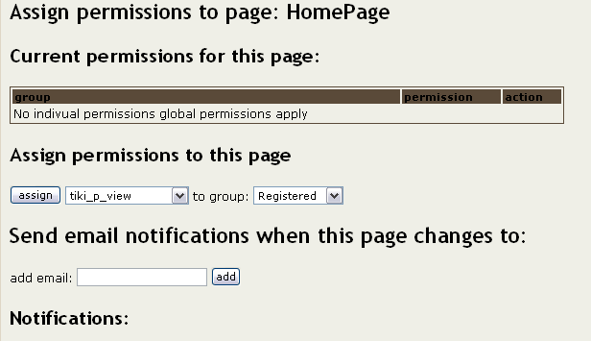

If you set up the tiki_p_view permission for group “foo” only the users in the “foo” group will be able to view this page, other users won’t be able to see the page even if the have the tiki_p_view permission. (Of course users with tiki_p_admin are always enabled to do anything)

Notifications

From this screen you can also set email addresses that will be notified when a page changes, as an admin you may want to monitor some special or sensitive pages in your site, using this feature Tiki will send an email to the addresses configured here whenever the page changes.

History

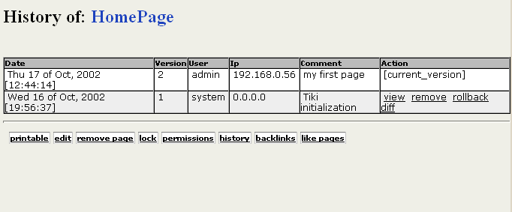

One of the most interesting features of the Wiki is that each time you edit a page the previous version is not discarded but stored in the history. If you have the right permissions you can view previous versions and rollback a page to a previous version if needed. This is how vandalizing is prevented/countered if a page is vandalized it will stay in that state only until a user restores a previous version.

In the history screen you can see all the page versions and if you have the right permissions you will see some options for each version, the options are:

- View: view any version of a page
- Remove: remove a specific version of a page
- Rollback: rollback a page to any version
- Diff: view a diff between any version and the current version

View

View will show you that version of the Page.

Remove

Remove can be used to remove a version, you will be asked for confirmation before removing a version.
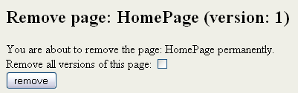

Diff

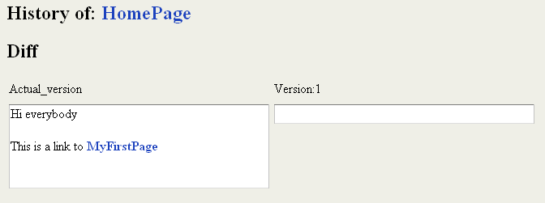

Diff shows a diff between the actual version of the page and the version you selected.

Rollback

Rollback is used to revert a page to a given version. You will be asked for confirmation before rolling back a page to a previous version.

The rollback option can be used if you don’t like the current version of a page and want to switch to an older version, an alternative is to remove all the versions that you don’t like until the desired version becomes the current one.

Note: If you want a feature to do a “massive” rollback of several pages you may want to read about “Tags”, you can find about tags in the Admin section.

Backlinks

Backlinks are links from any page to the current page (the page you are reading), you can use the backlinks option to see which pages are linking to a particular page and find “orphan” pages, pages with no backlinks. Orphan pages are likely to get very few visits if any and in many ocasions orphan pages are old pages that were removed from the Wiki and you may need to delete them.
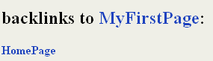

Like Pages

Like pages show a listing of pages named similar to the current page. As you know a page is named using CapitalizedWordsSmashedTogether, “like pages” show pages where one of this smashed words is the same as one of the words in the current pages. For example “MyPage NFLResultsPage OpinionsPage” are similar becasue they share the word “Page”.

Editing Pages

Editing pages is the most important feature of the Wiki. The edit screen allows you to edit a page, preview the page as many times as you want and then save it. To edit pages you use a special syntax common to many Wiki systems that is called “The Wiki Tag System”, this will allow you to use bold text, italics, images and many other things in your pages. If you have the permission you may also use regular HTML code in your Wiki pages thus permitting a page to be anything you want to be. IF you have permission to use HTML you should be able to see a checkbox labeled “Allow HTML” at the bottom of the page. The checkbox is enabled by default, if you uncheck it then HTML tags will be removed when saving the page.
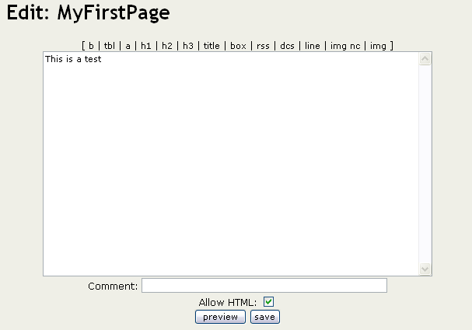

Now let’s understand the Wiki Tag System.

The Wiki Tag System

The wiki-tag system is the “language” you can use when you edit wiki pages, there’s a common set of features that are usually present at all wikis that Tiki mantains and some special features not frequently found in Wikis that Tiki adds.

You have a quick-reference to the wiki-tag system available at the bottom when you edit a page in the Wiki.

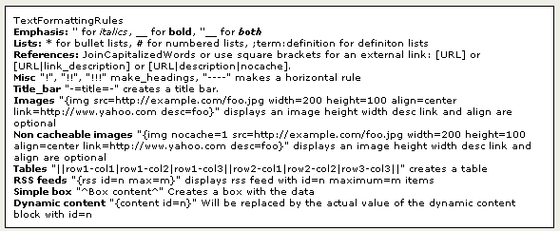

Normal text

Normal text is just entered as-is.

References to other wiki pages

References are created when you use capitalized words smashed togeteher, if the page exists a link to the page will be shown, if not a link to edit the page will be displayed.

ThisIsaReference

Links to external pages

Links to external pages can be entered using one of the following formats:

[http://www.somesite.com]
[http://www.somesite.com|This is a nice site to visit]
[http://www.somesite.com|Hey|nocache]

The first format will display the URL as a link while the second one will display the description as a link to the given URL. The third syntax can be used to prevent the link to the cache from being displayed in the page.

Tiki will automatically cache references to external pages or sites and a link to the cache will be displayed following the link, this is particulary useful when you link to notes or sections that may change or that may disappear in a near future. (Very similar to the google cache when you see the results of a search in google). You can disable caching pages from the admin screen.

Bold and italic text

Bold text can be entered using two underscores before and after the text.

__This is text in bold__

Italics are displayed using two quotes before and after the text

‘’this will be displayed in italics’’

Lists

Bullet lists

Bullet lists are automatically created when you prefix a line of text with an asterisk “*” (as you do when using Word for example)

Numbered lists

Numbered lists can be entered prefixing each line in the line with a hash mark “#”

Definition lists

Definition lists can be entered using the following format:

;term1:definition1
;term2:definition2
etc...

Monospaced text

Monospaced text can be used to show portions of code or text that needs to be properly aligned (ASCII art anyone?). To enter monospaced text prefix each line of text with a blank space. Lines starting with a blank are displayed in a courier monospaced font.

Using tables

You can create rudimentary tables using Tiki, a table can be entered using the following notation:

||row1-column1|row1-column2||row2-column1|row2-column2||

Note: || delimites the table and rows, | delimites cells.

Including images in your pages

Images can be included using regular HTML code if you have the permission or the Wiki syntax for images explained here:

Images can be included in a Wiki page using the following syntax

{img src=http://www.something/image.jpg width=100 height=100 desc=foo align=center link=http://site.com}

Where only src is mandatory and the rest of the attributes are optional. Note that you mustn’t use quotes for the attribute values. The attributes are:

src | URL for the image
height | Image height
width | Image width
align | can be center, right or left
desc | Image description to be displayed below the image
link | an URL to make the image link to that URL

If you include an image from a URL Tiki will automatically “capture” the image and replace the link to an internal database-stored version of the image, that allows images to persist in the pages even if they are removed from the remote servers that originally had them. (You can disable this feature from the admin screen)
Important TIP: If you have the image cache enabled but don’t want to cache some image (for example you want to display an image that changes along time) add a nocache option to the image src.
Example: <img src=”http://somesite.com/foo.jpg?nocache=1 />
Or : {img src=http://something.com?nocache=1

Title bar

You can include a title bar using the following syntax:

-=This is a title=-

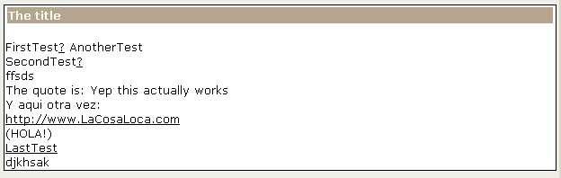

Boxes

You can include text in a box using:

^This is some text in a box^

Including RSS feeds ins your pages

Tiki can be configured to use RSS feeds provided from other sites, to configure RSS feeds see the “Using external RSS feeds” sections in the admin section of this manual. Once configured you can include the results of an RSS feed in a Wiki page using:

{rss id=1}

Where the id is the id of the RSS feed that you want to display.

The result will be a list of bullets with links to each feed:



This can be used to display dynamic news and information in your sites that you want to pick up from other sites.

Including dynamic content in your pages

Another cool feature is that you can include a dynamic block in a Wiki pages, dynamic blocks are configured as admin using the “Edit dynamic content” feature, basically a dynamic content block is some text that is programmed to appear from a given date. You can include dynamic content using:

{content id=1}

That will display the current value of the dynamic content block with id=1

Or

{rcontent id=1}

That will display a random value for all the contents defined for the block with id=1 (ideal for cookies or taglines!!)

The help links

At the top of the editing area you will see links that can be used to insert a wiki-tag at the end of the page (sorry can’t insert at the cursor position). The links are:

bold | table | reference | h1 | h2 | h3 | title bar | box | rss feed | dynamic content | line | image (no cache) | image

Full HTML editing

If you are admin or if you have the proper permission you can use full HTML when you edit a Wiki page, normally you don’t want regular users to use HTML since they can use wrong HTML, alter the page layout or break pages that’s why the Wiki-Tag system exists. However for admins or trusted editors full HTML editing is a powerful way to make a page look exactly as you want. Whenever you edit a page containing HTML code make sure that the “Allow HTML” checkbox is checked or the HTML tags will be eliminated. IF you accidentally estroy a page that previously contained HTML don’t worry just rollback the page to the previous version using the rollback button from the page history.

Special Pages

There’re two kinds of “special pages” where rules for editing and permissions are different than for regular pages:

The SandBox

We already mentioned the SandBox, the SandBox is a practice arena were users can practice their editing skills.

The special rules for the SandBox are:

- everybody can edit edit the SandBox bypassing permissions.
- No versions of the SandBox will be stored, the page cannot be deleted, or rolled back.

You can enable/disable the SandBox from the admin screen.

Personal User Pages

Each user with a login name and password in Tiki has its own personal page named “UserPagename” where name is the user login, for example “UserPageMitch003”. The personal user page is a special page in the Wiki since only admins or the user can edit the page even if anonymous users can edit the page. This is an easy way to provide users with a personal page to start publishing their interests, the personal page will be always editable only by the user so the user can be sure that he can publish there without others changing or modifying the content.

Permissions for the Wiki

If you want to configure the permission system for the Wiki you will be able to set the following permissions for groups:

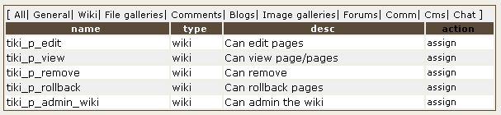

The tiki_p_admin_wiki permission is a master permission that automatically includes the other 4 permissions that can be set for the Wiki.

Image Galleries

Image Galleries are collection of images, if you have the right permission you will be able to create galleries and upload images to the galleries.

The galleries menu

This is the menu that is displayed when you expand the Image Galleries section in the main menu. There’re three options in the menu: Galleries, Rankings and Upload Images (options may change depending on your permissions). We are going to examine each option in detail.
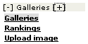

Galleries

The galleries screen will display a list of all the Tiki Image Galleries available and if you have the right permissions a link to create a new gallery and links to edit/remove/browse etc listed galleries if you have the permission.

Note that all galleries can be accessed by all users, there’s not a way to make a gallery only accesible by some users, don’t include private photos in a gallery unless you can accept that everybody can see the images. There’s no thing such a “private gallery”. You can control who can create or edit galleries but not who can “view/browse” a gallery.

If you are following the manual your first visit to the Galleries screen will display no records.

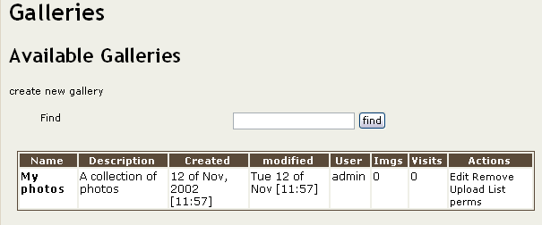

Creating a gallery

If you click in the “create gallery” link a screen with a form to create a new gallery will be displayed:

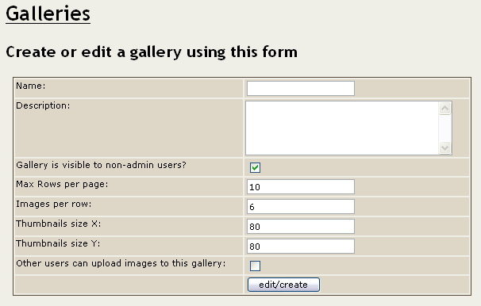

The fields are explained in the following table:

The fields are described as follow:

Field | Description
Name | The gallery name
Description | The gallery description
Gallery is visible to non-admin users | If not set then the gallery will be visible only to users with the tiki_p_admin_galleries permission set.
Max Rows per page | Maximum number of rows of thumbnails that will be displayed when someone visits the gallery.
Images per row | Maximum number of thumbnails per row when visiting the gallery.
Thumbnails size X | Width for Thumbnails
Thumbnails size Y | Height for Thumbnails
Other users can upload images to this gallery | If checked then other users can upload images to your gallery, they won’t be able to delete images or change the gallery.

Create a gallery for testing if you want, we’ll use it in the next sections.

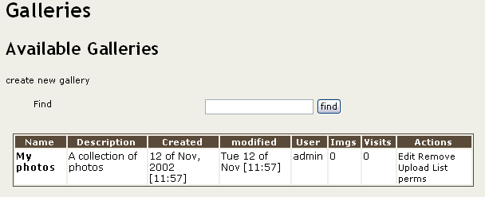

After creating a gallery you can see the options you have in the listing (again options may vary according to permissions), the whole package of options is:

- Edit: edit the gallery information
- Remove: remove the gallery
- Upload: upload images to the gallery
- Browse: browse the gallery (click on the gallery name)
- List: gallery listing
- Configure individual permissions for the gallery (if admin)

Edit

Edit will allow you to edit the gallery using the same form you used to create the gallery, you can change the gallery information here, size of thumbnails, etc. Note that changin the size of the thumbnails doesn’t actually rebuild the thumbnails, you must use the rebuild thumbnails option when browsing the gallery to rebuild them.
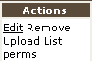

Remove

Remove will remove the gallery and all the images in the galleries, this won’t ask for confirmation, all the galleries and images will be gone so use it very carefully.

Upload

This option will take you to the upload image screen that is explained later.

Browse

The browse option (clicking on the gallery name) can be used to browse the gallery, when you browse a gallery you will see thumbnails for the gallery images. We’ll show you an example of browsing a gallery after we explain how to upload images to the gallery.

List

List is a non-graphical representation of a gallery instead of thumbnails for each image you will see a listing with one row per image, if you want to delete images or take a quick-look at a gallery content without viewing the images you may want to use “list” instead of “browse” since listing is faster than browsing the gallery.

Upload Image

The Upload image screen let’s you upload images to galleries.

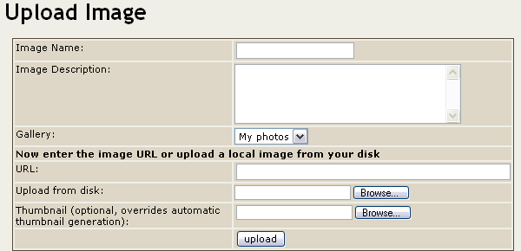

The fields are self-explanatory, note that you have to select a gallery where the image will be uploaded, you can upload images to galleries you created or public galleries created by other users(!).

Thre’re two ways to upload images: entering the image URL or uploading an image from your disk, the upload screen admits both formats but you should use only one method for each image. (If you enter a URL you dont’ have to upload and if you upload you don’t have to enter a URL). If you use both then the result is unpredictable.

Optionally you can also upload a thumbnail for the image, if you don’t upload a thumbnail Tiki will auto-generate a thumbnail using a reduced version of the uploaded image, if you don’t like how Tiki generates thumbnails or if you want to provide your own thumbnails or if you want thumbnails different than the full image you should upload a thumbnail along with the image.

If everything goes fine the image will be uploaded and you will see the image and the thumbnail displayed.

For example:

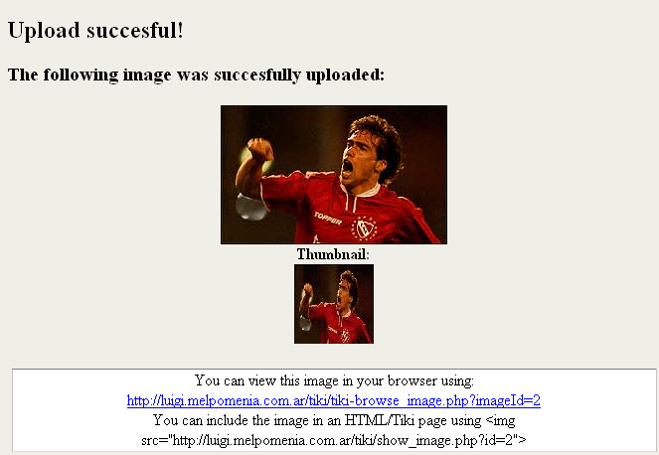

The image was uploaded and stored into the Tiki database!

You will se the image, the thumbnail and information about how to browse the image and how to include the image in an HTML page or a Wiki page. Keep this links in mind since you may want to upload some images to a gallery that can later be used in your Wiki pages or in your Blog posts. Uploading images to a gallery is a nice way to keep images stored in the Tiki system so they won’t fail if a site that held them goes offline or removes the images.

If you see the thumbnail with the same size as the image then: if the image was a GIF file this is normal, don’t worry, if the image is not a GIF your PHP installation doesn’t have the GD extension or the GD extension is too old, in such a case thumnbnails will be generated resizing the original image.
Uploading Images reminder:
Note: You can upload images to:
1) Galleries created by you
2) Public galleries (galleries with the public option set)

Browsing galleries

Once you have some images uploaded you may want to browse the gallery you created:

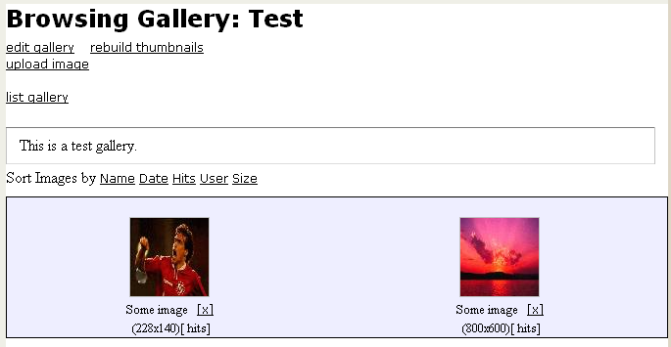

The browse gallery screen displays the thumbnails, the gallery description and links to edit the gallery, rebuild the thumbnails and upload images (if you have the right permissions). The [x] link can be used to remove an image from the gallery if you want.

There’re options to sort the images in the galleries by Name, Date, Hits, Size and User if you want a different order (clicking the link again will reverse the ordering)

For each image a thumbnail is displayed showing the image title, it’s size and the number of hits (a hit is computed each time the image is browsed). If you click on the image you will browse the image:

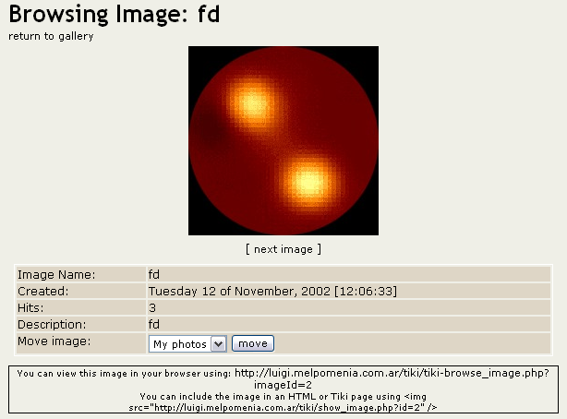

In the browse image screen you will see the full image, the image information, an option to move the image to another gallery (if you have permission) and the information on how to link to browsing the image or how to display the image in an HTML page or a Wiki page, an article or a Blog.

You will also see links to the next/prev image in the gallery to browse all the gallery images if you want.

Individual permissions for image galleries

From the gallery listing screen if you have the right permissions you will see a link labeled “perms” this link can be used to set-up individual permissions for an image gallery:

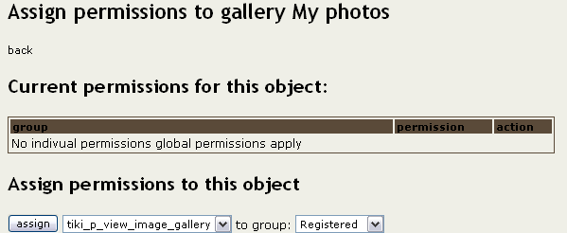

When you assign a individual permission for a gallery the individual permissions will override the global permissions system and only the users that have the permission for the individual gallery can view/edit/upload to the gallery. This feature can be used to configure private galleries, paid galleries or galleries where only a special group of users can upload images for example.

Rankings

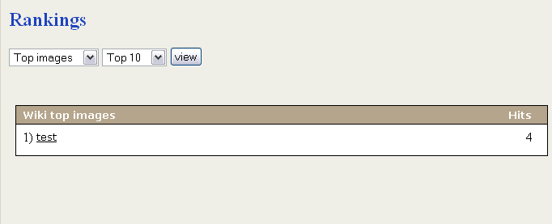

The rankings screen for image galleries is similar to other ranking screens you can select the ranking to show, the number of results to display and clicking the “view” button will display the Ranking.

The System Gallery

As you already know if enabled from the admin screen Tiki can capture images referenced from other sites/URLs storing them in the Tiki database. Those images will be stored in a special gallery called “The system gallery” if you are admin you can browse the system gallery and check what images are stored there, and if you want you can also remove images (if they are no longer referenced from user pages). A feature to automatically remove orphan images (images not being used in any page) will be added to future Tiki versions.

Image galleries permissions

The following are the permissions you can set for image galleries:

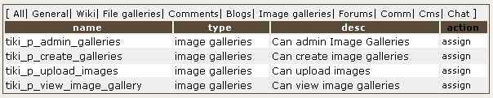

The tiki_p_admin_galleries is a “master” permission that automatically includes the other 3 permissions for image galleries.

Articles and Submissions

Articles and submissions are the most important part of the Tiki CMS system, with the articles and submissions system you can build the basement for a site like those constructed using other CMSs systems like PHPNuke or Postnuke with all the advantages that Tiki has. Basically there’re three structural components for the CMS system: Topics, Articles and Submissions.

The Articles menu:

As a user this is a simple menu, you can visit the Articles Home, you can see a list of articles, you can see the Rankings, send a submission or view active submissions. Of course what you can or can’t do and what you see in this menu is configurable.
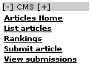

If you are admin click the “Edit article” link in the admin menu to enter a new article.

Editing Articles

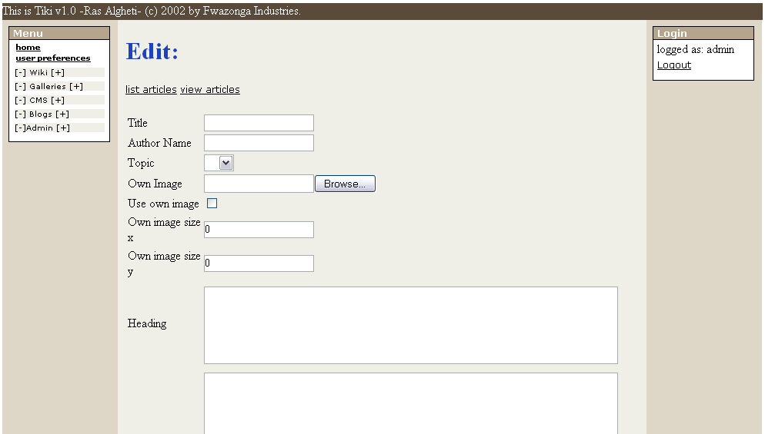

This is the screen where you can edit and existing article or create a new article, we’ll examine each field in detail:

Title is the article title, AuthorName is the name of the author as it will appear in the article (you can use any name here). Topic is the topic where the article will belong, if you don’t see options in the select box for topics then you must first create a topic, use the admin topics link in the admin menu to create a topic and then go back to the edit article screen.
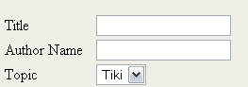

Articles can have an associated image, if you want your article to have an associated image you can upload an image using the Own Image field. By deafault the article will display the topic image (each topic has an image), if you want the article to display it’s own image instead of the topic image check the “Use own image” checkbox. If you are using the article image you may want to check the size that you will like for the image.
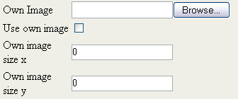

The heading and the body are selft explanatory, note that you can use the Wiki Tag System here as if you were editinng a Wiki Page, read about the Wiki Tag System if you didn’t. If you want to use HTML in the article make sure that the AllowHTML option is checked at the bottom.
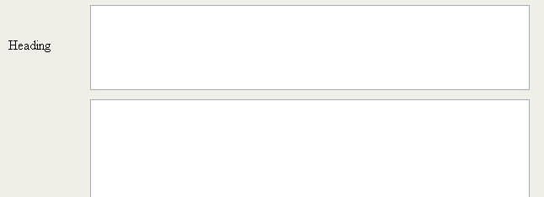

At the bottom set the publishing date for the article and verify the Allow HTML option (if you have permissions), use the preview feature as many times as you want to preview the article and then click save.
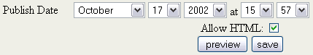

We entered a sample article to show you the Articles Home page.

Articles Home

The Articles Home displays the last “n” articles of the CMS system, “n” can be configured from the admin menu, this page can be set up as the Tiki Home Page from the admin screen if you want to use Tiki as if it were a normal CMS system.

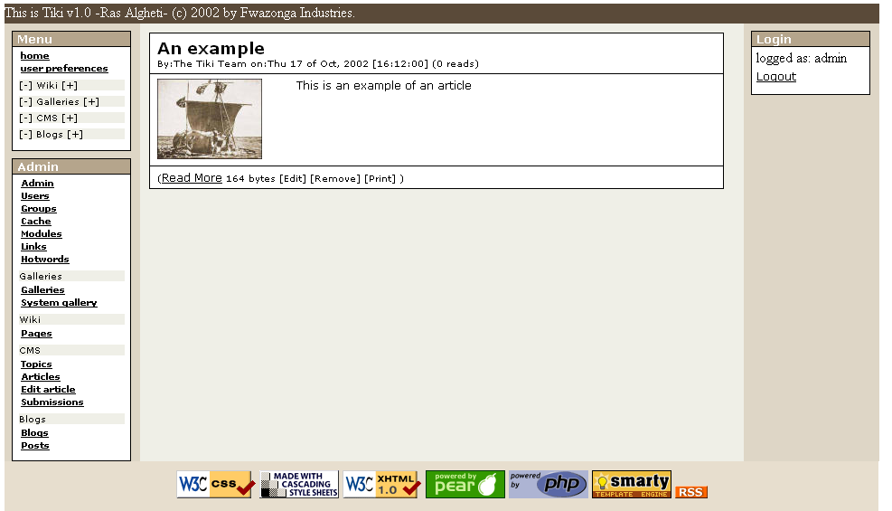

You will see each article displayed showing the heading and a link to read more where you can read the whole article:

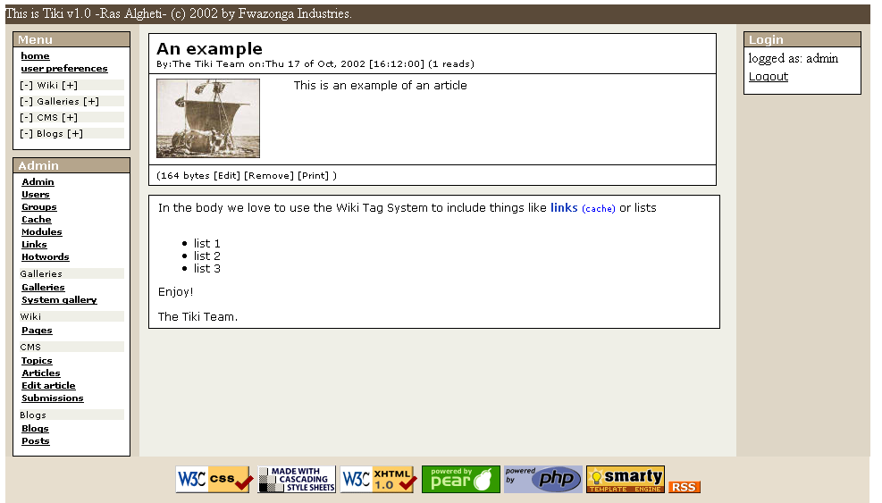

List Articles

The list articles section shows a list of articles.

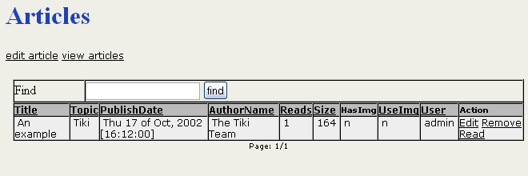

You can sort the list by any column, you can filter articles containing some word and if you have the permissions you will se options to edit, read or remove the article. This screen is useful for administrators as well as regular users.

Rankings

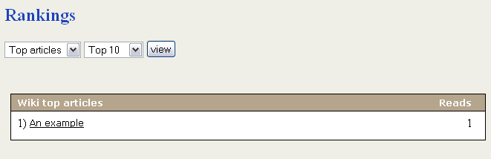

In the Rankings page you will access to rankings for the CMS system such as Top Articles, Top Authors, etc. You have to select the ranking to display and the number of records to display and click the view button to see the ranking.

Submit Article

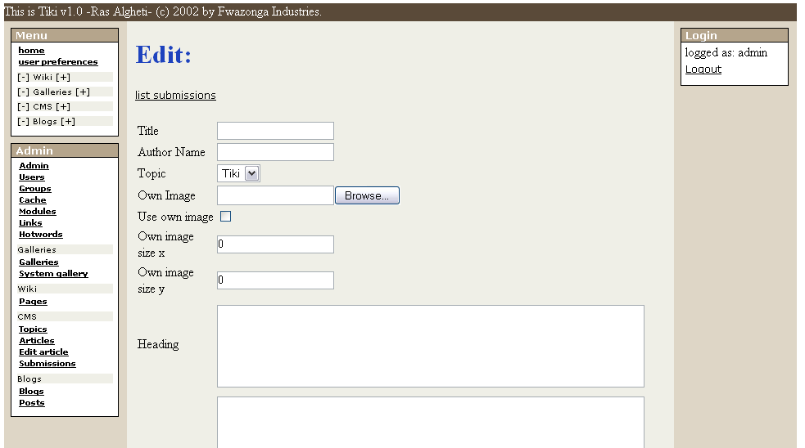

Submitting and article is the same as editing an article with the difference that the result will be stored as a submission and not published inmediately as an article. The process to edit and send a submission is the same as editing and article so you should read about editing articles if you haven’t to find out.

View Submissions

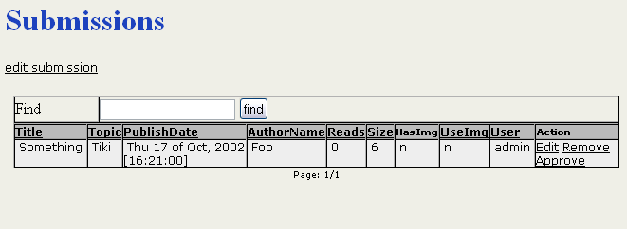

You will a list of submissions and if you have the permissions yoy may see links to edit, remove or approve a submission. Once a submission is approved it becomes an article.

Permissions for articles and submissions

The following permissions can be configured for articles and submissions:

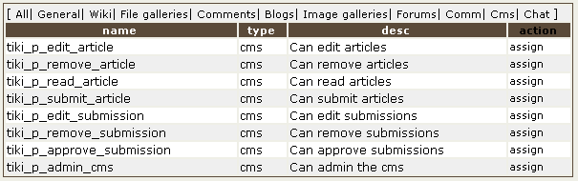

The tiki_p_admin_cms permission is a “master” permission that automatically includes the other 7 permissions in this listing. You can use it to have a group of users that can admin the whole articles/.submissions system without the need of assigning each permission to the group.

The Blog System

Blogs are a very hot topic in the web lately, basiccaly a blog is a collection of posts, a blog can be set up as a personal Journal for a user, a set of reviews of movies, comments about sites, news about a product, world news, whatever.

The Tiki Blog system is quite powerful, let’s take a look at the menu for blogs in the main menu:

There’re four options in this menu: List blogs, Rankings, Create/Edit Blog and Post. We’ll examine each option in detail next.
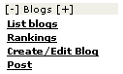

Create/Edit Blog

So you want to set up your personal Journal in the web, you should then create a new weblog, the screen will display a form as the folllowing.

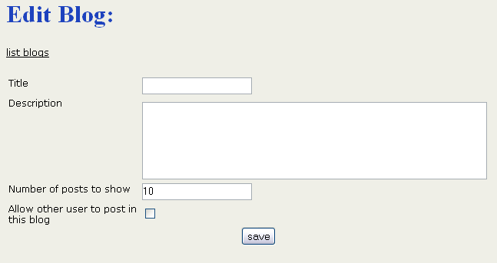

You must enter a title for the Blog, a description, the maximum number of posts to show per page and you have to indicate if you will allow other users (any users) to post entries into this weblog. Normally blogs are private for the user that created the blog but sometimes you may want to allow other users to post entries, you can delete the entries if you don’t want them later.

Once a blog is created you can start “posting” to the weblog.

List Blogs

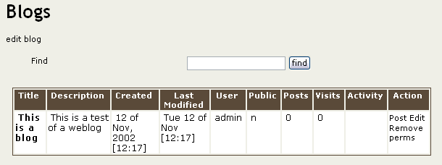

In this screen you will see a list of available blogs, if you have the right permissions you may see links to post, edit, remove or read a weblog. Remove will remove the whole weblog and all it’s posts so use it very carefully. Perms can be used (if admin) to set individual permissions for a weblog.

Post

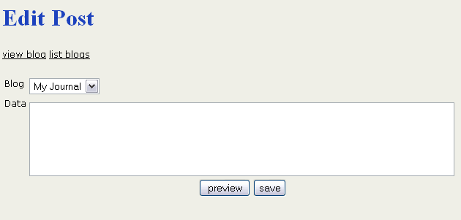

Posting is how weblogs are populated when you post you have to select which weblog to use (you will see all your weblogs plus public ones available) and you enter the weblog entry. As you can imagine you can use the Wiki Tag System to edit weblog entries and you can use regular HTML too. Since weblogs are normally private initiatives by users HTML is always allowed, if you break your own weblog then it will be your problem.

After posting or clicking a read link in the blog listing or by a link you can “read” a weblog:

Reading a weblog

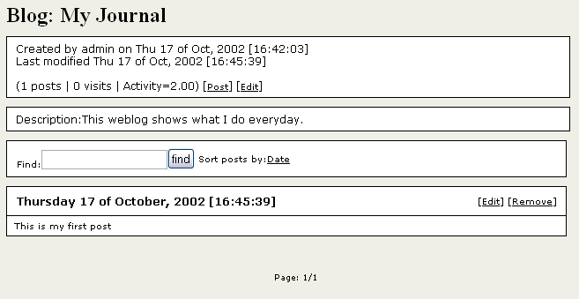

When you read a weblog you will see all the posts for today or the previous days, you can navigate the posts using the next/prev buttons at the bottom of the page or you can use the calendar module if enabled to browse posts for any given day.

The read screen will display information about the weblog such as number of posts, visits, activity rate and last modification date and if you have the permissions it will display links to post or edit the weblog.
There’s a find button that let’s you search for posts containing some specific information.

For each post if you have the permission you will see links to edit the post or remove the post.

Setting individual permissions for a weblog

Clicking the “perms” link from the weblog listing will take you to a page where you will be able to configure individual permissions for the weblog.

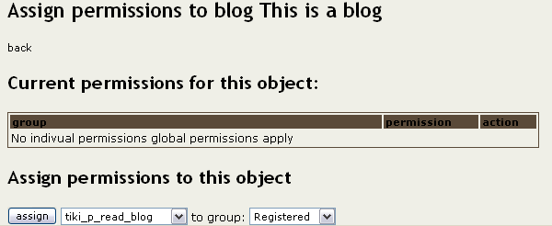

Individual permissions , if set, will override the global permissions set for weblogs, this can be used to set-up private weblogs in your site.

Rankings

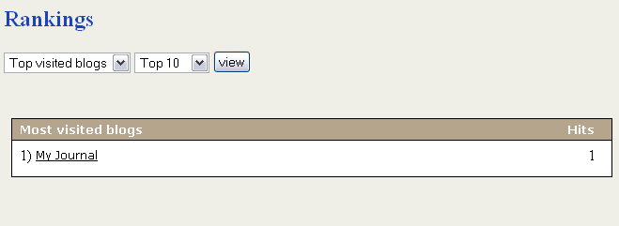

The rankings screen for weblogs displays several rankings and charts about the weblogs, you should select the ranking and the number of positions to show and then click the “view” button.

Using Desktop Applications for your Blogs

One of the great features of Tiki is that it implements the XMLRPC API of blogger, a popular blogger with a lot of tools and users in the market. This API is used by several windows applications that can be used to manage your weblogs, any application implementing the Blogger XMLRPC API can be used to edit Tiki blogs.


Using wBloggar
Note: The XMLRPC feature should be enabled from the admin screen to make this programs work, the feature is disabled by deafult so if you are admin and want to use Desktop programs for blogs please enable the feature.

In this section we’ll introduce wBloggar a very nice application to manage blogs that can be used to manage Tiki blogs, note that this is not the only application that can be used, any application that you like implementing the Blogger XMLRPC API can be used.

Installing wBloggar

wBloggar is one of the nice applications you can use to edit Tiki weblogs, wBloggar can be downloaded from: http://wbloggar.com/. The application is a normal windows application that has a installer, once installed you should configure bloggar to access the Tiki database.
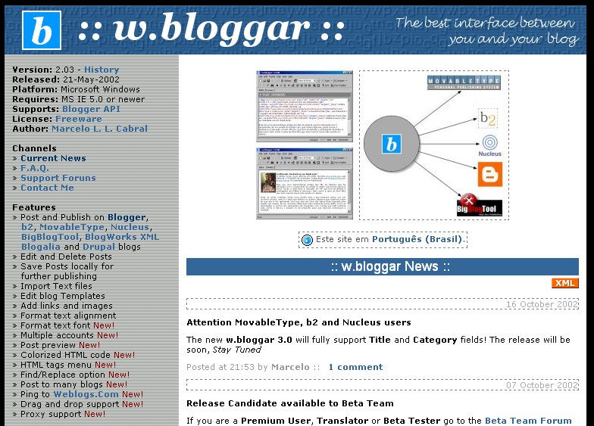

Setting up your account

This is the first screen displayed when you start wBloggar: In this screen you should enter your tiki username and password as you use it in Tiki. Then once in the wBloggar application you should enter file->account_connection and configure the Tiki server:
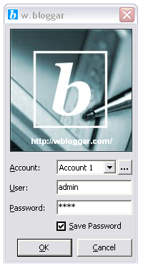

Setting up the Tiki server

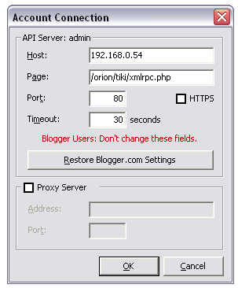
Enter the Tiki IP address or the tiki hostname (for example www.mytiki.org) in the Host field. Then enter the path to the xmlrpc.php file that is distributed within tiki in the “Page” field, for example: /tiki/xmlrpc.php if you installed Tiki at the Document Root of your server. , the port should normally be 80 unless you changed it and the timeout can be left in 30 seconds. If everything is ok you are ready to use wBloggar to edit Tiki weblogs!

Getting list of available blogs

Now go to file->settings->account and you will see:

Click the reload blog list button to get a list of available blogs where you can post. Once the list is loaded from the server you are ready to use wBloggar.
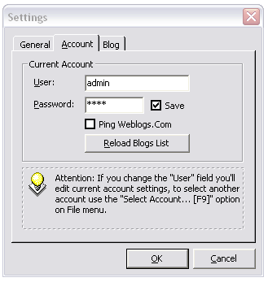

Using wBloggar

This is the main screen of wBloggar:

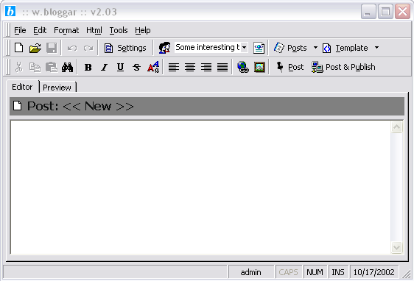

You can select the blog that will be used at the top (next to settings), you can send pots, edit posts, remove a post, preview posts and do anything that you want. Note that you can also store posts in your local disk and post them when you want. All in one wBloggar is an excellent companion to Tiki blogs that you can use to manage your blogs in any way that you want.

As an example select a blog, enter some text and post it, if everything goes fine you will see the post in your Tiki weblog (!!)

Permissions for the blog system

The following permissions can be set for weblogs:

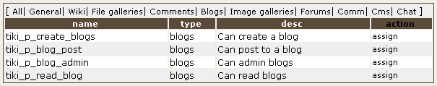

The tiki_p_blog_admin permission is a master permission that automatically gives the group the other 3 permission for weblogs.

File Galleries

If you enable the file galleries section from the admin menu you’ll see a menu section in the main menu for file galleries. From the menu according to the permissions you have you will be able to list existing file galleries (where you can create a new gallery) or upload a file to a gallery.
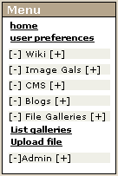

A file gallery is just a collection of files that can be downloaded, files are kept in the Tiki database and the number of downloads for each file are registered.

The List galleries option in the main menu will take you to the following screen:

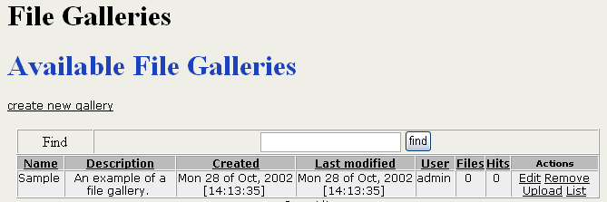

From this screen you can create a new gallery, edit existing galleries, remove existing galleries, upload a file to a gallery or list the contents (files) of an existing gallery. The options you see as a user depend on the permissions the admins have set for your groups.

To create a new file gallery click the “create new gallery” link and the following form will be displayed.

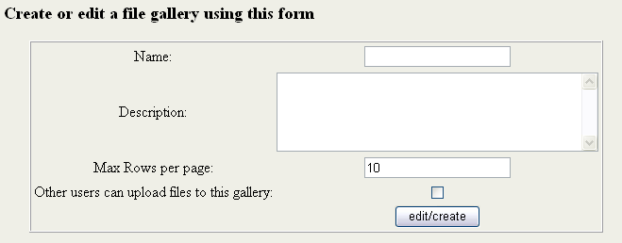

The same form is displayed to edit and existing gallery, you have to fill the gallery name, a description and the maximum number of rows (files) that will be displayed for each page in the file gallery listing.

You can make a gallery invisible to normal users unchecking the “gallery is visible to non-admin users” checkbox. This can be used to set-up galleries that can’t be browsed but contain files that you will make available for downloading in your site using direct links to download the file.

If you want to allow uploads to this gallery from other user check the checkbox above the edit/create button. If the checkbox is not checked then only the gallery creator or admins can upload files to the gallery.

To upload a file you use the following form:

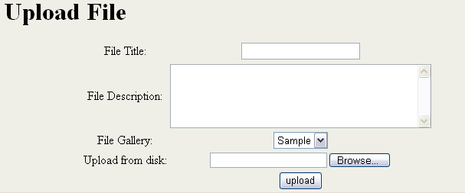

In this form you enter a title and description for the file, the gallery where the file will be stored and then the file from your local disk to upload. If everything goes well you will see a message indicating that the file was uploaded.

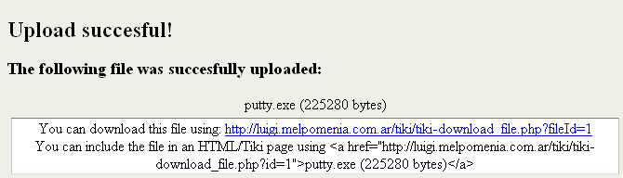

Once you have some files uploaded to the gallery you can visit the gallery from the gallery listing menu and see the uploaded files:

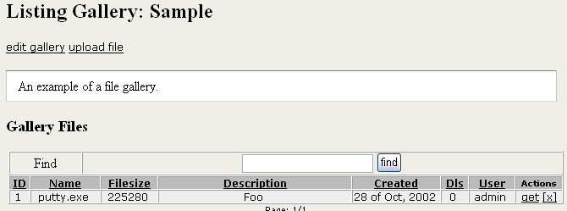

From this screen you will see the gallery description and the files uploaded to this gallery (the number of files per page varies), you can order the list by any of the columns in the listing. Clicking the “get” link in the actions column will download the file to your local disk.

Permissions

The following permissions can be set for the file galleries section:

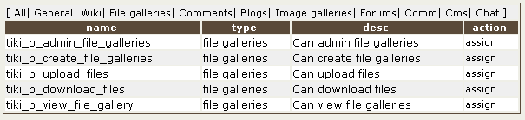

The tiki_p_admin_file_galleries is a master permission that automatically includes the other 4 permissions.

Comments

Comments can be used in

- Articles
- Wiki pages
- Image galleries
- File galleries
- Polls

If you enable comments for some of the features of Tiki from the admin menu you will se links to show/hide comments and the number of comments for the object being viewed. In this section we’ll explain comments for Tiki pages, everything will be the same for other Tiki features such as articles, weblogs, polls, etc.

If you see this bar at the bottom of the central part of the screen (or somewhere else if the customization changed the appearance) then you can see/enter comments. Click the “Show comments” link to display comments and a form to post new comments (if you have the permission).

Controling the display of comments

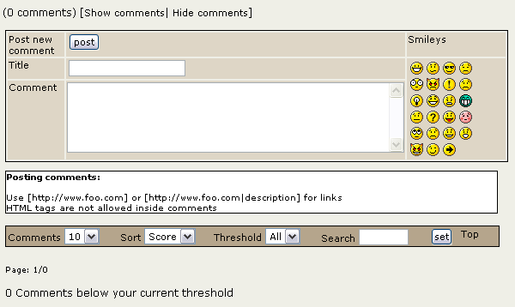

You can see here the comments panel, you can enter a new comment, set which comments you want displayed and see the comments. To get started enter some comment.

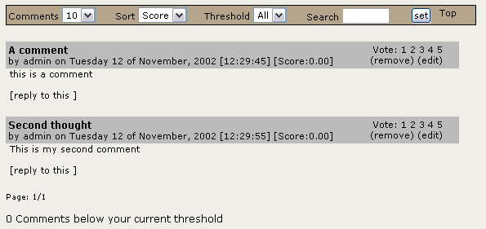

The toolbar at the top can be used to configure how many comments to display per page, how comments will be sorted (Score/Date), the minimum number of points for a comment to be displayed, the minimum score for a comment to be displayed (threshold) and a find box to filter comments containing some word. The “top” link can be used to get back to first page of comments from any page of comments. If you reply to a comment replies will be displayed nested to the comment as in the following screen:

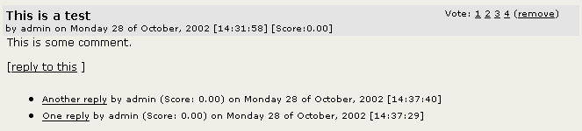

Clicking any of the replies will take you to a page where replies for the comment are displayed and you can enter a new reply or reply an existing reply.

If you are admin or the comment was entered by you as a registered user (not anonymous) you will be able to remove a comment after posting it if you didn’t meant to post that comment or if you made some mistake.

Voting comments and the karma system

If enabled by the admin you may be able to “vote” comments from 1 (poor) to 5 (very cool) in the title bar for each comment. When a user votes a comment the “Tiki karma” system for comments is applied, the karma system works following this rules:

- Each registered user have an associated number of “points”, an average between the user points and the number of votes gives a user a certain “karma level” varying from 0 to 5.
- Users gain points when a comment posted by him/her is voted, when someone votes a user comment with “3” the user gains 3 points and earns one vote.
- When a user votes a comment the number of poinst added to the comment depends on the karma level of the user, if the user has a high karma level the comment receives more points. For example a vote of “5” for a comment may add 4.22 points if the user has a very good karma or only 0.23 if the user has a lower karma level.

This system makes users that post good comments gain more karma and so their votes will make comments voted by them rank higher .

Permissions

The following permissions control the comment system:

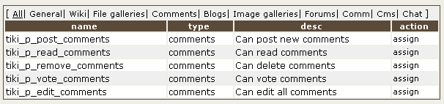

The search engine

If the search feature is enabled and you assign the search box module to the left or right side bar you will see a search box where that you can use to search content in Tiki, the search box will display a select box allowing you to search for a word in:
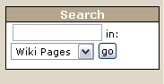

- Wiki Pages
- Images
- Articles
- Image Galleries
- File Galleries
- Blogs
- Blog posts
- Forums

Once you select a feature and click the search button you will be redirected to the searchresults page :

In this screen you will see a list of results for the search, the links below the title can be used to search in different areas of Tiki such as pages, galleries, images, blogs, posts or articles. If there’re a lot of results you will see links to the next/prev pages at the bottom, the number of items where the search ciretria was found can be located just below the links to search different features.
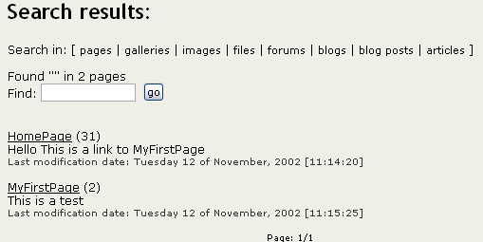

This integrated search engine is very useful to quick-find content or information in Tiki and it will automatically detect which features/sections are enabled or disabled admitin the search only in enabled features. If you disable the Wiki for example you won’t be able to find things in Wiki pages.

Featured Links

Featured liks are links to sites/pages of special interest by the user community of the Wiki, when you click on a featured site link the site will be displayed as a Wiki page (as if it were framed). That’s all, links to sites.

The user preferences screen

If enabled from the admin menu you will see a link to “user preferences” in the main menu, the user preferences page is a page for registered users (users with a valid login and password already logged in the system) where they can set up several preferences about the site and where they can see some stats and quick links to pages, blogs or galleries they have created.
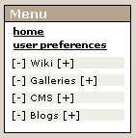

The user preferences will display a screen such as the one presented on the left, as you can see it has a box where the user can change his email, the theme, his real name, home page and it has a link to the user personalwikipage as well as a link to edit the page.
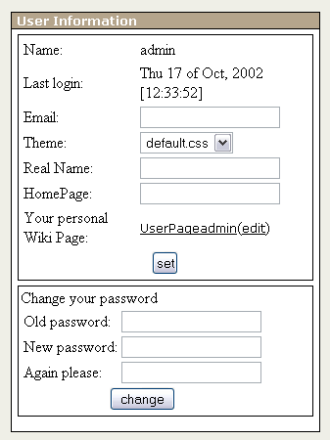

This screen can be used to set up different themes for users, in the future we plan to add a lot of themes, specially themes for users needing special accesibility features such as aural properties, bigger than normal text, abscense of colors, etc.

This screen will be also enhanced with new preferences and setting in future versions allowing the users to finer control how they use the site and how they make the site look.

Polls

As an admin you can configure polls that the users can vote, if there’s a poll enabled and a module assigned to display the poll as a user you will see a box like the one we are displaying on the left.
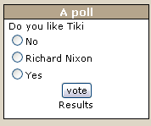

You can click on an option and press the vote button to vote or you can click the “results” option to see the poll results, a simple system is used to prevent users from voting many times, if anonymous users can vote the system can be tricked and the user will be able to vote again in a new session. If only registered users can vote then the system always works and users won’t be able to vote twice since votes are registered for each username.

The results are dislayed in a screen like this one:



The “other polls” link can be used to display other polls:

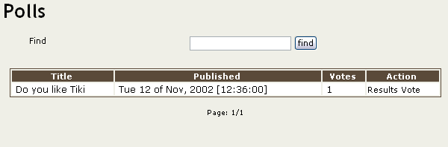

From this screen the user can see the results of other polls and vote any poll that is not “closed” once a poll is closed by an admin users won’t be able to vote that poll.

Permissions

The tiki_p_vote_poll permission can be used to control who can vote polls.

Categories

Categories are used to classify Tiki objects, you can classify objects and create/edit categories from the “admin categories” screen. As a user you can browse existing categories using the “categories” link in the application menu (if categories are enabled).

The category browser will be displayed and will look similar to this screen:

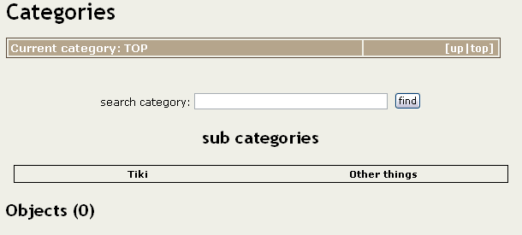

The top bar indicates the category that you are browsing, in this case “Top”, the up/top links on that bar can be used to go to the parent category or the “top” category.

In this example we are in the category “admin” inside the category “tiki” as you can see the full category path is displayed to give the user the context of what is he browsing. Clicking “top” will take us to the top category while “up” will take us to the Tiki category. The name of each category is also a link, so you can go back to any category in the category path.



The sub categories section list available subcategories from the current category, click on any subcategory to navigate to that category.

Finally the objects part lists the objects that are classified in the category that the user is browsing:

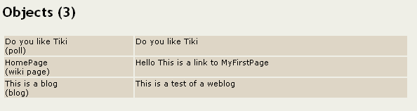

In this example we observe that there’re three objects in the current category, a poll, a Wiki page and a weblog. The name of the object is a link to the object the description is automatically generated from the object information.

The search category bar can be used to search for specific information inside a category.

Permissions:

The tiki_p_admin_categories permission controls who can admin categories. (See the admin categories section in the admin section of this panel)

Chat

If enabled you will see a link to “chat” from the application menu, the link will take you to a screen where you can select a chat channel to be entered. As an admin you have to first configure at least one chat channel before enabling the chat feature or the users won’t be able to enter any channel. If you are not logged in (if you are anonymous) a field will be shown where a nickname has to be entered that will be the name used in the chatroom, if you are registered your login name will be your name in the chat room. Entering the chat room shows the following screen:
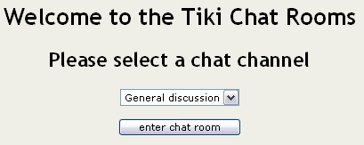

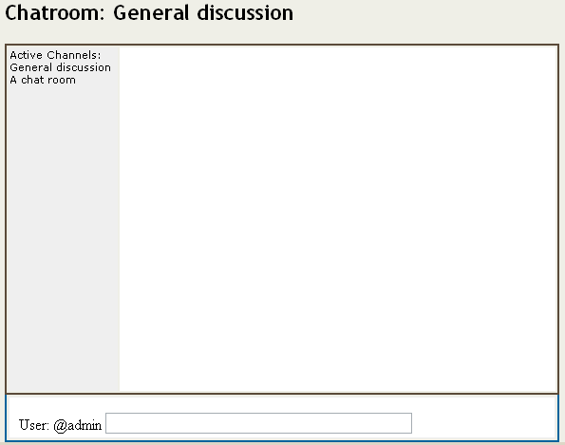

The process is simple, type some text and see the text that other users enter, a list of available channels is displayed on the left and you can click on any active channel to change the channel where you are chatting.

Some smileys can be used in the chat text:

- (:biggrin:)
- (:confused:)
- (:cool:)
- (:cry:)
- (:eek:)
- (:evil:)
- (:exclaim:)
- (:frown:)
- (:idea:)
- (:lol:)
- (:mad:)
- (:mrgreen:)
- (:neutral:)
- (:question:)
- (:razz:)
- (:redface:)
- (:rolleyes:)
- (:sad:)
- (:smile:)
- (:surprised:)
- (:twisted:)
- (:wink:)
- (:arrow:)

HTML is not allowed in the chat text but if you want to write a link you can use

[http://www.foo.com]
or
[http://www.foo.com|description]

And it will be displayed as a link.

In 1.2 this is all the chatroom offers, a place to chat with other users. Be sure that new features will be added to the chat system in future releases.

Permissions

The following permissions can be set for the chat system:

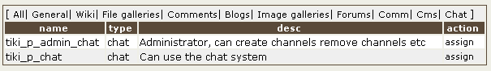

Forums

Welcome to one of the most interesting features in Tiki: the forums system, the concepts are very simple:

- A forum is a collection of “topics” about a subject, you can have a forum to discuss a product, to discuss movies, to discuss about a car, anything.
- A topic is a collection of messages in a forum
- A message is a message a user posted about any topic.

The forums menu in the application menu displays 2 links, one to the forum listing and another to the forum rankings.


If you are admin you will be able to configure forums from the admin-forums screen in the administration menu. Let’s go to the admin forums screen to create a forum:

The admin forums screen show a list of available forums and a form to create/edit a new forum, the form has the following format:

Creating/editing forums

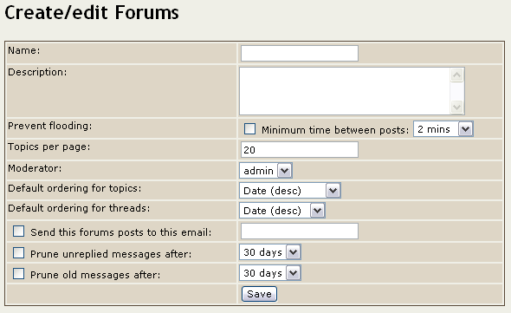

The fields are described next:

Field | Description
Name | The forum name as will be displayed in the forum listing
Description | A description for the forum
Prevent flooding | If enabled then the users won’t be able to post a message after another message without waiting at least the indicated amount of time. This can be used to prevent a user from flooding the forum with messages.
Topics per page | The number of topics that will be displayed in each page when listing the forum topics.
Moderator | A user can be set as the forum moderator, when a user is the moderator he will be granted all the permissions for this forum.
Default ordering for topics | How will be the topics orderded in the list of forum topics by default. Options are:  - Date: Creation date of the topic  - Replies: Number of replies (messages) the topic has  - Reads: Number of times the topic has been read.  - Last post: Date of the last post in the topic. (the last message posted)  - Title: topic title.
Default ordering for message s (threads) | How will be the messages for a topic ordered by default:  - Date: message date  - Title: message title  - Score: Message score
Send this forum posts to this email | You can configure an email address that will receive all the topics and messages posted to the forum
Prune unreplied messages after | If enabled topics that don’t have a reply will be automatically after the amount of time indicated
Prune old messages after | If enabled topics and messages will be automatically removed when they are older that the indicated amount of time.

Once a forum is created you can see it displayed in the listing:

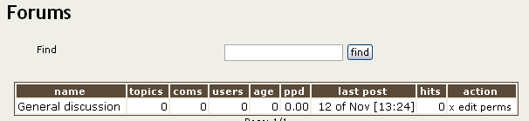

The edit link can be used to edit the forum while the perms link can be used to set-up individual permissions for the forum.

Using the forum

As a user you can enter the “forums” section clicking the “forums” link in the application menu.

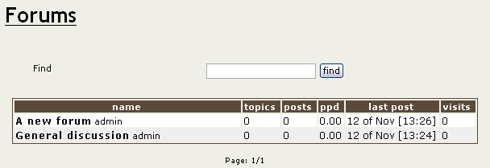

You can order the forum listing as you want and you can click on the forum name to enter the forum.

When you enter to a forum a list of “topics” will be displayed:

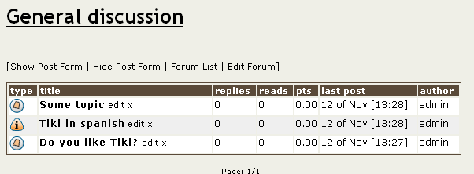

Topics are listed using the default ordering for topics set for the forum, as a user you can order the topics by any of the fields in the topic listing. The “type” is used to classify topics (more on this later). When the “type” icon is shown reddish (as in this case) the topic is new for the user.

If you have the permission to post a topic you will see a link to display/hide the form to post a new topic. This is the form when displayed:

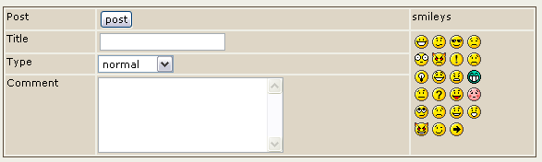
You will have to enter the title for the topic, the type and the comment (the topic text), you can use some smileys shown at the right if you want. The topic-type that you can set will be “normal” unless you are an admin for this forum, in which case you can use any type. Topics type are described next:

Type | Icon | Description
Normal |  | A normal topic.
Hot |  | A “hot” topic, a topic that is very important or polemical or anything you consider “hot”
Announce |  | An announcement
Sticky |  | A sticky topic will be displayed on top of the list of topics regardless of the ordering selected for topics.
Locked |  | A locked topic is a topic where users can’t post messages, admins can lock a topic by changing the type of any topic to “locked”

If you clikc on the topic name for any topic a list of topic messages will be displayed:

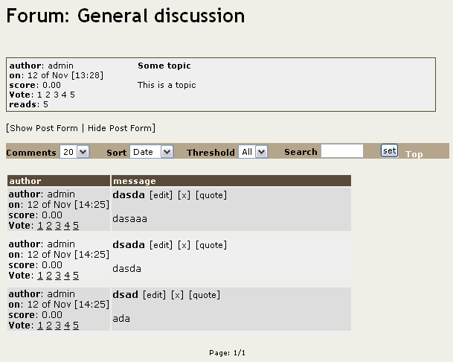

From this screen you can post new messages (if you have the permission), edit or remove messages (again if you have the permission) and quote a message if you want. The form to post a message for a topic is almost indentical to the form used to post a new topic.

The toolbar can be used to sort messages by date, score or title, limit the minimum score for a message to be displayed (threshold) or find messages containing some word.

Setting Individual permissions for a forum

From the admin forums screen you can click on the “perms” link to set –up individual permissions for a forum.

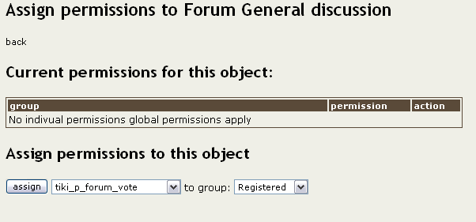

Setting individual permissions can be used to have private forums, to control who can post new topics in some special forums, to give admin privileges to a group of user only for some forums, etc. As usual when individual permissions are set for a forum global permissions don’t apply.

Forum Rankinks

The forum rankings screen can be used to display rankings for the forums.

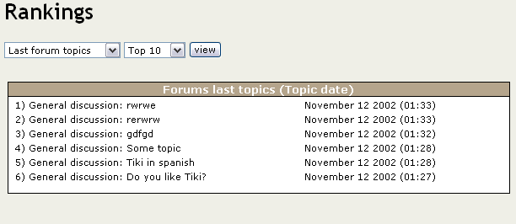

Forum permissions

From the admin groups screen you can set up the global permissions for the forums:

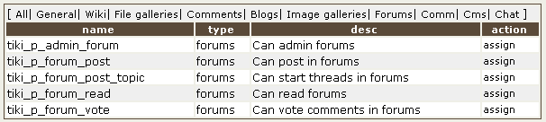

The communications center

The communications center can be used to send/receive objects from Tiki, in version 1.2 only Wiki Pages can be send/received but other objects will be added in future versions.

In order to use the communications center the feature must be enabled from the admin screen.

If you enable the communications center you will see a link to “send” pages from the wiki menu and a link to “received pages” from the wiki menu (if you have the right permissions)

Sending objects

Clicking the send link from the application menu displays the screen where you can send Tiki objects to other sites:

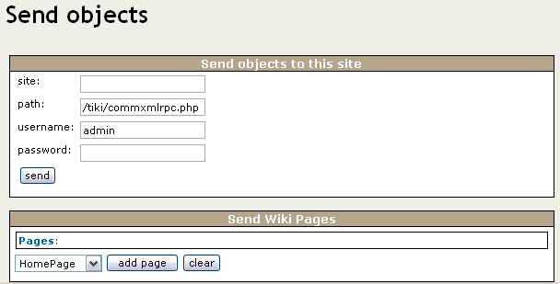

The first part of the screen must be filled after you selected all the objects to send, the second part can be used to select the Wiki pages that will be sent to another site, select pages (as many as you want) clicking the “add page” link. When you have selected all the pages to send fill the information at the top as follows:

Site: The URL for the site, for example: www.foo.com (Don’t use http://....)
Path: The path to the commxmlrpc.php script for the site, a typical value is /tiki/commxmlrpc.php, but if the installation is different it can be another path, sites should inform the path to the commxmlrpc.php script.
Username: The username that will be used to send objects to the site (it must be a valid username for the destination site and the user must have the permission to send objects. In other words the destination site must have a user with his name and configure permission to send objects for that user)
Password: password for the username.

If everything goes well you will see a message describing the result of the operation:

How to test if this is working.

From the admin screen make sure that you have the communications feature enabled, then use the following information to send an object to yourself:

Site: localhost
Path: /tiki/commxmlrpc.php (change it you installed Tiki in other directory)
User: admin
Password: admin

The communication should be performed and you are ready to examine the received pages.

Administering received Wiki pages

From the Wiki section in the application menu clickj the “received pages” link. The following screen will be displayed:

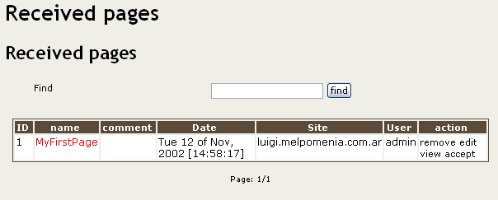

In this screen you can see the list of pages received the date when the page was received, the site that sent the page and the user used from the sending site to send the page.

If the name of the page is in “red” then the page has the same name as an existing page in your system and so you have to rename the page before being able to accept it.

For each page you can remove it (if you don’t want it), edit the page (where you can rename it), view the page or accept it.

Once accepted the page will be part of your Wiki as a normal Wiki page.

Permissions

The following permissions can be used to control the communications center:

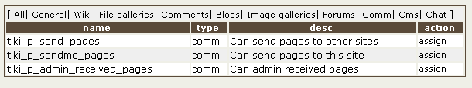

If you want to configure a user that other sites can use to send objects to your site put the user in a group with the tiki_p_sendme_pages permission.

Administration

So you are the admin user, you are the one that can decide what other users can or can’t do and how the application will be used by your users, Tiki allows a lot of flexibility that requieres just a little reading.

Tiki can be configured to be a Wiki, a CMS system, a portal, a Weblog, many weblogs, a community site, a combination or whatever your imagination needs. Any configuration can be constructed using the admin screens and the permission system and while it is a very flexible and powerful system it can be learned in just a few minutes and it will be easy to use.

Understanding users and groups

The most important part of the Tiki administration is uderstanding the permission system used by Tiki, basically the rules are:

- Administrators can create and edit groups.
- Users can be assigned to one or several groups.
- Permissions are assigned to groups, NOT users.

There’re two pre-defined groups:

- Anonymous : Users that are not logged automatically belong to the anonimous group.
- Registered group: Users logged in automatically belong to this group.

Tiki has the option to allow users to register themselves using the application or not, so registered users can or can’t be trusted depending on that setting.

User administration

The user administration screen allows you to administer users:

You can create new users (useful if users can’t register themselves), you can remove users and you can assign groups to a particular users. You can find users by login name using the find button at the top of the listing (it will act as a filter)

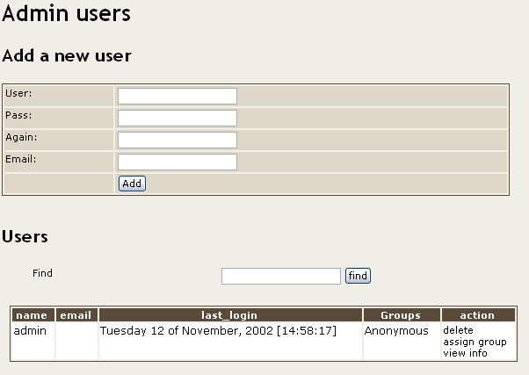

Group administration

The group administration screen is similar.

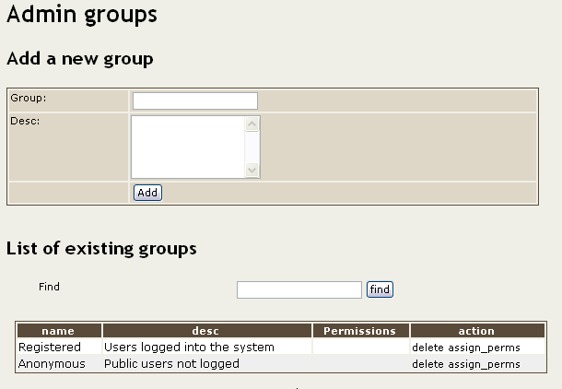

You can create groups, delete groups, find groups by name/description and you can assign permissions to a particular group clicking assign_perms in the row of the group. Note that by default the Registered and Anonymous groups are predefined.

Assigning users to groups.

Create a group, for example test and create a user, for example foo, then from the user administration screen click assign_groups for the user. You will be able to assign groups to that particular user a user can belong to as many groups as you want.

Assigning permissions to groups.

From the group administration screen click on assign_perms for a paritcular group and you will see a screen like this one:

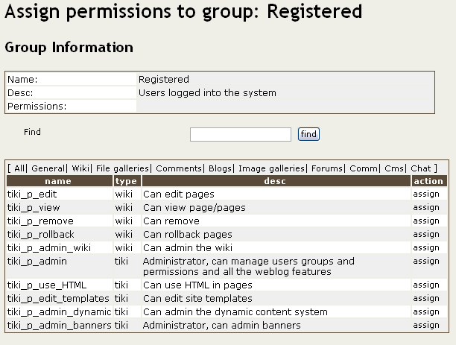

From this screen you will be able to add or remove permissions from a group. You can select a “type” of permission to see if you want to assign permissions for a specific section of Tiki for example File galleries.

When a user belongs to more than one group the permissions are accumulated.

Permissions

Permissions are what groups CAN do, note that permissions always ALLOW groups to do things, there’re no restrctive permissions in Tiki because they can conflict if the user has more than one group.

The list of permissions that you can assign to groups are:

General permissions

Permission | Description
tiki_p_admin | Makes the group ‘admin’ admins can do everything. This can be used to have more than one admin in the Wiki (the user named ‘admin’ is automatically assigned to this permission)
tiki_p_use_HTML | Allows the user to use HTML when editing a page, article or submission. (doesn’t give edit permission to the group)
tiki_p_edit_templates | Can edit templates (A missedited template may break the layout)
tiki_p_admin_banners | Can add/edit and remove banners
tiki_p_admin_dynamic | Can admin/edit the dynamic content system
tiki_p_admin_categories | Can admin categories, create/edit categories and add/remove objects from categories.
tiki_p_vote_poll | Can vote polls.

Wiki permissions

Permission | Description
tiki_p_view | Groups with this permission can visit and read the Wiki pages
tiki_p_rollback | Allows the group to rollback a page to any previous version
tiki_p_remove | Allows the group to remove pages and versions of pages
tiki_p_edit | Allows the group to edit Wiki pages
tiki_p_admin_wiki | A permission that includes the 4 permissions described above.

Image gallery permissions

Permission | Description
tiki_p_admin_galleries | A permission including all the permissions for image galleries
tiki_p_create_galleries | Allows the group to create image galleries
tiki_p_upload_images | Allows users to upload images to their galleries or galleries that were created allowing other users to upload images
tiki_p_view_image_gallery | Can view image galleries (browse the gallery, access images etc)

Articles & Submissions permissions

Permission | Description
tiki_p_read_article | Can read articles, you should normally assign this permission to all the groups but if you want to charge for reading articles you may want to assign this permission only to the ‘paid’ (for example) group.
tiki_p_edit_article | Allow the group to edit articles
tiki_p_remove_article | Allow the group to remove articles
tiki_p_submit_article | Allow ythe group to send submissions.
tiki_p_edit_submission | Allow the group to edit/change submissions.
tiki_p_remove_submission | Allow the group to remove submissions.
tiki_p_approve_submission | Allow the group to approve submissions.
tiki_p_admin_cms | A permission including all the permissions describe above.

Blog permissions

Permission | Description
tiki_p_create_blog | Groups with this permission can create new blogs.
tiki_p_blog_post | Can post to blogs created by them or public blogs.
tiki_p_read_blog | Can read weblogs
tiki_p_blog_admin | Includes all the blog permissions

File Galleries

Permission | Description
tiki_p_admin_file_galleries | Includes all the permissions for file galleries
tiki_p_create_file_galleries | Can create new file galleries
tiki_p_upload_files | Can upload files to file galleries created by the user or public file galleries
tiki_p_download_files | Can download files from file galleries.
tiki_p_view_file_galleries | Can view file galleries (list files in the galleries)

Comments

Permission | Description
tiki_p_post_comment | Can post comments
tiki_p_read_comments | Can read comments
tiki_p_vote_comments | Can vote comments
tiki_p_remove_comments | Can remove comments
tiki_p_edit_comment | Can edit comments

Forums

Permission | Description
tiki_p_admin_forum | Includes all the permissions for the forums.
tiki_p_forum_post | Can post messages in a forum topic
tiki_p_forum_post_topic | Can post a new topic in a forum
tiki_p_forum_read | Can read forums
tiki_p_forum_vote | Can vote forum messages

Chat

Permission | Description
tiki_p_admin_chat | Can admin chat channels, create channels, remove them, etc.
tiki_p_chat | Can use the chat system

Communications

Permission | Description
tiki_p_send_pages | Can send pages from this site to other sites.
tiki_p_sendme_pages | Can send pages from other sites to this site
tiki_p_admin_received_pages | Can admin received pages, remove them, accept them, edit them etc.

Permissions for individual users

What if you want to give a specific user some permissions? Just create an artificial group, assign the user to that group and give the group the permissions that you need.

Individual permissions

As we explained you can set-up individual permissions for some Tiki objects, when assigning individual permissions the permissions you can assign are the same you have in the global permissions screen, once an object has individual permissions only the individual permissions apply to the object and not the global permissions.

The following objects accept indvidual permissions:

- Wiki pages
- Image galleries
- File galleries
- Forums
- Weblogs

The general administration panel

The admin panel is where several settings about Tiki can be set, only users with admin permission can enter this screen, you can access it using the admin link from the Admin menu box.

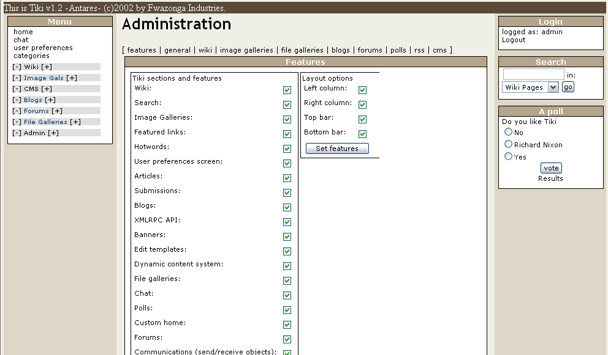

The admin panel is divided in sections which are:

- Features
- General preferences and settings
- Wiki settings
- Image Galleries settings
- File Galleries settings
- CMS settings
- Blog settings
- Forums settings
- RSS feeds settings

Features

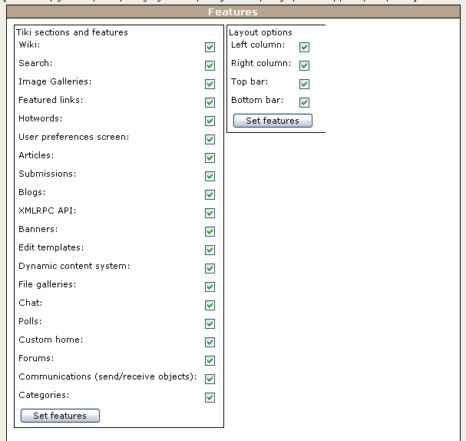

The features panel can be used to set-up which features will be enabled and which features will be disabled in the application. When you disable a feature all the screens and modules related to the feature will produce an error screen if accessed. This allows you to use Tiki for your needs without configuring the rest of the application if you don’t want to.

The features are:

- Wiki: Enables/disables the wiki
- Search: Enables/disables the search box and search results screen.
- Image galleries: enables/disables image galleries, gallery creation, image uploading, image rankings etc.
- Featured links: enables/disables featured links.
- Hotwords: enables/disables hotwords, when hotwords is enabled the Wiki pages are parsed and some words are automatically converted to links, if you have admin permissions you can edit this words from the admin hotwords screen.
- User preferences: enables/disables a screen where the users can setup their preferences, for example the theme.
- Articles: Enables disables articles.
- Submissions: Enables/disables submissions/
- Blogs: Enables disables blogs.
- XMLRPC API: Enables/diables the Blogger XMLRPC API that can be activated to allow Blogger compatible applications to manage tiki weblogs. Note that the API is carefully implemented to respect Tiki permissions so it is NOT a security compromise to enable this feature it is as safe as the rest of the site.
- Banners: Enables/disables the banner system
- Edit templates: Enables/disables dynamic template editing
- Dynamic content system: Enables/disables the dynamic content system
- File galleries: Enables/disables file galleries
- Chat: Enables/disables the chat system
- Polls: Enables/disables the polls system
- Custom Home: Enables/disables the custom home, if enabled then a custom home page is an option to be used as a home page. (more in the section about setting the home page)
- Forums: Enables/disables the forums system
- Communications: Enables/disables the communications system
- Categories: Enables/disables categories

Layout options

This part of the features section can be used to control the look and feel (layout) of your Tiki site, basically you can enable/disable the columns, the top bar (where the Tiki version is indicated) and the footer. If you want a 1-column layout this is the way to go without changing anything in the code.
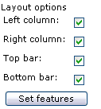
Some users asked if there’s a need to display the copyright message for Tiki the answer is a clear NO, you can use Tiki for whatever you want and you can customize to look exactly as you want.

General preferences and settings

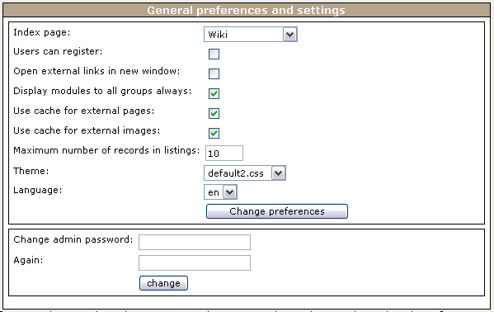

This panel controls settings and preferences generic to Tiki. The settings are explained below:

Index Page:

(How to set the site’s home page)

This is a very interesting feature, with this setting you can select what to use as the Home Page of tiki, the Home page has the following properties:

- It’s where you go if you click the “home” link in the main menu
- It’s where you go after you log in
- It’s where you go if you use http://some.com/tiki/index.php or http://some.com/tiki/
- It’s where you go if you click the logo in the logo module.

You have 6 options for the home page:

- The wiki home page.
If selected then the home page will be the Wiki Page named HomePage.
- The Articles Home Page
If selected the home page will be the articles home page where you can see the last “n” articles entered
- A Blog
If selected then the home page will be a vweblog that you have to select in the weblog settings part of this screen. (if you don’t set it or no blogs exist please don’t select this option as the home page it will break the site)
- An Image gallery
If selected the home page will be an image gallery that you can select in the Image galleries setting section of this screen, if you don’t have any galleries please don’t select this option because it won’t work at all.
- A file gallery
If selected the home page will be a file gallery that can be selected in the file galleries settings section of this screen. If you don’t have any file galleries please don’t select this options or the home page will be broken.
- A forum
If selected the home page will be the list of topics of a forum selected from the forums setting section of this screen.
- A custom home page
If selected the home page will be a customized home page, the
customized home page is called using tiki-custom_home.php which does nothing but display the tiki-custom_home.tpl template so you can edit the template and put whatever HTML you want for your home page with images, links to wiki pages, links to forums, anything you want. This is a neat way to make your Tiki site very personal, design your home as you want and provide links to different Tiki sections from there. Maybe you can even use some flash (ouchi!!) ☺

Users can register:

If turned on then the login box will display a “register” link when the user is not logged and the user will have the option to register using a webform.

Open external links in a new window:

If checked then links to external pages will be opened in a new window (please note that featuredLinks and hotwords links don’t use this property. This property applies only to external links in wiki pages.

Display modules to all groups always:

In the admin modules screen when you assign a module to the left or right sidebar you can select which groups will be able to see the module. If this box is checked then modules will be always displayed to all users without considering their group. Use this feature if you are not interested in having modules that are displayed only to specific groups. (Note: The admin menu module is displayed only to admins)

Use cache for external pages:

If checked then Tiki will try to cache external links to make them available if the site goes offline or the page is changed. If you are running Tiki in an intranet or you don’t won’t the cache feature you can disable the feature here.

Use cache for external images:

When this option is checked Tiki will download images, store them in the database and replace their URLs by a local one. This allows you to always have images available even if they were taken from a external site and the site goes offline.

Note: You may need permission according to your local law to cache or download pages or images from external sites.
Maximum number of versions for history:

This option sets the maximum number of versions that will be stored for Wiki pages. This is a Wiki setting so it may be moved to the wiki settings panel in the next version.

Maximum number of records in listings

This option sets the maximum number of records that will be displayed in listings, there’re seveal listings in Tiki, when the listing would show more than this number of rows then links to prev/next pages are displayed (pagination is used).

Theme

This option sets the theme of the application, please note that if the user preferences feature is enabled then users can choose their own theme overriding this setting.

Language

This option selects the language that the site will use.

Wiki settings

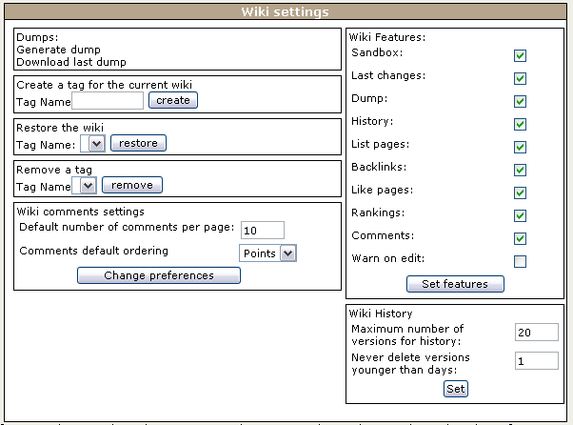

This panel controls settings specific to the Wiki, there’re three sections in this panel: Dumps, tags and Wiki Features.

Dumps:
In the Dumps section of the panel you can generate a dump for the wiki and you can also download the dump if you want.

Tags:

A tag is a “mark” that you can create for the Wiki at any moment, when you create a tag all the current versions of the pages in the Wiki are marked under that name. Later you can restore all the pages in the Wiki to a specific state using the tag, for example you may want to tag your wiki before testing several features and then recover the state before the test. You can create a tag enetering a name and pressing the create tag button. You can also restore the Wiki to any tag using the restore button (selecting a tag first) and you can also select a tag and remove it if you don’t need it any more (tags uses some space in the database)
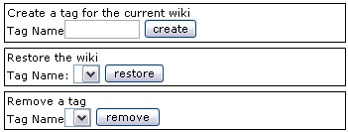

When you create a tag the pages are saved to a special table, they are not only “marked” so you can always recover a tag even if all the pages were removed using the remove feature and even if all the versions were removed too. The restore option will automatically recreate the pages from the versions saved under the tag.

Features

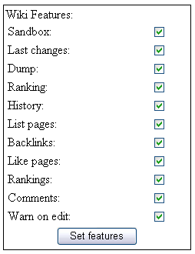

In this section you can set which features will be enabled in the Wiki and which features won’t be enabled.

The “Warn on edit” feature:

This is something that may be helpful if you plan to administer an open wiki with lot of users, if this feature is enabled then Tiki will try to detect when a user is editing a page, if a user “may” be editing a page then the “edit” button will be displyed in red, for the page, example:

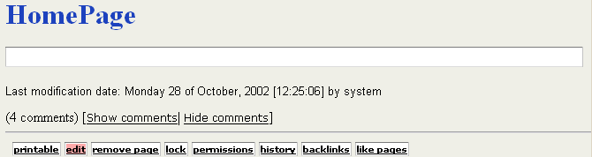

Note that a user can still click the edit button and edit the page and that the edit button may be red even if no user is actually editing the page, however the button will try to be as accurate as possible and will be helpful to prevent many two users from editing the same page at the same time.

History settings

The history settings are used to control automatic prunning of the history for wiki pages, you can set-up how many versions to keep for each page and how old should a version be in order to be deleted. The oldest the versions older than the period indicated that overflow the number of versions to keep are automatically removed. The “age” for a page to be deleted is used to prevent a malicious user from editing a page until no version is stored but his. So admins can ckech from time to time and recover a vandalized page no matter how many times it was edited.
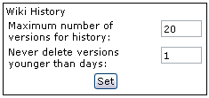
If you set age to “0” the setting will not be used and only the last “n” versions will be stored for a page.

Image Galleries settings

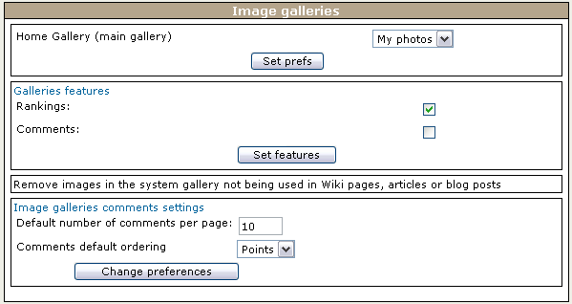

You can enable/disable rankings, set values for comments and you can select which is the Home gallery, the Home gallery will have the following properties:

- If not selected it will default to the first gallery created
- It’s where you go if you click on galleries in the main menu (without expanding the menu)
- It’s where you go as the home page if you select the home page to be a gallery (in the general settings)

Al link is also provided to remove images in the system gallery (cached images) that are not being used in Wiki pages, blogs or articles (maybe they were used once but the page was then deleted and the image remains in the cache). A usefule function for space-saving in the database.

File Galleries

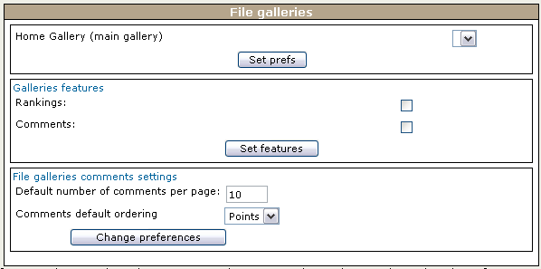

This panel is almost indentical to the file galleries panel, select the home file gallery, the comment settings for file galleries and if rankings/comments are used or not for file galleries.

CMS settings

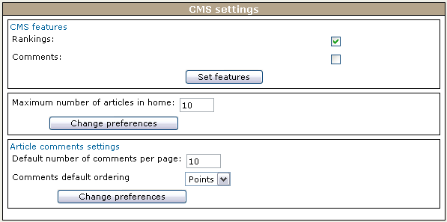

You can select here if the rankings/comments feature is enabled for articles and submissions and you can also select the maximum number of articles to display in the articles home page.

Blog settings

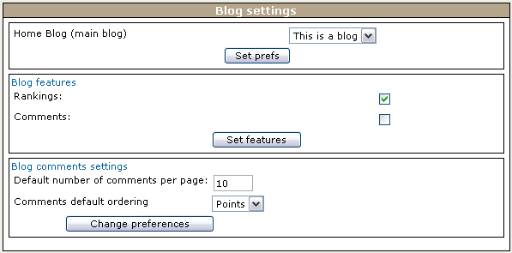

You can enable/disable rankings/comments and you can select which is the Home gallery, the Home gallery will have the following properties:

- If not selected it will default to the first blogcreated
- It’s where you go if you click on blogs in the main menu (without expanding the menu)
- It’s where you go as the home page if you select the home page to be a blog (in the general settings)

Forums settings

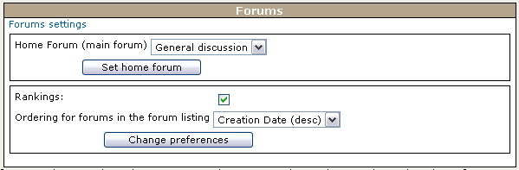

From this panel you can control which forum will be used as the Home forum, if rankings will be used or not for the forums and the default ordering for forums in the forum listing.

RSS feeds settings

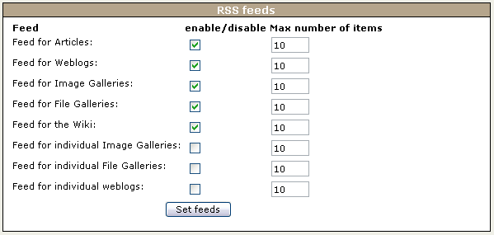

This panel can be used to control the RSS feeds that Tiki generates on-the-fly as they are requested. RSS feeds can be used to syndicate different aspects of your Tiki web site to other web sites. In this panel you can enable/disable feeds and you can control the maximum number of items that will be generated for each feed. The list of available feeds and their meanings is displayed next:

Feed | Description
Articles | This feed lists the last “n” articles in your site.
Weblogs | This feed lists the last “n” posts to weblogs (any weblogs) in your site.
Image galleries | This feed lists the last images uploaded to image galleries (any) in your site
File galleries | This feed lists the last “n” files uploaded to file galleries (any) in your site.
Wiki | This feed lists the last changes to the Wiki.
Individual Image galleries | This feed lists the last uploaded images to a given gallery. (There’s a feed for each gallery)
Individual file galleries | This feed lists the last files uploaded to a given file gallery. (There’s a feed for each file gallery)
Individual weblog | This feed lists the last posts to a given weblog. (There’s a feed for each weblog)

Modules

Modules are the boxes you see in the left and right side bars of the application, modules can be configured to appear on the left or right bar and you can also configure the order in which modules appear. Finally you can create your own modules using HTML content and they will be ready to be placed as regular Tiki modules.

The modules are administered from the module administration screen:

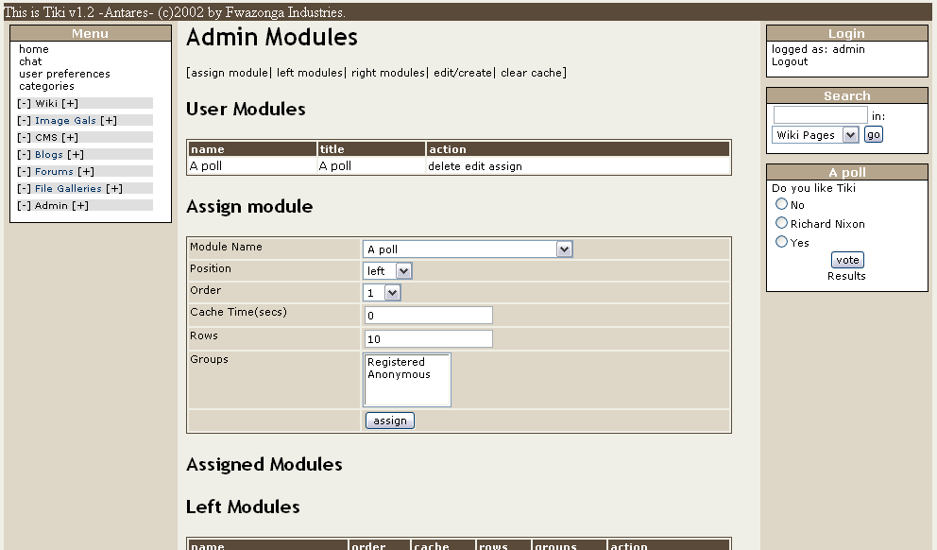

The screen is divided in 4 parts:

- User modules
- Assign modules
- Assigned modules
- Create/edit modules

User modules

User modules are modules where the content can be anything you want. You can use text, you can use HTML code and you can also use “Smarty” templates special instructions, we’ll talk about these advanced options later.

First let’s see how to edit, remove and create user modules. This is the user module listing in the admin modules panel:

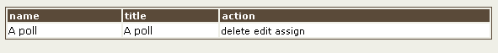

This shows a list of user modules and you have the option to edit or delete a module, user modules are created or edited in this same screen at the bottom.

Assign module

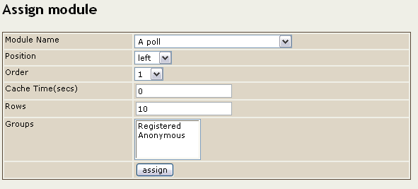

This is where you can assign a module to be displayed on the left or right side bar of the application, you have to select the module name, the position (left or right) and the order, modules will be displayed in an ascending order way so module 1 goes first then 2, etc. If two modules share the same order value they will be displayed in random order but never before a module with a lower number or before a module with a higher order.

Cache Time is the time that the module content can be in the cache (regardelss of this number some modules are never cached), if a module can be cached then it will be refreshed after the indicated time passes. Use 0 if you don’t want modules to be cached.

Rows are the maximum number of rows a module will display if that makes sense to the module, modules displaying rankings or listings will use this number.

Groups is used to select which groups will see the module if it is assigned. Note that if you don’t select at list one group no one will be able to see the module. If more than one group is selected then the module will be displayed if the user belongs to ANY of the groups selected.

Note: There’s a setting in the main admin panel called ‘display modules to all groups always’ when this setting is checked modules will be displayed always without examining the user group.

Assigned modules

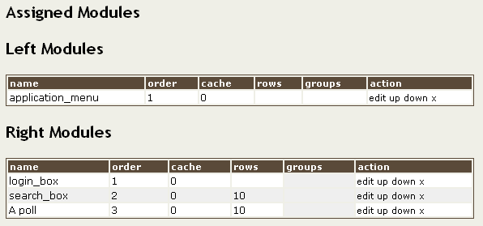

This part of the screen shows currently assigned modules and their order, cache,groups and number of rows. There’re two tables, one for the modules at the left bar and other for the modules at the right bar. You can edit (assign) a module, remove it (it will only unassign the module, you can reassigned later) and you can also move the module up or down one position using the up/down links.

Edit/Create user module

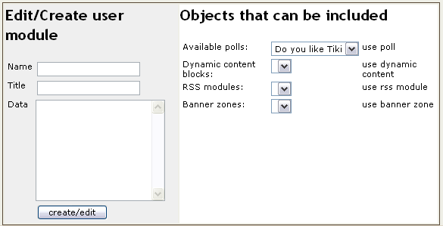

This allows the creation of a new user module, you need to indicate the name (used in the select box to assign the module), the title and the data that will be displayed, the data must be HTML (any since you are admin). The right part of this panel can be used to help you include some objects that can be used in user modules, you can include in an user module:

- A poll (it will display the form to vote for the indicated poll) {poll id=n}
- Any poll from the acive polls {poll}
- The current value of a dynamic content block {content id=n}
- A random value from a dynamic content block {rcontent id=n}
- An RSS feed {rss id=n}
- A banner {banner zone=foo}

Including dynamic content in user modules

You can include dynamic blocks in a user module using a simple syntax:

Today quote: {content id=3}

In the example we are including the current version of the dynamic block “3”. You can create/edit and program dynamic blocks using the Dynamic Content System (DCS). Read about the DCS in the DCS section to learn more.

Including banners in user modules

If you want you can include a banner in a user module, using the following syntax:

{banner zone=sidebar}

Where zone must be the name of an existing zone in the banners system and there should be at least one banner assigned to the zone (or nothing will be displayed). You can learn more about banners in the banners section.

Including polls in user modules

You can display the form to vote a poll in a user module using the syntax

{poll id=n}

If you want Tiki to display the form to vote some (random) poll from all the active polls you can use:

{poll}

Including RSS feeds in user modules

You can display the content of an RSS feed from another site in a user module after you created the feed (see using external RSS feeds later on this section), the syntax is:

{rss id=n maximum=m}

It will display the rss feed with id=n and it will display up to “m” elements from the feed.

Advanced editing

If you are not familiar with “Smarty” the template engine used by Tiki you should skip this section.
User modules are parsed by the Smarty template engine before being displayed, you may have noticed that dynamic content and banners are included using two special Tiki smarty plugins. So if you know about Smarty template editing you can use any Smarty tag in your user modules. You can do loops, if constructions, includes, etc.

If you want to learn about Smarty visit http://smarty.php.net you will find the Smarty documentation there that you can use in order to check out what can you use in your user modules.

Available System Modules

Some modules are already defined by Tiki, this is the list of modules distributed with this version of tiki.

Module | Uses Rows? | Cache? | Description
Application menu | N | N | The application menu (normally you don’t want to remove/unassign this module)
Calendar | N | N | A calendar Please see the calendar module below.
Comm received objects | N | Y | A summary of objects received in your site from other sites.
Featured Links | Y | Y | Featured links
Forum best voted topics | Y | Y | The messages with the best scores from the forums
Forums last topics | Y | Y | The last topics in the forums
Forums most commented topics | Y | Y | The topics with most replies in the forums
Forums most read topics | Y | Y | The most read topics
Forums most visited | Y | Y | The most visited forums
Last articles | Y | Y | Last published articles
Last file galleries | Y | Y | Last modified file galleries
Last files | Y | Y | Last uploaded files to file galleries
Last Galleries | Y | Y | Last modified galleries
Last Modified | Y | Y | Last modified pages
Last modified blogs | Y | Y | Last modified weblogs
Last submissions | Y | Y | Last submited articles (pending of approval)
Logged users | N | N | Number of online users
Login Box | N | N | The login box
Logo Box | N | N | Logo box, shows the tiki logo linking to tiki-index.php
My Pages | N | N | Pages created by the user
MyGalleries | N | N | Galleries created by the user
Number of submissions | N | Y | Number of pending submissions
Old articles | Y | Y | Old articles (articles not displayed in the articles home page)
Search Box | N | N | The search box. NOTE: You can give focus to the search box pressing ALT+s (Windows) or CTRL+s (Mac)
Top active blogs | Y | Y | Most active weblogs
Top articles | Y | Y | Most read articles
Top file galleries | Y | Y | Most visited (accessed) file galleries
Top files | Y | Y | Most downloaded files
Top Galleries | Y | Y | Most accessed galleries
Top Images | Y | Y | Most accessed images from the galleries listing the image name.
Top Images th | Y | Y | Most accessed images from the galleries listing the image thumbnail.
Top Pages | Y | Y | Most accessed pages
Top visited blogs | Y | Y | Top visited weblogs
User blogs | N | N | Blogs created by the user

Special modules: The calendar module

The calendar module if enabled can be used to control some aspects of the Tiki application. First of all it is a normal calendar that can be navigated changing the month and year and you can always return to the day for today clicking the today link.
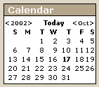
When you click on a day the calendar will mark it as the current day for the page you are viewing, if you change the page the calendar will go back to “today”.

How the calendar affects articles

For the articles home only articles with a publishing date lower than the day selected in the calendar will be displayed, this can be used to see the articles home for any previous day. If the date is future and you are admin you can see future versions of the home using to-be-published articles. If you are not admin you won’t see future articles.

How the calendar affects blogs

For the blogs system any weblog will only display posts with dates equal or lower than the date selected in the calendar. If the date is future it is the same as today since we don’t have posts with a future publishing date “yet” in the blogs system.

Note that once you select a date in the calendar it won’t remain selected if you change the page you are viewing it will be restored to the current date.

Featured Links

You can access the screen to admin featured links following the “links” link from the admin menu. The featured links screen let’s you enter links that will be displayed in the featured links module.

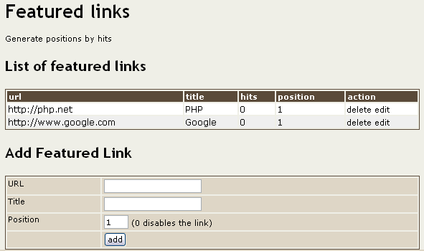

In this screen you can enter links, remove or edit existing links and set the position for each link in the featured links modules. Links with position = 0 won’t be displayed so you can use that number to temporarly disable a link without removing it from the listing.

You will also have an option to automatically generate the positions for featured links using the number of hits “visits” that each link has.

The cache

Whenever Tiki founds a link to an external site in a Wiki page the lilnk is cached in the Tiki cache, this allows the Wiki users to visit the page even if the site is offline or the page is removed or changed.

The “cache” option in the Admin menu lets you administer the Tiki cache:

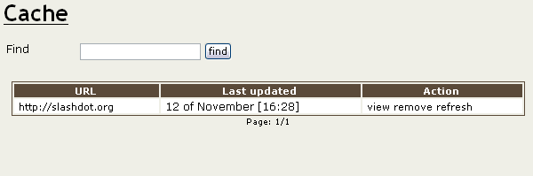

You can list the cached pages, find pages using the find button and for each cache entry you can view it, remove it, or refresh it (will retrieve a fresh copy of the page). If the enrty is removed it will no longer display a “cache” link from the Wiki page where the site is referentiated.

Hotwords

Hotwords is a feature that allows the admin to make some words in WikiPages appear as a link. If enabled as a feature hotwords can be administered from the hotwords administration screen:

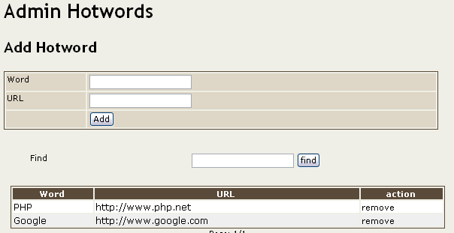

Using this screen is simple, just add the word-link pairs as needed, remove them if you want, etc. The replacement will be case-insensitive if you add “PHP” you don’t need to add “php” as well. If you have a problem or don’t want this feature just disable it from the main admin screen.

Edit templates

If enabled from the main admin screen you will see a link to “edit templates” in the admin menu.

If you want Tiki to be able to edit templates you must make sure that PHP can write to the the “templates” directory in the Tiki tree
Editing templates is a very powerful feature but it is dangerous too, if you miss-edit a template you may break the site layout and all your pages will display wrongly. We recommend you to use this feature with extreme caution and don’t give the permission to edit templates to groups of users that are not careful.

The edit templates screen will display a list of templates:

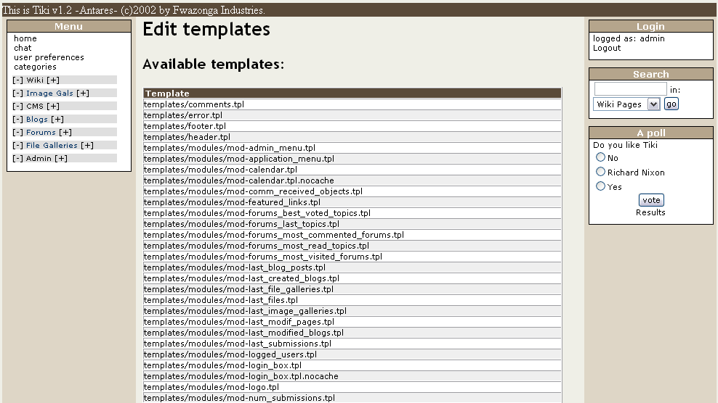

You can select any template and edit it:

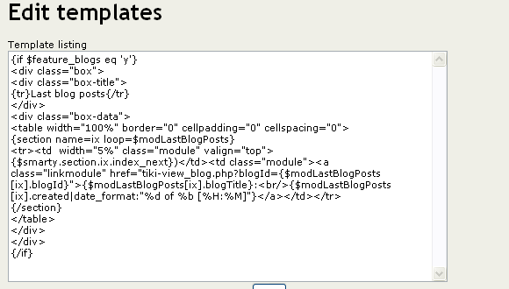

Save the template and check the result.

This feature can be used to make very nice changes or effects in your sites, for example you can include a logo at the top of the page editint the tiki.tpl template and you can change the logo on special occassions (as google does) editinh the template.

Banners

If you have enabled banners from the admin menu you will see a link to admin banners in the admin menu. This will take you to the banner administration screen.

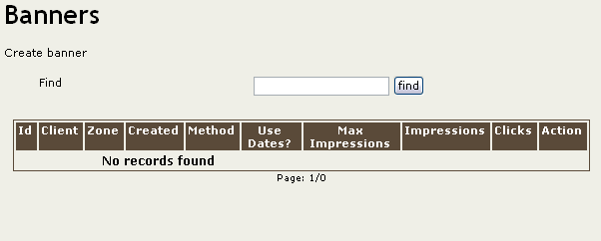

If you have permission to admin banners this screen will show you all the banners in the system with options to edit/remove/view each one. If you are a regular use this screen will display your banners with an option to view the banner stats for each one.
Note: There’s no link in the main menu to the banner listing, you may want to provide your banner clients with a link to the banner listing screen by email or other method. (May be we should add a link in the main menu if the user is a client and has some active banner in a next version)
Since we won’t have any banners initially let’s click in the “create banner” link at below “Banners” to create a new banner.

Creating and editing banners

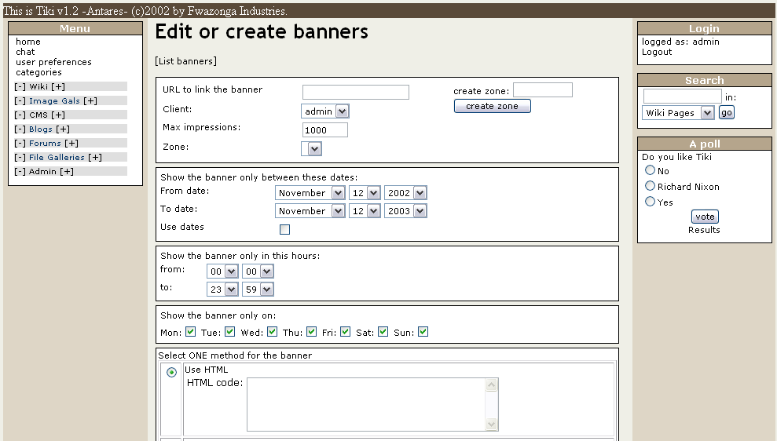

This is the form to create or edit banners, it’s quite big so we are going to examine each section in detail to explain how to create different banners:

In the first panel you have to indicate the URL where the banner will link, you have to select a client for the banner and you have to indicate the maximum number of impressions for the banner and the zone where the banner will be used. If you have no zones you can create a zone using the “create zone” field and button on the right side.
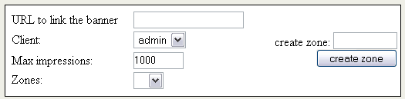

What are zones?

Zones are sections of your site where banners will be displayed, for example we may want to set-up 3 different banners in our site, a normal “480x60” banner at the top of the screen, a text add in a user-module box and some button-like banner at the footer. Since we don’t want a 480x60 banner being displayed in the textadd box we should set-up three different banner zones. You can name zones as yoou want, if you will only use normal/regular 480x60 banners at the top create a zone with any name and assign all your banners to that zone.

Later when displaying a banner in a Tiki template the syntax will make us indicate which zone will be used in that position.

For example create a zone “textadd” that will be used to put some textadds on the right side bar. After creating the zone you will be able to select the zone in the drop down.

Let’s examine the next panel

This box can be used to limit the banner lifetime to certain dates, you should enter when the banner will start to be active and when it will stop and check the use dates checkbox in the panel. If use dates is not checked the banner will be active until it has run out of impressions (using the maximum number of impressions in the previous box). If use dates is active the banner will stop if it runs out of impressions or if the current date is not between the dates in this box. This panel is useful, for example to create a special banner for the holidays or a special date.


In this box you should select the hours when the banner will be active, for example you may want a banner to be displayed only at night or a banner to be displayed between 3pm and 4pm to announce a sports event.
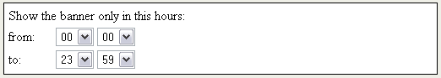

This box can limit the weekdays where the banner will be displayed. You may have a banner for Fridays, special banners for the weekends, etc.
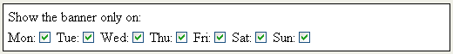

And finally here’s where you actually indicate the banner. You have four different banner types and you must select only one to create the banner data. The options are:
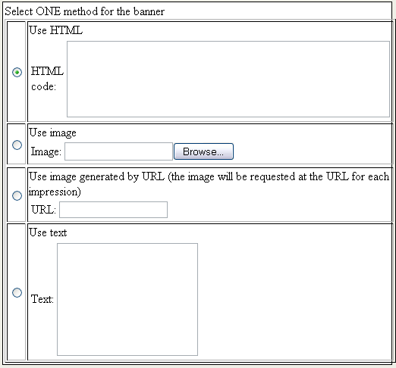

- HTML banner
- Image banner
- Fixed URL banner
- Text banner

Each option will be explained as follows:

HTML banners

HTML banners use a snippet of HTML code, this is very common for banner exchange sites where they will send you (show you) a portion of HTML code that you have to display in order to proceed with the banner exchange. Just paste/enter the HTML code in the text area and make sure the radio button is selecting HTML code to use HTML banners.

Image banner

An image banner is just an image displayed as a banner linking to the URL you indicated. You should upload the image to be used for the banner. Use the upload box to upload the banner and make sure the radio button is pointing at the Use image option.

Fixed URL banner

A fixed URL banner is a banner that will be retrieved from a URL, this is typical for dynamic “chaning” banners, for example http://bannerserver/mybanner?id=foo or something like that. For this option you should enter the banner URL, each time tha banner is selected to be displayed the content will be retrieved from the URL and displayed.

Text banner

A text banner is just a snippet of text, this is known as “text adds” which are very common in sites such as Google or Kuro5hin.

For the example enter a couple of textadd banners in the textadd zone.

Displaying banners

Once you have created your banners you want to display them, you can display a Tiki banner in any Tiki template including user modules system. You have to use the following syntax to include a banner in any template:

{banner zone=foo}

Where zone is the zone to be used.
In our example let’s create a user module from the user modules screen to display our textadds:

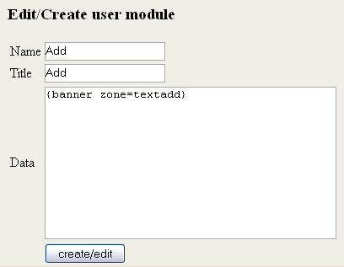

Once created assign the banner to some sidebar:

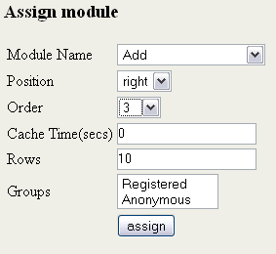

Now you should have a user module displaying the text add banners at the right side bar, refresh the screen to see how the banners are rotated (if you created more than one add). You now have textadds in your Tiki site just as Google or Kuro5hin!
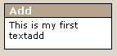

Viewing stats

Once banners are running you or your clients (friends) will want to check how they banners are doing in the Tiki system, from the banner listing you will see a link to “stats”.

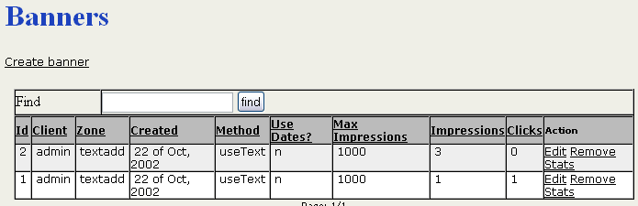

Clicking on “stats” will display the banner stats:

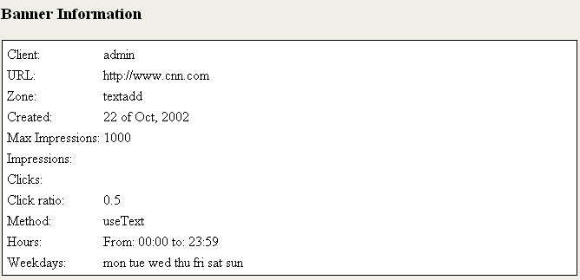

The banner information screen displays the statistics for the selected banner.

Future versions of Tiki will enhance the banner systems even more, new constraints will be added to the banner creation form (max impressions per week, restriction by group, etc) and new stats and graphics will be added to the stats page. New versions will be compatible with this version so you can start using the banners right now. Please let us know what would you add to the banners system to make it usable and we’ll be happy to include ou suggestions in a new version.

Dynamic Content System

The Dynamic Content System (DCS) is a very easy and flexible tool to display dynamic content in your Tiki sites/applications. This tool is very easy to use but somehow it’s difficult to explain exactly what it is ☺.

The DCS let’s you administer “blocks” and program “content” for those blocks. Later on you will be able to display any block in any Tiki template or user module.

First of all enable DCS from the main admin screen, you will now see a link to “admin content” at the end of the admin menu. Clicking on that link will take us to the DCS edit screen:

Creating and editing blocks

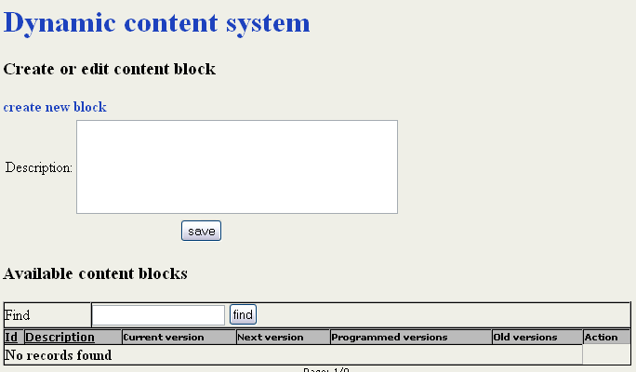

In this screen you can see a list of dynamic blocks, to create a block you just need to provide a description, for example create the “quote of the moment” block:

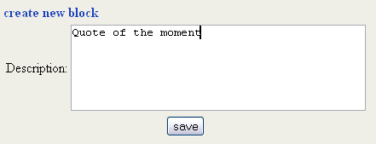

Once created you will see the block in the listing:

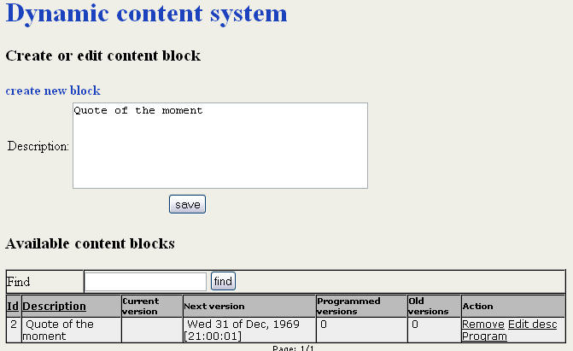

From the listing you can remove the block (all content if present will be removed as well), you can edit the block description (Edit desc) or you can program some content for the block. Let’s click on “program” to add some content:

Creating and editing content for a block

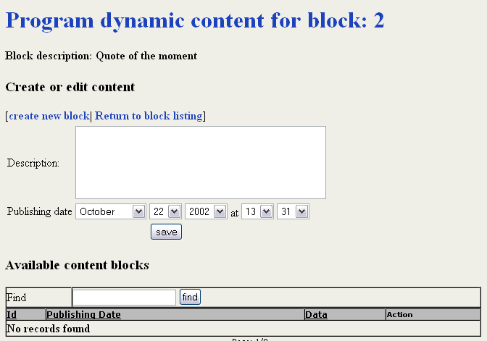

In this screen you will see a listing of all the programmed content for the block and you will be able to edit a content, create a new one remove content etc. Enter some quote using the default date (will be the current date)

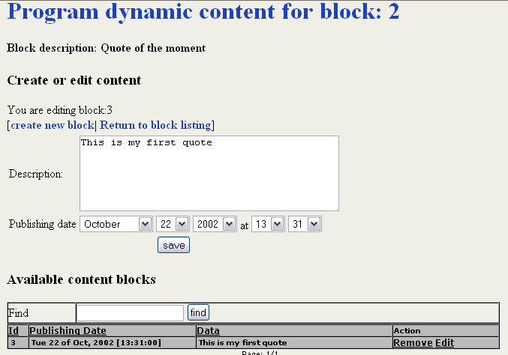

So you have some content for the block “2”. It’s very important to note the block number that you are editing at the top of the page.

Displaying DCS blocks

You can display dynamic content blocks in any Tiki template or user block using the following syntax:

{content id=1}

Note: the ids may be different in your installation

Where the id is the id of the block (not the id of the block content!!).

Now let’s see how we can use the content in a user block.

Edit a user module as follows:

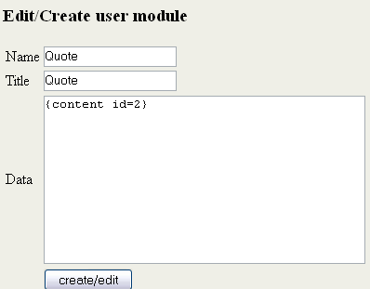

And assign it to the right sidebar.

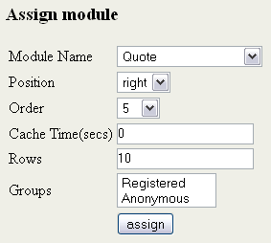

You wil now see the user module displaying the content you just entered in the DCS!
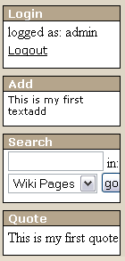

Programming content

Now let’s program some content for the future, go again to the Admin content screen, Click program for the block with the id=2 (or the id you receive when testing). Click on program and enter some data changing the date for 5 minutes ahead of the current time.

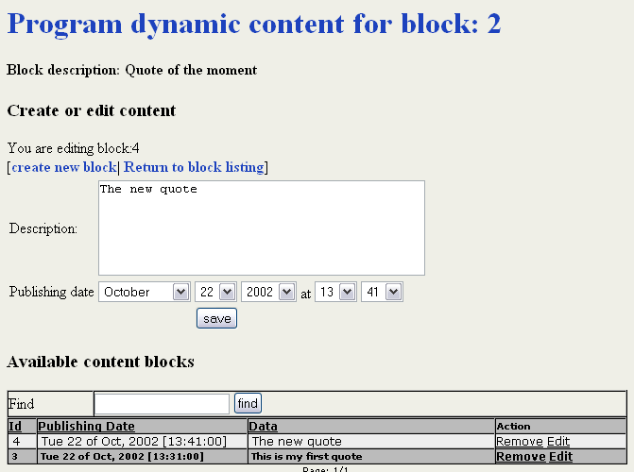

The listing will show in a dark shadow the “current” content active for the block and in a lighter color the rows for “future” content or “old” content. As you can see we have a block displaying “The new quote” that will be displayed at 13:41. Now just wait until that time and refresh the screen, the user block on the right side bar will change!

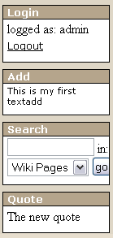
This is how the DCS works, remember that you can display a dynamic block in any Tiki template not just user modules so you can design your site or design new pages for your Tiki-powered site including editable/dynamic/programmable blocks wherever you want.

You can use the DCS for whatever you want, you may want to display news, announcements, special notifications for special dates, sports results, messages to your site users, special offers, promotions, adds, etc.

The DCS system offers a lot of flexibility to your Tiki powered site, use it as you want and enjoy the results.

The Menu Builder

The menu builder can be used to build menus that can be displayed in user modules, you can enter the menu builder using the “menus” link from the admin section of the application menu.

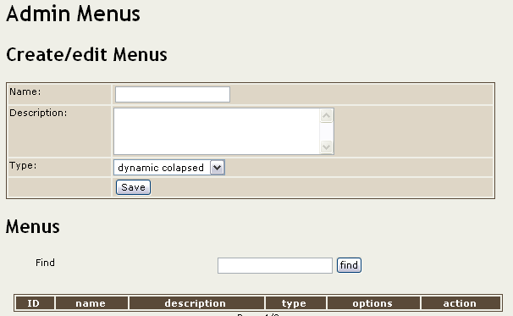

In this screen you can create menus, remove menues and go to edit the options for an existing menu.

Creating and editing menus

To create a menu enter a name and a description and select the menu type, there’re three different types that can be used:

- Static: The menu will be static all the options will be displayed in the menu module.
- Dynamic collapsed: The menu is dynamic only the sections will be displayed in the menu module and there will be +/- links to open/close sections. The application menu in tiki is an example of this class of menu.
- Dynamic expanded: The same as before but all the sections are expanded by default and the user can close with (-) the options that he wants to close.

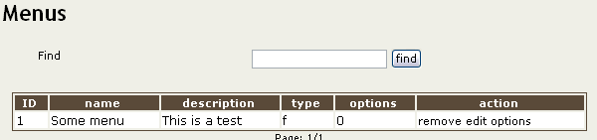

Once a menu is created you can edit the menu options clicking the options link from the menu listing.

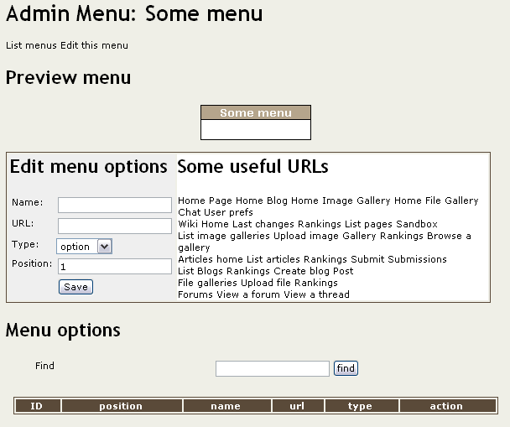

This screen is where you manipulate the options in a menu, at the top a preview of the menu will be displayed, a form to add options/sections to the menu is displayed next, then a list of the sections and options in the menu is displayed. To illustrate how to create menus we created a menu with two sections and two options in each section:

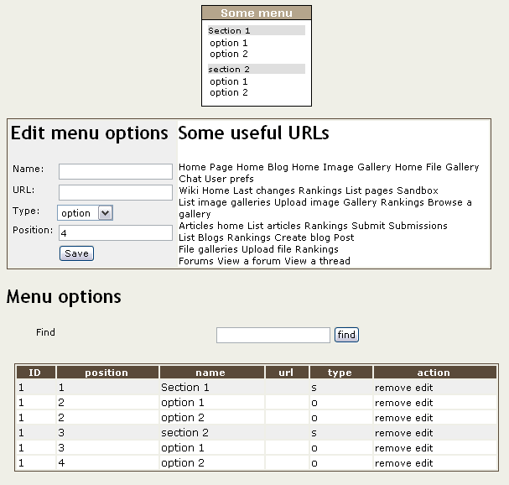

The links at the right of the form to add/edit options can be used to insert common links to Tiki sections if you don’t remember the URI for such items.

You can create a menu for whatever you want, to replace the application menu, to have a list of options to your favorite sites, to display a menu of galleries you like, download sections, whatever.

Including menus in user modules

Menus are displayed using user modules, the syntax to include a menu in a user module is:

{menu id=n}

Polls

In Tiki you can create/display and use as many polls as you want, to admin polls use the polls link from the admin section in the application menu.

Creating/editing polls

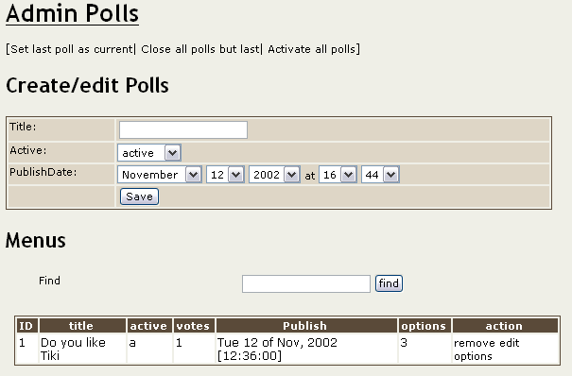

In this screen you can edit/create new polls and remove existing polls, to create a poll you have to indicate the title the type of polls and the publishDate, the type can be:

- Active: The poll can be voted The form to vote can be displayed in a user module using {poll id=n}
- Current: The poll can be voted and can be selected to be shown in a module using {poll} without indicating an id. It can also be displayed using {poll id=n}
- Closed: The poll is closed it won’t be displayed and the users can’t vote this poll any more. Results can be seen.

The publishDate is used to control when the poll will be enabled, you can program polls for the future if you want. A poll can’t be viewed/voted/anything until the current date is greater on equal than then poll publishingDate.

Some special links are also provided:

- “Close all polls but last” will close all polls except the last one.
- “Set last poll as current” will set the last poll as the current poll
- “Activate all polls” will make all polls active

If you click “activate all polls” and “set last poll as current” you will have all polls active and the last one being the current poll.
If you click “close all polls but last” and “set last poll as current” you will have all polls closed and the last one being the current one (only the current poll can be voted in this scheme)

To edit the options in a poll clikc in the “options” link from the poll listing:

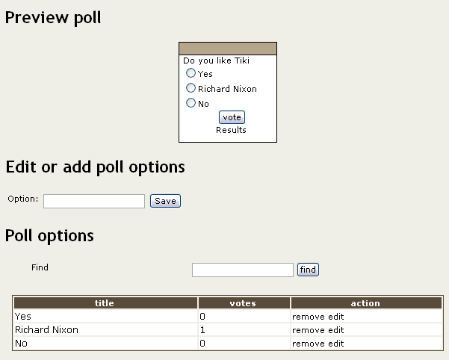

In this screen you will see a preview of the poll, a form to edit/add an option to a poll and the list of options, you can edit options, remove options and add options to a poll as you want.

Using polls

Once created the form to vote a poll can be displayed using user modules, the syntax to include a poll can be:

{poll}

This will display a random poll from the list of polls with type = “current” and that have been published.

{poll id=n}

This can be used to dsiplay any active or current poll indicating the id of the poll to displayed.

Using RSS feeds from other sites

An RSS feed is a summary of news/files/activiy in any website, RSS files are usually used to syndicate news and articles from one site to many, popular RSS files are used to display slashdot news in a site, freshmeat releases, etc.

Tiki can be used to display RSS feeds from other sites in user modules, but first you have to configure the feeds that you want to use. As an admin click the “RSS feeds” link from the admin section of the application menu to admin RSS feeds.

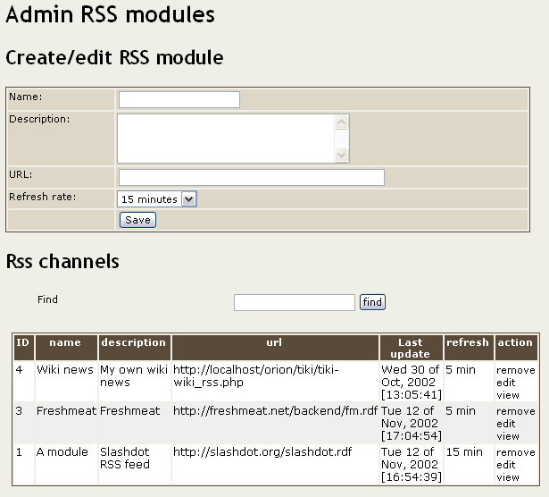

This screen can be used to configure RSS feeds that can be used in your site, you have to enter a name for the feed, a description, the URL where the RSS feed can be found an the refresh rate. Normally you don’t want to refresh the feed each time you dislpay it since that can make the site offering the feed slower so Tiki caches RSS feeds and refreshes the feeds using the interval of time you indicated here.

In this example we have 3 feeds configured:

The wiki news is from our own site, is refreshed each 5 minutes and the URI is http://localhost/orion/tiki/tiki-wiki_rss.php
The Freshmeat feed is refreshed each 5 minutes and the URL is http://freshmeat.net/backend/fm.rdf
The slashdot feed is refreshed each 15 minutes and the URI is http://slashdot.org/slashdot.rdf

Clicking “view” can be used to see a preview of the feed:



You can also see the last time the feed was updated in the list of feeds, unlike other weak RSS systems Tiki won’t crunch the cache if it cannot connect to the site when it needs to refresh the site, so if a site goes down Tiki will show the last cached version of the feed without errors or problems to your site.

Feeds can be displayed in user modules using the following syntax:

{rss id=n}

For example we used {rss id=1} to display the slashdot news in a user module.

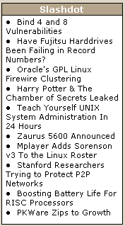

Each piece of new is a link to the corresponding article on Slashdot.

The Chat system

You can admin the chat system clicking the “chat” link from the admin section of the application menu. The chat administration screen is similar to the following one:

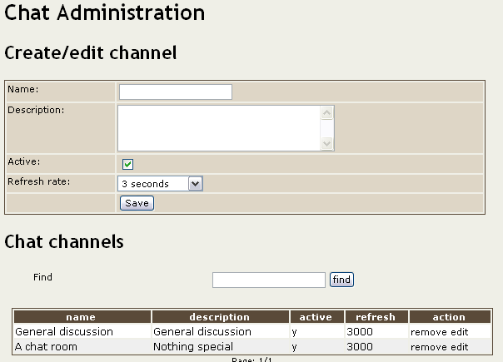

You can create/edit/remove chat channels using this screen, you can also activate/deactivate chat channels if you want. The important item here is the refresh rate, the refresh rate indicates how often will the user browser poll your site for chat messages and it can be different for each channel. A very low refresh rate makes the chat “real-time” since messages appear inmediately after a user types the message but will also make a lot of requests to your web server. You have to find the proper refresh rate depending on the performance of your web server and the comodity of your users.

Categories

From the admin section of the application menu you can see a link to admin categories if you decided to enable categories, the admin categories screen is like the next one:

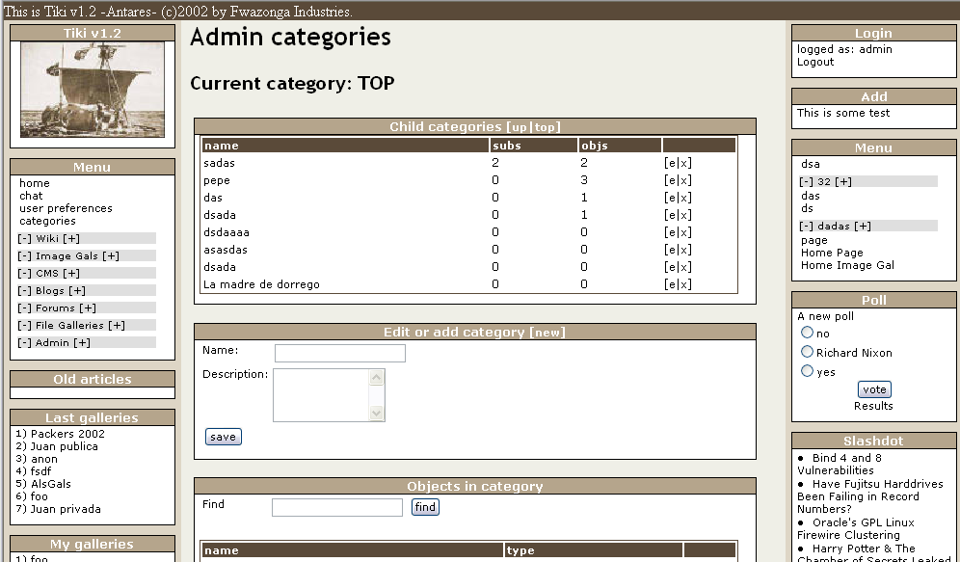

There’re 4 sections (tables) in this screen that we’ll explain:

The subcategories listing:

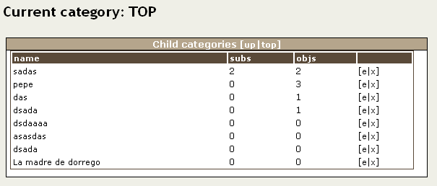

This section shows the current category (where you are) being “TOP” the top category (the only category with no parent). The table shows the list of sub-categories for the current category, for each sub-category the name, number of sub-sub-ctagories, number of objects in the category and links to edit/remove the category are displayed. The up/top links can be used to go to the parent category (up) or the top category (top).

Editing or adding sub categories

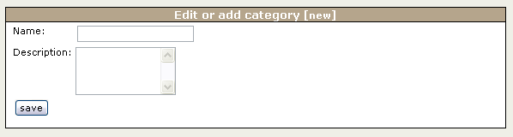

This section displays a form where you can edit or add a subcategory to the current category, just indicate a name and a description.

Category objects

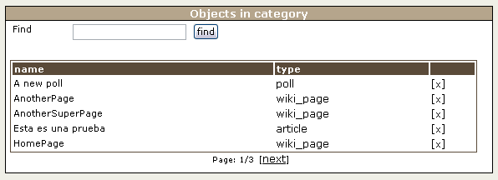

This section shows a list of objects in the current category, you can remove the objects that you don’t want. Removing an object from a category does not remove the object from Tiki.

Adding objects to the current category

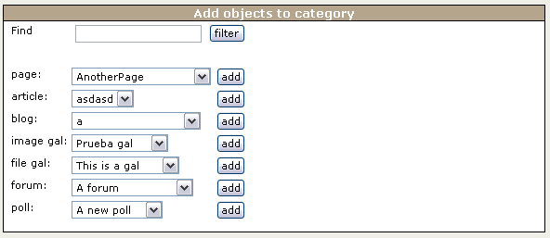

Finally you can add existing Tiki objects to the current category, just select the object from one of the combos and click add, if you have too many objects you may want to filter first the object names using the find filter at the top. As you can see you can categorize the following objects:

- Wiki pages
- Articles
- Weblogs
- Image galleries
- File galleries
- Forums
- Polls

Creating Themes

Themes are what give a look and feel to tiki, in Tiki themes are stored using CSS (Cascading style sheets), the standard to define the presentation style for HTML elements by the W3C.

Your version of Tiki may be shipped with a variety of themes, there’re two themes that we’ll mention since they can be used as “master” themes to produce new themes and are:

- The subsilver theme (subsilver.css)
- The deafult2 theme (default2.css)

Subsilver 2 is a FULL Tiki 1.2 CSS file adpating/modifying this theme you can control the look and feel of every element in Tiki, every table column, links in different screens, etc. It’s a very long file that may take some time to adapt but it is well documented and can be used to make Tiki look like anything you want.
Default2 is a Tiki 1.2 short CSS file, this stylesheet applies the same style to many Tiki elements, for example all the tables look similar. If you want to configure colors, backgrounds, links but you are not interested in defining different colors for different Tiki sections you should edit/adapt this file. It’s shorter and it’s also documented so you can create a new theme in just some hours.

The default2 theme:

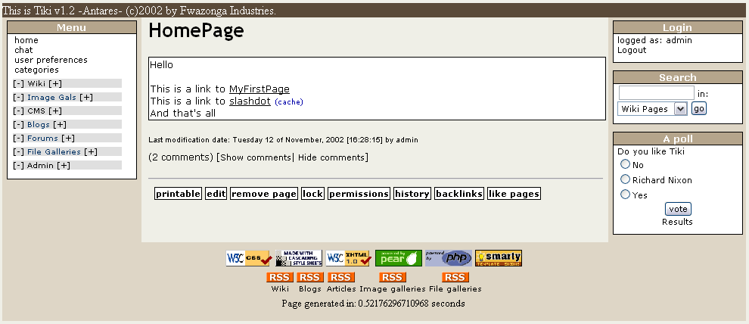
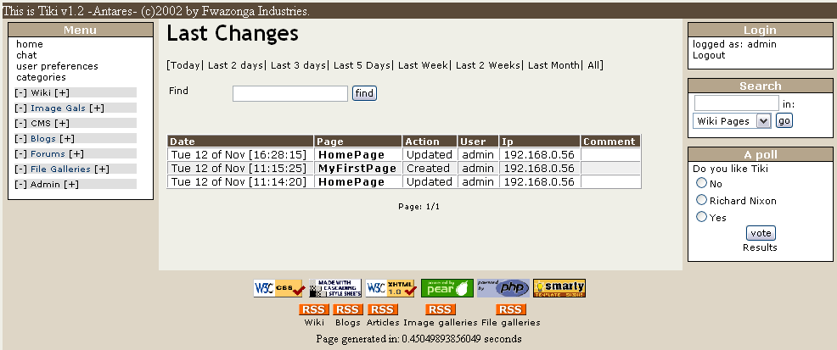

The subsilver theme:

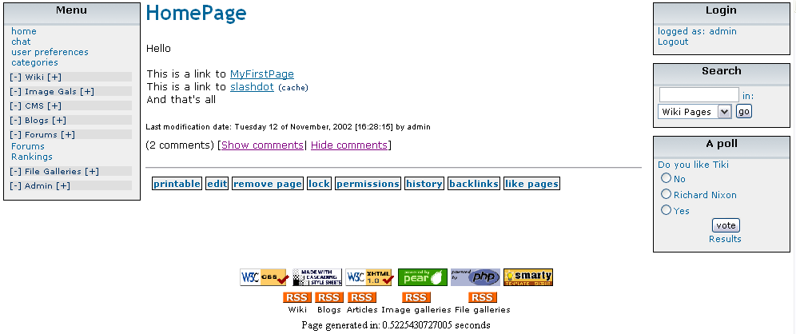

If you design a nice theme we can distribute it with the official Tiki distribution and include some screenshots in this manual, just send the CSS file to lrargerich@yahoo.com and we’ll do the rest.
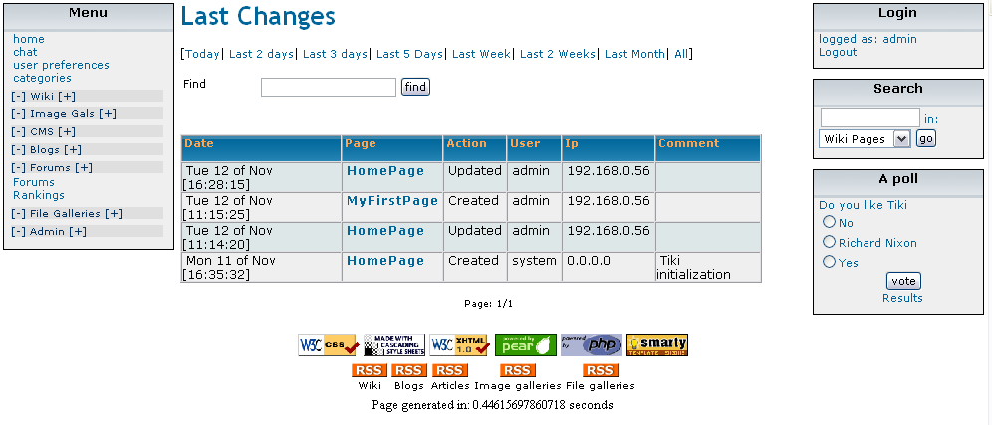

Customizing the application (Tiki for programmers )

Tiki is an application designed to grow in a neat and usable way, the’re several features that allow this application to be easily enhanced and customized by programmers.

- Smarty (the template engine) is used to sepparate content from presentation, all the logic is in the foo.php files and there’s a foo.tpl file that contains the template used to display what the php file generates.
- The whole layout of the application is present in only one file: tiki.tpl (the main template) so you can change the layout as you want by changing just this file
- CSS is used to define the presentation properties of all the elements in the Tiki pages, themes are defined creating new CSS files and putting them in the CSS directory.
- All the database-accessing functions are in library files in the lib directory as classes, the code in PHP files access/changes entities by calling the Tiki API.If you code new pages/modules/whatever please respect this, thanks!
- Tiki is really easy to customize/extend, please give it a chance!

Internationalization and languages

Tiki supports multiple languages and defines a mechanism to easily make the application available in other languages. In the PHP scripts all the strings must be written as tra(“here goes the string”); calling the “tra” function that translates the string. In templates you should use the Smarty {tr} block, for example {tr}Hello world{/tr}. This is how you write string in Tiki to be language-aware.

Once you have modified Tiki the “get_strings.php” script can be used to scan all the .php and .tpl files in the application regenerating/changing the language files. New strings are added to language files untranslated.

Creating a new language (this is easy!)

- Create a new directory under the “lang” directory, please name it using a 2 letter convention, example: en=english, sp=spanish.
- Copy a language file from some other language that you are familiar to this directory.
- Edit/translate the language.php file.
- The language is ready to use from Tiki (Tiki will automatically detect the new language)

When tetsing new languages keep in mind that modules can be cached so they may not change their language unless you clear the cache (in the module administration screen you have an option to clear the cache)

Adding new features to Tiki

If you want to use Tiki to build your site or your application or if you want to join the Tiki developers community this is what you want to read.

Tiki is an application environment designed to be extensible and customizable, if you know PHP and want to extend Tiki this section will explain how to create new features for Tiki.

Basic rules

Let’s start with the basic rules:

Rule 0 (Zeroth): Everybody is welcome to the Tiki developers community, if you need help ask if you want to try try, if you want us to review your work send it.

- Tiki pages are always compunded by two files: a php file and a template. All the logic and PHP code goes in the PHP file and all the presentation, displaying and layout goes to the template.
- All the database-access funcionality is abstracted into libraries in the lib directory, tikilib is the system library for tiki core modules.
- PEAR is used in libraries and only in libraries to access the databases, direct DBMS functions such as MySQL API functions are not used.
- All the strings are written to be easily translated using the “tra” function in PHP or the {tr}{/tr} blocks in templates.
- All your HTML code must be XHTML 1.0 transitional compatible, use the W3C validator to check your module before releasing it.
- Put style to your XHTML code using CSS stylesheets.
- Everything must work with all the warnings and errors reported
- Everything must work if register_globals is turned off

Tutorial: adding a graffiti wall to Tiki

Now as a tutorial let’s imagine that we want to write a new feeature to Tiki called “graffitti wall”, the graffitti wall will display the last “n” graffitis (configurable) and will provide users with a simple text area were a graffitti can be entered. HTML code will not be allowed.

Planning our module

We’ll need one screen for the graffitti wall:

- tiki-graffitti : Display the last “n” graffittis and provide a form to enter a new graffiti.

The screen will be compunded by:

tiki-graffitti.php : PHP code
tiki-graffitti.tpl : Template

We’ll also add a new library to Tiki called ‘graffittilib.php’ in the lib directory.

Since we need to store graffittis somewhere we have to create a table to store graffittis, we’ll write the .sql creation script in a file called graffitti.sql this will be our table:

drop table if exists tiki_graffittis;
create table tiki_graffittis (
graffittiId integer(12) not null auto_increment,
data text,
timestamp integer(14),
primary key(graffittiId)
);

Note: Timestamps and dates are stored in tiki tables as Unix timestamps and are represented as 14 digit long integers. Please use this format to keep the tables consistent.

Execute the .sql script using for example

mysql tiki < graffitti.sql

The library

Now we’ll write the library that will be used to access the graffittis table, we’ll call the library graffittilib.php and it will be a class where we’ll encapsulate all the functions that will be used to display graffittis.

This is the library:

<?

class GraffittiLib {
var $db; // The PEAR db object used to access the database

function GraffittiLib($db)
{
if(!$db) {
die("Invalid db object passed to UsersLib constructor");
}
$this->db = $db;
}

function sql_error($query, $result)
{
trigger_error("MYSQL error: ".$result->getMessage()." in query:<br/>".$query."<br/>",E_USER_WARNING);
die;
}

function add_graffitti($data)
{
$data = addslashes(strip_tags($data));
$now = date("U");
$query = "insert into tiki_graffittis(data,timestamp) values('$data',$now)";
$result = $this->db->query($query);
if(DB::isError($result)) $this->sql_error($query, $result);
return true;
}

function get_graffittis($n)
{
$query = "select * from tiki_graffittis order by timestamp desc limit 0,$n";
$result = $this->db->query($query);
if(DB::isError($result)) $this->sql_error($query, $result);
$ret = Array();
while($res = $result->fetchRow(DB_FETCHMODE_ASSOC)) {
$ret[] = $res;
}
return $ret;
}
}

?>

The form in which this class was written should be followed by all the libraries used in Tiki.

The class constructor receives a pear connection object used to access the database through PEAR in the class, we added a method to display SQL errors and two application methods: add_graffitti($data) that will be used to add a new graffitti and get_graffittis($n) that will return an array with the last “n” graffittis.

Writing skeletons and putting all together

Now put graffittilib.php in the lib directory.

Create tiki-graffitti.php in the main tiki directory and write the following skeleton:

<?
require_once('tiki-setup.php');
require_once('lib/graffittilib.php');
$glib = new GraffittiLib($dbTiki);
$smarty->assign('mid','tiki-graffitti.tpl');
$smarty->display('tiki.tpl');
?>

Let’s examine the code, tiki-setup is a php file that MUST be included in all the Tiki scripts, in that file permissions and preferences are loaded the database connection is stablished, the session is checked to determine if the user is logged etc. Don’t forget to include it in your Tiki modules.
Then we included our library from the lib directory.
After including the lib we create a GraffitttiLib object passing the global variabl $dbTiki that contains the default database connection as indicated in db/tiki-db.php.
Finally we set-up the template to use inthe middle area of Tiki and we display the template tiki.tpl.

Create the skeleton layout tiki-graffitti.tpl and put it in the templates directory.

<h1>Graffittis</h1>

Just a title since the templates are normal HTML code mixed with Smarty directives.

Now check if everything is ready to be filled in by accessing tiki-graffiti.php from a browser:

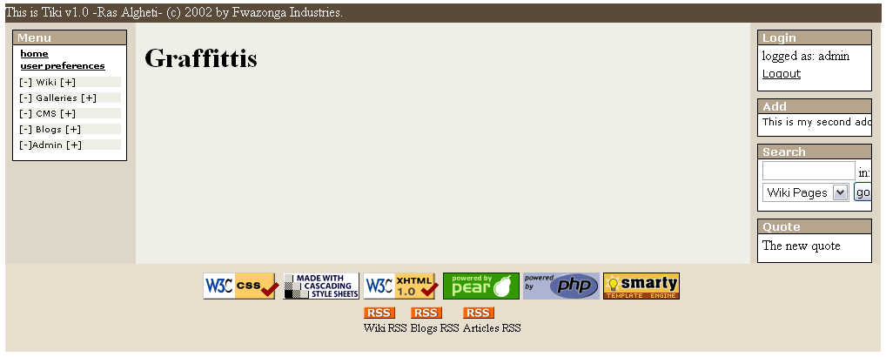

Wow! The tile is displayed and we are ready to code our Graffitti module.
If you are an experienced PHP developer and know Smarty this is all you need to start coding new features for Tiki, if you need help or have questions you are free to ask, subscribe to tiki-devel the Tiki developers mailing list and start coding. (You can subscribe to the mailing list from the sourceforge page: http://tikiwiki.sourceforge.net)

If you want to learn more and learn how to code the Graffitti module just keep reading!

Coding the graffitti module

Now, we have the skeleton ready to be filled in, we’ll start by adding a form to the template to enter new graffittis.

This is tiki-graffitti.tpl with the form.

<h1>Graffittis</h1>
<h3>Write a new graffitti to the wall</h3>
<form method="post" action="tiki-graffitti.php">
<textarea name="data" rows="5" cols="80"></textarea>
<input type="submit" name="send" value="{tr}write graffitti{/tr}" />
</form>

Very important notes:

- Forms usually are processed by the same script that displayed the template containing the form, in this example tiki-graffitti.php
- XHTML should be used note how the <input> tag ends with “/>”
- The {tr}{/tr} smarty block must be used to escape strings that can be translated to different languages.

And this is displayed if you access tiki-graffitti.php

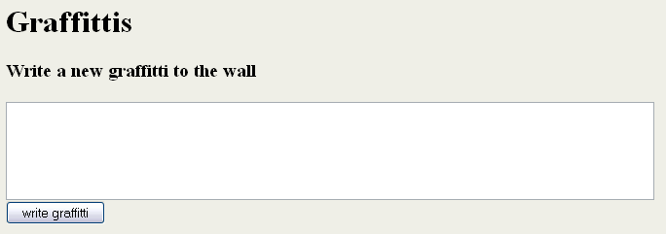

Now we are ready to process the addition of a new graffitti to the wall, let’s go to tiki-graffitti.php and add the code to process an addition.

<?
require_once('tiki-setup.php');
require_once('lib/graffittilib.php');

$glib = new GraffittiLib($dbTiki);

if(isset($_REQUEST["send"])) {
$glib->add_graffitti($_REQUEST["data"]);
}

$smarty->assign('mid','tiki-graffitti.tpl');
$smarty->display('tiki.tpl');
?>

Note how $_REQUEST is used to access submitted variables, this is to make sure that the script will work in PHP installations where register_globals is turned off. It’s very important to respect this in your Tiki modules.

The code is easy if we are processing a submit button named “send” then call the add_graffitti method in our library to add the graffitti.

So now you can add graffittis but you can’t see them!, let’s add some code to get the list of graffittis from the database. Add this before the code that processes the form in tiki-graffitti.php

$graffittis = $glib->get_graffittis(10);
$smarty->assign_by_ref('graffittis',$graffittis);

This gets the last 10 graffittis from the database and assigns them to a smarty template variable called ‘graffittis’ now we have to display the graffittis in the template. Edit tiki-graffitti.tpl

<h1>Graffittis</h1>
<h3>Write a new graffitti to the wall</h3>
<form method="post" action="tiki-graffitti.php">
<textarea name="data" rows="5" cols="80"></textarea>
<input type="submit" name="send" value="{tr}write graffitti{/tr}" />
</form>
<h3>Last graffittis</h3>
{section name=i loop=$graffittis}
<div class="simplebox">
{$graffittis[i].data}
</div>
{/section}

Note how the Smarty {section} directive is used to loop the $graffittis template variable assigned in the PHP file, for each graffitti we display the data in a div classed ‘simplebox’ the result is simple:

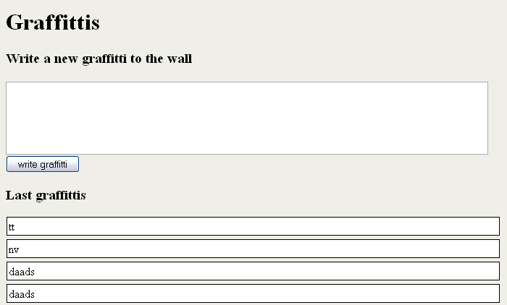

Write graffittis and see them appearing at the top, once you reach more than 10 only the last 10 graffittis will be displayed.

Adding the graffitti module as a tiki feature.

Once you have a successful module doing everything you want you should add it as a Tiki feature allowing the admin to enable/disable the new feature from the Tiki main screen menu.

In order to do this you must edit tiki-admin.tpl and tiki-admin.php, in tiki-admin.tpl add a checkbox with a name proper to your module example: $feature_graffittis, you can copy-paste-edit the code for another feature. In tiki-admin.php add the code to process the new checkbox, you can copy the code used to process the checkbox for another feature. Once you did this work you will be able to use something like this in tiki-graffitti.php

if($feature_graffittis != 'y') {
$smarty->assign('msg',tra("This feature is disabled"));
$smarty->display('error.tpl');
die;
}

Note how the error template is called with an error message, note also the use of the “tra” PHP function to translate the error message string.

There’re many imporvements to this module, purging all graffittis, removing graffittis if you are admin, displaying the date along with the graffitti. Etc... Since the module is just an example we’ll leave it as is and you can code more if you want.

This was an introduction to the Tiki development world, we strongly hope you like the application and the way in which new features are coded. If you have complaints, suggestions or want to help just contact us.

Appendix A: FAQ

This appendix lists some very common questions that we received and may be useful to other users, some things that are not very clear in the manual and some tips and tricks.

Q: Is Tiki a Wiki or more?

A: If you read this manual you may have found the answer to that question ☺

Q: Can I use Tiki for a commercial site/ application, can I sell Tiki-based products.

A: Yes, yes, yes, yes....

Q: Will tiki be free forever?

A: Yes it will. Tiki is an open-source product and anybody will always be able to download the last stable version from the Tiki site and anybody will be able to get the last “from the kitchen” version from the public CVS.

Q: Is it mandatory to display the copyright message? Can I remove it?

A: Of course you can remove it, you can use Tiki as you want and customize to look like anything you want, if you produce a nice customization then you may deserve your own copyright message!

Q: Can I use Tiki as a replacement for PHPNuke or PostNuke?

A: Yes you can but please note that Tiki is still in it’s early stages, it’s just a baby and may have some bugs and errors that are less likely to appear in a more mature software, however since there’re many advtages in Tiki over those systems we do recommend migrating from *Nuke to Tiki.

Q: How can I add XXX feature to Tiki ?

A: If the feature you need is something that maybe useful to many Tiki users the best option is to fill a feature-request form at the SourceForge site, the Tiki team will consider all the requests from users and try to address the request in the next version of Tiki if possible.
If the feature you need is just for your personal use read the section about customizing tiki/adding a module to tiki.

Q: Can I join the development team?

A: Of course we’d love to see new developers in our team, subscribe to the tikiwiki-devel mailing list at sourceforge and we’ll get you started

Q: How often will you release versions?

A: Until getting to a super-stable-mature product we’ll release versions very often, then we’ll try to release new versions as new features are added to Tiki

Q: What kind of features are planned for next versions?

A: You can get a good understanding of what’s about to come reading the feature requests in SourceForge, we’ll try to address our user’s feature requests in the next versions so any open FR is likely to appear soon. Besides that requests we have a lot of ideas for future versions that will be announced as we find a good development-plan/strategy for them

Q: What about postgress? I hate MySQL!

A: Hating a database is not a good feeling but anyway a Postgress compatible version of Tiki is on the way thanks to Marcin who will lead that subproject.

Q: What is the relationship between Tiki and astronomy?

A: None, Tiki versions are named after popular starts. Just that.

