SAT Record

22.05.24: I have made adts to model the event, teams, and goals, using 3 different header files to discretely define the classes separately.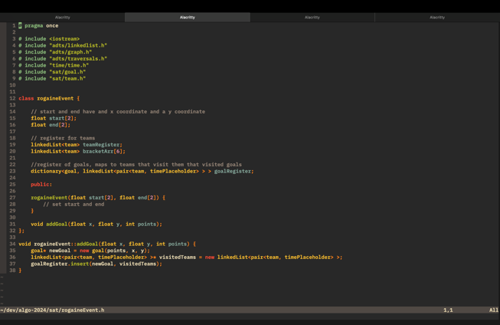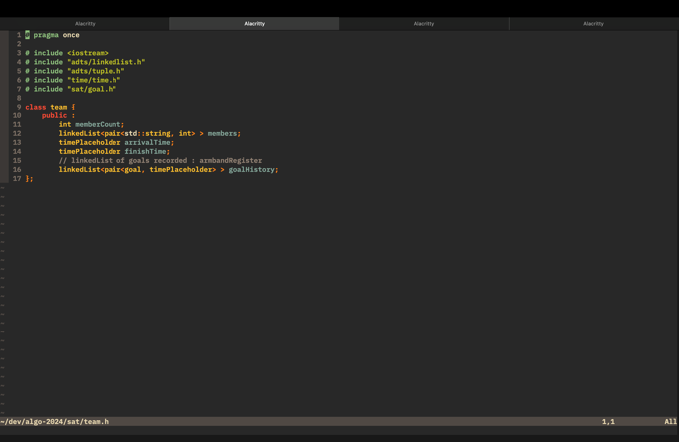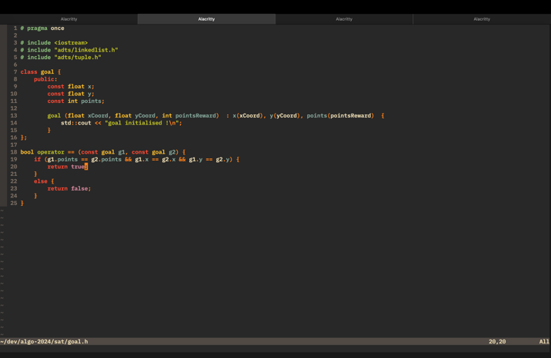

28.05.24: I have begun constructing the criterion 1 word document, outlining all of the things I will need to discuss.

