1.Declare function and call it by reference for swapping numbers.

#include<iostream>
using namespace std;

void swap(int &x, int &y){
int temp=x;
x=y;
y=temp;
}
int main(){
int a,b;
cout<<"Enter the numbers:";
cin>>a>>b;
swap(a,b);
cout<<"The swapped numbers are:"<<"a= "<<a<<" "<<"b= "<<b<< endl;
return 0;
}

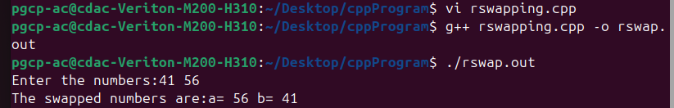

2.Create function for printing an array and call it from main.
#include<iostream>
#include<cstring>
using namespace std;
class Student{
private:
int roll_no;
char name[35];
public:
void acceptdata(){
cout<<"Enter the roll no. and name";
cin>>roll_no;
cin>>name;
}
void displaydata(){
cout<<"The roll no. is:"<<roll_no<<endl;
cout<<"The name is:"<<name<<endl;
}

};
int main(){
Student s;
s.acceptdata();
s.displaydata();
return 0;
}

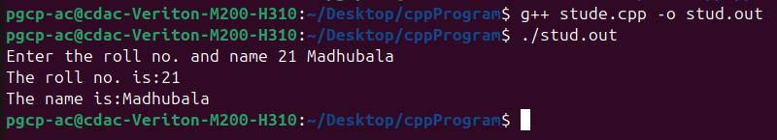

3. Function for printing factorial series with recursion.

#include<iostream>
using namespace std;

int fact(int n){
if(n==1){
return 1;
}
return n*fact(n-1);
}
int main(){
int n;
cout<<"Enter the number :";
cin>>n;
for(int i=1;i<=n;i++){
cout<<fact(i)<<" ";
}
cout<<endl;
return 0;
}
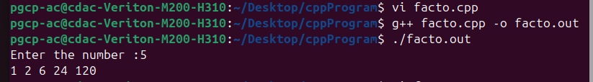

4.Reverse string (char array) with recursion.
#include<iostream>
#include<cstring>
using namespace std;
void reverse(char *arr,int start,int end){
if(start>=end){
return ;
}
char temp=arr[start];
arr[start]=arr[end];
arr[end]=temp;
reverse(arr,start+1,end-1);
}
int main(){
char *arr=new char[20];
cout<<"Enter the string:";
cin>>arr;
int length=strlen(arr);
reverse(arr,0,length-1);
cout<<"Reversed string is "<<arr<<endl;
delete[] arr;
return 0;
}
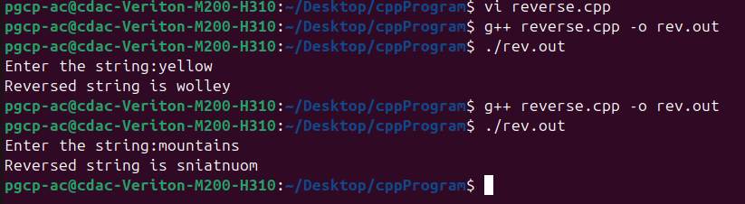

5.Create student class and add roll no. and name in it. Create accept() function which will take an array of students as input. Write one more function to display student data. This display() function should receive student array.

#include<iostream>
#include<cstring>
using namespace std;
class Student{
private:
int sroll_no;
char sname[30];
public:

void acceptdata(){
cout<<"Enter the roll_no and student name:";
cin>>sroll_no;
cin>>sname;}

void display(){
cout<< sroll_no<<" ";
cout<<sname<<endl;
}
};

int main(){
int size;
cout<<"Enter the number of students you want to store the data for:";
cin>>size;
Student s[size];
for(int i=0;i<size;i++){
s[i].acceptdata();
}
for(int i=0;i<size;i++){
s[i].display();
}

return 0;
}

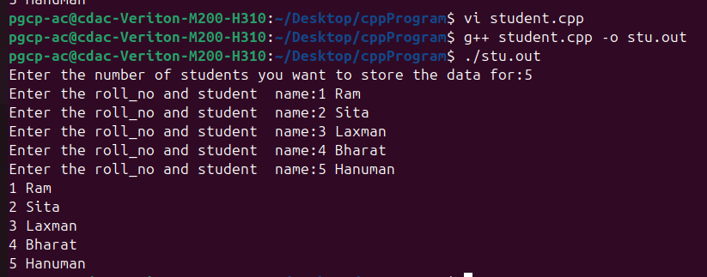

6.Menus:
- Accept n numbers from users and store them into dynamically allocated array. Write a function to sort and display sorted array.
- Accept n characters from user and print it as string
- Accept n numbers from user and write a function to find out avg and display avg
- Accept n numbers from user and write a function to multiply each function by 2 and display result

#include<iostream>
#include<cstring>
using namespace std;

void acceptdata(int* arr,int n){
for(int i=0;i<n;i++){
cin>>arr[i];
}
}

void acceptdata(char* arr,int n){
for(int i=0;i<n;i++){
cout<<"Enter the character:";
cin>>arr[i];
cout<<endl;
}
}
void sortarray(int* arr,int n ){
int temp;
for(int i=0;i<n-1;i++){
for(int j=0;j<n-i-1;j++){
if(arr[j]>arr[j+1]){
temp=arr[j];
arr[j]=arr[j+1];
arr[j+1]=temp;
}
}
}
}

void display(int* arr,int n){
for(int i=0;i<n;i++){
cout<<arr[i]<<" ";
}
cout<<endl;
}

int avg(int* arr,int n){
int sum=0;
for(int i=0;i<n;i++){
sum=sum+arr[i];
}
return sum/n;
}

void multiply(int* arr,int n){
for(int i=0;i<n;i++){
arr[i]=arr[i]*2;
}
}

string createstring(char* arr,int n){
string str=arr;
return str;
}

int main(){
int choice,n;
int *arr=new int[20];
char *arr1=new char[20];
cout<<"1.Sorted array"<<endl<<"2.Creating string using chracters"<<endl<<"3.Finding average"<<endl<<"4.Double the array"<<endl;
cout<<"Enter the choice:";
cin>>choice;
switch(choice){
case 1:
cout<<"Enter the array size :";
cin>>n;
acceptdata(arr,n);
sortarray(arr,n);
display(arr,n);
break;
case 2:
cout<<"Enter the number of characters you want:";
cin>>n;
acceptdata(arr1,n);
cout<<"The string is :"<<createstring(arr1,n);
break;

case 3:
cout<<"Enter the array size :";
cin>>n;
acceptdata(arr,n);
cout<<"The average is :"<<avg(arr,n)<<endl;
break;
case 4:
cout<<"Enter the array size :";
cin>>n;
acceptdata(arr,n);
multiply(arr,n);
display(arr,n);
break;
default:
cout<<"Enter the correct choice !!!!!"<<endl;
}
return 0;
}
