- Write a c++ program to calculate simple and compound interest.

#include<iostream>
#include<cmath>
using namespace std;

double simple(double p,double r,double t){
double si=0;
si=(p*r*t)/100;
return si;
}

double compound(double p,double r,double t){
double ci=0;
ci=p*pow((1+(r/100)),t);
return ci-p;
}

int main(){
double p,r,t;
cout<<"enter the Principle:";
cin>>p;
cout<<"enter the interest rate:";
cin>>r;
cout<<"enter the time:";
cin>>t;
cout<<"Simple Interest is "<<simple(p,r,t)<<endl;
cout<<"Compound Interest is "<<compound(p,r,t)<<endl;
return 0;
}

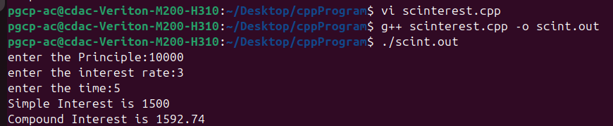

2.Write c++ program to transpose one matrix and display both the matrices with proper prompt.

#include<iostream>
using namespace std;

void acceptMatrix(int a[10][10], int r, int c)
{
cout<<"Enter elements of matrix:"<<endl;
for(int i=0;i<r;i++)
{
for(int j=0;j<c;j++)
{
cin>>a[i][j];
}
}
}

void displayMatrix(int a[10][10], int r, int c)
{
for(int i=0;i<r;i++)
{
for(int j=0;j<c;j++)
{
cout<<a[i][j]<<" ";
}
cout<<endl;
}
}

void transposeMatrix(int a[10][10], int t[10][10], int r, int c)
{
for(int i=0;i<r;i++)
{
for(int j=0;j<c;j++)
{
t[j][i] = a[i][j];
}
}
}

int main()
{
int a[10][10], t[10][10];
int r,c;

cout<<"Enter number of rows: ";
cin>>r;

cout<<"Enter number of columns: ";
cin>>c;

acceptMatrix(a,r,c);

cout<<"\nOriginal Matrix:\n";
displayMatrix(a,r,c);

transposeMatrix(a,t,r,c);

cout<<"\nTranspose Matrix:\n";
displayMatrix(t,c,r);

return 0;
}

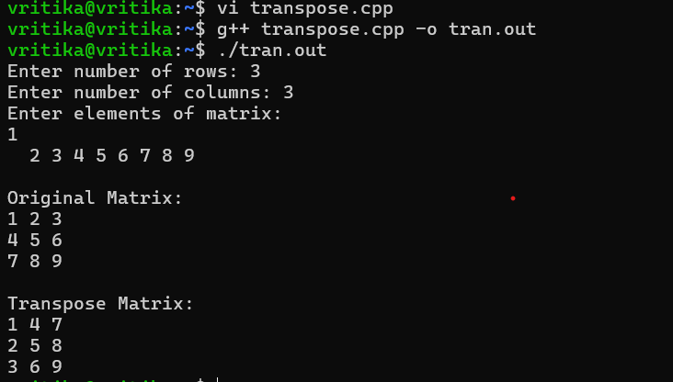

3.Write a c++ program to process student marks with the help of class. The class is private variables for name, marks1, marks 2, marks 3. It has 2 member functions grtdata() to get input and result() to print the result. All subjects marks must be >= 50 for pass othwrwise fail. Implement this program for n number of students.

#include<iostream>
#include<string>
using namespace std;

class Student{
private:
string name;
int m1,m2,m3;

public:
Student(){
name="\0";
m1=0;
m2=0;
m3=0;
}

Student(string n,int ma1,int ma2,int ma3){
name=n;
m1=ma1;
m2=ma2;
m3=ma3;
}

void getdata(){
cout<<"Enter name:";
cin>>name;
cout<<"Enter marks in 3 Subjects:";
cin>>m1>>m2>>m3;
}

void result(){
if(m1>=50 && m2>=50 && m3>=50){
cout<<name<< " result Pass"<<endl;
}
else{
cout<<name<<" result Fail!!"<<endl;
}
}
};

int main(){
Student *sarr[100];
int n;
cout<<"enter the number of students:"<<endl;
cin>>n;
for(int i=0;i<n;i++){
sarr[i]=new Student();
sarr[i]->getdata();
}
for(int i=0;i<n;i++){
sarr[i]->result();
}
return 0;
}

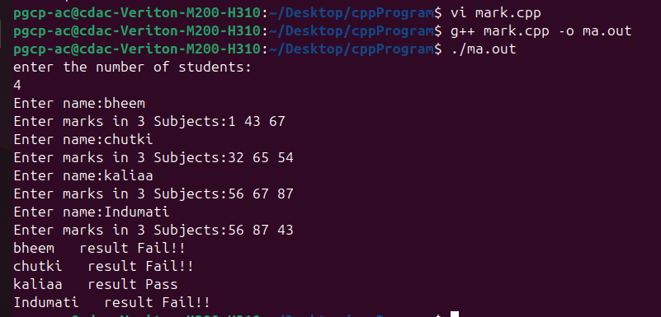

4. Write a c++ program which allow users to input 5 grades marks between 0 to 100. The program must calculate the avg marks, and state the number of marks less than 65

#include<iostream>
using namespace std;

void acceptmarks(double* arr){
for(int i=0;i<5;i++){
cin>>arr[i];
}
}
int check(double* arr){
int count=0;
for(int i=0;i<5;i++){
if(arr[i]<=65){
count++;
}
}
return count;
}
double avg(double* arr){
double sum=0,avg;
for(int i=0;i<5;i++){
sum=sum+arr[i];
}
avg=sum/5;
return avg;
}
int main(){
double arr[5];
cout<<"Enter 5 grades: ";
acceptmarks(arr);
cout<<"count:"<<check(arr)<<endl;
cout<<"average is:"<<avg(arr)<<endl;
return 0;
}

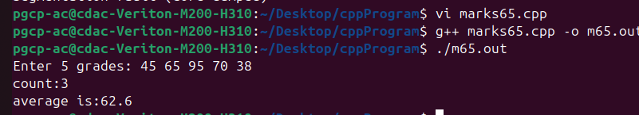

5. Write a menu driven C++ program to add, subtract and multiply given two matrices defined in class. Modify your program using operator overloading method.

#include<iostream>
using namespace std;

class Matrix
{
int a[10][10];
int r,c;
public:
void accept()
{
cout<<"Enter number of rows: ";
cin>>r;

cout<<"Enter number of columns: ";
cin>>c;

cout<<"Enter matrix elements:\n";
for(int i=0;i<r;i++)
{
for(int j=0;j<c;j++)
{
cin>>a[i][j];
}
}
}
void display()
{
for(int i=0;i<r;i++)
{
for(int j=0;j<c;j++)
{
cout<<a[i][j]<<" ";
}
cout<<endl;
}
}
Matrix operator+(Matrix m)
{
Matrix temp;
temp.r = r;
temp.c = c;
for(int i=0;i<r;i++)
{
for(int j=0;j<c;j++)
{
temp.a[i][j] = a[i][j] + m.a[i][j];
}
}

return temp;
}

Matrix operator-(Matrix m)
{
Matrix temp;
temp.r = r;
temp.c = c;

for(int i=0;i<r;i++)
{
for(int j=0;j<c;j++)
{
temp.a[i][j] = a[i][j] - m.a[i][j];
}
}

return temp;
}

Matrix operator*(Matrix m)
{
Matrix temp;
temp.r = r;
temp.c = m.c;

for(int i=0;i<r;i++)
{
for(int j=0;j<m.c;j++)
{
temp.a[i][j] = 0;

for(int k=0;k<c;k++)
{
temp.a[i][j] += a[i][k] * m.a[k][j];
}
}
}

return temp;
}
};

int main()
{
Matrix m1,m2,m3;
int choice;

cout<<"Enter First Matrix\n";
m1.accept();

cout<<"\nEnter Second Matrix\n";
m2.accept();

do
{
cout<<"1. Addition\n";
cout<<"2. Subtraction\n";
cout<<"3. Multiplication\n";
cout<<"4. Exit\n";

cout<<"Enter choice: ";
cin>>choice;

switch(choice)
{
case 1:
m3 = m1 + m2;
cout<<"\nAddition Result:\n";
m3.display();
break;

case 2:
m3 = m1 - m2;
cout<<"\nSubtraction Result:\n";
m3.display();
break;

case 3:
m3 = m1 * m2;
cout<<"\nMultiplication Result:\n";
m3.display();
break;

case 4:
cout<<"Program Ended\n";
break;

default:
cout<<"Invalid choice\n";
}

}while(choice!=4);

return 0;
}
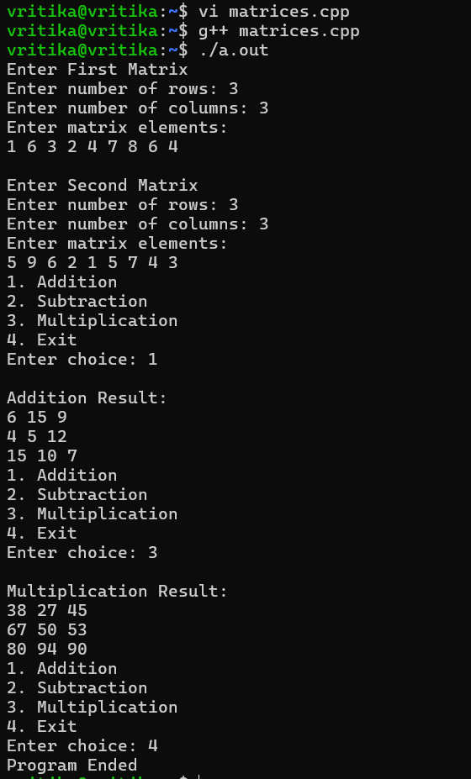

6. Create a class DONOR that contains donor number, donor name, age address, sex and blood group. Write a Menu driven C+ + program to display the number, name and address of the donors for the following categories:
a. blood donors having the blood group 0+
b. blood donors in the age group between 18 to 25
c. female donors having blood group A in the age between 21 and 24.

#include<iostream>
#include<string>
using namespace std;
class Donor{
private:
int number;
string name;
int age;
string address;
char gender;
string blood;
public:
void accept(){
cout<<"Enter donor number:";
cin>>number;
cout<<"Enter donor name:";
cin>>name;
cout<<"Enter donor age:";
cin>>age;
cout<<"Enter donor address:";
cin>>address;
cout<<"Enter donor gender:";
cin>>gender;
gender = toupper(gender);
cout<<"Enter donor blood group:";
cin>>blood;
}
void display(){
cout<<"Number :"<<number;
cout<<"Name :"<<name;
cout<<"Age :"<<age;
cout<<"Address :"<<address;
cout<<"Gender :"<<gender;
cout<<"Blood group :"<<blood;
}

string getaddress(){
return address;
}
int getnumber(){
return number;
}
string getname(){
return name;
}
string getblood(){
return blood;
}

int getage(){
return age;
}
char getgender(){
return gender;
}

void searchbyblood(Donor** arr,int size){
for(int i=0;i<size;i++){
if(arr[i]->getblood()=="o+"){
arr[i]->result();
}

}
}

void searchbyage(Donor** arr,int size){
for(int i=0;i<size;i++){
if(18<=arr[i]->getage() && arr[i]->getage()<=25){
arr[i]->result();
}

}
}
void searchbyblood2(Donor** arr,int size){
for(int i=0;i<size;i++){
if(arr[i]->getgender()=='F' && arr[i]->getage()>=21 && arr[i]->getage()<=24 && (arr[i]->getblood()=="a+" || arr[i]->getblood()=="a-")){
arr[i]->result();
}

}
}

void result(){
cout<<number<<","<<name<<","<<address<<endl;
}

};

int main(){

int choice,count=0;
Donor *darr[100];
do{
cout<<"1.Add data \n2. blood donors having blood group o+ \n 3. blood donors in the age group between 18-25 \n 4. female donors having blood group A in the age between 21 and 24 \n 5. exit\n";
cout<<"Enter choice";
cin>>choice;
switch(choice){
case 1:
darr[count]=new Donor();
darr[count]->accept();
count++;
break;

case 2:

darr[0]->searchbyblood(darr,count);
break;
case 3:

darr[0]->searchbyage(darr,count);
break;
case 4:

darr[0]->searchbyblood2(darr,count);
break;

case 5:
cout<<"Thank you"<<endl;
break;
}
}while(choice!=5);

for (int i = 0; i < count; i++) delete darr[i];

return 0;
}

donor.cpp
Displaying donor.cpp.

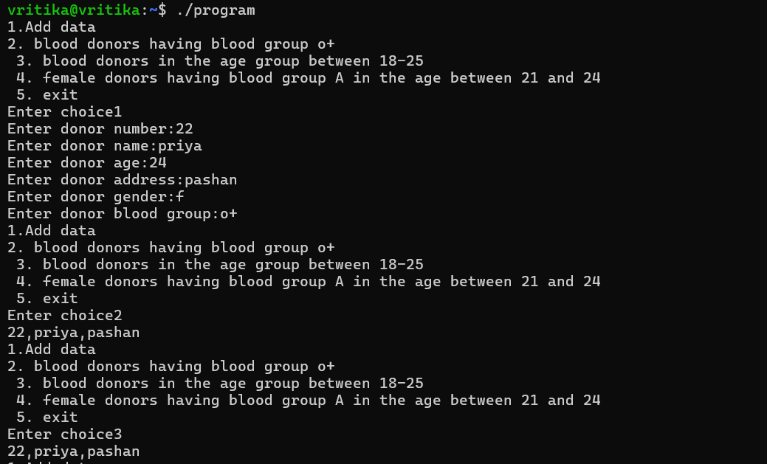

7. An electricity board charges the following rates to domestic users:
For the first 100 units - F. 5.5P per unit For next 200 units - 7. 7.25P per unit Beyond 300 units - 2. 8.75P per unit
All users are charged a minimum of 7. 60.
If the total amount is more than 2. 750 then an additional surcharge of 10% is added on the higher slab units.
Write a C++ program to read the names of users and number of units consumed and print out the charges with names.

#include<iostream>
#include<string>
using namespace std;

float calculateBill(int units)
{
float bill;

if(units <= 100)
bill = units * 5.5;

else if(units <= 300)
bill = (100 * 5.5) + (units - 100) * 7.25;

else
bill = (100 * 5.5) + (200 * 7.25) + (units - 300) * 8.75;

if(bill < 60)
bill = 60;

if(bill > 750)
bill = bill + (bill * 0.10);

return bill;
}

void displayBill(string name, int units, float bill)
{
cout<<"User Name : "<<name<<endl;
cout<<"Units Consumed : "<<units<<endl;
cout<<"Total Bill : "<<bill<<endl;
}

int main()
{
string name;
int units;
float bill;

cout<<"Enter User Name: ";
getline(cin,name);

cout<<"Enter Units Consumed: ";
cin>>units;

bill = calculateBill(units);

displayBill(name, units, bill);

return 0;
}
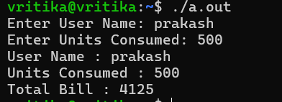
8. Implement the calculator through a C++ program (use switch). The program should ask the user to input two operands and an operator. Your program should print the result of performing the required operation on the input operands

#include<iostream>
using namespace std;

int add(int a,int b)
{
return a+b;
}

int sub(int a,int b)
{
return a-b;
}

int mul(int a,int b)
{
return a*b;
}

float divi(int a,int b)
{
return (float)a/b;
}

int main()
{
int a,b,choice;

cout<<"Enter first number: ";
cin>>a;

cout<<"Enter second number: ";
cin>>b;
cout<<"1. Addition\n";
cout<<"2. Subtraction\n";
cout<<"3. Multiplication\n";
cout<<"4. Division\n";

cout<<"Enter your choice: ";
cin>>choice;

switch(choice)
{
case 1:
cout<<"Addition = "<<add(a,b);
break;

case 2:
cout<<"Subtraction = "<<sub(a,b);
break;

case 3:
cout<<"Multiplication = "<<mul(a,b);
break;

case 4:
cout<<"Division = "<<divi(a,b);
break;

default:
cout<<"Invalid Choice";
}

return 0;
}
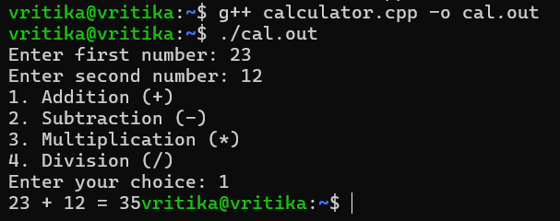

9. Create Time Class which contains the members as hour, minute and secono Nrite a C+ + program that accepts member data for one Time class object from the keyboard. Then, ask the user to perform one of the following functions to that Time object:
AddSeconds
And finally display the newly modified Time information.

#include <iostream>
using namespace std;

class Time {
private:
int hour, minute, second;

public:
void getTime() {
cout << "Enter hours: ";
cin >> hour;
cout << "Enter minutes: ";
cin >> minute;
cout << "Enter seconds: ";
cin >> second;
}

void addHours(int h) {
hour += h;
}

void addMinutes(int m) {
minute += m;
hour += minute / 60;
minute = minute % 60;
}

void addSeconds(int s) {
second += s;
minute += second / 60;
second = second % 60;

hour += minute / 60;
minute = minute % 60;
}

void displayTime() {
cout << "Updated Time: " << hour << " : " << minute << " : " << second << endl;
}
};

int main() {
Time t;
int choice, value;

t.getTime();

cout << "\n1. Add Hours\n2. Add Minutes\n3. Add Seconds\n";
cout << "Enter choice: ";
cin >> choice;

cout << "Enter value: ";
cin >> value;

if(choice == 1)
t.addHours(value);
else if(choice == 2)
t.addMinutes(value);
else if(choice == 3)
t.addSeconds(value);
else
cout << "Invalid choice";

t.displayTime();

return 0;
}
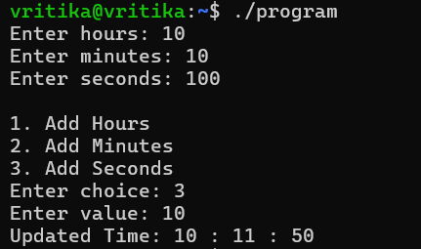
10. Write a menu driven program to perform the following options using separate functions. Accept a number and then, do the following operations on this number:
1. Prime number or not
2. Odd or Even
3. Positive or Negative
4. Exit

#include<iostream>
using namespace std;

void checkPrime(int n)
{
int flag = 0;

for(int i=2;i<n;i++)
{
if(n%i==0)
{
flag = 1;
break;
}
}

if(flag==0 && n>1)
cout<<"Number is Prime\n";
else
cout<<"Number is Not Prime\n";
}

void checkOddEven(int n)
{
if(n%2==0)
cout<<"Number is Even\n";
else
cout<<"Number is Odd\n";
}

void checkPosNeg(int n)
{
if(n>0)
cout<<"Number is Positive\n";
else if(n<0)
cout<<"Number is Negative\n";
else
cout<<"Number is Zero\n";
}

int main()
{
int n,choice;

cout<<"Enter a number: ";
cin>>n;

do
{
cout<<"1. Check Prime Number\n";
cout<<"2. Check Odd or Even\n";
cout<<"3. Check Positive or Negative\n";
cout<<"4. Exit\n";
cout<<"Enter your choice: ";
cin>>choice;
switch(choice)
{
case 1:
checkPrime(n);
break;

case 2:
checkOddEven(n);
break;

case 3:
checkPosNeg(n);
break;

case 4:
cout<<"Program Ended\n";
break;

default:
cout<<"Invalid Choice\n";
}

}while(choice!=4);

return 0;
}
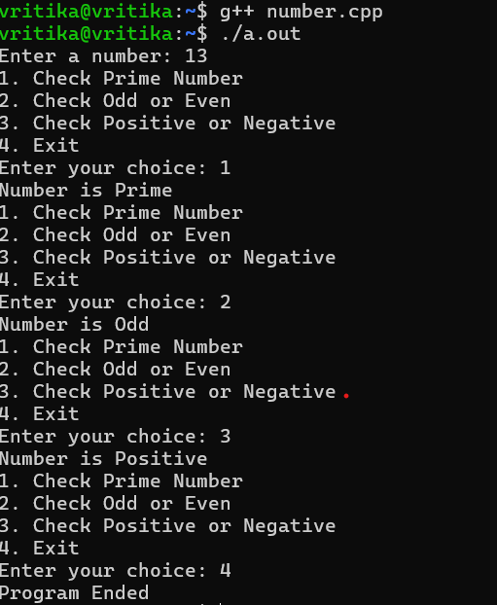

11. Write a function reverse() that reverses the character strings. Use it to write a program that reverses its input a line at a time.

#include<iostream>
#include<cstring>
using namespace std;

void reverse(char str[])
{
int i=0;
int j=strlen(str)-1;
char temp;

while(i<j)
{
temp = str[i];
str[i] = str[j];
str[j] = temp;
i++;
j--;
}
}
int main()
{
char str[100];

cout<<"Enter a string: ";
cin.getline(str,100);

reverse(str);

cout<<"Reversed string: "<<str;

return 0;
}
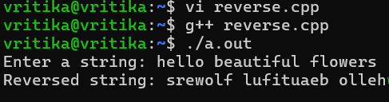

12. Write a C++ Program to Compare Two given Strings and display the result.

#include<iostream>
#include<string>
using namespace std;
void compareStrings(string s1, string s2)
{
if(s1 == s2)
cout<<"Strings are Equal";
else
cout<<"Strings are Not Equal";
}
int main()
{
string str1, str2;
cout<<"Enter first string: ";
getline(cin,str1);

cout<<"Enter second string: ";
getline(cin,str2);
compareStrings(str1,str2);

return 0;
}
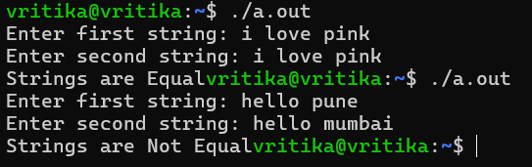

13. Write a program in C++ to determine how many of the characters are vowels and how many are consonants in a given line of text. Also terminate the string when the input character encountered is other than the alphabets (a-z or A-Z) and Blank spaces.

#include <iostream>
using namespace std;

int main() {
string text;
int vowels = 0, consonants = 0;

cout << "Enter a line of text: ";
getline(cin, text);

for(int i = 0; i < text.length(); i++) {

char ch = text[i];

// Stop if character is not alphabet or space
if(!((ch >= 'a' && ch <= 'z') || (ch >= 'A' && ch <= 'Z') || ch == ' ')) {
break;
}

if(ch == ' ') {
continue;
}

// Check vowels
if(ch=='a'||ch=='e'||ch=='i'||ch=='o'||ch=='u'||
ch=='A'||ch=='E'||ch=='I'||ch=='O'||ch=='U') {
vowels++;
}
else {
consonants++;
}
}

cout << "Vowels: " << vowels << endl;
cout << "Consonants: " << consonants << endl;

return 0;
}
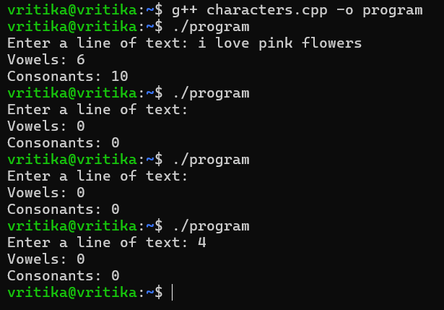

14. Create a C++ class for a stock item abstract data type. It should have the attributes of stock levels (an integer) and unit price (a float). Define the methods to return the values of these two attributes and to set them using parameters. Add two more methods to allow stock receipt and issues updating the stocklevel as appropriate. Write a menu driven C++ program to solve the problem.

#include <iostream>
using namespace std;

class Stock
{
private:
int stockLevel;
float unitPrice;

public:
void setValues(int s, float p)
{
stockLevel = s;
unitPrice = p;
}

int getStockLevel()
{
return stockLevel;
}

float getUnitPrice()
{
return unitPrice;
}

void receiveStock(int qty)
{
stockLevel = stockLevel + qty;
cout << "Stock received successfully.\n";
}
.5839 void issueStock(int qty)
{
if (qty <= stockLevel)
{
stockLevel = stockLevel - qty;
cout << "Stock issued successfully.\n";
}
else
{
cout << "Not enough stock available.\n";
}
}
};

int main()
{
Stock s;
int choice, qty, level;
float price;

do
{

cout << "1. Set Stock Details\n";
cout << "2. Display Stock Details\n";
cout << "3. Receive Stock\n";
cout << "4. Issue Stock\n";
cout << "5. Exit\n";
cout << "Enter your choice: ";
cin >> choice;

switch (choice)
{
case 1:
cout << "Enter Stock Level: ";
cin >> level;
cout << "Enter Unit Price: ";
cin >> price;
s.setValues(level, price);
break;

case 2:
cout << "Stock Level: " << s.getStockLevel() << endl;
cout << "Unit Price: " << s.getUnitPrice() << endl;
break;

case 3:
cout << "Enter quantity to receive: ";
cin >> qty;
s.receiveStock(qty);
break;

case 4:
cout << "Enter quantity to issue: ";
cin >> qty;
s.issueStock(qty);
break;

case 5:
cout << "Exiting program...\n";
break;

default:
cout << "Invalid choice!\n";
}

} while (choice != 5);

return 0;}
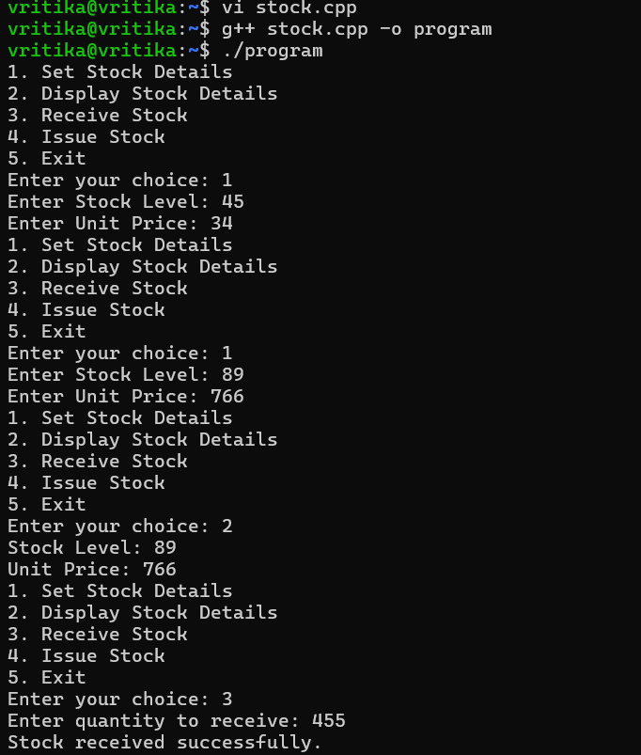
15. Raising a number n to power p is the same as multiplying by itself t times. Write a function called power() that makes a double value for n and an int value for p and returns the result as double value. Use default argument of 2 for p, so that if this argument is omitted, the number will be squared. Write a main() function that gets values from the user to test this function.

#include <iostream>
using namespace std;

double power(double n, int p = 2)
{
if (p == 0)
return 1;
else
return n * power(n, p - 1);
}

int main()
{
double n;
int p;
cout << "Enter the number: ";
cin >> n;
cout << "Enter the power: ";
cin >> p;
double result = power(n, p);
cout << "Result = " << result << endl;
return 0;
}
