1. Create Address class with data members
HouseNo
Colony
Area
City
Pincode
Implement followings
• Default constructor
• Parameterized constructor
• Accept Function for data input
• Display function for data display
• Separate header and implementation files
• Write function to find whether two addresses are same or different.
• Overlaod == operator

address.h
class Address{
private:
int houseno;
char colony[100];
char area[100];
char city[35];
int pincode;

public:
Address();
Address(int hn,char* co,char* a, char* c,int p);
void accept();
void display();
void comp(Address a1,Address a2);

bool operator==(const Address &ad);
};

Address.cpp
#include<iostream>
#include<cstring>
#include"address.h"
using namespace std;

Address::Address(){
houseno=0;
colony[0]='\0';
area[0]='\0';
city[0]='\0';
pincode=0;
}

Address::Address(int hn,char* co,char* a,char* c,int p){
houseno=hn;
strcpy(colony,co);
strcpy(area,a);
strcpy(city,c);
pincode=p;
}

void Address::accept(){
cout<<"Enter the House no:";
cin>>houseno;
cout<<"Enter the colony:";
cin>>colony;
cout<<"Enter the area:";
cin>>area;
cout<<"Enter the city:";
cin>>city;
cout<<"Enter the pincode";
cin>>pincode;
}

void Address::display(){
cout<<"House no."<<houseno<<"\n colony: "<<colony<<"\n area: "<<area<<"\n city: "<<city<<"\n pincode: "<<pincode<<endl;
}
void Address::comp(Address a1,Address a2){
if(a1==a2){
cout<<"Address is same<<endl";
}
else{
cout<<"Address is different"<<endl;
}
}

bool Address::operator==(const Address &a1){
if(houseno==a1.houseno && strcmp(colony,a1.colony)==0 && strcmp(area,a1.area)==0 && strcmp(city,a1.city)==0 && pincode==a1.pincode){
return true;
}
return false;
}

Testaddress.cpp
#include<iostream>
#include<cstring>
#include"address.h"
using namespace std;

int main(){
Address a1;
a1.accept();
a1.display();
Address a2;
a2.accept();
a2.display();
Address a3;
a3.comp(a1,a2);
return 0;
}

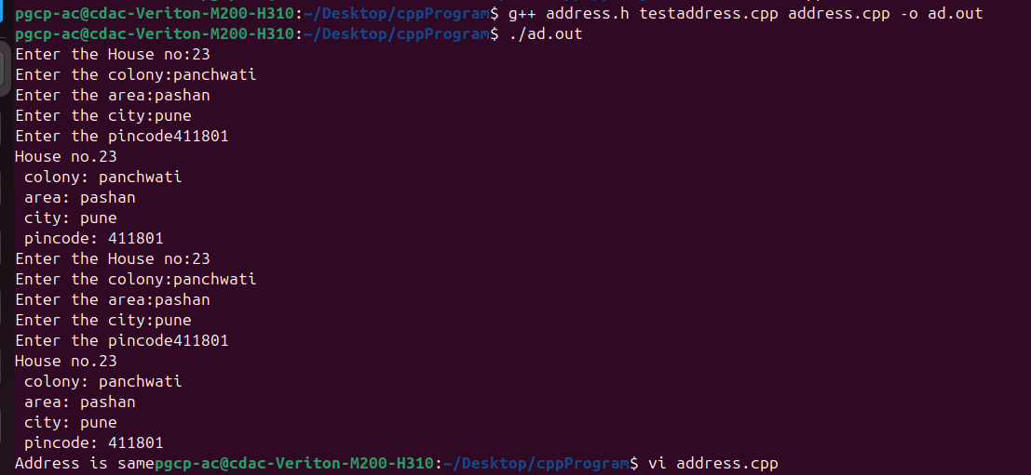
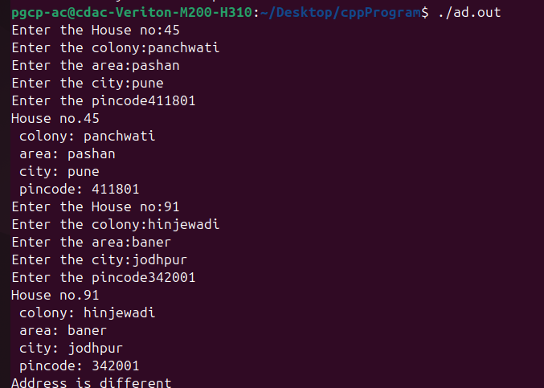

2. Create Payslip class with data members
EmpNo
EmpName
DA
HRA
BasicSalary
Implement followings
• Default constructor
• Parameterized constructor
• Accept Function for data input
• Display function for data display
• Function to calculate salary from DA, HRA and Basic Salary
• Separate header and implementation files

Employee.h
class Employee{
private:
int empno;
char empname[30];
double da;
double hra;
double bsalary;
public:
Employee();
Employee(int eno, char *ename, double d, double h, double s);
void accept();
void display();
double salary();

};

Employee.cpp
#include<iostream>
#include<cstring>
#include"employee.h"
using namespace std;

Employee::Employee(){
empno=0;
empname[0]='\0';
da=0;
hra=0;
bsalary=0;
}
Employee::Employee(int eno,char *ename, double d, double h, double s){
empno=eno;
strcpy(empname, ename);
da=d;
hra=h;
bsalary=s;
}
void Employee::accept(){
cout<<"Enter employee number: ";
cin>>empno;
cout<<"Enter employee name: ";
cin>>empname;
cout<<"Enter DA: ";
cin>>da;
cout<<"Enter HRA : ";
cin>>hra;
cout<<"Enter employee's basic salary: ";
cin>>bsalary;

}
void Employee::display(){
cout<<"Employee no. is :"<<empno<< "\n Employee name is: "<<empname<< "\n DA is: "<<da<<"\n HRA is: "<<hra<< "\n Basic salary is: "<<bsalary<<endl;
}

double Employee::salary(){
return ((da/100)*bsalary)+((hra/100)*bsalary)+bsalary;
}

Testemployee.cpp
#include<iostream>
#include<cstring>
#include"employee.h"
using namespace std;
int main(){
Employee e1;
e1.accept();
e1.display();
cout<<"Salary is "<<e1.salary()<<endl;
Employee e2;
e2.accept();
e2.display();
cout<<"Salary is "<<e2.salary()<<endl;
return 0;

}

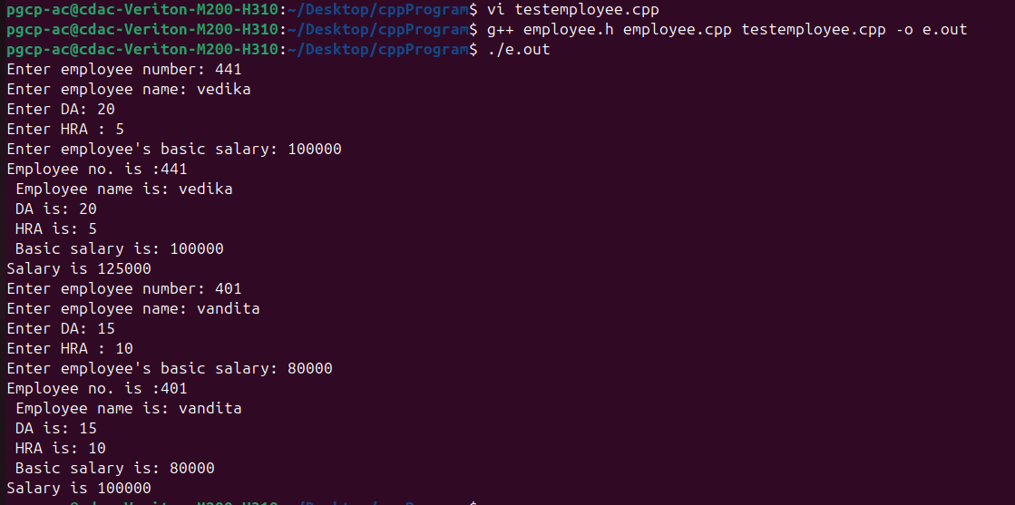

3. Create MobilePhone class with data members
ModelNo
Price
Manufacturer
Quantity
Implement followings
• Default constructor
• Parameterized constructor
• Accept Function for data input
• Display function for data display
• Function to search MobilePhone model availability
• Write menu driven program with following menus
o Add Mobile
o Display List of available mobiles
o Find out quantity of particular mobile type
o Find out availability of Particular model

mobile.h
#include<iostream>
#include<cstring>
using namespace std;

class Mobile{
private:
int modelno;
int price;
char manufacturer[35];
int quantity;

public:
Mobile();
Mobile(int mno,int p,char* m,int q);
void accept();
int getmno();
int getquantity();
void display();
char* getmanu();
};

mobile.cpp
#include<iostream>
#include<cstring>
#include"mobile.h"
using namespace std;

Mobile::Mobile(){
modelno=0;
price=0;
manufacturer[0]='\0';
quantity=0;
}

Mobile::Mobile(int mno,int p,char* m,int q){
modelno=mno;
price=p;
strcpy(manufacturer,m);
quantity=q;
}

void Mobile::accept(){
cout<<"Enter the model number:";
cin>>modelno;

cout<<"Enter the price:";
cin>>price;

cout<<"Enter the name of the manufacturer:";
cin>>manufacturer;

cout<<"Enter the total Quantity:";
cin>>quantity;
}

void Mobile::display(){
cout<<"Model number is "<<modelno
<<"\nPrice is "<<price
<<"\nManufacturer is "<<manufacturer
<<"\nQuantity is "<<quantity<<endl;
}

int Mobile::getmno(){
return modelno;
}

int Mobile::getquantity(){
return quantity;
}

char* Mobile::getmanu(){
return manufacturer;
}

testmobile.cpp
#include<iostream>
#include<cstring>
#include"mobile.h"
using namespace std;

int searchByManufacturer(Mobile **marr,int size,char *name){
for(int i=0;i<size;i++){
if(strcmp(marr[i]->getmanu(),name)==0){
return i;
}
}
return -1;
}

int main(){
Mobile *marr[100];
int choice=0,count=0,pos;
char name[35];

do{
cout<<"\n1.Add Mobile";
cout<<"\n2.Display list of available mobiles";
cout<<"\n3.Find out quantity of particular mobile type";
cout<<"\n4.Find out availability of particular model";
cout<<"\n5.Exit";

cout<<"\nEnter the choice:";
cin>>choice;

switch(choice){

case 1:
marr[count] = new Mobile();
marr[count]->accept();
count++;
break;

case 2:
for(int i=0;i<count;i++){
marr[i]->display();
}
break;

case 3:
cout<<"Enter the Manufacturer:";
cin>>name;

pos=searchByManufacturer(marr,count,name);

if(pos!=-1){
cout<<"Quantity is "<<marr[pos]->getquantity()<<endl;
}
else{
cout<<"Out of Stock!!!!!"<<endl;
}
break;

case 4:
cout<<"Enter the Manufacturer:";
cin>>name;

pos=searchByManufacturer(marr,count,name);

if(pos!=-1){
cout<<"Available"<<endl;
}
else{
cout<<"Out of Stock!!!!!"<<endl;
}
break;

case 5:
cout<<"Thank you"<<endl;
break;
}

}while(choice!=5);

return 0;
}
