OS LAB

EXPERIMENT 1: Basic Linux Commands

1. ls:it lists the content of directory



1. cat:it displays the content of the file

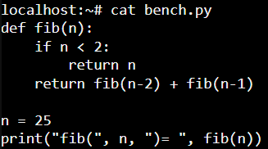

1. pwd:it prints the current working directory



1. whoami:it displays the current users name



1. clear:it clears the terminal screen

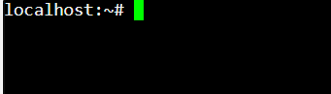

1. 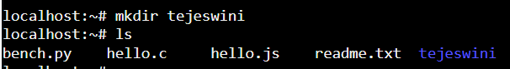mkdir:it creates the new directory
2. cd:it changes the current working directory



1. cd .. it moves back to the parent directory



1. rmdir:it deletes the directory

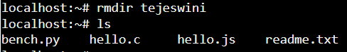

1. cat >hello.txt:it allows to create a file hello.txt and

allows to write content in it. Press ctrl+d to save and exit.

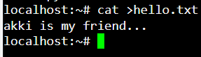

1. cat>>hello.txt:it appends the content of the file hello.txt.

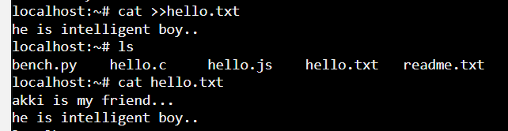

1. cp hello.txt bye.txt:it copies hello.txt file to a new file bye.txt here hello.txt is a source file and bye.txt is destination file.

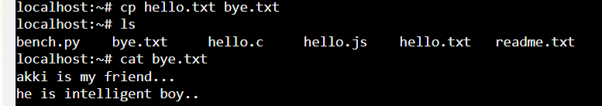

1. mv bye.txt file.txt:it renames or moves bye.txt to file.txt

here bye.txt is a source file and file.txt is a destination file.

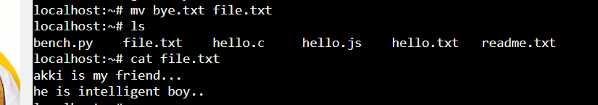

1. rm file.txt:it deletes file.txt

