**EXPERIMENT 2.**

Create an Animal directory, now create 2 more directories in Animal namely Mammal

and Reptile. In Mammal directory create 2 files cow.txt and lizard.txt with 2 lines about

cow and lizard respectively. Now, move lizard.txt from mammal to reptile directory.

**Step1.**

Create a directory Animal

mkdir animal



**Step2.**

In Animal Create 2 directories mammal and reptiles

cd animal

mkdir mammal reptile

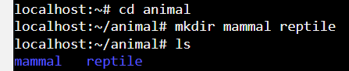

**Step3.**

In mammals add a file cow.txt with two lines on cow written in the file

cd mammals

cat>cow.txt

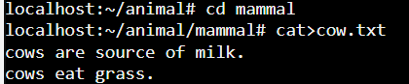

**Step4.**

Again in mammal add a file lizard.txt with 2 lines on lizard written in the file

cat>lizard.txt

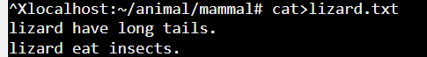

**Step5.**

Now move lizard.txt to reptiles from mammals

mv lizard.txt ../reptile/lizard.txt

