AEROHUB SMART AIRPORT SYSTEM
GLOBAL VS. LOCAL AVIATION NETWORK ANALYSIS
TECHNICAL SPECIFICATION REPORT:
LAN • WAN • DNS • ROUTERS • PACKET ROUTING
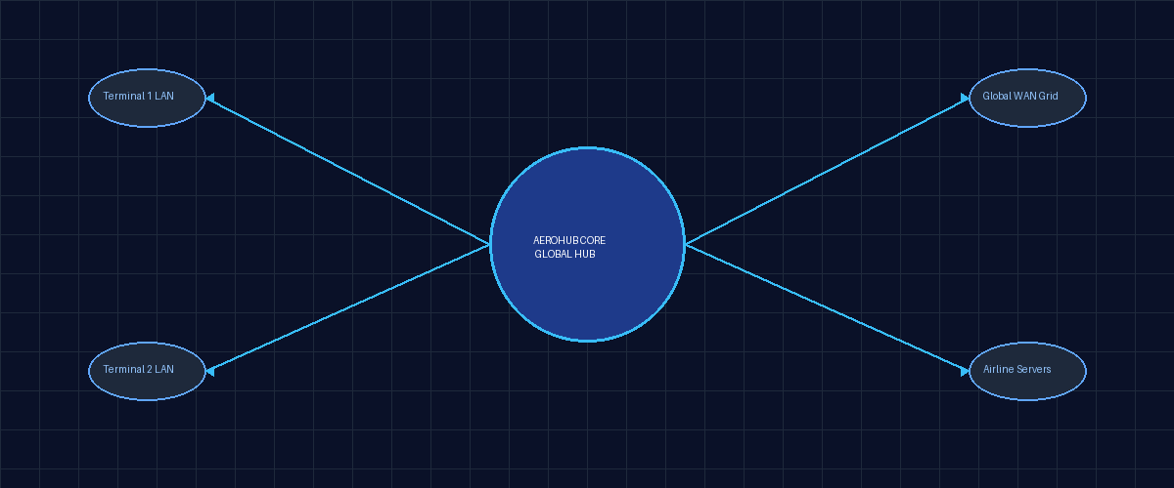

Student Name: Mohamed Yasser
Course: Advanced Airport Computer Networking & Smart Infrastructure
System: AeroHub Smart Aviation Framework
1. Task. Operational Framework

This technical report explains the network infrastructure used by the AeroHub Smart Airport System. Shows how its different parts work together.

Modern international airports depend on reliable and fast data communication. Every day systems have to deal with passenger information, flight departures, baggage tracking, security and communication with aviation organizations.

To support these operations AeroHub uses two types of networks. The Local Area Network (LAN) connects devices and systems inside the airport while the Wide Area Network (WAN) is used to communicate with airports, airline headquarters and international aviation systems.

This report also explains the role of edge routers the Domain Name System (DNS) and packet routing. Together these technologies allow information to move between airport systems and external destinations.

⚡ NETWORK INTEGRITY MANDATE

The main network design rule is to keep airport equipment, such as scanners, check‑in terminals and databases on isolated LAN segments. This helps provide local communication and allows important services to operate locally.

The WAN is used for communication between AeroHub and external aviation systems.

2. Section 1. Local Area Network (LAN)

A Local Area Network (LAN) is the high‑speed network used inside the AeroHub airport facilities. It connects the devices that are needed for passenger processing and daily airport operations.

The main LAN devices include:

- Boarding Pass Scanners: scanners located at boarding gates. They are used to read and validate passengers boarding passes.

- Check‑in Computers: Workstations used by airport staff to check passengers in assign seats, process baggage and confirm passenger information.

- Gate Computers: Computers used by gate staff to monitor boarding queues passenger lists and gate operations.

- Local Airport Server: A server that runs important airport services and reduces the airports dependence on an outside internet connection.

- Airport Database: The main database that stores passenger records, flight schedules and baggage tracking information.

- Printers & Monitoring Workstations: Printers are used to produce baggage tags and other documents while monitoring workstations are used to check the status of airport systems.

Figure 2. Diagram 1: AeroHub Local Area Network (LAN) Topology

The diagram shows the devices connected to the AeroHub LAN and how they communicate with the local server and airport database.

3. Section 2. Wide Area Network (WAN)

A Wide Area Network (WAN) allows AeroHub to communicate with systems located outside the airport.

Unlike the LAN, which is limited to the airport facilities a WAN can cover larger distances. This makes it suitable for communication between AeroHub and other airports, airline headquarters, aviation centers and cloud services.

The main external systems include:

- Foreign Airports: AeroHub can exchange information about arrivals, departures, flight data and customs manifests.

- Global Airline Hubs: These connections can be used to synchronize reservations and passenger manifests with airline headquarters, such as EgyptAir headquarters.

- Aviation Centers: AeroHub can connect to Air Traffic Control (ATC) networks and international aviation safety databases.

- External Airline Servers & Cloud Services: These systems can provide databases, cloud services and remote AI luggage analysis.

Figure 3. Diagram 2: AeroHub Wide Area Network (WAN) Interconnections

The diagram shows how AeroHub connects to airports, airline systems, aviation centers and external cloud services through the WAN.

4. Section 3. LAN vs. WAN Comparative Analysis

Feature | Local Area Network (LAN) 🏢 | Wide Area Network (WAN) 🌍

--- | --- | ---

Definition | Internal high‑speed network Geographically distributed network

Coverage | AeroHub terminal buildings | Cities, regions and countries

Location | Inside the airport facilities | External networks and ISP infrastructure

Purpose | Communication between devices and servers | Long‑distance communication with external systems

AeroHub Example | Boarding Pass Scanner ➔ Airport Database | AeroHub Edge Router ➔ Foreign Airport Hub

Equipment | Ethernet switches, access points CAT6a | Edge routers, optical links, satellite gateways

Communication Distance | Short distance less than 1 km | Can extend for thousands of kilometres

The main difference between the two networks is their area of use. The LAN is mainly responsible for communication inside AeroHub while the WAN is used when information needs to travel to international systems.

5. Section 4. Complete AeroHub Network Architecture

The complete AeroHub network combines the LAN with the external WAN.

The LAN contains the airports devices, including check‑in computers, boarding pass scanners, servers and databases. The WAN represents the networks that AeroHub communicates with.

The AeroHub Edge Router provides the connection between the external networks. A firewall is placed between the networks to help protect airport systems from unwanted external traffic.

Keeping the LAN and WAN areas separate also makes the network easier to manage and helps protect airport systems.

Figure 4. Diagram 3: Complete AeroHub Network Architecture (WAN vs. LAN Segregation)

The diagram shows the separation between the LAN area and the external WAN area with the firewall‑protected AeroHub Edge Router connecting the two sides.

6. Section 5 & 6. Domain Name System (DNS) Workflow

When an airport computer needs to connect to a server such as egyptair.com it needs to know the servers IP address.

People normally use domain names because they are easier to remember. Computers use IP addresses for network communication. The Domain Name System (DNS) solves this problem by translating a domain name into its IP address.

Step‑by‑Step DNS Lookup Resolution Protocol

STEP 1: The user or client application requests egyptair.com.

STEP 2: The workstation checks its DNS cache to see if an IP address is already available.

STEP 3: If the address is not cached the DNS resolver receives the request.

STEP 4: The resolver searches through the DNS hierarchy, including the Root and TLD DNS servers.

STEP 5: The authoritative DNS server for egyptair.com provides the DNS record.

STEP 6: The resolver receives the IP address. Can store it temporarily in its cache.

STEP 7: The IP address is returned to the client workstation.

STEP 8: The computer can then establish a TCP/IP connection with the destination server.

⚡ DYNAMIC IP MAPPING

The IP address associated with a domain name can change over time. For example a service may use servers, load balancing or change its network infrastructure.

DNS allows the domain name to remain the same while the associated IP address can be updated when necessary. This means the client can continue using egyptair.com without needing to know the IP address manually.

Figure 5. Diagram 4: DNS Resolution Workflow (egyptair.com)

The diagram shows the process of resolving egyptair.com into an IP address before the airport computer connects to the destination server.

7. Section 7 & 8. Edge Routers & Global Packet Routing

Routers are used to connect networks and decide where data packets should be sent.

Inside the AeroHub LAN switches forward data between local devices. When a device needs to communicate with a system outside the airport the data is sent toward the AeroHub Edge Router.

The router examines the destination IP address. Uses its routing information to decide where the packet should go next.

A packet may pass through routers and networks before reaching its final destination. Each router forwards the packet toward the network until it eventually reaches the destination system.

Figure 6. Diagram 5: Global Data Packet Multi‑Hop Routing Pathway

The diagram shows an example of a data packet travelling through routers and networks from AeroHub to an international destination.

8. Section 9. DNS vs. Routing Distinction

DNS and routing are both important for network communication. They have different jobs.

DNS answers:

"Which IP address belongs to this domain name?"

This is the translation stage.

Routing answers:

"Where should this packet go next to reach that IP address?"

This is the forwarding stage.

In terms DNS finds the address while routing determines how the packet gets to that address.

9. Smart Airport Integration & Verification Checklist

| Status | Task | Verification Criteria

|--------|------|-----------------------|

| ✔ | VERIFIED LAN devices correctly identified and isolated. | ✔ |

| ✔ | VERIFIED WAN systems correctly identified and mapped. | ✔ |

| ✔ | VERIFIED Boarding pass scanners shown on LAN. ✔ |

| ✔ | VERIFIED Complete AeroHub network architecture diagram included. | ✔ |

| ✔ | VERIFIED DNS resolution workflow (egyptair.com) detailed. ✔ |

| ✔ | VERIFIED Multi‑hop packet routing path diagrammed. | ✔ |

10.

The AeroHub Smart Airport System uses a combination of high‑speed LAN connections and external WAN links to support airport operations.

The LAN allows devices such as boarding pass scanners, check‑in computers, servers and databases to communicate within the airport. The WAN provides the connection to airports, airline headquarters, aviation centers and external cloud services.

DNS makes it possible to use an easy‑to‑remember domain name such as egyptair.com of having to remember an IP address. Once the IP address is found routers handle the movement of data packets between networks and toward the destination.

Overall the AeroHub network design separates airport operations from external communication while using DNS, routers and packet routing to keep the different systems connected. This provides a network structure, for both everyday airport operations and international aviation communication.

