AEROHUB SMART AIRPORT SYSTEM
TASK 3 — GLOBAL VS. LOCAL AVIATION NETWORK ANALYSIS
TECHNICAL SPECIFICATION REPORT: LAN • WAN • DNS • ROUTERS • PACKET ROUTING
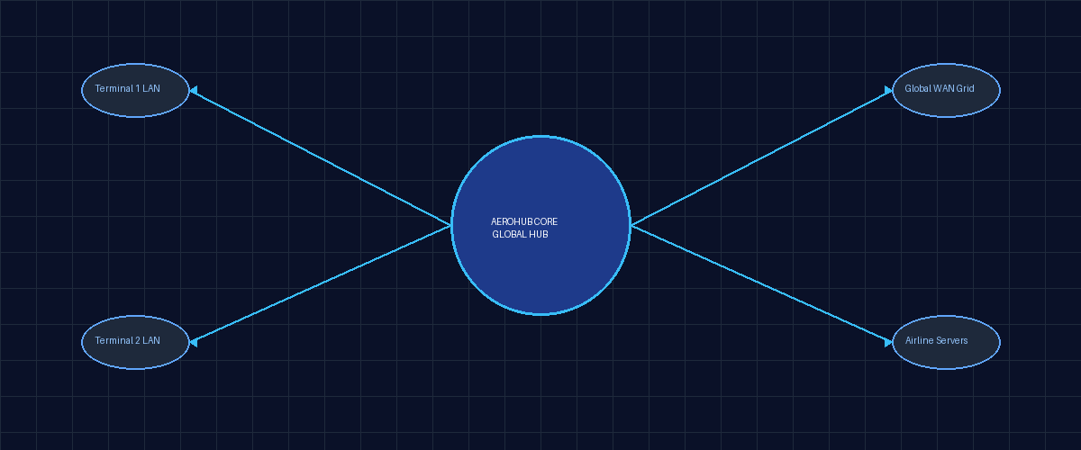
Student Name: Mohamed
Course: Advanced Airport Computer Networking & Smart Infrastructure
System: AeroHub Smart Aviation Framework

1. Task Objective & Operational Framework
This technical report provides a comprehensive architectural analysis of the networking infrastructure powering the AeroHub Smart Airport System. Modern international airports depend on real-time data flows to process thousands of passengers, coordinate flight departures, and manage global security synchronization.
To achieve operational excellence, AeroHub establishes a strict distinction between Local Area Networks (LAN) operating internally within terminal facilities and Wide Area Networks (WAN) connecting to external international aviation bodies. This project details the role of edge routers, Domain Name System (DNS) translation, and packet routing mechanics that make seamless flight operations possible.
⚡ NETWORK INTEGRITY MANDATE
Core Architectural Rule: Internal airport hardware (scanners, databases, check-in terminals) must run on isolated LAN segments to guarantee low latency and operational autonomy, while WAN pathways handle secure international inter-system communications.

2. Section 1 — Local Area Network (LAN)
A Local Area Network (LAN) encompasses the high-speed communications infrastructure deployed across AeroHub's physical campus. It directly connects internal terminal hardware, passenger management kiosks, and local administrative databases.
- Boarding Pass Scanners: Optical barcode scanners positioned at gate departure lanes to validate passenger credentials instantly.
- Check-in Computers: Agent workstations managing baggage drop-off, seat assignments, and passenger identity confirmation.
- Gate Computers: Operational terminals monitoring boarding queues, flight manifests, and door control status.
- Local Airport Server: High-availability local server rack running terminal management services without relying on internet connectivity.
- Airport Database: Primary database cluster housing encrypted passenger lists, flight schedules, and baggage tracking records.
- Printers & Monitoring Workstations: Hardware endpoints producing physical luggage tags and displaying facility telemetry.
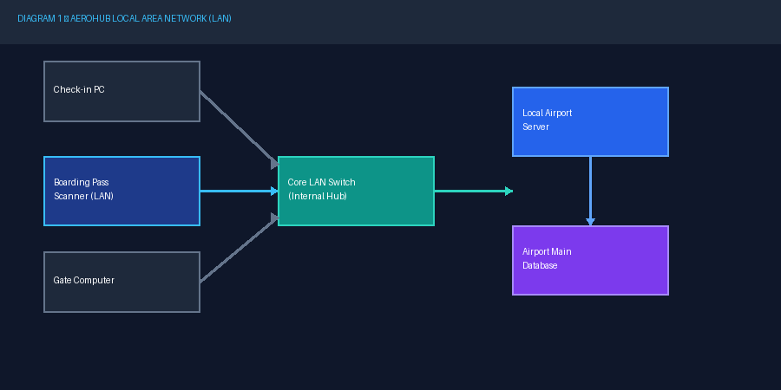
Figure 2 — Diagram 1: AeroHub Local Area Network (LAN) Topology
3. Section 2 — Wide Area Network (WAN)
A Wide Area Network (WAN) provides long-distance telecommunications linking AeroHub to external airports, global airline headquarters, and central aviation cloud networks across continents.
- Foreign Airports: Exchanging inbound/outbound international flight telemetry and customs manifests.
- Global Airline Hubs: Synchronizing ticket reservations and passenger manifests with parent carriers (e.g., EgyptAir headquarters).
- Aviation Centers: Connecting to Air Traffic Control (ATC) networks and international civil aviation safety databases.
- External Airline Servers & Cloud Services: Processing central loyalty databases and remote AI luggage analysis models.
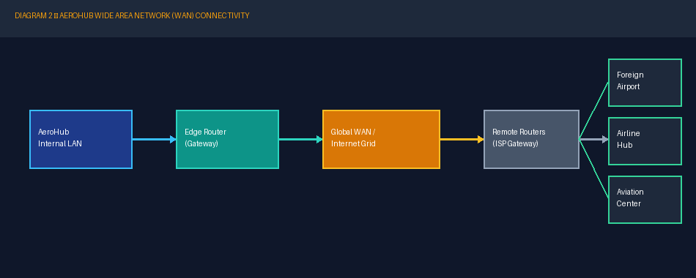
Figure 3 — Diagram 2: AeroHub Wide Area Network (WAN) Interconnections
4. Section 3 — LAN vs. WAN Comparative Analysis
Feature | Local Area Network (LAN) 🏢 | Wide Area Network (WAN) 🌍
Definition | Internal high-speed localized network | Geographically distributed external network
Coverage | Restricted to AeroHub terminal buildings | Spans global cities, regions, and countries
Location | Inside airport facility perimeter | External ISP backbones & public internet
Purpose | Local workstation & server communication | Long-distance data sync with external systems
AeroHub Example | Boarding Pass Scanner ➔ Airport Database | AeroHub Edge Router ➔ Foreign Airport Hub
Equipment | Ethernet switches, access points, CAT6a | Edge routers, optical links, satellite gateways
Communication Distance | Short distance (< 1 km) | Unlimited global distance (1,000s of km)

5. Section 4 — Complete AeroHub Network Architecture
The complete topology map below illustrates the complete data hierarchy. Note the clear physical segregation between the upper WAN Area (External) and the lower LAN Area (Internal Facility), mediated by the firewall-protected AeroHub Edge Router.
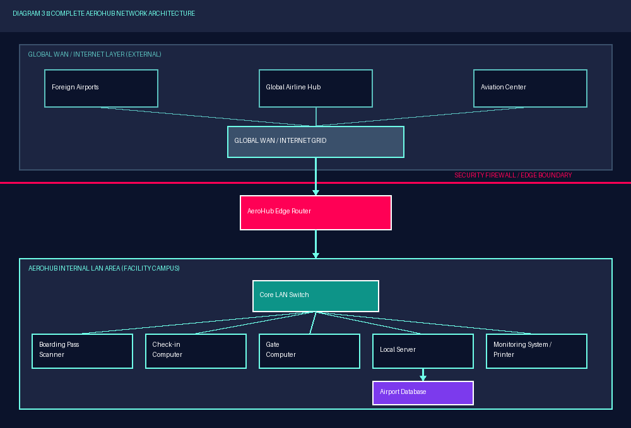
Figure 4 — Diagram 3: Complete AeroHub Network Architecture (WAN vs. LAN Segregation)
6. Section 5 & 6 — Domain Name System (DNS) Workflow
When an airport computer needs to transmit data to an external server like egyptair.com, it uses the Domain Name System (DNS) to translate the human-readable domain into a machine-routable IP address.
Step-by-Step DNS Lookup Resolution Protocol:
STEP 1: User or client application initiates query for egyptair.com.
STEP 2: Workstation checks local DNS cache memory for active IP mapping.
STEP 3: DNS resolver receives query if uncached locally.
STEP 4: Resolver performs recursive lookup through Root and TLD DNS hierarchy.
STEP 5: Authoritative DNS server for egyptair.com provides the official DNS record.
STEP 6: The resolver receives and caches the mapped IP address.
STEP 7: IP address information is returned to the client workstation.
STEP 8: Computer establishes direct TCP/IP socket connection with the destination airline server.
⚡ DYNAMIC IP MAPPING
Dynamic DNS Note: IP addresses associated with domain names like egyptair.com change over time due to load balancing and server management. DNS ensures clients always obtain the active operational IP dynamically.

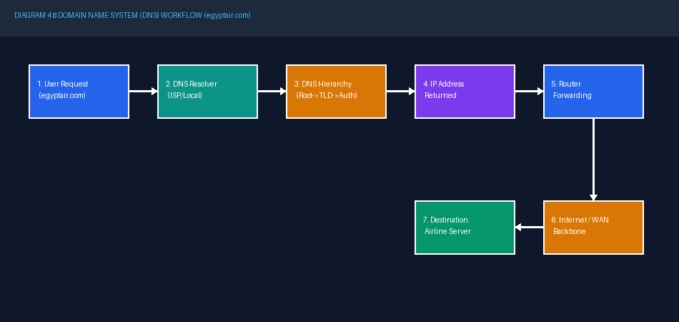
Figure 5 — Diagram 4: DNS Resolution Workflow (egyptair.com)
7. Section 7 & 8 — Edge Routers & Global Packet Routing
Routers connect distinct networks together. While LAN switches forward frames within AeroHub, the AeroHub Router reads network layer addresses to forward segmented data packets across public ISP backbones to international destinations.
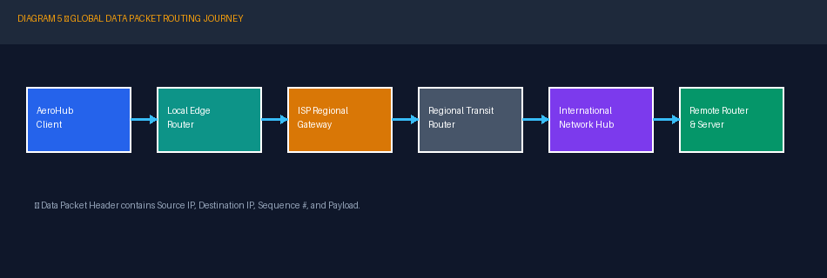
Figure 6 — Diagram 5: Global Data Packet Multi-Hop Routing Pathway
8. Section 9 — DNS vs. Routing Distinction
DNS answers: 'Which IP address belongs to this domain name?' (Translation stage).
Routing answers: 'Where should this packet go next to reach that IP?' (Forwarding stage).
9. Smart Airport Integration & Verification Checklist
Status | Task Verification Criteria
✔ VERIFIED | LAN devices correctly identified and isolated.
✔ VERIFIED | WAN systems correctly identified and mapped.
✔ VERIFIED | Boarding pass scanners shown strictly on LAN.
✔ VERIFIED | Complete AeroHub network architecture diagram included.
✔ VERIFIED | DNS resolution workflow (egyptair.com) detailed.
✔ VERIFIED | Multi-hop packet routing path diagrammed.

10. Conclusion
In conclusion, the AeroHub Smart Airport System leverages a hybrid network model combining high-speed internal LANs with secure global WAN links. By maintaining clear logical segregation, utilizing DNS translation, and deploying intelligent packet routing via edge routers, AeroHub ensures uninterrupted local performance and international coordination.

