**1:** Your organization has different server builds, none of which are identical. You have chosen to use customized images to aid deployment. Should you think about using thick or thin images?

⃝ Thick

⃝ Thin

Answer:

2.

**Scenario**

|  |  |
| --- | --- |
| You have been assigned the task of planning a server installation strategy, selecting suitable installation and deployment tools, and planning an appropriate server deployment method. A. Datum Automated Server Installation and Deployment Strategy Document | |
| Document Reference Number: BS00929/1 | |
| Document Author  Date | Brad Sutton  5th July |
| Requirements Overview:  To design an automated server installation and deployment strategy document, consider the following design factors:  • Familiarity with operating system image management of the IT staff  • Number of servers that must be deployed  • Variation in server configurations  • Use of retail or volume license media  • Network configuration, both in terms of the distribution of servers to be deployed and in terms of the services currently installed to support the deployment process  The IT staff is planning to deploy Windows Server 2012 to various offices, and has some experience with imaging and deployment. The configuration of the various servers is expected to be fairly consistent.  There is no requirement to upgrade settings from existing servers because there are plans to introduce new server hardware and to virtualize workloads where possible. | |
| Proposals  1. Would lite-touch or zero-touch deployment be applicable for this scenario?  2. Which deployment technologies would you consider to implement the server upgrade plan?  3. What are the requirements for implementing this deployment technology?  4. Produce a list of the deployment components necessary to support your server deployment plan  Answer: | |

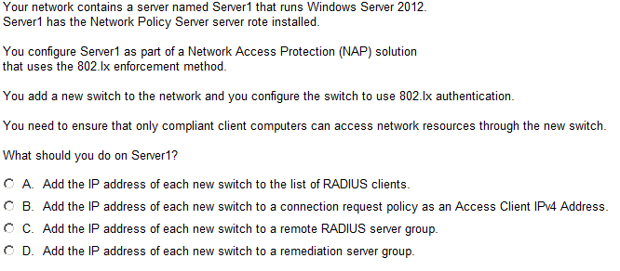

Answer:

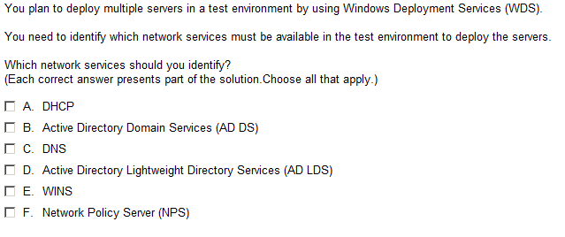

Answer:

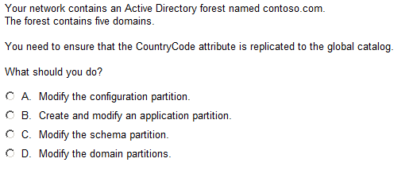

Answer:

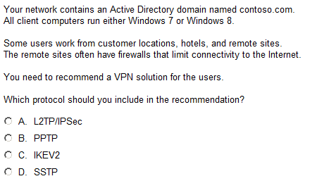

Answer:

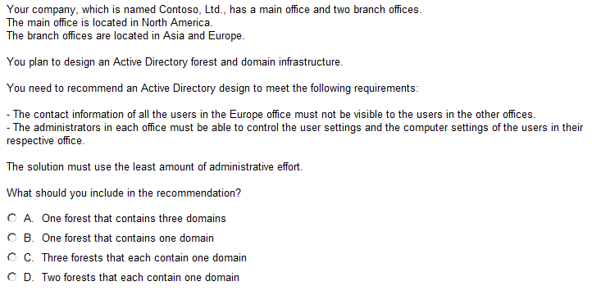

Answer:

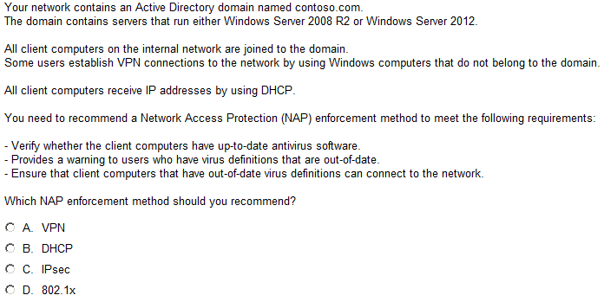

Answer:

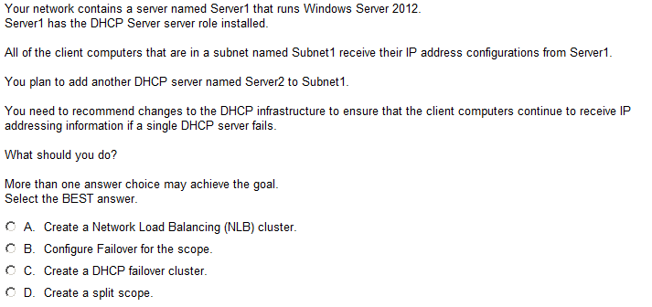

Answer:

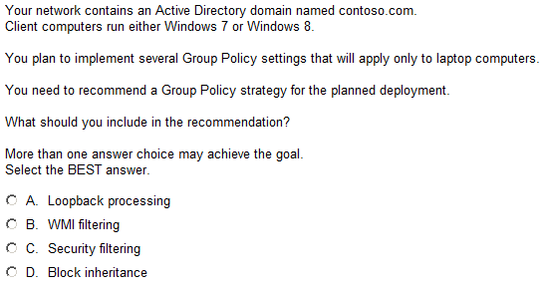

Answer:

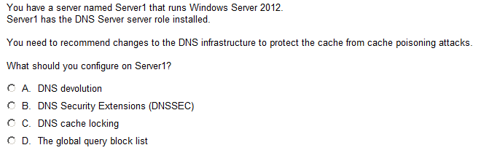

Answer:

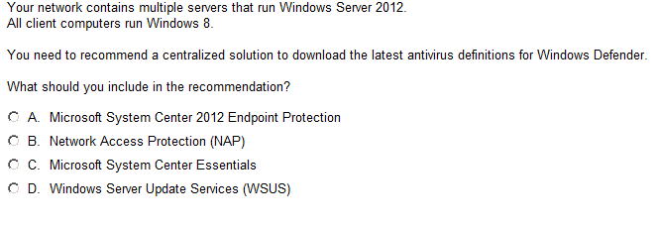

Answer: