1. You network contains an Active Directory domain named contoso.com. The domain contains a DHCP server named Server1. All client computers run Windows 10 and are configured as DHCP clients. Your helpdesk received calls today from users who failed to access the network from their Windows 10 computer. You open the DHCP console as shown in the exhibit. (Click the Exhibit button.)

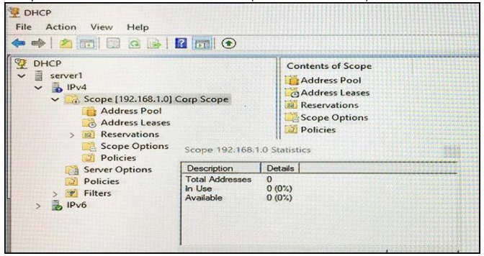

You need to ensure that all o the Windows 10 computers can receive a DHCP lease. Solution: You increase the scope size. Does this meet the goal?

A. Yes

B. No

1. Your network contains an Active Directory forest named contoso.com. The forest contains two domains named contoso.com and litwareinc.com. Your company recently deployed DirectAccess for the members of a group named DA_Computers. All client computers are members of DA_Computers. You discover that DirectAccess clients can access the resources located in the contoso.com domain only. The clients can access the resources in the litwareinc.com domain by using an L2TP VPN connection to the network.

You need to ensure that the DirectAccess clients can access the resources in the litwareinc.com domain. What should you do?

A. From a Group Policy object (GPO), modify the Name Resolution Policy Table (NRPT).

B. From the properties of the servers in litwareinc.com, configure the delegation settings.

C. On an external DNS server, create a zone delegation for litwareinc.com.

D. Add the servers in litwareinc.com to the RAS and IAS Servers group.

1. You network contains an Active Directory domain named contoso.com. The domain contains a member server named Server1 that runs Windows Server 2016 and has the DNS Server role installed. Automatic scavenging of state records is enabled and the scavenging period is set to 10 days. All client computers dynamically register their names in the contoso.com DNS zone on Server1. You discover that the names of multiple client computers that were removed from the network several weeks ago can still be resolved. You need to configure Server1 to automatically remove the records of the client computers that have been offline for more than 10 days.  
   Solution: You run the dnscmd.exe command and specify the /AgeAllRecords parameter for the zone.  
   Does this meet the goal?  
     
   A. Yes  
   B. No
2. You have a subnet mask of 255.255.240.0. What would the CIDR notation be?

A. /16

B. /20

C. /24

D. /28

1. You have a DHCP server named Server1 that has three network cards. Each network card is configured to use a static IP address. Each network card connects to a different network segment. Server1 has an IPv4 scope named Scope1. You need to ensure that Server1 only uses one network card when leasing IP addresses in Scope1. What should you do?  
     
   A. From the properties of Scope1, modify the Conflict detection attempts setting.  
   B. From the properties of Scope1, configure Name Protection.  
   C. From the properties of IPv4, configure the bindings.  
   D. From IPv4, create a new filter.  
   E. From the properties of Scope1, create an exclusion range.  
   F. From IPv4, run the DHCP Policy Configuration Wizard.  
   G. From Control Panel, modify the properties of Ethernet.  
   H. From Scope1, create a reservation.
2. Your company has a main office in London and a branch office in Seattle. The offices connect to each other by using a WAN link. In the London office, you have a Distributed File System (DFS) server named FS1 that contains a folder named Folder1. In the Seattle office, you have a DFS server named FS2. All servers run Windows Server 2016. You configure replication of Folder1 to FS2. Users in both offices frequently add files in Folder1. You monitor DFS Replication, and you discover excessive replication over the WAN link during business hours. You need to reduce the amount of bandwidth used for replication during business hours. The solution must ensure that the users can continue to save content to Folder1. What should you do?  
     
   A. Modify the quota settings on Folder1 on FS2.  
   B. Modify the properties of the replication group.  
   C. Configure the copy of Folder1 on FS2 as read-only.  
   D. Modify the replicated folder properties of Folder1 on FS1.
3. What is used to uniquely identify a host on a TCP/IP network?

A. IP address

B. MAC address

C. bit pattern

D. router name

1. You network contains an Active Directory domain named contoso.com. The domain contains a DHCP server named Server1. All client computers run Windows 10 and are configured as DHCP clients. Your helpdesk received calls today from users who failed to access the network from their Windows 10 computer. You open the DHCP console as shown in the exhibit. (Click the Exhibit button.)



You need to ensure that all of the Windows 10 computers can receive a DHCP lease.  
Solution: You activate the scope.  
Does this meet the goal?  
  
A. Yes  
B. No

1. You have a DNS server named Server1 that has a Server Core Installation on Windows Server. You need to view the time-to-live (TTL) value of a name server (NS) record that is cached by the DNS Server service on Server1.

What should you run?

A. Show-DNSServerCache

B. dnscacheugc.exe

C. ipconfiq.exe /displaydns

D. nslookup.exe

1. Your network contains an Active Directory domain named contoso.com. You have a standard primary zone names contoso.com. You need to ensure that only users who are members of a group named Group1 can create DNS records in the contoso.com zone. All other users must be prevented from creating, modifying, or deleting DNS records in the zone.

What should you do first?

A. Run the Zone Signing Wizard for the zone.

B. From the properties of the zone, change the zone type.   
C. Run the new Delegation Wizard for the zone.

D. From the properties of the zone, modify the Start Of Authority (SOA) record.

1. Your network contains an Active Directory domain named contoso.com. The domain contains a server named Server1 that runs Windows Server.You enable and configure Routing and Remote Access (RRAS) on Server1.You create a user account named User1.You need to ensure that User1 can establish VPN connections to Server1.

What should you do?

A. Modify the members of the Remote Management Users group.

B. Modify the Dial-in setting of User1.

C. Create a connection request policy.

D. Add a RADIUS client.