
SMARTWORKER
AN INTELLIGENT JOB PORTAL AND RECRUITMENT MANAGEMENT SYSTEM

Submitted by:
Shaheen Shah (Registration No. ____________________)
Hamad Khan (Registration No. ____________________)

Supervised by:
____________________________
Department of Software Engineering
University of Swat, Khyber Pakhtunkhwa, Pakistan
Session 2022-2026

Declaration
We, Shaheen Shah and Hamad Khan, declare that the final year project thesis entitled SmartWorker: An Intelligent Job Portal and Recruitment Management System is our own work. The project has been prepared for the award of the Bachelor of Science degree in Software Engineering at the University of Swat. To the best of our knowledge, this work has not been submitted, in whole or in part, to any other institution for the award of a degree.
Student Name: Shaheen Shah Signature: ____________________
Student Name: Hamad Khan Signature: ____________________

Forwarding Sheet
This is to certify that the project entitled SmartWorker: An Intelligent Job Portal and Recruitment Management System has been completed by Shaheen Shah and Hamad Khan under the supervision of the undersigned. The project is submitted in partial fulfilment of the requirements for the Bachelor of Science degree in Software Engineering at the University of Swat.
Supervisor: __________________________
Designation: _________________________
Department of Software Engineering
University of Swat

Dedication
This project is dedicated to our parents, families, teachers, and friends whose encouragement, prayers, and guidance supported us throughout our academic journey.

Final Approval
This is to confirm that the project titled SmartWorker: An Intelligent Job Portal and Recruitment Management System, presented by Shaheen Shah and Hamad Khan, has been reviewed and is accepted towards the completion of the Bachelor of Science degree in Software Engineering at the University of Swat.

Final Project Evaluation Committee
External Examiner
Name: ____________________________ Designation: ____________________________
Institute: _________________________ Signature: _____________________________
Supervisor
Name: ____________________________ Designation: ____________________________
Institute: _________________________ Signature: _____________________________
Chairman
Name: ____________________________ Designation: ____________________________
Institute: _________________________ Signature: _____________________________

Acknowledgements
First of all, we are thankful to Almighty Allah for giving us the strength, patience, and ability to complete this final year project. We express our sincere gratitude to our teachers and the Department of Software Engineering, University of Swat, for their academic support and guidance. We are also grateful to our parents, friends, and classmates for their encouragement throughout the analysis, design, development, testing, and documentation of SmartWorker.
Shaheen Shah and Hamad Khan

Abstract
SmartWorker is a web-based job portal and recruitment management system designed to connect job candidates, employers, and administrators on one platform. The project addresses the problems of fragmented job discovery, unstructured recruitment records, manual application tracking, and weak communication between applicants and employers. The system provides role-based workflows that allow candidates to manage their profiles and resumes, discover and save jobs, submit applications, receive notifications, and communicate with employers. Employers can create company profiles, post and manage jobs, review applications, identify suitable candidates, and update hiring status. Administrators can moderate users, jobs, contact messages, and applications.
The application is implemented using Laravel, PHP, Blade templates, Vite, and Tailwind CSS. SmartWorker also includes an explainable matching service that uses skills, location, and rating information to recommend jobs and candidates. Input validation, role middleware, private document access, password hashing, CSRF protection, and security headers are included to protect the system. The project demonstrates how a centralised web solution can make recruitment more organised, transparent, and accessible.
Keywords: Job Portal, Recruitment Management, Laravel, Candidate, Employer, Smart Matching, Web Application.

Table of Contents
Declaration
Forwarding Sheet
Dedication
Final Approval
Acknowledgements
Abstract
List of Figures
Chapter 1: Introduction
Chapter 2: Software Development Methodology
Chapter 3: Software Requirement Specification
Chapter 4: System Design
Chapter 5: Implementation
Chapter 6: Testing
Chapter 7: Conclusion and Future Work
References
Appendix A: SmartWorker Screenshots

List of Figures
Figure 1: SmartWorker Use-Case Diagram
Figure 2: SmartWorker System Architecture
Figure 3: SmartWorker Entity Relationship Diagram
Figure 4: Login Screen
Figure 5: Registration Screen
Figure 6: Home Page
Figure 7: Candidate Dashboard
Figure 8: Job Categories
Figure 9: Job Categories - Alternate View
Figure 10: Job Details
Figure 11: Job Details - Alternate View
Figure 12: Manage Applications
Figure 13: Employer Dashboard
Figure 14: Post a Job
Figure 15: Candidate Application History
Figure 16: Candidate Profile
Figure 17: Employer Company Profile

CHAPTER 1
INTRODUCTION

1.1 Introduction
The growth of online recruitment has changed the way candidates search for employment and the way employers find suitable people. However, many recruitment activities are still handled through separate advertisements, social-media posts, spreadsheets, email messages, and manual follow-up. This makes it difficult for candidates to manage their information and for employers to organise job vacancies and applications. SmartWorker was developed as a single web platform to improve these activities.

1.2 Problem Statement
Job candidates need a simple and reliable way to create professional profiles, upload resumes, search relevant vacancies, apply for jobs, and check their application status. Employers need an organised system to post jobs, view applications, find candidates, communicate with applicants, and update hiring decisions. A secure role-based system is therefore required to manage these processes without allowing unauthorised access to sensitive information.

1.3 Scope of Project
The scope of SmartWorker includes job discovery, candidate and company profiles, job posting, application management, saved jobs, protected CV and resume access, notifications, chat, ratings, categories, contact messages, and administrator moderation. The project supports three major roles: candidate, employer, and administrator. Payroll processing, employee attendance, and a complete enterprise human-resource system are outside the current scope.

1.4 Project Objectives
1. To provide a centralised platform for candidates to find and apply for jobs.
2. To allow employers to post, update, activate, and manage job listings.
3. To organise candidate profiles, resumes, cover letters, and application status.
4. To implement role-based access control for candidates, employers, and administrators.
5. To recommend suitable jobs and candidates using skills, location, and rating data.
6. To provide notifications, chat, and ratings for improved communication.
7. To protect user information through validation, authorisation, and private document access.

1.5 Project Features
Module | Core Features
Candidate | Profile, skills, resume upload, job search, saved jobs, applications, recommendations, alerts, and chat.
Employer | Company profile, job creation, job management, application review, candidate matching, and chat.
Administrator | User activation/verification, job moderation, contact-message management, and application oversight.
Security | Validation, authentication, role checks, private document downloads, CSRF protection, and security headers.

CHAPTER 2
SOFTWARE DEVELOPMENT METHODOLOGY

2.1 Agile Development Model
An Agile-oriented software development approach was used for SmartWorker. The project was divided into manageable increments so that requirements, database entities, interfaces, validations, and role workflows could be reviewed throughout development. The iterative approach supports continuous improvement because job portal requirements can be refined while the application is being implemented and tested.

2.2 Project Plan
Phase | Activities
Requirements Analysis | Identify candidate, employer, and administrator workflows.
Design | Prepare user-interface structure, database entities, relationships, and access rules.
Development | Build authentication, profiles, jobs, applications, dashboards, and administration.
Smart Features | Add matching, notifications, chat, ratings, and protected documents.
Testing | Run feature tests, validate workflows, and correct defects.
Documentation | Prepare project report, diagrams, testing results, and screenshots.

2.3 Selection of Tools and Technologies
Category | Technology | Use
Programming Language | PHP 8.3 | Server-side implementation.
Framework | Laravel 13 | Routes, controllers, models, migrations, authentication, validation.
Frontend | Blade, Vite, Tailwind CSS | Web pages, layout, assets, and responsive styling.
Database | Laravel migration-based relational database | Users, profiles, jobs, applications, messages, ratings, notifications.
Testing | PHPUnit and Laravel Feature Tests | Authentication, job posting, applications, and route access.
Development Tools | VS Code, Composer, npm | Code editing and dependency management.

2.4 Risk Plan
Risk | Level | Mitigation
Unauthorised role access | Medium | Role middleware allows only active and permitted users.
Invalid input | Medium | Form Request validation checks registration, profiles, jobs, and contacts.
Private file exposure | High | Resume/CV download controllers perform authorisation checks.
Recommendation quality | Medium | Explainable scoring can be reviewed and adjusted.
Deployment configuration | Medium | Environment configuration and deployment blueprint are maintained.

CHAPTER 3
SOFTWARE REQUIREMENT SPECIFICATION

3.1 System Requirements
SmartWorker is a web application that requires a computer or mobile device with a modern web browser and an internet connection. For development, the system uses PHP, Laravel, Composer, npm, a relational database, and a code editor. The user-facing interface is designed for candidates, employers, and administrators.

3.2 Functional Requirements
ID | Function | Requirement
FR-01 | Registration and login | Candidates and employers can create accounts, log in, log out, and reset passwords.
FR-02 | Profile management | Users can update personal/company details, location, skills, documents, and media.
FR-03 | Job browsing | Visitors and candidates can browse active jobs and job categories.
FR-04 | Job posting | Employers can create, edit, manage, and delete their job listings.
FR-05 | Applications | Candidates can submit a CV and cover letter and view their application history.
FR-06 | Application handling | Employers can review applications and update the hiring status.
FR-07 | Matching and alerts | The system can recommend jobs/candidates and create job-match notifications.
FR-08 | Administration | Administrators can manage users, job listings, contacts, and applications.

3.3 Non-Functional Requirements
Requirement | Description
Usability | The interface must provide clear navigation and role-specific dashboards.
Security | Data must be protected through authentication, authorisation, validation, and secure document access.
Reliability | Database constraints and validation must prevent duplicate applications and invalid input.
Maintainability | Laravel MVC structure separates routes, controllers, models, services, and requests.
Scalability | The system design permits later use of queues, mobile clients, and improved matching services.

3.4 Use-Case Diagram
The use-case diagram shows the main interactions of candidates, employers, and administrators with SmartWorker. Candidate and employer actions are separated through role middleware, while administration is controlled through a dedicated administrator route group.
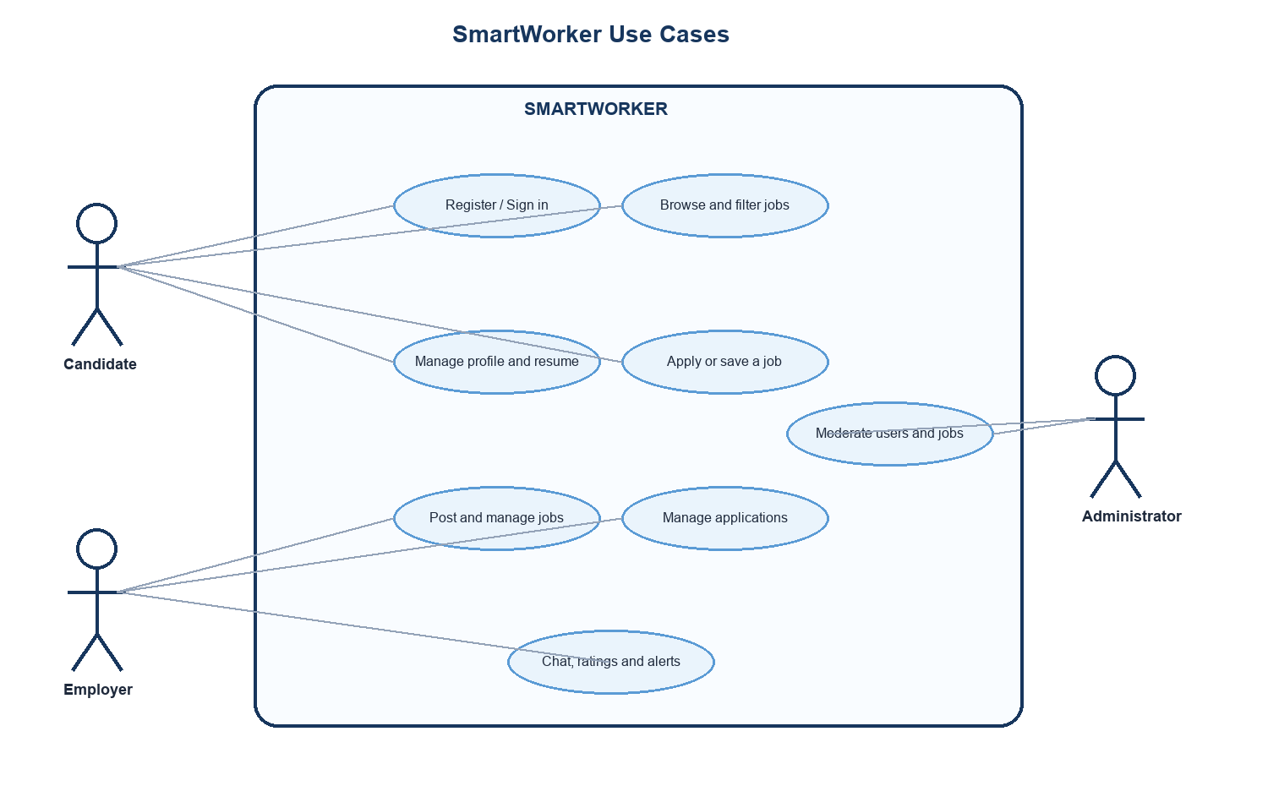
Figure 1: SmartWorker Use-Case Diagram

CHAPTER 4
SYSTEM DESIGN

4.1 System Architecture
SmartWorker uses the Model-View-Controller architecture provided by Laravel. Web routes receive requests and send them to controller methods. Controllers manage validation, data access, service calls, and Blade views. Eloquent models communicate with the relational database, while the MatchingService and SmartNotificationService implement important business functions. Private files are stored separately and are downloaded only after access checks.
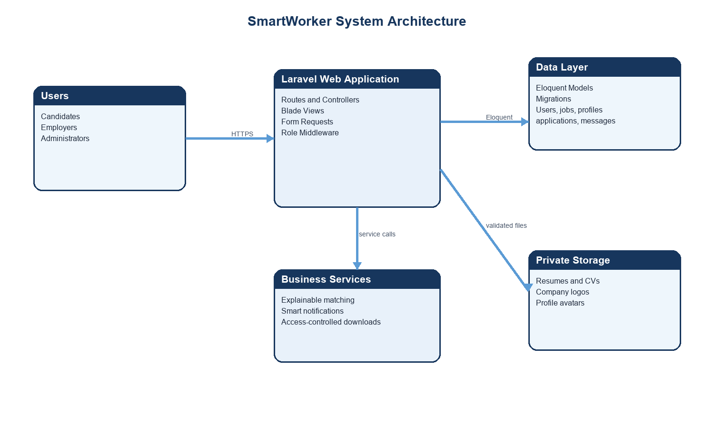
Figure 2: SmartWorker System Architecture

4.2 Entity Relationship Diagram
The database design is centred on the User entity. User profiles hold candidate or company details. Employers create job listings, candidates save jobs and create applications, and conversations connect candidates with employers. Ratings and notifications are associated with users and application activity. The diagram below presents the major entities and relationships implemented in the project.
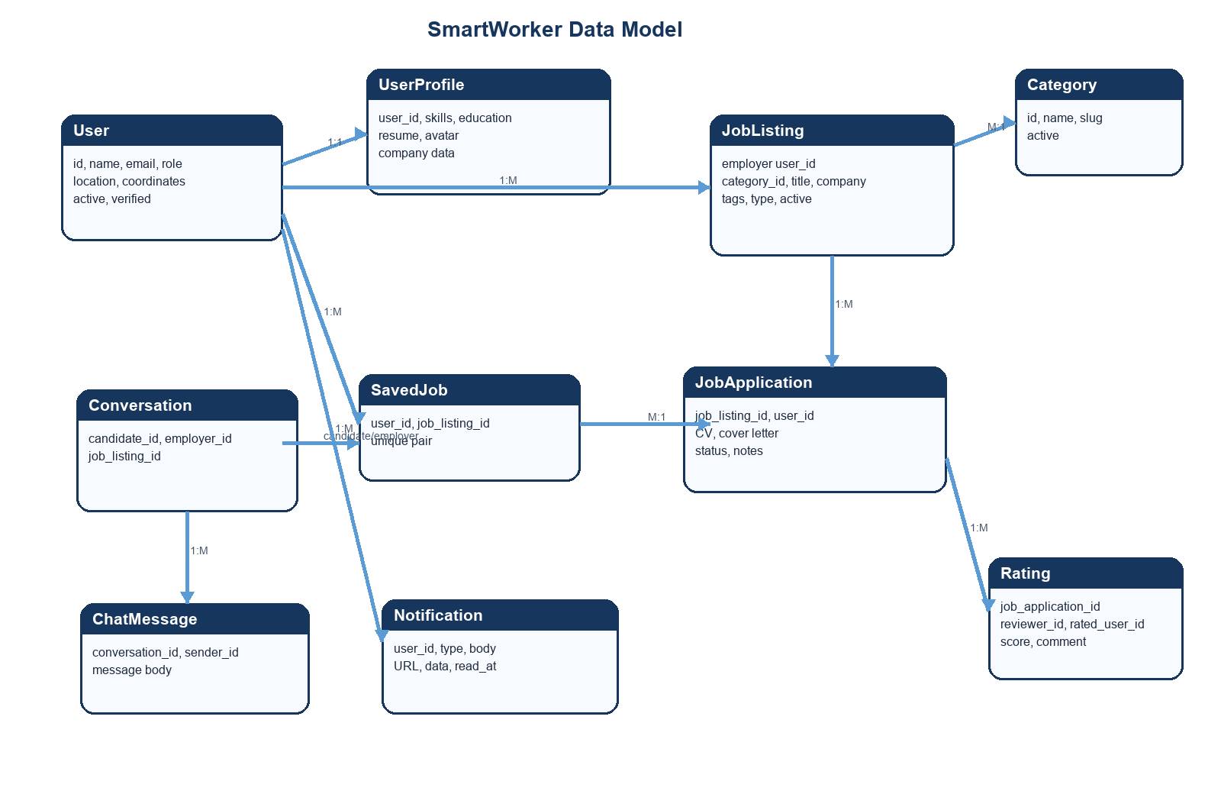
Figure 3: SmartWorker Entity Relationship Diagram

4.3 Security and Access Design
Access is controlled at route level. Candidate-only actions require a candidate account, employer-only actions require an employer or administrator account, and administrative actions require an administrator account. The middleware also requires the account to be active. Sensitive documents are protected with ownership and role checks before a response is returned.

CHAPTER 5
IMPLEMENTATION

5.1 Implementation Overview
SmartWorker is implemented as a Laravel web application. Named web routes define public pages, authentication, candidate functions, employer functions, shared account controls, and administrator functions. Controllers manage the workflows, Form Requests validate user input, Eloquent models represent database records, and Blade templates present the interface.

5.2 Candidate Module
The candidate module provides registration, login, profile update, skills and resume information, job browsing, category browsing, saved jobs, applications, job recommendations, notifications, and chat. The candidate dashboard summarises saved jobs, applications, and recommended vacancies. A candidate can submit one application per job listing and can monitor application status from the application-history screen.

5.3 Employer Module
The employer module provides company-profile management, job posting, job management, application review, candidate matching, notifications, and chat. Employers can create a listing by providing job title, location, type, category, salary details, requirements, application information, and company details. The application-management page allows employers to review candidates and update their status to reviewing, shortlisted, hired, or rejected.

5.4 Smart Matching, Notifications, and Chat
The matching service calculates a transparent recommendation score from skills, location, and rating information. Candidates receive recommended jobs and employers can view suitable candidates for a listing. The notification service creates job-match alerts for alert-enabled candidates with an appropriate score. The chat module creates conversations between candidates and employers and stores messages within the related conversation.

5.5 Administration and Security
The administrator module provides user management, job moderation, contact-message handling, application overview, and account verification. Security controls include password hashing, CSRF protection, Form Request validation, role-based middleware, private resume/CV downloads, and security response headers. The following appendix contains screenshots of the implemented SmartWorker interface.

CHAPTER 6
TESTING

6.1 Testing Approach
Testing was carried out through Laravel feature tests and inspection of the implemented workflows. The tests cover authentication, role access, job posting, application workflow, post-job pages, and compatibility routes. Validation rules and database constraints are also used to reject invalid data and prevent duplicate applications or saved-job entries.

6.2 Automated Test Result
The project test command was executed during preparation of this thesis. The run completed without a test failure: 13 tests were registered, 5 tests passed, 8 tests were skipped, and 10 assertions were reported. The runner produced a non-blocking warning because it could not update the PHPUnit result-cache file; the warning did not cause a test failure.

6.3 Representative Test Cases
Area | Test | Expected Result
Authentication | Register/login with valid credentials | User is authenticated and directed to the correct role workflow.
Role Access | Candidate accesses employer route | Role middleware rejects unauthorised access.
Job Posting | Employer submits valid job data | Validated job listing is stored and manageable by its owner.
Application | Candidate applies for active job | One application is stored for the candidate/listing pair.
Documents | Unauthorised CV/resume request | Access check prevents public file exposure.
Notifications | Eligible job match is created | Targeted job-match alert can be created for the candidate.

6.4 Validation
The application validates registration information, email uniqueness, password confirmation, job type, coordinates, URLs, salary ranges, required job description, and file types. Resumes are restricted to PDF, DOC, and DOCX formats, while profile and company images are validated before upload. These checks support the reliability and security of the system.

CHAPTER 7
CONCLUSION AND FUTURE WORK

7.1 Conclusion
SmartWorker provides a centralised job portal and recruitment-management system for candidates, employers, and administrators. It combines professional profiles, job listings, applications, saved jobs, protected documents, notifications, chat, ratings, recommendations, and administration in one web application. The role-based architecture, validation, and access-control mechanisms help protect recruitment information and keep user workflows organised.
The project meets its objective of simplifying the recruitment process through a practical web system. Its explainable matching approach provides a clear basis for job and candidate recommendations, while the implemented feature tests provide an initial quality baseline for important workflows.

7.2 Future Work
1. Introduce an evaluated machine-learning recommendation model with configurable matching weights.
2. Develop Android and iOS mobile clients through a secured API.
3. Add richer hiring analytics, reporting, and application funnel dashboards.
4. Use queues for high-volume notifications and long-running jobs.
5. Perform broader browser, accessibility, load, and security testing.
6. Add audit logs, improved monitoring, and data-retention controls.

References
Laravel. Laravel Documentation. https://laravel.com/docs
PHP Documentation. https://www.php.net/docs.php
Tailwind CSS. Documentation. https://tailwindcss.com/docs
Vite. Guide. https://vite.dev/guide/
PHPUnit. Documentation. https://docs.phpunit.de/
OWASP Foundation. Cheat Sheet Series. https://cheatsheetseries.owasp.org/
SmartWorker project source code: routes, controllers, models, migrations, services, Form Requests, and feature tests.

Appendix A
SMARTWORKER IMPLEMENTATION SCREENSHOTS

Login Screen
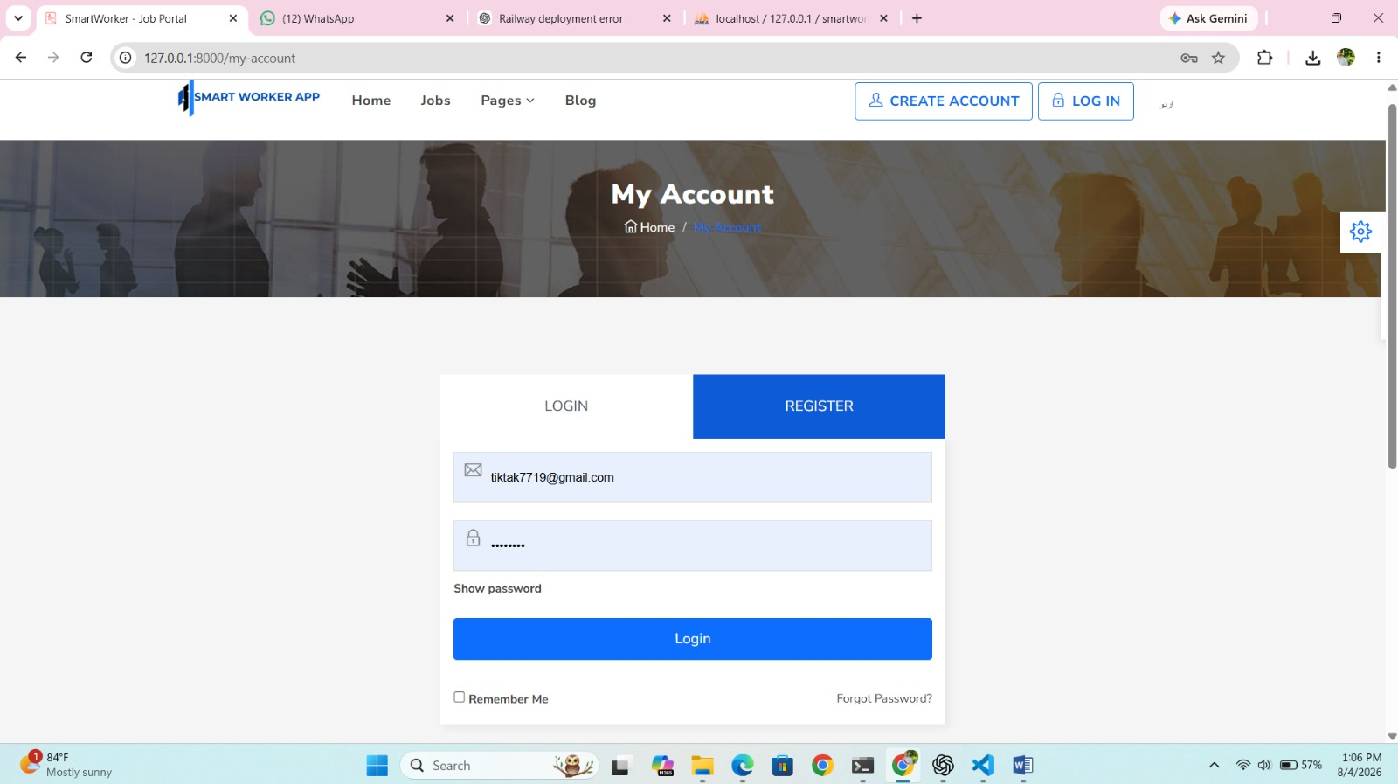
Figure 4: Login Screen

Registration Screen
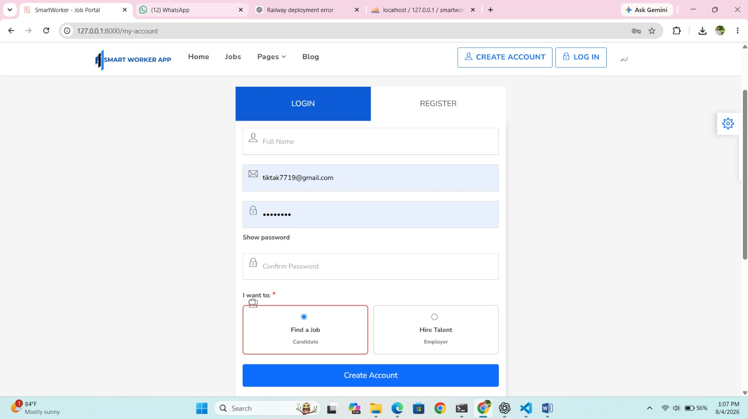
Figure 5: Registration Screen

SmartWorker Home Page
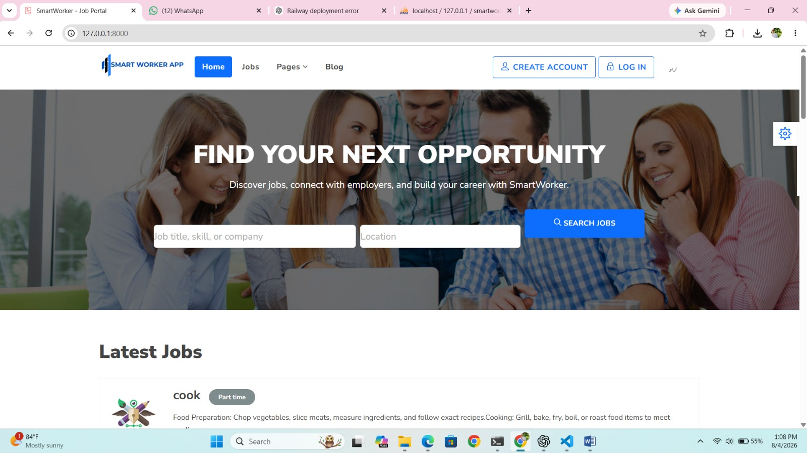
Figure 6: SmartWorker Home Page

Candidate Dashboard and Job Recommendations
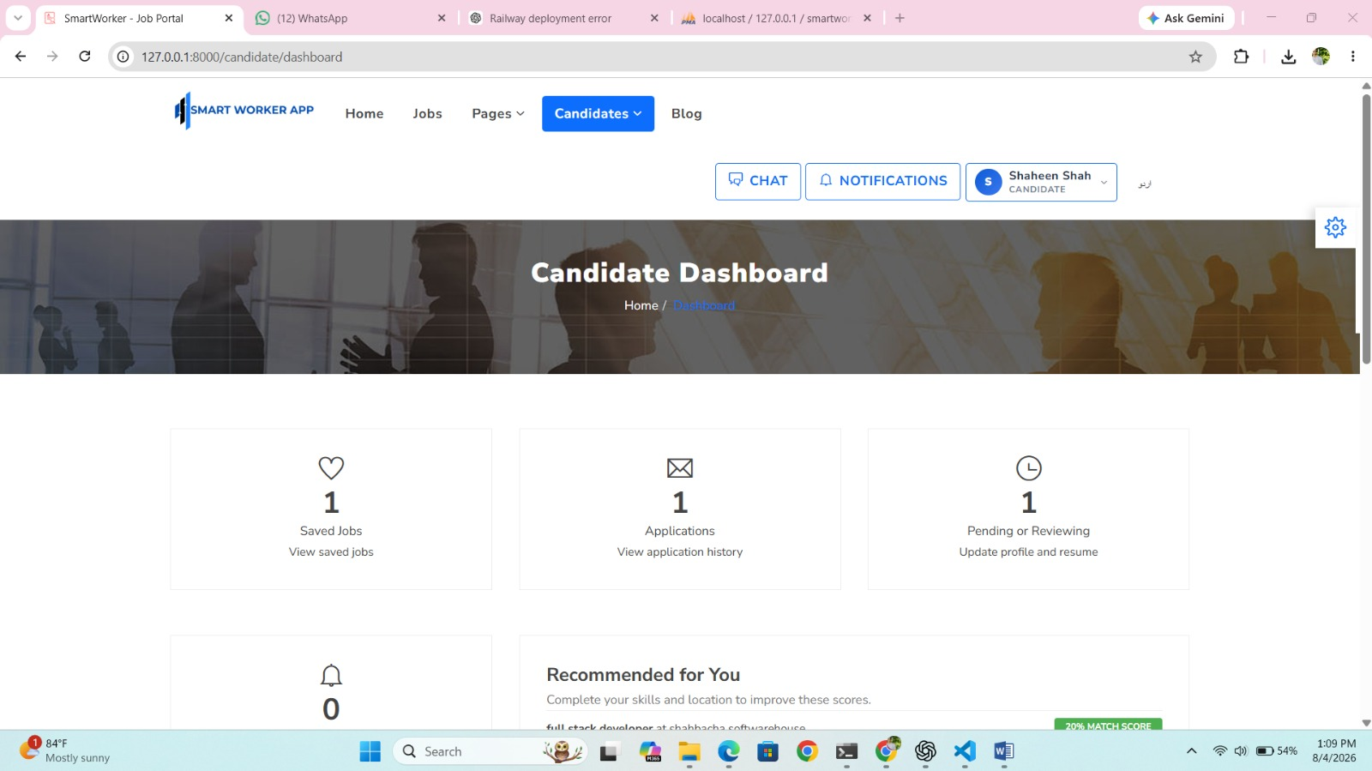
Figure 7: Candidate Dashboard and Job Recommendations

Job Categories
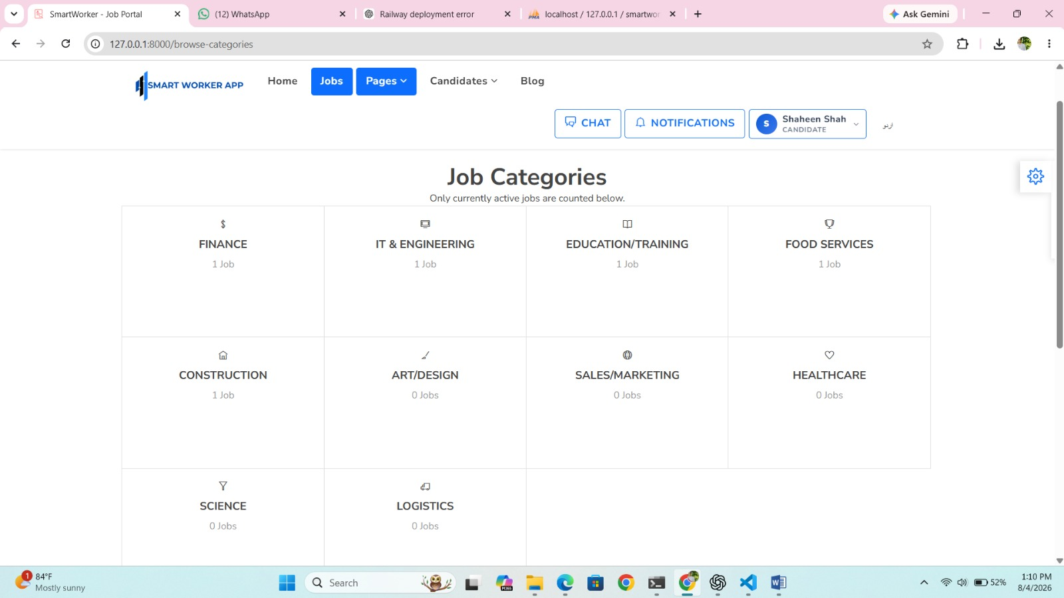
Figure 8: Job Categories

Job Categories - Alternate View
Figure 9: Job Categories - Alternate View

Job Details and Application Area
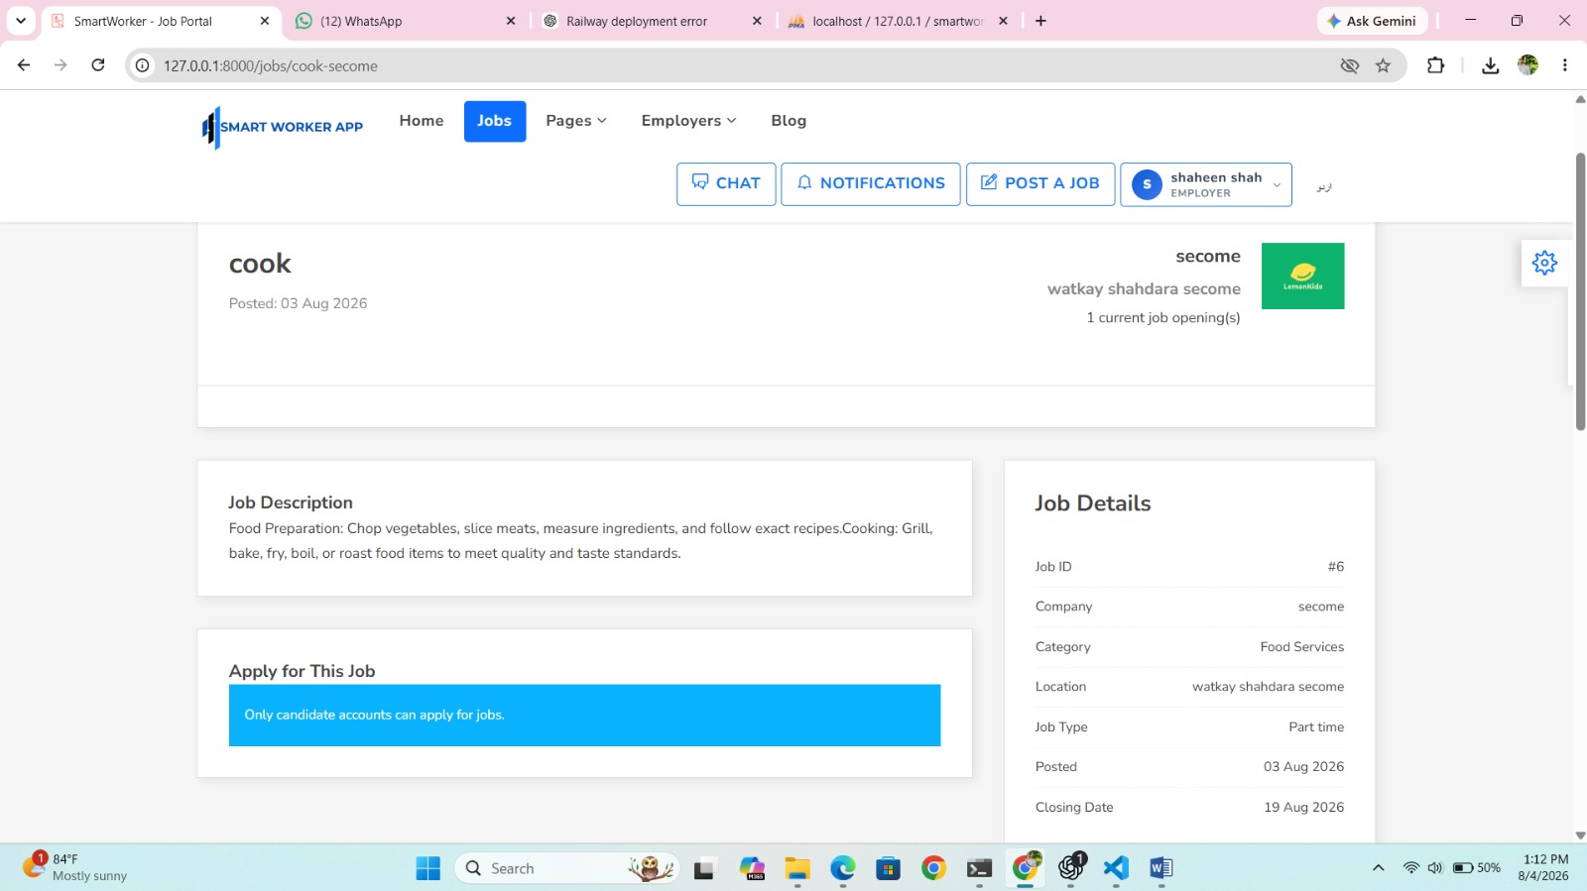
Figure 10: Job Details and Application Area

Job Details - Alternate View
Figure 11: Job Details - Alternate View

Employer Manage Applications
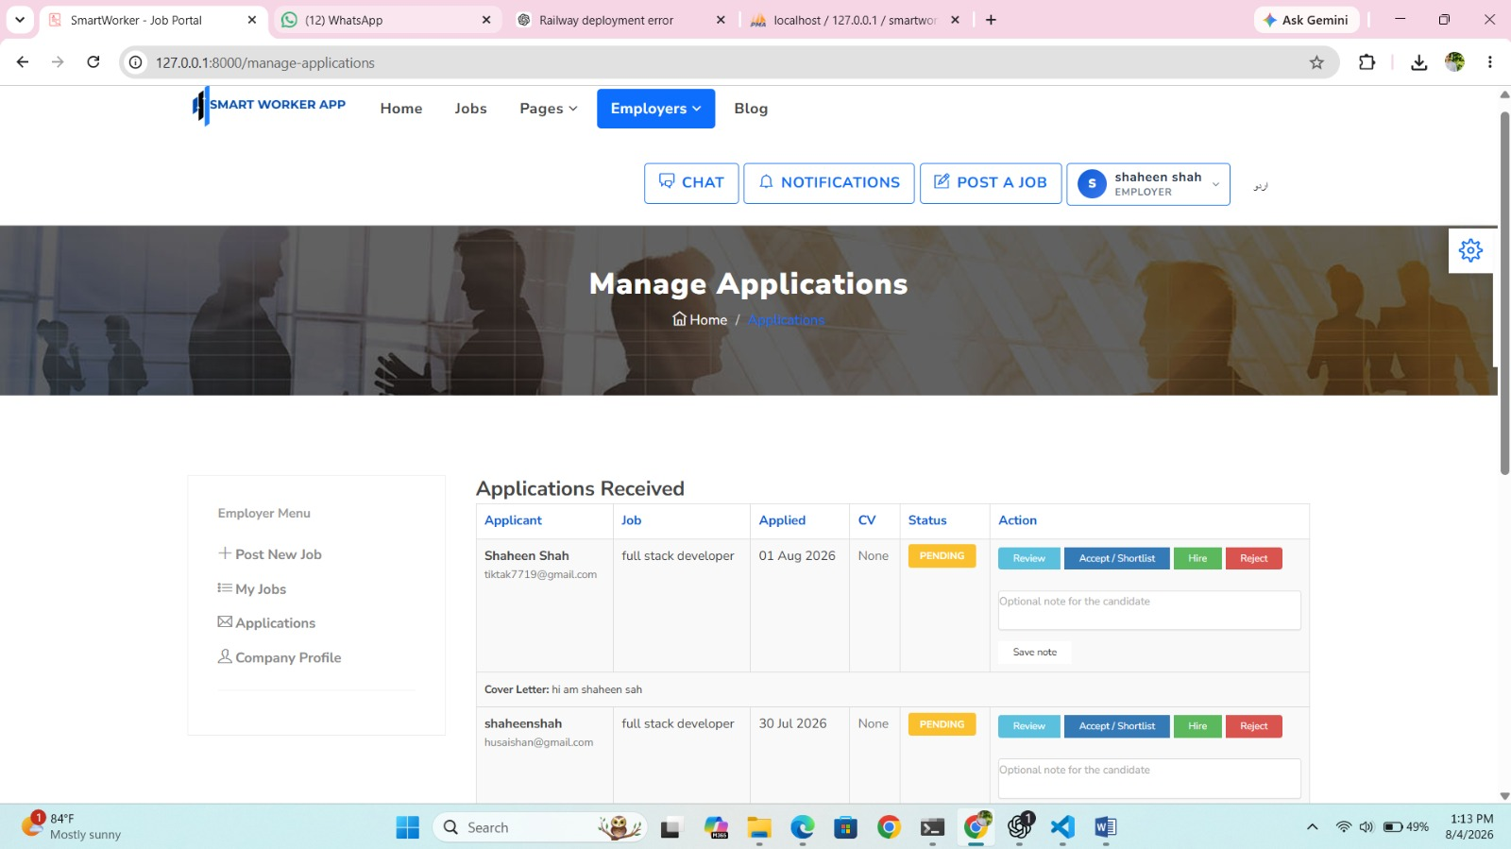
Figure 12: Employer Manage Applications

Employer Dashboard
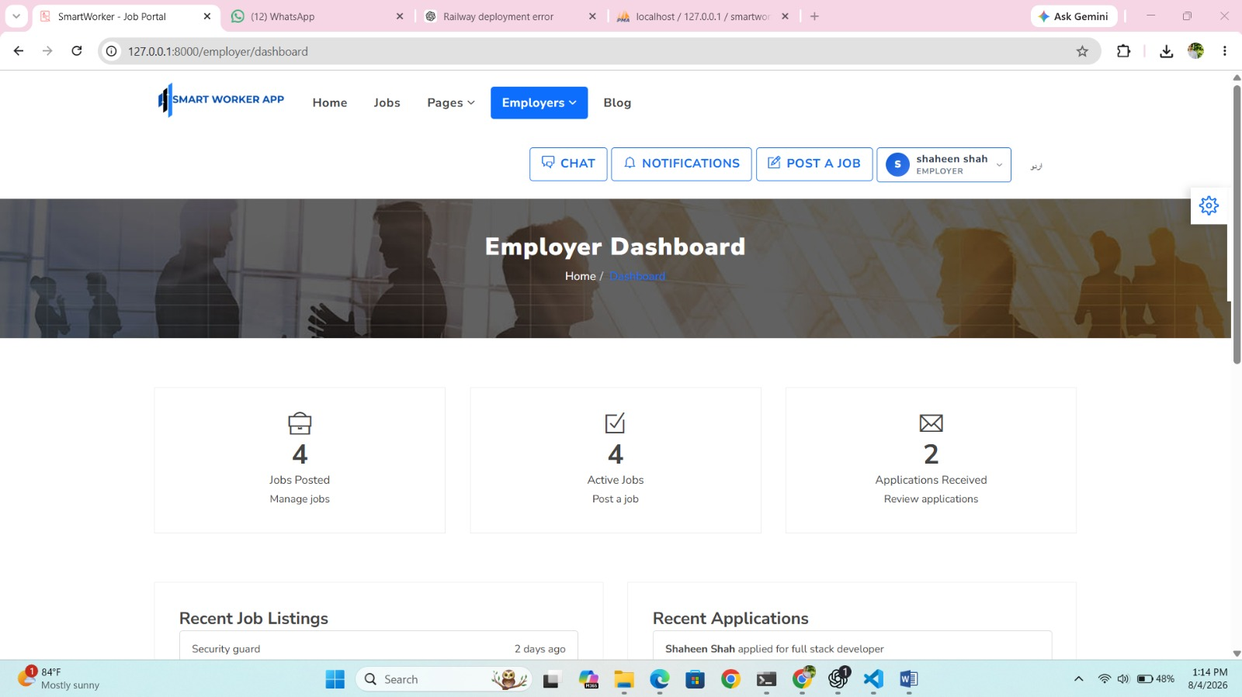
Figure 13: Employer Dashboard

Post a Job Form
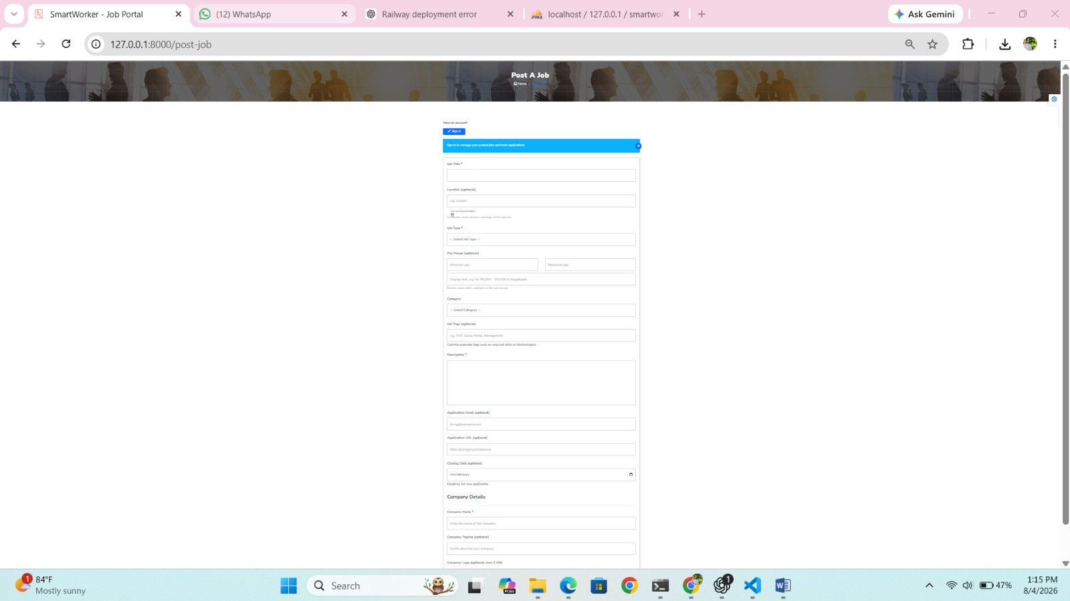
Figure 14: Post a Job Form

Candidate Application History
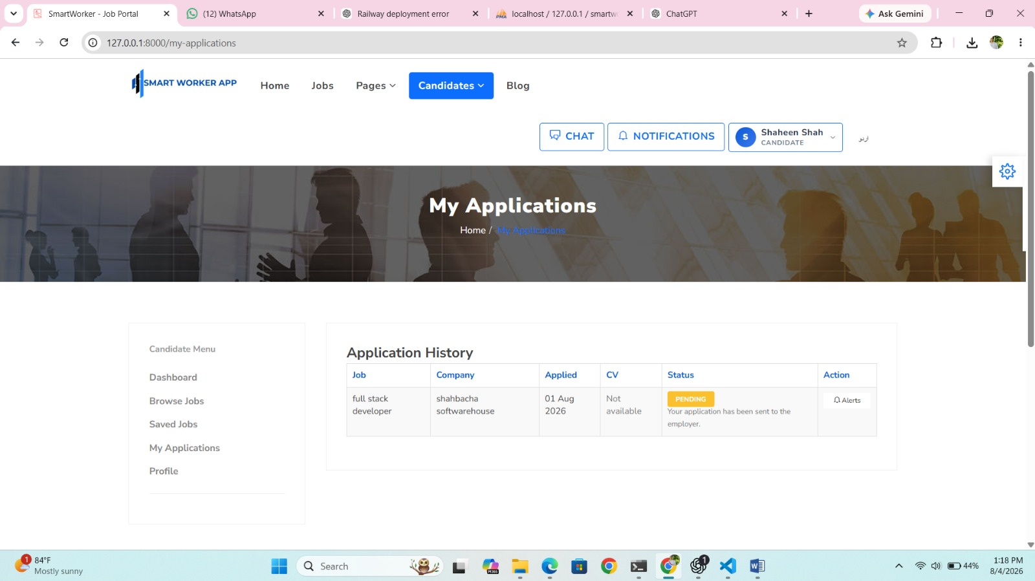
Figure 15: Candidate Application History

Candidate Profile Update
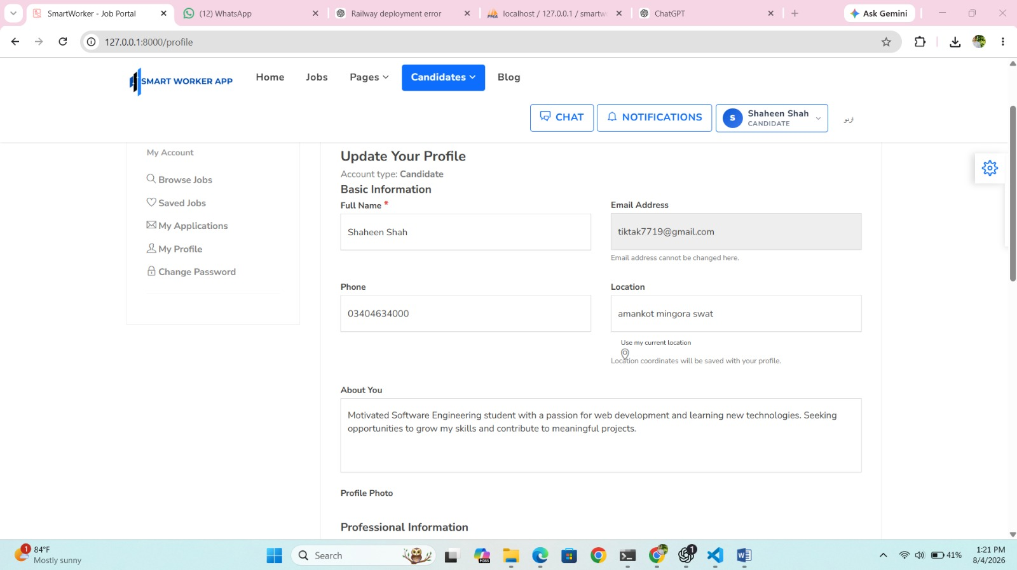
Figure 16: Candidate Profile Update

Employer Company Profile Update
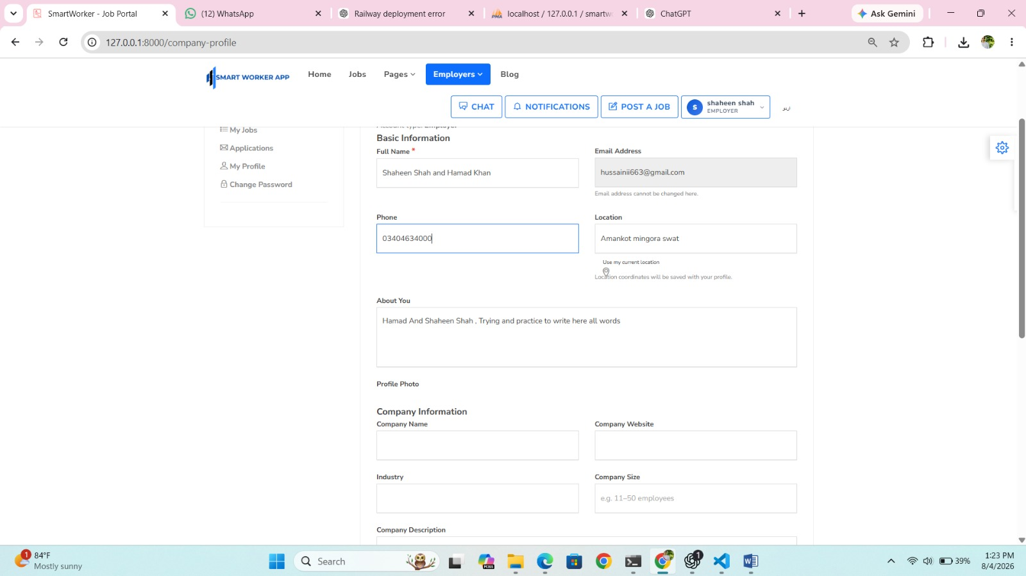
Figure 17: Employer Company Profile Update

