* This is the function (line no. 76 – 101) which is used to log information to Application Insight. It uses a key called “APPINSIGHTS_INSTRUMENTATION_KEY” to authenticate which is stored in the .env file.

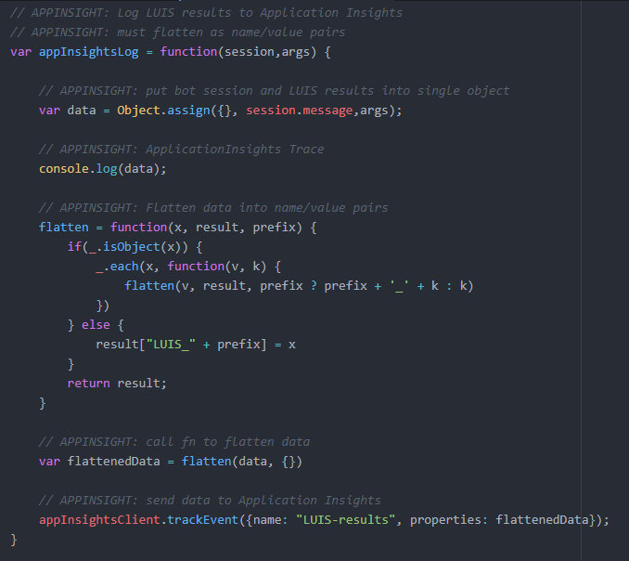

* These methods are used to call the LUIS intents. In every such method, ‘**appInsightsLos()**’ is used inorder to log the data to application insights.

