# Deployment steps to deploy ProcessOEEData project:

1. Unzip the Source code file
2. Open ProcessOEEData.sln file in Visual Studio 2017
3. Open appsettings.json file and change the value of BlobConnectionString and ContainerName keys.
4. Build the Source code.
5. Right click on Project Name and click on Publish.

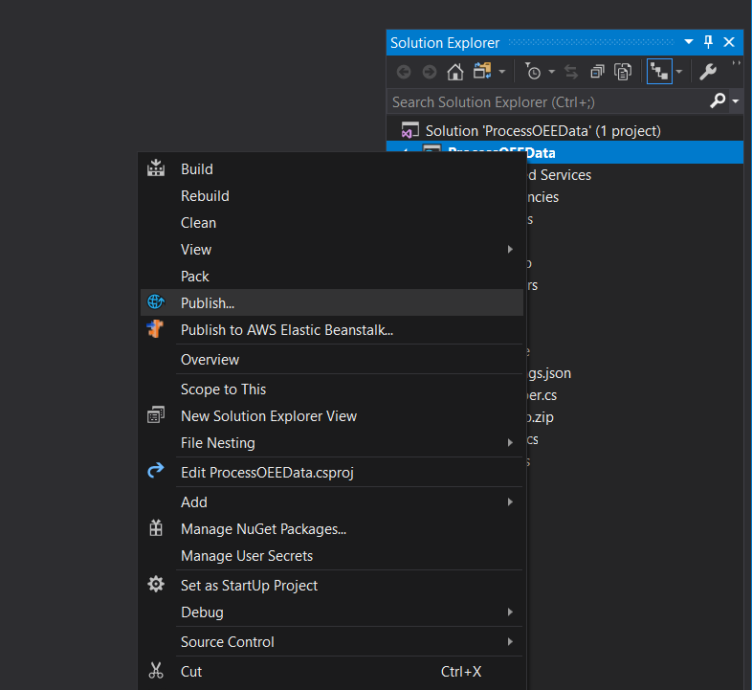

1. Click on New Profile...

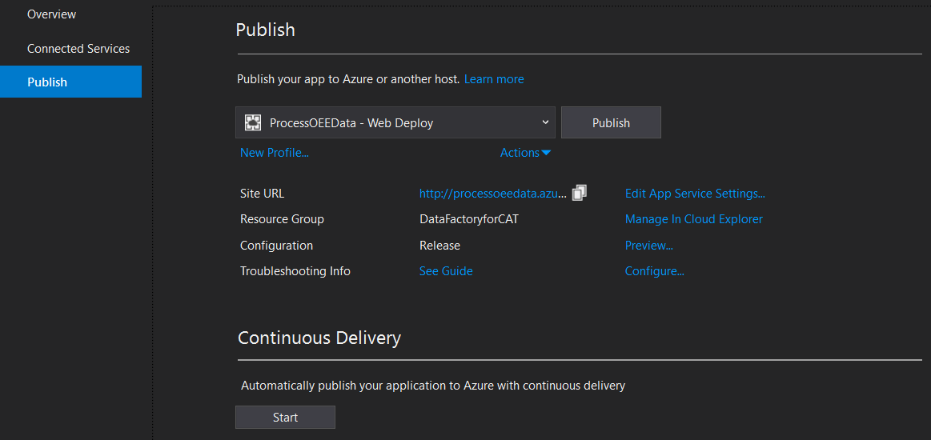

1. Select “App Service”. If Azure App service is not created then select “Create New” and click on Create Profile button.

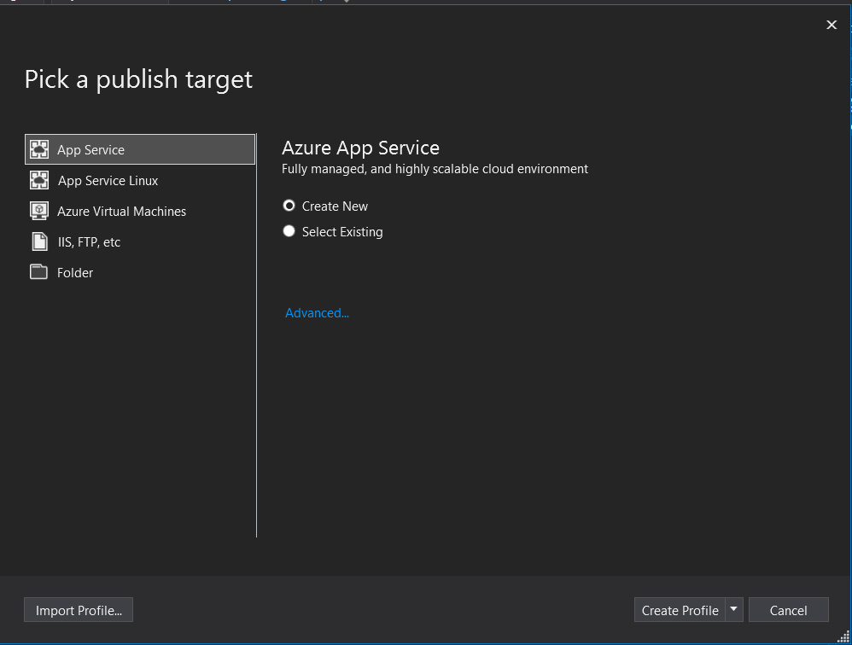

1. Select tenant from top right list. Specify App Name, select subscription and resource group and Hosting plan. We can create new resource group and Hosting Plan.

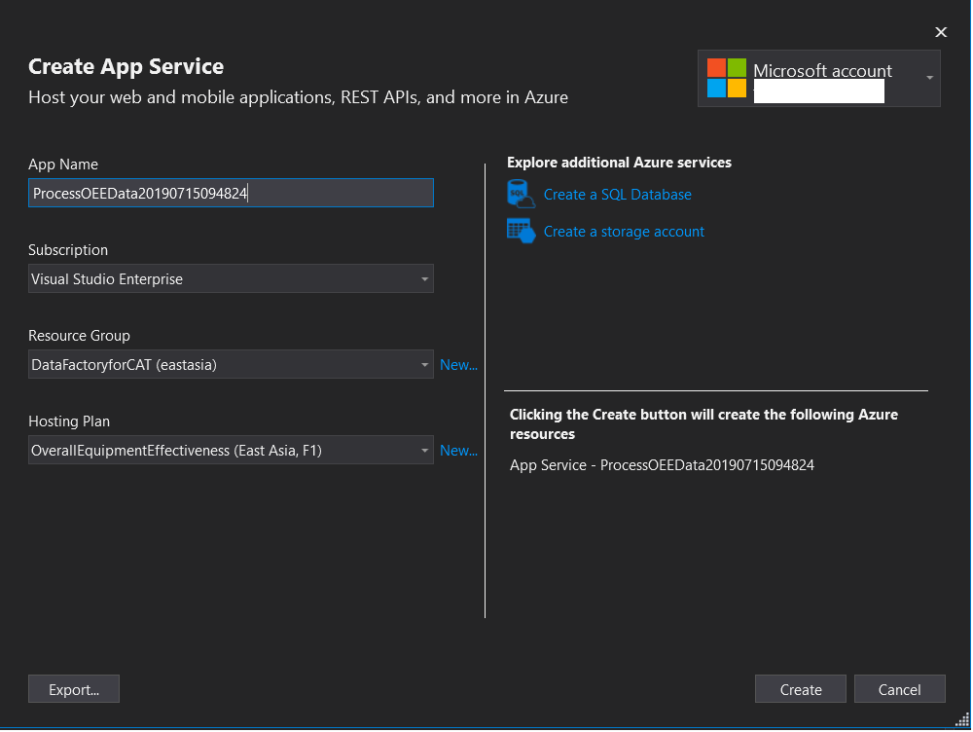

1. Click on Create button. It will create the App Name and deploy code to it. Once code is deploy, it will open the WebApp in the default browser.
2. Once code is deploy, go to App service and select the App which you have created.

# Deployment steps to deploy ProcessOEEData project using FTP:

1. Create Azure App service. Click on App Services and then click on Add button. You will see below screen:

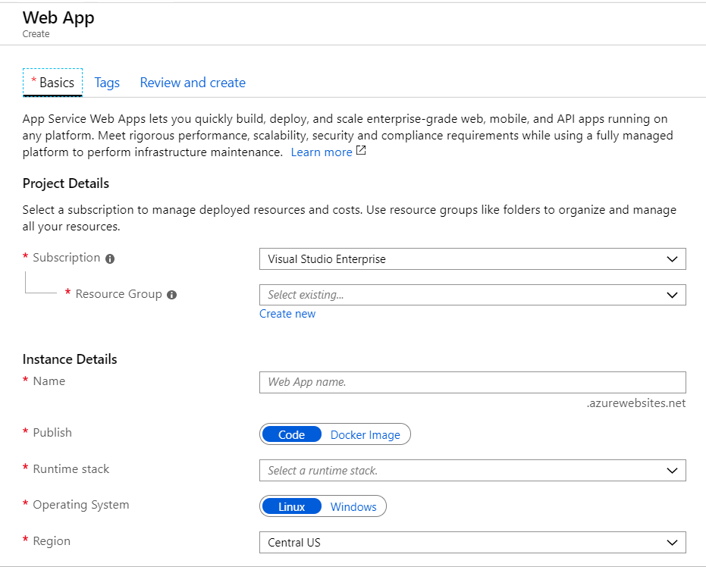

1. Select the subscription, resource group
2. Specify name of the service
3. Select “.Net Core 2.1” under Runtime stack
4. Select “Operating System” as Windows
5. Select appropriate region
6. Create new App Service plan. Click on “Create new” link.8.

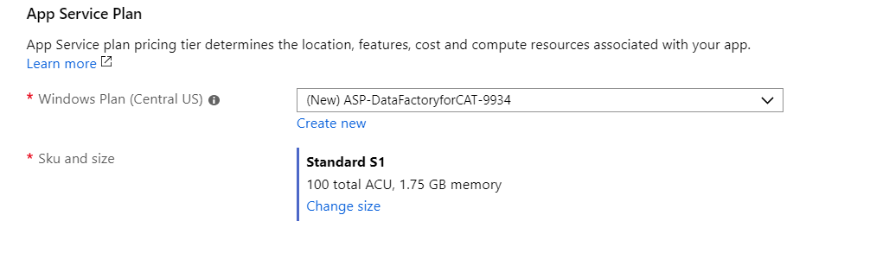

1. Specify name of the plan. 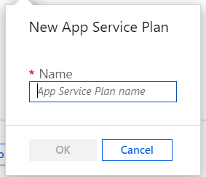
2. Click on Review and Create button.
3. Once an App service is created, go to “Deployment Center” and click on FTP. Please refer below screen shot:

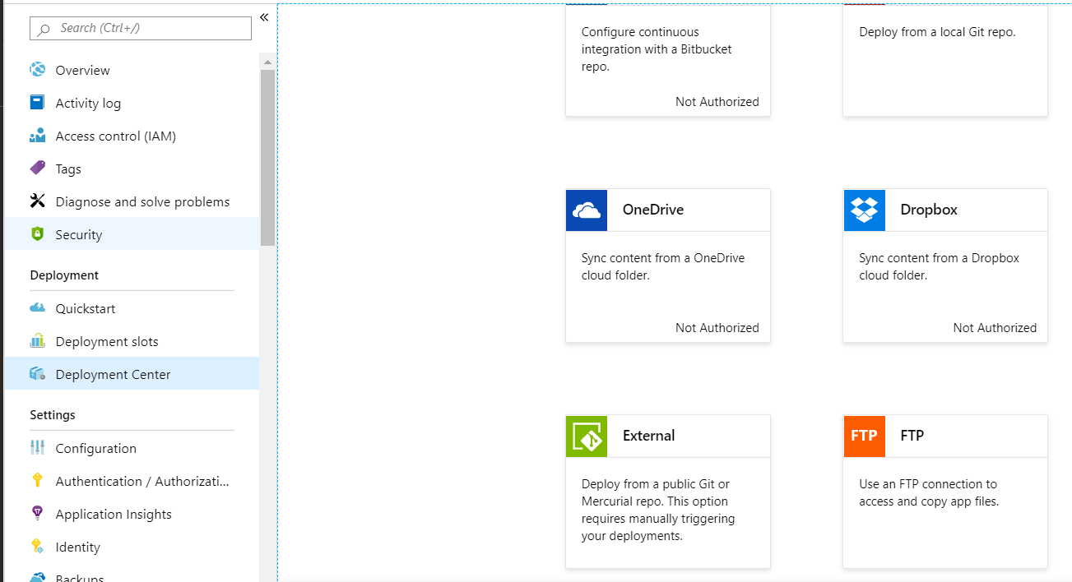

1. Copy FTP endpoint and credentials. Please refer below screen shot:

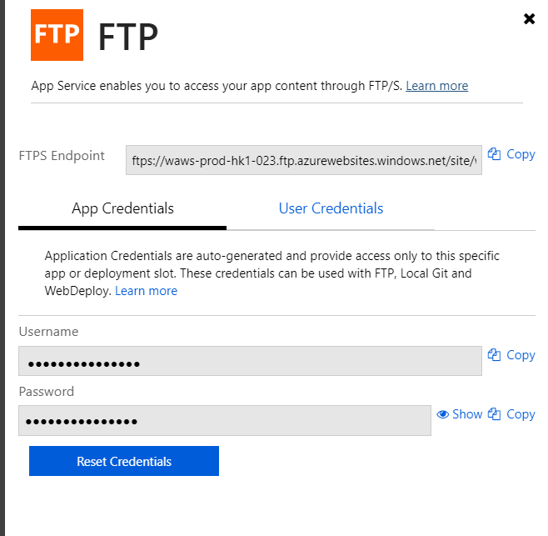

1. Connect to FTP from any FTP client using above credentials
2. Open the deployment folder share.
3. Open appsettings.json file and change the value of BlobConnectionString and ContainerName keys.
4. Upload all files of deployment folder to FTP.