Assignment 2: Natural-Language Video Retrieval Using MSR-VTT
Text-to-Video Retrieval Using Semantic and Temporal Video Representations
Course: Multimodal Information Retrieval · Environment: BITS Virtual Lab
Group No. | Member Name | BITS ID | Contribution
10 | BALA GANGADHARA TILAK | 2025AE05975 | System design, data pipeline, CLIP features, FAISS retrieval, lab execution
10 | OM PRAKASH UNIYAL | 2025AE05324 | Temporal models (pooling, Transformer, LSTM) and research ablation study
10 | KIRAN P | 2025AE05409 | Evaluation metrics, significance tests and results analysis
10 | GAURISHA MATHUR | 2025AE05642 | Streamlit dashboard and query edge-case handling
10 | KARAN RUPANI | 2025AE05813 | Experiments write-up and technical report

Results generated: 2026-11-06 22:22:00 · backbone: openai/clip-vit-base-patch32 · 16 frames/clip · device: cpu

Executive summary
We built an end-to-end text-to-video retrieval system over a 100-clip MSR-VTT index (5 clips × 20 categories) queried by 200 natural-language captions (a 200 × 100 search matrix), with a Streamlit dashboard for arbitrary queries, playable Top-K results and live evaluation. Frames are encoded with a frozen CLIP ViT and mapped, together with the text query, into CLIP's shared 512-d embedding space. With mean-pooled frame embeddings the system reaches R@1 = 57.5%, R@5 = 84.5%, R@10 = 88.5%, MRR = 0.702 and a median rank of 1.
Research Investigation 1 – answer: No temporal model significantly outperforms mean pooling after correction for multiple comparisons. Mean pooling of CLIP frame embeddings is sufficient for this text-to-video retrieval setting: MSR-VTT captions are dominated by static appearance cues (objects, scenes, people) that are already captured by averaging frames.

1. Dataset and evaluation protocol
Item | Value
Source | MSR-VTT (Xu et al., CVPR 2016) – Hugging Face mirror friedrichor/MSR-VTT
Index size N | 100 clips = 5 clips × 20 categories, drawn from the 1k-A test split
Query set Q | 200 queries = 2 human captions per clip (the official 1k-A caption + one randomly chosen other caption)
Search corpus matrix | 200 × 100
Training pool (learned heads only) | 500 clips from the 9k train split, all 20 captions; disjoint from the index (asserted in code)
Sampling | stratified by category, fixed seed 42; undecodable clips are skipped and replaced
Content filter | clips whose captions use sexual/explicit wording are excluded from index and training pool (34 candidate clips skipped)
Relevance | T2V: the clip a caption describes (1 relevant / query). V2T: the 2 captions of a clip

Categories (5 clips each): music, people, gaming, sports/actions, news/events/politics, education, tv shows, movie/comedy, animation, vehicles/autos, howto, travel, science/technology, animals/pets, kids/family, documentary, food/drink, cooking, beauty/fashion, advertisement

2. System architecture
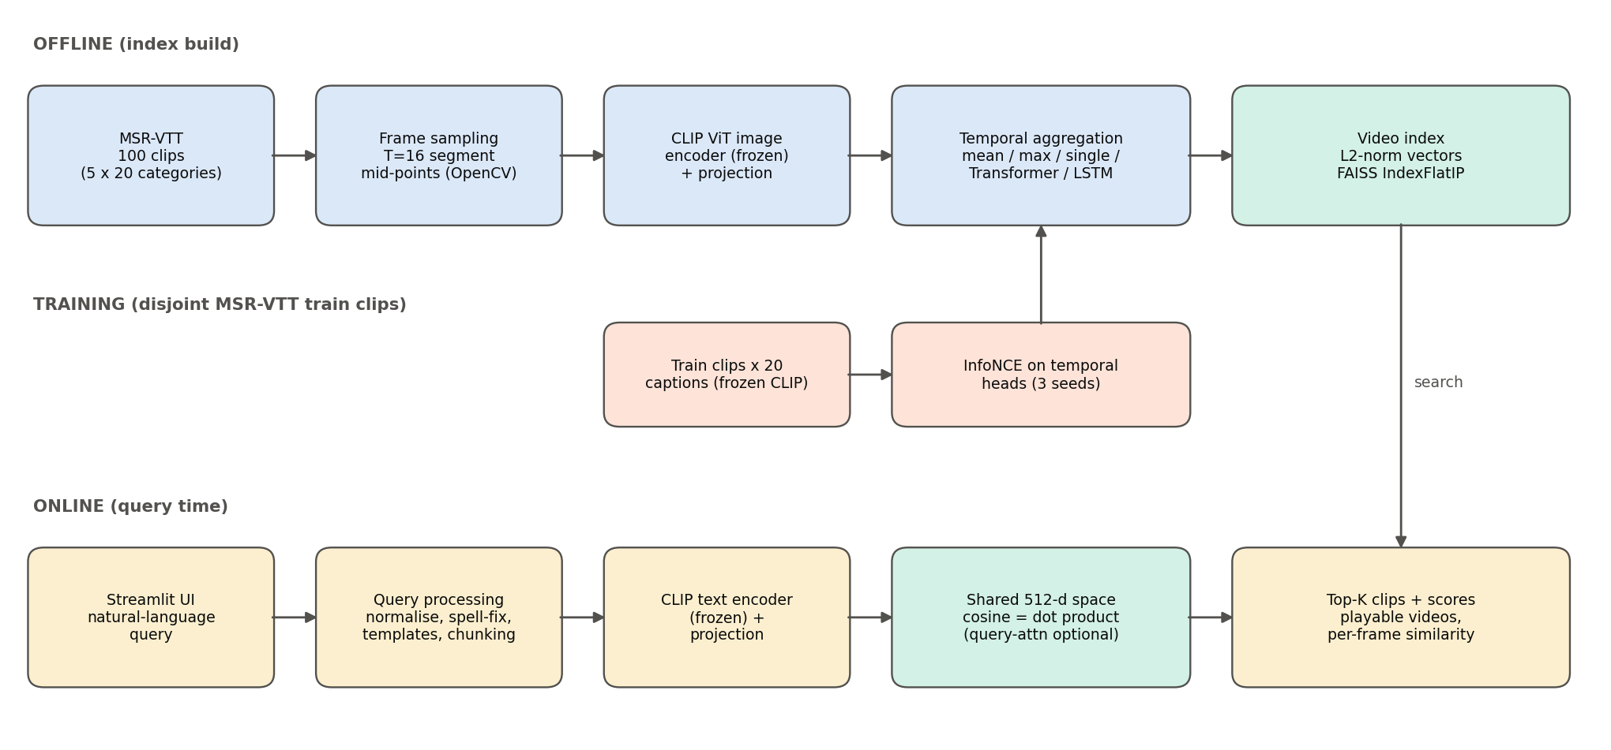
Figure 1 – Offline indexing, training and online query pipelines.
Module (file) | Responsibility
mvr/data.py | Download annotations/videos, stratified 5×20 sampling, OpenCV frame decoding (TSN segment mid-points), thumbnails
mvr/encoders.py | CLIP image/text encoders (frozen) → shared 512-d space; CLIP pre-processing; optional X-CLIP
mvr/temporal.py | Mean/max/single/query-attentive pooling; learned temporal heads (MLP, Set-TFM, Temporal-TFM, LSTM) + InfoNCE training
mvr/index.py | FAISS IndexFlatIP per representation (cosine via inner product of unit vectors) + frame-level matrix
mvr/query.py | Query normalisation, unknown-word detection, spelling correction, prompt templates, long-query chunking
mvr/metrics.py | R@K, MRR, mAP, nDCG@10, MdR, MnR; paired bootstrap, Wilcoxon, Holm correction
mvr/pipeline.py | Orchestration with on-disk caching; evaluation & research experiments
app.py | Streamlit dashboard (pipeline runner, search, V2T, evaluation, research, dataset, report)

3. Data ingestion and feature engineering
- Frame sampling: each clip is split into T = 16 equal temporal segments and the middle frame of each segment is decoded (TSN-style uniform coverage of the whole clip). Frames are read sequentially with grab/retrieve for frame-accurate sampling; a full-decode fallback handles wrong frame-count metadata.
- Pre-processing: RGB conversion, bicubic resize of the short side to the model resolution, centre crop, normalisation with CLIP's channel mean/std.
- Visual features: frozen CLIP ViT image tower + visual projection (openai/clip-vit-base-patch32), producing one L2-normalised 512-d embedding per frame (fp16 on GPU).
- Indexing: video-level vectors for every representation are stored in FAISS IndexFlatIP (exact inner-product search = cosine similarity on unit vectors); the (N × T × D) frame tensor is kept for query-conditioned pooling and per-frame similarity visualisation. Everything is cached to .npy/.faiss files.
- Cost: decode 52 ms/clip, CLIP encode 5733 ms/clip, index build 5659.9 ms (faiss.IndexFlatIP).

4. Cross-modal embedding and retrieval engine
Queries are encoded by CLIP's text Transformer and text projection into the same 512-d space as the frames (CLIP was contrastively trained so that matching image/text pairs have high cosine similarity). Score(q, v) = cos(e_q, e_v) = e_q · e_v for unit vectors; the Top-K clips are returned with their scores. For query-attentive pooling, Score = Σ_t softmax_t(s_t/τ)·s_t with s_t = e_q · f_t (τ = 0.05 chosen on the training pool, never on the test queries).

Representations compared
Representation | Description | Order-aware | Trained
Single middle frame | No temporal information (lower bound). | no | no
Mean pooling (baseline) | Average of L2-normalised CLIP frame embeddings - order-agnostic. | no | no
Max pooling | Element-wise max over frame embeddings - order-agnostic. | no | no
Query-attentive pooling | Text-conditioned softmax over per-frame similarities (parameter-free, order-agnostic). | no | no
MLP adapter (control) | Trained residual MLP on the mean-pooled vector; same data/loss as the temporal models but NO inter-frame modelling. | no | yes
Set Transformer (no positions) | Trained self-attention across frames WITHOUT positional embeddings - models frame interactions but not order. | no | yes
Temporal Transformer (+positions) | Trained self-attention across frames WITH learned temporal position embeddings (CLIP4Clip seqTransf-style) - explicit temporal order. | yes | yes
Temporal LSTM | Trained uni-directional LSTM over the ordered frame sequence (CLIP4Clip seqLSTM-style). | yes | yes
X-CLIP (pretrained video model) | Off-the-shelf spatio-temporal video-language model (cross-frame attention + multi-frame integration transformer). | yes | pre-trained

Edge-case handling
Edge case | Handling in the engine
Empty / punctuation-only query | Rejected with a helpful message (no meaningless search)
Unicode noise, URLs, extra spaces | NFKC normalisation, control-char removal, whitespace collapse
Unknown / misspelled vocabulary | Words not in CLIP's BPE vocabulary or the MSR-VTT training lexicon are flagged; frequency-ranked edit-distance (≤2) correction; BPE sub-words as fallback
Very short queries (≤2 content words) | Prompt-template ensemble: 'a video of {q}.', 'a video showing {q}.', '{q}'
Long / detailed queries (>77 tokens) | Sentence/clause-aware chunking, chunk embeddings averaged (no silent truncation)
Non-English text | Detected and flagged (CLIP text encoder is English-only)
No good match in the collection | Low-confidence warning when the top score is below the 5th percentile of correct-match scores

Effect of the edge-case handling (mean-pool index, all 200 queries perturbed):
Query condition | Handling | R@1 | R@5 | MRR | MdR
Original captions | none | 57.5 | 84.5 | 0.702 | 1
Short (2 content words) | raw | 17.5 | 45.0 | 0.310 | 7
Short (2 content words) | prompt-template ensemble | 20.5 | 46.0 | 0.332 | 7
Typo-corrupted | raw | 46.5 | 70.5 | 0.575 | 2
Typo-corrupted | spelling correction | 52.0 | 81.5 | 0.656 | 1
Detailed (multi-sentence) | truncate at 77 tokens | 84.0 | 97.5 | 0.904 | 1
Detailed (multi-sentence) | chunk + average | 86.5 | 98.0 | 0.920 | 1

5. Streamlit interactive dashboard
- Pipeline Runner – every step (download, frame extraction, CLIP encoding, training, indexing, X-CLIP, evaluation) is launched from buttons with live progress; no manual script execution is required.
- Text → Video Search – free-text query, choice of representation, Top-K slider; results show playable clips, cosine scores, category, per-frame similarity profile, captions, query-processing diagnostics and latency.
- Video → Text – the reverse modality: pick a clip, retrieve its Top-K captions with relevance marks.
- Evaluation – metric tables (T2V and V2T), interactive charts, frame sweep, per-category heat-map, robustness and efficiency.
- Research Investigation – ablation ladder, significance tests, order ablation and conclusions.
- Dataset Browser and Report pages (this document is generated from the Report page).

6. Quantitative performance evaluation
Table 1 – Text→Video retrieval (200 queries × 100 clips). Learned heads: mean ± sd over 3 seeds. With one relevant clip per query mAP equals MRR.
Method | R@1 | R@5 | R@10 | MRR | mAP | nDCG@10 | MdR | MnR
Single middle frame | 50.0 | 71.5 | 79.0 | 0.606 | 0.606 | 0.643 | 1.5 | 8.7
Mean pooling (baseline) | 57.5 | 84.5 | 88.5 | 0.702 | 0.702 | 0.744 | 1.0 | 5.7
Max pooling | 41.0 | 66.5 | 77.5 | 0.530 | 0.530 | 0.580 | 2.0 | 8.6
Query-attentive pooling | 59.0 | 86.0 | 92.0 | 0.713 | 0.713 | 0.761 | 1.0 | 4.4
MLP adapter (control) | 59.2±2.1 | 88.5±0.8 | 93.8±0.6 | 0.724±0.011 | 0.724±0.011 | 0.775±0.010 | 1.0 | 3.7±0.2
Set Transformer (no positions) | 59.2±2.0 | 84.7±0.8 | 92.0±1.8 | 0.709±0.008 | 0.709±0.008 | 0.757±0.008 | 1.0 | 4.2±0.2
Temporal Transformer (+positions) | 57.8±0.8 | 85.0±1.5 | 90.7±0.2 | 0.703±0.008 | 0.703±0.008 | 0.749±0.006 | 1.0 | 4.4±0.2
Temporal LSTM | 59.0±1.8 | 87.5±1.4 | 94.5±0.8 | 0.723±0.010 | 0.723±0.010 | 0.775±0.010 | 1.0 | 3.6±0.1
X-CLIP (pretrained video model) | 3.5 | 14.5 | 24.5 | 0.116 | 0.116 | 0.124 | 21.0 | 32.4

Table 2 – Video→Text retrieval (100 clips × 200 captions; 2 relevant captions per clip).
Method | R@1 | R@5 | R@10 | MRR | mAP | nDCG@10 | MdR | MnR
Single middle frame | 46.0 | 82.0 | 89.0 | 0.622 | 0.512 | 0.593 | 2.0 | 5.6
Mean pooling (baseline) | 64.0 | 89.0 | 98.0 | 0.752 | 0.636 | 0.720 | 1.0 | 2.4
Max pooling | 44.0 | 80.0 | 89.0 | 0.599 | 0.474 | 0.560 | 2.0 | 4.5
Query-attentive pooling | 65.0 | 92.0 | 98.0 | 0.766 | 0.664 | 0.740 | 1.0 | 2.2
MLP adapter (control) | 68.7±2.1 | 95.3±0.5 | 98.0±0.8 | 0.796±0.009 | 0.681±0.005 | 0.759±0.004 | 1.0 | 2.0±0.0
Set Transformer (no positions) | 66.0±3.6 | 94.0±1.4 | 97.7±1.2 | 0.775±0.022 | 0.654±0.027 | 0.733±0.024 | 1.0 | 2.1±0.2
Temporal Transformer (+positions) | 69.7±0.5 | 93.0±1.6 | 98.3±0.9 | 0.793±0.006 | 0.672±0.019 | 0.751±0.018 | 1.0 | 2.0±0.1
Temporal LSTM | 66.3±2.1 | 94.7±0.9 | 98.3±0.5 | 0.778±0.010 | 0.670±0.009 | 0.751±0.009 | 1.0 | 2.0±0.1
X-CLIP (pretrained video model) | 55.0 | 83.0 | 90.0 | 0.675 | 0.525 | 0.604 | 1.0 | 5.3

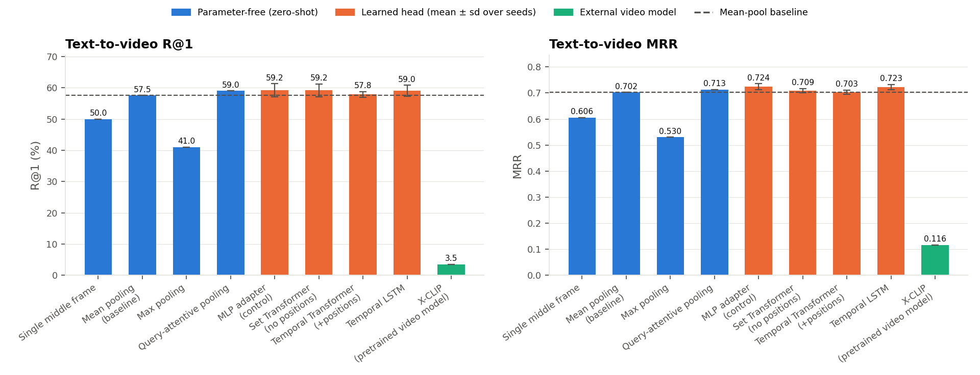
Figure 2 – T2V R@1 and MRR per representation (error bars: sd over seeds; dashed: mean-pool baseline).

7. Research Investigation 1: is mean pooling sufficient?

7.1 Experimental design
To separate the effect of temporal modelling from confounds we use an ablation ladder in which each step adds exactly one capability on top of the same frozen CLIP frame features: (0) a single frame; (1) mean pooling; (1b) zero-shot max and query-attentive pooling; (2) an MLP adapter trained on in-domain data but with no frame interaction (control for domain adaptation); (3) a Set Transformer with frame–frame attention but no positional information (control for interaction without order); (4) a Temporal Transformer with learned temporal position embeddings and (4b) an LSTM – both explicitly model order. All learned heads are zero-initialised residuals of mean pooling, use the same data, loss (symmetric InfoNCE), optimiser (AdamW, one-cycle), temporal sub-sampling augmentation and early stopping on held-out training clips, and are run with multiple seeds. We additionally (i) shuffle/reverse frame order at test time, (ii) vary the number of frames, (iii) split queries by temporal language, and (iv) compare against X-CLIP, a natively spatio-temporal video-language model, when available.

7.2 Statistical tests
Query-level paired bootstrap (10,000 resamples) 95% confidence intervals on ΔMRR and ΔR@K, Wilcoxon signed-rank tests on per-query reciprocal ranks, Holm–Bonferroni correction across comparisons.
Comparison (A vs B) | ΔMRR | 95% CI | ΔR@1 | ΔR@5 | p (Wilcoxon) | p (Holm) | A better/worse/tie
Single middle frame vs Mean pooling (baseline) | -0.096 | [-0.147, -0.046] | -7.5 | -13.0 | 0.000512 | 0.00512 | 37/73/90
Max pooling vs Mean pooling (baseline) | -0.172 | [-0.230, -0.116] | -16.5 | -18.0 | 3.21e-08 | 3.53e-07 | 32/93/75
Query-attentive pooling vs Mean pooling (baseline) | +0.011 | [-0.019, +0.041] | +1.5 | +1.5 | 0.0809 | 0.679 | 45/27/128
MLP adapter (control) vs Mean pooling (baseline) | +0.022 | [-0.007, +0.052] | +1.7 | +4.0 | 0.35 | 1 | 54/46/100
Set Transformer (no positions) vs Mean pooling (baseline) | +0.007 | [-0.020, +0.034] | +1.7 | +0.2 | 0.933 | 1 | 55/56/89
Temporal Transformer (+positions) vs Mean pooling (baseline) | +0.001 | [-0.022, +0.023] | +0.3 | +0.5 | 0.748 | 1 | 54/49/97
Temporal LSTM vs Mean pooling (baseline) | +0.020 | [-0.009, +0.050] | +1.5 | +3.0 | 0.182 | 1 | 54/40/106
X-CLIP (pretrained video model) vs Mean pooling (baseline) | -0.586 | [-0.641, -0.530] | -54.0 | -70.0 | 3.4e-31 | 4.08e-30 | 12/181/7
Temporal Transformer (+positions) vs Set Transformer (no positions) | -0.007 | [-0.023, +0.010] | -1.3 | +0.3 | 0.195 | 1 | 46/61/93
Set Transformer (no positions) vs MLP adapter (control) | -0.015 | [-0.036, +0.005] | -0.0 | -3.8 | 0.217 | 1 | 48/60/92
Temporal Transformer (+positions) vs MLP adapter (control) | -0.021 | [-0.047, +0.004] | -1.3 | -3.5 | 0.0754 | 0.679 | 41/60/99
Temporal LSTM vs MLP adapter (control) | -0.002 | [-0.019, +0.015] | -0.2 | -1.0 | 0.974 | 1 | 43/42/115

7.3 Temporal-order ablation and frame count
Method | MRR original | MRR shuffled | MRR reversed | R@1 original | R@1 shuffled
Mean pooling (baseline) | 0.702 | 0.702 | 0.702 | 57.5 | 57.5
Max pooling | 0.530 | 0.530 | 0.530 | 41.0 | 41.0
Query-attentive pooling | 0.713 | 0.713 | 0.713 | 59.0 | 59.0
MLP adapter (control) | 0.724 | 0.724 | 0.724 | 59.2 | 59.2
Set Transformer (no positions) | 0.709 | 0.709 | 0.709 | 59.2 | 59.2
Temporal Transformer (+positions) | 0.703 | 0.702 | 0.703 | 57.8 | 57.7
Temporal LSTM | 0.723 | 0.722 | 0.717 | 59.0 | 59.2

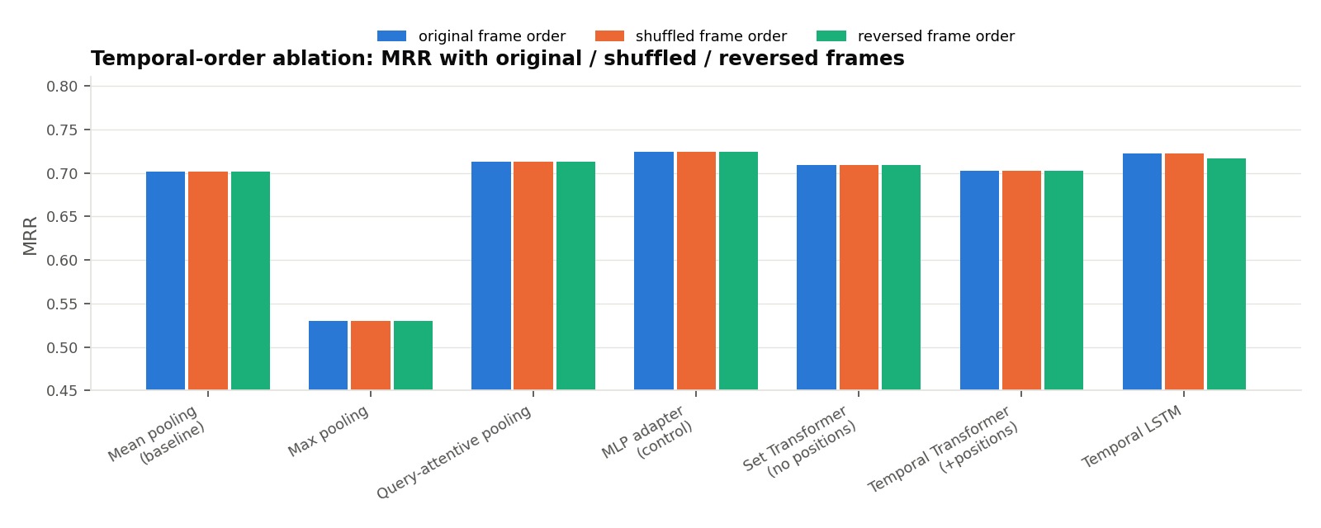
Figure 3 – MRR when the frame order is shuffled or reversed at test time.
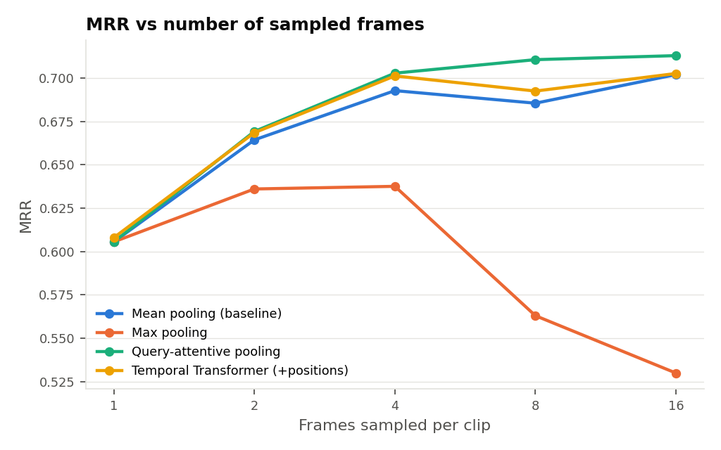
Figure 4 – MRR as a function of the number of sampled frames.
Queries containing explicit temporal language (13 of 200, e.g. 'then', 'after', 'starts'):
Method | MRR – temporal-language queries | MRR – other queries
Single middle frame | 0.589 | 0.607
Mean pooling (baseline) | 0.691 | 0.703
Max pooling | 0.488 | 0.533
Query-attentive pooling | 0.690 | 0.715
MLP adapter (control) | 0.706 | 0.725
Set Transformer (no positions) | 0.708 | 0.709
Temporal Transformer (+positions) | 0.692 | 0.703
Temporal LSTM | 0.734 | 0.722
X-CLIP (pretrained video model) | 0.072 | 0.119

Positive control – synthetic clips 'state A then state B' vs 'B then A' whose captions encode the ordered pair (only temporal order separates them). This verifies that the set-up can detect a temporal benefit when it exists:
Method | MRR (order-only task)
Mean pooling (baseline) | 0.718
Max pooling | 0.620
MLP adapter (control) | 0.718
Set Transformer (no positions) | 0.718
Temporal Transformer (+positions) | 1.000
Temporal LSTM | 0.966

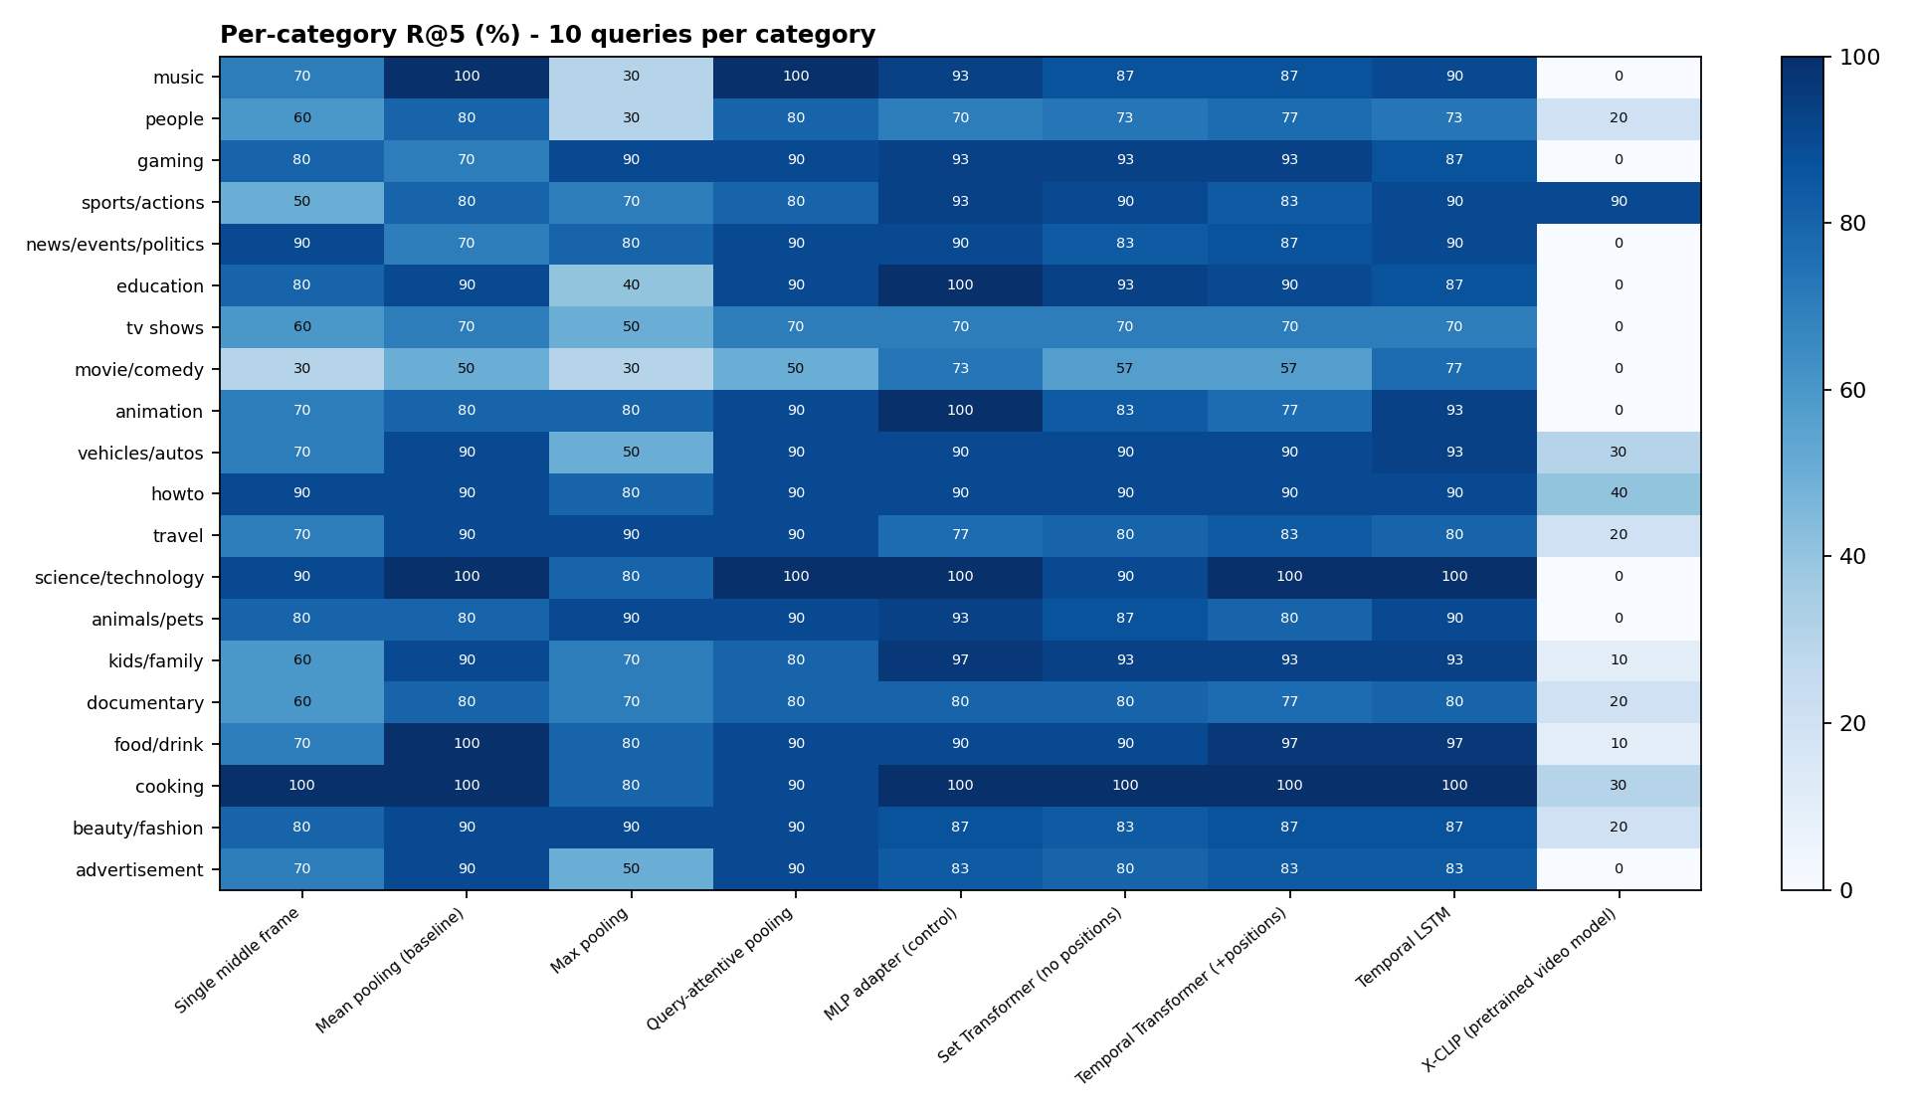
Figure 5 – Per-category R@5 (each cell = 10 queries).
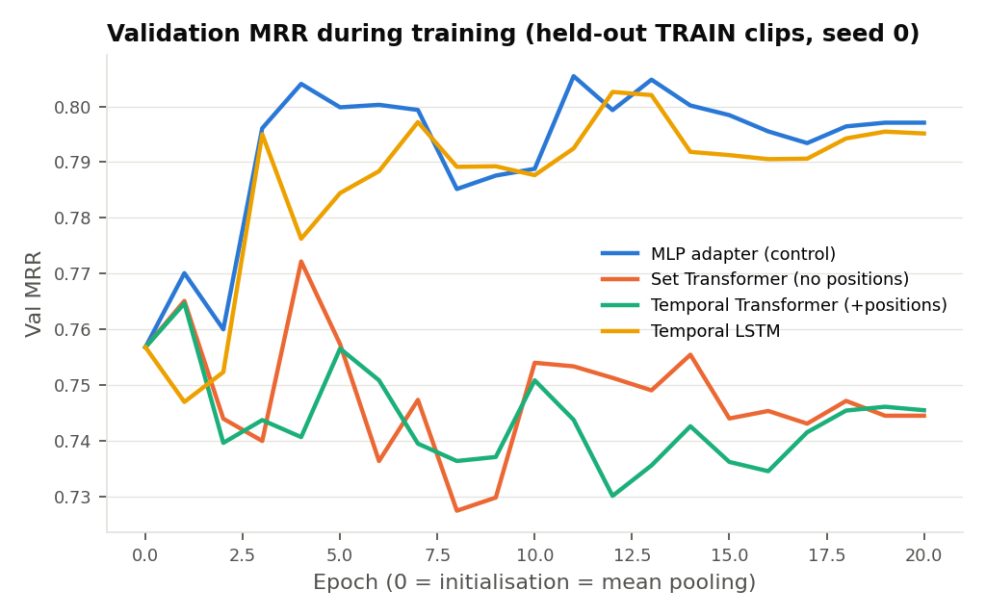
Figure 6 – Validation MRR during training; epoch 0 equals mean pooling.

7.4 Findings and conclusion
- Mean pooling reaches R@1=57.5% / MRR=0.702 vs. a single middle frame at R@1=50.0% / MRR=0.606 (+0.096 MRR), so aggregating evidence over the whole clip clearly helps.
- Among parameter-free (zero-shot) aggregators the best is Query-attentive pooling (MRR 0.713); difference vs. mean pooling: +0.011 (95% CI -0.019 to +0.041; Wilcoxon p=0.0809, Holm-adj. p=0.679).
- Mean pooling saturates quickly: with 4 frame(s) it already achieves >=98% of its best MRR (0.693 vs 0.702); adding more frames brings diminishing returns.
- Temporal Transformer (+positions) vs mean pooling: MRR 0.703 vs 0.702, R@1 57.8% vs 57.5%; delta MRR = +0.001 (95% CI -0.022 to +0.023; Wilcoxon p=0.748, Holm-adj. p=1).
- Decomposition of that difference: (i) domain adaptation alone (MLP adapter, no temporal mixing) changes MRR by +0.022; (ii) adding cross-frame self-attention without order (Set Transformer) adds -0.015; (iii) adding temporal ORDER (position embeddings) adds -0.007 [order effect: -0.007 (95% CI -0.023 to +0.010; Wilcoxon p=0.195, Holm-adj. p=1)].
- The order-aware LSTM obtains MRR 0.723 (R@1 59.0%), i.e. +0.020 vs mean pooling and -0.002 vs the MLP control.
- Shuffling the frame order at test time changes the Temporal Transformer's MRR from 0.703 to 0.702 (reversed: 0.703); order-agnostic methods are unaffected by construction (mean pooling: 0.702 -> 0.702). The small change shows the model barely relies on frame order for these queries.
- On the 13 queries with explicit temporal language (e.g. 'then', 'after', 'starts') the Temporal Transformer changes MRR by +0.001 vs mean pooling, against +0.001 on the remaining 187 queries.
- The off-the-shelf spatio-temporal model X-CLIP (fine-tuned on Kinetics-400 action labels) reaches only R@1=3.5% / MRR=0.116 (median rank 21) versus 57.5% / 0.702 for mean-pooled CLIP. Its text tower was adapted to ~400 short action-class names, so it does not transfer to free-form MSR-VTT captions: a model that natively encodes time is not automatically better - large-scale image-text alignment matters more than temporal architecture for this task.
- Positive control: on a synthetic task where only frame ORDER distinguishes clips, mean pooling scores MRR 0.718 and the order-free Set Transformer 0.718, while the Temporal Transformer reaches 1.000 and the LSTM 0.966. The temporal heads and the evaluation are therefore capable of detecting a temporal benefit when one exists; any lack of gain on MSR-VTT reflects the data, not the models.
- Caveat: with 200 queries a 1-query change is 0.5 R@1 points, so small differences fall inside the 95% bootstrap confidence intervals; conclusions are based on paired tests, not raw deltas.
Conclusion: No temporal model significantly outperforms mean pooling after correction for multiple comparisons. Mean pooling of CLIP frame embeddings is sufficient for this text-to-video retrieval setting: MSR-VTT captions are dominated by static appearance cues (objects, scenes, people) that are already captured by averaging frames.

7.5 Insights
- MSR-VTT captions mostly describe *what* is visible (people, objects, scenes, activities recognisable from single frames), so a frame-level image–text model already captures most of the retrievable signal; averaging frames adds robustness to unrepresentative frames.
- Gains from trained heads must be compared with an equally-trained, order-free control. Without the MLP adapter and Set-Transformer controls, domain-adaptation gains are easily misattributed to temporal modelling.
- Test-time frame shuffling is a cheap diagnostic of whether a 'temporal' model really uses order.
- Temporal modelling is most likely to matter for queries whose meaning depends on event order or motion direction (e.g. 'opens then closes', 'falls down'); such queries are rare in MSR-VTT, which limits the measurable benefit on this benchmark.

8. Efficiency
Method | Search latency (ms/query, top-10)
Single middle frame | 0.177
Mean pooling (baseline) | 0.152
Max pooling | 0.174
MLP adapter (control) | 0.206
Set Transformer (no positions) | 0.169
Temporal Transformer (+positions) | 0.174
Temporal LSTM | 0.211
Query-attentive pooling | 0.753

Query text encoding: 91.0 ms/query (batched) on cpu.

9. Limitations and future work
- 200 queries give wide confidence intervals (one query = 0.5 R@1 points); results are reported with CIs and paired tests.
- Learned heads are trained on a few hundred clips with a frozen backbone; end-to-end fine-tuning on the full 9k training split (as in CLIP4Clip) could change the picture.
- Audio and on-screen text (ASR/OCR) are not used although many MSR-VTT categories (music, news) rely on them.
- Future work: temporally-grounded benchmarks (e.g. order-sensitive caption sets), motion features (optical flow / VideoMAE), and hybrid scoring that adds temporal evidence only when the query contains temporal language.

10. Reproducibility
- pip install -r requirements.txt → streamlit run app.py → Pipeline Runner → 'Run full pipeline'.
- All randomness is seeded (sampling seed, training seeds); outputs are cached under artifacts/.
- Configuration used: {"clip_model": "openai/clip-vit-base-patch32", "num_frames": 16, "train_videos_per_category": 25, "epochs": 20, "train_seeds": [0, 1, 2], "seed": 42}

Appendix A – Execution evidence (BITS Virtual Lab)
All screenshots were captured from the BITS Virtual Lab session (window title “Lab – 13029 – s2025ae05975”) with the Streamlit app served at http://localhost:8501. The session token in the remote-desktop address bar has been redacted.

A.1 Dashboard overview
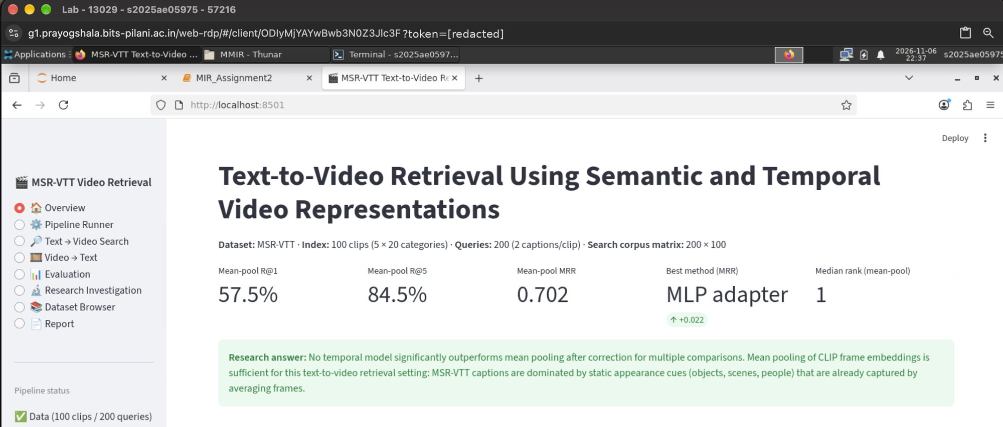
Figure A.1 – Overview page: headline metrics and the research answer.
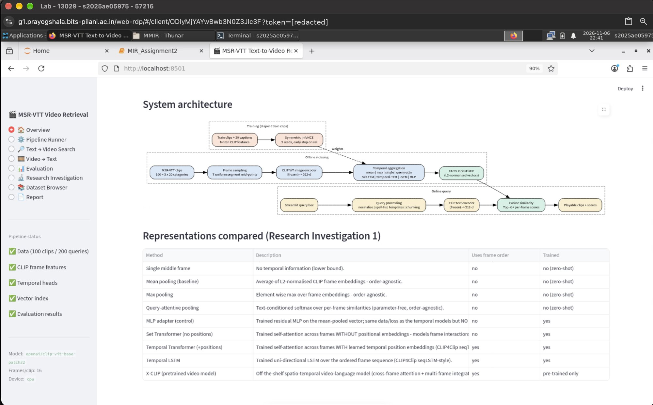
Figure A.2 – Overview page: system architecture and the representations compared.

A.2 Pipeline executed from the front-end
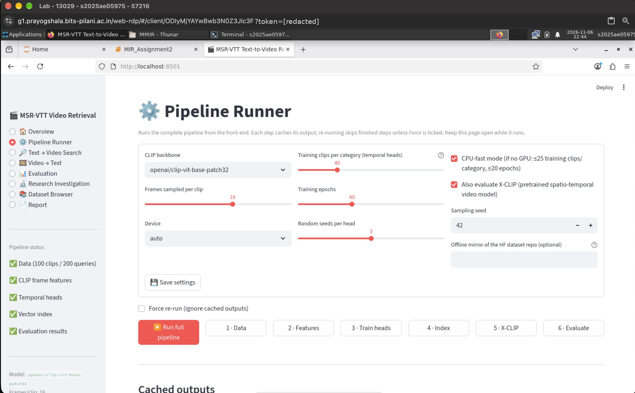
Figure A.3 – Pipeline Runner: configuration and step buttons.
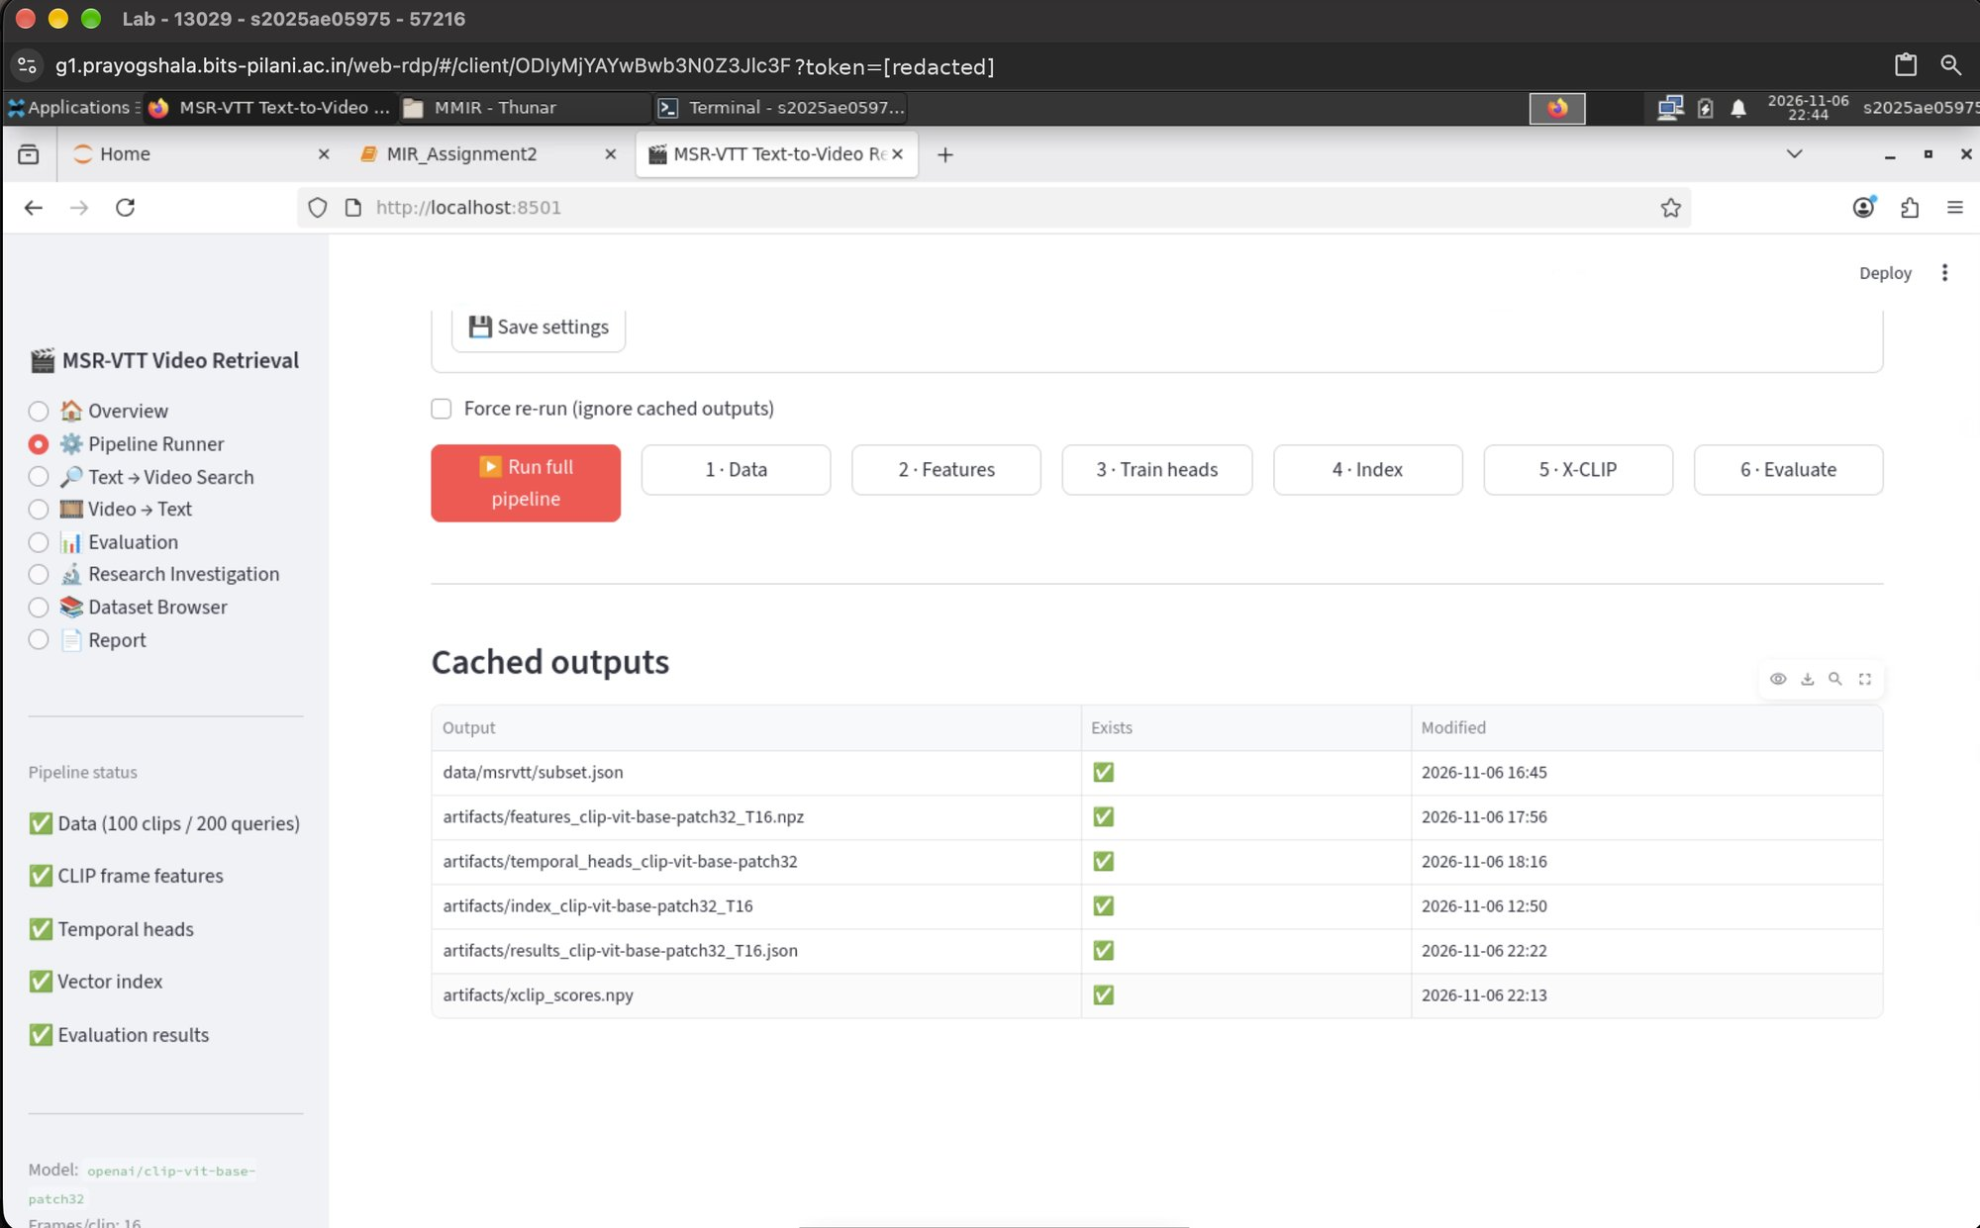
Figure A.4 – Pipeline Runner: all cached outputs present after the run.

A.3 Text → Video retrieval (Top-K playable clips with scores)
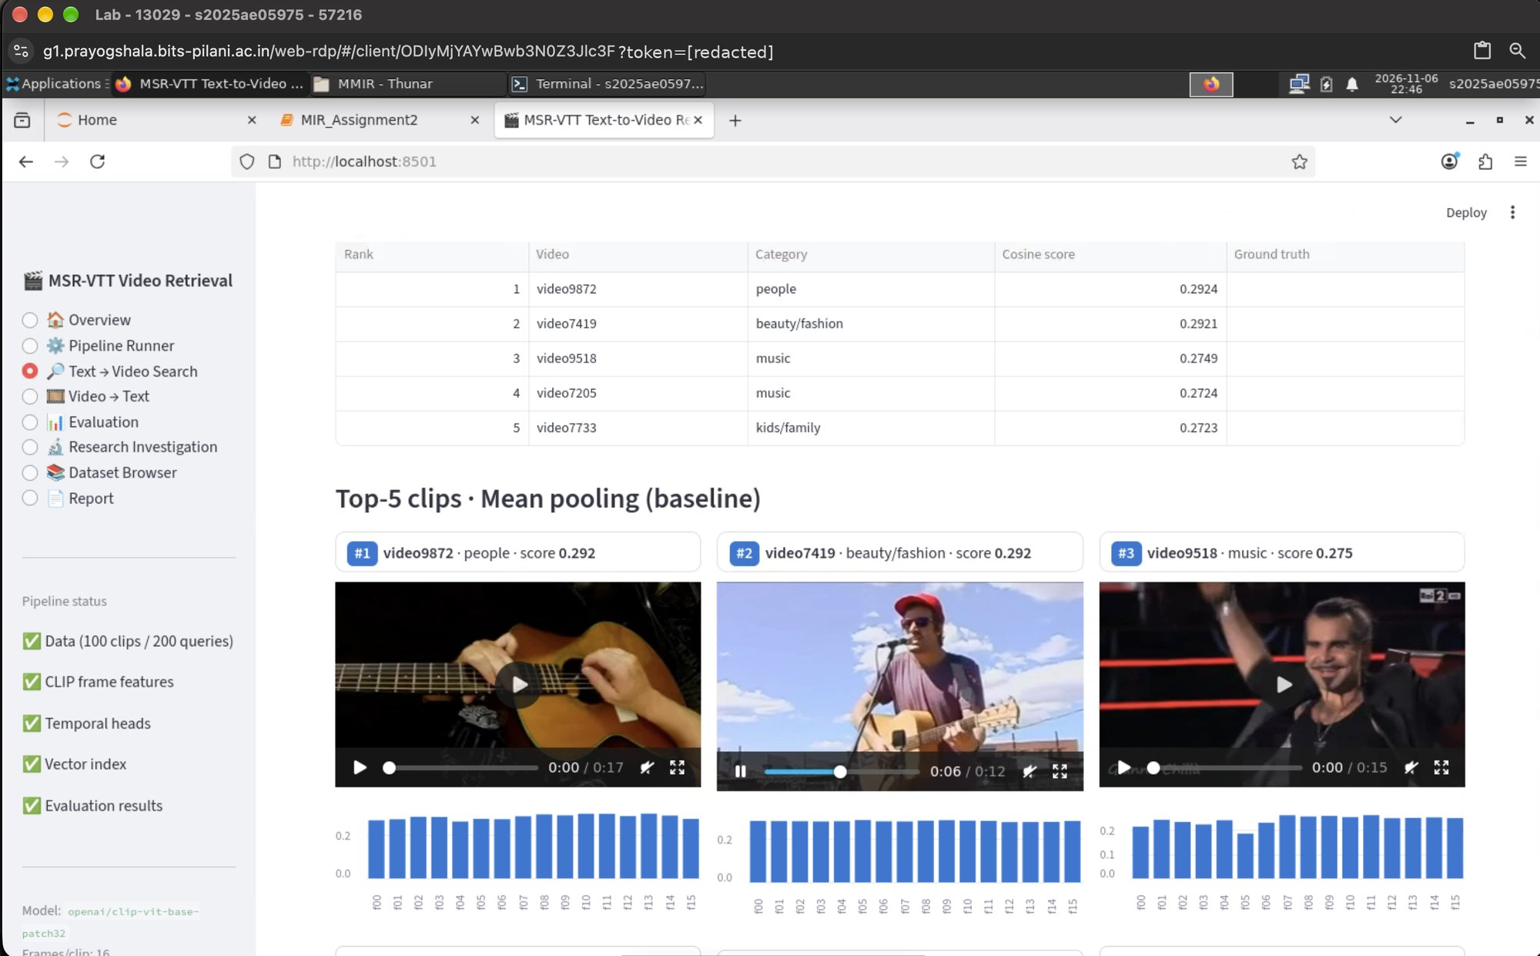
Figure A.5 – Query 'a person is playing guitar on a stage': Top-5 clips, cosine scores, per-frame similarity.
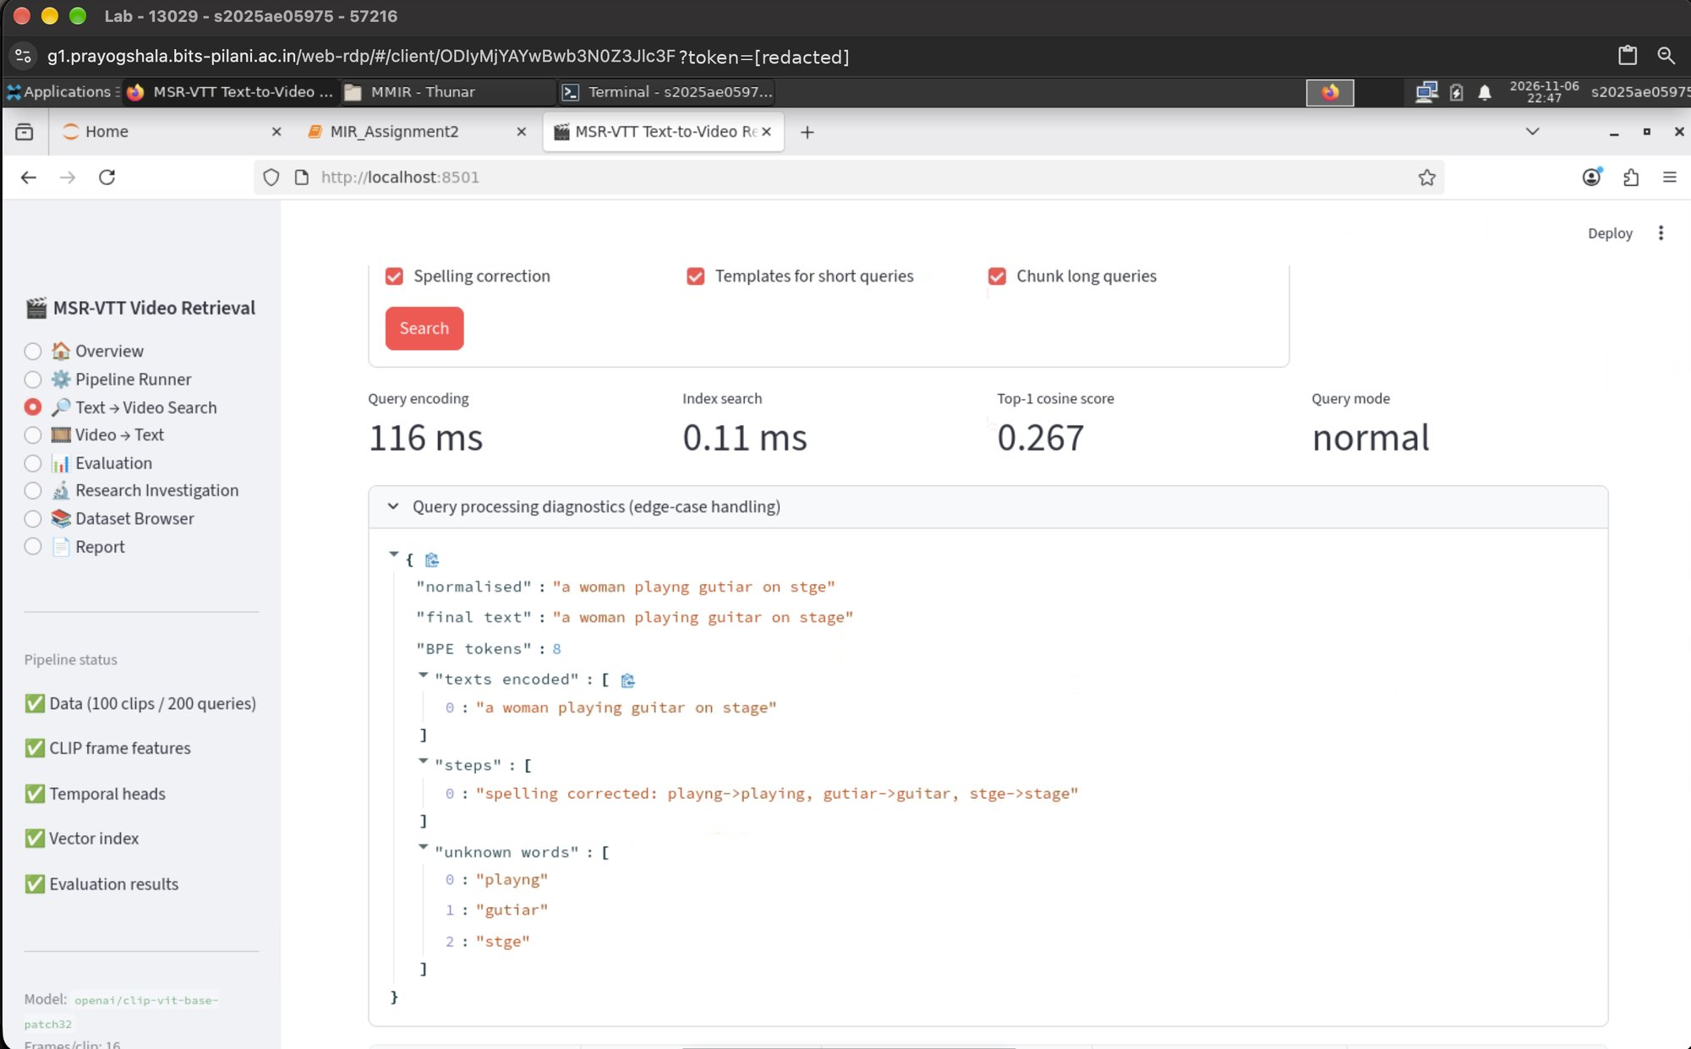
Figure A.6 – Edge case – misspelled query corrected (playng→playing, gutiar→guitar, stge→stage).
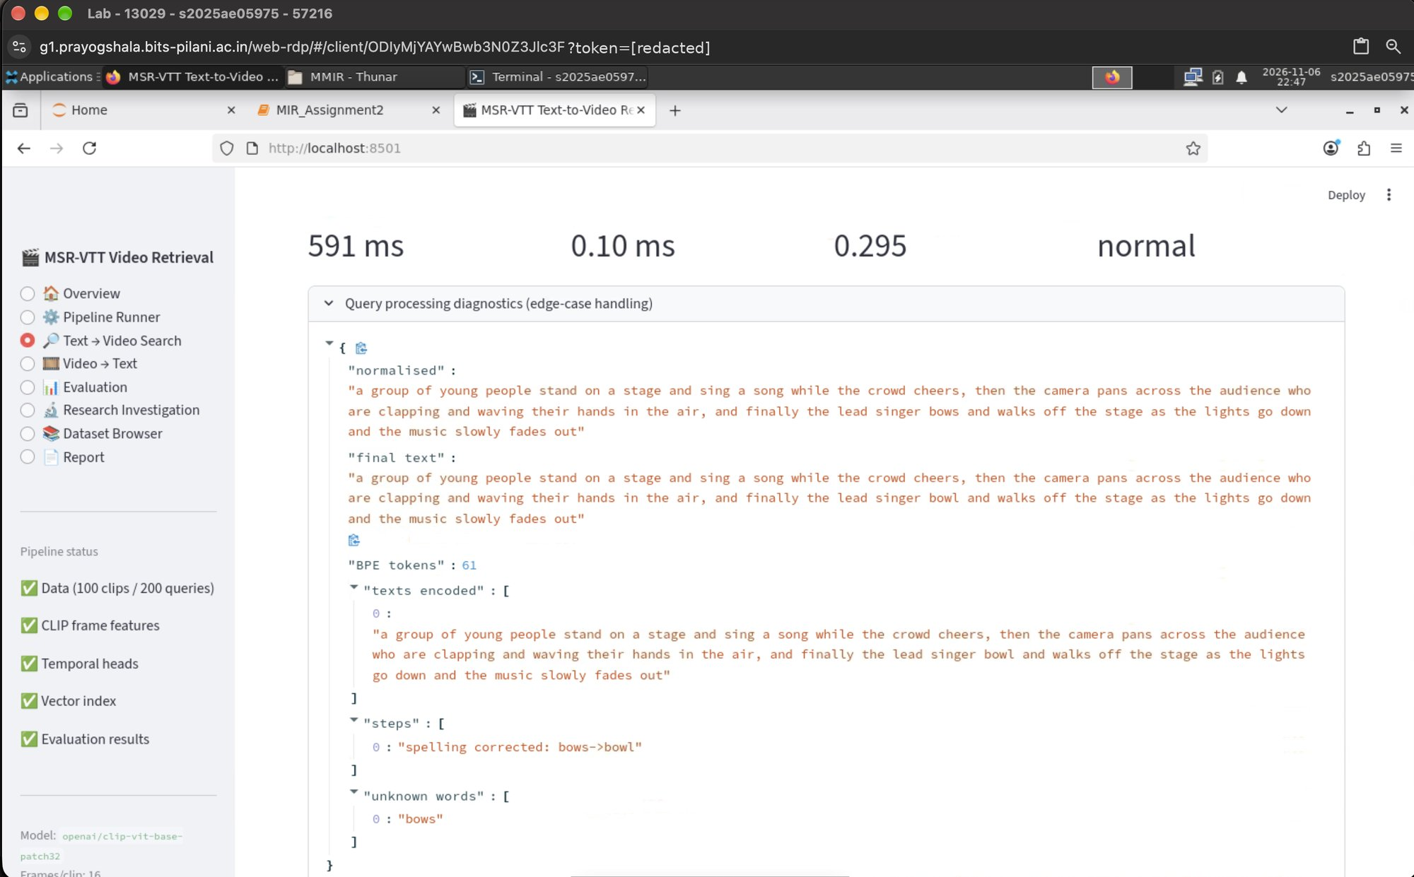
Figure A.7 – Edge case – detailed query longer than 77 tokens split into chunks.
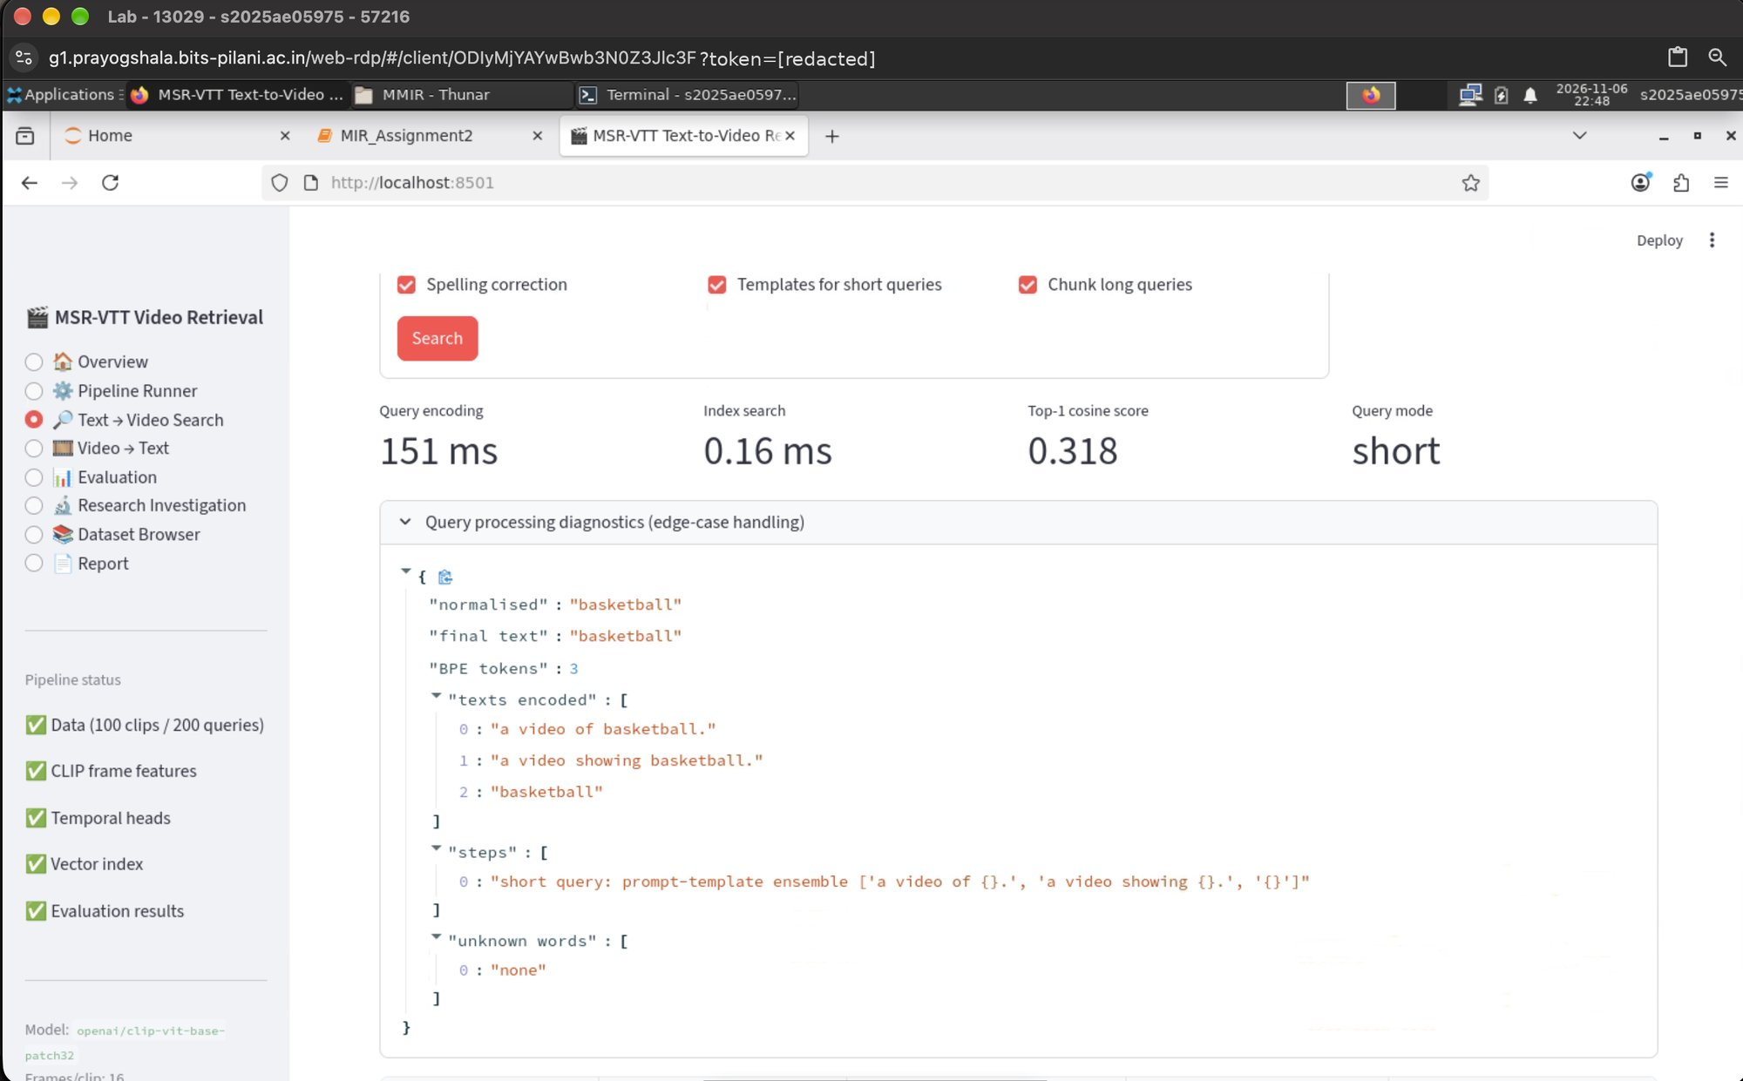
Figure A.8 – Edge case – one-word query handled with a prompt-template ensemble.

A.4 Video → Text retrieval (reverse modality)
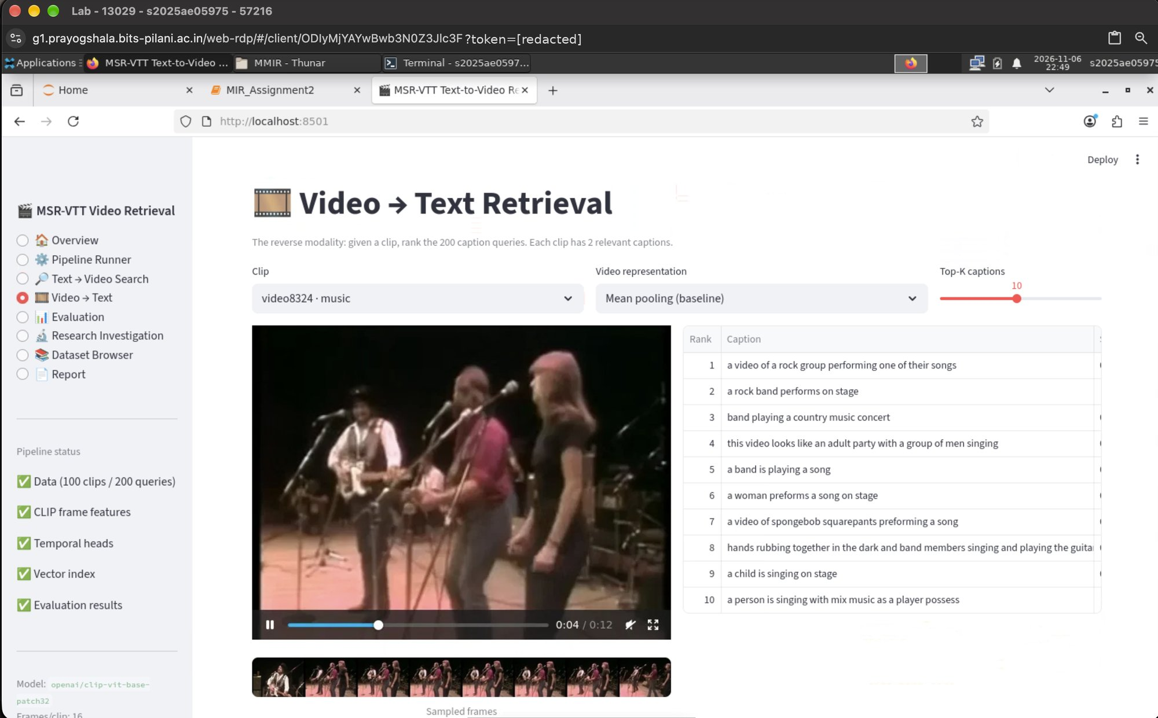
Figure A.9 – Top-K captions retrieved for a selected clip; relevant captions marked.

A.5 Quantitative evaluation
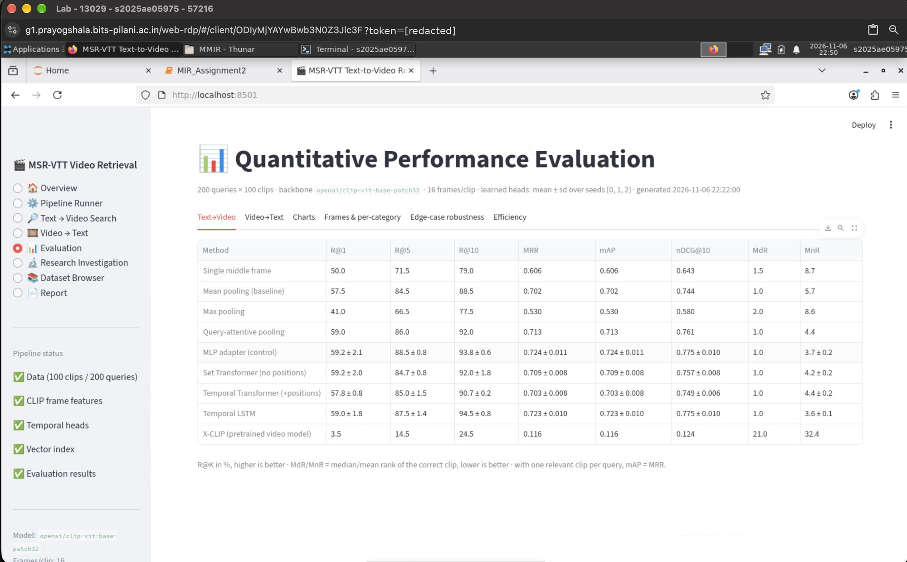
Figure A.10 – Text→Video metrics for all representations.
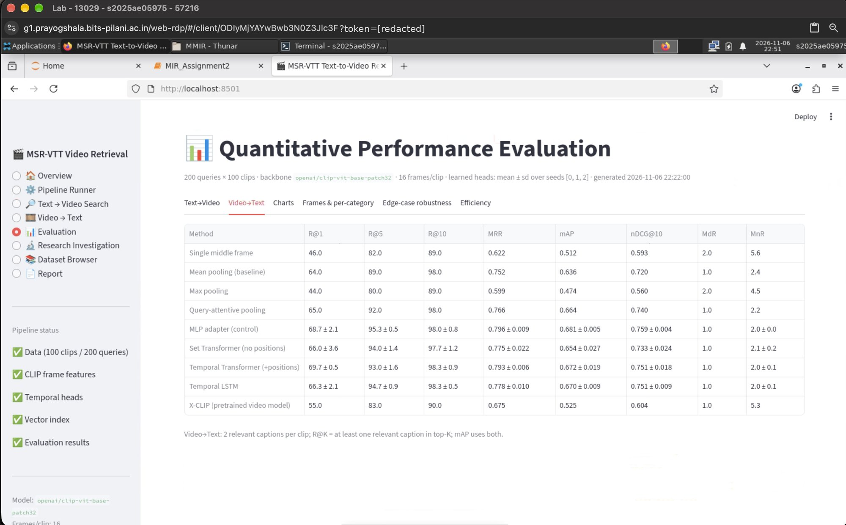
Figure A.11 – Video→Text metrics.
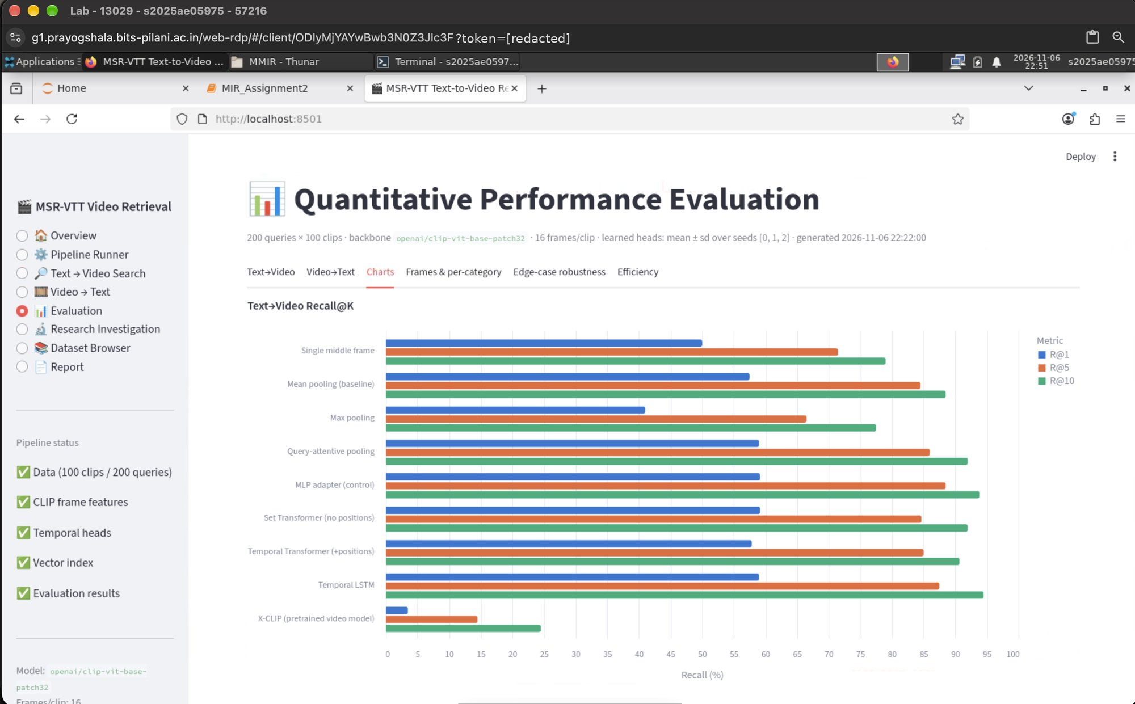
Figure A.12 – Recall@K and MRR charts.
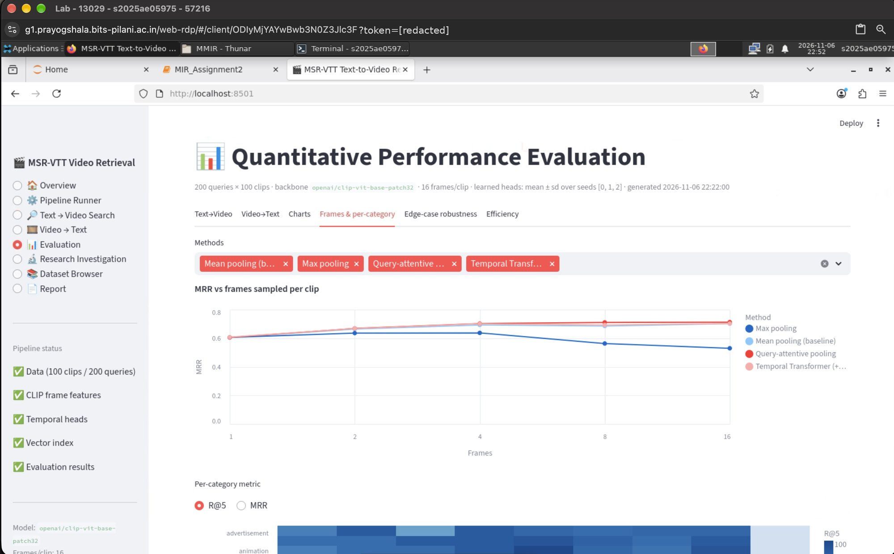
Figure A.13 – MRR vs number of frames and per-category heat-map.
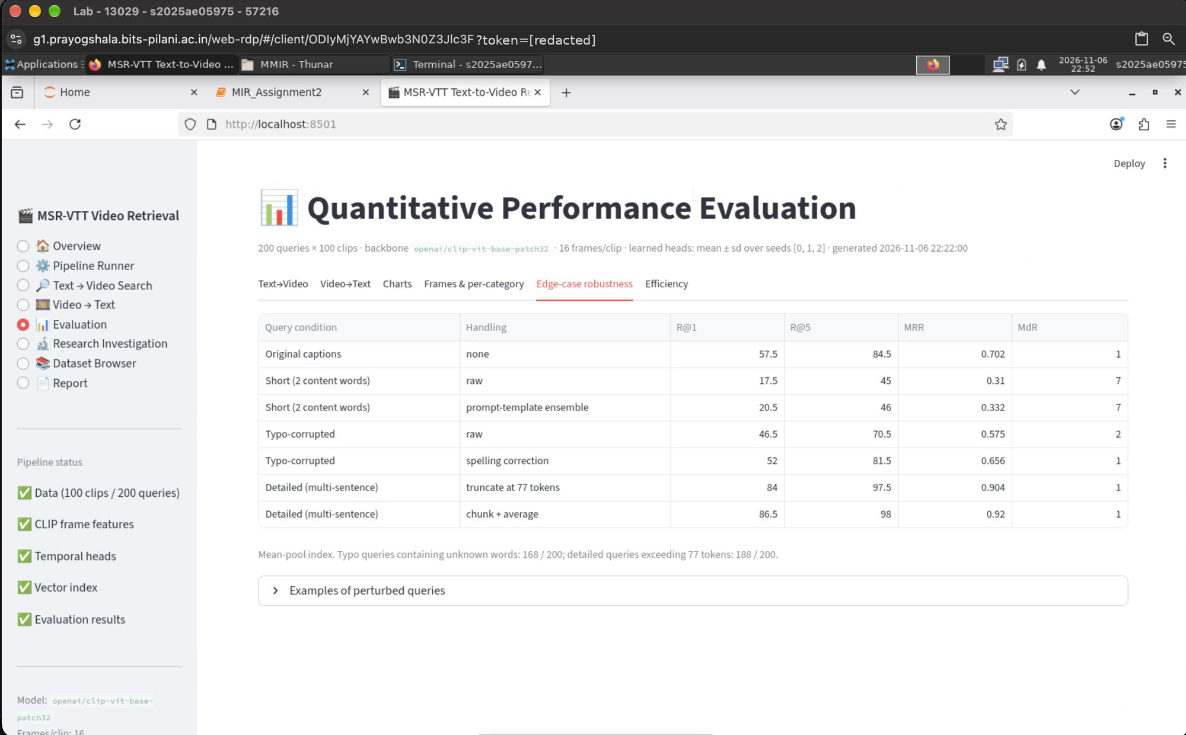
Figure A.14 – Edge-case robustness study.
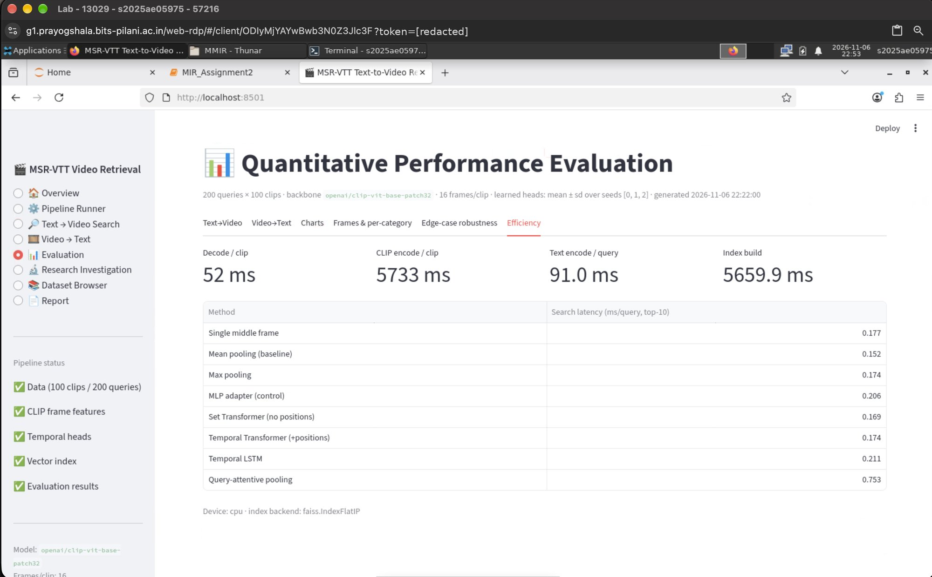
Figure A.15 – Efficiency: encoding and search latency.

A.6 Research Investigation 1
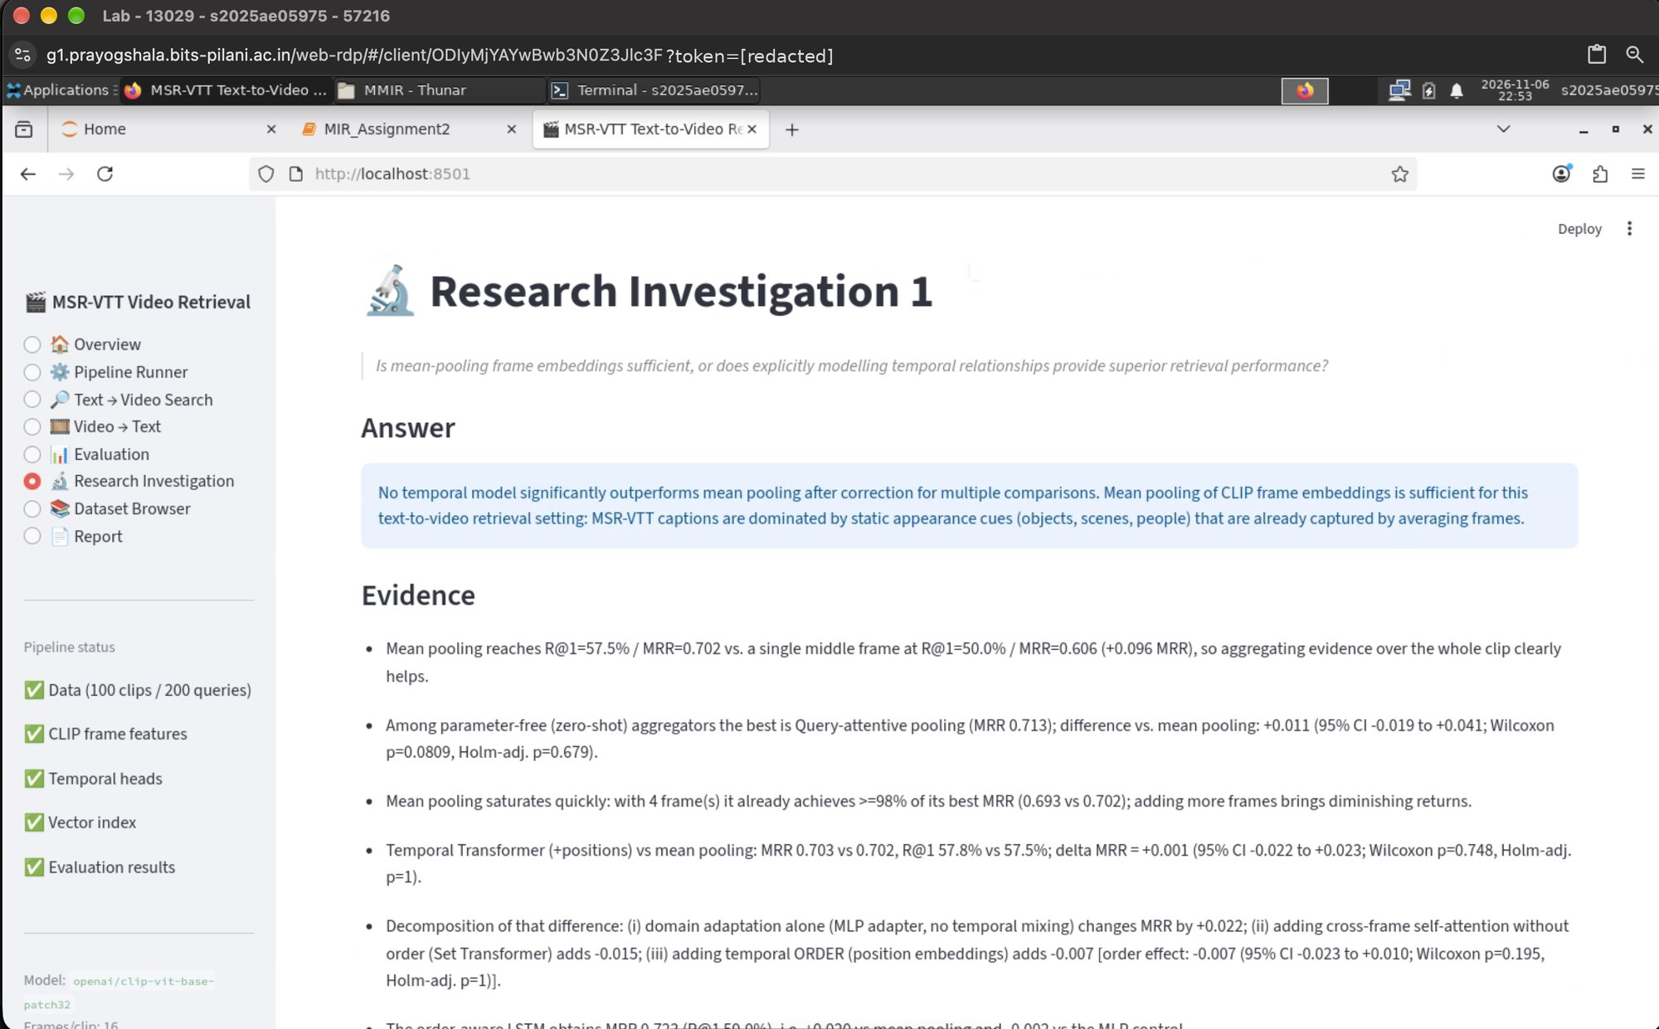
Figure A.16 – Data-driven answer and evidence.
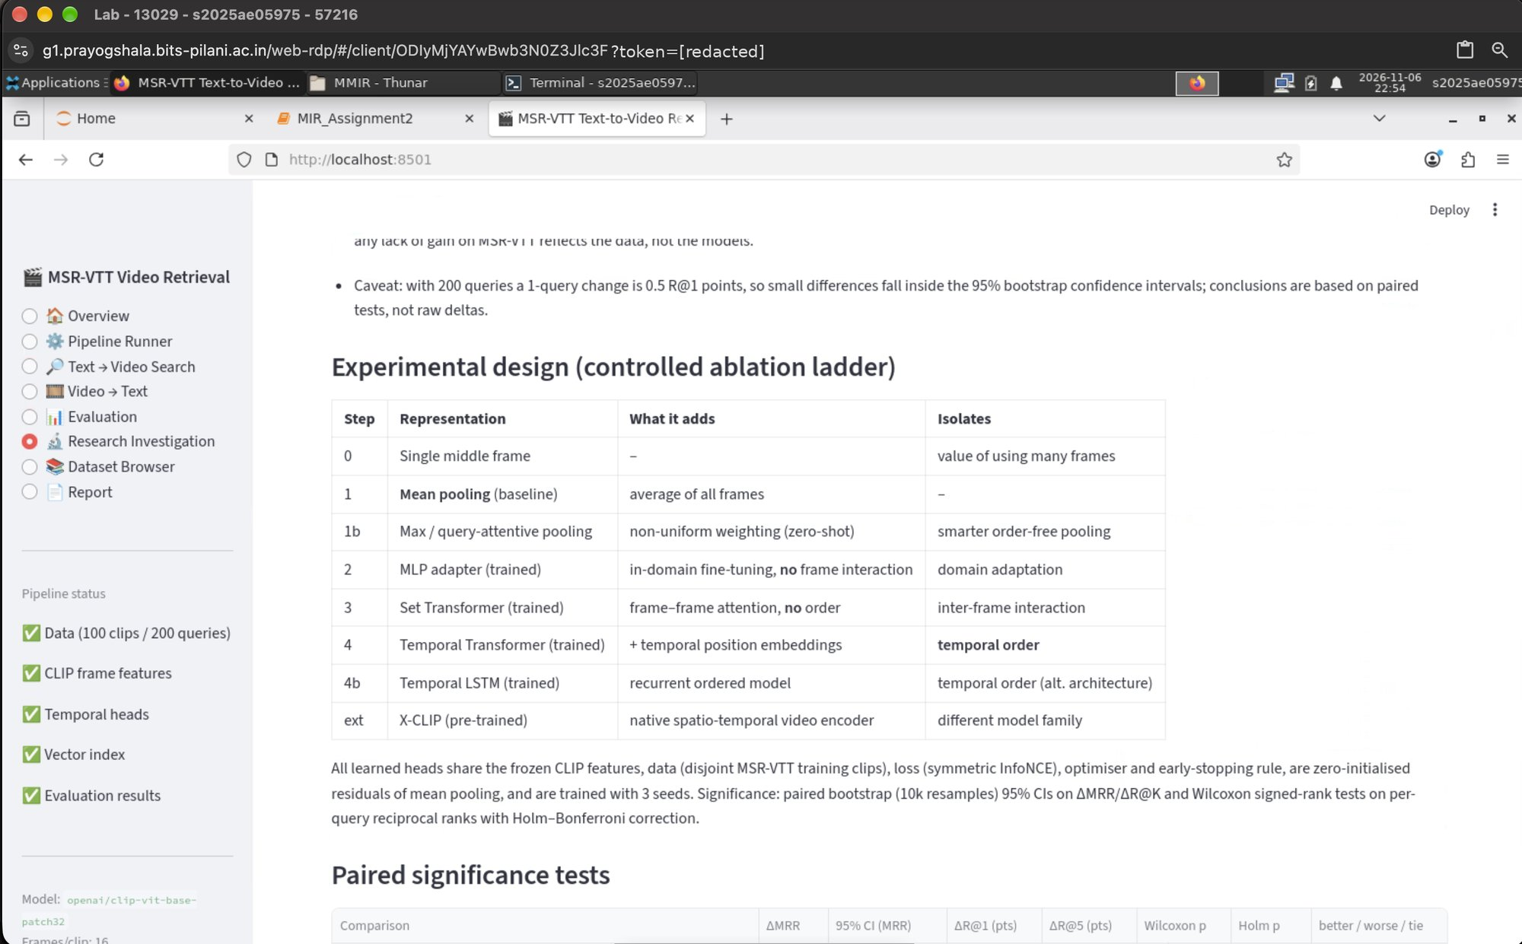
Figure A.17 – Ablation ladder and paired significance tests.
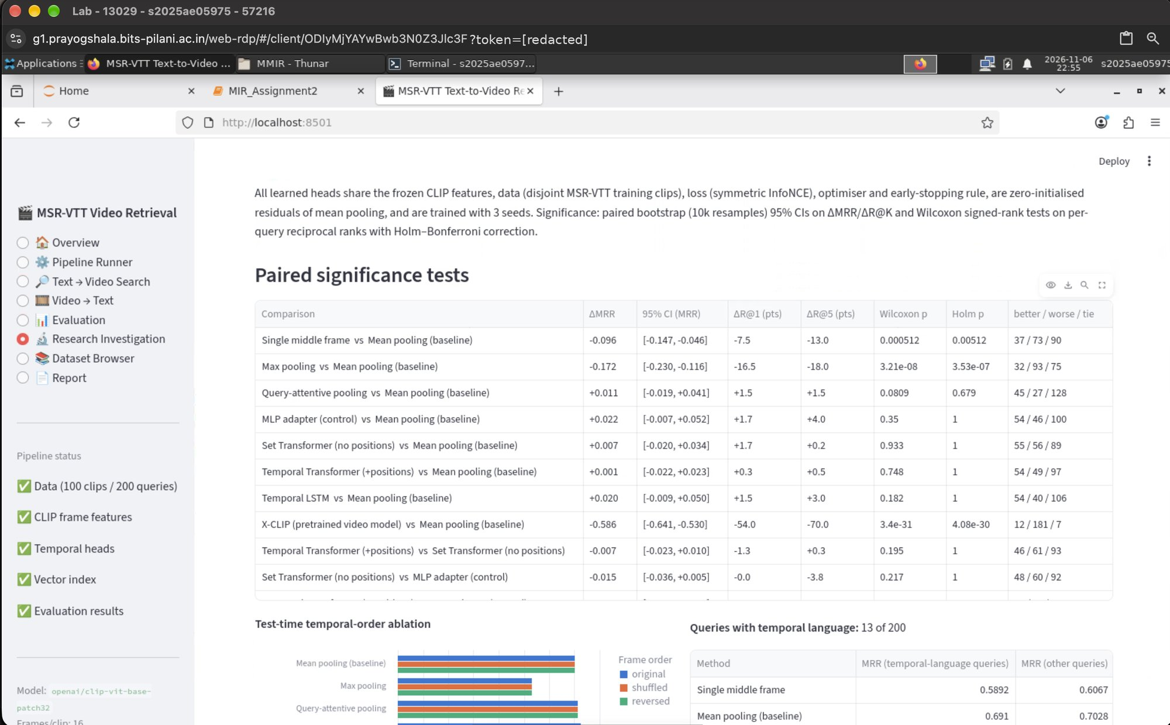
Figure A.18 – Significance tests (bootstrap CIs, Wilcoxon, Holm).
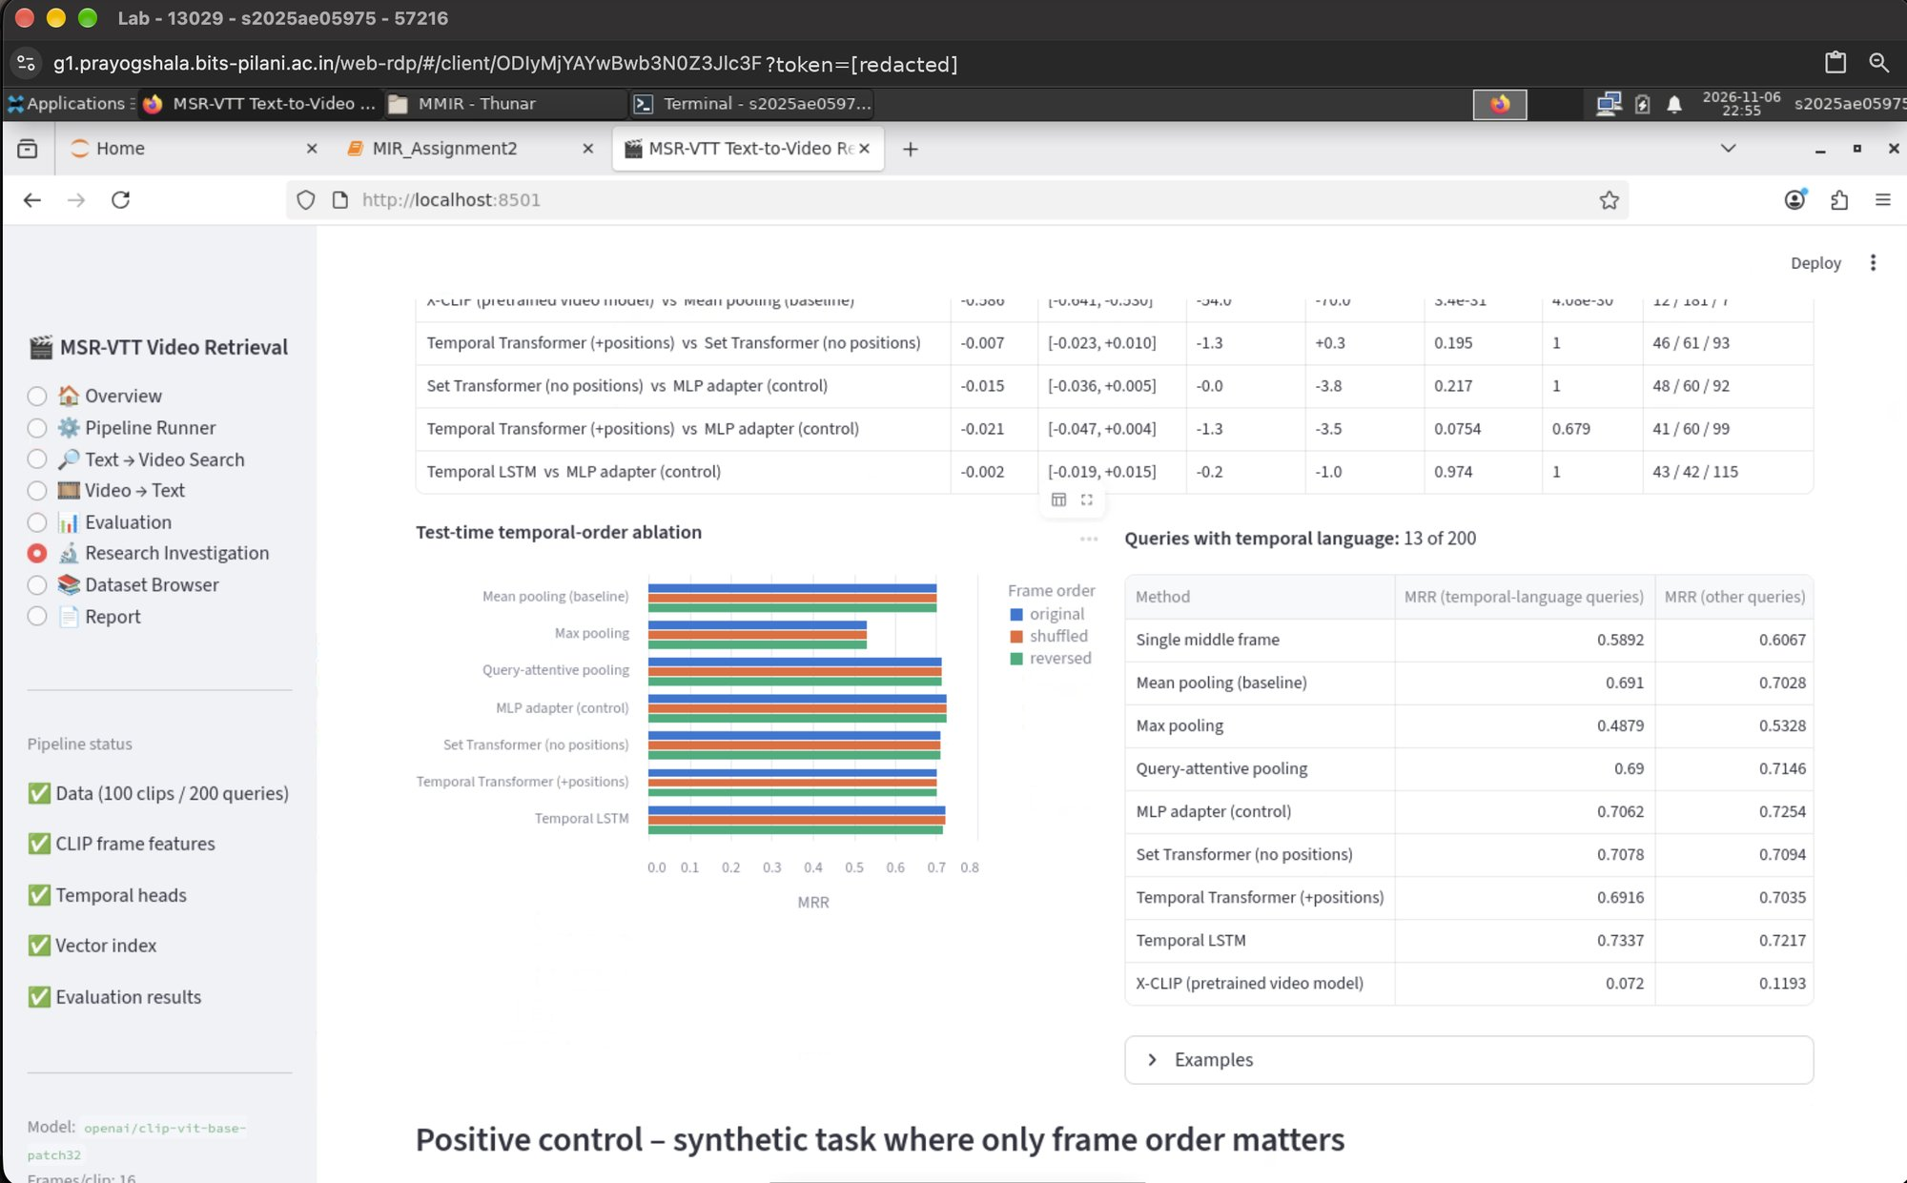
Figure A.19 – Temporal-order ablation and temporal-language queries.
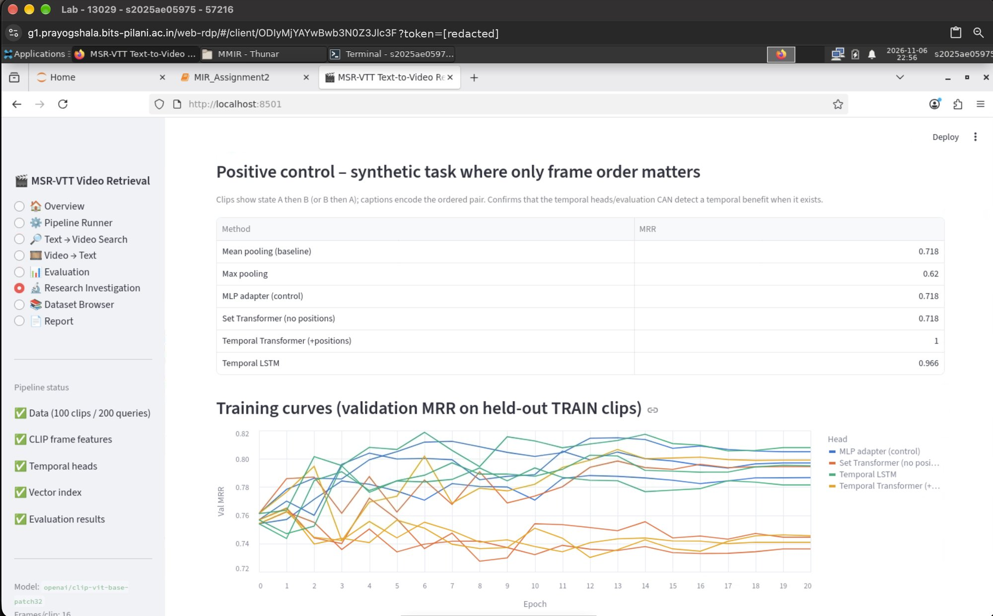
Figure A.20 – Positive control and training curves.

A.7 Dataset browser and report generation
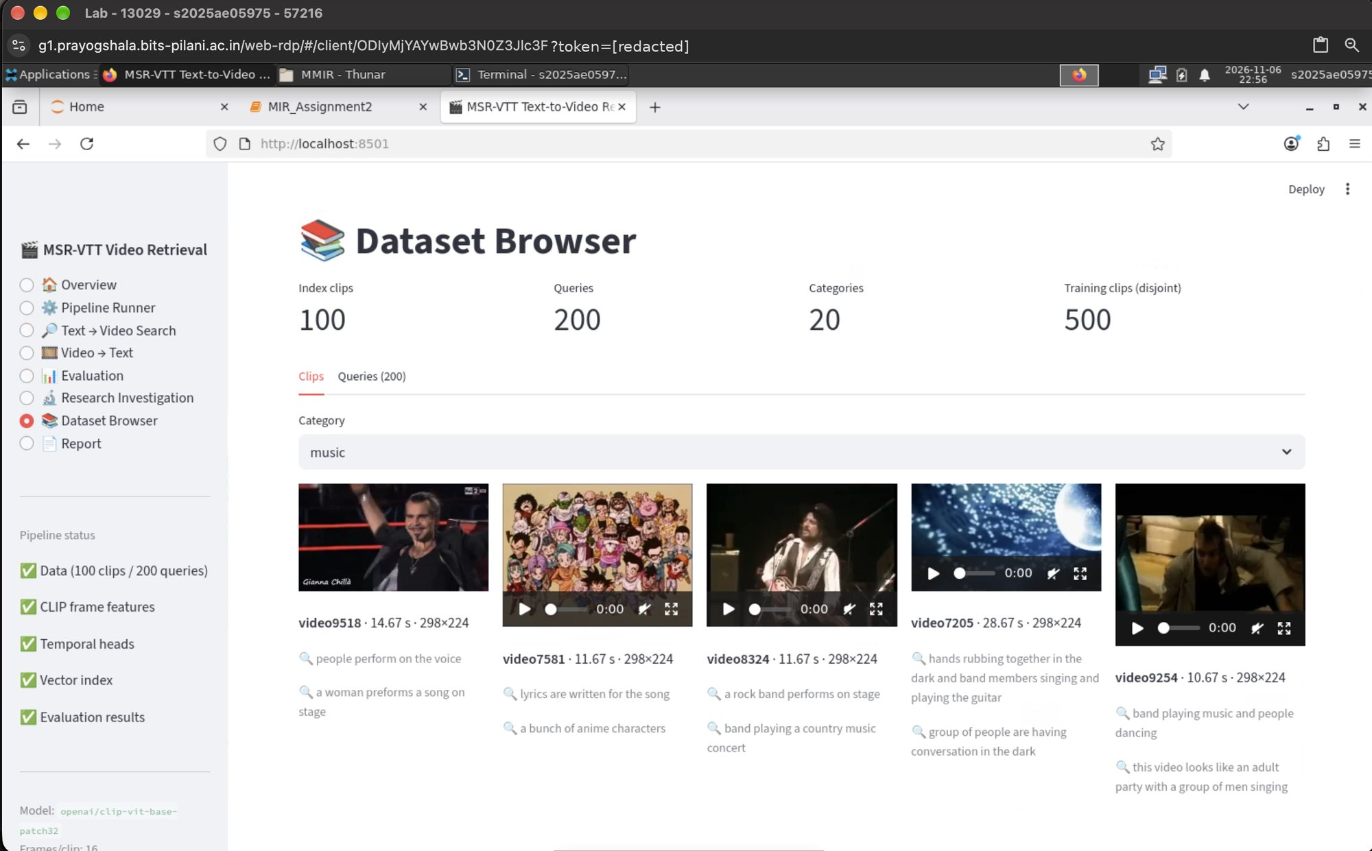
Figure A.21 – Dataset Browser: index clips per category.
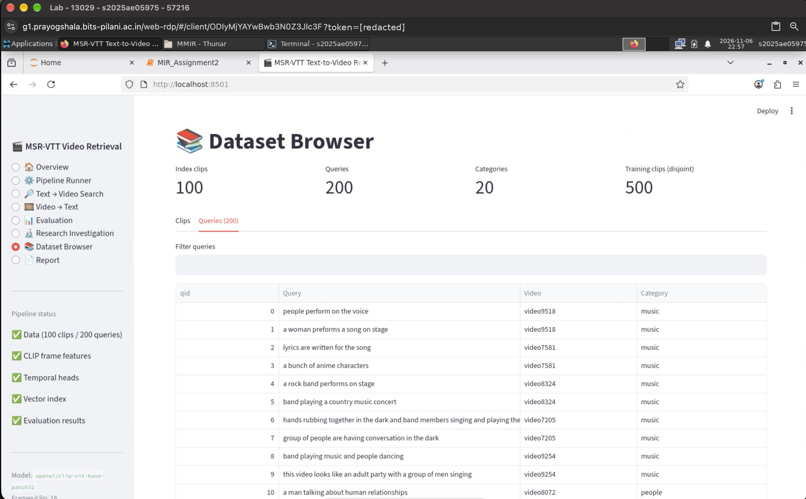
Figure A.22 – Dataset Browser: the 200 queries.
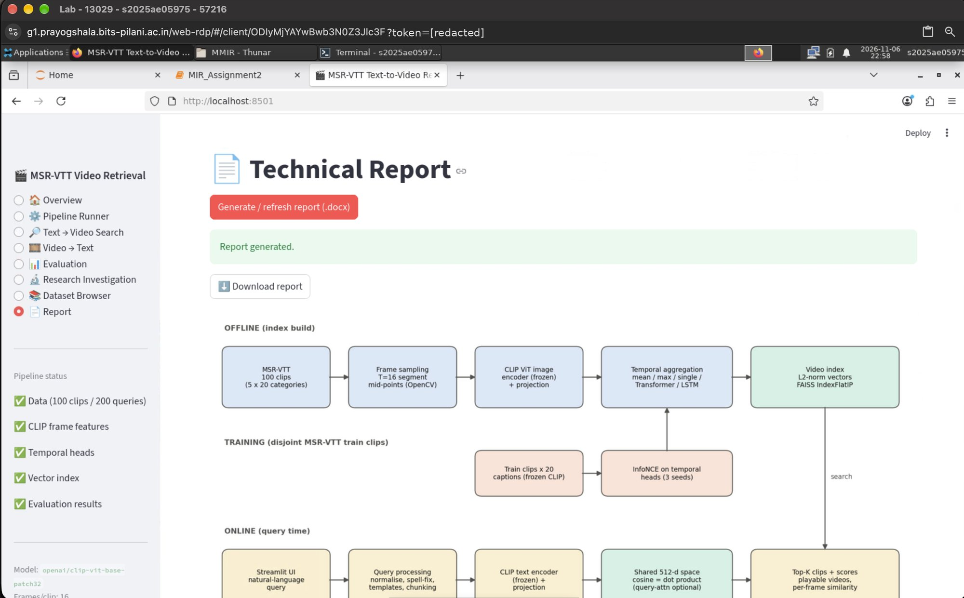
Figure A.23 – Report page: technical report generated from the results.

A.8 Jupyter notebook executed in the BITS Virtual Lab
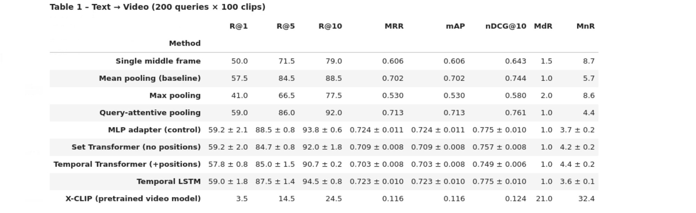
Figure A.24 – Notebook Section 8 – Text→Video results table.
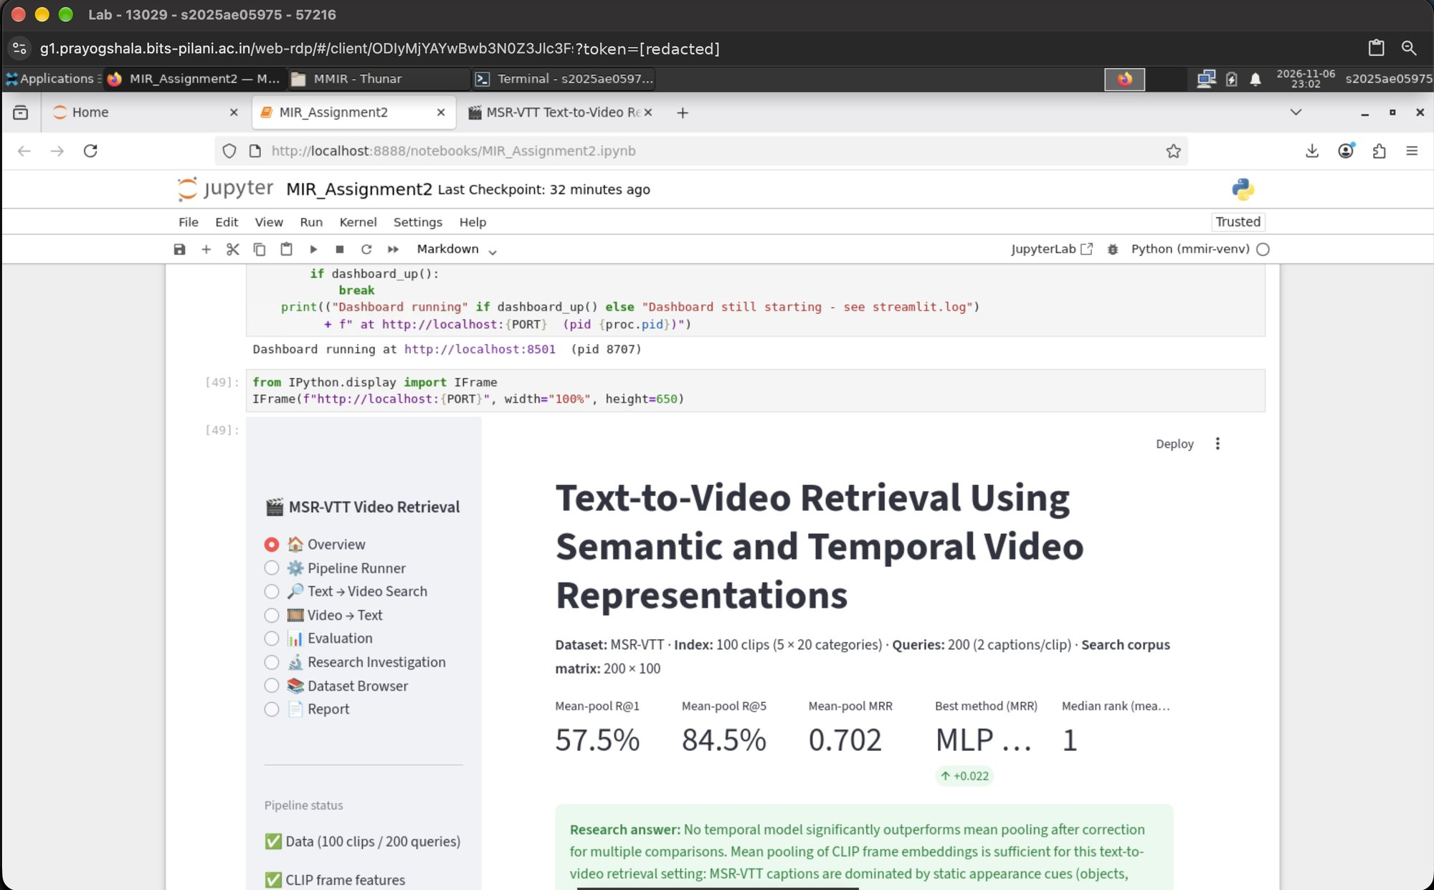
Figure A.25 – Notebook Section 15 – Streamlit dashboard launched from the notebook.

