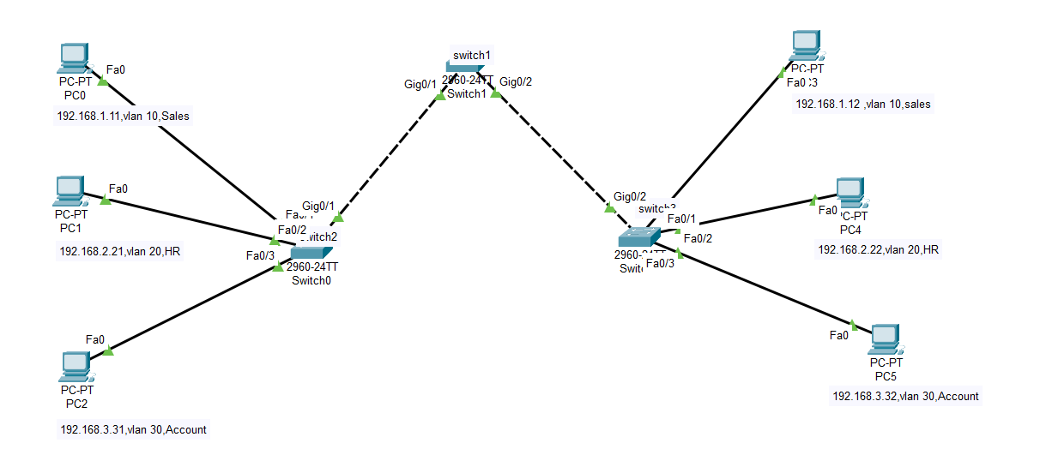Lab5:

