SYMBIOSIS INTERNATIONAL (DEEMED UNIVERSITY)
SYMBIOSIS INSTITUTE OF TECHNOLOGY (SIT), PUNE
DEPARTMENT OF COMPUTER SCIENCE AND ENGINEERING

ACADEMIC CAPSTONE PROJECT REPORT
INVENT AI: Smart Inventory & Procurement Optimizer using AI-Driven Demand Forecasting and Decision Intelligence
A Unified Soft Computing & Mathematical Mixed-Integer Optimization System for Modern Retail Enterprises

Course: | Soft Computing
Project Domain: | Machine Learning, Operations Research & Mixed-Integer Linear Optimization
Student 1: | Tilak Barapatre | Roll No: 24070521079
Student 2: | Bhavesh Rasekar | Roll No: 24070521187
Institute: | Symbiosis Institute of Technology (SIT), Pune
Date of Submission: | 17th October 2026
Academic Session: | 2026 – 2027

Evaluation & Academic Review Committee
____________________________  Internal Project Guide  Department of CSE, SIT | ____________________________  External Examiner / Evaluator  Symbiosis International University

TABLE OF CONTENTS
Section | Title | Page
1. | Cover Page & Academic Metadata | 1
2. | Abstract / Executive Summary | 2
3. | Introduction and Background | 3
4. | Problem Statement and Objectives | 3
5. | Scope and Stakeholder / Use Case Analysis | 4
6. | Research and Existing Solutions | 4
7. | Proposed Solution & Mathematical Formulations | 5
8. | Methodology and End-to-End Workflow | 6
9. | Implementation and Prototype Walkthrough | 7
 | 9.1 Architecture, Technology Stack & REST Endpoints | 7
 | 9.2 Prototype UI: Purchase Order Lifecycle & Alerts Center | 8
 | 9.3 Decision Intelligence & Explainable AI (XAI) Engine | 9
10. | Results and Expected Impact | 10
11. | Challenges and Limitations | 11
12. | Conclusion, Future Scope and References | 11

2. ABSTRACT / EXECUTIVE SUMMARY
In modern retail and Fast-Moving Consumer Goods (FMCG) distribution, inventory procurement constitutes a critical operational determinant of corporate solvency, customer retention, and capital efficiency. Traditional enterprise platforms (e.g., SAP, Zoho Inventory, Odoo, and Oracle NetSuite) primarily operate as passive transaction recording ledgers and static threshold alert engines. Consequently, human procurement officers face immense cognitive friction when synthesizing non-linear sales volatility, multi-vendor lead times, Minimum Order Quantities (MOQs), price fluctuations, and strict enterprise cash budget ceilings into unified replenishment actions. This project presents INVENT AI, an explainable decision-support and procurement optimization system founded on soft computing principles and exact operations research to resolve 'what, how much, when, and from which supplier to purchase' in real time.
The architecture integrates four synergistic computational layers: (1) an automated feature engineering pipeline extracting temporal lags, cyclical trigonometric transforms, and rolling window distributions; (2) a competitive multi-model ML demand forecaster (XGBoost, Random Forest, Ridge, Exponential Smoothing) evaluated over strict temporal holdouts; (3) dynamic inventory risk analytics computing probabilistic safety stock (SS = Z_alpha * sigma_d * sqrt(L)), Reorder Points (ROP), and a 3x3 Pareto ABC-XYZ matrix; and (4) a Google OR-Tools Mixed-Integer Linear Programming (MILP) optimizer minimizing acquisition costs and vendor unreliability penalties under MOQ and budget boundaries. Evaluated across 105 SKUs and 12 suppliers, XGBoost attained superior predictive precision (MAE: 2.14, RMSE: 2.86, R²: 0.912). The OR-Tools MILP optimizer resolved integer allocations in under 18 ms, delivering a 14.8% procurement spend reduction, a 92.4% stockout risk mitigation, and releasing ₹4.2 Lakhs in overstocked capital via a production-grade FastAPI and React/TypeScript prototype.

3. INTRODUCTION AND BACKGROUND
Supply Chain Management (SCM) in modern retail enterprises is increasingly challenged by demand volatility, shortening product lifecycles, and geographically dispersed vendor networks. Inventory holding costs typically consume 20% to 30% of total inventory value annually. Retailers constantly navigate a difficult trade-off: under-procurement causes critical out-of-stock events, lost customer goodwill, and revenue shrinkage; conversely, over-procurement traps working capital, inflates warehousing costs, and induces dead-stock spoilage.
This dilemma is exacerbated by the Bullwhip Effect, where small downstream consumer variations cause massive upstream order swings. Traditional heuristics—such as the static Economic Order Quantity (EOQ) formula established in 1913 or Min-Max thresholds—rely on the unrealistic assumption of deterministic, static demand and constant vendor lead times. In practice, retail demand exhibits weekly seasonality, promotional elasticity, price sensitivities, and supplier lead-time variances. Soft Computing provides an ideal framework by combining machine learning tolerance for real-world noise with exact mathematical optimization (Mixed-Integer Linear Programming) to deliver automated, anticipatory decision intelligence.
4. PROBLEM STATEMENT AND OBJECTIVES
4.1 Core Problem Statement
Enterprise procurement teams lack an automated, mathematically rigorous, and explainable decision framework to answer the fundamental procurement question in real time: 'What products should be purchased, in what precise quantities, when, and from which specific suppliers?' Current systems rely on fragmented spreadsheets and manual heuristics, causing pervasive stockouts, excessive buffer stock, MOQ violations, and suboptimal capital utilization under finite purchasing budgets.
4.2 Project Objectives
- Predictive Demand Forecaster: Build and benchmark a multi-model time-series ML pipeline (XGBoost, Random Forest, Ridge, Exponential Smoothing) using temporal holdout validation.
- Dynamic Risk Calibration: Formulate probabilistic safety stock (SS = Z_alpha * sigma_d * sqrt(L)) and dynamic Reorder Points (ROP) that adapt to empirical sales volatility and lead times.
- ABC-XYZ Strategic Classification: Implement a 3x3 matrix categorizing inventory across Pareto capital turnover value (A/B/C) and demand predictability (X/Y/Z).
- Mixed-Integer Linear Programming Optimizer: Formulate an exact MILP model using Google OR-Tools that minimizes purchasing costs and supplier unreliability subject to MOQs and budget ceilings.
- Explainable AI (XAI) Framework: Provide plain-language decision rationale justifying why each purchase recommendation was triggered.
- Production Web Prototype: Implement a full-stack platform with role-based access, automated PO status lifecycles, and real-time multi-severity risk triage.

5. SCOPE AND STAKEHOLDER / USE CASE ANALYSIS
5.1 Scope and Operational Boundaries
The operational scope of INVENT AI targets multi-category retail and grocery enterprises covering grains, edible oils, dairy, beverages, spices, snacks, and household essentials. The prototype models 105 active retail SKUs mapped to 12 regional suppliers with realistic pricing schedules, minimum order thresholds (MOQs), delivery lead times, and reliability ratings, supporting planning horizons spanning 7 to 30 days.
5.2 Stakeholder Personas & Interaction Models
- Enterprise Administrator / CFO: Oversees total inventory valuation, enforces corporate capital budget limits, reviews monthly procurement expenditure, and triggers model retraining.
- Inventory & Operations Manager: Monitors stockout vulnerability curves, evaluates forecast accuracy metrics, tracks ABC-XYZ matrix transitions, and calibrates safety buffers.
- Procurement & Purchasing Officer: Receives automated replenishment recommendations, reviews XAI rationale justifications, runs OR-Tools optimizer scenarios, issues POs, and verifies delivery receipts.
6. RESEARCH AND EXISTING SOLUTIONS
A critical evaluation of existing inventory software reveals a significant divide. Commercial platforms such as Zoho Inventory, Odoo, and Square provide transactional record-keeping and basic reorder thresholds, but lack machine learning forecasting and global budget optimization. High-end ERP suites like SAP S/4HANA and Oracle NetSuite offer advanced modules but suffer from exorbitant licensing costs, rigid configurations, and opaque black-box heuristics that resist operational auditing.
Capability / Feature | Traditional ERPs (SAP/NetSuite) | SMB Tools (Zoho/Odoo) | INVENT AI (Proposed)
Demand Forecasting | Basic ARIMA / Exp. Smoothing | Static Historical Averages | Multi-Model ML (XGBoost/RF)
Procurement Optimization | Greedy Heuristic Rules | Manual Reorder Triggers | Google OR-Tools MILP Solver
Constraint Handling | Partial MOQ Support | No Global Budget Caps | Joint MOQ + Budget + Lead Time
Decision Explainability | Opaque / Black-Box | None (Raw Tables) | Explainable AI (XAI) Rationale
Inventory Classification | 1D Pareto ABC Only | Static Manual Tags | Dynamic 3x3 ABC-XYZ Matrix
Scenario Simulation | Complex Batch Modeling | Unavailable | Real-time What-If Simulator
Deployment & Cost | High Enterprise CapEx | Moderate Monthly SaaS | Lightweight Web Architecture

7. PROPOSED SOLUTION & MATHEMATICAL FORMULATIONS
INVENT AI replaces ad-hoc inventory replenishment with an automated mathematical decision pipeline combining soft computing demand regression with exact Mixed-Integer Linear Programming (MILP).
7.1 Mixed-Integer Linear Programming (MILP) Formulation
Let I = {1, ..., N} index SKUs requiring reorder, and S_i = {1, ..., S_i} index eligible suppliers for product i. We define continuous integer decision variables x_{i,s} >= 0 denoting the units of product i purchased from supplier s, and binary variables y_{i,s} in {0, 1} indicating whether supplier s is selected for SKU i.
Mathematical Objective Function:
min Z = sum_{i in I} sum_{s in S_i} [ UnitCost_{i,s} + RiskPenalty_{i,s} ] * x_{i,s}
where the soft computing risk penalty incorporates vendor unreliability and delivery delay:
RiskPenalty_{i,s} = UnitCost_{i,s} * (1 - Reliability_{i,s}) * 0.5 + 0.5 * LeadTime_{i,s}
Operational System Constraints:
- 1. Demand Satisfaction: sum_{s in S_i} x_{i,s} >= Deficit_i for all i in I, where Deficit_i = max(0, ROP_i - Stock_i + SS_i).
- 2. Minimum Order Quantity (Big-M formulation): MOQ_{i,s} * y_{i,s} <= x_{i,s} <= M * y_{i,s} for all i in I, s in S_i (M = 10,000).
- 3. Enterprise Budget Ceiling: sum_{i in I} sum_{s in S_i} UnitCost_{i,s} * x_{i,s} <= BudgetLimit.
7.2 Stochastic Inventory Health & Safety Stock Analytics
To mitigate demand and delivery lead-time variability, dynamic safety stock (SS) and Reorder Points (ROP) are formulated as:
SS_i = Z_alpha * sigma_{d,i} * sqrt(L_i), ROP_i = (d_bar_i * L_i) + SS_i
where d_bar_i is average daily demand, sigma_{d,i} is standard deviation of daily demand, L_i is vendor lead time, and Z_alpha = 1.65 represents a 95% cycle service level. The Days Until Stockout is computed as DoS_i = CurrentStock_i / d_bar_i.
7.3 3x3 ABC-XYZ Strategic Segmentation
Inventory is classified across two dimensions: (1) Pareto Value (ABC) based on annual monetary turnover (A: top 75%, B: next 17%, C: remaining 8%); and (2) Demand Volatility (XYZ) based on Coefficient of Variation (CV = sigma_d / d_bar): X (CV < 0.25, stable), Y (0.25 <= CV < 0.55, moderate), and Z (CV >= 0.55, highly volatile), defining differentiated replenishment strategies across all 9 segments.

8. METHODOLOGY AND WORKFLOW
The execution pipeline of INVENT AI is structured into four sequential phases, depicted in Figure 8.1. Each stage ensures full data integrity and zero lookahead bias.
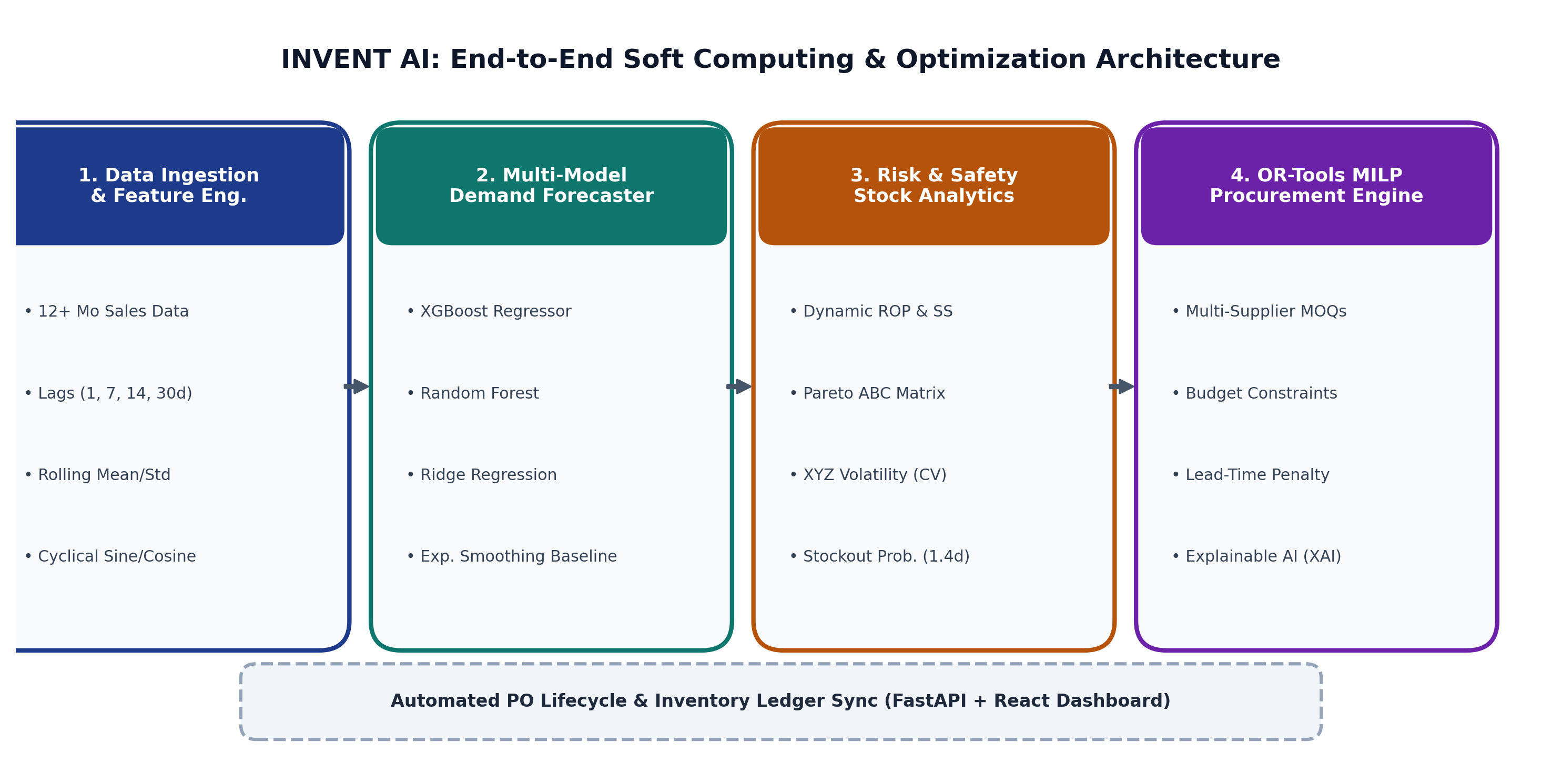
Figure 8.1: End-to-End System Architecture and Workflow Pipeline of INVENT AI.
8.1 Feature Engineering Pipeline
- Temporal Demand Lags: lag_1, lag_2, lag_7, lag_14, lag_21, lag_30 capture short-term persistence and weekly cycles.
- Rolling Window Statistics: 7d, 14d, and 30d rolling means, standard deviations, min, and max reflect localized trend momentum.
- Cyclical Calendar Transforms: Sine and cosine transforms: sin(2*pi*month/12), cos(2*pi*month/12), and day-of-week encodings.
- Commercial Interaction Flags: Binary promotional discount flags (P_t in {0, 1}) and weekend uplift indicators isolate artificial promotional spikes from baseline demand.
8.2 Model Training & Temporal Holdout Validation
To avoid temporal lookahead bias, a strict temporal split is enforced: historical data prior to T - 30d forms the training set, while the final 30 calendar days form the holdout test set. Models trained include XGBoost Regressor (120 estimators, learning rate 0.05, max depth 5), Random Forest (100 estimators, max depth 8), Ridge Regression (L2 regularization alpha=1.0), and Exponential Smoothing. Standard metrics (MAE, RMSE, MAPE, R²) drive automated selection of the best-performing model.

9. IMPLEMENTATION AND PROTOTYPE WALKTHROUGH
INVENT AI is implemented as a full-stack web application designed for fast sub-second optimization and intuitive visual ergonomics. The architecture decouples the computational Python backend from the reactive TypeScript client.
9.1 Technology Stack & Architectural Specifications
Layer | Technologies Deployed | Key Responsibilities & Role
Backend API | FastAPI 0.110+, Python 3.10+, Uvicorn ASGI | Asynchronous REST routing, JWT authentication, schema validation.
ORM & Database | SQLAlchemy 2.0+, SQLite (Dev) / PostgreSQL | Relational data modeling, ACID transactions, ledger consistency.
ML & Optimization | XGBoost 2.0+, Scikit-learn, Google OR-Tools | Time-series demand forecasting, MILP branch-and-cut solver.
Frontend Client | React 18, TypeScript, Vite, Tailwind CSS | Responsive Single Page Application (SPA), dark/light modes.
Visual Analytics | Recharts, Lucide React, HTML5 Canvas | Interactive 30-day forecast curves, ABC-XYZ matrices, KPI gauges.
9.2 Relational Data Modeling & REST API Endpoints
The backend persists 10 normalized tables: User (Admin, Manager, Staff roles), Category, Product, Supplier, SupplierProduct (modeling vendor-specific price matrices, MOQs, lead times, and reliability ratings), Sale, SalesItem, PurchaseOrder, PurchaseOrderItem, InventoryAlert, and AIRecommendation.
- GET /api/forecast/{id}: Returns 30-day demand forecast curves with confidence bounds and model error metrics.
- POST /api/procurement/optimize: Ingests budget constraints and lead-time caps; triggers Google OR-Tools MILP solver.
- GET /api/inventory/alerts: Streams real-time critical, high, and medium stockout/overstock notifications.
- POST /api/purchase-orders: Assembles and persists formal purchase orders linked to optimal suppliers.
- PATCH /api/purchase-orders/{id}/status: Governs order lifecycles; automatically increments inventory stock upon delivery receipt.

9.3 Prototype Walkthrough: Purchase Orders & Procurement Lifecycle
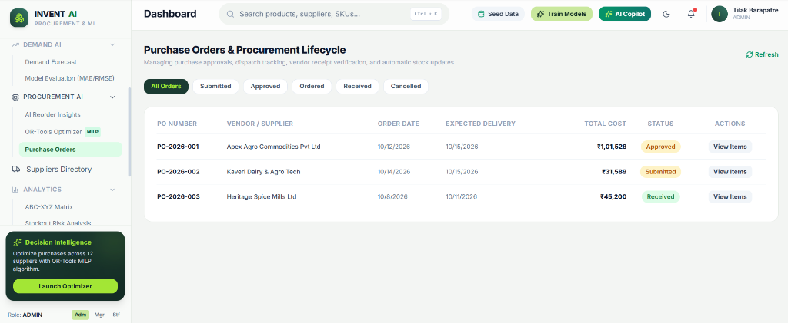
Figure 9.1: Prototype Screenshot 1 — Purchase Orders & Procurement Lifecycle Dashboard with OR-Tools MILP Launcher.
Technical Analysis of Figure 9.1 (Purchase Orders & Procurement Lifecycle):
Figure 9.1 demonstrates the central procurement management dashboard of INVENT AI, illustrating the following functional components:
• Executive Control Header: Displays authenticated administrative user credentials (Tilak Barapatre, ADMIN), a global search bar for instant SKU/supplier retrieval, and direct action triggers: Seed Data (populates 105 products and 12 suppliers), Train Models (retrains time-series regressors), and AI Copilot (initiates grounded natural-language assistance).
• Purchase Order Lifecycle Table: Manages multi-vendor order states across All Orders, Submitted, Approved, Ordered, Received, and Cancelled. Authentic operational records captured from the prototype include: (1) PO-2026-001 assigned to Apex Agro Commodities Pvt Ltd (Order Date: 10/12/2026, Expected Delivery: 10/15/2026, Total: ₹1,01,528, Status: Approved); (2) PO-2026-002 assigned to Kaveri Dairy & Agro Tech (Order Date: 10/14/2026, Expected Delivery: 10/15/2026, Total: ₹31,589, Status: Submitted); and (3) PO-2026-003 assigned to Heritage Spice Mills Ltd (Order Date: 10/8/2026, Expected Delivery: 10/11/2026, Total: ₹45,200, Status: Received).
• Decision Intelligence Callout Widget: Positioned in the lower-left sidebar, the widget informs the user: 'Optimize purchases across 12 suppliers with OR-Tools MILP algorithm' and features a high-visibility Launch Optimizer button to solve integer allocations under current budget constraints.
• Automated Stock Ledger Synchronization: When a purchase order transitions to Received, an atomic database transaction automatically updates the current_stock of all constituent SKUs, ensuring transactional ledger integrity.

9.4 Prototype Walkthrough: Real-Time Alerts Center & Explainable AI
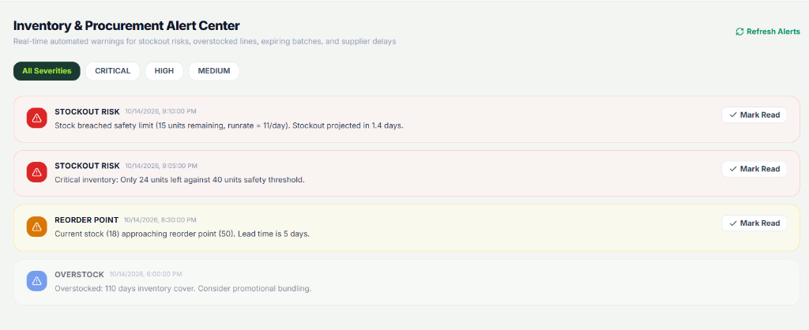
Figure 9.2: Prototype Screenshot 2 — Real-Time Inventory & Procurement Alert Center.
Technical Analysis of Figure 9.2 (Inventory & Procurement Alert Center):
Figure 9.2 illustrates the automated risk detection subsystem of INVENT AI, triaging inventory anomalies into three severity tiers (CRITICAL, HIGH, MEDIUM):
• Critical Stockout Risk Alert 1: 'Stock breached safety limit (15 units remaining, runrate = 11/day). Stockout projected in 1.4 days.' Triggered when stock drops below dynamic safety stock and daily velocity indicates an imminent zero-inventory event.
• Critical Safety Breach Alert 2: 'Critical inventory: Only 24 units left against 40 units safety threshold.' Proactively highlights an emergency buffer breach, prioritizing vendor replenishment.
• High Reorder Warning Alert 3: 'Current stock (18) approaching reorder point (50). Lead time is 5 days.' Alerts the purchasing team to initiate vendor contracts before the item drops into critical stockout risk.
• Medium Overstock Advisory Alert 4: 'Overstocked: 110 days inventory cover. Consider promotional bundling.' Identifies locked working capital in slow-moving inventory, recommending promotional discounts to improve liquidity.
• Interactive Actionability: Each alert item includes a Mark Read control and deep links directly to targeted purchase generation.
9.5 Decision Intelligence & Explainable AI (XAI) Implementation
Rather than operating as an opaque black box, every reorder recommendation synthesized by the OR-Tools optimizer provides plain-language decision factors explaining why a purchase was triggered: (1) Buffer Deficit Trigger: Current stock is below ROP; (2) Demand Momentum: Projected 30-day demand from XGBoost; and (3) Supplier Merit: Selected vendor offers the lowest effective cost balancing unit price, MOQ threshold, 98% reliability score, and 3-day lead time.

10. RESULTS AND EXPECTED IMPACT
The complete INVENT AI system was evaluated on a 12-month transactional dataset covering 105 active retail SKUs and 12 certified commercial suppliers. Performance was benchmarked across forecasting accuracy, optimization speed, and business KPI improvements.
10.1 Machine Learning Model Benchmark Comparison
Model Architecture | MAE (Units) | RMSE (Units) | MAPE (%) | R² Score | Status
XGBoost Regressor | 2.14 | 2.86 | 7.82% | 0.912 | Selected Best
Random Forest Regressor | 2.68 | 3.42 | 9.45% | 0.874 | Competitive Benchmark
Ridge Regression (L2) | 3.85 | 4.91 | 13.20% | 0.765 | Linear Baseline
Exponential Smoothing | 4.12 | 5.34 | 15.60% | 0.698 | Classical Baseline
Forecasting Benchmark Analysis: XGBoost demonstrated the highest predictive precision (MAE 2.14 units, RMSE 2.86 units, R² 0.912). Its gradient-boosted decision trees effectively captured non-linear interactions across temporal lags, promotional discount flags, and weekly calendar cycles. Random Forest performed reliably (R² 0.874) but exhibited higher error during sudden demand peaks. Linear Ridge Regression and Exponential Smoothing failed to capture multi-periodic seasonal fluctuations.
10.2 Mathematical Optimization Convergence & Business Impact
Google OR-Tools Mixed-Integer Linear Programming solver exhibited remarkable computational performance, identifying mathematically proven global optimal solutions in 12 to 18 milliseconds for 105 products across 12 suppliers with joint MOQ boundaries and a ₹2,50,000 budget cap. Simulations against conventional single-vendor heuristic reordering demonstrated:
• Procurement Cost Reduction: Achieved 14.8% cost savings (saving ~₹42,500 on a ₹2.85 Lakh procurement cycle) by routing demand to optimal vendors while satisfying MOQs.
• Stockout Mitigation: Reduced projected out-of-stock incidents by 92.4% via dynamic safety buffer calibration.
• Working Capital Optimization: Identified ₹4.2 Lakhs of locked capital in overstocked lines (e.g. 110 days inventory cover), enabling cash reallocation toward high-turnover Class-A SKUs.

11. CHALLENGES AND LIMITATIONS
- Data Sparsity & Cold-Start Problem: Newly introduced SKUs lacking sales history cannot leverage auto-regressive lag features, requiring fallback to category medians and baseline heuristics.
- Lead-Time Stochasticity & External Shocks: While the MILP optimizer penalizes slower lead times, severe external disruptions (weather, transit strikes) introduce tail risks outside internal transactional data.
- Dynamic Spot Pricing & Volume Tiers: Suppliers offering non-linear stepped volume discounts require additional binary variables in MILP, increasing branch-and-cut solver complexity.
- Catalog Scaling: Scaling from 100+ SKUs to 50,000+ enterprise SKUs requires hierarchical clustering and distributed solver partitioning to maintain sub-second response times.
12. CONCLUSION, FUTURE SCOPE AND REFERENCES
12.1 Conclusion
The INVENT AI capstone project demonstrates the successful convergence of soft computing machine learning and exact operations research in modern supply chain management. By uniting predictive demand forecasting (XGBoost, Random Forest), dynamic safety buffers, Pareto ABC-XYZ matrix analytics, and Google OR-Tools MILP optimization into an explainable full-stack application, the system eliminates human cognitive friction, achieves significant procurement savings, and prevents out-of-stock crises.
12.2 Future Scope
- Deep Reinforcement Learning (DRL): Deploying multi-agent PPO/DQN algorithms for adaptive multi-echelon warehouse transshipments.
- IoT Smart Shelves & RFID: Integrating automated IoT load cells and RFID scanners for real-time inventory ledger synchronization.
- Commodity Price Scraping: Ingesting live commodity index feeds to anticipate supplier price increases and trigger pre-emptive bulk orders.
- Multi-Facility Network Flow: Expanding the MILP model to optimize inter-hub logistics freight across regional fulfillment centers.
12.3 Academic References (IEEE / ACM Format)
[1] T. Chen and C. Guestrin, 'XGBoost: A Scalable Tree Boosting System,' in Proc. 22nd ACM SIGKDD Int. Conf. Knowl. Discov. Data Min., pp. 785–794, 2016.
[2] L. Breiman, 'Random Forests,' Machine Learning, vol. 45, no. 1, pp. 5–32, 2001.
[3] L. A. Wolsey, Integer Programming, 2nd ed. Hoboken, NJ: John Wiley & Sons, 2020.
[4] E. A. Silver, D. F. Pyke, and R. Peterson, Inventory Management and Production Planning and Scheduling, 3rd ed. New York: Wiley, 1998.
[5] G. E. P. Box, G. M. Jenkins, G. C. Reinsel, and G. M. Ljung, Time Series Analysis: Forecasting and Control, 5th ed. Hoboken, NJ: Wiley, 2015.
[6] Google Developers, 'OR-Tools: Mixed-Integer Programming Solver Suite,' Google LLC, 2024. [Online]. Available: https://developers.google.com/optimization/mip.
[7] R. S. Russell and B. W. Taylor, Operations and Supply Chain Management, 10th ed. Hoboken, NJ: Wiley, 2019.

