Execution cycle
#!/bin/sh
sudo nodejs lib/db_config.js --force &&
sudo nodejs index.js --load-config ./config.json --force &&
sudo nodejs index.js --loadSeedFile seedf.json --force
sudo nodejs index.js

1. creates a db_config.json file with mongodb config and a bot_name. <config/db_config.json>

2. Loads user config.<config.json>

3. Loads a seed file. <seed.json>

4. Starts the crawler

Class Responsibility

Crawler – Main class, loads all the components of the crawler.

Message – Globally shared object which has instances of all the classes. It is passed to all other classes so that they can share resources and communicate. <lib/message.js>

Spawn – It is started within a new process, and is used to crawl batches of url. This class is the multiprocessing part of the fetcher. <spawn.js>

Tika – This is the class which handles docs in the crawler. It will download and parse text from the documents using tika-server.jar library. <tika.js>

JSONX – Usually JSON does not support regex. This class provides functionality to store regex in JSON format. <lib/jsonx.js>

ObjectX – Provides function for advanced Object operations such as equivalent, clone etc. <lib/ObjectX.js>

ArgumentProcesser – This class parses command line arguments and according to arg passed it either takes the action or set appropriate signal in Message object. <lib/argv.js>

Bot - This class provides functions such as start-bot, stop-bot, update-stats, and elect master if the old master dies. <lib/bot.js>

Bucket – Takes care of making new batches of url from existing urls in the pool.
<lib/bucket.js>

BucketProxy – Class which caches the urls loaded from the db for faster access.
<lib/bucket_proxy.js>
Explanation : When creating a bucket for each domain we need to fetch a particular amount of discovered links from the db. Fetching for each domain is slow. Thus, the above class is used as a cache in which we load urls in bulk in single db fetch, and this class provides the urls to bucket creator.

ChildManager – Creates new Spawn instances and manage them by process communication. Send the job to one of the spawned processes. Gets the amount of work done by the spawned processes and flushes the new inlinks into db.
<lib/child_manager.js>

Cluster – Has functions to communicate with other bots in the cluster.
<lib/cluster.js>

Config – Config manager and reloader. Responsibilites includes syncing, validating and providing config. <lib/config-reloader.js>

DBConfig - Gets the db_config from the user and writes to disk. <lib/db_config.js>

DepCheck – Checks software dependencies. <lib/depcheck.js>

Seed File Partitioning - How to handle big seed files?

Various other crawlers suffer performance issues when the seed file is big. (about 100 crores of domains) in that case holding this big seed file in memory for various crawler operations becomes difficult.

To, handle this issue we choose seed file partitioning as our first layer of distribution. In this partitioning scheme the seeds having same fetch interval are grouped together. Then a domain group is created which is a group of 10 domains having same fetch interval. Each domain group is assigned to an existing bot in the cluster. A bot can have various domain groups. But, domain groups are always alloted uniformly to the bots in the cluster.

^{Bot1} | ^{monthly} | ¹ | ² | ³ | ⁴ | ⁵ | ⁶ | ⁷ | ⁸ | ⁹ | ¹⁰
^{Bot1} | ^{weekly} | ¹¹ | ¹² | ¹³ | ¹⁴ | ¹⁵ | ¹⁶ | ¹⁷ | ¹⁸ | ¹⁹ | ²⁰
^{Bot2} | ^{always} | ²¹ | ²² | ²³ | ²⁴ | ²⁵ | ²⁶ | ²⁷ | ²⁸ | ²⁹ | ³⁰
^{Bot2} | ^{weekly} | ³¹ | ³² | ³³ | ³⁴ | ³⁵ | ³⁶ | ³⁷ | ³⁸ | ³⁹ | ⁴⁰

A seed list of 40 domains divided into four domain groups and assigned to two bots in the cluster.

Now, if any bot is not working in the cluster, domain groups will be reassigned.

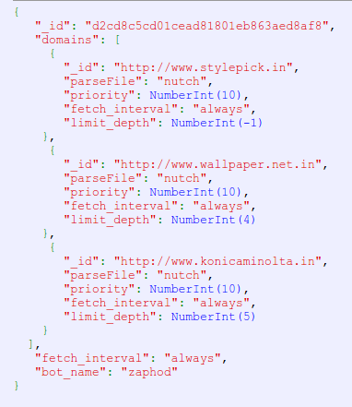

Domain group representation in mongodb.

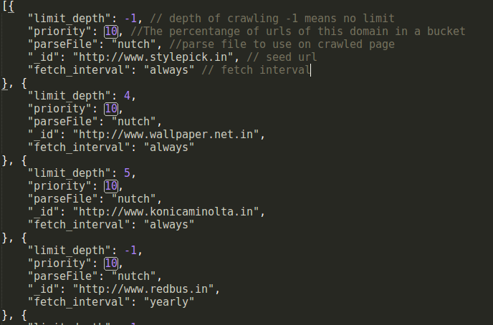
Seed file example

Uniform crawling: How to maintain a crawl-delay, when the crawling is distributed?

Uniform crawling is a major concern in distributed crawlers. Managing crawl delays in the current bot can be maintained but, to achieve crawl delays in the entire cluster is difficult. Many distributed crawlers create a proxy server through which they achieve delays. When many bots are hitting one domain these proxy servers only fullfill few requests and then queue the others.

In our distributed crawling environment we are maintaining a uniform breadth first crawling without using a proxy server.

The design of our system makes it easy for us to maintain crawl delays.

Seed file

Domain Group
Domain Group
Domain Group
Domain Group
Domain Group

Cluster
Bot1
Bot2

Fetcher 1
Fetcher 2
Fetcher 1
Fetcher 1
Fetcher 2
Fetcher 3

According to the above diagram at any given point of time one domain group would be fetched by only one bot. This also implies that the domains within the domain group will be fetched in only one fetcher in the entire cluster.

So, all the domain groups will be countinously fetched by fetchers but no two fetchers will be fetching the same domain.

There is also some disadvantages of this scheme such as one cannot crawl single seed in distributed mode. Our crawler works best when large number of seeds are present, it is when it's distributed uniform crawling is best.

Problems:

1. How to maintain a crawl-delay, when the crawling is distributed?
2. How to handle big seed files?
3. How to perform more fetching than running table scans, and other db tasks?
4. How to distribute and create jobs within many bots in the cluster?
5. How to handle many combinations of responses from the web page?
6. How to handle canonical pages?
7. How to reduce deduplication?
8. How to perform a BFS crawl in distributed mode?

Diagrams

Seed List partitioning

Sno | Seed 1 | Seed 2 | Seed 3 | Seed 4 | Seed 5 | Seed 6 | Seed 7 | Seed 8 | Seed 9 | Seed 10
Url | http://www.google.com | http://www.yahoo.com | http://www.indiatimes.com | http://www.bbc.com | http://www.indiabix.com | http://www.geeksforgeeks.com | http://www.aajtak.com | http://www.facebook.com | http://www.twitter.com | http://www.whatsapp.com
Percentage of urls of this domain in the bucket | 10 | 15 | 40 | 5 | 5 | 5 | 5 | 5 | 5 | 5
Fetch interval monthly

Representation of a bucket

