CONFIDENTIAL
ONEWAYGUARD
NETWORK THREAT ANALYSIS REPORT
(Passive, Metadata-Only Detection — Critical Infrastructure Monitoring Enclave)
Report No. | OWG-2026-0915-001
Report Type | Network Threat Analysis Report — Passive Detection
Prepared By | OneWayGuard Automated Threat Detection Pipeline
Analysis Mode | Live Capture
Monitored Interface | Wi-Fi (mirrored via optical tap / hardware data diode)
Analysis Period / Duration | 66 seconds (see Section II for session timestamps)
Capture Classification | Metadata-Only — No Payload Inspected, Decrypted, or Retained
Report Classification | CONFIDENTIAL — For Internal / Authorized Use Only

I. PRELIMINARY STATEMENT
1. This report is issued by the OneWayGuard passive cyber-threat detection pipeline in connection with the continuous security monitoring of the above-referenced critical-infrastructure monitoring enclave. It sets forth the findings of an automated analysis session conducted on the date and interface identified in the Report Control Table above.
2. This report is based exclusively on metadata-only features extracted from unidirectional network traffic. At no point during the underlying analysis was any packet payload accessed, decrypted, copied, or retained, and at no point did the reporting system transmit any traffic, complete any handshake, or otherwise interact with the monitored network.
3. The findings set forth herein are statistical and behavioral in nature. They identify traffic patterns consistent with the threat categories described below and are intended to support, and not to substitute for, review and verification by a qualified security analyst prior to any escalation, remediation, or disclosure action.
II. SCOPE, METHODOLOGY, AND LIMITATIONS
4. Architecture. OneWayGuard operates under strict physical and architectural constraints. It ingests unidirectional IP traffic across a hardware data diode or optical tap and has no return path into the production network. It cannot send probes, complete TCP handshakes, decrypt TLS/QUIC payloads, or perform inline blocking of any kind.
5. Detection Method. The system extracts streaming, metadata-only features — including packet timing jitter, volume asymmetry, TCP flag dynamics, and DNS entropy — and evaluates them in near real time through a hybrid detection engine combining an adaptive Kalman filter operating on innovation residuals, a regularized XGBoost classification model, and specialist threat heuristics.
6. Scope of Detection. The detection engine is designed to identify six threat vectors: (a) volumetric distributed denial-of-service (DDoS) activity; (b) botnet command-and-control (C2) beaconing; (c) domain generation algorithm (DGA) activity and DNS tunneling; (d) encrypted session anomalies; (e) reconnaissance and port scanning; and (f) data exfiltration.
7. Limitations. Because the system does not inspect payload content and cannot verify traffic through active means, all findings reflect probabilistic detection based on observed metadata patterns. No finding in this report should be construed as a confirmed determination that a compromise, intrusion, or policy violation has occurred absent independent analyst verification.
III. SUMMARY OF FINDINGS
8. The following table summarizes the quantitative results of the analysis session identified in the Report Control Table.
Metric | Result
Packets Observed | 554
Flows Processed | 61
Flows Flagged | 28
Flag Rate | 45.90%
Highest Severity Observed | Medium
Classification Model | XGBoost (Regularized)
Anomaly Model | Adaptive Kalman Filter (Innovation Residuals)

IV. DETAILED THREAT FINDINGS
9. The analysis session identified the threat categories set forth in the table below, each supported by the evidence summarized therein and detailed further in Section V.
No. | Threat Category | Severity | Confidence | Supporting Evidence
1 | C2 Beaconing | HIGH | 93.4% | Low-jitter periodic traffic
2 | Reconnaissance | MEDIUM | 87.2% | Repeated connection attempts
3 | DNS Anomaly | MEDIUM | 81.5% | Abnormal DNS entropy / query characteristics

10. Severity and confidence values are produced by the fused Kalman-residual / XGBoost detection engine described in Section II and reflect statistical likelihood rather than confirmed compromise. Each finding requires independent analyst verification prior to escalation.
V. DETECTION EVIDENCE
Flow of Record: 192.168.1.7 → 203.0.113.44:443
Source Address | 192.168.1.7
Destination Address | 203.0.113.44
ML Classifier Probability | 0.91
Kalman Anomaly Score | 4.72
Fused Confidence Score | 0.934
Packet Count | 11
Byte Count | 814
Protocol | TCP
Destination Port | 443

11. Basis for Flagging. The above flow was flagged on the basis of a high classifier probability combined with anomalous temporal and flow-volume behavior consistent with periodic command-and-control beaconing, specifically low inter-packet jitter and stable byte volume across repeated connections to the same destination.
12. Recommended Analyst Action. It is recommended that the source host identified above be investigated and correlated against endpoint detection and response (EDR) and firewall/proxy logs for the corresponding time window. Destination reputation for the address and port identified above should be independently confirmed before any containment action is taken, as this system cannot itself block traffic or confirm payload content.

VI. EXHIBITS
13. The following exhibits are incorporated into and form part of this report.
EXHIBIT A — Threat Distribution by Category
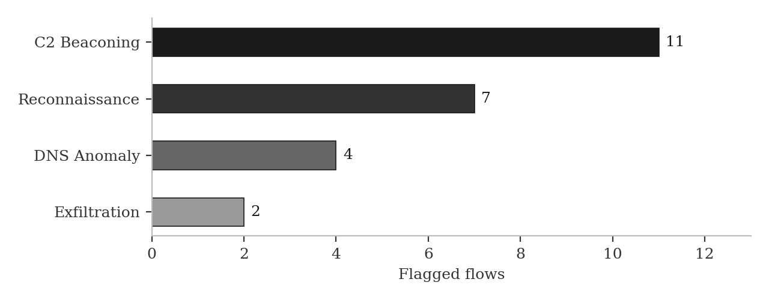
EXHIBIT B — Confidence Score Distribution
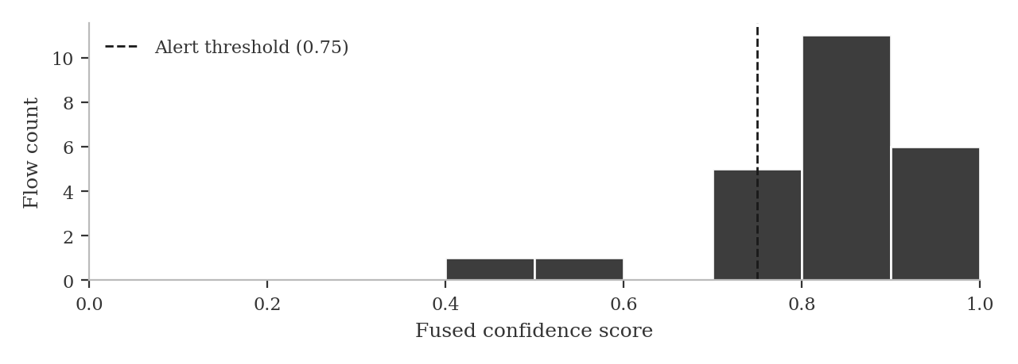
EXHIBIT C — Chronological Alert Timeline
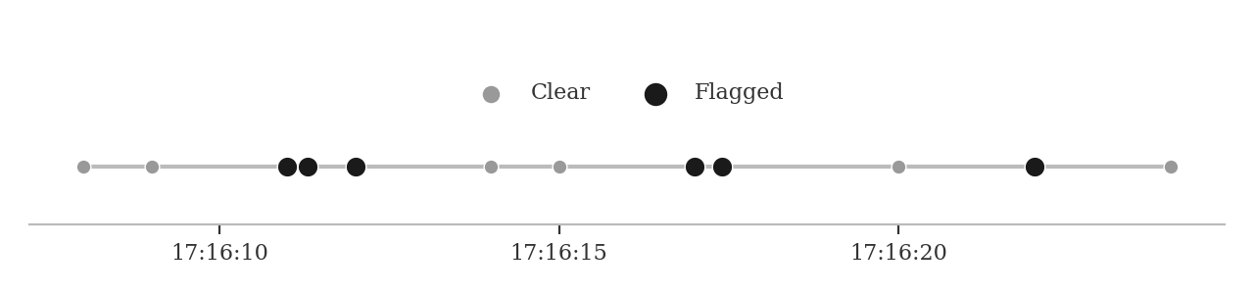

VII. CORRELATED INCIDENT RECORD
14. Where multiple flagged flows share a common source, destination, or behavioral signature, such flows are consolidated into a single correlated incident record, as set forth below, rather than reported individually.
Incident No. | OWG-INC-001
Threat Classification | Possible Command-and-Control (C2) Beaconing
Severity | HIGH
Confidence | 94.1%
Affected Source | 192.168.1.7
Destination | 203.0.113.44 : 443
Related Flows | 5
First Observed (UTC) | 2026-09-15 17:16:11
Last Observed (UTC) | 2026-09-15 17:17:02

Supporting Evidence (5 Related Flows)
- 17:16:11 UTC — 192.168.1.7:51422 → 203.0.113.44:443 — Fused Confidence 0.934
- 17:16:24 UTC — 192.168.1.7:51430 → 203.0.113.44:443 — Fused Confidence 0.921
- 17:16:37 UTC — 192.168.1.7:51441 → 203.0.113.44:443 — Fused Confidence 0.918
- 17:16:49 UTC — 192.168.1.7:51455 → 203.0.113.44:443 — Fused Confidence 0.927
- 17:17:02 UTC — 192.168.1.7:51468 → 203.0.113.44:443 — Fused Confidence 0.941

VIII. CERTIFICATION
15. I certify, to the best of my knowledge and based upon the automated detection processes described in Section II, that the foregoing report accurately and completely reflects the metadata-only findings generated by the OneWayGuard system during the analysis session identified in the Report Control Table, and that no payload data was accessed, decrypted, or relied upon in the preparation of this report.
16. This report is provided for internal security operations, investigative, and/or compliance purposes. It does not constitute a legal conclusion regarding the occurrence of any unauthorized access, breach, or violation of law, and is submitted subject to independent review and verification by qualified personnel.
IX. CHAIN OF CUSTODY AND REPORT AUTHENTICATION
17. The following information establishes the provenance of this report and supports its use as supporting documentation in internal investigations, compliance filings, or other proceedings requiring a documented chain of custody.
Report Generated (UTC) | 2026-09-15 17:17:14
Generated By | OneWayGuard Report Engine v[x.x]
Sensor / Tap Identifier | [capture interface / data-diode ID]
Analyst of Record | [name / SOC handle]
Report Integrity Hash (SHA-256) | [auto-computed on export]
Source Data Retention Period | [per organizational retention policy]
X. SIGNATURES
18. IN WITNESS WHEREOF, the undersigned have reviewed and, where applicable, approved this report for the purposes stated herein.
_______________________________________
Analyst of Record
Printed Name: ______________________________
Title: ______________________________________
Date: _______________________ Location: ______________________
_______________________________________
Reviewing Officer / SOC Lead
Printed Name: ______________________________
Title: ______________________________________
Date: _______________________ Location: ______________________

