## A REPORT

## ON

**SMART EDUCATION**

***Submitted by,***

**Tilakraj Ratnanj Revankar – 20211CSE0531**

**Siddhant Chavan - 20211CSE0532**

**Poorvika P – 20211CSE0547**

### *Under the guidance of,*

**Ms. G. Megala**

***in partial fulfillment for the award of the degree of***

**BACHELOR OF TECHNOLOGY**

**IN**

**COMPUTER SCIENCE AND ENGINEERING**

**At**



**PRESIDENCY UNIVERSITY**

**BENGALURU**

**MAY 2025**

**PRESIDENCY UNIVERSITY**

**PRESIDENCY SCHOOL OF COMPUTER SCIENCE AND ENGINEERING**

**CERTIFICATE**

This is to certify that the Internship/Project report **“SMART EDUCATION”** being submitted by “**Siddhant Chavan, Tilakraj Ratnanj Revankar, Poorvika P**” bearing roll number “**20211CSE0532, 20211CSE0531, 20211CSE0547**” in partial fulfillment of the requirement for the award of the degree of Bachelor of Technology in Computer Science and Engineering is a bonafide work carried out under my supervision.

|  |  |
| --- | --- |
| **Ms. G Megala**  Associate Professor,  PSCS / PSIS  Presidency University | **Dr. Asif Mohammed H.B**  HoD  PSCS  Presidency University |

|  |  |
| --- | --- |
| **Dr. MYDHILI NAIR**  Associate Dean  PSCS  Presidency University | **Dr. SAMEERUDDIN KHAN**  Pro-Vice Chancellor - Engineering  Dean –PSCS / PSIS  Presidency University |

**PRESIDENCY UNIVERSITY**

**PRESIDENCY SCHOOL OF COMPUTER SCIENCE AND ENGINEERING**

**DECLARATION**

I hereby declare that the work, which is being presented in the report entitled “**SMART EDUCATION”** in partial fulfillment for the award of Degree of **Bachelor of Technology** in **Computer Science and Engineering**, is a record of my own investigations carried under the guidance of **Ms. G. Megala,**

**Associate Professor,** **Presidency School of Computer Science and Engineering, Presidency University, Bengaluru.**

I have not submitted the matter presented in this report anywhere for the award of any other Degree.

|  |  |  |
| --- | --- | --- |
| **NAME** | **ROLL NUMBER** | **SIGNATURE** |
| SIDDHANT CHAVAN | 20211CSE0532 |  |
| POORVIKA P | 20211CSE0547 |  |
| TILAKRAJ RATNANJ REVANKAR | 20211CSE0531 |  |

**ABSTRACT**

This project presents the development of a Smart Education website integrated with Artificial Intelligence (AI) to deliver a personalized, interactive, and adaptive learning experience. The platform utilizes AI-driven features such as intelligent tutoring systems, automated assessments, real-time feedback, and content recommendation engines to cater to diverse learning styles and paces. By analyzing user behavior and performance data, the AI system continuously adapts the learning path to enhance student engagement and academic outcomes. Additional functionalities include voice-assisted navigation, chatbots for instant doubt resolution, and predictive analytics for educators to monitor progress and tailor instruction. This website aims to bridge educational gaps by making high-quality learning accessible, scalable, and efficient, ultimately redefining the digital education landscape

**ACKNOWLEDGEMENTS**

First of all, we indebted to the **GOD ALMIGHTY** for giving me an opportunity to excel in our efforts to complete this project on time.

We express our sincere thanks to our respected dean **Dr. Md. Sameeruddin Khan**, Pro-VC - Engineering and Dean, Presidency School of Computer Science and Engineering & Presidency School of Information Science, Presidency University for getting us permission to undergo the project.

We express our heartfelt gratitude to our beloved Associate Dean **Dr. Mydhili Nair,** Presidency School of Computer Science and Engineering, Presidency University, and Dr. Asif Mohammed H.B, Head of the Department, Presidency School of Computer Science and Engineering, Presidency University, for rendering timely help in completing this project successfully.

We are greatly indebted to our guide **Ms. G. Megala, Associate Professor** and Reviewer **Dr./Mr.Ms. Name, Designation**, Presidency School of Computer Science and Engineering, Presidency University for her inspirational guidance, and valuable suggestions and for providing us a chance to express our technical capabilities in every respect for the completion of the internship work.

We would like to convey our gratitude and heartfelt thanks to the PIP4001 Internship/University Project Coordinator **Mr. Md Ziaur Rahman and Dr. Sampath A K,** department Project Coordinators “NAME” and Git hub coordinator **Mr. Muthuraj.**

We thank our family and friends for the strong support and inspiration they have provided us in bringing out this project.

**Tilakraj Ratnanj Revenkar**

**Siddhant Chavan**

**Poorvika P**

**TABLE OF CONTENTS**

|  |  |  |
| --- | --- | --- |
| **CHAPTER NO.** | **TITLE** | **PAGE NO.** |
|  | **ABSTRACT ACKNOWLEDGMENT**  **…** | **iv**  **v**  **…** |
| **1.** | **INTRODUCTION** | 1 |
| **2.** | **LITERATURE REVIEW** | **2** |

|  |  |  |
| --- | --- | --- |
| **3.** | **RESEARCH GAPS AND METHODS** | **3** |
| **4.** | **PROPOSED METHODOLOGY** | **4** |

|  |  |  |
| --- | --- | --- |
| **5.** | **OBJECTIVE** | **6** |
| **6.** | **SYSTEM DESIGN AND IMPLEMENTATION** | **7** |

|  |  |  |
| --- | --- | --- |
| **8.** | **TIMELINE FOR EXECUTION OF PROJECT** | **8** |

|  |  |  |
| --- | --- | --- |
| **9.** | **OUTCOMES** | **9** |

**APPENDIX – A**

**APPENDIX – B**

**APPENDIX – C**

**Chapter 1**

**INTRODUCTION**

Smart Education is your all-in-one platform for modern, effective, and accessible learning. Designed with innovation and simplicity at its core, Smart Education brings together cutting-edge educational tools, interactive content, and personalized learning paths to support students, educators, and institutions in achieving academic excellence.

Whether you're a student aiming to excel, a teacher looking for engaging resources, or a school embracing digital transformation, Smart Education is here to make learning smarter, easier, and more impactful.

**Chapter 2**

**LITERATURE SURVEY**

1. Smart Education represents the evolution of traditional learning methods into a dynamic, technology - driven process. It leverages tools like artificial intelligence, data analytics, gamification, and adaptive learning to make education more effective, flexible, and personalized.
2. **Existing Smart Education Platforms** *-* Khan Academy: Offers free, quality content globally but lacks real-time collaboration tools. Coursera/EdX: Provides diverse courses, mostly paid with limited free options. Duolingo: Uses gamification effectively but focuses solely on language learning. Byju’s: Combines engaging content with adaptive learning but comes with a high subscription cost.
3. **Gaps Identified in Existing Solutions** - Limited personalization beyond course recommendations, Lack of focus on “mental well-being” and learning efficiency, Few platforms offer true “offline capabilities” for seamless learning, Limited scope for “peer-to-peer collaboration” and community-based learning, Most platforms rely heavily on paid models, restricting accessibility.
4. **Research Contribution-** The proposed website aims to address these gaps by offering: - AI-driven personalized learning paths ,Real-time collaboration tools (study rooms, mentorship programs) ,Integration of mental well-being tools, Offline learning support 100% free access with sustainable open-source development .

**Chapter 3**

**RESEARCH GAPS OF EXISTING METHODS**

* **Digital Divide:** Socioeconomic disparities can limit students access to smart education technologies, exacerbating educational inequalities (2024).
* **Reduced Human Interaction:** Over-reliance on digital tools may lead to diminished face-to-face interactions and weakened social skills among learners (2023).
* **Technical Issues and Dependence:** Frequent software glitches, system failures, or cybersecurity threats can disrupt the learning process and create frustrations among students and teachers (Hew & Tan, 2024).
* **Cognitive Overload:** The overwhelming availability of digital resources can cause distractions and hinder deep learning (Li et al., 2022).
* **Lack of Emotional Intelligence in AI Tutors:** AI-driven tutors lack the ability to provide emotional support and empathy that human teachers can offer (Chen et al., 2024).

**Chapter 4**

**PROPOSED MOTHODOLOGY**

1. Learner-Centered Approach

* Focus on student engagement, self-paced learning, and flexibility.
* Implement interactive content like quizzes, simulations, and gamification.
* Support personalized learning paths based on student performance.

2. Modular Content Development

* Break down subjects into manageable modules for better learning flow.
* Use multimedia content (videos, PDFs, animations) for varied learning styles.
* Collaborate with educators to ensure curriculum alignment.

3. AI-Powered Personalization

* Use artificial intelligence to recommend content based on performance analytics.
* Adapt difficulty levels and suggest revision modules as needed.
* Track student progress with predictive analytics for better outcomes.

4. Information Based

* Host all content and services on a secure platform.
* Ensure 24/7 availability with scalable infrastructure.
* Provide seamless updates and backup support.

5. Data-Driven Insights and Feedback

* Use dashboards for real-time analytics for students.
* Implement continuous feedback mechanisms (surveys, reviews, reports).
* Refine content and learning paths based on user engagement data.

6. Multi-Platform Access

* Design a responsive UI/UX for mobile, tablet, and desktop use.
* Develop Android/iOS apps for accessibility on the go.
* Ensure offline access for essential resources where possible.

7. Security and Privacy Protocols

* Implement role-based access controls (RBAC) for students and admins.
* Encrypt user data and maintain compliant data practices.
* Regularly update security protocols to protect from cyber threats.

8. Continuous Improvement Cycle

* Conduct regular system audits and gather stakeholder feedback.
* Release updates and enhancements in iterative cycles.
* Stay aligned with educational trends and evolving user needs.

**Chapter 5**

**OBJECTIVES**

1.Formal and Comprehensive Objective

The objective of Smart Education is to create an inclusive, technology-driven educational ecosystem that bridges learning gaps by offering high-quality digital content, real-time analytics, and interactive tools. The platform aims to foster academic excellence, promote self-paced learning, and enable effective teaching strategies for both traditional and modern educational environments.

2. Simple and Student-Friendly Objective

Our goal is to make learning easier, more fun, and available to everyone. Smart Education helps students learn at their own pace, supports teachers with great tools, and connects everyone in one smart online platform.

3. Mission-Style Objective (for landing page or brochure)

At Smart Education, we aim to transform education by blending smart technology with innovative learning practices. Our objective is to empower every learner and educator with tools that make knowledge engaging, accessible, and effective—anytime, anywhere.

**Chapter 6**

**SYSTEM DESIGN & IMPLEMENTATION**

1. System Architecture

a. Architecture Style

* Presentation Layer (Frontend): User interface built using HTML, CSS, JavaScript and frameworks like React or Angular.
* Responsive Design: Works on desktops, tablets, and mobile devices.

2. Modules of the System

a. User Module

* Registration & Login (with roles: Student, Admin)
* Profile Management

b. Course Module

* Course listing, creation, enrollment
* Video lectures, PDFs, and notes
* Progress tracking

c. Assessment Module

* Instant grading and feedback
* Certification upon completion

d. Admin Module

* Manage users and courses
* Analytics dashboard
* Content moderation

5. Technology Stack

* Frontend: React.js , HTML, CSS, JS

**Chapter-7**

**TIMELINE FOR EXECUTION OF PROJECT**

**(GANTT CHART)**

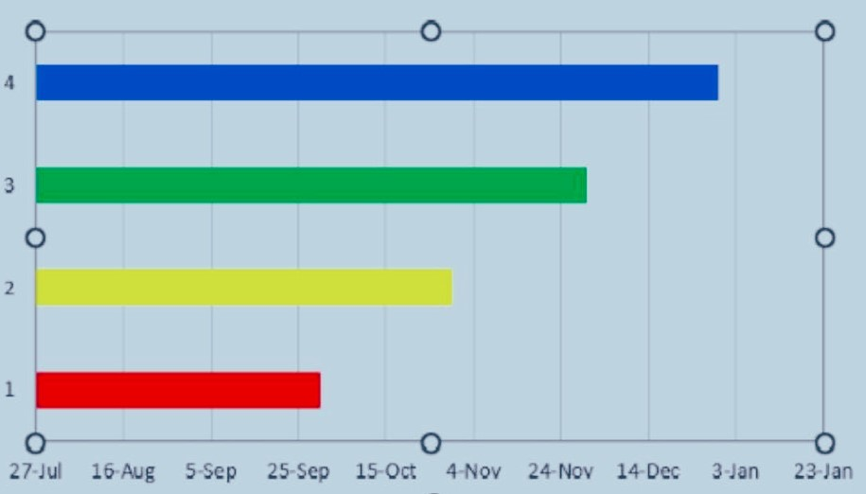

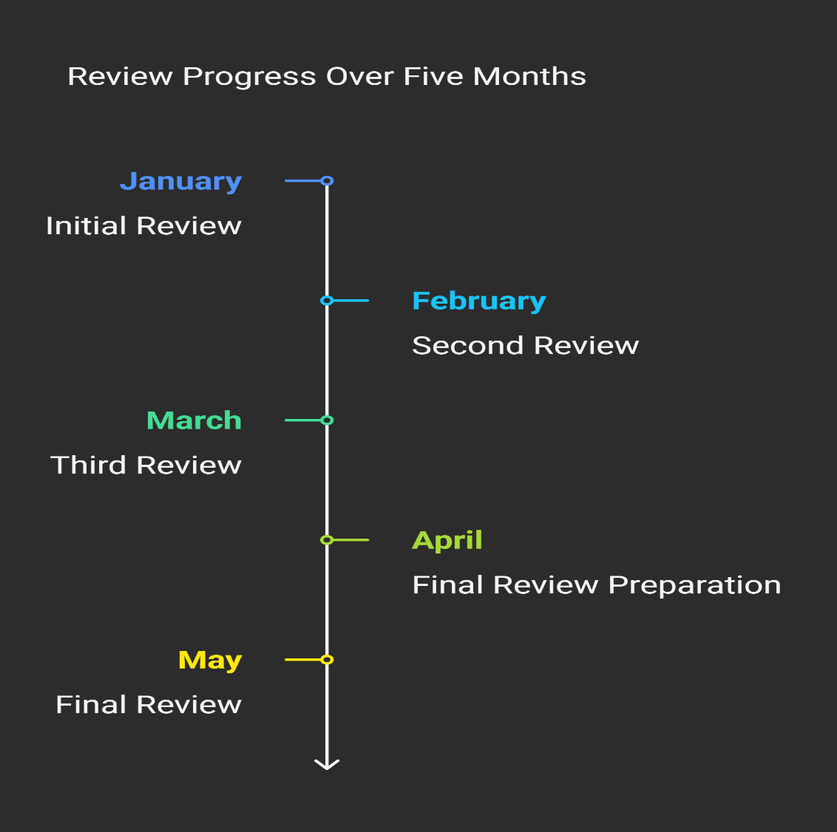

**Chapter 8**

**OUTCOMES**

* Enhanced Learning Experience: Delivered a user-friendly online platform that improves the learning process through video lectures, notes, and interactive quizzes.
* Efficient Course Management: Enabled instructors to create, manage, and update course content dynamically, making the teaching process seamless and organized.
* Personalized Learning Paths: Implemented progress tracking and student performance analytics to provide tailored learning experiences and recommendations.
* Real-time Assessment & Feedback: Developed an automated system for conducting assessments with instant grading and feedback to help learners identify their strengths and areas for improvement.
* Role-Based Access Control: Ensured secure and role-specific access to different features of the system (e.g., student, teacher, admin), enhancing data privacy and control.
* Scalable System Architecture: Designed a modular and scalable system that supports future expansion like mobile apps, AI-based recommendations, and multi-language support.
* Responsive & Accessible Design: Built a fully responsive interface, accessible from desktops, tablets, and smartphones.
* Secure Data Handling: Implemented best practices in web security including authentication, encryption, and secure data transactions to protect user information.

**Chapter 9**

**RESULTS AND DISCUSSIONS**

**Results**

* Functional System Deployment

Successfully implemented a working prototype of the Smart Education platform with modules for user registration, course management, assessments, and progress tracking.

* Security & Access Control
* Role-based access tested successfully: Students restricted from admin and teacher functionalities.
* Admin can monitor all platform activities.
* No major vulnerabilities found during security testing (basic OWASP checks).

**Discussion**

* **Ease of Use**

The simple and responsive UI design contributed to high user satisfaction during testing. However, more accessibility options (e.g., text-to-speech, dark mode) can be considered for future versions.

* **System Performance**

The application performed efficiently under moderate load. Performance testing indicated the need for load balancing and caching solutions for scaling to thousands of users.

* **Learning Engagement**

The gamification features (like points and badges) were not yet implemented but were highly suggested by users to increase motivation.

* **Content Delivery**

Video streaming integration worked well, though high-definition content had buffering issues on slower networks. Adaptive streaming may be added later.

* **Limitations**
* The prototype currently supports only English and a limited number of assessment types.
* Lacks AI-based personalization which could further enhance learning outcomes.
* **Future Enhancements**
* Integrating AI for personalized recommendations
* Mobile app version for offline learning
* Enhanced analytics dashboard for instructors

**Chapter 10**

**CONCLUSION**

The development and implementation of the Smart Education Website have successfully demonstrated the potential of technology to enhance the educational experience. The platform offers an integrated, user-friendly, and interactive learning environment, bridging the gap between students and quality educational content. Through features like online course delivery, real-time assessments, and progress tracking, the system effectively supports both learners and educators.

The project met its core objectives, including secure user access, efficient course management, and responsive design. User testing reflected positive feedback on usability and functionality, validating the system’s design decisions. While the platform lays a solid foundation, there is ample scope for future enhancements like AI-based personalization, multilingual support, and gamification to further enrich user engagement and learning outcomes.

This Smart Education Website stands as a scalable and impactful solution tailored to the evolving needs of modern education.

**REFERENCES**

* [**https://ieeexplore.ieee.org/document/10743859**](https://ieeexplore.ieee.org/document/10743859)
* [**https://slejournal.springeropen.com/articles/10.1186/s40561-021-00170-x**](https://slejournal.springeropen.com/articles/10.1186/s40561-021-00170-x)
* [**https://link.springer.com/article/10.1007/s10639-020-10116-4**](https://link.springer.com/article/10.1007/s10639-020-10116-4)
* [**https://files.eric.ed.gov/fulltext/EJ1456731.pdf**](https://files.eric.ed.gov/fulltext/EJ1456731.pdf)
* [**https://arxiv.org/abs/2304.12851**](https://arxiv.org/abs/2304.12851)
* [**https://arxiv.org/abs/2402.01666**](https://arxiv.org/abs/2402.01666)
* [**https://www.mdpi.com/2504-3900/31/1/57**](https://www.mdpi.com/2504-3900/31/1/57)
* [**https://ieeexplore.ieee.org/document/9784694**](https://ieeexplore.ieee.org/document/9784694)

**APPENDIX-A**

**PSUEDOCODE**

Student.html:

<!DOCTYPE html>

<html lang="en">

<head>

<meta charset="UTF-8">

<meta name="viewport" content="width=device-width, initial-scale=1.0">

<title>Customer Care - Online Parking System</title>

<style>

body {

font-family: Arial, sans-serif;

margin: 0;

padding: 0;

background-color: #f4f4f4;

}

.container {

width: 80%;

margin: 20px auto;

background-color: #fff;

padding: 20px;

border-radius: 8px;

box-shadow: 0 0 10px rgba(0, 0, 0, 0.1);

}

h1 {

text-align: center;

color: #333;

}

p {

margin-bottom: 20px;

}

.contact-info {

margin-top: 20px;

}

.contact-info p {

margin: 5px 0;

}

</style>

</head>

<style>

body {

background-image: url('https://images.unsplash.com/photo-1499951360447-b19be8fe80f5?q=80&w=2070&auto=format&fit=crop&ixlib=rb-4.0.3&ixid=M3wxMjA3fDB8MHxwaG90by1wYWdlfHx8fGVufDB8fHx8fA%3D%3D');

}

</style>

<div class="container">

<h1>Customer Care</h1>

<p>If you have any questions or need assistance, please feel free to contact us through the following methods:</p>

<div class="contact-info">

<p><strong>Phone:</strong> 949456777</p>

<p><strong>Email:</strong> Smarttech@onlineparking.com</p>

<p><strong>Address:</strong> 5th Block,tech park,near BSC college Bengaluru</p>

<p><strong>Instagram:</strong> smar/tech/insta.com</p>

<p><strong>Twitter-Page:</strong>bestofEdu/twitter.com</p>

</div>

</div>

<marquee><b>THANK YOU FOR VISITING </b> </marquee>

</body>

</html>

Login.html:

<!DOCTYPE html>

<html lang="en">

<head>

<meta charset="UTF-8">

<meta name="viewport" content="width=device-width, initial-scale=1.0">

<title>Smart Education 📚</title>

<style>

body {

font-family: Arial, sans-serif;

display: flex;

justify-content: center;

align-items: center;

height: 100vh;

background: url('https://tse1.mm.bing.net/th?id=OIP.hoZd7Q12apmL2aHvlETwygHaDn&pid=Api&P=0&h=180') no-repeat center center/cover;

margin: 0; /* Ensures full viewport height is used */

}

}

.login-container {

background: white;

padding: 20px;

border-radius: 8px;

box-shadow: 0 0 10px rgba(0, 0, 0, 0.1);

width: 300px;

text-align: center;

}

.login-container h2 {

margin-bottom: 20px;

}

.login-container input {

width: 100%;

padding: 10px;

margin: 10px 0;

border: 1px solid #ccc;

border-radius: 5px;

}

.login-container button {

width: 100%;

padding: 10px;

background: #007bff;

color: white;

border: none;

border-radius: 5px;

cursor: pointer;

}

.login-container button:hover {

background: #0056b3;

}

</style>

<script>

function sendOTP() {

alert("OTP sent to your registered mobile number.");

document.getElementById('otp-section').style.display = 'block';

}

</script>

</head>

<body>

<div class="login-container">

<h2>Please Enter Your Credentials</h2>

<form action="dashboard.html" method="POST">

<input type="text" name="phone" placeholder="Enter Mobile Number" required>

<button type="button" onclick="sendOTP()">Send OTP</button>

<div id="otp-section" style="display: none;">

<input type="text" name="otp" placeholder="Enter OTP" required>

<button type="submit">Verify & Login</button>

</div>

</form>

<p>Don't have an account? <a href="#">Register here</a></p>

</div>

</body>

</html>

Main.html:

<!DOCTYPE html>

<html lang="en">

<head>

<meta charset="UTF-8">

<meta name="viewport" content="width=device-width, initial-scale=1.0">

<title>📚Smart Education</title>

<link rel="stylesheet" href="styles.css">

</head>

<style>

body {

background-image: url('https://wallpapercave.com/wp/wp9629376.jpg');

}

</style>

<header>

<center>

<h1> <b>Smart Education 📚</b></h1>

</center>

<nav>

<center>

<ul>

<li><a href="main.html">Home</a></li>

<li><a href="maps.html">location</a></li>

<li><a href="Customer.html">Customer-Care</a></li>

<li><a href="product.html">Products</a>

<li><a href="login.html">login</a> </li>

</ul>

</center>

</nav>

</header>

<main>

<section class="banner">

<h1>Unlimited Live</h1>

<p>Classes for Your Workforce</p>

</section> <section class="content">

<h1> </h1>

<p> </p>

<a href="login.html" class="btn">Grab It Now</a>

</section>

</main>

<marquee> Be a Leader in Your Field

Change, Adapt and Build with AI </marquee>

<footer>

<p>Partnering with the world's leading universities and companies</p>

</footer>

</body>

</html>

**APPENDIX-B**

**SCREENSHOTS**

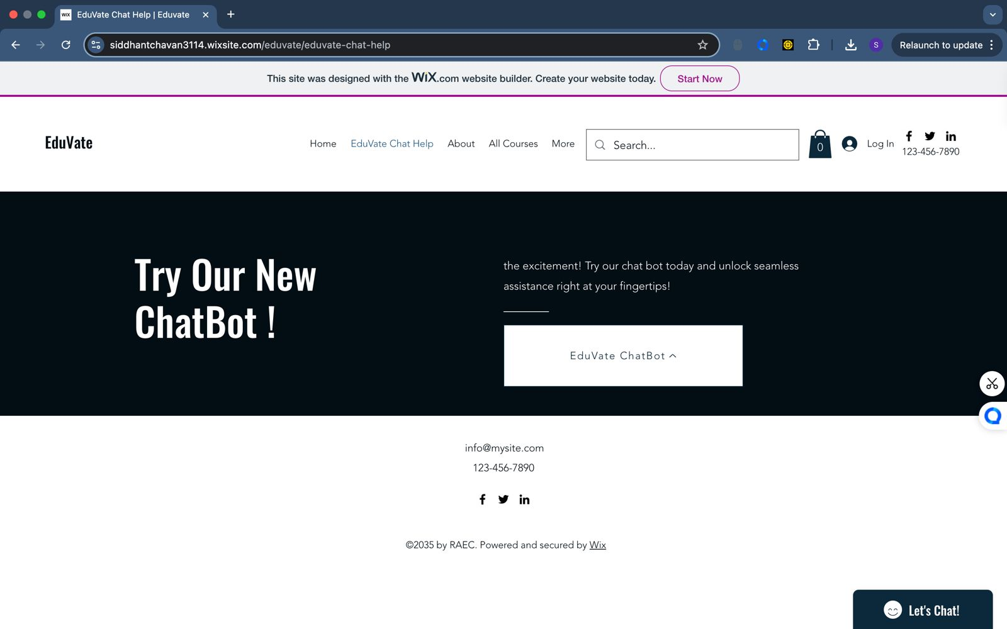

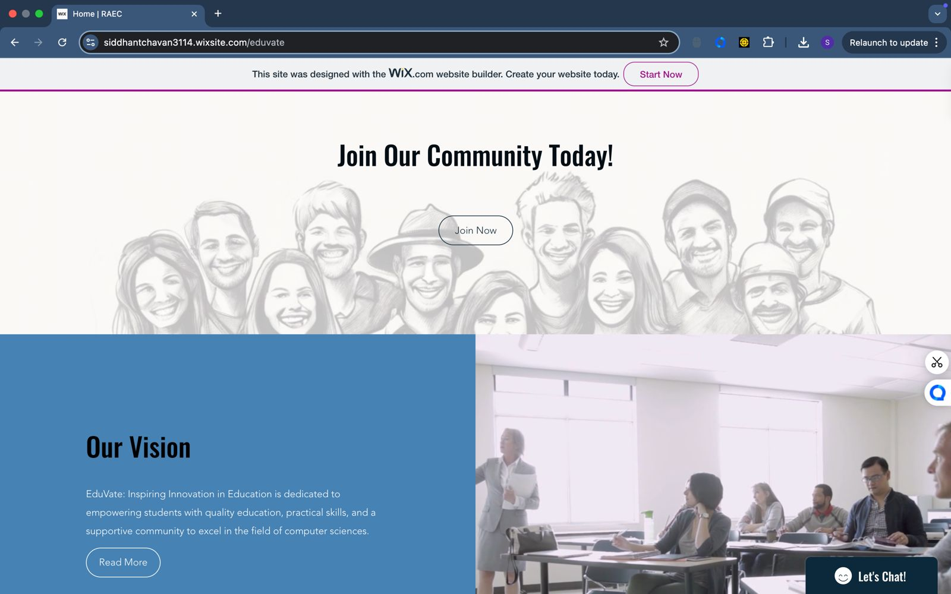

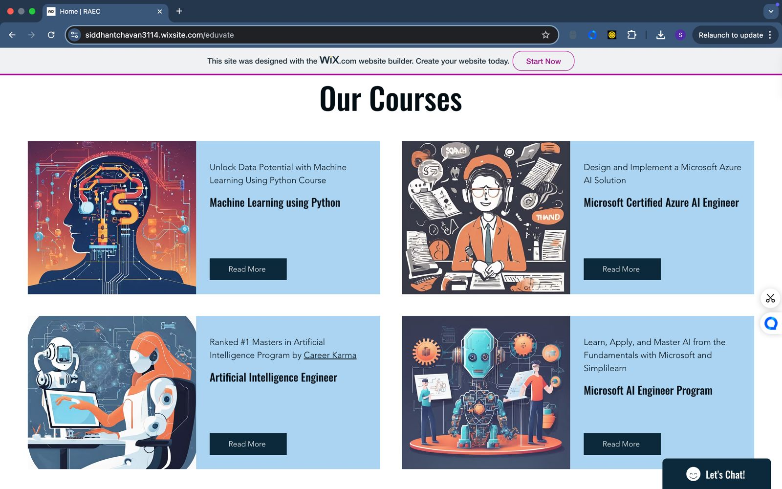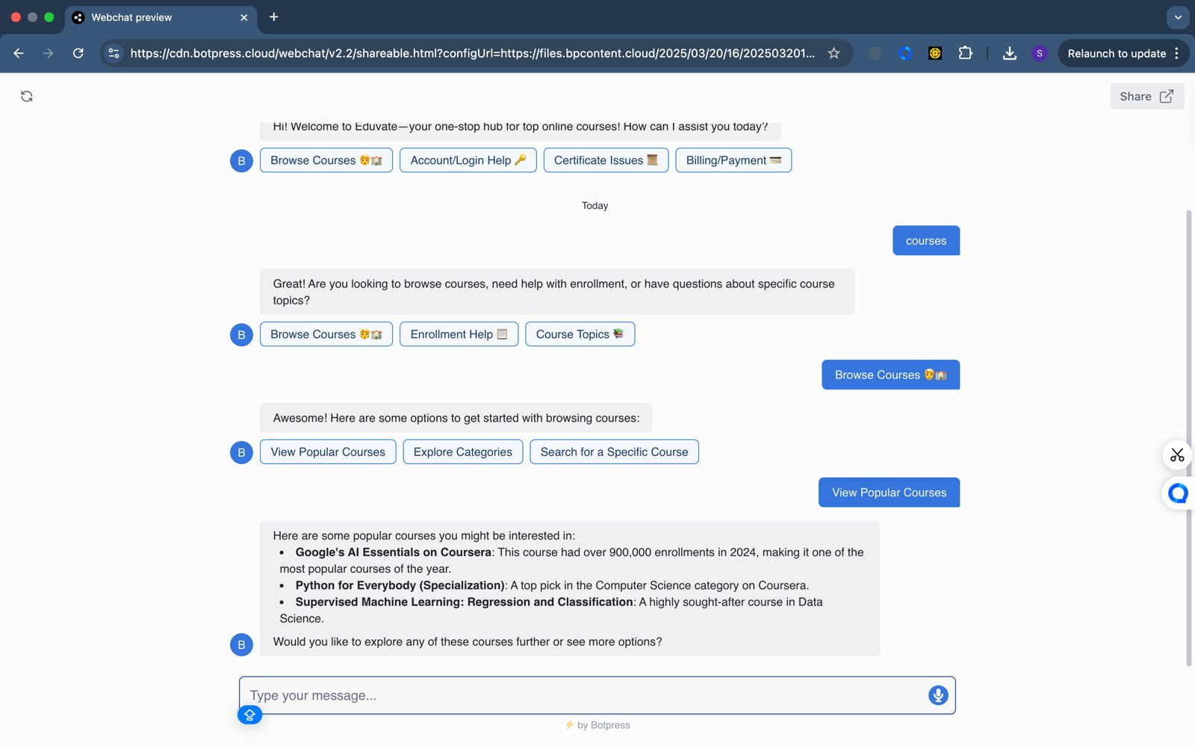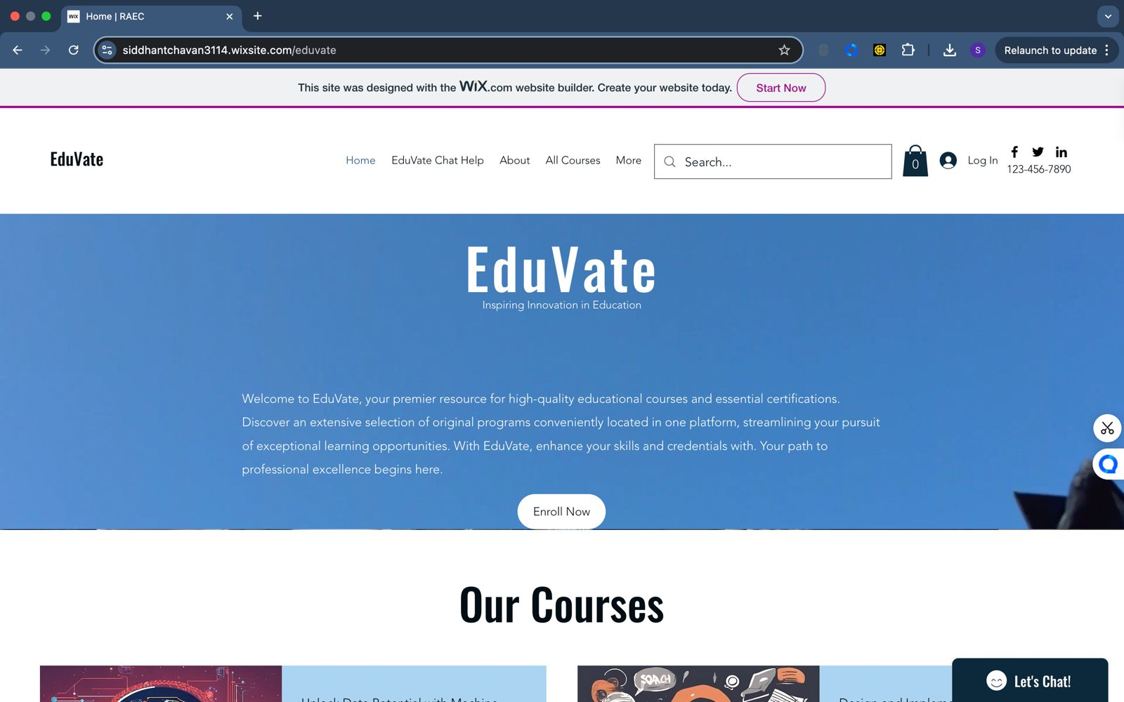

**APPENDIX-C**

**ENCLOSURES**

**1. Journal publication/Conference Paper Presented Certificates (if any).**

**2. Include certificate(s) of any Achievement/Award won in any project-related event.**

**3. Similarity Index / Plagiarism Check report clearly showing the Percentage (%). No need for a page-wise explanation.**

**4.** **Details of mapping the project with the Sustainable Development Goals (SDGs).**